**Supplementary Information**

**Molecular-level investigation on removal mechanisms of aqueous hexavalent chromium by pine needle biochar**

Yuting Zhanga, Na Liub, Peng Liuc, YingYing Liu d,e[1]*, Yutao Leif[2]*

aKey Laboratory of Songliao Aquatic Environment, Ministry of Education, Jilin Jianzhu University, Changchun 130118, China

bInstitute of Groundwater and Earth Science, Jinan University, Guangzhou 510632, China

cSchool of Environmental Studies, China University of Geosciences, 388 Lumo Rd., Wuhan 430074, China

dKey Laboratory of Groundwater Resources and Environment, Ministry of Education, Jilin University, Changchun 130021, China

eCollege of New Energy and Environment, Jilin University, Changchun 130021, China

fSouth China Institute of Environmental Sciences, MEP, 510530, China

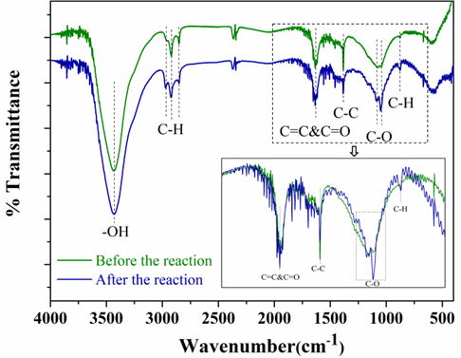

Fig. S1. FTIR spectra of pine needle biochar before and after Cr(VI) removal.

1. * Corresponding author: YingYing Liu;

   E-mail address: yingyingl@jlu.edu.cn
2. * Corresponding author: Yutao Lei

   E-mail address: leiyutao@scies.org