**Catalytic activity of Mn(III) porphyrin complex supported onto cross linked polymers in the green oxidation of Malathion with hydrogen peroxide in aqueous solution**

*Sahar H. El-Khalafy1*, Mahmoud T. Hassanein1, Samia M. Elsigeny 2, Hazem F. Taha1, Kamel R.Shoueir3, El-Refaie S. Kenawy4*

1Department of Chemistry, Faculty of Science, University of Tanta, Tanta 31527, Egypt.

2Department of Chemistry, Faculty of Science, Kafrelshiekh University, Kafrelsheikh, 33516 Egypt.

3Institute of Nanoscience & Nanotechnology, Kafrelsheikh University, 33516 Kafrelsheikh, Egypt

4Polymer Research Group, Department of Chemistry, Faculty of Science, University of Tanta, Tanta 31527, Egypt.

*\* Corresponding authors: Sahar H. El-Khalafy E-mail: sehar­_hasouna@science.tanta.edu.eg, Tel: +20-1007276665.*

**Supplementary Materials**

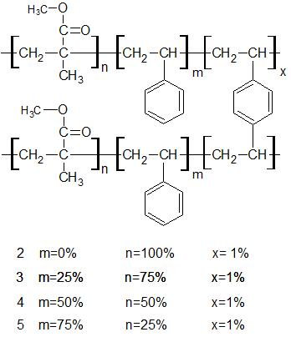

**2: PMMA m= 0% n= 99% x= 1%**

**3: PMMA/ST m= 49.5% n= 49.5 % x= 1%**

Fig S1: Structure of polymethyl methacrylate (PMMA) **2** and poly (methyl methacrylate -co- styrene) (PMMA/ST) **3**



Fig S2.a : FT-IR spectra of PMMA



Fig S3.a : FT-IR spectra of PMMA/ST 3



Fig S2.b: FT-IR spectra of Mn(III)OAc/ PMMA 4



Fig S3.b: FT-IR spectra of Mn(III) OAc /(PMMA/ ST ) 5