**Supplementary Information**

**for**

**Supramolecular Fluorescence Sensing for Quality Evaluation of Traditional Chinese Medicine**

Jia-Hong Tian a, Yi-Lin Lin a, d, Juan-Juan Li a,Rong Ma a, Huijuan Yu b,c, Yuefei Wang b,c,* , Xin-Yue Hu a,* , Dong-Sheng Guo a,*

a College of Chemistry, Key Laboratory of Functional Polymer Materials (Ministry of Education), State Key Laboratory of Elemento-Organic Chemistry, Collaborative Innovation Center of Chemical Science and Engineering, Nankai University, Tianjin, 300071, China.

b State Key Laboratory of Component-based Chinese Medicine, Tianjin Key Laboratory of TCM Chemistry and Analysis, Tianjin University of Traditional Chinese Medicine, Tianjin, 301617, China.

c Haihe Laboratory of Modern Chinese Medicine, Tianjin, 301617, China.

d State Key Laboratory of Biobased Fiber Manufacturing Technology, Tianjin University of Science and Technology, Tianjin, 300457, China.

* Corresponding author. E-mail address: wangyf0622@tjutcm.edu.cn (Y. Wang); huxinyue@nankai.edu.cn (X.-Y. Hu); dshguo@nankai.edu.cn (D.-S. Guo).

Table of Contents

1. Syntheses of QAAC4A and TAAC4A 3

2.Theoretical calculations 7

3. Supporting information and raw data 11

### 1. Syntheses of QAAC4A and TAAC4A

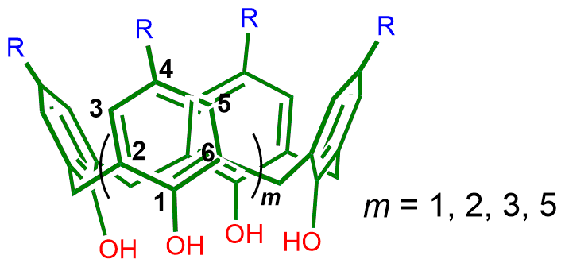

**Fig. S1.** Structure of calix[*n*]arenes (*n* = 4−8).

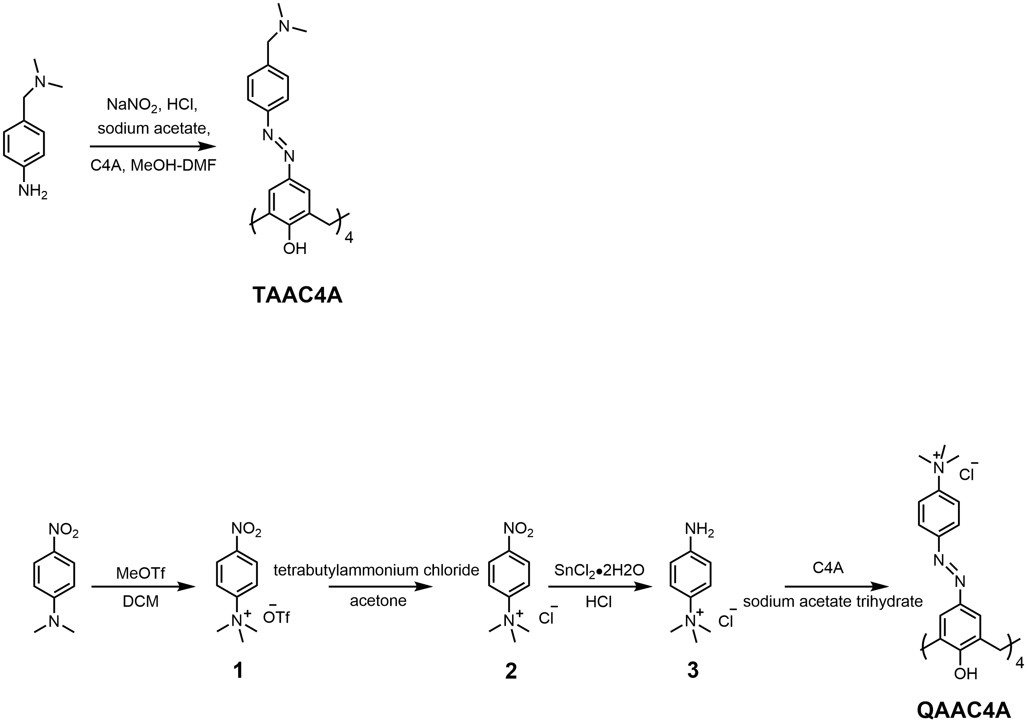

**Scheme S1.** The synthetic route of quaternary-ammonium modified azocalix[4]arene (QAAC4A).

General procedure for synthesis of QAAC4A: *N, N*-dimethyl-*p*-nitroaniline (2.1 mmol) was dissolved in 8.0 mL dichloromethane (DCM) and then the solution was cooled to 0 °C. Methyl trifluoromethanesulfonate solution (MeOTf, 1.0 mL, 4.2 mmol) was slowly added. After two hours of reaction, a pale-yellow solid was obtained by filtration, namely compound **1** (yield: 59%). Compound **1**(2.0 mmol) was dissolved in 15.0 mL acetone, and tetrabutylammonium chloride (2.1 mmol) was added to the solution to form a white precipitate, which was filtered and washed with acetone three times to obtain compound **2** (yield: 95%). Compound **2** (3.0 mmol) was dissolved in 5.0 mL concentrated hydrochloric acid and stannous chloride dihydrate (21.0 mmol) was added. The solution was stirred overnight and then adjusted to pH 7 with NaOH. After filtration, the filtrate was spin-dried to obtain a white solid, which was added to 5.0 mL methanol. After stirring for 15 min, the compound **3** was obtained by filtration(yield: 78%). Compound **3** (6.6 mmol) and concentrated hydrochloric acid (1.1 mL) were added to 15.0 mL water at 0−5 °C. A solution of sodium nitrite (7.2 mmol) in water (5 mL) was slowly added to the compound **3** and then this mixture was stirred at 0−5 °C for 30 min. The obtained solution was slowly added into a solution of 25,26,27,28-tetrahydroxycalix[4]arene (C4A, 1.6 mmol) and sodium acetate trihydrate (19.8 mmol) in MeOH-DMF (26 mL, 5:8, v:v). After stirring at room temperature for 2.5 h, the solvent was removed by rotary evaporation. The residue was recrystallized with water/acetone, then the solution was filtered and dried to obtain a reddish solid of QAAC4A(yield: 30%).

1H NMR (400 MHz, DMSO-*d*6) *δ* 8.09 (d, 8H, *J* = 8.0 Hz, Ar-H), 7.93 (d, 8H, *J* = 8.0 Hz, Ar-H), 7.80 (s, 8H, calix-H), 4.43 and 3.70 (m, 8H, Ar-CH2-H), 3.63 (s, 36H, CH3) ppm.

13C NMR (100 MHz, DMSO-*d*6) *δ* 161.13, 152.97, 147.90, 144.72, 131.09, 124.70, 123.33, 122.27, 56.93, 32.31 ppm.



**Fig. S2.** 1H NMR spectrum of QAAC4A (DMSO-*d*6, 400 MHz, 25 °C).



**Fig. S3.** 13C NMR spectrum of QAAC4A (DMSO-*d*6, 100 MHz,25 °C).

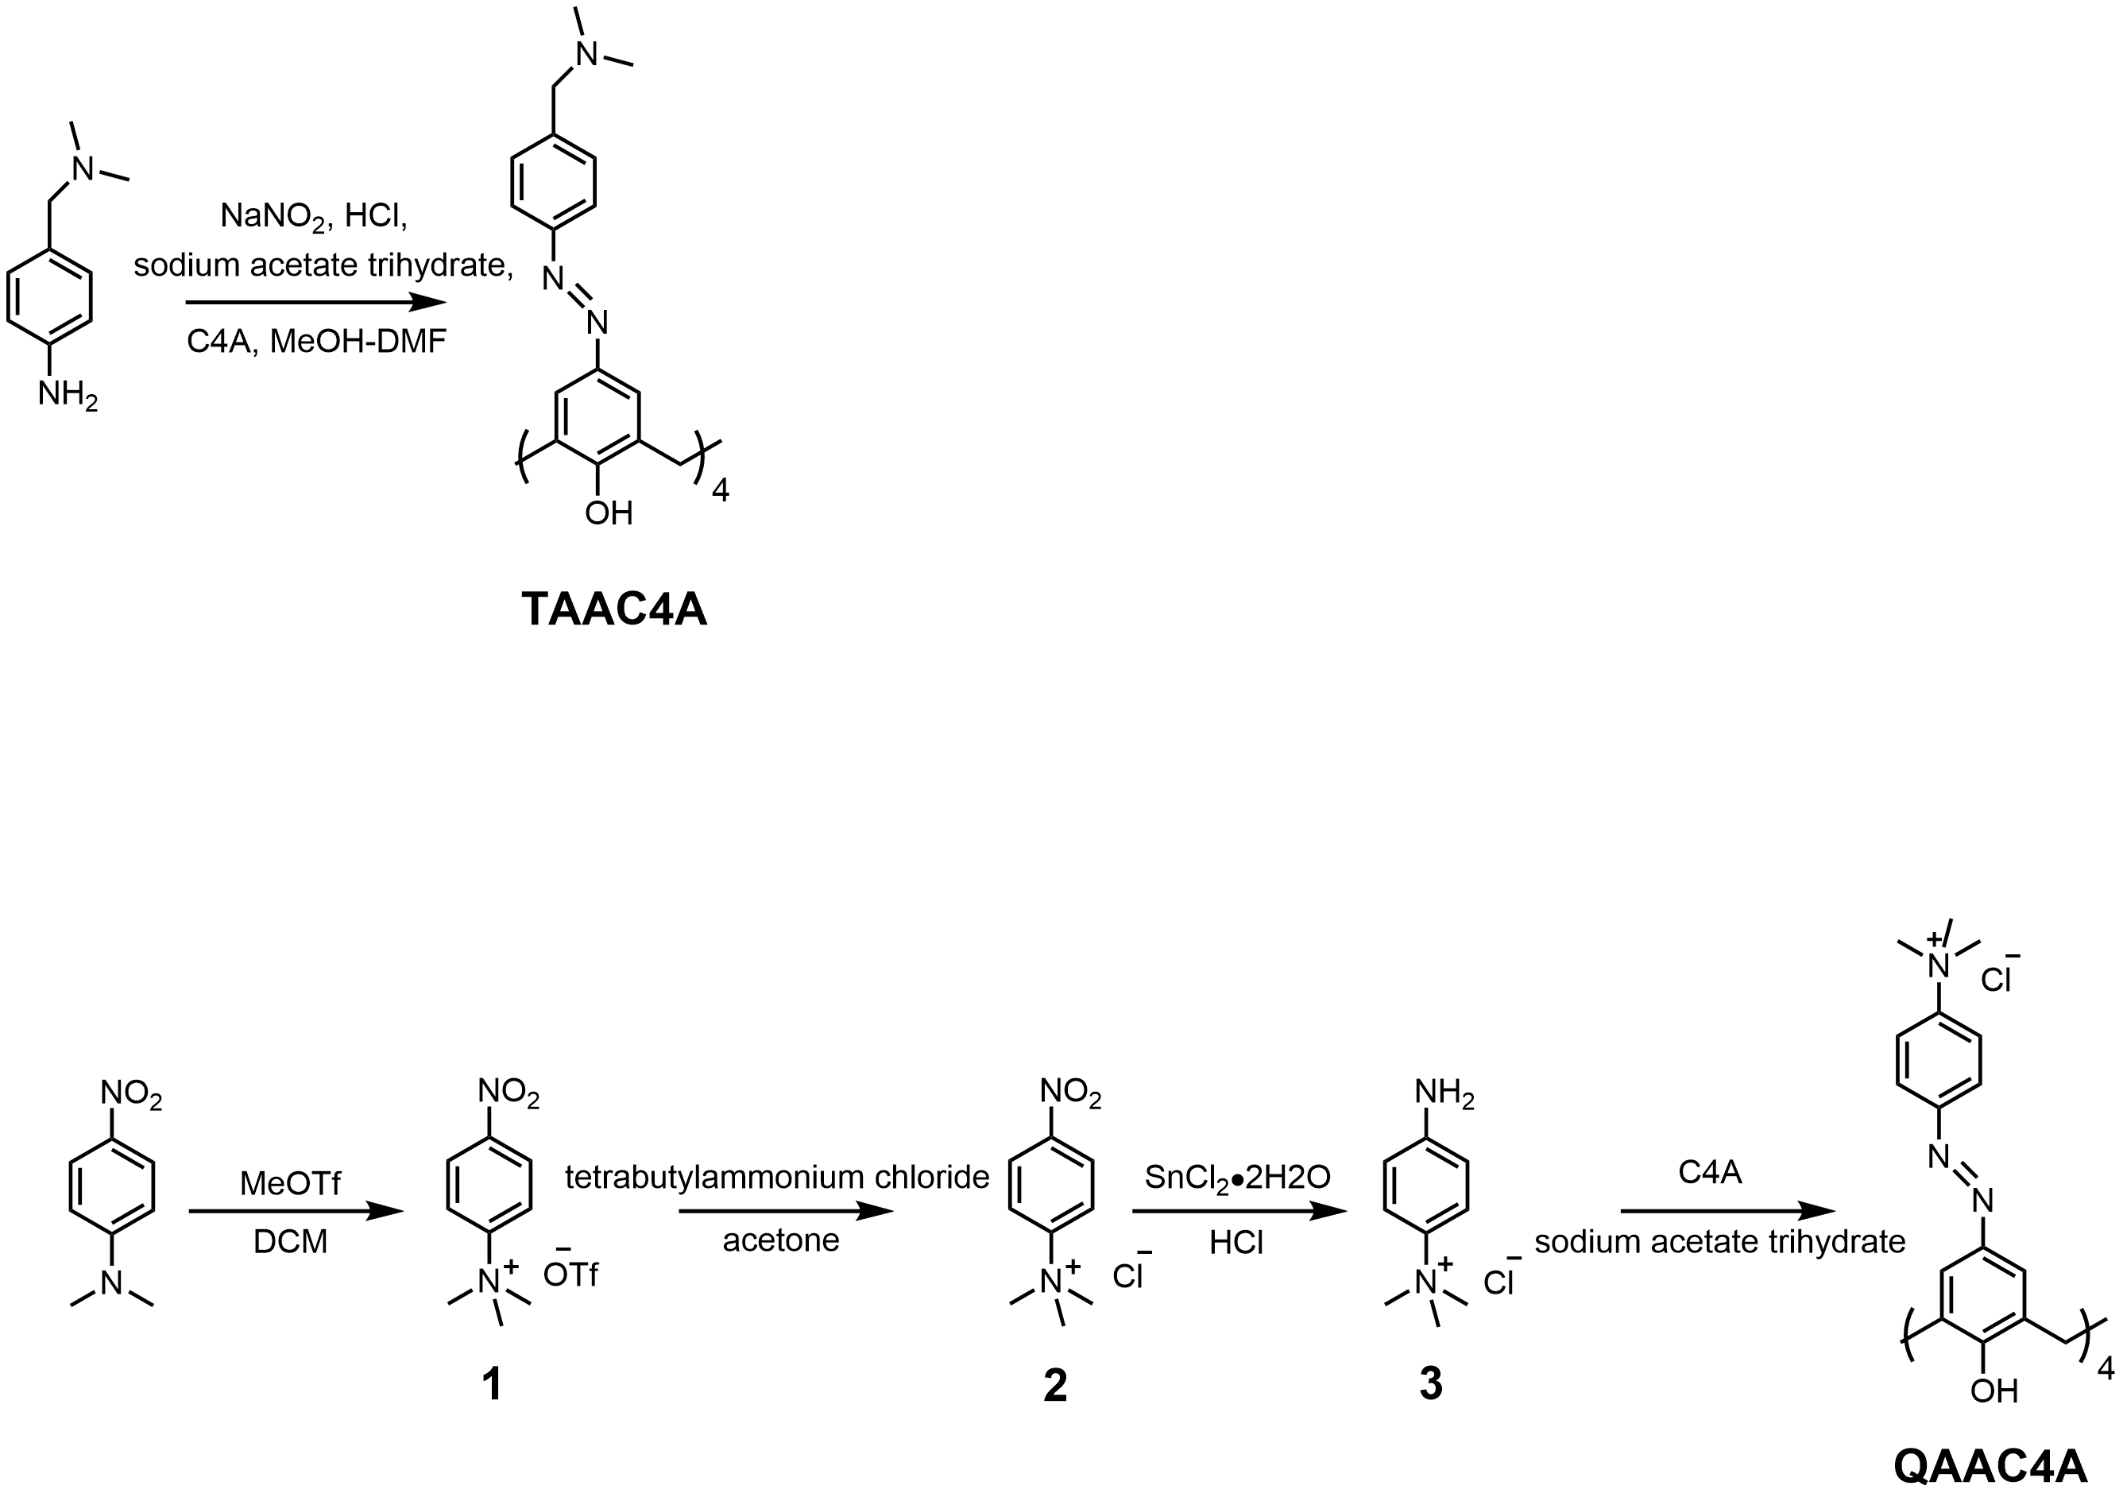

**Scheme S2.** The synthetic route of tertiary-ammonium modified azocalix[4]arene (TAAC4A).

General procedure for synthesis of TAAC4A: 4-Amino-*N, N*-dimethylbenzylamine(5.0 mmol) and concentrated hydrochloric acid (1.3 mL) were dissolved in 7.0 mL water in a round bottom flask. After cooling the solution to 2 °C under an ice-water bath, a solution of sodium nitrite (3.0 mL, 5.2 mmol, in water) was slowly added, while the temperature was controlled to lower than 5 °C. The obtained solution was slowly added into a solution of C4A (1.2 mmol) and sodium acetate trihydrate (25.0 mmol) in MeOH-DMF (19.5 mL, 5:8, v:v) to obtain a red suspension. After stirring at room temperature for 2 h, hydrochloric acid solution (37%) was added until the solution was adjusted to pH = 1. After warming to 60 °C for 30 min, the mixture was filtered and washed with water and MeOH to obtain a reddish solid of TAAC4A (yield: 92%).

1H NMR (400 MHz, DMSO-*d*6) *δ* 7.73 (s, 8H, Ar-H), 7.72 (d, *J* = 8.0 Hz, 8H, Ar-H), 7.38 (d, *J* = 8.0 Hz, 8H, Ar-H), 4.40 (d, *J* = 7.6 Hz, 4H, Ar-CH2-H), 3.65 (d, *J* = 7.6 Hz, 4H, Ar-CH2-H), 2.13 (s, 24H, N-(CH3)2) ppm. The two hydrogens of the alkyl chain were masked in the solvent peak.

13C NMR (100 MHz, DMSO-*d*6) *δ* 159.42, 151.99, 144.87, 141.38, 131.25, 129.97, 123.88, 122.55, 63.33, 45.37, 32.47 ppm.



**Fig. S4.** 1H NMR spectrum of TAAC4A (DMSO-*d*6, 400 MHz, 25 °C).



**Fig. S5.** 13C NMR spectrum of TAAC4A (DMSO-*d*6, 100 MHz, 25 °C).

### 2.Theoretical calculations

Model reporter pairs were given with assumed binding constants. The free dye concentrations can be calculated using the following formulas. We considered that a dye (D) formed a 1:1 host-dye complex with a host (H) at an association constant (*K*a), which satisfied the respective law of mass action relating to the equilibrium concentrations of free host, [H], free dye, [D], and host-dye complex, [HD]. Also, the relationship between the total concentrations of host, [H]0, and dye, [D]0, and their equilibrium concentrations were introduced by the law of mass conservation (equations 2−1 and 2−2). Among them, *K*a, [H]0 and [D]0 are all given values. [D] can be obtained by calculation. Here, [D] was calculated using a JavaScript-based tool from the website of Prof. Nau's group (<http://www.jacobs-university.de/ses/wnau>) under the column of “Data Analysis”.

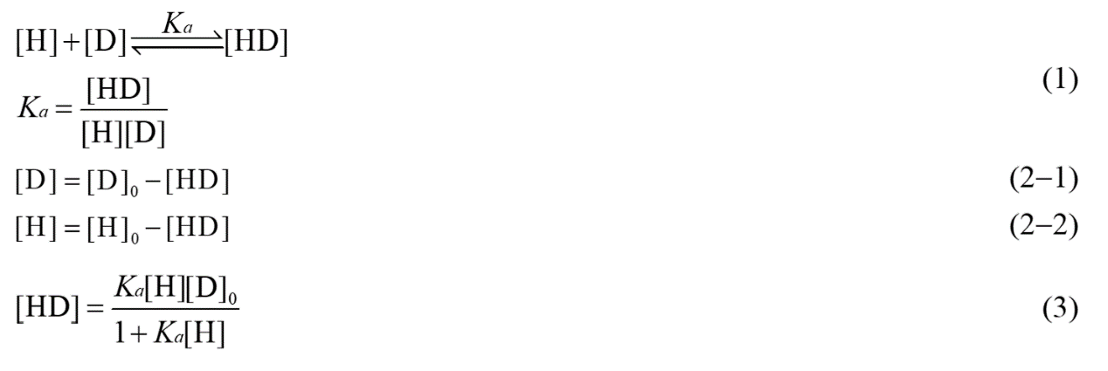

The binding constants between hosts and analytes were also assumed. When the analytes were added to the host-dye complex, part of the dye was replaced by competition. The total concentrations of free dye were calculated by the following formulas. The competitor (C) could bind to a host’s cavity in a 1:1 stoichiometry at an association constant (*K*C). Free host, [H], free analyte, [C], and host-analyte complex, [HC] obeyed the respective law of mass action referring to the equilibrium concentrations. Also, [H]0 and the total concentrations of analyte, [C]0, and their equilibrium concentrations satisfied the law of mass conservation (equations 5−1 and 5−2). Among them, *K*a, *K*C, [H]0, [D]0 and [C]0 were all given values. [H] can be obtained by solving a cubic equation in one variable (equation 6). Then according to equations 1 and 2−1 together, the changed [D] can be obtained by calculation.

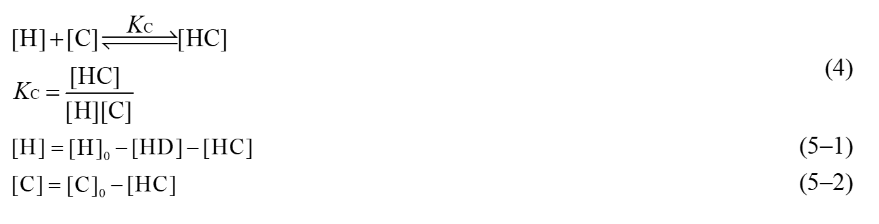

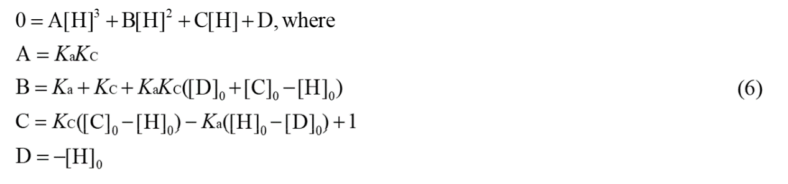

**Table S1.** The fluorescence response values calculated based on the assumed binding constants by direct complexation of the host with the analyte at different binding constants and concentrations.

|  |  |  |  |  |  |
| --- | --- | --- | --- | --- | --- |
|  | [Analyte]0 / M | [Host]/ M | *K*a / M-1 | [Free analyte]/ M | [Free analyte]/[Analyte]0 * |
| 1 | 1.0 × 10-6 | 1.0 × 10-6 | 1.0 × 105 | 6.2 × 10-7 | 0.62 |
| 2 | 1.0 × 10-6 | 1.0 × 10-6 | 5.0 × 105 | 2.7 × 10-7 | 0.27 |
| 3 | 5.0 × 10-7 | 1.0 × 10-6 | 1.0 × 105 | 2.8 × 10-7 | 0.56 |

* When the analyte is inherently fluorescent, such as QZC, the fluorescence response value is calculated based on the concentration ratio of the free analyte.

**Table S2.** The fluorescence response values calculated based on the assumed binding constants by competitive complexation of the analyte at different binding constants and concentrations.

|  |  |  |  |  |  |  |  |  |
| --- | --- | --- | --- | --- | --- | --- | --- | --- |
|  | [Host]/ M | [Dye] / M | *K*a / M-1 | [Free dye]0 / M | [Analyte] / M | *K*c / M-1 | [Free dye]/ M | [Free dye]/[ Free dye]0 |
| 1 | 1.0 × 10-6 | 1.0 × 10-6 | 5.0 × 107 | 1.3 × 10-7 | 1.0 × 10-6 | 1.0 × 107 | 3.3 × 10-7 | 2.54 |
| 2 | 1.0 × 10-6 | 1.0 × 10-6 | 5.0 × 107 | 1.3 × 10-7 | 1.0 × 10-6 | 5.0 × 106 | 2.7 × 10-7 | 2.07 |
| 3 | 1.0 × 10-6 | 1.0 × 10-6 | 5.0 × 107 | 1.3 × 10-7 | 5.0 × 10-7 | 1.0 × 107 | 2.5 × 10-7 | 1.91 |

### 3. Supporting information and raw data



**Fig. S6.** UV-Vis spectrum of QZC extract (120.0 μg/mL) at 25 °C.

**Table S3.** The raw data of intraday precision test results of the quality evaluation method of QZC (*n* = 6).

|  |  |  |  |  |  |  |  |  |
| --- | --- | --- | --- | --- | --- | --- | --- | --- |
| *I*/*I*0 | 1 | 2 | 3 | 4 | 5 | 6 | Average | RSD (%) |
| CAC4A | 0.6614 | 0.6674 | 0.6781 | 0.6690 | 0.6707 | 0.6734 | 0.6700 | 0.8 |
| SAC4A | 0.5617 | 0.5820 | 0.5716 | 0.5649 | 0.5649 | 0.5740 | 0.5699 | 1.3 |
| SAC5A | 0.6751 | 0.6643 | 0.6805 | 0.6693 | 0.6738 | 0.6715 | 0.6724 | 0.8 |
| SAC8A | 0.6366 | 0.6416 | 0.6366 | 0.6362 | 0.6406 | 0.6440 | 0.6393 | 0.5 |
| QAAC4A | 0.6613 | 0.6588 | 0.6416 | 0.6430 | 0.6499 | 0.6405 | 0.6492 | 1.4 |
| TAAC4A | 0.6955 | 0.6733 | 0.6795 | 0.6757 | 0.6759 | 0.6692 | 0.6782 | 1.3 |
| QAAC4A/  AlPcS4 | 0.5714 | 0.5423 | 0.5589 | 0.5579 | 0.5412 | 0.5325 | 0.5507 | 2.6 |
| TAAC4A/  AlPcS4 | 0.5859 | 0.5745 | 0.5560 | 0.5592 | 0.5548 | 0.5483 | 0.5631 | 2.5 |

**Table S4.** The raw data of interday precision test results of the quality evaluation method of QZC (*n* = 3).

|  |  |  |  |  |  |
| --- | --- | --- | --- | --- | --- |
| *I*/*I*0 | 1 | 2 | 3 | Average | RSD (%) |
| CAC4A | 0.6700 | 0.6701 | 0.6743 | 0.6715 | 0.4 |
| SAC4A | 0.5699 | 0.5805 | 0.5789 | 0.5764 | 1.0 |
| SAC5A | 0.6724 | 0.6744 | 0.6657 | 0.6708 | 0.7 |
| SAC8A | 0.6393 | 0.6404 | 0.6375 | 0.6391 | 0.2 |
| QAAC4A | 0.6492 | 0.6532 | 0.6509 | 0.6511 | 0.3 |
| TAAC4A | 0.6782 | 0.6812 | 0.6775 | 0.6790 | 0.3 |
| QAAC4A/  AlPcS4 | 0.5507 | 0.5599 | 0.5768 | 0.5625 | 2.4 |
| TAAC4A/  AlPcS4 | 0.5631 | 0.5694 | 0.5695 | 0.5673 | 0.6 |

**Table S5.** The raw data of repeatability test results of the quality evaluation method of QZC (*n* = 6).

|  |  |  |  |  |  |  |  |  |
| --- | --- | --- | --- | --- | --- | --- | --- | --- |
| *I*/*I*0 | 1 | 2 | 3 | 4 | 5 | 6 | Average | RSD (%) |
| CAC4A | 0.6539 | 0.6495 | 0.6491 | 0.6635 | 0.6570 | 0.6454 | 0.6531 | 1.0 |
| SAC4A | 0.5788 | 0.5625 | 0.5699 | 0.5623 | 0.5646 | 0.5558 | 0.5656 | 1.4 |
| SAC5A | 0.6693 | 0.6625 | 0.6537 | 0.6658 | 0.6642 | 0.6596 | 0.6625 | 0.8 |
| SAC8A | 0.6330 | 0.6374 | 0.6035 | 0.6219 | 0.6303 | 0.6316 | 0.6263 | 2.0 |
| QAAC4A | 0.6569 | 0.6583 | 0.6499 | 0.6544 | 0.6550 | 0.6451 | 0.6533 | 0.8 |
| TAAC4A | 0.6801 | 0.6840 | 0.6704 | 0.6774 | 0.6706 | 0.6909 | 0.6789 | 1.2 |
| QAAC4A/  AlPcS4 | 0.5133 | 0.5183 | 0.4958 | 0.4905 | 0.4847 | 0.5187 | 0.5035 | 3.0 |
| TAAC4A/  AlPcS4 | 0.5729 | 0.5691 | 0.5545 | 0.5914 | 0.5541 | 0.5789 | 0.5702 | 2.5 |

**Table S6.** Measurement results of 10 batches of QZC (*n* = 6).

|  |  |  |  |  |  |  |  |  |
| --- | --- | --- | --- | --- | --- | --- | --- | --- |
| *I*/*I*0 | CAC4A | SAC4A | SAC5A | SAC8A | QAAC4A | TAAC4A | QAAC4A/AlPcS4 | TAAC4A  /AlPcS4 |
| 180101 | 0.6606 | 0.5584 | 0.6577 | 0.6365 | 0.6506 | 0.6698 | 0.5202 | 0.5567 |
| 180102 | 0.6624 | 0.5645 | 0.6544 | 0.6363 | 0.6475 | 0.6813 | 0.5025 | 0.5727 |
| 180103 | 0.6579 | 0.5573 | 0.6541 | 0.6407 | 0.6476 | 0.6737 | 0.5000 | 0.5814 |
| 180104 | 0.6565 | 0.5651 | 0.6526 | 0.6388 | 0.6415 | 0.6785 | 0.5286 | 0.5856 |
| 180105 | 0.6587 | 0.5583 | 0.6620 | 0.6321 | 0.6616 | 0.6728 | 0.5261 | 0.5631 |
| 180106 | 0.6617 | 0.5592 | 0.6533 | 0.6353 | 0.6494 | 0.6738 | 0.5443 | 0.5924 |
| 180107 | 0.6550 | 0.5609 | 0.6579 | 0.6325 | 0.6531 | 0.6764 | 0.5470 | 0.6015 |
| 180108 | 0.6580 | 0.5796 | 0.6683 | 0.6342 | 0.6545 | 0.6944 | 0.5118 | 0.5623 |
| 180109 | 0.6619 | 0.5803 | 0.6650 | 0.6354 | 0.6451 | 0.6934 | 0.5091 | 0.5747 |
| 180110 | 0.6701 | 0.5807 | 0.6568 | 0.6351 | 0.6498 | 0.6918 | 0.5380 | 0.5929 |
| Average | 0.6603 | 0.5664 | 0.6582 | 0.6357 | 0.6501 | 0.6806 | 0.5228 | 0.5783 |
| Standard deviation | 0.0042 | 0.0094 | 0.0053 | 0.0026 | 0.0055 | 0.0085 | 0.0169 | 0.0129 |
| RSD (%) | 0.7 | 1.8 | 0.9 | 0.4 | 0.9 | 1.3 | 3.4 | 2.4 |
| Lower limit | 0.6518 | 0.5475 | 0.6476 | 0.6305 | 0.6391 | 0.6637 | 0.4890 | 0.5526 |
| Upper limit | 0.6688 | 0.5853 | 0.6688 | 0.6409 | 0.6611 | 0.6975 | 0.5566 | 0.6040 |

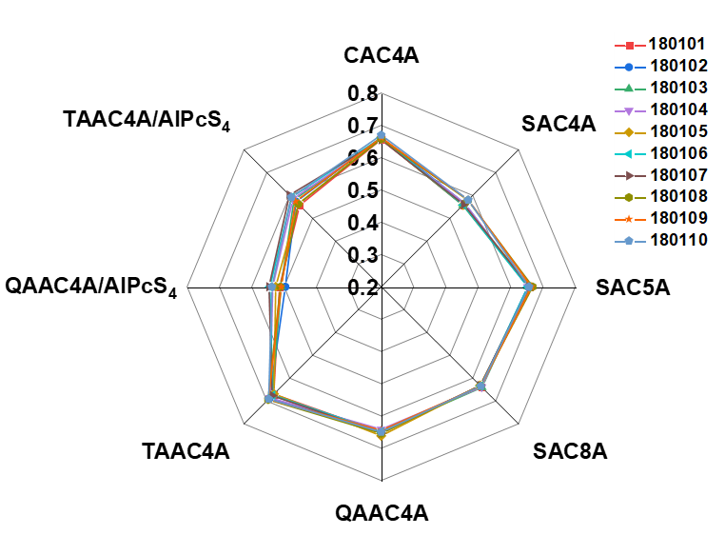

**Fig. S7.** The radar chart of *I*/*I*0 results (*n* = 6) for the quality evaluation of ten batches of QZC through the constructed eight sensing elements (For direct complexation, [QZC] = 20.0 μg/mL, [CAC4A] = 0.8 μM, [SAC4A] = 1.0 μM, [SAC5A] = [SAC8A] = 2.0 μM, [QAAC4A] = [TAAC4A] = 4.0 μM. For competitive complexation, [QAAC4A] = [AlPcS4] = 1.0 μMand[QZC] = 80.0 μg/mL, [TAAC4A] = [AlPcS4] = 1.0 μMand[QZC] = 40.0 μg/mL).

**Table S7.** Measurement results of 3 batches of expired QZC (*n* = 6).

|  |  |  |  |  |  |  |  |  |
| --- | --- | --- | --- | --- | --- | --- | --- | --- |
| *I*/*I*0 | CAC4A | SAC4A | SAC5A | SAC8A | QAAC4A | TAAC4A | QAAC4A/AlPcS4 | TAAC4A  /AlPcS4 |
| 1 | 0.6441 | 0.6612 | 0.6679 | 0.6313 | 0.6234 | 0.7673 | 0.5979 | 0.8283 |
| 2 | 0.6570 | 0.6662 | 0.6800 | 0.6295 | 0.6040 | 0.7703 | 0.5894 | 0.8291 |
| 3 | 0.6624 | 0.6466 | 0.6466 | 0.6435 | 0.6078 | 0.7623 | 0.6392 | 0.8260 |

**Table S8.** The training matrix of fluorescence response patterns against different concentrations of QZC extract used for LDA analysis.

|  |  |  |
| --- | --- | --- |
| Groups | *I*/*I*0 in QAAC4A/AlPcS4 sensing | *I*/*I*0 in TAAC4A/AlPcS4 sensing |
| 90.0 μg/mL  QZC extract | 0.6034 | 0.5465 |
| 0.5948 | 0.5503 |
| 0.6327 | 0.5756 |
| 0.5761 | 0.5500 |
| 0.5887 | 0.5694 |
| 0.5943 | 0.5496 |
| 67.5 μg/mL  QZC extract | 0.4849 | 0.4777 |
| 0.4625 | 0.4591 |
| 0.4971 | 0.4692 |
| 0.5316 | 0.4749 |
| 0.5006 | 0.4675 |
| 0.4973 | 0.4700 |
| 45.0 μg/mL  QZC extract | 0.3910 | 0.3628 |
| 0.3572 | 0.3491 |
| 0.3663 | 0.3666 |
| 0.3796 | 0.3839 |
| 0.3527 | 0.3632 |
| 0.3796 | 0.3752 |
| 22.5 μg/mL  QZC extract | 0.2555 | 0.2967 |
| 0.2274 | 0.2932 |
| 0.2469 | 0.3138 |
| 0.2449 | 0.3073 |
| 0.2408 | 0.2898 |
| 0.2496 | 0.2953 |

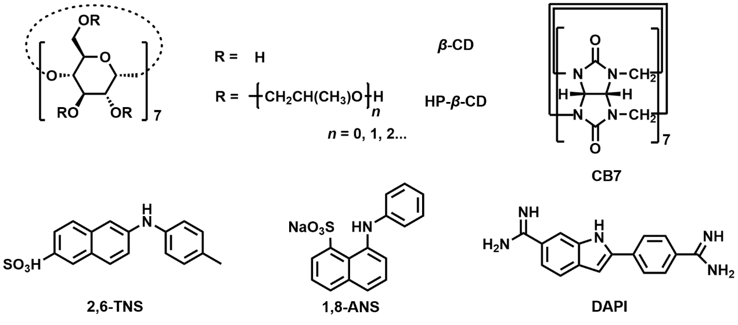

**Fig. S8.** Chemical structures of the cyclodextrins, cucurbituril, and dye used for quality evaluation of SHL injection.

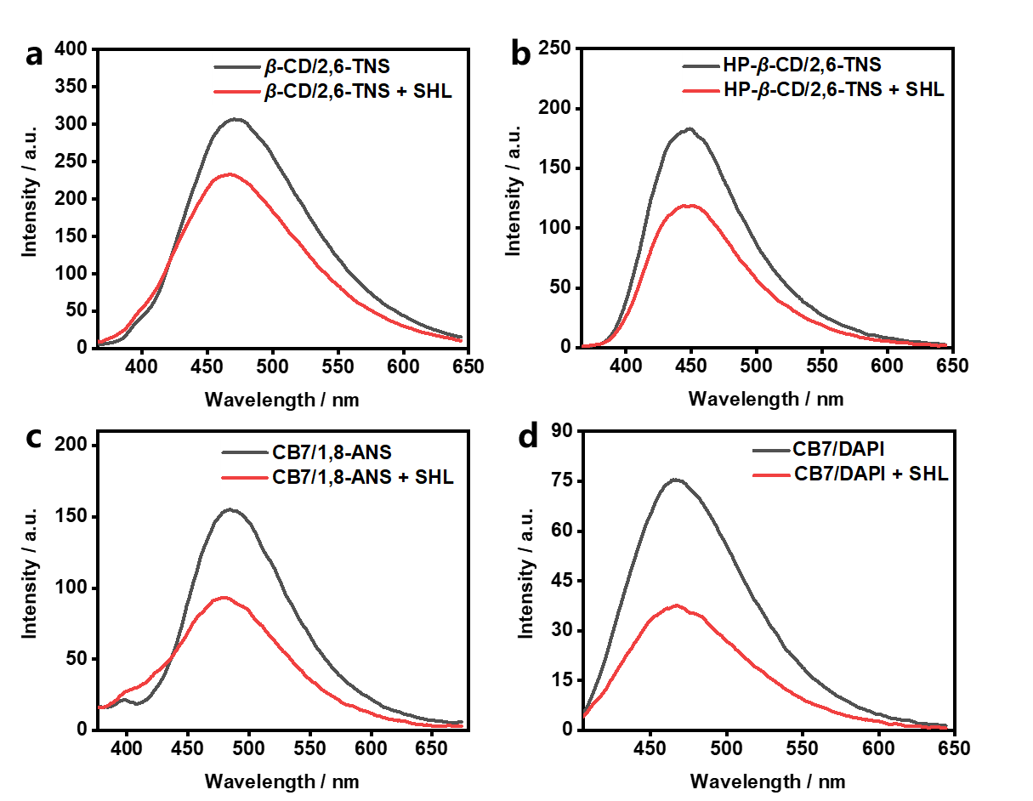

**Fig. S9.** Fluorescence spectra of (a) *β*-CD/2,6-TNS ([*β*-CD] = 800.0 μM, [2,6-TNS] = 10.0 μM), (b) HP-*β*-CD/2,6-TNS ([HP-*β*-CD] = 1.0 mM, [2,6-TNS] = 10.0 μM), (c) CB7/1,8-ANS ([CB7] = 1.0 mM, [1,8-ANS] = 10.0 μM), and (d) CB7/DAPI ([CB7] = 2.0 μM, [DAPI] = 1.0 μM), and responses by SHL displacement. (a, b and d) 5.0 μL or (c) 4.0 μL of SHL injection was taken directly from the ampoules without any treatment and added to the sensing solution.

**Table S9.** Measurement results of 10 batches of SHL injection (*n* = 6).

|  |  |  |  |  |
| --- | --- | --- | --- | --- |
| *I*/*I*0 | *β*-CD/2,6-TNS | HP-*β*-CD/2,6-TNS | CB7/1,8-ANS | CB7/DAPI |
| 2002241 | 0.7472 | 0.6516 | 0.5641 | 0.4972 |
| 2002251 | 0.7601 | 0.6367 | 0.5615 | 0.5126 |
| 2002261 | 0.7559 | 0.6389 | 0.5683 | 0.5245 |
| 2002271 | 0.7565 | 0.6399 | 0.5798 | 0.5155 |
| 2002281 | 0.7631 | 0.6424 | 0.5856 | 0.5368 |
| 2002291 | 0.7493 | 0.6363 | 0.5654 | 0.5464 |
| 2002301 | 0.7509 | 0.6392 | 0.5895 | 0.5483 |
| 2002311 | 0.7428 | 0.645 | 0.5942 | 0.5448 |
| 2002321 | 0.7473 | 0.6316 | 0.5911 | 0.5382 |
| 2002331 | 0.7502 | 0.6465 | 0.5927 | 0.5145 |
| Average | 0.7523 | 0.6408 | 0.5792 | 0.5279 |
| SD | 0.0060 | 0.0055 | 0.0124 | 0.0166 |
| RSD (%) | 0.8 | 0.9 | 2.3 | 3.3 |
| Lower limit | 0.7403 | 0.6299 | 0.5543 | 0.4947 |
| Upper limit | 0.7644 | 0.6517 | 0.6041 | 0.5611 |

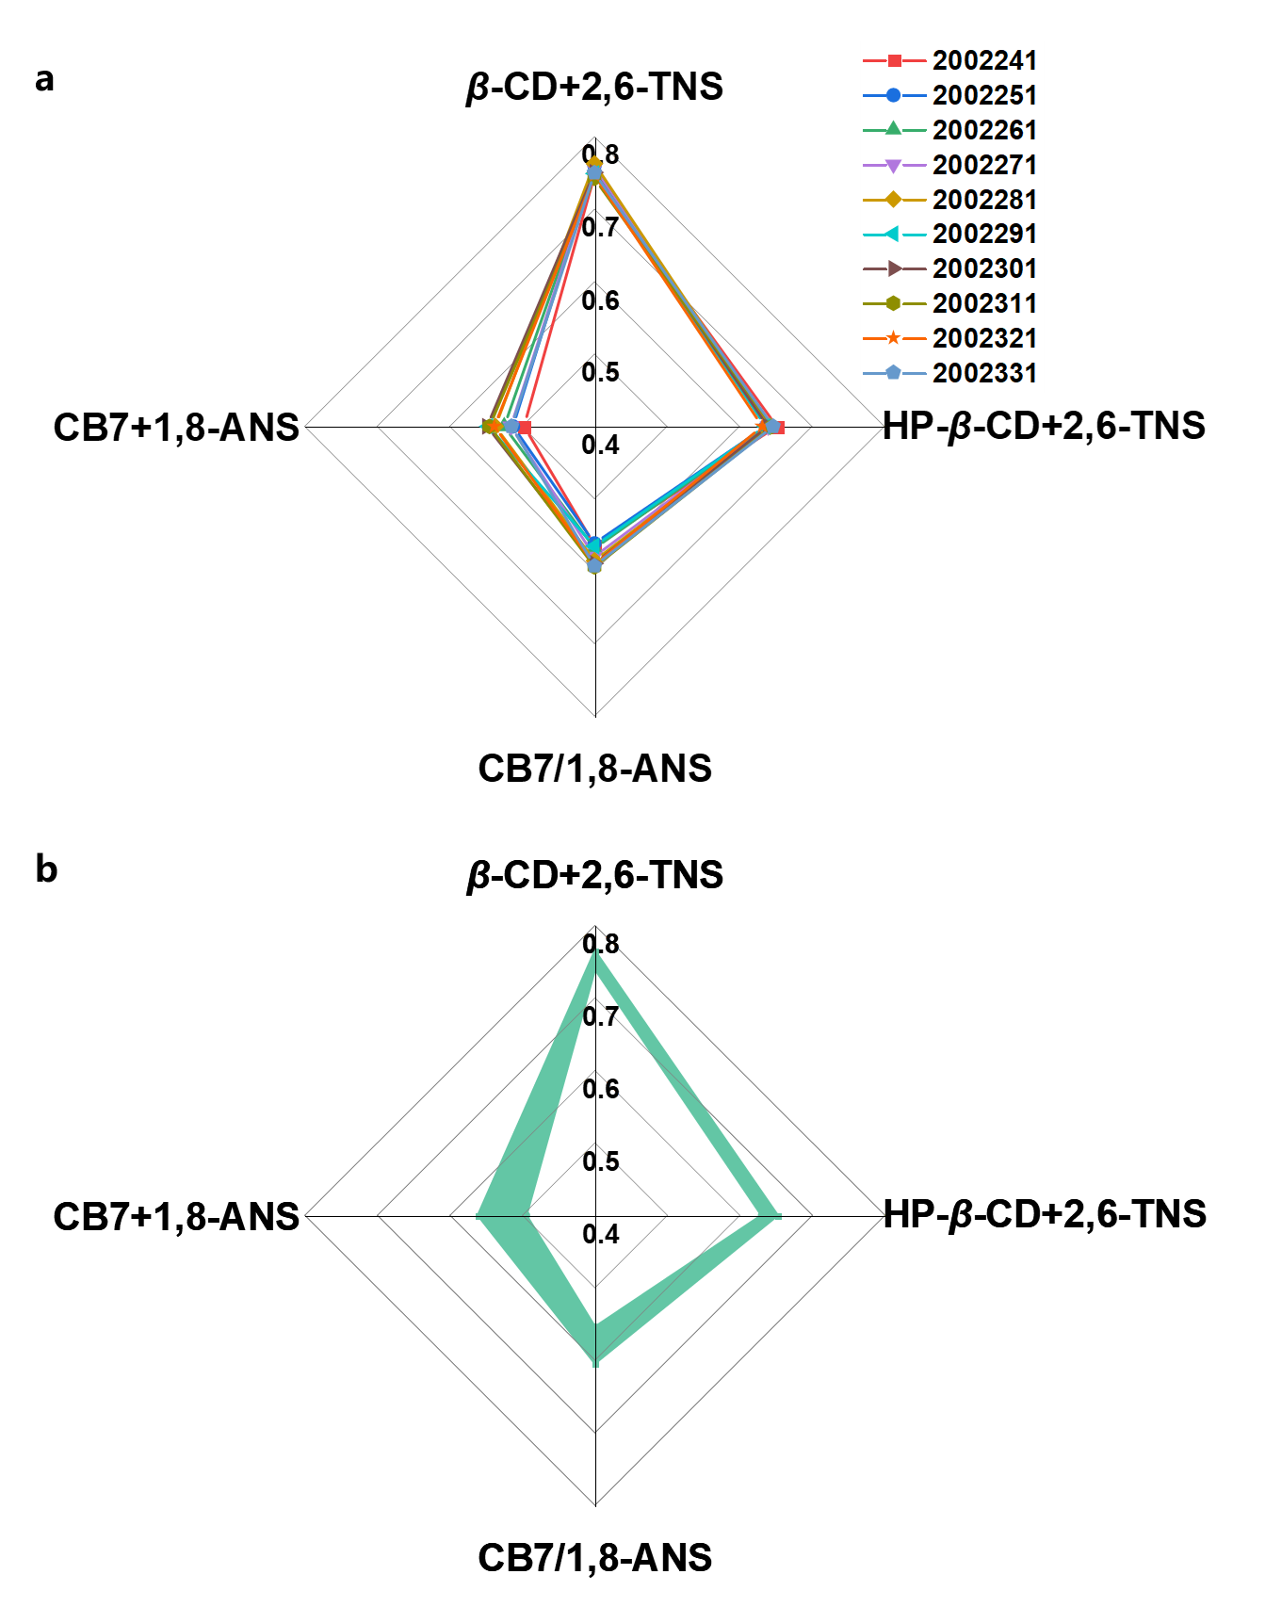

**Fig. S10.** (a) Radar chart of *I*/*I*0 results (*n* = 6) for the quality evaluation of ten batches of SHL injection through four sensing elements. (b) The scope of the standard SHL products.