**CuI nanoparticles-immobilized on a hybrid material composed of IRMOF-3 and a sulfonamide-based porous organic polymer as an efficient nanocatalyst for one-pot synthesis of 2,3-disubstituted benzo[b]furans**

Samaneh Koosha,a Sedigheh Alavinia,a Ramin Ghorbani-Vaghei,*,a

aDepartment of Organic Chemistry, Faculty of Chemistry, Bu-Ali Sina University, 6517838683, Hamadan, Iran

Corresponding Author: Fax: Tel./Fax: +98-8138380709*

E-mail: [rgvaghei@yahoo.com &](mailto:rgvaghei@yahoo.com%20&) ghorbani@basu.ac.ir

1H NMR (400 MHz, CDCl3) δ 8.05 (s, 1H), 7.73 (s, 4H), 7.30-7.33 (m, 5H), 7.08 (d, *J* = 7.1 Hz, 2H), 6.79 (t, *J* = 6.6 Hz, 2H), 4.42 (s, 2H), 3.13 (s, 3H). 13C NMR (101 MHz, CDCl3) δ 153.54, 150.22, 136.29, 133.10, 129.07, 128.64, 128.17, 127.92, 127.66, 127.08, 125.16, 123.17, 118.25, 112.97, 42.09, 29.53.

****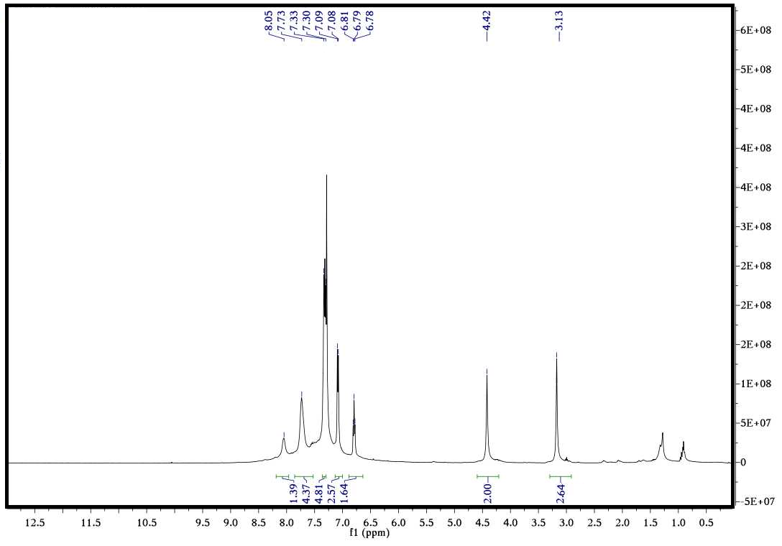

****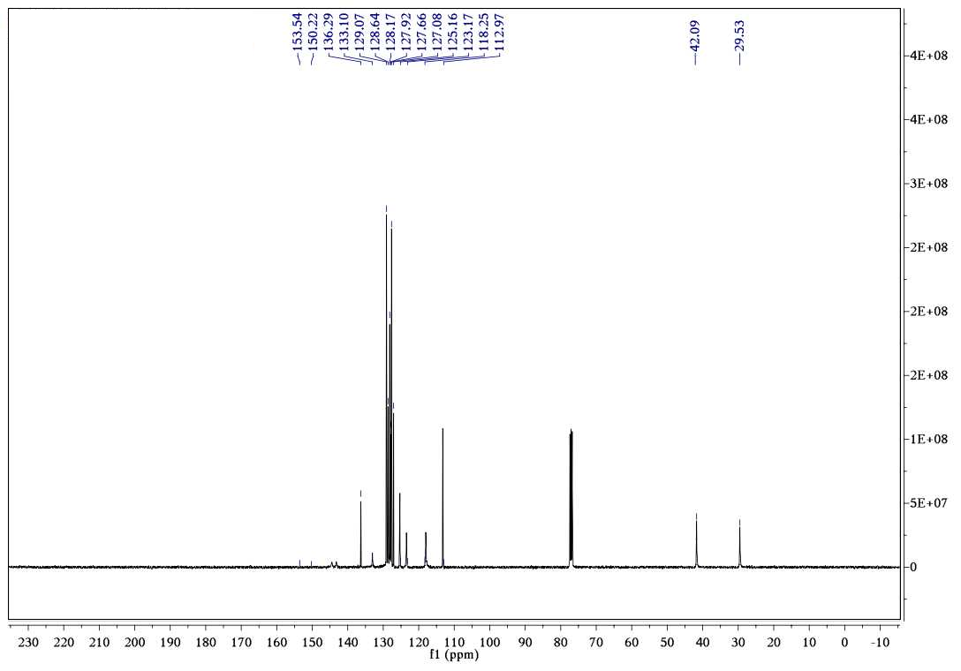

****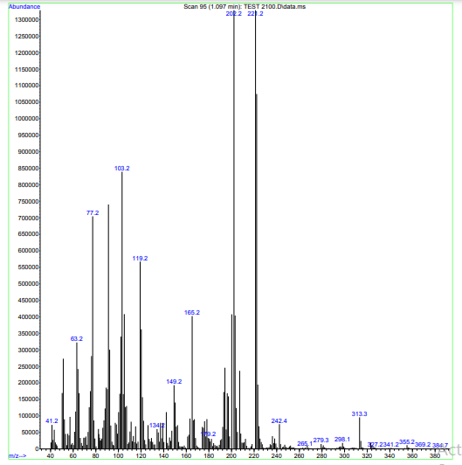

1H NMR (400 MHz, CDCl3) δ 8.20 (s, 1H), 7.84 (s, 1H), 7.73 (s, 1H), 7.54 (d, *J* = 11.5 Hz, 3H), 7.32 (d, *J* = 7.5 Hz, 4H), 7.12 (s, 1H), 7.07 (d, *J* = 6.4 Hz, 2H), 6.81 (s, 1H), 4.40 (s, 2H), 3.21 (s, 3H). 13C NMR (101 MHz, CDCl3) δ 136.50, 132.03, 131.25, 130.88, 130.33, 129.35, 129.17, 127.99, 127.81, 127.12, 123.17, 114.96, 113.28, 44.38, 31.87.

****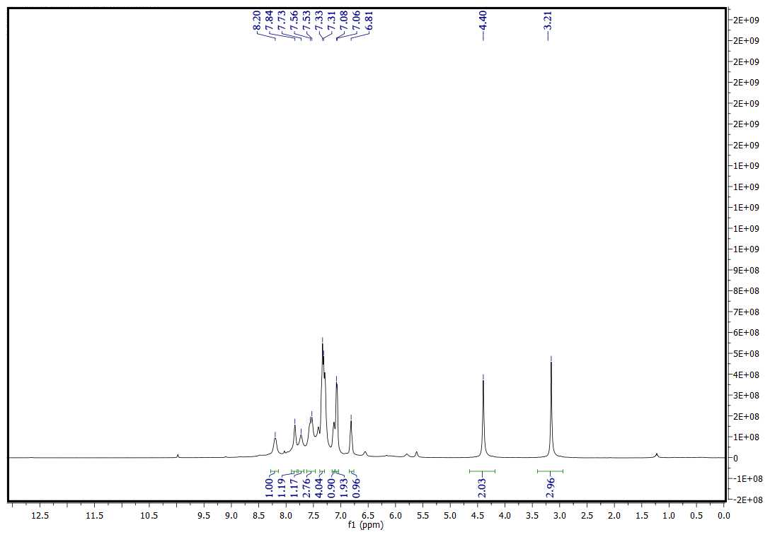

****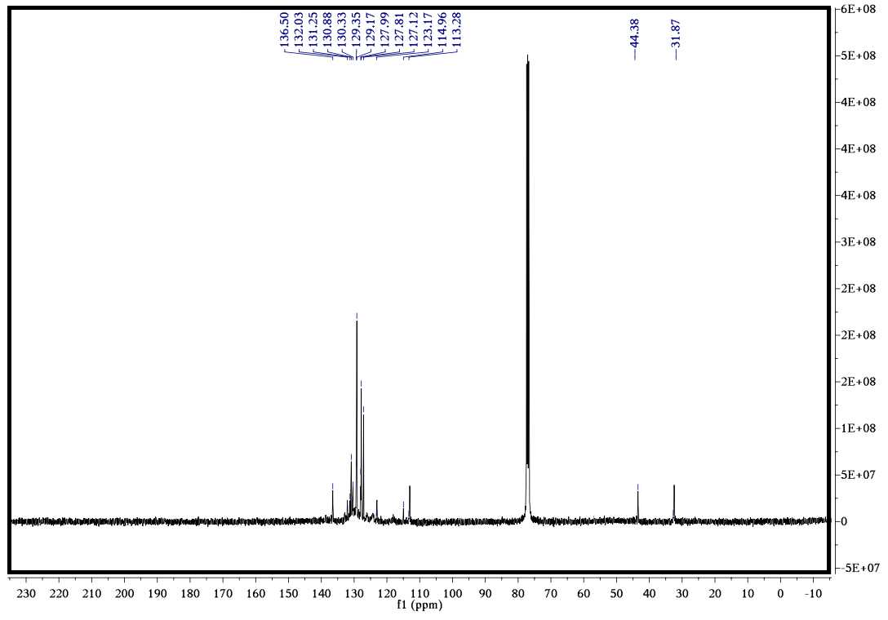

1H NMR (400 MHz, CDCl3) δ 7.97 (s, 3H), 7.61 (s, 4H), 7.53 (s, 8H), 7.42 (s, 7H), 7.21 (dd, *J* = 21.1, 6.3 Hz, 27H), 6.96 (d, *J* = 5.6 Hz, 8H), 6.72 (s, 4H), 4.28 (s, 2H). 13C NMR (101 MHz, CDCl3) δ 163.05, 153.56, 136.17, 133.99, 132.09, 131.30, 130.65, 129.52, 127.97, 127.57, 127.16, 114.63, 112.96, 41.47, 29.60.

****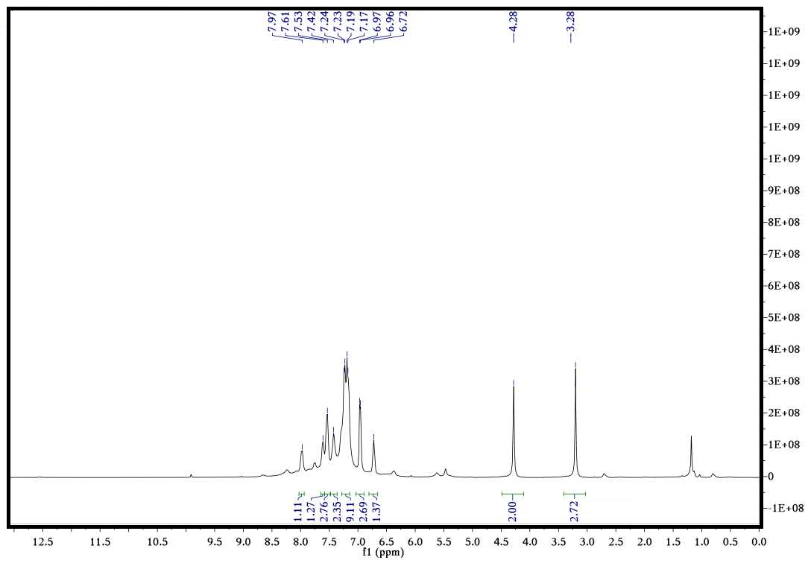

****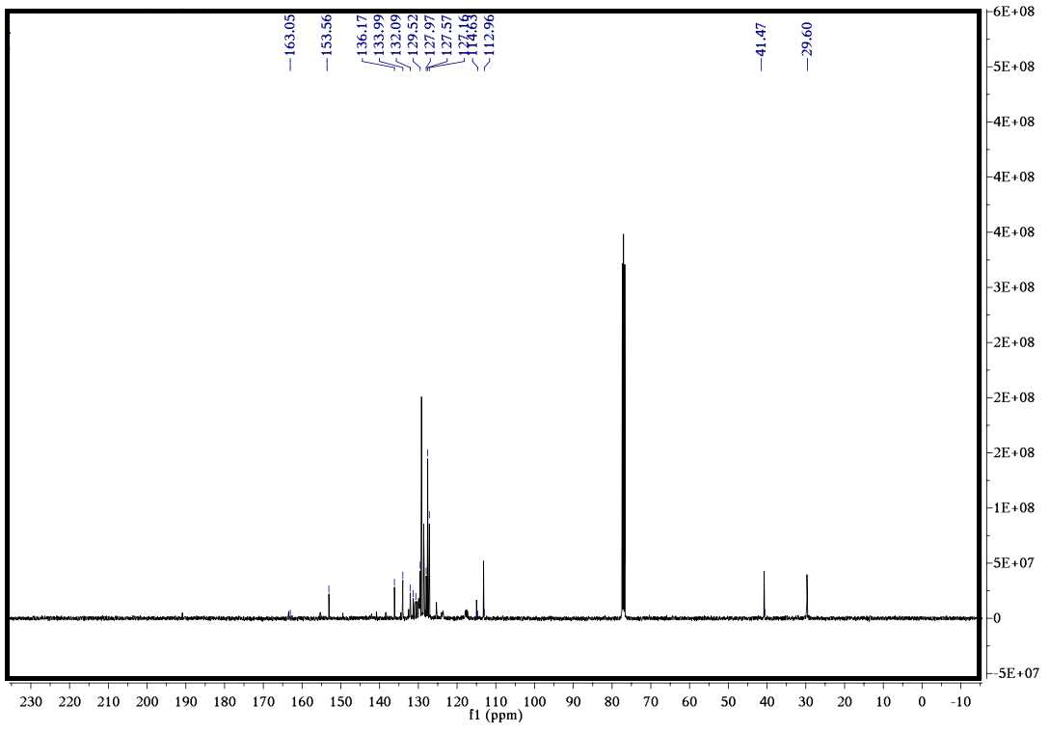

****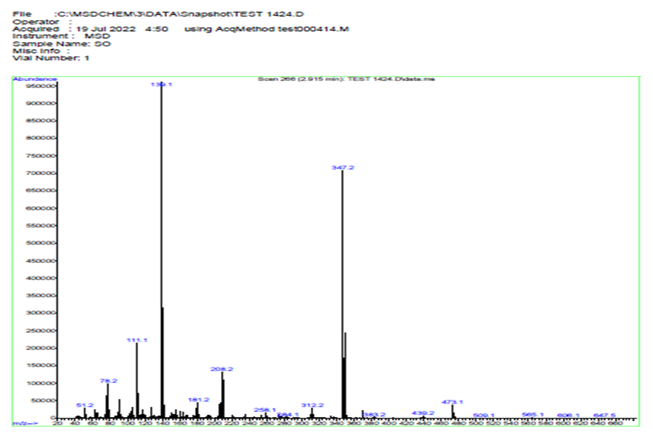

1H NMR (400 MHz, CDCl3) δ 8.22 (s, 1H), 7.65 (m, 4H), 7.33 (m, 3H), 7.02 (m, 2H), 6.93 (m, 2H), 6.82 (m, 1H), 4.36 (s, 2H), 3.28 (s, 3H), 13C NMR (101 MHz, CDCl3) δ 163.76, 161.21, 136.52, 131.87, 129.99, 129.54, 129.44, 127.85, 126.81, 124.19, 115.74, 115.53, 113.27, 41.76, 31.89.

****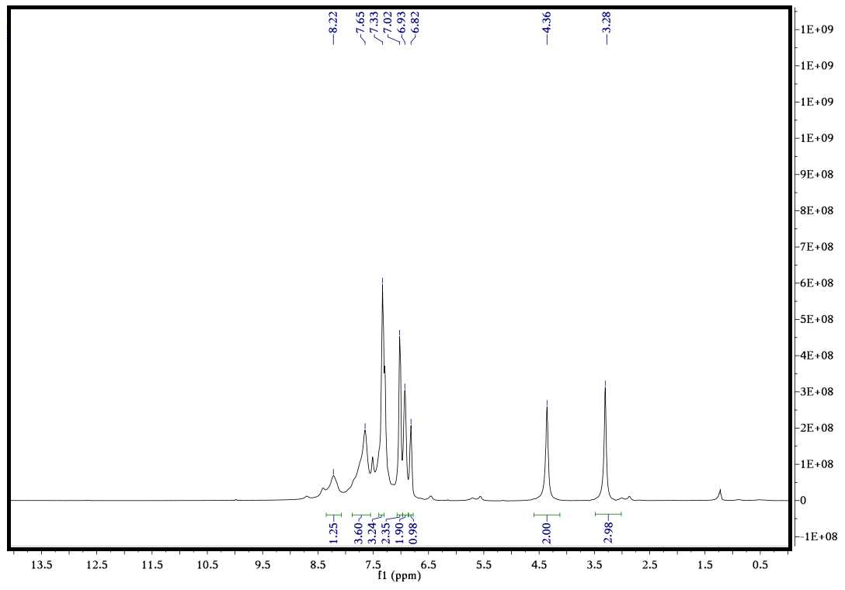

****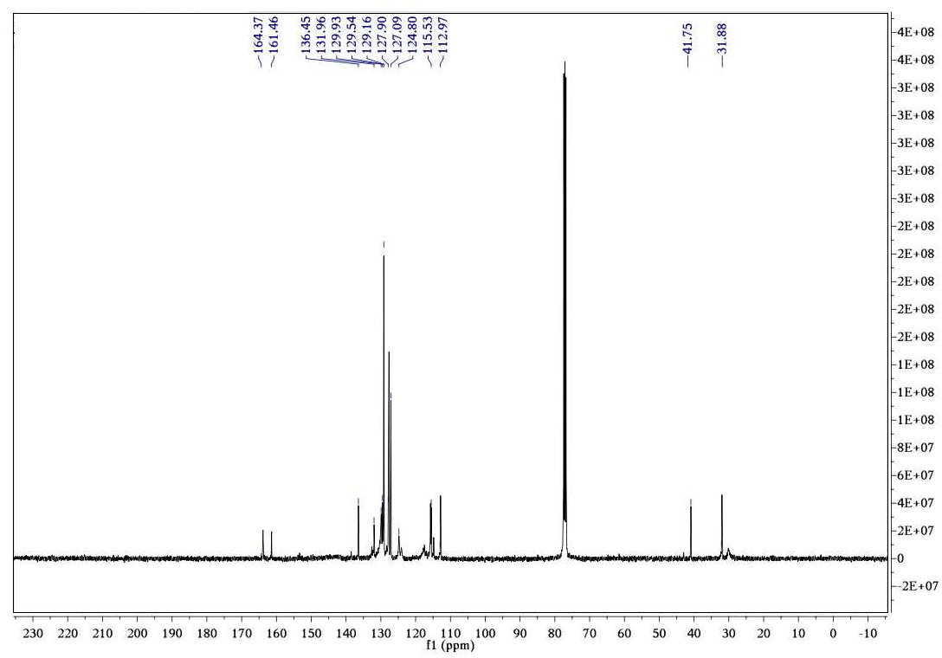

1H NMR (400 MHz, CDCl3) δ 7.51 (s, 2H), 7.35 – 7.30 (m, 4H), 7.15 (d, *J* = 4.0 Hz, 3H), 7.10 (d, *J* = 7.0 Hz, 2H), 6.79 (t, *J* = 6.6 Hz, 2H), 4.41 (s, 2H), 3.35 (s, 3H), 2.32 (s, 3H). 13C NMR (101 MHz, CDCl3) δ 164.06, 153.53, 138.03, 131.03, 130.38, 130.15, 129.78, 129.32, 129.27, 128.69, 127.70, 126.99, 124.83, 123.16, 116.62, 112.98, 41.77, 29.90, 15.14.

****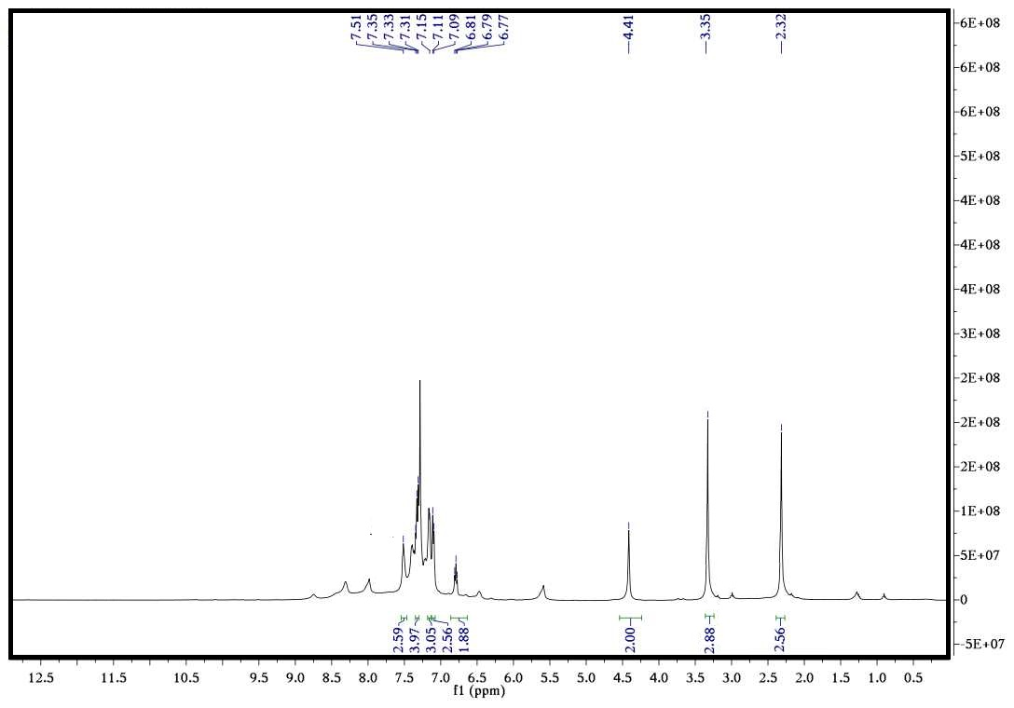

****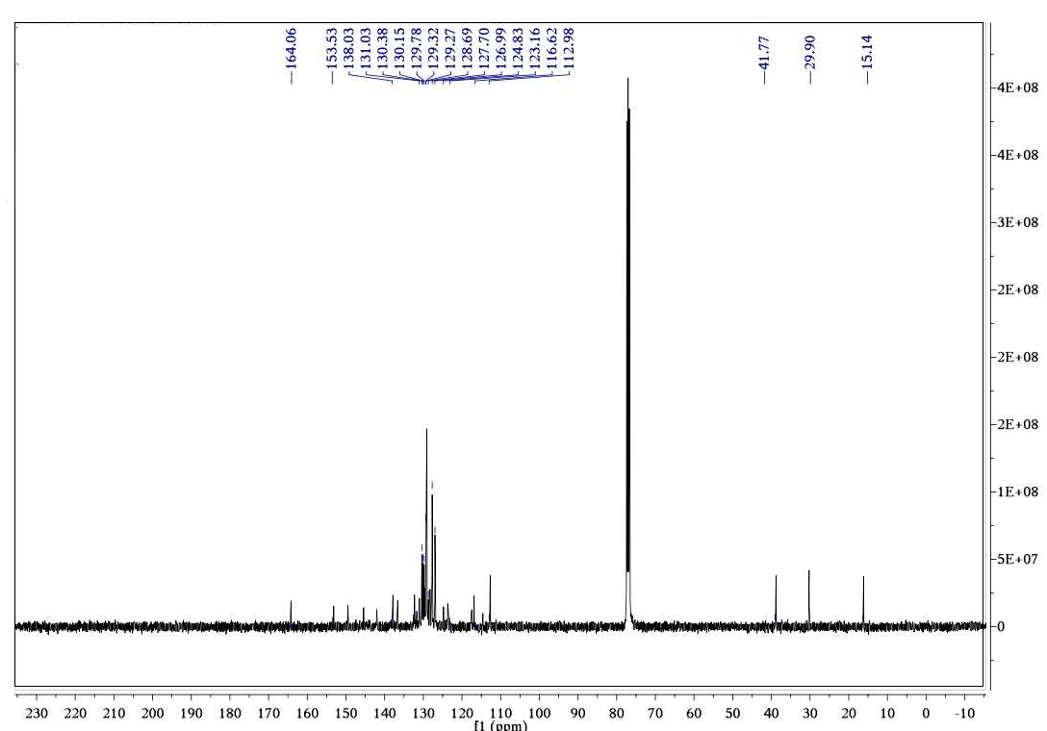

1H NMR (400 MHz, CDCl3) δ 7.93 (d, *J* = 31.6 Hz, 2H), 7.68 (m, 3H), 7.38 – 7.31 (m, 3H), 7.09 (d, *J* = 7.2 Hz, 2H), 6.88 (m, 2H), 6.79 (t, *J* = 6.6 Hz, 1H), 4.42 (s, 2H), 3.77 (s, 3H), 3.32 (s, 3H), 13C NMR (101 MHz, CDCl3) δ 165.39, 163.75, 159.50, 152.83, 149.90, 136.29, 131.87, 130.39, 129.64, 129.13, 127.64, 127.07, 115.32, 113.79, 113.11, 55.25, 41.44, 31.24.

.

****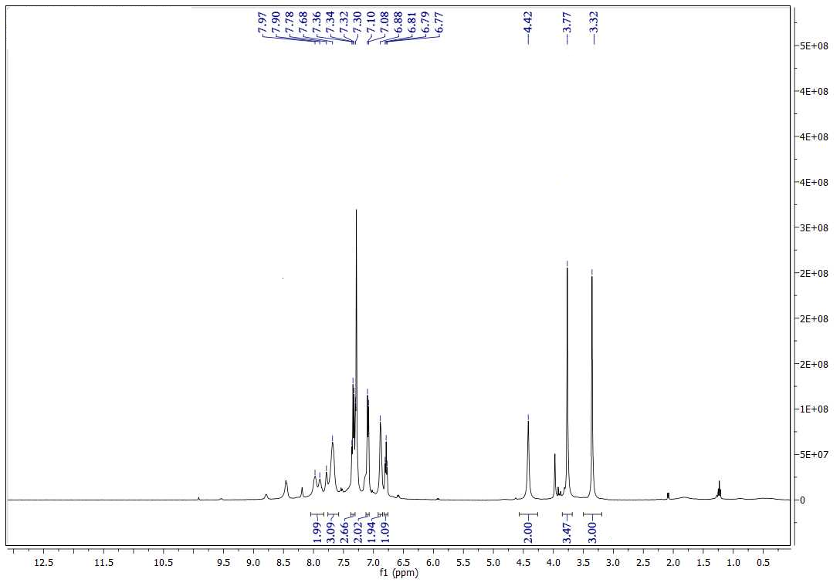

****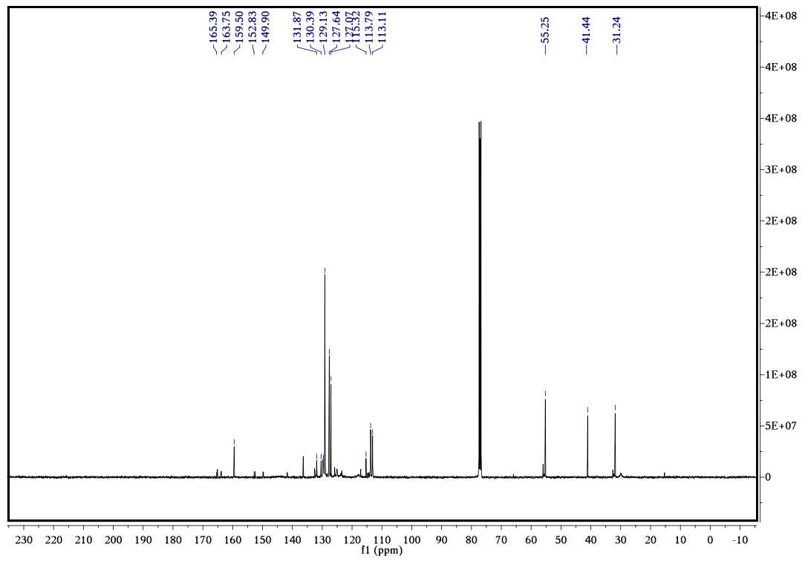

****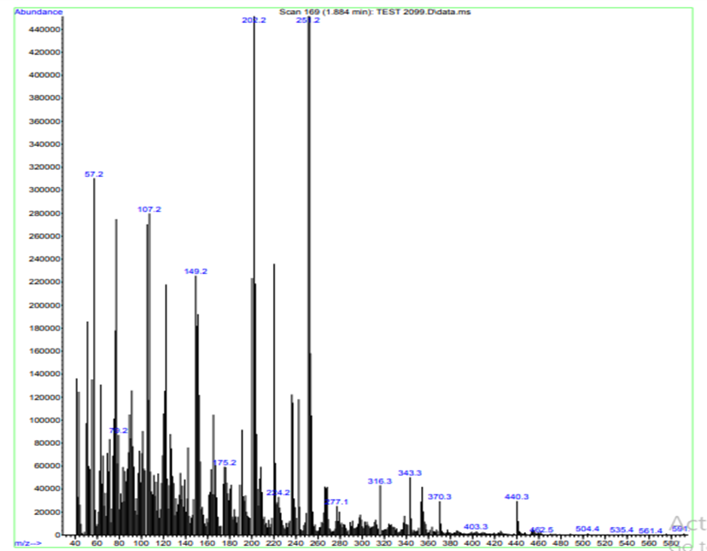

1H NMR (400 MHz, CDCl3): δ= 3.16 (m, 4H), 3.82 (m, 4H), 4.32 (s, 2H), 6.50 (d, *J* = 2.0 Hz, 1H), 7.19 (dd, *J*= 8.6 Hz, 2.1 Hz, 1H), 7.30 (m, 6H), 7.66 (d, *J*= 2.0 Hz, 1H), 9.32 (s, 1H). 13C NMR (63 MHz, CDCl3) δ 159.70, 151.85, 128.93, 127.79, 126.89, 125.30, 121.75, 117.66, 114.90, 110.89, 105.73, 67.43, 54.13, 29.69.

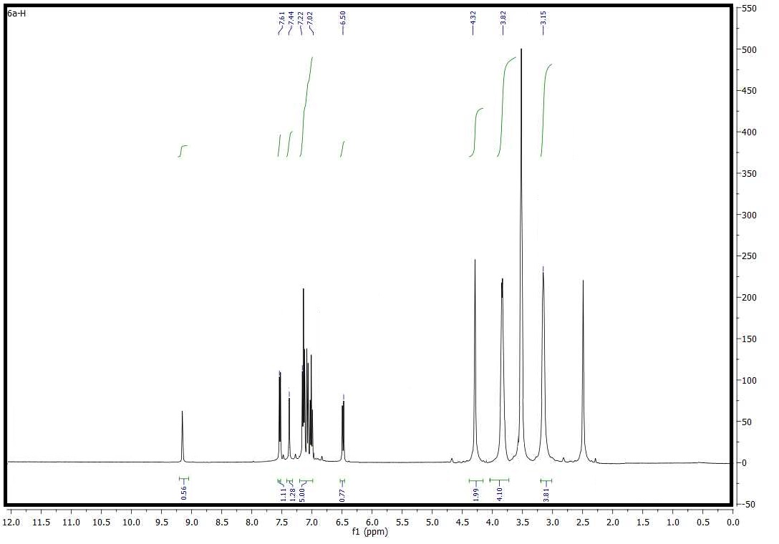

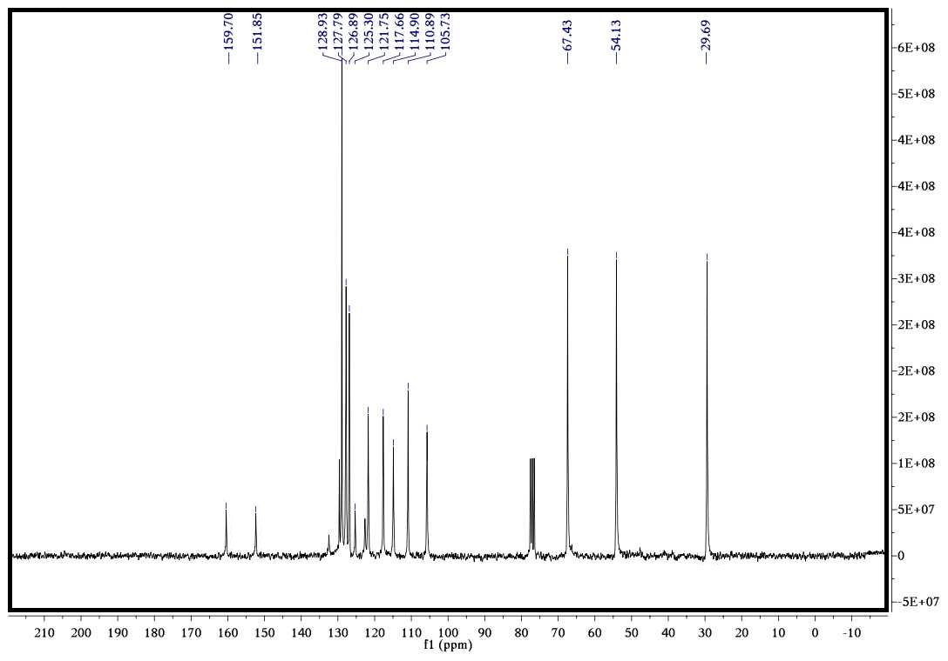

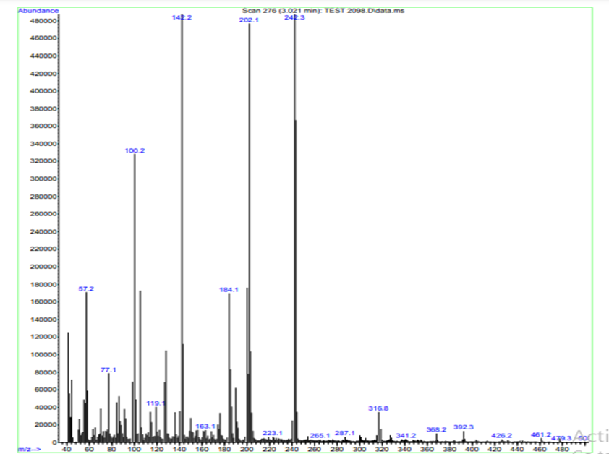

1H NMR (400 MHz, DMSO-*d6*,): δ= 3.11 (m, 4H), 3.75 (m, 4H), 4.16 (s, 2H), 7.23 (m, 3H), 7.19 (m, 3H), 7.44 (d, J= 7.40 Hz, 1H), 7.71 (d, J= 7.0 Hz, 1H) ppm;

13C NMR (126 MHz, DMSO-*d6*) δ 153.37, 149.03, 138.23, 129.33, 126.41, 126.11, 123.82, 122.80, 120.51, 112.00, 67.64, 52.50, 32.49.

****

