**Supplementary Materials**

# Elemental distribution table of each element

**Table S1.** Elemental distribution table of each element

|  |  |
| --- | --- |
| **Name** | **Atomic %** |
| |  | | --- | | C1s | | N1s | | Co | | Ni | | S | | O | | |  | | --- | | 43.39 | | 15.83 | | 11.92 | | 9.46 | | 16.08 | | 3.32 | |

# Kinetics Analysis of COD Degradation

**Table S2.** Relationship between the COD of quinoline solution and reaction time.

|  |  |  |
| --- | --- | --- |
| **Reaction Time** | **Ct (mg/L)** | **Ln (C0/Ct)** |
| 0 | 3540 | 0 |
| 5 | 2169 | 0.4899 |
| 15 | 799 | 1.4885 |
| 20 | 542 | 1.8766 |
| 25 | 290 | 2.5020 |
| 30 | 155 | 3.1285 |

# Investigation on the material stability

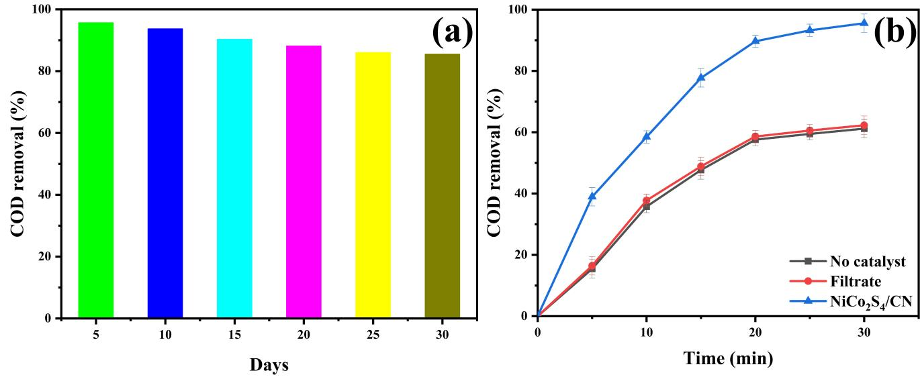

**Figure S1.** (a) COD removal efficiency in continuous runs of 3D-CPE system; (b) Co and Ni ions leach experiment.

**Table S3.** Metallic elemental analysis of NiCo2S4/g-C3N4 particles

|  |  |  |  |  |  |  |
| --- | --- | --- | --- | --- | --- | --- |
| Time (days) | 0 | 5 | 10 | 15 | 20 | 25 |
| Ni content (%) | 5.35 | 5.28 | 5.21 | 5.17 | 5.10 | 5.02 |
| Co content  (%) | 7.87 | 7.82 | 7.78 | 7.70 | 7.65 | 7.61 |

# HPLC-MS analysis

Figure S2 shows the total ion current chromatograms of quinoline and degradation products by HPLC-MS under optimal process conditions in positive ion mode. We analyzed seven peaks at 4.240, 5.102, 5.648, 6.394, 6.576, 9.674 and 10.453 min. Figure S3 illustrated the mass spectra in positive ion mode at different retention times. The peaks at m/z = 79, 124, 146, 130, 162, 152 and 122 were associated with protonated intermediates and quinolines, respectively. The possible molecular structures of the degradation products are shown in Table 1.

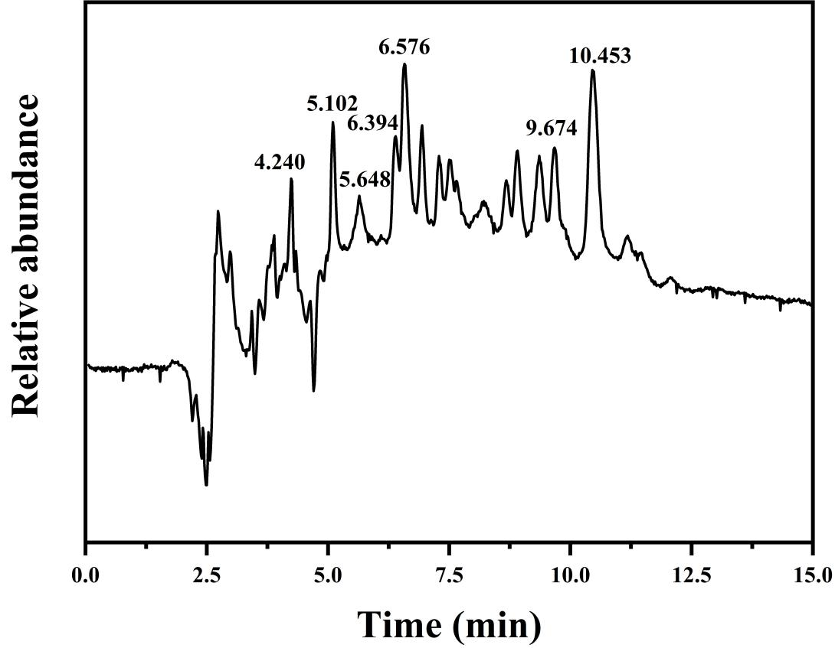

**Figure S2.** Total ion current chromatograph of quinoline and degradation products by HPLC-MS in positive ion mode

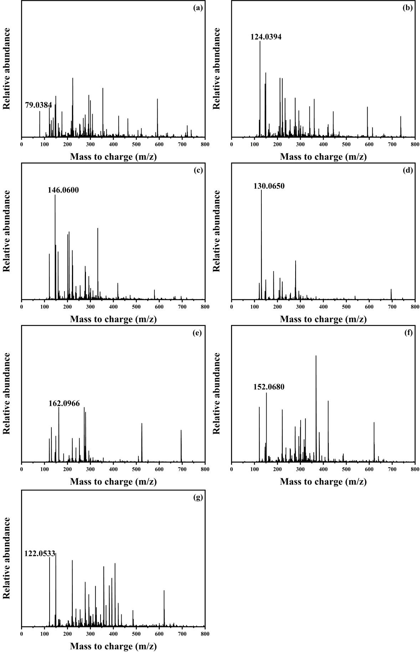

**Figure S3.** Mass spectra of quinoline degradation in different retention times: (a) 3.992~4.306 min; (b) 5.019~5.052 min; (c) 5.416~5.814 min; (d) 6.311~6.328 min ; (e) 6.493~6.526 min; (f) 9.525~9.641 min; (g) 10.304~10.353 min in positive ion mode.

# Biochemical analysis of wastewater

In our study, eight main intermediates, including benzene, picolinic acid, quinolin-8-ol, quinolin-2-ol, quinolin-2(1H)-one, quinoline-5,8-diol, 3-formylpicolinic acid and N-phenylformamide, were indentified in the process of quinolone degradation by HPLC-MS. They are hydroxylated derivatives of quinoline and most of them are less harmful than quinoline itself, toxicological partial data of quinoline and its degradation products are as follows Table S5. It is well known that these small molecules substance can provide carbon sources for subsequent biological treatment.

**Table S4.** Indicators of quinoline wastewater before and after treatment by 3D-EF.

|  |  |  |  |
| --- | --- | --- | --- |
| **Indicators** | **COD (mg/L)** | **BOD (mg/L)** | **B/C** |
| Before treatment | 3540 | 855 | 0.24 |
| After treatment | 155 | 72 | 0.46 |

**Table S5.** Toxicological partial data of quinoline and its degradation products

|  |  |
| --- | --- |
| **Compounds** | **Toxicity** |
| quinoline | LD50: 460 mg/kg (rat oral) |
| benzene | LD50: 1800 mg/kg (rat oral) |
| picolinic acid | LD50: 562 mg/kg (quail transoral) |
| quinolin-8-ol | LD50: 1200 mg/kg (rat oral) |
| N-phenylformamide | LDLo: 400mg/kg (dog oral) |

All data in the table are from MSDS database