Supplementary data



Fig. S1 UV-vis absorption spectra for Pt-hsy in different solvents (c=10μM).

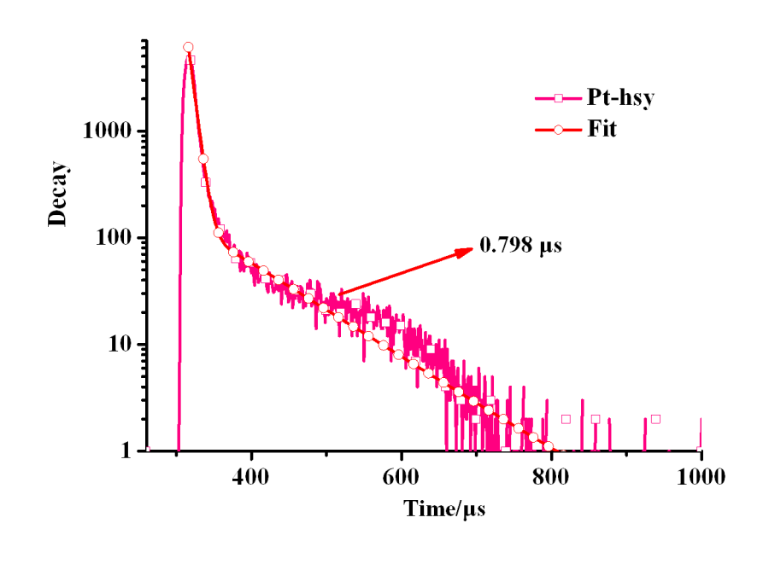

Fig. S2 The transient emission decay profiles for Pt-hsy (10-5M) in DMSO solvent.