**Materials and methods**

***Assessment of DNA binding activity of the complex***

The ability of the complex to intercalate with ctDNA was assessed according to the method adopted by Dehghan (Dehghan et al., 2011). The intrinsic binding constant was determined by the following equation:

DNA/εa-εf = DNA/εb-εf + 1/Kb(εb-εf)

Where DNA represents the number of base pairing of DNA, Kb represents intrinsic binding constant, εa represents the extinction coefficient (Aobs/Ru) factor, εf is the free drug related extinction coefficient and εb represents bound drug associated extinction coefficient and complex associated calibration curve is derived from εf in the aqueous solution. εa represents the ratio of recorded absorbance to concentration of the complex by Beer’s law.

***Toxicity study***

*Acute oral toxicity study*

The acute oral toxicity study of taxifolin ruthenium-p-cymene complex was carried out according to the guidelines provided by the Organization for Economic Co-operation and Development (OECD), TG 420 (adopted in December 2001) for the evaluation of LD50 dose of the complex. The animals were starved overnight prior to the initiation of the experiment. Total twenty Swiss albino mice, 10 of each sex were randomly divided into five groups (four animals per group and two of each sex) viz., control group (supplied with 0.5% carboxy methyl cellulose (CMC) in double distilled water at a dose volume of 10 ml/kg body weight) and four test groups (2000 mg/kg, 1000 mg/kg, 800 mg/kg, 600 mg/kg taxifolin ruthenium-p-cymene complex). The animals were provided with food and water immediately after drug treatment and observed up to 3 days.

*Sub-acute toxicity study*

A 28-days repeated oral toxicity study (sub-acute toxicity) was performed according to the OECD Guideline, TG 407 (adopted in December 2001). Twenty swiss albino mice of both sexes was randomly distributed into five experimental groups: vehicle control group (given 0.5% CMC in double distilled water at a dose volume of 10 ml/kg body weight) and four test groups (400 mg/kg, 200 mg/kg, 100 mg/kg, 50 mg/kg of the complex). Each group comprised of four animals, two of each sex. The animals were given food and water immediately after the administration of the complex and monitored for general clinical appearance, body weights, and mortality for up to 28 days. Animals were euthanized under the anesthesia of pentobarbital sodium (45 mg/kg, i.p) and investigated for haematological, serum biochemical, and histopathological evaluations.

*Hematological and serum biochemical analysis*

The blood samples were collected from the retro-orbital plexus of the animals and different hematological parameters were evaluated using Medonic CA-20 cell analyzer systems (Boule Medical, Stockholm, Sweden). The serum from the blood samples were separated by centrifugation for 10 minutes at 3000 rpm and used for biochemical analysis by using Microlab 3000 auto-analyzer.

*Histopathological studies of the organs*

After 28 days of repeated oral dose toxicity study animals were sacrificed and major organs (liver, kidney, stomach, pancreas, and testis) were excised and fixed for 24 hours in formalin. The excised tissues were dehydrated and embedded in paraffin wax. The tissues of 5 µm thickness were kept on slides and rehydrated by graded alcohol. The slides were stained using hematoxylin and eosin (H&E), which were observed under the light microscope (Labline Olympus Microscope LED, MX21i) for histological evaluation.

***Antioxidant assay of lung tissue***

Lung tissue samples were homogenized using D-160 homogenizer (D-LAB, USA) in a lysis buffer solution at a concentration of 1 g tissue/10 ml. The homogenate was centrifuged at 800x g for 30 min at 4oC and the supernatant was used for further experimentation. The CAT (catalase) reaction was performed according to the method adopted by Sinha and his associates (Sinha et al., 1972). The absorbance was recorded at 620 nm and the action of CAT was evaluated as μMol of H2O2/min/mg protein consumed. The SOD (superoxide dismutase) activity was evaluated by the method of Awasthi (Awasthi et al., 1989). The action of SOD was denoted as units/min/mg protein. The assessment of GPx (Glutathione Peroxidase) was performed according to the method described by Rotruck (Rotruck et al., 1973). The GPx activity was determined as µMol of GSH (glutathione) consumed/min/mg protein.

**Results**

***Successful binding of taxifolin ruthenium-p-cymene complex with ctDNA***

The broad range of absorption spectra of the complex in presence of ctDNA has been depicted in (Fig. S1). The addition of the ctDNA to the complex showed a decrease in the absorption rate of the absorption peak. The change in the intensity can be identified as the intra-ligand transition band at 383 nm, with increasing the concentration of the complex in the DNA.

***Toxicity study***

*Acute and sub-acute toxicity study*

The LD50 dose of the complex was found to be 600 mg/kg body weight after acute oral toxicity study and sunsequently the sub-acute doses were determined to be 50, 100, 200, 400 mg/kg body weight. No treatment related death was observed in the sub-acute toxicity study.

*Hematological and serum biochemical analysis*

The hematological and serum biochemical profile of the animals (control and 50, 100, 200, 400 mg/kg complex treated animals) has been represented in the Table S1-S4. According to the report the WBC and RBC levels were found to be high for 400 mg/kg of complex treated animals in compare to the control group (p<0.05). Additionally the ALT, AST and ASP levels were also increased for the 400 mg/kg of complex treated animals (p<0.05). The levels of glucose and BUN were also altered significantly (p<0.05). Therefore the 400 mg/kg dose of the complex was not considered for the subsequent study as it causes toxicity to the animals.

*Histopathology*

The histopathological analysis of the vital organs like liver, kidney, stomach, pancreas, and testis were performed after sub-acute toxicity study. In the normal control group the morphological architecture of liver (Fig. S2 (i)A) showed the central vein (*cv*), portal vein (*pv*), bile duct (*bd*), hepatic artery (*ha*), sinusoids (*s*), lymph vessel (*lv*), hepatocytes (*h*), kupffer cells (*kc*). The 400 mg/kg group (Fig. S2 (i)E) depicted periportal mononuclear infiltrates (*pmi*), hepatocytes degeneration (*hd*) and focal inflammation (*fi*). The 50 and 100 mg/kg treated group (Fig. S2 (i)B, C) was not associated with any alterations of liver whereas minor changes were recorded in 200 mg/kg complex treated group (Fig. S2 (i)D). In normal control group, the histopathology of kidney (Fig. S2 (ii)A) showed normal structure of glomerulus (*g*), bowman’s capsular space (*bc*), proximal convoluted tubules (*pct*), distal convoluted tubule (*dct*), macula densa (*md*), jaxtaglomerular cells (*jgc*), podocytes (*p*), vascular pole (*vp*), urinary pole (*up*) and mesangium cells (*mc*). The 400 mg/kg treated group depicted thickening of capsular membrane (*tm*), desquamated epithelial cells (*dec*), vascular congestion (*vc*), infiltration of inflammatory cells (*iic*) and haemorrhages (*h*). Whereas, 50 and 100 mg/kg treated group (Fig. S2 (ii)B, C) did not caused any histological alterations of kidney (Fig. S2 (ii)D). In normal control group (Fig. S2 (iii)A) the histology of stomach tissue demonstrated muscularis mucosa (*mm*), submucosa (*s*), lamina propia (*lp*) and gastric pits (*gp*), gastric mucosa (*gm*), gastric cavity (*gc*), gastric epithelium (*ge*), muscularis propia (*mp*), circular muscle (*cm*), longitudinal muscle (*lm*), serosa (*s*), blood vessels (*bv*). The 50 and 100 mg/kg treated group (Fig. S2 (iii)B, C) denoted no histopathological alterations in the stomach tissue. The 200 mg/kg dose (Fig. S2 (iii)E) showed some thickening of submucosal area (*tsa*), desquamation of gastric mucosa (*d*), vacuolization (*v*). On the other hand, 400 mg/kg group (Fig. S2 (iii)E) showed vascular congestion (*vc*), thickening of submucosal area (*tsa*), cellular infiltration (*ci*), desquamation of gastric mucosa (*d*), vacuolization (*v*), glandular widening (*gw*). In the normal control group (Fig. S2 (iv)A) the morphological architecture of pancreas showed normal structure of β cells of islets of Langerhans (*i*), with normal acinar arrangements with basal basophila and apical acidophila (*a*), exocrine protion (*ep*), collagen (*c*), intralobular duct (*id*), vascular stroma (*vs*). The 400 mg/kg group (Fig. S2 (iv)E) depicted oedema (*oe*), degenerated entrapped islet of Langerhans (*d*), shrinkage of islet of Langerhans (*sil*), vacuolization (*v*) in pancreatic duct. The 50 and 100 mg/kg treated group (Fig. S2 (iv)B, C) was not associated with any alterations of liver whereas minor changes were recorded in 200 mg/kg complex treated group (Fig. S2 (iv)D). In normal control group, the histopathology of testis (Fig. S2 (v)A) showed seminiferous tubules (st), sertoli cells (sc), spermatogina (*sg*), primary spermatocytre (*ps*), spermatozoa (*sz*), leydig cells (*lc*), lumen (*lu*), round spermatids (*rs*), elongated spermatid (*es*), basement membrane (*bm*). The 400 mg/kg treated group (Fig. S2 (v)E) depicted degeneration in seminiferous tubules (*d*), oedema in interstitial tissues (*oe*), vacuolization (*v*), exfoliated cells (*ec*), empty lumen (*el*), atrophy of leydig cells (*a*), multinucleated giant cells (*mng*). However, no structural abnormalities were found in 50 and 100 mg/kg treated group (Fig. S2 (v)B, C) but the 200 mg/kg (Fig. S2 (v)D) group showed slight oedema (*oe*), empty lumen (*el*) and vacuolization (*v*).

***In vivo antioxidant activity***

The effect of taxifolin ruthenium-p-cymene complex on the antioxidant levels of lung tissue has been depicted in Fig. S3. The induction of benzo-α-pyrene significantly decreases the antioxidant levels. Whereas, treatment with the complex drastically upregulated the antioxidant levels in lung. The highest levels of antioxidant enzymes were observed in the 200 mg/kg complex treated group.

**References**

1. Dehghan G, Dolatabadi JE, Jouyban A, Zeynali KA, Ahmadi SM, Kashanian S (2011) Spectroscopic studies on the interaction of quercetin-terbium(III) complex with calf thymus DNA. DNA Cell Biol 30(3):195-201. <https://doi.org/10.1089/dna.2010.1063>
2. Sinha BBP, Peterson GA, Li GC, Whitney RR, Sick I, McCarthy JS (1972) Nuclear change distribution of isotone pairs I. 31P and 32S. Phys Rev C 6:1657-1663. <https://doi.org/10.1103/PhysRevC.7.1930>
3. Awasthi S, Kakkar P, Viswanathan PN, Bharadwaj R (1989) Effect of anaesthetic ether on lipid peroxidation and superoxide dismutase isozymes of young and adult rat brain. Indian J Exp Biol 27(7):647-649.
4. Rotruck JT, Pope AL, Ganther HE, Swanson AB, Hafeman DG, Hoekstra WG (1973) Selenium: biochemical role as a component of glutathione peroxidase. Science 179(4073):588-590. <https://doi.org/10.1126/science.179.4073.588>

**Table S1** Hematological finding in male Swiss albino mice treated with taxifolin ruthenium-p-cymene complex for 28 days repeated-dose oral sub-acute toxicity study

|  |  |  |  |  |  |
| --- | --- | --- | --- | --- | --- |
| **Parameters (± SEM)** | **Control** | **taxifolin ruthenium-p-cymene (400 mg/kg)** | **taxifolin ruthenium-p-cymene (200 mg/kg)** | **taxifolin ruthenium-p-cymene (100 mg/kg)** | **taxifolin ruthenium-p-cymene (50 mg/kg)** |
| Haemoglobin (%) | 11.23±0.015 | 13.47±0.01 | 12.68±0.01 | 12.26±0.01 | 12.59±0.02 |
| Total RBC (106/µ) | 4.25±0.003 | 5.11±0.001* | 4.49±0.001 | 4.35±0.002 | 4.64±0.001 |
| Platelet count (105/ µ) | 2.85±0.001 | 4.27±0.03* | 2.67±0.004 | 2.70±0.001 | 2.87±0.001 |
| WBC (103/ µ) | 8.87±0.02 | 13.20±0.02* | 12.83±0.02*# | 3.54±0.01*#$ | 6.53±0.04*#$α |
| MCV (fL) | 89.76±0.01 | 92.24±0.01* | 87.40±0.03 | 88.95±0.01 | 88.76±0.01 |
| MCH (pg) | 28.45±0.01 | 29.96±0.09 | 26.13±0.01*# | 29.18±0.03 | 28.12±0.01 |
| MCHC (%) | 33.20±0.02 | 31.75±0.06 | 31.85±0.01 | 30.26±0.01 | 31.58±0.02 |
| Neutrophil (%) | 27.77±0.10 | 30.05±0.02* | 25.27±0.12*# | 27.32±0.15#$ | 25.18±0.03*#α |
| Eosinophil (%) | 2.1±0.03 | 6.07±0.03* | 6.09±0.03* | 5.23±0.08*#$ | 1.05±0.01*#$α |
| Monocytes (%) | 1.20±0.08 | 2.12±0.06 | 1.23±0.08 | 1.19±0.08 | 2.13±0.06 |
| Basophil (%) | 0.0±0.0 | 0.0±0.0 | 0.0±0.0 | 0.0±0.0 | 0.0±0.0 |

Standard error of mean= standard deviation (SD)/√ Total subject. Result are analyzed by one-way ANOVA and confirmed by Tukey’s multiple comparison test.

MCV: mean corpuscular volume; MCH: mean corpuscular haemoglobin; MCHC: mean corpuscular haemoglobin concentration; RBC: red blood cell; WBC: white blood cell.

* Significant difference at p<0.05, when compared with control group.

# Significant difference at p<0.05, when compared with 400 mg/kg group.

$ Significant difference at p<0.05, when compared with 200 mg/kg group.

α Significant difference at p<0.05, when compared with 100 mg/kg group.

**Table S2** Hematological finding in female Swiss albino mice treated with taxifolin ruthenium-p-cymene complex for 28 days repeated-dose oral sub-acute toxicity study

|  |  |  |  |  |  |
| --- | --- | --- | --- | --- | --- |
| **Parameters (± SEM)** | **Control** | **taxifolin ruthenium-p-cymene (400 mg/kg)** | **taxifolin ruthenium-p-cymene (200 mg/kg)** | **taxifolin ruthenium-p-cymene (100 mg/kg)** | **taxifolin ruthenium-p-cymene (50 mg/kg)** |
| Haemoglobin (%) | 12.25±0.024 | 13.44±0.13 | 12.66±0.02 | 12.25±0.024 | 13.12±0.17 |
| Total RBC (106/µ) | 4.27±0.005 | 5.08±0.24* | 4.54±0.004 | 4.33±0.003 | 4.64±0.003 |
| Platelet count (105/ µ) | 2.94±0.002 | 3.20±0.005 | 2.63±0.002 | 2.70±0.002 | 2.89±0.002 |
| WBC (103/ µ) | 8.85±0.03 | 13.28±0.02* | 12.84±0.02*# | 3.67±0.03*#$ | 5.12±0.004*#$α |
| MCV (fL) | 88.74±0.02 | 91.25±0.02* | 87.34±0.05# | 88.96±0.23# | 87.12±0.23# |
| MCH (pg) | 28.23±0.19 | 31.08±0.03* | 29.10±0.03# | 27.16±0.02# | 27.78±0.26# |
| MCHC (%) | 33.20±0.044 | 30.64±0.05* | 30.68±0.05* | 31.24±0.02* | 31.65±0.03* |
| Neutrophil (%) | 27.60±0.24 | 31.24±0.05* | 25.80±0.20*# | 26.83±0.20*# | 24.03±0.31*#α |
| Eosinophil (%) | 2.16±0.09 | 1.23±0.12 | 6.06±0.04*# | 5.05±0.04*# | 1.01±0.02*$α |
| Monocytes (%) | 1.02±0.02 | 2.33±0.09 | 1.02±0.04 | 1.06±0.06 | 2.03±0.01 |
| Basophil (%) | 0.0±0.0 | 0.0±0.0 | 0.0±0.0 | 0.0±0.0 | 0.0±0.0 |

Standard error of mean= standard deviation (SD)/√ Total subject. Result are analyzed by one-way ANOVA and confirmed by Tukey’s multiple comparison test.

MCV: mean corpuscular volume; MCH: mean corpuscular haemoglobin; MCHC: mean corpuscular haemoglobin concentration; RBC: red blood cell; WBC: white blood cell.

* Significant difference at p<0.05, when compared with control group.

# Significant difference at p<0.05, when compared with 400 mg/kg group.

$ Significant difference at p<0.05, when compared with 200 mg/kg group.

α Significant difference at p<0.05, when compared with 100 mg/kg group.

**Table S3** Serum biochemistry findings in male Swiss albino mice treated with taxifolin ruthenium-p-cymene complex for 28 days repeated-dose oral sub-acute toxicity study

|  |  |  |  |  |  |
| --- | --- | --- | --- | --- | --- |
| **Parameters (± SEM)** | **Control** | **taxifolin ruthenium-p-cymene (400 mg/kg)** | **taxifolin ruthenium-p-cymene (200 mg/kg)** | **taxifolin ruthenium-p-cymene (100 mg/kg)** | **taxifolin ruthenium-p-cymene (50 mg/kg)** |
| Aspartate aminotransferase (AST) | 39.18±0.12 | 50.02±0.02* | 41.05±0.01*# | 35.37±0.07*#$ | 32.16±0.04*#$α |
| Alanine aminotransferase (ALT) | 31.27±0.03 | 52.01±0.02* | 44.57±0.01*# | 37.44±0.07*#$ | 34.13±0.03*#$α |
| Alkaline phosphatase (ALP) | 355.4±0.13 | 496±0.06* | 355.5±0.07# | 366.4±0.26*#$ | 223.3±0.06*#$α |
| Blood urea nitrogen (mg/dl) | 17.11±0.02 | 30.22±0.02* | 28.46±0.09*# | 18.46±0.01#$ | 17.10±0.02#$ |
| Creatinine (mg/dl) | 0.63±0.0 | 0.64±0.002 | 0.63±0.002 | 0.54±0.0 | 0.56±0.002 |
| Glucose (mg/dl) | 114.9±0.13 | 130.9±0.10* | 116.7.7±0.23*# | 111.7±0.23*#$ | 104.2±0.06*#$α |
| Cholesterol(mg/dl) | 47.15±0.02 | 52.08±0.02* | 47.16±0.03# | 45.14±0.03*#$ | 43.15±0.02*#$α |

Standard error of mean= standard deviation (SD)/√ Total subject. Result are analyzed by one-way ANOVA and confirmed by Tukey’s multiple comparison test.

* Significant difference at p<0.05, when compared with control group.

# Significant difference at p<0.05, when compared with 400 mg/kg group.

$ Significant difference at p<0.05, when compared with 200 mg/kg group.

α Significant difference at p<0.05, when compared with 100 mg/kg group.

**Table S4** Serum biochemistry findings in female Swiss albino mice treated with taxifolin ruthenium-p-cymene complex for 28 days repeated-dose oral sub-acute toxicity study

|  |  |  |  |  |  |
| --- | --- | --- | --- | --- | --- |
| **Parameters (± SEM)** | **Control** | **taxifolin ruthenium-p-cymene (400 mg/kg)** | **taxifolin ruthenium-p-cymene (200 mg/kg)** | **taxifolin ruthenium-p-cymene (100 mg/kg)** | **taxifolin ruthenium-p-cymene (50 mg/kg)** |
| Aspartate aminotransferase (AST) | 31.25±0.12 | 50.03±0.02* | 40.06±0.01*# | 34.39±0.07*#$ | 32.14±0.04#$α |
| Alanine aminotransferase (ALT) | 31.29±0.08 | 50.04±0.02* | 37.56±0.04*# | 46.48±0.07*#$ | 35.08±0.04*#$α |
| Alkaline phosphatase (ALP) | 352.4±0.10 | 401.7±0.36* | 383.8±0.27*# | 312.3±0.80*#$ | 220.5±0.21*#$α |
| Blood urea nitrogen (mg/dl) | 18.13±0.03 | 30.15±0.02* | 27.56±0.02*# | 28.47±0.04*# | 19.05±0.02*#$α |
| Creatinine (mg/dl) | 0.61±0.002 | 0.62±0.002 | 0.62±0.002 | 0.56±0.002 | 0.53±0.004 |
| Glucose (mg/dl) | 116.2±0.37 | 128.4±0.40* | 114.2±0.37*# | 114.7±0.23*# | 127.4±0.40*#$α |
| Cholesterol(mg/dl) | 47.12±0.044 | 51.12±0.05* | 47.07±0.03*# | 45.07±0.04*#$ | 43.05±0.04*#$α |

Standard error of mean= standard deviation (SD)/√ Total subject. Result are analyzed by one-way ANOVA and confirmed by Tukey’s multiple comparison test.

* Significant difference at p<0.05, when compared with control group.

# Significant difference at p<0.05, when compared with 400 mg/kg group.

$ Significant difference at p<0.05, when compared with 200 mg/kg group.

α Significant difference at p<0.05, when compared with 100 mg/kg group.

**Figure legends**

**Fig. S1** Absorbance spectra of CT-DNA in the presence of taxifolin ruthenium-p-cymene complex.

**Fig. S2** Histopathological representation of Swiss albino mice (**i**) liver, (**ii**) kidney, (**iii**) stomach, (**iv**) pancreas, and (**v**) testis at 10X [inset 40X] where (**A**) Normal control (**B**) 50 mg/kg complex (**C**) 100 mg/kg complex (**D**) 200 mg/kg complex (H&E). Normal liver showing the central vein (*cv*), portal vein (*pv*), bile duct (*bd*), hepatic artery (*ha*), sinusoids (*s*), kupffer cell (*kc*), lymph vessel (*lv*), hepatocytes (*h*) and 200 mg/kg group showing periportal mononuclear infiltrates (*pmi*), hepatocytes degeneration (*hd*), focal inflammation (*fi*). Normal kidney tissue showing glomerulus (*g*), bowman’s capsular space (*bc*), proximal convoluted tubules (*pct*), distal convoluted tubule (*dct*), macula densa (*md*), jaxtaglomerular cells (*jgc*), podocytes (*p*), vascular pole (*vp*) (black circle), urinary pole (*up*) (black circle), mesangium cells (*mc*) and 200 mg/kg group showing thickening of capsular membrane (*tm*), desquamated epithelial cells (*dec*), vascular congestion (*vc*), infiltration of inflammatory cells (*iic*) and haemorrhages (*h*). Normal stomach showing muscularis mucosa (*mm*), submucosa (*s*), lamina propia (*lp*) and gastric pits (*gp*), gastric mucosa (*gm*), gastric cavity (*gc*), gastric epithelium (*ge*), muscularis propia (*mp*), circular muscle (*cm*), longitudinal muscle (*lm*), serosa (*s*), blood vessels (*bv*) and 200 mg/kg group showing vascular congestion (*vc*), thickening of submucosal area (*tsa*), cellular infiltration (*ci*), desquamation of gastric mucosa (*d*), vacuolization (*v*), glandular widening (*gw*). Normal pancreas showing islets of Langerhans (*I*), Normal acinar arrangements with basal basophila and apical acidophila (*a*), exocrine protion (*ep*), collagen (*c*), intralobular duct (*id*), vascular stroma (*vs*) and 200 mg/kg group showing oedema (*oe*), degenerated entrapped islet of Langerhans (*d*), shrinkage of islet of Langerhans (*sil*), vacuolization (*v*). Normal testis showing seminiferous tubules (st), sertoli cells (sc), spermatogina (*sg*), primary spermatocytre (*ps*), spermatozoa (*sz*), leydig cells (*lc*), lumen (*lu*), round spermatids (*rs*), elongated spermatid (*es*), basement membrane (*bm*) and 200 mg/kg group showing degeneration in seminiferous tubules (*d*), oedema in interstitial tissues (*oe*), vacuolization (*v*), exfoliated cells (*ec*), empty lumen (*el*), atrophy of leydig cells (*a*), multinucleated giant cells (*mng*).

**Fig. S3** In vivo antioxidant activity of taxifolin ruthenium-p-cymene complex. * represented p<0.05 as compared to normal control. Similarly, # represented p<0.05 as compared to carcinogen control, $ represented p<0.05 as compared to 50 mg/kg complex treated group, α represented p<0.05 as compared to 100 mg/kg complex treated group, β represented p<0.05 as compared to 200 mg/kg complex treated group, γ represented p<0.05 as compared to 50 mg/kg taxifolin treated group. Data represented as means ± SEM from different experiments in triplicate. The results were compared using ANOVA, followed by a Tukey’s multiple comparison post-hoc analysis.

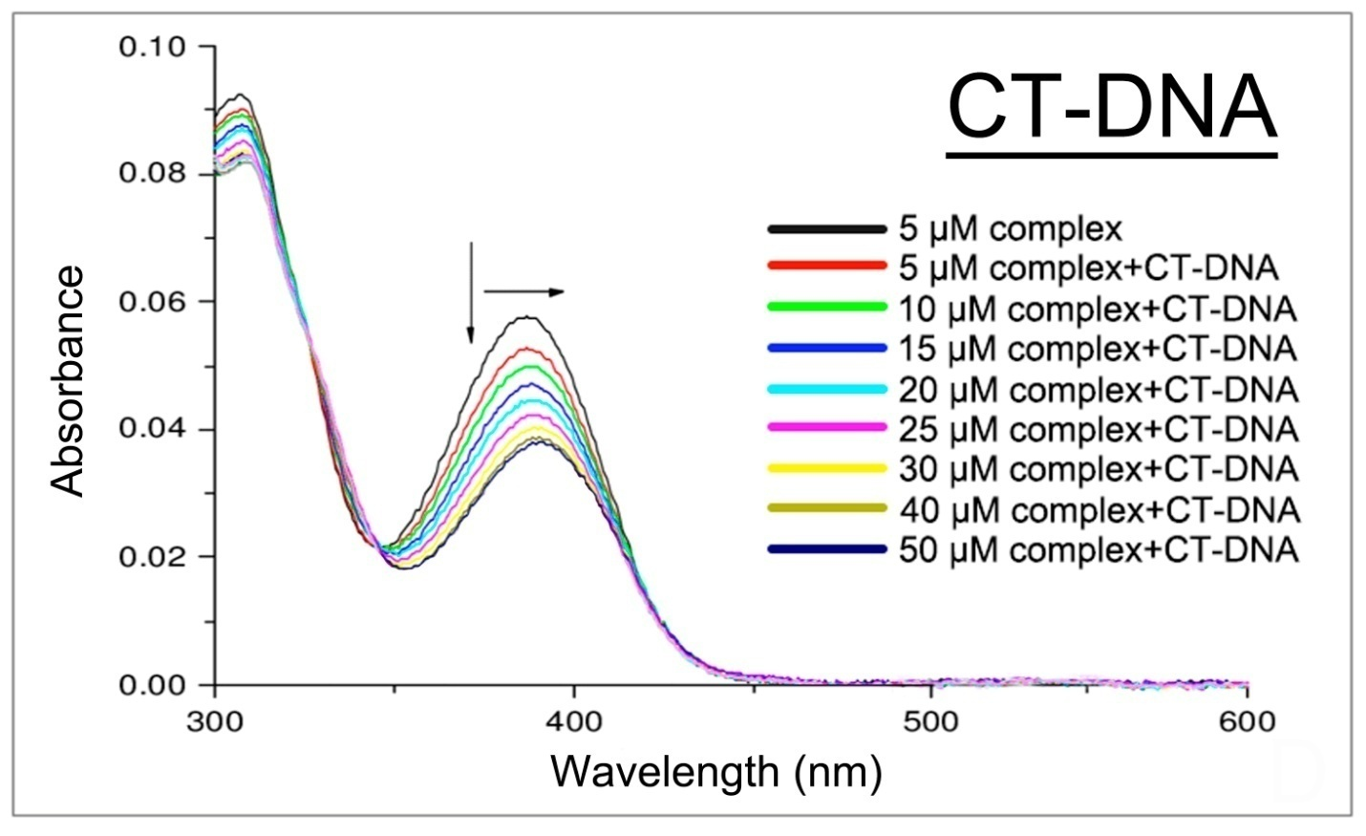

**Fig. S1**

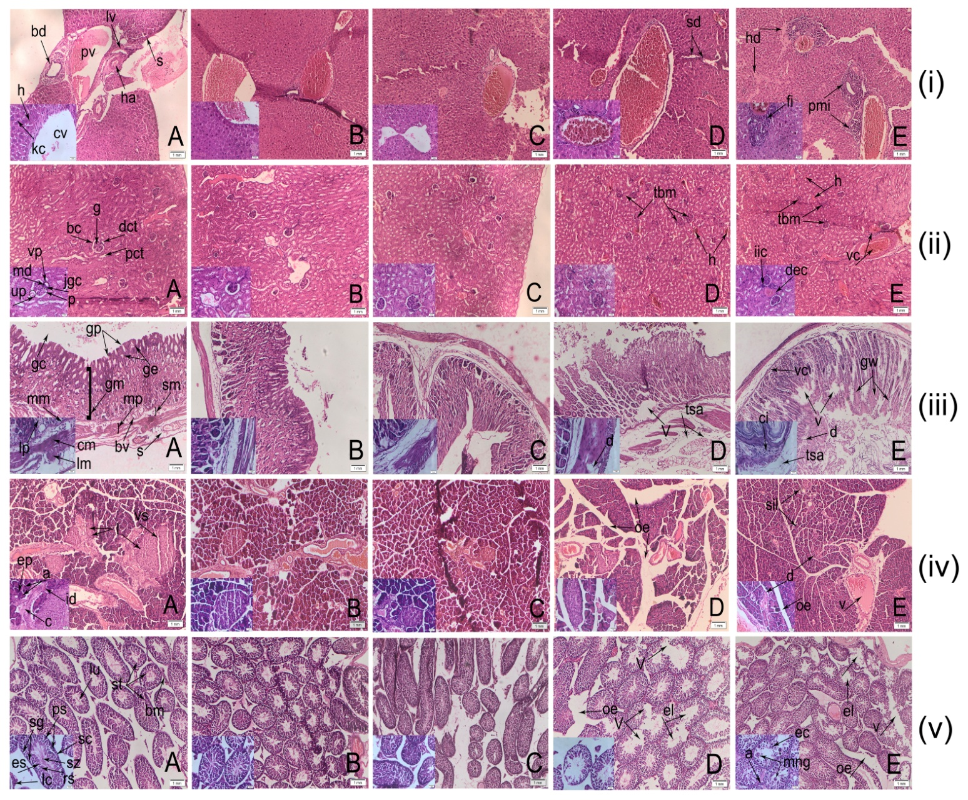

**Fig. S2**

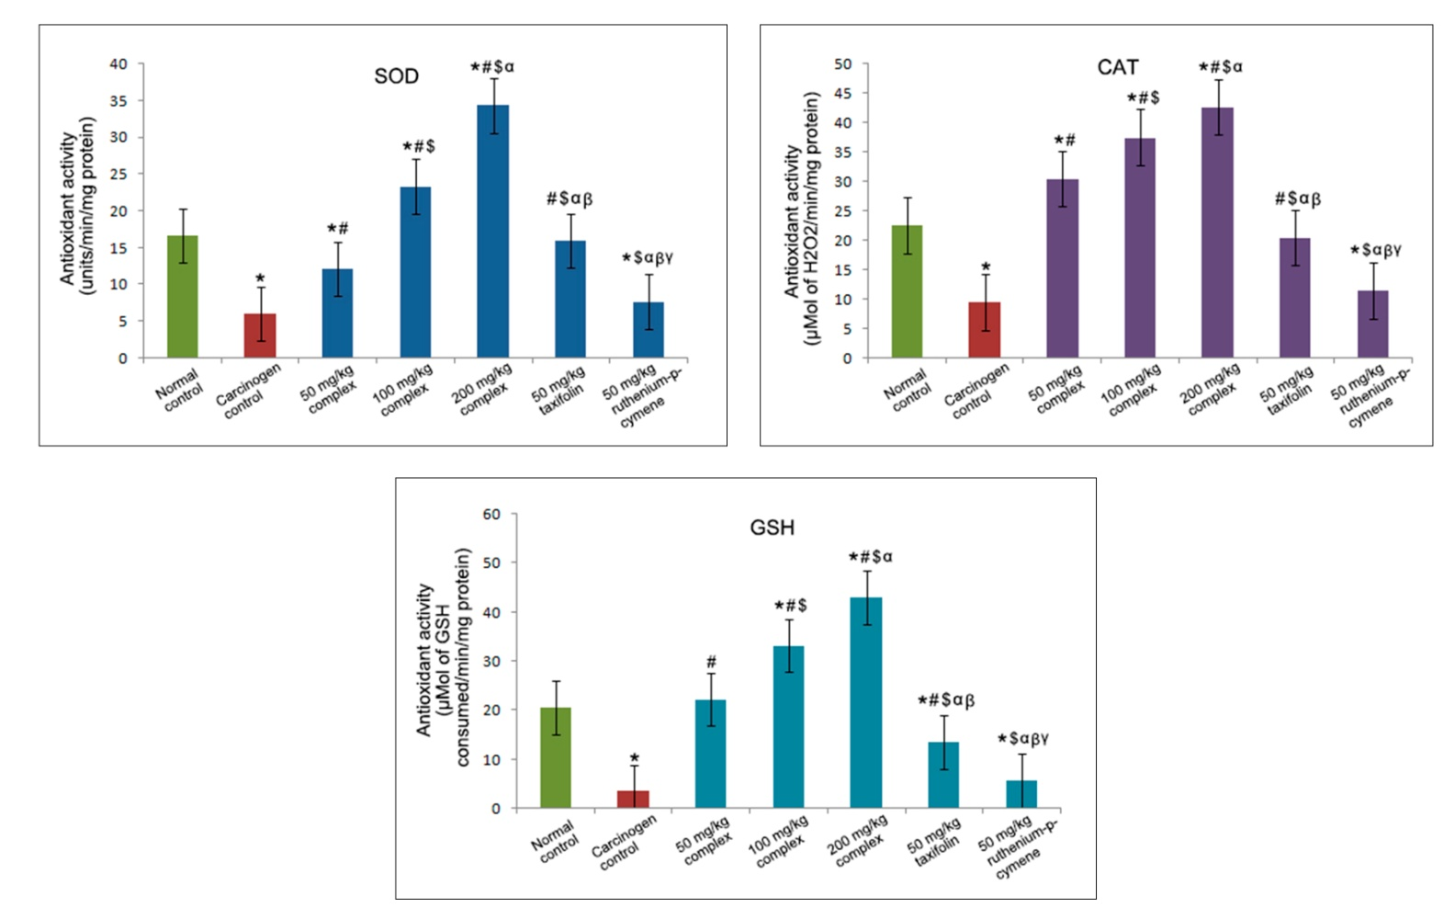

**Fig. S3**