**<** **Arabian Journal of Chemistry>**

**An enhanced approach for targeted multi-residue screening of pesticides in complex herbal medicines by ultra high-performance liquid chromatography tandem ion mobility/quadrupole time-of-flight mass spectrometry**

Huiqin Pan1, Heng Zhou1, Lan Lan1, Shui Miao1, Yufan Gu1, Jiayin Cao1, Ming Yuan2, Xiuhong Mao1, Qing Hu1,*, Shen Ji 1,*

*1 NMPA Key Laboratory for Quality Control of Traditional Chinese Medicine, Shanghai Institute for Food and Drug Control, 1500 Zhangheng Road, Shanghai 201203, China*

*2 Waters Technologies Ltd. (Shanghai), 1000 Jinhai Road, Shanghai, 201203, China*

Corresponding authors: Shen Ji and Qing Hu, NMPA Key Laboratory for Quality Control of Traditional Chinese Medicine, Shanghai Institute for Food and Drug Control, 1500 Zhangheng Road, Shanghai 201203, China; Tel.: +86 21 38830990; Fax: +86 21 50798195.

*E-mail addresses*: jishen2021@126.com (S. Ji); huqingyjs@163.com (Q. Hu).

**Contents**

**Table S1** Information on eight compounds in a commercial standard solution for the quality control of acquired data.

**Table S2** Information on 104 batches of Lonicerae Japonicae Flos samples.

**Table S3** Labile tuning parameter settings.

**Table S4** An Excel template for development of a basic structure library and an example.

**Table S5** Information on four-dimension identification points of 438 pesticides recorded in the established Pesticide Scientific Library (PSL).

**Table S6** Validation results for qualitative analyses of 438 pesticides spiked to the ten LJF samples at three concentration levels.

**Figure S1** Labile paraoxon-ethyl as an example for illustrating effects of the reduced capillary voltage, sampling cone voltage and low-energy channel voltage on fragmentations in the full scan.

**Figure S2** Labile paraoxon-ethyl as an example for illustrating effects of collision gas on fragmentations in the full scan. (The proposed fragmentation of paraoxon-ethyl to produce Fragment P1 (*m/z* 220.00055) and Fragment P2 (*m/z* 248.03185) (A); the low-energy (LE) spectra of *m/z* 276.06315 with argon (B) and nitrogen (C) as collision gas, respectively.)

**Figure S3** Labile aminocarb as an example for illustrating effects of collision gas on fragmentations in the full scan. (The proposed fragmentation of aminocarb to produce Fragment A1 (*m/z* 152.10699) and Fragment A2 (*m/z* 137.08352) (A); the low-energy (LE) spectra of *m/z* 209.12845 and the overlapped mobiligram of the extracted ions of *m/z* 209.12845, 152.10699 and 137.08352 with argon (B) and nitrogen (C) as collision gas, respectively.)

**Figure S4** Response ratio of 443 molecular ions detected with nitrogen as the collision gas to argon (RN/A).

**Figure S5** The response variations of eight representative pesticides from different sub-structure types at different capillary voltage settings (0.5, 1.0, 1.5, 2.0, 2.5, 3.0 and 3.5 kV).

**Figure S6** The low-energy spectra of demeton-*S*-methyl-sulfoxide and metrafenone at different sampling cone voltage settings (40, 50 and 60 V).

**Figure S7** The high-energy spectra of tralkoxydim and pirimiphos-methyl at different LME (20, 25 and 30 eV) and HME settings (55, 60 and 65 eV).

**Figure S8** The intraday precision (n=6) and interday precision (n=15) of CCS measurements.

**Figure S9** A two-dimension distribution of CCS values against retention times for 443 pesticide entries (R2: linearity regression correlation coefficient).

**Figure S10** A two-dimension distribution of CCS values against *m/z* for 443 pesticide entries (R2: linearity regression correlation coefficient).

**Figure S11** The extracted ion chromatograms of sebuthylazine and propazine.

**Figure S12** The retention time derivations (A) and the CCS derivations (B) of the eight compounds from the QC.

Table S1 Information on eight compounds in a commercial standard solution for the quality control of acquired data

|  |  |  |  |  |  |
| --- | --- | --- | --- | --- | --- |
| Component | *m/z* | *t*R/min | Formula | Adducts | CCS/Å2 |
| Caffeine | 195.08765 | 5.00 | C8H10N4O2 | +H | 138.2 |
| Sulfaguanidine | 215.05972 | 2.98 | C7H10N4O2S | +H | 146.8 |
| Sulfadimethoxine | 311.08085 | 5.74 | C12H14N4O4S | +H | 168.4 |
| Val-Tyr-Val | 380.21800 | 5.03 | C19H29N3O5 | +H | 191.7 |
| Verapamil | 455.29043 | 6.68 | C27H38N2O4 | +H | 208.8 |
| Terfenadine | 472.32101 | 10.98 | C32H41NO2 | +H | 228.7 |
| Leucine-Enkephalin | 556.27657 | 5.90 | C28H37N5O7 | +H | 229.8 |
| Reserpine | 609.28066 | 7.67 | C33H40N2O9 | +H | 252.3 |

Table S2 Information on 104 batches of Lonicerae Japonicae Flos samples

|  |  |  |  |
| --- | --- | --- | --- |
| **No.** | **Sample label** | **Collection regions** | **Batch No.** |
| 1 | S1 | Henan Province, China | 20180501 |
| 2 | S2 | Henan Province, China | 20180502 |
| 3 | S4 | Henan Province, China | 20180720 |
| 4 | S5 | Henan Province, China | 20180528 |
| 5 | S6 | Henan Province, China | 20180516 |
| 6 | S8 | Henan Province, China | 20180623 |
| 7 | S9 | Henan Province, China | 20180711 |
| 8 | S10 | Henan Province, China | 20180626 |
| 9 | S14 | Henan Province, China | 160301 |
| 10 | S15 | Henan Province, China | 160302 |
| 11 | S16 | Henan Province, China | 150601 |
| 12 | S17 | Henan Province, China | 150602 |
| 13 | S18 | Henan Province, China | 150901 |
| 14 | S19 | Henan Province, China | 150902 |
| 15 | S20 | Henan Province, China | 170601 |
| 16 | S21 | Henan Province, China | 170602 |
| 17 | S22 | Henan Province, China | 170801 |
| 18 | S23 | Henan Province, China | 170802 |
| 19 | S24 | Henan Province, China | 170803 |
| 20 | S25 | Henan Province, China | 171001 |
| 21 | S26 | Henan Province, China | 171201 |
| 22 | S27 | Henan Province, China | 171202 |
| 23 | S28 | Henan Province, China | 171203 |
| 24 | S29 | Henan Province, China | 180201 |
| 25 | S30 | Henan Province, China | 180202 |
| 26 | S31 | Henan Province, China | 180203 |
| 27 | S32 | Henan Province, China | 180401 |
| 28 | S33 | Henan Province, China | 180402 |
| 29 | S34 | Henan Province, China | 180403 |
| 30 | S35 | Henan Province, China | 180601 |
| 31 | S36 | Henan Province, China | 201805-1 |
| 32 | S37 | Henan Province, China | 201805-2 |
| 33 | S38 | Henan Province, China | 201805-3 |
| 34 | S39 | Henan Province, China | 201805-4 |
| 35 | S40 | Shandong Province, China | 20180503 |
| 36 | S41 | Shandong Province, China | 20180506 |
| 37 | S42 | Shandong Province, China | 20180510 |
| 38 | S43 | Henan Province, China | 201807-1 |
| 39 | S44 | Henan Province, China | 201807-2 |
| 40 | S45 | Henan Province, China | 201807-3 |
| 41 | S46 | Henan Province, China | S160401 |
| 42 | S47 | Hunan Province, China | BZ0101 |
| 43 | S48 | Shandong Province, China | BZ0102 |
| 44 | S49 | Hebei Province, China | BZ0103 |
| 45 | S50 | Hebei Province, China | BZ0104 |
| 46 | S51 | Hebei Province, China | BZ0105 |
| 47 | S52 | Hunan Province, China | BZ0106 |
| 48 | S53 | Shandong Province, China | BZ0107 |
| 49 | S54 | Guizhou Province, China | BZ0108 |
| 50 | S55 | Hunan Province, China | BZ0109 |
| 51 | S56 | Hunan Province, China | BZ0110 |
| 52 | S57 | Hunan Province, China | BZ0111 |
| 53 | S58 | Hunan Province, China | BZ0112 |
| 54 | S59 | Hunan Province, China | BZ0113 |
| 55 | S60 | Hebei Province, China | BZ0114 |
| 56 | S61 | Hunan Province, China | BZ0115 |
| 57 | S62 | Hunan Province, China | BZ0116 |
| 58 | S63 | Hunan Province, China | BZ0117 |
| 59 | S64 | Hubei Province, China | BZ0118 |
| 60 | S65 | Shandong Province, China | YN0101 |
| 61 | S66 | Yunnan Province, China | YN0102 |
| 62 | S67 | Hunan Province, China | YN0103 |
| 63 | S68 | Guizhou Province, China | HX0101 |
| 64 | S69 | Guizhou Province, China | HX0102 |
| 65 | S70 | Chongqing Province, China | HX0103 |
| 66 | S71 | Chongqing Province, China | HX0104 |
| 67 | S72 | Sichuan Province, China | HX0105 |
| 68 | S73 | Sichuan Province, China | HX0106 |
| 69 | S74 | Sichuan Province, China | HX0107 |
| 70 | S75 | Sichuan Province, China | HX0108 |
| 71 | S76 | Sichuan Province, China | HX0109 |
| 72 | S77 | Shandong Province, China | HX0110 |
| 73 | S78 | Shandong Province, China | HX0111 |
| 74 | S79 | Guizhou Province, China | GZ0101 |
| 75 | S80 | Guizhou Province, China | GZ0102 |
| 76 | S81 | Guizhou Province, China | GZ0103 |
| 77 | S82 | Guizhou Province, China | GZ0104 |
| 78 | S83 | Henan Province, China | HB0101 |
| 79 | S84 | Shandong Province, China | HB0102 |
| 80 | S85 | Shandong Province, China | HB0103 |
| 81 | S86 | Hebei Province, China | HB0104 |
| 82 | S87 | Hebei Province, China | HB0105 |
| 83 | S88 | Hebei Province, China | HB0106 |
| 84 | S89 | Hebei Province, China | HZ0101 |
| 85 | S90 | Henan Province, China | HZ0102 |
| 86 | S91 | Sichuan Province, China | HZ0103 |
| 87 | S92 | Henan Province, China | HZ0104 |
| 88 | S93 | Henan Province, China | HZ0105 |
| 89 | S94 | Hebei Province, China | HZ0106 |
| 90 | S97 | Henan Province, China | 190302 |
| 91 | S98 | Shandong Province, China | 20190701 |
| 92 | S99 | Henan Province, China | 191101 |
| 93 | S100 | Henan Province, China | 191102 |
| 94 | S101 | Henan Province, China | 191103 |
| 95 | S01 | Henan Province, China | ZJM-01 |
| 96 | S02 | Henan Province, China | ZJM-02 |
| 97 | S03 | Henan Province, China | ZJM-03 |
| 98 | S04 | Henan Province, China | ZJM-04 |
| 99 | S05 | Henan Province, China | ZJM-05 |
| 100 | S06 | Henan Province, China | ZJM-06 |
| 101 | S07 | Henan Province, China | ZJM-07 |
| 102 | S08 | Henan Province, China | ZJM-08 |
| 103 | S09 | Henan Province, China | ZJM-09 |
| 104 | S010 | Henan Province, China | ZJM-10 |

Table S3 Labile tuning parameter settings

|  |  |
| --- | --- |
| **Parameter** | **Labile Tune** |
| Cone | 30 |
| Source offset | 50 |
| SW1 offset | 5 |
| SW1 pulse heigh | 5 |
| SW2 velocity | 200 |
| MS profile | Cover mass range of analytes e.g., 100/150/200 @25/25/25/25 |
| Ion guide RF gain | 2 |
| Cell2 RF gain | 2 |
| Stepwave RF | 250 |
| Trap/IMS RF | 250 |

Table S4 An Excel template for development of a basic structure library and an example

|  |  |  |  |  |
| --- | --- | --- | --- | --- |
| Item Name | Synonym "pesticide classification" | Synonym "CAS number" | Item Tag " group" | Structure |
| 1-Naphthyl-acetamide | plant growth regulators | 86-86-2 | 7 | 542.mol* |

* 542. mol was the file name of 1-Naphthyl-acetamide in mol..

Table S5 Information on four-dimension identification points of 438 pesticides recorded in the established Pesticide Scientific Library (PSL)

|  |  |  |  |  |  |  |  |  |  |  |  |  |
| --- | --- | --- | --- | --- | --- | --- | --- | --- | --- | --- | --- | --- |
| **No.** | **Item Name** | **Synonym "Chinese Name"** | **Formula** | **Adduct** | **Expected *m/z*** | **CCS** | **t/R** | **F1** | **F2** | **F3** | **F4** | **F5** |
| 1 | Abamectin-B1a | 阿维菌素 | C48H72O14 | +Na | 895.48143 | 299.09 | 17.05 | 449.25338 | 305.21112 | 521.28977 | 549.32107 | 567.33163 |
| 2 | Acetamiprid | 啶虫脒 | C10H11ClN4 | +H | 223.07450 | 150.37 | 5.57 | 126.01050 | 90.03383 |  |  |  |
| 3 | Acetochlor | 乙草胺 | C14H20ClNO2 | +H | 270.12553 | 155.78 | 11.53 | 224.08367 | 59.04914 | 148.11208 |  |  |
| 4 | Akton | 硫虫畏 | C12H14Cl3O3PS | +H | 374.95396 | 167.80 | 14.85 | 169.96846 | 204.93731 | 96.95076 | 346.92266 | 318.89136 |
| 5 | Aldicarb-sulfone | 涕灭威砜 | C7H14N2O4S | +Na | 245.05665 | 147.22 | 4.55 | 86.06004 | 81.00048 | 76.03930 |  |  |
| 6 | Alloxydim | 禾草灭 | C17H25NO5 | +H | 324.18055 | 175.81 | 11.83 | 192.10191 | 164.10699 | 234.11247 | **266.13868** | 178.04987 |
| 7 | Ametoctradin | 苯唑嘧菌胺 | C15H25N5 | +H | 276.21827 | 175.59 | 13.49 | 176.09307 | 149.08217 | 190.10872 |  |  |
| 8 | Ametryn | 莠灭净 | C9H17N5S | +H | 228.12774 | 154.13 | 9.58 | 186.08079 | 158.04949 | 144.05899 | 116.02769 | 68.02432 |
| 9 | Amicarbazone | 胺唑草酮 | C10H19N5O2 | +Na | 264.14310 | 168.75 | 6.74 | 165.07468 |  |  |  |  |
| 10 | Aminocarb | 灭害威 | C11H16N2O2 | +H | 209.12845 | 150.17 | 4.49 | 122.06004 | 137.08352 | 152.10699 |  |  |
| 11 | Anilofos | 莎稗磷 | C13H19ClNO3PS2 | +H | 368.03053 | 177.78 | 12.28 | 124.98206 | 170.96978 | 166.00542 | 198.96470 |  |
| 12 | Atrazine | 阿特拉津 | C8H14ClN5 | +H | 216.10105 | 149.13 | 8.35 | 174.05410 | 146.02280 | 132.03230 | 104.00100 | 138.07742 |
| 13 | Atrazine-desethyl | 脱乙基阿特拉津 | C6H10ClN5 | +H | 188.06975 | 139.86 | 5.98 | 146.02280 | 110.04612 | 104.00100 | 68.02432 |  |
| 14 | Atrazine-desisopropyl | 脱异丙基莠去津 | C5H8ClN5 | +H | 174.05410 | 132.82 | 5.35 | 68.02432 | 146.02280 | 104.00100 |  |  |
| 15 | Azaconazole | 氧环唑 | C12H11Cl2N3O2 | +H | 300.03011 | 161.55 | 8.80 | 158.97628 | 230.99741 |  |  |  |
| 16 | Azamethiphos | 甲基吡啶磷 | C9H10ClN2O5PS | +H | 324.98093 | 158.34 | 6.60 | 182.99558 | 139.00575 | 111.99485 |  |  |
| 17 | Azimsulfuron | 四唑嘧磺隆 | C13H16N10O5S | +H | 425.10986 | 192.22 | 8.14 | 182.05602 | 139.05020 | 227.03457 | 156.07675 | 244.06112 |
| 18 | Azinphos-ethyl | 乙基谷硫磷(益棉磷) | C12H16N3O3PS2 | +Na | 368.02629 | 174.80 | 11.29 | 77.03858 | 132.04439 | 232.94905 | 289.01165 | 137.00556 |
| 19 | Azinphos-methyl | 甲基谷硫磷(保棉磷) | C10H12N3O3PS2 | +Na | 339.99499 | 167.00 | 9.22 | 132.04439 | 77.03858 | 124.98206 | 105.03349 |  |
| 20 | Aziprotryne | 叠氮津 | C7H11N7S | +H | 226.08694 | 146.93 | 10.86 | 184.06514 | 198.08079 | 156.03384 | 142.04334 | 111.05395 |
| 21 | Azoxystrobin | 腈嘧菌酯 | C21H14N3O4 | -e | 372.09788 | 186.54 | 9.65 | 329.07949 | 344.10297 | 328.07167 | 172.03930 |  |
| 22 | Beflubutamid | 氟丁酰草胺 | C18H17F4NO2 | +H | 356.12682 | 180.92 | 11.99 | 91.05423 | 193.02710 |  |  |  |
| 23 | Benalaxyl | 苯霜灵 | C20H23NO3 | +H | 326.17507 | 171.74 | 12.40 | 148.11208 | 133.08860 | 208.13321 | 294.14886 | 266.15394 |
| 24 | Benfuracarb | 丙硫克百威 | C20H30N2O5S | +H | 411.19482 | 198.95 | 13.94 | 195.04340 | 162.06753 | 252.06889 | 158.11756 |  |
| 25 | Benodanil | 麦锈灵 | C13H10INO | +H | 323.98798 | 148.62 | 8.03 | 202.93522 | 230.93013 | 76.03075 |  |  |
| 26 | Benoxacor | 解草嗪 | C11H11Cl2NO2 | +H | 260.02396 | 146.85 | 9.49 | 134.06004 | 160.07569 | 120.04439 | 149.08352 |  |
| 27 | Bensulfuron-methyl | 苄嘧磺隆 | C16H18N4O7S | +H | 411.09690 | 187.86 | 9.26 | 182.05602 | 149.05971 | 119.04914 | 91.05423 | 139.05020 |
| 28 | Bensulide | 地散磷 | C14H24NO4PS3 | +Na | 420.04973 | 189.38 | 11.83 | 141.00048 | 77.03858 | 200.01983 | 158.02703 | 218.03040 |
| 29 | Benthiavalicarb-isopropyl | 苯噻菌胺 | C18H24FN3O3S | +H | 382.15952 | 188.54 | 10.72 | 180.02777 | 197.05432 | 116.07060 |  |  |
| 30 | Benzoximate | 苯螨特 | C18H18ClNO5 | +Na | 386.07657 | 189.10 | 12.88 | 199.01565 | 183.99217 | 170.00033 | 140.97378 |  |
| 31 | Benzoylprop-ethyl | 新燕灵 | C18H17Cl2NO3 | +Na | 388.04777 | 192.94 | 12.55 | 77.03858 | 105.03349 | 292.02905 | 320.02396 |  |
| 32 | Benzyladenine | 苄腺嘌呤 | C12H11N5 | +H | 226.10872 | 148.38 | 6.39 | 148.06177 | 91.05423 |  |  |  |
| 33 | Bispyribac | 双草醚 | C19H18N4O8 | +H | 431.11974 | 198.07 | 10.29 | 275.06625 | 413.10918 | 243.04003 | 381.08296 | 139.05020 |
| 34 | Boscalid | 啶酰菌胺 | C18H12Cl2N2O | +H | 343.03994 | 172.65 | 10.49 | 271.08659 | 307.06327 | 111.99485 | 139.98977 |  |
| 35 | Bromfenvinfos | 溴苯烯磷 | C12H14BrCl2O4P | +H | 402.92629 | 167.30 | 12.71 | 169.96846 | 98.98417 | 80.97361 | 248.88679 | 155.04677 |
| 36 | Brompyrazon | 溴莠敏 | C10H8BrN3O | +H | 265.99235 | 141.86 | 5.81 | 186.06619 | 189.96105 | 236.97838 | 172.93450 | 92.04948 |
| 37 | Bromuconazole,cis | 糠菌唑 | C13H12BrCl2N3O | +H | 375.96136 | 168.45 | 11.06 | 158.97628 | 172.95555 | 144.96063 | 70.03997 |  |
| 38 | Bromuconazole,trans | 糠菌唑 | C13H12BrCl2N3O | +H | 375.96136 | 169.61 | 12.13 | 158.97628 | 172.95555 | 144.96063 | 70.03997 |  |
| 39 | Bupirimate | 乙嘧酚磺酸酯 | C13H24N4O3S | +H | 317.16419 | 174.52 | 11.65 | 210.16009 | 166.09749 | 208.14444 | 272.10634 | 150.10257 |
| 40 | Buprofezin | 噻嗪酮 | C16H23N3OS | +H | 306.16346 | 173.05 | 14.43 | 106.06513 | 77.03858 | 201.10561 |  |  |
| 41 | Butafenacil | 氟丙嘧草酯 | C20H18ClF3N2O6 | +NH4 | 492.11437 | 211.55 | 11.10 | 331.00918 | 179.98468 | 123.99485 | 151.98977 | 349.01975 |
| 42 | Butralin | 仲丁灵 | C14H21N3O4 | +H | 296.16048 | 168.90 | 15.70 | 222.08732 | 178.07368 | 208.07167 | 240.09788 |  |
| 43 | Buturon | 炔草隆 | C12H13ClN2O | +H | 237.07892 | 152.30 | 8.52 | 207.03197 | 126.01050 | 93.05730 | 222.05544 |  |
| 44 | Cafenstrole | 唑草胺 | C16H22N4O3S | +Na | 373.13048 | 191.03 | 10.95 | 119.08553 | 105.06988 | 72.04439 | 100.07569 | 252.08012 |
| 45 | Carbetamide | 双酰草胺 | C12H16N2O3 | +H | 259.10531 | 164.83 | 6.49 | 92.04948 | 120.04439 | 77.03858 | 192.06552 |  |
| 46 | Carbosulfan | 丁硫克百威 | C20H32N2O3S | +H | 381.22064 | 189.86 | 17.20 | 128.14338 | 160.11545 | 123.04406 | 76.02155 | 118.06850 |
| 47 | Carboxin | 萎锈灵 | C12H13NO2S | +H | 236.07398 | 149.72 | 7.31 | 93.05730 | 143.01613 |  |  |  |
| 48 | Carfentrazone-ethyl | 唑草酮 | C15H14Cl2F3N3O3 | +H | 412.04371 | 180.00 | 12.08 | 345.99561 | 276.97415 | 302.03025 | 366.00184 |  |
| 49 | Carpropamid | 加普胺 | C15H18Cl3NO | +H | 334.05267 | 172.82 | 12.35 | 103.05423 | 77.03858 | 139.03090 | 102.04640 | 160.05237 |
| 50 | Chlorantraniliprole | 氯虫酰胺 | C18H14BrCl2N5O2 | +Na | 503.96001 | 204.52 | 9.11 | 283.92208 | 450.93587 | 177.00883 | 194.00033 | 205.00374 |
| 51 | Chlorbromuron | 氯溴隆 | C9H10BrClN2O2 | +H | 292.96869 | 151.53 | 10.56 | 204.92884 | 182.02414 | 125.00268 | 203.92102 | 153.02140 |
| 52 | Chlorfenvinphos | 毒虫畏 | C12H14Cl3O4P | +H | 358.97681 | 164.95 | 12.48 | 169.96846 | 98.98417 | 80.97361 | 204.93731 | 155.04677 |
| 53 | Chloridazon | 氯草敏 | C10H8ClN3O | +H | 222.04287 | 141.31 | 5.71 | 193.02889 | 146.01157 | 77.03858 | 104.04948 | 92.04948 |
| 54 | Chlorimuron-ethyl | 氯嘧磺隆 | C15H15ClN4O6S | +H | 415.04736 | 192.63 | 10.58 | 186.00648 | 121.02841 | 184.99031 | 143.00067 |  |
| 55 | Chloroxuron | 枯草隆 | C15H15ClN2O2 | +H | 291.08948 | 172.10 | 11.14 | 218.03672 | 72.04439 | 183.06787 |  |  |
| 56 | Chlorphoxim | 氯辛硫磷 | C12H14ClN2O3PS | +H | 333.02240 | 166.89 | 12.63 | 138.01050 | 102.03383 | 110.99960 | 249.94890 | 163.00575 |
| 57 | Chlorpyrifos | 毒死蜱 | C9H11Cl3NO3PS | +H | 349.93356 | 163.90 | 15.07 | 197.92747 | 161.95080 | 96.95076 | 275.86040 | 293.87096 |
| 58 | Chlorpyrifos-methyl | 甲基毒死蜱 | C7H7Cl3NO3PS | +H | 321.90226 | 152.84 | 13.36 | 289.87605 | 124.98206 |  |  |  |
| 59 | Chlorpyrifos-oxon | 氧毒死蜱 | C9H11Cl3NO4P | +H | 333.95640 | 159.69 | 11.75 | 197.92747 | 277.89380 | 161.95080 | 259.88324 | 133.95588 |
| 60 | Chlorsulfuron | 氯磺隆 | C12H12ClN5O4S | +H | 358.03713 | 175.76 | 6.94 | 167.05635 | 141.07709 | 83.02399 | 110.99960 |  |
| 61 | Chlortoluron | 绿麦隆 | C10H13ClN2O | +H | 213.07892 | 145.79 | 8.05 | 72.04439 | 140.02615 |  |  |  |
| 62 | Cinidon-ethyl | 吲哚酮草酯 | C19H17Cl2NO4 | +H | 394.06074 | 192.99 | 14.47 | 348.01888 | 239.96136 | 213.98210 | 366.02944 |  |
| 63 | Cinosulfuron | 醚磺隆 | C15H19N5O7S | +H | 414.10780 | 191.62 | 6.22 | 183.05127 | 280.02608 | 83.02399 | 157.07200 |  |
| 64 | Clethodim | 烯草酮 | C17H26ClNO3S | +H | 360.13947 | 189.76 | 13.78 | 166.08626 | 164.07061 | 136.07569 | 149.05971 | 268.13658 |
| 65 | Clodinafop-propargyl | 炔草酯 | C17H13ClFNO4 | +H | 350.05899 | 179.47 | 12.02 | 222.01165 | 238.04295 | 238.06656 | 266.03786 | 91.05423 |
| 66 | Clomazone | 异恶草酮 | C12H14ClNO2 | +H | 240.07858 | 145.89 | 9.45 | 125.01525 | 89.03858 |  |  |  |
| 67 | Cloransulam-methyl | 氯酯磺草胺 | C15H13ClFN5O5S | +H | 430.03827 | 189.60 | 7.02 | 306.01886 | 369.98076 | 152.99759 | 398.01206 | 185.02381 |
| 68 | Coumaphos | 蝇毒磷 | C14H16ClO5PS | +H | 363.02174 | 180.36 | 12.46 | 226.99263 | 288.94857 | 211.01565 | 225.98480 | 306.95913 |
| 69 | Coumaphos-oxon | 氧蝇毒磷 | C14H16ClO6P | +H | 347.04458 | 175.40 | 9.29 | 211.01565 | 272.97141 | 290.98198 | 319.01328 | 209.00000 |
| 70 | Coumatetralyl | 杀鼠醚 | C19H16O3 | +H | 293.11722 | 162.84 | 11.10 | 121.02841 | 91.05423 | 175.03897 |  |  |
| 71 | Crimidine | 鼠立死 | C7H10ClN3 | +H | 172.06360 | 131.73 | 6.19 | 136.08692 | 109.07602 | 80.04948 | 120.05562 | 95.06037 |
| 72 | Crufomate | 育畜磷 | C12H19ClNO3P | +H | 292.08638 | 163.47 | 11.84 | 236.02378 | 203.99757 | 260.06017 | 108.02089 | 230.99723 |
| 73 | Cumyluron | 苄苯隆 | C17H19ClN2O | +H | 303.12587 | 165.26 | 10.95 | 185.04762 | 125.01525 | 91.05423 | 119.08553 |  |
| 74 | Cyanazine | 氰草净 | C9H13ClN6 | +H | 241.09630 | 154.71 | 6.46 | 214.08540 | 174.05410 | 132.03230 | 104.00100 |  |
| 75 | Cyazofamid | 氰霜唑 | C13H13ClN4O2S | +H | 325.05205 | 164.92 | 11.54 | 216.03230 | 182.07127 | 155.06037 | 164.02615 | 108.01138 |
| 76 | Cycluron | 环锈隆 | C11H22N2O | +H | 199.18049 | 148.39 | 8.90 | 72.04439 | 89.07094 | 69.06988 |  |  |
| 77 | Cyflufenamid | 环氟菌胺 | C20H17F5N2O2 | +H | 413.12830 | 182.01 | 12.67 | 203.02269 | 221.03325 | 183.01646 | 241.03948 | 295.08643 |
| 78 | Cyhalothrin | 氯氟氰菊酯 | C23H19ClF3NO3 | +Na | 472.08978 | 207.66 | 15.64 | 181.06479 | 141.05103 | 225.02885 | 161.05726 |  |
| 79 | Cymiazole | 螨蜱胺 | C12H14N2S | +H | 219.09505 | 147.10 | 5.64 | 171.09167 | 203.06375 | 156.06820 | 130.06513 | 144.08078 |
| 80 | Cyprazine | 环丙津 | C9H14ClN5 | +H | 228.10105 | 151.80 | 8.48 | 144.03230 | 186.05410 | 108.05562 | 150.07742 |  |
| 81 | Cyproconazole-1 | 环唑醇(环丙唑醇) | C15H18ClN3O | +H | 292.12112 | 168.00 | 11.23 | 125.01525 | 70.03997 |  |  |  |
|  | Cyproconazole-2 | 环唑醇(环丙唑醇) | C15H18ClN3O | +H | 292.12112 | 167.14 | 10.87 | 125.01525 | 70.03997 |  |  |  |
| 82 | Cyprodinil | 嘧菌环胺 | C14H15N3 | +H | 226.13387 | 152.62 | 12.21 | 210.10257 | 77.03858 | 93.05730 | 108.08078 |  |
| 83 | Cyprofuram | 酯菌胺 | C14H14ClNO3 | +H | 280.07350 | 159.98 | 7.41 | 130.06513 | 166.04180 | 184.05237 |  |  |
| 84 | Cyprosulfamide | 环丙磺酰胺 | C18H18N2O5S | +H | 375.10092 | 191.47 | 6.32 | 135.04406 | 254.08117 | 121.02841 | 77.03858 |  |
| 85 | Cythioate | 畜蜱磷 | C8H12NO5PS2 | +H | 297.99673 | 160.42 | 6.05 | 154.97150 | 233.94430 | 265.97051 | 184.98206 | 217.00828 |
| 86 | DEET | 避蚊胺 | C12H17NO | +H | 192.13829 | 143.17 | 8.36 | 91.05423 | 119.04914 |  |  |  |
| 87 | Demeton-S-methyl-sulfoxide | 磺吸磷 | C6H15O4PS2 | +H | 247.02221 | 141.45 | 4.72 | 109.00491 | 124.98206 | 169.00828 | 105.03686 |  |
| 88 | Demeton-S-methyl-sulphon | 砜吸磷 | C6H15O5PS2 | +H | 263.01713 | 142.97 | 4.86 | 124.98206 | 169.00828 | 78.99434 | 109.00491 |  |
| 89 | Desmedipham | 甜菜胺 | C16H16N2O4 | +Na | 323.10023 | 179.02 | 8.80 | 136.03930 | 108.04439 | 93.03349 | 154.04987 | 182.08117 |
| 90 | Diallate | 燕麦敌 | C10H17Cl2NOS | +H | 270.04807 | 155.29 | 13.72 | 108.96063 | 106.97168 | 72.98395 |  |  |
| 91 | Diazinon | 二嗪磷 | C12H21N2O3PS | +H | 305.10833 | 170.62 | 12.49 | 169.07940 | 153.10224 | 96.95076 | 84.04439 |  |
| 92 | Diazinon-O-analog | 二嗪磷氧同系物 | C12H21N2O4P | +H | 289.13117 | 168.56 | 9.14 | 153.10224 | 233.06857 | 84.04439 | 261.09987 |  |
| 93 | Dichlorfenthion | 除线磷 | C10H13Cl2O3PS | +H | 314.97728 | 157.06 | 14.83 | 222.93801 | 258.91468 | 204.92744 | 240.90412 | 162.97120 |
| 94 | Dichlorvos | 敌敌畏 | C4H7Cl2O4P | +H | 220.95318 | 133.93 | 6.79 | 109.00491 | 127.01547 | 78.99452 |  |  |
| 95 | Diclobutrazol | 苄氯三唑醇 | C15H19Cl2N3O | +H | 328.09779 | 171.96 | 12.14 | 158.97628 | 70.03997 |  |  |  |
| 96 | Diclosulam | 双氯磺草胺 | C13H10Cl2FN5O3S | +H | 405.99382 | 181.80 | 7.34 | 160.97936 | 125.00268 | 377.96252 |  |  |
| 97 | Dicrotophos | 百治磷 | C8H16NO5P | +H | 238.08389 | 147.81 | 5.09 | 109.00491 | 127.01547 | 193.02604 |  |  |
| 98 | Diethatyl-ethyl | 乙酰甲草胺 | C16H22ClNO3 | +H | 312.13610 | 168.01 | 11.97 | 147.10425 | 132.08078 | 162.12773 | 117.05730 | 238.09932 |
| 99 | Diethofencarb | 乙霉威 | C14H21NO4 | +Na | 290.13628 | 177.36 | 9.93 | 124.03930 | 152.07061 | 108.04439 | 180.10191 | 226.10738 |
| 100 | Difenoconazole | 苯醚甲环唑 | C19H17Cl2N3O3 | +H | 406.07197 | 199.36 | 13.22 | 251.00250 | 188.03873 | 223.00758 | 337.03928 |  |
| 101 | Difenoxuron | 枯秀隆 | C16H18N2O3 | +H | 287.13902 | 174.21 | 8.52 | 214.08626 | 95.04914 | 186.09134 | 72.04439 | 123.04406 |
| 102 | Difenzoquat-methyl-sulfate | 野燕枯 | C17H17N2 | -e | 249.13862 | 159.74 | 5.56 | 193.08860 | 233.10732 | 130.06513 | 234.11515 |  |
| 103 | Diflufenican | 吡氟酰草胺 | C19H11F5N2O2 | +H | 395.08135 | 186.95 | 13.45 | 266.04234 | 246.03611 | 238.04742 | 218.04120 | 233.05210 |
| 104 | Dimefuron | 恶唑隆 | C15H19ClN4O3 | +H | 339.12184 | 191.14 | 9.30 | 167.00067 | 139.98977 | 212.05852 | 72.04439 |  |
| 105 | Dimethachlor | 二甲草胺 | C13H18ClNO2 | +H | 256.10988 | 150.25 | 9.05 | 148.11208 | 224.08367 | 132.08078 | 105.06988 | 118.06513 |
| 106 | Dimethametryn | 异戊乙净 | C11H21N5S | +H | 256.15904 | 164.97 | 11.92 | 186.08079 | 158.04949 | 138.07742 | 144.05899 | 116.02769 |
| 107 | Dimethenamid | 二甲吩草胺 | C12H18ClNO2S | +H | 276.08195 | 154.16 | 10.36 | 168.08415 | 244.05574 | 111.02630 | 152.05285 | 126.03720 |
| 108 | Dimethomorph-1 | 烯酰吗啉 | C21H22ClNO4 | +H | 388.13101 | 199.81 | 10.14 | 301.06260 | 165.05462 | 273.06768 | 258.04421 |  |
|  | Dimethomorph-2 | 烯酰吗啉 | C21H22ClNO4 | +H | 388.13101 | 200.47 | 10.71 | 301.06260 | 165.05462 | 273.06768 | 258.04421 |  |
| 109 | Dimethylvinphos | 甲基毒虫畏 | C10H10Cl3O4P | +H | 330.94550 | 157.61 | 11.05 | 169.96846 | 127.01547 | 109.00491 | 204.93731 |  |
| 110 | Dimetilan | 敌蝇威 | C10H16N4O3 | +H | 241.12952 | 153.30 | 5.64 | 72.04439 | 151.01382 | 196.07167 |  |  |
| 111 | Dimoxystrobin | 醚菌胺 | C19H22N2O3 | +H | 327.17032 | 172.54 | 12.06 | 223.09917 | 238.12264 | 116.04948 | 280.13321 | 89.03858 |
| 112 | Diniconazole | 烯唑醇 | C15H17Cl2N3O | +H | 326.08214 | 174.16 | 13.25 | 70.03997 | 158.97628 | 252.00898 | 204.07003 |  |
| 113 | Dinitramine | 氨氟灵 | C11H13F3N4O4 | +H | 323.09617 | 158.76 | 12.90 | 215.06648 | 247.04374 | 289.09069 | 261.05939 | 305.08560 |
| 114 | Dioxathion-1 | 敌杀磷 | C8H16O4PS2 | -e | 271.02221 | 145.80 | 14.13 | 96.95076 | 128.92283 | 140.97698 | 78.94020 | 184.98543 |
|  | Dioxathion-2 | 敌杀磷 | C8H16O4PS2 | -e | 271.02221 | 146.15 | 14.34 | 96.95076 | 128.92283 | 140.97698 | 184.98543 |  |
| 115 | Diphenamid | 双苯酰草胺 | C16H17NO | +H | 240.13829 | 153.56 | 8.95 | 134.09643 | 167.08553 |  |  |  |
| 116 | Dipropetryn | 异丙净 | C11H21N5S | +H | 256.15904 | 165.78 | 12.01 | 144.03384 | 214.11209 | 186.08079 | 172.06514 | 102.01204 |
| 117 | Disulfoton sulfone | 乙拌磷砜 | C8H19O4PS3 | +H | 307.02558 | 156.16 | 7.95 | 96.95076 | 78.94020 | 171.02393 | 260.98372 |  |
| 118 | Dithiopyr | 氟硫草定 | C15H16F5NO2S2 | +H | 402.06154 | 176.87 | 13.55 | 271.99876 | 248.03292 | 296.03629 | 223.99762 | 354.05817 |
| 119 | Diuron | 敌草隆 | C9H10Cl2N2O | +H | 233.02429 | 147.00 | 8.86 | 159.97153 | 125.00268 | 72.04439 |  |  |
| 120 | Dodemorph | 十二环吗淋 | C18H35NO | +H | 282.27914 | 176.16 | 8.84 | 116.10699 | 98.09643 |  |  |  |
| 121 | Dodine | 多果定 | C13H29N3 | +H | 228.24342 | 176.59 | 12.82 | 186.22163 | 211.21688 |  |  |  |
| 122 | Doramectin | 多拉菌素 | C50H74O14 | +Na | 921.49708 | 306.68 | 17.78 | 777.42084 | 331.22677 | 593.34728 | 575.33672 | 833.44705 |
| 123 | Drazoxolon | 肼菌酮 | C10H8ClN3O2 | +H | 238.03778 | 146.04 | 11.38 | 130.06513 | 177.02140 | 220.02722 | 142.05255 |  |
| 124 | Edifenphos | 克瘟散 | C14H15O2PS2 | +H | 311.03238 | 159.54 | 12.25 | 109.01065 | 154.97150 | 77.03858 | 172.98206 | 283.00108 |
| 125 | Emamectin B1A Benzoate | 甲氨基阿维菌素 | C49H75NO13 | +H | 886.53112 | 300.03 | 14.68 | 158.11756 | 82.06513 | 868.52055 | 302.19620 |  |
| 126 | EPN | 苯硫膦 | C14H14NO4PS | +H | 324.04539 | 167.59 | 13.40 | 156.98715 | 262.02637 | 278.00353 | 138.97658 | 261.03347 |
| 127 | Eprinomectin B1a | 依立诺克丁 | C50H75NO14 | +Na | 936.50798 | 309.09 | 16.61 | 154.08626 | 144.10191 | 199.11174 | 298.16490 |  |
| 128 | Esprocarb | 戊草丹 | C15H23NOS | +H | 266.15731 | 159.92 | 14.40 | 91.05423 | 196.07906 |  |  |  |
| 129 | Etaconazole | 乙环唑 | C14H15Cl2N3O2 | +H | 328.06141 | 172.15 | 11.43 | 158.97628 |  |  |  |  |
| 130 | Ethametsulfuron-methyl | 胺苯磺隆 | C15H18N6O6S | +H | 411.10813 | 197.64 | 7.30 | 168.05160 | 83.02399 | 196.08290 | 142.07234 | 135.04406 |
| 131 | Ethidimuron | 磺噻隆 | C7H12N4O3S2 | +H | 265.04236 | 151.45 | 5.35 | 208.02089 | 116.02769 | 74.00590 | 116.02769 | 161.97903 |
| 132 | Ethiprole | 乙虫腈 | C13H9Cl2F3N4OS | +H | 396.98990 | 182.66 | 10.36 | 254.96981 | 350.94803 | 227.95892 |  |  |
| 133 | Ethirimol | 乙嘧酚 | C11H19N3O | +H | 210.16009 | 151.76 | 7.06 | 182.12879 | 140.10699 | 193.13354 | 165.10224 | 98.06004 |
| 134 | Ethoprophos | 灭线磷 | C8H19O2PS2 | +H | 243.06368 | 148.55 | 11.44 | 215.03238 | 96.95076 | 78.94020 | 172.98543 | 130.93848 |
| 135 | Ethoxysulfuron | 乙氧磺隆 | C15H18N4O7S | +H | 399.09690 | 187.56 | 10.77 | 139.03763 | 261.02882 | 154.06110 | 182.05602 |  |
| 136 | Etobenzanid | 乙氧苯草胺 | C16H15Cl2NO3 | +H | 340.05018 | 178.80 | 12.44 | 121.02841 | 93.03349 | 149.05971 | 282.00831 | 179.07027 |
| 137 | Etoxazole | 乙螨唑 | C21H23F2NO2 | +H | 360.17696 | 186.50 | 15.40 | 141.01465 | 113.01973 | 304.11436 | 177.12739 |  |
| 138 | Famphur | 伐灭磷 | C10H16NO5PS2 | +H | 326.02803 | 168.79 | 7.74 | 154.97150 | 217.00828 | 171.97424 | 184.98206 | 201.98480 |
| 139 | Fenamidone | 咪唑菌酮 | C17H17N3OS | +H | 312.11651 | 170.35 | 10.23 | 236.11822 | 134.07262 | 150.02462 | 92.04948 | 264.11314 |
| 140 | Fenamiphos | 苯线磷 | C13H22NO3PS | +H | 304.11308 | 169.64 | 11.79 | 201.98480 | 217.00828 | 234.03483 | 184.98206 | 276.08178 |
| 141 | Fenamiphos sulfone | 苯线磷砜 | C13H22NO5PS | +H | 336.10291 | 179.08 | 6.87 | 188.04711 | 266.02466 | 170.03654 | 308.07161 |  |
| 142 | Fenamiphos sulfoxide | 苯线磷亚砜 | C13H22NO4PS | +H | 320.10799 | 179.87 | 6.69 | 233.00319 | 216.00045 | 154.04469 | 217.97972 |  |
| 143 | Fenarimol | 氯苯嘧啶醇 | C17H12Cl2N2O | +H | 331.03994 | 173.85 | 11.34 | 268.05237 | 189.06988 | 138.99452 | 278.06053 |  |
| 144 | Fenazaquin | 喹螨醚 | C20H22N2O | +H | 307.18049 | 172.74 | 16.53 | 147.05529 | 131.08553 | 161.13248 | 146.10900 | 91.05423 |
| 145 | Fenbuconazole | 腈苯唑 | C19H17ClN4 | +H | 337.12145 | 183.43 | 11.66 | 125.01525 | 70.03997 | 128.06205 |  |  |
| 146 | Fenchlorphos oxon | 氧皮蝇磷 | C8H8Cl3O4P | +H | 304.92985 | 153.15 | 11.40 | 257.88017 | 272.90364 | 109.00491 | 127.01547 |  |
| 147 | Fenfuram | 甲呋酰胺 | C12H11NO2 | +H | 202.08626 | 141.55 | 7.53 | 109.02841 |  |  |  |  |
| 148 | Fenhexamid | 环酰菌胺 | C14H17Cl2NO2 | +H | 302.07091 | 164.19 | 11.32 | 143.01324 | 142.00542 | 177.98210 | 97.10118 |  |
| 149 | Fenoxaprop-ethyl | 精恶唑禾草灵 | C18H16ClNO5 | +H | 362.07898 | 189.40 | 14.04 | 288.04220 | 91.05423 |  |  |  |
| 150 | Fenoxycarb | 苯氧威 | C17H19NO4 | +H | 302.13868 | 178.85 | 11.89 | 256.09682 | 116.07060 | 88.03930 |  |  |
| 151 | Fenpiclonil | 拌种咯 | C11H6Cl2N2 | +H | 236.99808 | 149.54 | 9.36 | 202.02923 | 140.04948 | 166.05255 | 174.01050 | 201.02140 |
| 152 | Fenpropidin | 苯锈啶 | C19H31N | +H | 274.25293 | 166.85 | 9.07 | 147.11683 | 117.06988 | 119.08553 | 132.09335 |  |
| 153 | Fenpyrazamine | 胺苯吡菌酮 | C17H21N3O2S | +H | 332.14272 | 177.86 | 10.94 | 216.11314 | 230.12879 | 189.08966 | 130.06513 | 272.17574 |
| 154 | Fenpyroximate | 唑螨酯 | C24H27N3O4 | +H | 422.20743 | 215.45 | 15.80 | 366.14483 | 214.09749 | 199.08659 | 107.04914 | 138.06619 |
| 155 | Fensulfothion | 丰索磷 | C11H17O4PS2 | +H | 309.03786 | 171.97 | 8.28 | 234.96470 | 218.98754 | 140.02904 | 157.03178 | 252.97526 |
| 156 | Fensulfothion-oxon | 氧丰索磷 | C11H17O5PS | +H | 293.06071 | 168.03 | 5.88 | 236.99811 | 218.98754 | 140.02904 | 201.98480 | 174.00765 |
| 157 | Fensulfothion-oxon-sulfone | 氧丰索磷砜 | C11H17O6PS | +H | 309.05562 | 168.72 | 5.97 | 175.01547 | 252.99302 | 157.00491 | 281.02432 |  |
| 158 | Fensulfothion-sulfone | 丰索磷砜 | C11H17O5PS2 | +H | 325.03278 | 170.54 | 8.58 | 190.99263 | 268.97018 | 172.98206 | 94.04132 | 173.02669 |
| 159 | Fenthion | 倍硫磷 | C10H15O3PS2 | +H | 279.02730 | 155.01 | 12.36 | 168.98715 | 121.01065 | 105.06988 | 247.00108 | 153.03686 |
| 160 | Fenthion-oxon-sulfoxide | 氧倍硫磷亚砜 | C10H15O5PS | +H | 279.04506 | 161.81 | 5.44 | 264.02158 | 247.01884 | 216.05460 |  |  |
| 161 | Fenthion-sulfone | 倍硫磷砜 | C10H15O5PS2 | +H | 311.01713 | 165.72 | 7.23 | 168.98715 | 246.96470 | 278.99901 | 167.97932 | 200.00554 |
| 162 | Fenthion-sulfoxide | 倍硫磷亚砜 | C10H15O4PS2 | +H | 295.02221 | 164.73 | 6.95 | 279.99874 | 168.98715 | 262.99600 | 232.03175 |  |
| 163 | Ferimzone | 嘧菌腙 | C15H18N4 | +H | 255.16042 | 164.40 | 10.03 | 117.05730 | 124.08692 | 91.05423 | 132.08078 | 163.09782 |
| 164 | Fipronil-sulfone | 氟虫腈砜MB46136 | C12H4Cl2F6N4O2S | +Na | 474.92284 | 197.36 | 12.27 | 243.97764 | 319.98379 | 242.96981 | 212.94802 |  |
| 165 | Flamprop-isopropyl | 麦草氟异丙酯 | C19H19ClFNO3 | +H | 364.11103 | 180.94 | 12.32 | 77.03858 | 105.03349 | 172.03238 | 136.05570 | 276.05860 |
| 166 | Flazasulfuron | 嘧啶磺隆 | C13H12F3N5O5S | +H | 408.05840 | 182.19 | 9.04 | 182.05602 | 139.05020 | 146.02121 | 227.00966 | 156.07675 |
| 167 | Flonicamid | 氟啶虫酰胺 | C9H6F3N3O | +H | 230.05357 | 146.46 | 4.94 | 148.03686 | 146.02121 | 176.03177 | 203.04267 | 183.03645 |
| 168 | Florasulam | 双氟磺草胺 | C12H8F3N5O3S | +H | 360.03727 | 170.21 | 5.90 | 129.03846 | 109.03223 | 128.03063 | 108.02440 | 130.04112 |
| 169 | Fluazifop-p-butyl | 精吡氟禾草灵 | C19H20F3NO4 | +H | 384.14172 | 196.67 | 14.06 | 282.07364 | 238.04742 | 328.07912 | 91.05423 | 254.07873 |
| 170 | Fluazuron | 吡虫隆 | C20H10Cl2F5N3O3 | +H | 506.00921 | 205.76 | 15.00 | 348.97529 | 141.01465 | 158.04120 |  |  |
| 171 | Flubendiamide | 氟虫双酰胺 | C23H22F7IN2O4S | +Na | 705.01254 | 224.07 | 11.88 | 273.93595 | 147.03148 | 407.97610 | 103.04165 | 570.97479 |
| 172 | Flucarbazone | 氟酮磺隆 | C12H11F3N4O6S | +H | 397.04242 | 174.52 | 5.64 | 130.06110 | 115.03763 |  |  |  |
| 173 | Flucycloxuron | 氟环脲 | C25H20ClF2N3O3 | +Na | 506.10535 | 219.07 | 15.28 | 132.04439 | 141.01465 | 289.07831 | 104.04948 |  |
| 174 | Flucythrinate | 氟氰戊菊酯 | C26H23F2NO4 | +NH4 | 469.19334 | 212.30 | 15.11 | 181.06479 | 157.04595 | 412.15433 | 107.04914 |  |
| 175 | Flufenacet | 氟噻草胺 | C14H13F4N3O2S | +Na | 386.05568 | 186.93 | 11.31 | 124.05570 | 152.05062 | 97.04480 | 109.04480 | 194.09757 |
| 176 | Flufenpyr-ethyl | 氟哒嗪草酯 | C16H13ClF4N2O4 | +H | 409.05727 | 181.83 | 11.75 | 335.02049 | 307.02558 | 271.04890 |  |  |
| 177 | Flumetsulam | 唑嘧磺草胺 | C12H9F2N5O2S | +H | 326.05178 | 164.97 | 5.34 | 129.03846 | 109.03223 | 144.02555 | 262.08988 |  |
| 178 | Flumiclorac-pentyl | 胺氟草酯 | C21H23ClFNO5 | +NH4 | 424.13216 | 208.15 | 14.22 | 308.04843 | 280.05351 | 288.04220 | 174.01165 | 354.05390 |
| 179 | Flumioxazin | 丙炔氟草胺 | C19H15FN2O4 | +H | 355.10886 | 185.71 | 9.15 | 299.08265 | 327.11395 | 259.05135 | 313.09830 | 176.05062 |
| 180 | Fluometuron | 氟草隆 | C10H11F3N2O | +H | 233.08962 | 147.04 | 7.74 | 145.02596 | 168.02555 | 160.03686 | 140.03063 |  |
| 181 | Fluopicolide | 氟吡菌胺 | C14H8Cl3F3N2O | +H | 382.97271 | 172.87 | 10.69 | 172.95555 | 144.96063 | 193.99789 | 108.98395 | 364.96214 |
| 182 | Fluopyram | 氟吡菌酰胺 | C16H11ClF6N2O | +H | 397.05369 | 175.11 | 11.09 | 208.01354 | 145.02596 | 173.02088 | 172.03686 |  |
| 183 | Fluoroglycofen-ethyl | 乙羧氟草醚 | C18H13ClF3NO7 | +Na | 470.02248 | 208.18 | 13.50 | 222.97682 | 300.00337 | 343.99320 | 178.98699 | 279.99714 |
| 184 | Fluoxastrobin | 氟嘧菌酯 | C21H16ClFN4O5 | +H | 459.08660 | 204.15 | 11.13 | 427.06039 | 188.03804 | 306.06733 | 367.03926 | 383.03417 |
| 185 | Fluquinconazole | 氯喹唑 | C16H8Cl2FN5O | +H | 376.01627 | 180.30 | 11.23 | 306.98357 | 272.01472 | 349.00537 | 163.03022 |  |
| 186 | Fluridone | 氟啶草酮 | C19H14F3NO | +H | 330.11003 | 178.15 | 9.32 | 309.09597 | 290.09757 | 259.09917 | 275.07409 |  |
| 187 | Flurochloridone | 氟咯草酮 | C12H10Cl2F3NO | +H | 312.01643 | 160.14 | 10.99 | 292.01020 | 212.06816 | 198.05251 | 240.06307 | 174.05251 |
| 188 | Flurprimidol | 抑嘧醇 | C15H15F3N2O2 | +H | 313.11584 | 170.06 | 10.74 | 269.05324 | 185.07094 | 242.04234 | 189.01579 |  |
| 189 | Flurtamone | 呋草酮 | C18H14F3NO2 | +H | 334.10494 | 177.13 | 10.02 | 247.07291 | 178.07770 | 227.06668 | 275.06783 |  |
| 190 | Flusilazole | 氟硅唑 | C16H15F2N3Si | +H | 316.10761 | 173.13 | 11.77 | 165.06968 | 219.04361 | 247.07491 | 227.06868 | 151.03738 |
| 191 | Fluthiacet-methyl | 嗪草酸甲酯 | C15H15ClFN3O3S2 | +H | 404.03002 | 186.79 | 12.15 | 239.02850 | 214.98405 | 344.00889 | 273.99736 | 331.00106 |
| 192 | Flutolanil | 氟酰胺 | C17H16F3NO2 | +H | 324.12059 | 172.50 | 10.63 | 242.06118 | 262.06741 | 145.02596 | 282.07364 |  |
| 193 | Flutriafol | 粉唑醇 | C16H13F2N3O | +H | 302.10994 | 163.77 | 8.09 | 95.02915 | 109.04480 | 123.02407 | 70.03997 |  |
| 194 | Fluxapyroxad | 氟唑菌酰胺 | C18H12F5N3O | +H | 382.09733 | 174.65 | 10.71 | 342.08487 | 314.08996 | 234.05251 | 271.06034 | 206.03379 |
| 195 | Foramsulfuron | 甲酰胺磺隆 | C17H20N6O7S | +H | 453.11869 | 199.69 | 7.17 | 182.05602 | 255.04340 | 139.05020 | 212.00120 | 227.01210 |
| 196 | Forchlorfenuron | 福芬素 | C12H10ClN3O | +H | 248.05852 | 153.07 | 8.74 | 129.02140 | 93.04472 | 155.00067 | 119.02399 |  |
| 197 | Fosthiazate | 噻唑膦 | C9H18NO3PS2 | +H | 284.05385 | 154.23 | 7.64 | 104.01646 | 96.95076 | 199.95995 | 227.99125 |  |
| 198 | Fuberidazole | 麦穗宁 | C11H8N2O | +H | 185.07094 | 134.77 | 5.94 | 157.07602 | 156.06820 | 119.06037 | 118.05255 | 92.04948 |
| 199 | Furalaxyl | 呋霜灵 | C17H19NO4 | +H | 302.13868 | 162.04 | 9.78 | 242.11756 | 95.01276 | 270.11247 |  |  |
| 200 | Furametpyr | 福拉比 | C17H20ClN3O2 | +H | 334.13168 | 176.80 | 7.99 | 157.01632 | 290.10547 | 254.12879 | 186.09134 | 131.03705 |
| 201 | Furathiocarb | 呋线威 | C18H26N2O5S | +H | 383.16352 | 191.98 | 14.20 | 162.06753 | 195.04743 | 252.06889 | 167.05251 |  |
| 202 | Furmecyclox | 拌种胺 | C14H21NO3 | +H | 252.15942 | 157.05 | 12.38 | 123.04406 | 170.08117 | 110.06004 |  |  |
| 203 | Griseofulvin | 灰黄霉素 | C17H17ClO6 | +H | 353.07864 | 179.64 | 7.85 | 215.01056 | 165.05462 | 285.05243 |  |  |
| 204 | Halofenozide | 氯虫酰肼 | C18H19ClN2O2 | +Na | 353.10273 | 186.95 | 10.28 | 105.03349 | 138.99452 | 275.05818 |  |  |
| 205 | Haloxyfop-2-ethoxyethyl | 氟吡乙禾磷 | C19H19ClF3NO5 | +H | 434.09766 | 187.31 | 14.06 | 316.03467 | 288.00337 | 272.00845 | 260.04728 | 344.02958 |
| 206 | Haloxyfop-methyl | 氟吡甲禾磷 | C16H13ClF3NO4 | +H | 376.0558 | 184.13 | 13.33 | 272.00845 | 316.03467 | 288.00337 |  |  |
| 207 | Heptenophos | 庚烯磷 | C9H12ClO4P | +H | 251.02345 | 143.65 | 8.65 | 127.01547 | 125.01525 | 109.00491 | 89.03858 | 215.04677 |
| 208 | Hexazinone | 环嗪酮 | C12H20N4O2 | +H | 253.16590 | 159.38 | 7.02 | 171.08765 | 85.07602 | 71.06037 | 114.06619 | 101.03455 |
| 209 | Hexythiazox | 噻螨酮 | C17H21ClN2O2S | +Na | 375.09045 | 184.29 | 15.08 | 168.05745 | 115.05020 | 116.05803 | 151.03090 | 228.02444 |
| 210 | Hydramethylnon | 氟蚁腙 | C25H24F6N4 | +H | 495.19779 | 240.70 | 13.05 | 323.14781 | 368.08685 | 238.05866 | 151.03538 |  |
| 211 | Imazalil | 烯菌灵 | C14H14Cl2N2O | +H | 297.05559 | 165.27 | 8.07 | 158.97628 | 255.00864 | 172.99193 | 200.98685 |  |
| 212 | Imazamethabenz-methyl | 咪草酸 | C16H20N2O3 | +H | 289.15467 | 168.00 | 6.93 | 144.04439 | 161.07094 | 116.04948 | 215.08150 | 229.13354 |
| 213 | Imazamox | 甲氧咪草烟 | C15H19N3O4 | +H | 306.14483 | 171.42 | 5.61 | 246.08732 | 193.06077 | 163.05020 | 218.09240 | 261.12337 |
| 214 | Imazapic | 甲咪唑烟酸 | C14H17N3O3 | +H | 276.13427 | 161.69 | 5.74 | 163.05020 | 216.07675 | 145.03964 | 188.08184 |  |
| 215 | Imazaquin | 灭草喹 | C17H17N3O3 | +H | 312.13427 | 170.95 | 6.62 | 199.05020 | 181.03964 | 198.06619 | 153.04472 | 252.07675 |
| 216 | Imazethapyr | 咪草烟 | C15H19N3O3 | +H | 290.14992 | 167.63 | 6.26 | 177.06585 | 230.09240 | 159.05529 | 202.09749 | 245.12845 |
| 217 | Imazosulfuron | 唑吡嘧磺隆(依速隆) | C14H13ClN6O5S | +H | 413.04294 | 187.49 | 10.45 | 257.97347 | 231.99420 | 153.02140 | 156.07675 | 182.05602 |
| 218 | Imibenconazole | 亚胺唑 | C17H13Cl3N4S | +H | 410.99993 | 189.01 | 14.62 | 125.01525 | 181.98257 | 89.03858 | 251.01527 |  |
| 219 | Imidacloprid-guanidine | 吡虫啉 | C9H11ClN4 | +H | 211.07450 | 146.62 | 4.21 | 126.01050 | 90.03383 | 175.09782 | 133.07602 | 91.04165 |
| 220 | Imidacloprid-urea | 吡虫啉脲 | C9H10ClN3O | +H | 212.05852 | 141.67 | 5.28 | 128.02615 | 126.01050 | 127.01833 | 93.05730 | 90.03383 |
| 221 | Indanofan | 茚草酮 | C20H17ClO3 | +Na | 363.07584 | 180.64 | 11.47 | 175.07536 | 323.08333 | 173.05971 | 131.04914 |  |
| 222 | Indaziflam | 茚嗪氟草胺 | C16H20FN5 | +H | 302.17755 | 177.52 | 11.58 | 138.07742 | 145.10118 | 158.08365 |  |  |
| 223 | Iodosulfuron-methyl | 甲基碘磺隆 | C14H14IN5O6S | +H | 507.97822 | 198.17 | 8.69 | 167.05635 | 260.94070 | 324.90260 | 389.89142 | 141.07709 |
| 224 | Iprovalicarb | 异丙菌胺 | C18H28N2O3 | +Na | 343.19921 | 182.93 | 11.07 | 119.08553 | 116.07061 | 203.13902 |  |  |
| 225 | Isocarbophos | 水胺硫磷 | C11H16NO4PS | +Na | 312.04299 | 165.73 | 8.50 | 121.02841 | 137.00556 | 230.98754 | 154.97150 | 93.03349 |
| 226 | Isofenphos | 异硫磷 | C7H6O4PS | -e | 216.97189 | 137.88 | 12.87 | 121.02841 |  |  |  |  |
| 227 | Isofenphos-methyl | 甲基异柳磷 | C14H22NO4PS | +Na | 354.08994 | 177.99 | 12.10 | 121.02841 | 109.01096 | 93.03349 |  |  |
| 228 | Isofenphos-oxon | 牛津郡异柳磷 | C15H24NO5P | +Na | 352.12843 | 181.55 | 11.04 | 200.99474 | 121.02841 | 138.99434 | 182.98417 | 200.01072 |
| 229 | Isomethiozin | 丁嗪草酮 | C12H20N4OS | +H | 269.14306 | 165.46 | 12.55 | 172.09029 | 200.08521 | 156.05899 | 142.04334 | 116.02769 |
| 230 | Isonoruron | 异草完隆 | C13H22N2O | +H | 223.18049 | 155.49 | 10.11 | 72.04439 | 91.05423 | 135.11683 | 89.07094 | 107.08553 |
| 231 | Isopropalin | 异丙乐灵 | C15H23N3O4 | +H | 310.17613 | 171.49 | 16.12 | 234.12370 | 208.07167 | 222.08732 | 218.09240 |  |
| 232 | Isoprothiolane | 稻瘟灵 | C12H18O4S2 | +Na | 313.05387 | 175.11 | 10.68 | 188.96746 | 144.97763 | 172.97255 | 84.97426 |  |
| 233 | Isoproturon | 异丙隆 | C12H18N2O | +H | 207.14919 | 150.45 | 8.55 | 72.04439 | 134.09643 | 119.07295 | 118.06513 | 165.10224 |
| 234 | Isopyrazam | 吡唑萘菌胺 | C20H23F2N3O | +H | 360.18820 | 183.70 | 13.28 | 320.17574 | 250.09749 | 238.09749 | 278.12879 | 244.08807 |
| 235 | Isoxaben | 异恶酰草胺 | C18H24N2O4 | +H | 333.18088 | 185.79 | 10.56 | 165.05462 | 150.03115 | 107.01276 | 122.03623 |  |
| 236 | Isoxadifen-ethyl | 双苯恶唑酸 | C18H17NO3 | +Na | 318.11006 | 188.12 | 12.02 | 204.08078 | 203.07027 | 232.07569 | 178.07770 | 250.08626 |
| 237 | Isoxathion | 恶唑磷 | C13H16NO4PS | +H | 314.06104 | 167.01 | 12.73 | 96.95076 | 77.03858 | 162.05495 | 114.96133 | 286.02974 |
| 238 | Ivermectin B1a | 伊维菌素 | C48H74O14 | +Na | 897.49708 | 300.85 | 18.59 | 551.33672 | 307.22677 | 567.33163 |  |  |
| 239 | Kadethrin | 噻嗯菊酯 | C23H24O4S | +H | 397.14681 | 193.51 | 13.60 | 128.06205 | 143.08553 | 91.05423 | 171.08044 |  |
| 240 | Karbutilate | 特胺灵 | C14H21N3O3 | +H | 280.16557 | 171.87 | 6.74 | 181.09715 | 136.03930 | 224.10297 | 72.04439 |  |
| 241 | Kresoxim-methyl | 亚胺菌 | C18H19NO4 | +Na | 336.12063 | 170.97 | 12.12 | 222.09134 | 235.07536 | 206.06004 | 116.04948 | 223.09917 |
| 242 | Lactofen | 乳氟禾草灵 | C19H15ClF3NO7 | +Na | 484.03814 | 211.38 | 14.21 | 222.97682 | 300.00337 | 343.99320 | 178.98699 |  |
| 243 | Leptophos | 溴苯磷 | C13H10BrCl2O2PS | +H | 410.87723 | 169.96 | 16.95 | 171.00280 | 138.97658 | 378.85102 | 155.02564 |  |
| 244 | Linuron | 利谷隆 | C9H10Cl2N2O2 | +H | 249.01921 | 148.91 | 10.19 | 160.97936 | 182.02414 | 125.00268 | 181.01632 | 153.02140 |
| 245 | Malaoxon | 马拉氧磷 | C10H19O7PS | +H | 315.06619 | 162.10 | 6.79 | 124.98206 | 99.00767 | 127.03897 | 142.99263 | 269.02432 |
| 246 | Malathion | 马拉硫磷 | C10H19O6PS2 | +Na | 353.02529 | 171.13 | 10.67 | 124.98206 | 99.00767 | 78.99434 | 127.03897 | 285.00148 |
| 247 | Mandipropamid | 双炔酰菌胺 | C23H22ClNO4 | +H | 412.13101 | 194.84 | 10.46 | 125.01525 | 328.10988 | 164.07061 | 356.10480 |  |
| 248 | Mefenpyr-diethyl | 吡唑解草酯 | C16H18Cl2N2O4 | +H | 373.07164 | 183.51 | 12.65 | 327.02977 | 298.99847 | 252.99299 | 159.97153 |  |
| 249 | Mepanipyrim | 嘧菌胺 | C14H13N3 | +H | 224.11822 | 152.12 | 11.25 | 131.06037 | 77.03858 | 104.04948 | 121.07602 | 106.06513 |
| 250 | Mephospholan | 地胺磷 | C8H16NO3PS2 | +H | 270.03820 | 152.15 | 6.61 | 139.95658 | 167.98788 | 121.94601 | 196.01918 | 242.00690 |
| 251 | Mepronil | 灭锈胺 | C17H19NO2 | +H | 270.14886 | 168.48 | 10.79 | 91.05423 | 228.10191 | 119.04914 | 136.03930 |  |
| 252 | Mesosulfuron-methyl | 甲基二磺隆 | C17H21N5O9S2 | +H | 504.08535 | 199.91 | 7.82 | 182.05602 | 139.05020 | 306.01005 | 162.05495 | 370.99888 |
| 253 | Metaflumizone | 氰氟虫腙 | C24H16F6N4O2 | +H | 507.12502 | 212.70 | 14.25 | 287.07906 | 178.04742 | 267.07283 | 247.06660 | 330.08487 |
| 254 | Metalaxyl | 甲霜灵 | C15H21NO4 | +H | 280.15433 | 160.37 | 8.42 | 160.11208 | 130.06513 | 192.13829 | 248.12812 | 220.13321 |
| 255 | Metamitron | 苯噻草酮 | C10H10N4O | +H | 203.09274 | 141.04 | 5.68 | 175.09782 | 104.04948 | 77.03858 |  |  |
| 256 | Metazachlor | 吡唑草胺 | C14H16ClN3O | +H | 278.10547 | 157.79 | 8.22 | 134.09643 | 105.06988 | 210.06802 |  |  |
| 257 | Metconazole | 叶菌唑 | C17H22ClN3O | +H | 320.15242 | 167.06 | 12.86 | 70.03997 | 125.01525 |  |  |  |
| 258 | Methabenzthiazuron | 甲苯噻隆 | C10H11N3OS | +H | 222.06956 | 141.26 | 8.35 | 165.04810 | 124.02155 | 150.02462 |  |  |
| 259 | Methidathion | 杀扑磷 | C6H11N2O4PS3 | +Na | 324.95108 | 160.20 | 8.99 | 85.03964 | 145.00662 |  |  |  |
| 260 | Methoprene | 烯虫酯 | C19H34O3 | +Na | 333.24002 | 188.90 | 17.06 | 107.08553 | 121.10118 | 191.17943 | 135.11683 |  |
| 261 | Methoprotryne | 盖草津 | C11H21N5OS | +H | 272.15396 | 166.54 | 9.55 | 170.04949 | 198.08079 | 240.12774 | 212.09644 | 230.10701 |
| 262 | Methoxyfenozide | 甲氧虫酰肼 | C22H28N2O3 | +Na | 391.19921 | 202.86 | 10.72 | 149.05971 | 91.05423 | 219.14919 | 313.15467 |  |
| 263 | Metobromuron | 溴谷隆 | C9H11BrN2O2 | +H | 259.00767 | 144.69 | 8.16 | 170.96781 | 169.95999 | 91.04165 | 148.06311 | 147.05529 |
| 264 | Metosulam | 磺草胺唑 | C14H13Cl2N5O4S | +H | 418.01381 | 187.72 | 6.78 | 174.99501 | 140.02615 | 173.98718 |  |  |
| 265 | Metoxuron | 甲氧隆 | C10H13ClN2O2 | +H | 229.07383 | 149.32 | 6.19 | 156.02107 | 106.02874 | 72.04439 |  |  |
| 266 | Metrafenone | 苯菌酮 | C19H21BrO5 | +H | 409.06451 | 181.74 | 13.05 | 209.08084 | 226.97022 | 166.06245 | 165.05462 | 168.96474 |
| 267 | Metribuzin | 草克净 | C8H14N4OS | +H | 215.09611 | 146.34 | 7.09 | 187.10119 | 171.05866 | 131.03859 | 145.05424 | 184.05391 |
| 268 | Metsulfuron-methyl | 甲磺隆 | C14H15N5O6S | +H | 382.08158 | 184.02 | 6.53 | 167.05635 | 263.99478 | 135.04406 | 199.00596 |  |
| 269 | Monalide | 庚酰草胺 | C13H18ClNO | +H | 240.11497 | 156.53 | 11.65 | 93.05730 | 128.02615 |  |  |  |
| 270 | Monolinuron | 绿谷隆 | C9H11ClN2O2 | +H | 215.05818 | 143.01 | 7.66 | 148.06311 | 127.01833 | 98.99960 |  |  |
| 271 | Monuron | 灭草隆 | C9H11ClN2O | +H | 199.06327 | 140.96 | 6.81 | 72.04439 | 126.01050 | 98.99960 |  |  |
| 272 | Moxidectin | 莫昔克丁 | C37H53NO8 | +Na | 662.36634 | 258.38 | 17.76 | 163.06278 | 622.37383 | 441.29994 | 590.34761 |  |
| 273 | Myclobutanil | 腈菌唑 | C15H17ClN4 | +H | 289.12145 | 171.11 | 10.92 | 125.01525 | 70.03997 | 115.05423 | 151.03090 |  |
| 274 | Napropamide | 敌草胺 | C17H21NO2 | +H | 272.16451 | 163.17 | 11.44 | 128.06205 | 171.08044 | 127.05423 | 199.07536 |  |
| 275 | N-desethyl-pirimiphos-methyl | N-去乙基甲基嘧啶磷 | C9H16N3O3PS | +H | 278.07228 | 159.62 | 8.83 | 246.04606 | 218.01476 | 109.00491 | 136.08692 | 124.98206 |
| 276 | Neburon | 草不隆 | C12H16Cl2N2O | +H | 275.07125 | 163.42 | 12.06 | 159.97153 | 88.11208 | 127.01833 | 125.00268 | 132.96063 |
| 277 | Nitenpyram | 烯啶虫胺 | C11H15ClN4O2 | +H | 271.09563 | 160.86 | 4.67 | 160.08692 | 224.09490 | 188.11822 | 126.01050 | 225.10273 |
| 278 | Nitralin | 甲磺乐灵 | C13H19N3O6S | +H | 346.10673 | 177.69 | 11.85 | 262.01283 | 258.01792 | 242.02300 | 304.05978 | 244.00227 |
| 279 | Norflurazon | 氟草敏 | C12H9ClF3N3O | +H | 304.04590 | 159.89 | 8.77 | 284.03967 | 264.03344 | 140.03063 | 145.02596 |  |
| 280 | Nuarimol | 氟苯嘧啶醇 | C17H12ClFN2O | +H | 315.06950 | 168.72 | 10.07 | 252.08192 | 217.02148 | 261.08225 | 138.99452 |  |
| 281 | O,S-TEPP | 硫代-四乙基焦磷酸酯 | C8H20O6P2S | +H | 307.05286 | 156.28 | 9.18 | 80.97361 | 98.98417 | 96.95076 | 194.92766 | 250.99026 |
| 282 | Octhilinone | 辛噻酮 | C11H19NOS | +H | 214.12601 | 156.13 | 11.44 | 102.00081 |  |  |  |  |
| 283 | Ofurace | 呋酰胺 | C14H16ClNO3 | +H | 282.08915 | 154.16 | 6.86 | 144.08078 | 160.11208 | 130.06513 | 148.11208 | 236.08367 |
| 284 | Orbencarb | 坪草丹 | C12H16ClNOS | +H | 258.07139 | 151.46 | 12.90 | 100.07569 | 125.01525 | 89.03858 |  |  |
| 285 | Oryzalin | 黄草消，氨磺乐灵 | C12H18N4O6S | +H | 347.10198 | 176.02 | 11.50 | 198.01455 | 213.02026 | 243.01825 | 259.01317 | 288.02848 |
| 286 | Oxasulfuron | 环丙氧磺隆(环氧嘧磺隆) | C17H18N4O6S | +H | 407.10198 | 197.16 | 6.35 | 150.06619 | 107.06037 | 209.98555 | 184.99031 | 121.02841 |
| 287 | Oxaziclomefone | 噁嗪草酮 | C20H19Cl2NO2 | +H | 376.08656 | 186.99 | 13.99 | 161.05971 | 190.08626 | 133.06479 | 115.05423 |  |
| 288 | Paclobutrazol | 多效唑 | C15H20ClN3O | +H | 294.13677 | 168.17 | 10.64 | 70.03997 | 125.01525 |  |  |  |
| 289 | Paraoxon-ethyl | 乙基对氧磷 | C10H14NO6P | +H | 276.06315 | 157.75 | 7.93 | 174.00765 | 202.99781 | 220.00055 | 94.04132 | 248.03185 |
| 290 | Paraoxon-methyl | 甲基对氧磷 | C8H10NO6P | +H | 248.03185 | 148.47 | 6.25 | 202.03895 | 186.00765 | 231.02911 | 109.00491 | 127.01547 |
| 291 | Penconazole | 戊菌唑 | C13H15Cl2N3 | +H | 284.07158 | 163.39 | 12.27 | 158.97628 | 137.01525 | 172.99193 |  |  |
| 292 | Pencycuron | 戊菌隆 | C19H21ClN2O | +H | 329.14152 | 179.59 | 13.11 | 125.01525 | 89.03858 |  |  |  |
| 293 | Penflufen | 氟唑菌苯胺 | C18H24FN3O | +H | 318.19762 | 175.64 | 12.09 | 141.04587 | 234.10372 | 115.06660 |  |  |
| 294 | Penoxsulam | 五氟磺草胺 | C16H14F5N5O5S | +H | 484.07086 | 194.71 | 7.08 | 194.06725 | 444.05840 | 164.05669 | 166.07234 |  |
| 295 | Pentanochlor | 蔬草灭 | C13H18ClNO | +H | 240.11497 | 156.40 | 12.01 | 106.06513 | 107.07295 | 142.04180 |  |  |
| 296 | Penthiopyrad | 吡噻菌胺 | C16H20F3N3OS | +H | 360.13519 | 177.49 | 12.14 | 177.02702 | 256.03507 | 216.02261 | 276.04129 | 236.02884 |
| 297 | Permethrin,cis | 氯菊酯 | C21H20Cl2O3 | +Na | 413.06817 | 190.96 | 16.94 | 183.08044 | 168.05697 | 319.13287 |  |  |
| 298 | Permethrin,trans | 氯菊酯 | C21H20Cl2O3 | +Na | 413.06817 | 184.88 | 17.44 | 183.08044 | 168.05697 | 319.13287 |  |  |
| 299 | Pethoxamid | 烯草胺 | C14H16ClNO | +H | 250.09932 | 153.83 | 11.39 | 131.08553 | 115.05423 | 216.13829 | 220.16959 |  |
| 300 | Phorate-sulfone | 甲拌磷砜 | C7H17O4PS3 | +Na | 314.99188 | 159.66 | 8.06 | 96.95076 | 114.96133 | 142.93848 | 78.94020 | 171.02393 |
| 301 | Phosfolan | 硫环磷 | C7H14NO3PS2 | +H | 256.02255 | 148.33 | 6.05 | 139.95658 | 121.94601 | 199.95995 | 227.99125 | 167.98788 |
| 302 | Phosfolan-methyl | 甲基硫环磷 | C5H10NO3PS2 | +H | 227.99125 | 138.29 | 5.06 | 167.98788 | 109.00491 | 135.96166 |  |  |
| 303 | Phosphamidon | 磷胺 | C10H19ClNO5P | +H | 300.07621 | 156.64 | 6.18 | 109.00491 | 127.01547 | 174.06802 | 226.98706 |  |
| 304 | Phthalicacid,benzylbutylester | 邻苯二甲酸丁苄酯 | C19H20O4 | +Na | 335.12538 | 177.57 | 13.57 | 91.05423 | 149.02332 | 77.03858 | 121.02841 | 163.03897 |
| 305 | Picolinafen | 氟吡酰草胺 | C19H12F4N2O2 | +H | 377.09077 | 186.96 | 14.37 | 238.04742 | 359.08020 | 145.02596 |  |  |
| 306 | Picoxystrobin | 啶氧菌酯 | C18H16F3NO4 | +Na | 390.09236 | 177.90 | 11.75 | 115.05423 | 145.06479 | 117.06988 | 102.04640 | 177.09101 |
| 307 | Piperalin | 哌丙灵 | C16H21Cl2NO2 | +H | 330.10221 | 176.06 | 7.47 | 172.95555 | 144.96063 | 230.99741 | 140.14338 | 112.11208 |
| 308 | Piperonyl butoxide | 胡椒基丁醚 | C19H30O5 | +Na | 361.19854 | 180.53 | 14.67 | 149.05971 | 177.09101 | 147.08044 |  |  |
| 309 | Piperophos | 哌草磷 | C14H28NO3PS2 | +H | 354.13210 | 181.96 | 13.37 | 142.93848 | 170.93340 | 174.09471 | 252.02763 | 96.95076 |
| 310 | Pirimicarb | 抗蚜威 | C11H18N4O2 | +H | 239.15025 | 154.59 | 7.37 | 182.12879 | 72.04439 | 150.10257 |  |  |
| 311 | Pirimiphos-ethyl | 乙基嘧啶磷 | C13H24N3O3PS | +H | 334.13488 | 176.37 | 14.52 | 198.10594 | 170.07464 | 182.12879 | 154.09749 | 164.11822 |
| 312 | Pirimiphos-methyl | 甲基嘧啶磷 | C11H20N3O3PS | +H | 306.10358 | 166.26 | 12.94 | 278.07228 | 164.11822 | 146.04606 | 108.05562 | 274.07736 |
| 313 | Pretilachlor | 丙草胺 | C14H19ClNO | -e | 252.11497 | 152.55 | 13.76 | 176.14338 | 132.08078 | 147.10425 | 117.05730 | 160.11208 |
| 314 | Primisulfuron-methyl | 氟嘧磺隆 | C15H12F4N4O7S | +H | 469.04356 | 198.84 | 10.66 | 204.02152 | 254.01833 | 186.01096 | 135.04406 |  |
| 315 | Probenazole | 烯丙苯噻唑 | C10H9NO3S | +H | 224.03759 | 139.75 | 6.42 | 168.99539 | 196.00629 | 77.03858 | 165.99573 | 184.00629 |
| 316 | Prochloraz | 咪酰胺 | C15H16Cl3N3O2 | +H | 376.03809 | 181.63 | 12.79 | 308.00064 | 194.91657 | 222.94787 |  |  |
| 317 | Prodiamine | 氨氟乐灵 | C13H17F3N4O4 | +H | 351.12747 | 168.45 | 14.63 | 250.03083 | 232.02026 | 267.03357 | 291.06995 | 309.08052 |
| 318 | Profenofos | 丙溴磷 | C11H15BrClO3PS | +H | 372.94242 | 165.79 | 14.07 | 302.86417 | 128.00234 | 205.93527 | 284.85360 |  |
| 319 | Profoxydim | 环苯草酮 | C24H32ClNO4S | +H | 466.18133 | 209.78 | 16.25 | 280.13658 | 180.10191 | 132.04439 | 194.06341 | 163.07536 |
| 320 | Prometon | 扑灭通 | C10H19N5O | +H | 226.16624 | 156.83 | 8.68 | 142.07234 | 184.11928 | 86.03489 | 100.05054 |  |
| 321 | Prometryn | 扑草净 | C10H19N5S | +H | 242.14339 | 160.24 | 11.04 | 158.04949 | 200.09644 | 116.02769 |  |  |
| 322 | Propachlor | 毒草胺 | C11H14ClNO | +H | 212.08367 | 141.83 | 8.45 | 170.03672 | 94.06513 | 106.06513 | 77.03858 |  |
| 323 | Propamocarb | 霜毒威 | C9H20N2O2 | +H | 189.15975 | 143.97 | 4.33 | 102.05495 | 74.02365 | 144.10191 |  |  |
| 324 | Propanil | 敌稗 | C9H9Cl2NO | +H | 218.01340 | 143.52 | 10.37 | 127.01833 | 161.98718 |  |  |  |
| 325 | Propaphos | 丙虫磷 | C13H21O4PS | +H | 305.09709 | 171.05 | 12.21 | 221.00319 | 202.99263 | 141.03686 | 187.96915 |  |
| 326 | Propaquizafop | 恶草酸 | C22H22ClN3O5 | +H | 444.13207 | 198.37 | 14.45 | 299.05818 | 327.05310 | 255.03197 | 163.00575 | 100.07569 |
| 327 | Propargite | 炔螨特 | C19H26O4S | +Na | 373.14440 | 190.51 | 15.43 | 175.11174 | 81.06988 | 163.11174 | 107.04914 | 231.17434 |
| 328 | Propazine | 扑灭津 | C9H16ClN5 | +H | 230.11670 | 154.72 | 10.16 | 146.02280 | 188.06975 | 104.00100 | 110.04612 | 79.00575 |
| 329 | Propiconazole | 丙环唑 | C15H17Cl2N3O2 | +H | 342.07706 | 176.42 | 12.59 | 158.97628 |  |  |  |  |
| 330 | Propoxycarbazone | 丙苯磺隆 | C15H18N4O7S | +H | 399.09690 | 188.90 | 6.06 | 116.04545 | 199.00596 | 209.98555 | 135.04406 | 367.07068 |
| 331 | Propyzamide | 炔苯烯草胺 | C12H11Cl2NO | +H | 256.02905 | 156.59 | 10.86 | 144.96063 | 172.95555 | 108.98395 | 189.98210 | 110.99960 |
| 332 | Proquinazid | 丙氧喹啉 | C14H17IN2O2 | +H | 373.04075 | 167.81 | 16.28 | 271.92030 | 288.94685 | 330.99380 |  |  |
| 333 | Prosulfocarb | 苄草丹 | C14H21NOS | +H | 252.14166 | 157.51 | 13.87 | 91.05423 |  |  |  |  |
| 334 | Prosulfuron | 氟磺隆 | C15H16F3N5O4S | +H | 420.09479 | 185.89 | 9.85 | 167.05635 | 141.07709 | 109.04480 |  |  |
| 335 | Prothiophos | 丙硫磷 | C11H15Cl2O2PS2 | +H | 344.97009 | 166.36 | 16.76 | 204.92744 | 240.90412 | 160.95555 | 222.89355 |  |
| 336 | Pymetrozine | 吡蚜酮 | C10H11N5O | +H | 218.10364 | 151.62 | 4.33 | 105.04472 | 78.03383 |  |  |  |
| 337 | Pyracarbolid | 吡喃灵 | C13H15NO2 | +H | 218.11756 | 148.26 | 7.15 | 125.05971 | 107.04914 | 97.02841 |  |  |
| 338 | Pyraclofos | 吡唑硫磷 | C14H18ClN2O3PS | +H | 361.05370 | 187.37 | 12.84 | 256.98773 | 138.01050 | 238.97717 | 272.96489 | 195.03197 |
| 339 | Pyraclostrobin | 吡唑醚菊酯 | C19H18ClN3O4 | +H | 388.10586 | 183.58 | 12.70 | 133.05222 | 163.06278 | 149.04713 | 194.08117 | 162.05495 |
| 340 | Pyraflufen-ethyl | 吡草醚 | C15H13Cl2F3N2O4 | +H | 413.02772 | 185.92 | 12.31 | 253.01746 | 338.99094 | 260.99922 | 288.99414 | 304.02209 |
| 341 | Pyrasulfotole | 磺酰草吡唑 | C14H13F3N2O4S | +H | 363.06209 | 174.71 | 5.96 | 250.99843 | 172.01305 | 113.07094 | 144.01814 |  |
| 342 | Pyrazophos | 定菌磷(吡嘧磷 吡菌磷) | C14H20N3O5PS | +H | 374.09340 | 189.68 | 12.96 | 194.05602 | 176.04545 | 222.08732 | 148.05054 | 205.08458 |
| 343 | Pyrazosulfuron-ethyl | 吡嘧磺隆 | C14H18N6O7S | +H | 415.10304 | 192.88 | 11.17 | 182.05602 | 139.05020 | 188.01244 | 213.99170 |  |
| 344 | Pyrazoxyfen | 苄草唑 | C20H16Cl2N2O3 | +H | 403.06107 | 189.34 | 12.34 | 91.05423 | 139.05020 | 172.95555 | 249.04253 | 105.03349 |
| 345 | Pyributicarb | 稗草畏 | C18H22N2O2S | +H | 331.14748 | 186.30 | 14.83 | 108.04439 | 181.04301 | 190.12264 | 93.02092 | 133.10118 |
| 346 | Pyridaben | 哒螨灵 | C19H25ClN2OS | +H | 365.14489 | 193.56 | 16.44 | 147.11683 | 309.08229 | 132.09335 |  |  |
| 347 | Pyridalyl | 啶虫丙醚 | C18H14Cl4F3NO3 | +H | 489.97527 | 201.58 | 18.54 | 164.03177 | 204.06308 | 146.02121 | 183.02073 | 108.96063 |
| 348 | Pyridaphenthion | 哒嗪硫磷 | C14H17N2O4PS | +H | 341.07194 | 174.28 | 10.90 | 189.06585 | 205.04301 | 171.05529 | 92.04948 |  |
| 349 | Pyrifenox-1 | 啶斑亏 | C14H12Cl2N2O | +H | 295.03994 | 167.25 | 11.03 | 93.05730 | 92.04948 | 263.01373 |  |  |
|  | Pyrifenox-2 | 啶斑亏 | C14H12Cl2N2O | +H | 295.03994 | 166.54 | 11.45 | 93.05730 | 92.04948 | 263.01373 |  |  |
| 350 | Pyriftalid | 环酯草醚 | C15H14N2O4S | +H | 319.07470 | 165.81 | 9.49 | 179.01613 | 301.06414 | 273.06922 | 287.04849 | 139.05020 |
| 351 | Pyrimethanil | 嘧霉胺 | C12H13N3 | +H | 200.11822 | 142.82 | 10.09 | 183.09167 | 107.06037 |  |  |  |
| 352 | Pyriproxyfen | 吡丙醚 | C20H19NO3 | +H | 322.14377 | 182.80 | 14.84 | 78.03383 | 185.05971 | 96.04439 | 227.10666 |  |
| 353 | Pyrithiobac | 嘧草硫醚 | C13H11ClN2O4S | +H | 327.02008 | 165.21 | 8.25 | 309.00952 | 199.99314 | 139.05020 | 195.96184 |  |
| 354 | Pyroquilon | 咯喹酮 | C11H11NO | +H | 174.09134 | 134.91 | 6.80 | 117.05730 | 132.08078 |  |  |  |
| 355 | Pyroxasulfone | 砜吡草唑 | C12H14F5N3O4S | +H | 392.06979 | 177.11 | 7.91 | 179.04267 | 159.03645 | 229.03948 | 131.04153 |  |
| 356 | Pyroxsulam | 啶磺草胺 | C14H13F3N6O5S | +H | 435.06930 | 187.39 | 6.55 | 194.06725 | 166.07234 | 124.05054 | 152.04545 | 258.02915 |
| 357 | Quinalphos | 喹硫磷 | C12H15N2O3PS | +H | 299.06138 | 161.80 | 12.07 | 163.03245 | 129.04472 | 147.05529 | 242.99878 | 96.95076 |
| 358 | Quinoclamine | 灭藻醌 | C10H6ClNO2 | +H | 208.01598 | 133.17 | 6.67 | 172.03930 | 77.03858 | 144.04439 | 137.01525 | 105.03349 |
| 359 | Quinoxyfen | 苯氧喹啉 | C15H8Cl2FNO | +H | 308.00397 | 161.26 | 15.06 | 272.02730 | 162.01050 | 196.97936 | 213.98210 | 287.99775 |
| 360 | Quizalofop-ethyl | 喹禾灵 | C19H17ClN2O4 | +H | 373.09496 | 191.95 | 14.12 | 299.05818 | 255.03197 | 163.00575 | 244.03979 |  |
| 361 | Rabenzazole | 吡咪唑 | C12H12N4 | +H | 213.11347 | 145.59 | 8.45 | 172.08692 | 118.05255 |  |  |  |
| 362 | Resmethrin | 灭虫菊酯 | C22H26O3 | +H | 339.19547 | 184.53 | 16.82 | 91.05423 | 171.08044 | 77.03858 |  |  |
| 363 | Rimsulfuron | 玉嘧磺隆(砜嘧磺隆) | C14H17N5O7S2 | +H | 432.06422 | 193.33 | 7.16 | 182.05602 | 325.09650 | 139.05020 | 106.06513 |  |
| 364 | Rotenone | 鱼藤酮 | C23H22O6 | +H | 395.14891 | 196.02 | 11.77 | 191.07027 | 213.09101 | 198.06753 | 203.07027 | 177.05462 |
| 365 | Saflufenacil | 苯嘧磺草胺 | C17H17ClF4N4O5S | +H | 501.06171 | 207.89 | 9.30 | 348.99976 | 197.97526 | 459.01476 | 366.02631 | 141.98543 |
| 366 | Sebuthylazine | 另丁津 | C9H16ClN5 | +H | 230.11670 | 152.67 | 9.99 | 174.05410 | 104.00100 | 146.02280 | 68.02432 | 132.03230 |
| 367 | Sebuthylazine-desethyl | 脱乙基另丁津 | C7H12ClN5 | +H | 202.08540 | 143.91 | 6.72 | 146.02280 | 104.00100 | 110.04612 |  |  |
| 368 | Secbumeton | 密草通 | C10H19N5O | +H | 226.16624 | 155.20 | 8.59 | 170.10364 | 142.07234 | 114.06619 |  |  |
| 369 | Sethoxydim | 稀禾定 | C17H29NO3S | +H | 328.19409 | 181.92 | 14.39 | 178.08626 | 180.10191 | 161.05971 | 150.09134 | 220.13321 |
| 370 | Siduron | 环草隆 | C14H20N2O | +H | 233.16484 | 156.44 | 10.22 | 77.03858 | 137.07094 | 94.06513 | 120.04439 |  |
| 371 | Silthiofam | 硅噻菌胺 | C13H21NOSSi | +H | 268.11859 | 161.31 | 11.96 | 252.08729 | 197.04509 | 210.04034 | 139.02121 |  |
| 372 | Simazine | 西玛津 | C7H12ClN5 | +H | 202.08540 | 141.79 | 7.04 | 174.05410 | 104.00100 | 68.02432 | 132.03230 | 124.08692 |
| 373 | Simeconazole | 硅氟唑 | C14H20FN3OSi | +H | 294.14324 | 166.89 | 11.37 | 115.05423 | 133.04480 | 70.03997 | 135.06045 |  |
| 374 | Simeton | 西玛通/西马津 | C8H15N5O | +H | 198.13494 | 143.90 | 6.27 | 100.05054 | 68.02432 | 128.08184 | 170.10364 | 124.08692 |
| 375 | Simetryn | 西草净 | C8H15N5S | +H | 214.11209 | 148.45 | 7.88 | 124.08692 | 144.05899 | 166.10872 | 116.02769 | 96.05562 |
| 376 | S-Metolachlor | S-异丙甲草胺 | C15H22ClNO2 | +H | 284.14118 | 158.70 | 11.62 | 176.14338 | 252.11497 | 134.09643 | 146.09643 | 160.11208 |
| 377 | Spinetoram | 乙基多杀菌素 | C42H69NO10 | +H | 748.49942 | 276.78 | 13.59 | 142.12264 | 98.09643 |  |  |  |
| 378 | Spinosad A/D | 多杀霉素 A | C41H65NO10 | +H | 732.46812 | 272.07 | 12.81 | 142.12264 | 98.09643 |  |  |  |
| 379 | Spirokamine | 螺咯胺 | C18H35NO2 | +H | 298.27406 | 180.85 | 10.43 | 144.13829 | 100.11208 | 72.08078 |  |  |
| 380 | Spiromesifen | 螺甲螨酯 | C23H30O4 | +Na | 393.20363 | 201.92 | 15.23 | 273.14852 | 255.13796 | 187.07536 | 209.13248 |  |
| 381 | Spirotetramat | 螺虫乙酯 | C21H27NO5 | +H | 374.19620 | 190.87 | 11.20 | 216.10191 | 270.14886 | 244.13321 | 330.20637 | 302.17507 |
| 382 | Spiroxamine | 螺环菌胺 | C18H35NO2 | +H | 298.27406 | 179.15 | 10.17 | 144.13829 | 100.11208 | 72.08078 |  |  |
| 383 | Sulcotrione | 磺草酮 | C14H13ClO5S | +H | 329.02450 | 170.69 | 5.95 | 293.04782 | 68.99711 | 249.03130 | 111.04406 | 139.03897 |
| 384 | Sulfentrazone | 甲磺草胺 | C11H10Cl2F2N4O3S | +Na | 408.97109 | 181.25 | 7.06 | 273.03492 | 306.99595 | 182.01157 | 198.94604 | 279.98505 |
| 385 | Sulfometuron-methyl | 甲嘧磺隆 | C15H16N4O5S | +H | 365.09142 | 184.00 | 6.70 | 150.06619 | 107.06037 | 135.04406 |  |  |
| 386 | Sulfosulfuron | 磺酰磺隆 | C16H18N6O7S2 | +H | 471.07511 | 199.51 | 9.40 | 211.05357 | 261.02882 | 139.03763 | 156.07675 |  |
| 387 | Sulfotep | 治螟磷 | C8H20O5P2S2 | +H | 323.03001 | 158.82 | 12.13 | 96.95076 | 114.96133 | 142.99263 | 266.96741 | 171.02393 |
| 388 | Sulprofos | 甲丙硫磷 | C12H19O2PS3 | +H | 323.03575 | 169.49 | 15.17 | 154.97150 | 200.95922 | 218.96978 | 139.02121 | 247.00108 |
| 389 | TCMTB | 苯噻硫氰 | C8H6NS2 | -e | 179.99362 | 129.51 | 10.06 | 136.02155 | 109.01065 | 166.98579 | 135.01372 |  |
| 390 | Tebuconazole | 戊唑醇 | C16H22ClN3O | +H | 308.15242 | 165.89 | 12.36 | 70.03997 | 125.01525 |  |  |  |
| 391 | Tebufenpyrad | 吡螨胺 | C18H24ClN3O | +H | 334.16807 | 192.29 | 14.33 | 145.05270 | 117.02140 | 171.03197 | 147.11683 |  |
| 392 | Tebupirimfos | 丁基嘧啶磷 | C13H23N2O3PS | +H | 319.12398 | 176.25 | 14.55 | 153.10224 | 231.03516 | 249.04573 | 215.05801 | 277.07703 |
| 393 | Tebutam | 牧草胺 | C15H23NO | +H | 234.18524 | 154.85 | 11.58 | 91.05423 | 192.13829 |  |  |  |
| 394 | Tebuthiuron | 丁噻隆 | C9H16N4OS | +H | 229.11176 | 150.08 | 7.17 | 172.09029 | 116.02769 | 157.06682 | 142.04334 |  |
| 395 | Tefluthrin | 七氟菊酯 | C17H14ClF7O2 | +NH4 | 436.09088 | 196.27 | 6.22 | 91.05423 | 126.02756 | 134.03623 | 109.02841 | 93.03349 |
| 396 | Temephos | 双硫磷 | C16H20O6P2S3 | +H | 466.99700 | 205.93 | 14.41 | 341.00656 | 418.99363 | 404.97798 |  |  |
| 397 | Tepraloxydim | 快捕净 | C17H24ClNO4 | +H | 342.14666 | 185.19 | 11.16 | 250.14377 | 166.08626 | 149.05971 | 222.14886 | 164.07061 |
| 398 | Terbufos-sulfone | 特丁硫磷砜 | C9H21O4PS3 | +Na | 343.02318 | 170.49 | 9.77 | 96.95076 | 114.96133 | 142.93848 | 78.94020 | 98.94865 |
| 399 | Terbufos-sulfoxide | 特丁硫磷亚砜 | C9H21O3PS3 | +Na | 327.02826 | 168.48 | 9.79 | 130.93848 | 96.95076 | 158.96978 | 187.00108 |  |
| 400 | Terbumeton | 特丁通 | C10H19N5O | +H | 226.16624 | 155.61 | 9.01 | 170.10364 | 142.07234 | 114.06619 | 128.08184 | 100.05054 |
| 401 | Terbuthylazine-desethyl | 去乙基特丁津 | C7H12ClN5 | +H | 202.08540 | 143.33 | 7.32 | 146.02280 | 110.04612 | 104.00100 |  |  |
| 402 | Terbutryn | 特丁净(去草净) | C10H19N5S | +H | 242.14339 | 159.56 | 11.19 | 186.08079 | 158.04949 |  |  |  |
| 403 | Tetraconazole | 四氟醚唑 | C13H11Cl2F4N3O | +H | 372.02881 | 174.12 | 11.34 | 157.97628 | 204.03230 | 70.03997 | 336.05213 |  |
| 404 | Tetramethrin | 胺菊酯 | C19H25NO4 | +Na | 354.16758 | 197.86 | 14.28 | 164.07061 | 135.11683 | 314.17507 | 332.18563 | 286.18016 |
| 405 | Thenylchlor | 甲氧噻草胺 | C16H18ClNO2S | +Na | 346.06390 | 178.75 | 11.30 | 134.09643 | 288.10528 | 246.09471 | 127.02121 |  |
| 406 | Thiabendazole | 噻菌灵 | C10H7N3S | +H | 202.04334 | 136.80 | 5.76 | 175.03245 | 131.06037 |  |  |  |
| 407 | Thiabendazole-5-hydroxy | 5-羟基噻苯哒唑 | C10H7N3OS | +H | 218.03826 | 141.06 | 4.91 | 191.02736 | 159.05529 | 108.04439 | 147.05529 |  |
| 408 | Thiacloprid | 噻虫啉 | C10H9ClN4S | +H | 253.03092 | 155.17 | 5.79 | 126.01050 | 90.03383 | 99.00115 |  |  |
| 409 | Thiamethoxam | 噻虫嗪 | C8H10ClN5O3S | +Na | 314.00851 | 158.42 | 4.93 | 181.05424 | 211.06481 | 108.05562 | 152.02769 |  |
| 410 | Thiazopyr | 噻唑烟酸 | C16H17F5N2O2S | +H | 397.10037 | 180.81 | 12.09 | 377.09414 | 335.04719 | 303.02097 | 275.02606 | 297.08454 |
| 411 | Thidiazuron | 噻苯隆 | C9H8N4OS | +H | 221.04916 | 144.69 | 6.95 | 102.01204 | 127.99131 | 77.03858 | 94.06513 |  |
| 412 | Thiencarbazone-methyl | 噻酮磺隆 | C12H14N4O7S2 | +H | 391.03767 | 180.48 | 5.98 | 130.06110 | 229.95763 | 218.97803 | 139.99265 | 283.96685 |
| 413 | Thifensulfuron-methyl | 噻吩磺隆 | C12H13N5O6S2 | +H | 388.03800 | 183.87 | 6.39 | 167.05635 | 204.96238 | 269.95120 | 174.95181 | 125.97700 |
| 414 | Thiodicarb | 硫双威 | C10H18N4O4S3 | +Na | 377.03824 | 190.15 | 7.29 | 88.02155 |  |  |  |  |
| 415 | Thiophanate-ethyl | 硫菌灵 | C14H18N4O4S2 | +H | 371.08422 | 186.25 | 8.66 | 151.03245 | 160.05054 | 118.05255 | 134.07127 | 149.01680 |
| 416 | Thiophanate-methyl | 甲基托布津 | C12H14N4O4S2 | +H | 343.05292 | 173.02 | 6.71 | 151.03245 | 160.05054 | 226.06447 | 268.02089 | 311.02671 |
| 417 | Tolclofos-methyl | 甲基立枯磷 | C9H11Cl2O3PS | +H | 300.96163 | 149.08 | 12.94 | 174.97120 | 218.94309 | 253.91194 | 268.93542 |  |
| 418 | Tolfenpyrad | 唑虫酰胺 | C21H22ClN3O2 | +H | 384.14733 | 206.68 | 14.52 | 197.09609 | 154.07770 | 169.10118 | 171.03197 | 145.05270 |
| 419 | Tralkoxydim | 三甲苯草酮 | C20H27NO3 | +H | 330.20637 | 187.10 | 15.15 | 284.16451 | 138.05495 | 96.04439 |  |  |
| 420 | Triadimefon | 三唑酮 | C14H16ClN3O2 | +H | 294.10038 | 171.92 | 10.83 | 141.01017 | 197.07277 | 129.01017 | 126.99452 |  |
| 421 | Tri-allate | 野麦畏 | C10H16Cl3NOS | +H | 304.00909 | 159.83 | 15.26 | 142.92166 | 82.94498 |  |  |  |
| 422 | Triasulfuron | 醚苯磺隆 | C14H16ClN5O5S | +H | 402.06334 | 186.01 | 6.40 | 167.05635 | 141.07709 | 83.02399 | 183.01104 | 137.00556 |
| 423 | Triazophos | 三唑磷 | C12H16N3O3PS | +H | 314.07228 | 172.11 | 11.04 | 162.06619 | 119.06037 | 96.95076 |  |  |
| 424 | Triazoxide | 咪唑嗪 | C10H6ClN5O | +H | 248.03336 | 148.68 | 8.29 | 149.99793 | 203.02448 | 221.02247 | 123.99485 |  |
| 425 | Tribufos (DEF) | 脱叶磷 | C12H27OPS3 | +H | 315.10344 | 175.96 | 16.47 | 112.92792 | 168.99052 | 259.04084 | 225.05312 |  |
| 426 | Trichlorfon | 敌百虫 | C4H8Cl3O4P | +H | 256.92985 | 135.09 | 5.67 | 109.00491 | 220.95318 | 127.01547 |  |  |
| 427 | Tricyclazole | 三环唑 | C9H7N3S | +H | 190.04334 | 133.78 | 6.04 | 163.03245 | 136.02155 | 121.01065 | 146.00590 |  |
| 428 | Tridemorph | 十三吗啉 | C19H39NO | +H | 298.31044 | 187.38 | 12.58 | 130.12264 | 240.26858 |  |  |  |
| 429 | Trietazine | 草达津 | C9H16ClN5 | +H | 230.11670 | 150.44 | 11.39 | 202.08540 | 174.05410 | 132.03230 | 124.08692 | 104.00100 |
| 430 | Trifloxystrobin | 肟菌酯 | C20H19F3N2O4 | +H | 409.13697 | 188.51 | 13.37 | 186.05251 | 145.02596 | 206.08117 |  |  |
| 431 | Trifloxysulfuron | 三氟啶磺隆 | C14H14F3N5O6S | +H | 438.06896 | 191.17 | 7.97 | 182.05602 | 176.03177 | 139.05020 | 257.02022 |  |
| 432 | Triflumizole | 氟菌唑 | C15H15ClF3N3O | +H | 346.09285 | 177.00 | 13.63 | 178.98699 | 205.99789 | 278.05540 |  |  |
| 433 | Triflumuron | 杀铃脲 | C15H10ClF3N2O3 | +H | 359.04048 | 168.71 | 12.78 | 138.99452 | 110.99960 | 156.02107 |  |  |
| 434 | Triflusulfuron-methyl | 氟胺磺隆 | C17H19F3N6O6S | +H | 493.11116 | 210.17 | 10.43 | 264.07029 | 238.09102 | 96.05562 | 461.08495 |  |
| 435 | Tritosulfuron | 三氟甲磺隆 | C13H9F6N5O4S | +H | 446.03522 | 185.04 | 8.42 | 195.04882 | 145.02596 | 221.02809 | 110.02231 |  |
| 436 | Valifenalate-1 | 缬菌胺 | C19H27ClN2O5 | +H | 399.16813 | 200.09 | 10.74 | 155.02582 | 165.01017 | 197.03638 | 313.13135 |  |
|  | Valifenalate-2 | 缬菌胺 | C19H27ClN2O5 | +H | 399.16813 | 200.57 | 10.96 | 155.02582 | 165.01017 | 197.03638 |  |  |
| 437 | Vernolate | 灭草敌 | C10H21NOS | +H | 204.14166 | 146.71 | 13.23 | 162.09471 | 102.12773 |  |  |  |
| 438 | Zoxamide | 苯酰草胺 | C14H16Cl3NO2 | +H | 336.03194 | 174.44 | 12.66 | 158.97628 | 186.97120 | 122.99960 | 300.05526 |  |

Table S6 Validation results for qualitative analyses of 438 pesticides spiked to the ten LJF samples at three concentration levels.

|  |  |  |  |  |
| --- | --- | --- | --- | --- |
| Item Name | No. of Detections | | | SDL (mg/kg) |
| 0.01 mg/kg | 0.05 mg/kg | 0.20 mg/kg |
| Abamectin-B1a | 0 | 4 | 15 | > 0.2 |
| Acetamiprid | 2 | 15 | 19 | 0.2 |
| Acetochlor | 19 | 20 | 20 | 0.01 |
| Akton | 6 | 20 | 20 | 0.05 |
| Aldicarb-sulfone | 3 | 18 | 19 | 0.2 |
| Alloxydim | 3 | 20 | 20 | 0.05 |
| Ametoctradin | 0 | 0 | 20 | 0.2 |
| Ametryn | 20 | 20 | 20 | 0.01 |
| Amicarbazone | 0 | 9 | 11 | > 0.2 |
| Aminocarb | 4 | 19 | 20 | 0.05 |
| Anilofos | 20 | 20 | 20 | 0.01 |
| Atrazine | 20 | 20 | 20 | 0.01 |
| Atrazine-desethyl | 3 | 5 | 16 | > 0.2 |
| Atrazine-desisopropyl | 18 | 18 | 17 | > 0.2 |
| Azaconazole | 20 | 20 | 20 | 0.01 |
| Azamethiphos | 20 | 20 | 20 | 0.01 |
| Azimsulfuron | 20 | 20 | 20 | 0.01 |
| Azinphos-ethyl | 0 | 10 | 20 | 0.2 |
| Azinphos-methyl | 0 | 0 | 20 | 0.2 |
| Aziprotryne | 19 | 20 | 20 | 0.01 |
| Azoxystrobin | 20 | 20 | 20 | 0.01 |
| Beflubutamid | 20 | 20 | 20 | 0.01 |
| Benalaxyl | 20 | 20 | 20 | 0.01 |
| Benfuracarb | 0 | 4 | 16 | > 0.2 |
| Benodanil | 20 | 20 | 20 | 0.01 |
| Benoxacor | 20 | 20 | 20 | 0.01 |
| Bensulfuron-methyl | 19 | 20 | 20 | 0.01 |
| Bensulide | 0 | 18 | 20 | 0.2 |
| Benthiavalicarb-isopropyl | 20 | 20 | 20 | 0.01 |
| Benzoximate | 0 | 0 | 18 | > 0.2 |
| Benzoylprop-ethyl | 0 | 0 | 18 | > 0.2 |
| Benzyladenine | 15 | 20 | 20 | 0.05 |
| Bispyribac | 20 | 20 | 20 | 0.01 |
| Boscalid | 19 | 20 | 20 | 0.01 |
| Bromfenvinfos | 20 | 20 | 20 | 0.01 |
| Brompyrazon | 4 | 20 | 20 | 0.05 |
| Bromuconazole,cis | 4 | 20 | 20 | 0.05 |
| Bromuconazole,trans | 0 | 19 | 20 | 0.05 |
| Bupirimate | 20 | 20 | 20 | 0.01 |
| Buprofezin | 20 | 20 | 20 | 0.01 |
| Butafenacil | 20 | 20 | 20 | 0.01 |
| Butralin | 0 | 19 | 20 | 0.05 |
| Buturon | 20 | 20 | 20 | 0.01 |
| Cafenstrole | 0 | 17 | 20 | 0.2 |
| Carbetamide | 0 | 2 | 12 | > 0.2 |
| Carbosulfan | 0 | 12 | 17 | > 0.2 |
| Carboxin | 18 | 20 | 20 | 0.05 |
| Carfentrazone-ethyl | 18 | 20 | 20 | 0.05 |
| Carpropamid | 18 | 20 | 20 | 0.05 |
| Chlorantraniliprole | 20 | 20 | 20 | 0.01 |
| Chlorbromuron | 20 | 20 | 20 | 0.01 |
| Chlorfenvinphos | 20 | 20 | 20 | 0.01 |
| Chloridazon | 0 | 20 | 20 | 0.05 |
| Chlorimuron-ethyl | 0 | 20 | 20 | 0.05 |
| Chloroxuron | 20 | 20 | 20 | 0.01 |
| Chlorphoxim | 20 | 20 | 20 | 0.01 |
| Chlorpyrifos | 20 | 20 | 20 | 0.01 |
| Chlorpyrifos-methyl | 0 | 20 | 20 | 0.05 |
| Chlorpyrifos-oxon | 20 | 20 | 20 | 0.01 |
| Chlorsulfuron | 20 | 20 | 20 | 0.01 |
| Chlortoluron | 20 | 20 | 20 | 0.01 |
| Cinidon-ethyl | 0 | 1 | 0 | undetectable |
| Cinosulfuron | 20 | 20 | 20 | 0.01 |
| Clethodim | 0 | 0 | 16 | > 0.2 |
| Clodinafop-propargyl | 20 | 20 | 20 | 0.01 |
| Clomazone | 20 | 20 | 20 | 0.01 |
| Cloransulam-methyl | 20 | 20 | 20 | 0.01 |
| Coumaphos | 20 | 20 | 20 | 0.01 |
| Coumaphos-oxon | 19 | 20 | 20 | 0.01 |
| Coumatetralyl | 20 | 20 | 20 | 0.01 |
| Crimidine | 0 | 20 | 20 | 0.05 |
| Crufomate | 20 | 20 | 20 | 0.01 |
| Cumyluron | 19 | 20 | 20 | 0.01 |
| Cyanazine | 12 | 20 | 20 | 0.05 |
| Cyazofamid | 20 | 20 | 20 | 0.01 |
| Cycluron | 20 | 20 | 20 | 0.01 |
| Cyflufenamid | 20 | 20 | 20 | 0.01 |
| Cyhalothrin | 2 | 12 | 20 | 0.2 |
| Cymiazole | 0 | 0 | 20 | 0.2 |
| Cyprazine | 20 | 20 | 20 | 0.01 |
| Cyproconazole-1 | 18 | 20 | 20 | 0.05 |
| Cyproconazole-2 | 15 | 19 | 20 | 0.05 |
| Cyprodinil | 20 | 20 | 20 | 0.01 |
| Cyprofuram | 0 | 20 | 20 | 0.05 |
| Cyprosulfamide | 18 | 20 | 20 | 0.05 |
| Cythioate | 0 | 6 | 20 | 0.2 |
| DEET | 20 | 20 | 20 | 0.01 |
| Demeton-S-methyl-sulfoxide | 6 | 20 | 20 | 0.05 |
| Demeton-S-methyl-sulphon | 20 | 20 | 20 | 0.01 |
| Desmedipham | 0 | 12 | 20 | 0.2 |
| Diallate | 0 | 5 | 19 | 0.2 |
| Diazinon | 20 | 20 | 20 | 0.01 |
| Diazinon-O-analog | 11 | 20 | 20 | 0.05 |
| Dichlorfenthion | 0 | 0 | 18 | > 0.2 |
| Dichlorvos | 0 | 20 | 20 | 0.05 |
| Diclobutrazol | 20 | 20 | 20 | 0.01 |
| Diclosulam | 18 | 20 | 20 | 0.05 |
| Dicrotophos | 0 | 12 | 20 | 0.2 |
| Diethatyl-ethyl | 20 | 20 | 20 | 0.01 |
| Diethofencarb | 0 | 0 | 20 | 0.2 |
| Difenoconazole | 20 | 20 | 20 | 0.01 |
| Difenoxuron | 20 | 20 | 20 | 0.01 |
| Difenzoquat-methyl-sulfate | 9 | 20 | 19 | 0.05 |
| Diflufenican | 20 | 20 | 20 | 0.01 |
| Dimefuron | 20 | 20 | 20 | 0.01 |
| Dimethachlor | 20 | 20 | 20 | 0.01 |
| Dimethametryn | 20 | 20 | 20 | 0.01 |
| Dimethenamid | 20 | 20 | 20 | 0.01 |
| Dimethomorph-1 | 20 | 20 | 20 | 0.01 |
| Dimethomorph-2 | 19 | 20 | 20 | 0.01 |
| Dimethylvinphos | 20 | 20 | 20 | 0.01 |
| Dimetilan | 2 | 18 | 20 | 0.2 |
| Dimoxystrobin | 1 | 3 | 1 | undetectable |
| Diniconazole | 20 | 20 | 20 | 0.01 |
| Dinitramine | 0 | 19 | 20 | 0.05 |
| Dioxathion-1 | 18 | 20 | 20 | 0.05 |
| Dioxathion-2 | 20 | 20 | 20 | 0.01 |
| Diphenamid | 20 | 20 | 20 | 0.01 |
| Dipropetryn | 0 | 0 | 0 | undetectable |
| Disulfoton sulfone | 20 | 20 | 20 | 0.01 |
| Dithiopyr | 20 | 20 | 20 | 0.01 |
| Diuron | 20 | 20 | 20 | 0.01 |
| Dodemorph | 20 | 20 | 20 | 0.01 |
| Dodine | 3 | 19 | 20 | 0.05 |
| Doramectin | 0 | 0 | 15 | > 0.2 |
| Drazoxolon | 18 | 20 | 20 | 0.05 |
| Edifenphos | 14 | 19 | 20 | 0.05 |
| Emamectin B1A Benzoate | 1 | 5 | 17 | > 0.2 |
| EPN | 1 | 20 | 20 | 0.05 |
| Eprinomectin B1a | 0 | 1 | 14 | > 0.2 |
| Esprocarb | 20 | 20 | 20 | 0.01 |
| Etaconazole | 20 | 20 | 20 | 0.01 |
| Ethametsulfuron-methyl | 10 | 20 | 20 | 0.05 |
| Ethidimuron | 0 | 0 | 19 | 0.2 |
| Ethiprole | 20 | 20 | 20 | 0.01 |
| Ethirimol | 5 | 12 | 20 | 0.2 |
| Ethoprophos | 20 | 20 | 20 | 0.01 |
| Ethoxysulfuron | 19 | 20 | 20 | 0.01 |
| Etobenzanid | 20 | 20 | 20 | 0.01 |
| Etoxazole | 20 | 20 | 20 | 0.01 |
| Famphur | 20 | 20 | 20 | 0.01 |
| Fenamidone | 20 | 20 | 20 | 0.01 |
| Fenamiphos | 18 | 19 | 20 | 0.05 |
| Fenamiphos sulfone | 20 | 20 | 20 | 0.01 |
| Fenamiphos sulfoxide | 20 | 20 | 20 | 0.01 |
| Fenarimol | 19 | 20 | 20 | 0.01 |
| Fenazaquin | 20 | 20 | 20 | 0.01 |
| Fenbuconazole | 20 | 20 | 20 | 0.01 |
| Fenchlorphos oxon | 20 | 20 | 20 | 0.01 |
| Fenfuram | 20 | 20 | 20 | 0.01 |
| Fenhexamid | 18 | 20 | 20 | 0.05 |
| Fenoxaprop-ethyl | 20 | 20 | 20 | 0.01 |
| Fenoxycarb | 20 | 20 | 20 | 0.01 |
| Fenpiclonil | 0 | 20 | 20 | 0.05 |
| Fenpropidin | 20 | 20 | 20 | 0.01 |
| Fenpyrazamine | 20 | 20 | 20 | 0.01 |
| Fenpyroximate | 20 | 20 | 20 | 0.01 |
| Fensulfothion | 20 | 20 | 20 | 0.01 |
| Fensulfothion-oxon | 20 | 20 | 20 | 0.01 |
| Fensulfothion-oxon-sulfone | 15 | 20 | 20 | 0.05 |
| Fensulfothion-sulfone | 20 | 20 | 20 | 0.01 |
| Fenthion | 15 | 20 | 20 | 0.05 |
| Fenthion-oxon-sulfoxide | 0 | 20 | 20 | 0.05 |
| Fenthion-sulfone | 20 | 20 | 20 | 0.01 |
| Fenthion-sulfoxide | 20 | 20 | 20 | 0.01 |
| Ferimzone | 19 | 20 | 20 | 0.01 |
| Fipronil-sulfone | 0 | 0 | 11 | > 0.2 |
| Flamprop-isopropyl | 1 | 20 | 20 | 0.05 |
| Flazasulfuron | 20 | 20 | 20 | 0.01 |
| Flonicamid | 0 | 17 | 20 | 0.2 |
| Florasulam | 0 | 17 | 20 | 0.2 |
| Fluazifop-p-butyl | 20 | 20 | 20 | 0.01 |
| Fluazuron | 20 | 20 | 20 | 0.01 |
| Flubendiamide | 17 | 20 | 20 | 0.05 |
| Flucarbazone | 0 | 0 | 19 | 0.2 |
| Flucycloxuron | 0 | 11 | 20 | 0.2 |
| Flucythrinate | 0 | 20 | 20 | 0.05 |
| Flufenacet | 0 | 0 | 19 | 0.2 |
| Flufenpyr-ethyl | 20 | 20 | 20 | 0.01 |
| Flumetsulam | 0 | 13 | 20 | 0.2 |
| Flumiclorac-pentyl | 20 | 20 | 20 | 0.01 |
| Flumioxazin | 8 | 20 | 20 | 0.05 |
| Fluometuron | 20 | 20 | 20 | 0.01 |
| Fluopicolide | 19 | 20 | 20 | 0.01 |
| Fluopyram | 20 | 20 | 20 | 0.01 |
| Fluoroglycofen-ethyl | 20 | 20 | 20 | 0.01 |
| Fluoxastrobin | 20 | 20 | 20 | 0.01 |
| Fluquinconazole | 3 | 20 | 20 | 0.05 |
| Fluridone | 20 | 20 | 20 | 0.01 |
| Flurochloridone | 17 | 20 | 20 | 0.05 |
| Flurprimidol | 20 | 20 | 20 | 0.01 |
| Flurtamone | 20 | 20 | 20 | 0.01 |
| Flusilazole | 20 | 20 | 20 | 0.01 |
| Fluthiacet-methyl | 20 | 20 | 20 | 0.01 |
| Flutolanil | 20 | 20 | 20 | 0.01 |
| Flutriafol | 20 | 20 | 20 | 0.01 |
| Fluxapyroxad | 20 | 20 | 20 | 0.01 |
| Foramsulfuron | 20 | 20 | 20 | 0.01 |
| Forchlorfenuron | 20 | 20 | 20 | 0.01 |
| Fosthiazate | 20 | 20 | 20 | 0.01 |
| Fuberidazole | 0 | 13 | 19 | 0.2 |
| Furalaxyl | 20 | 20 | 20 | 0.01 |
| Furametpyr | 20 | 20 | 20 | 0.01 |
| Furathiocarb | 20 | 20 | 20 | 0.01 |
| Furmecyclox | 17 | 20 | 20 | 0.05 |
| Griseofulvin | 20 | 20 | 20 | 0.01 |
| Halofenozide | 0 | 0 | 19 | 0.2 |
| Haloxyfop-2-ethoxyethyl | 20 | 20 | 20 | 0.01 |
| Haloxyfop-methyl | 20 | 20 | 20 | 0.01 |
| Heptenophos | 20 | 20 | 20 | 0.01 |
| Hexazinone | 8 | 20 | 20 | 0.05 |
| Hexythiazox | 20 | 20 | 20 | 0.01 |
| Hydramethylnon | 0 | 19 | 20 | 0.05 |
| Imazalil | 20 | 20 | 20 | 0.01 |
| Imazamethabenz-methyl | 0 | 0 | 19 | 0.2 |
| Imazamox | 0 | 3 | 19 | 0.2 |
| Imazapic | 11 | 17 | 20 | 0.2 |
| Imazaquin | 19 | 20 | 20 | 0.01 |
| Imazethapyr | 12 | 20 | 20 | 0.05 |
| Imazosulfuron | 19 | 20 | 20 | 0.01 |
| Imibenconazole | 0 | 19 | 20 | 0.05 |
| Imidacloprid-guanidine | 2 | 4 | 20 | 0.2 |
| Imidacloprid-urea | 0 | 0 | 11 | > 0.2 |
| Indanofan | 0 | 0 | 16 | > 0.2 |
| Indaziflam | 20 | 20 | 20 | 0.01 |
| Iodosulfuron-methyl | 20 | 20 | 20 | 0.01 |
| Iprovalicarb | 1 | 17 | 20 | 0.2 |
| Isocarbophos | 0 | 13 | 20 | 0.2 |
| Isofenphos | 20 | 20 | 20 | 0.01 |
| Isofenphos-methyl | 0 | 9 | 20 | 0.2 |
| Isofenphos-oxon | 20 | 20 | 20 | 0.01 |
| Isomethiozin | 20 | 20 | 20 | 0.01 |
| Isonoruron | 20 | 20 | 20 | 0.01 |
| Isopropalin | 15 | 20 | 20 | 0.05 |
| Isoprothiolane | 13 | 20 | 20 | 0.05 |
| Isoproturon | 0 | 0 | 20 | 0.2 |
| Isopyrazam | 20 | 20 | 20 | 0.01 |
| Isoxaben | 4 | 20 | 20 | 0.05 |
| Isoxadifen-ethyl | 0 | 0 | 18 | > 0.2 |
| Isoxathion | 18 | 20 | 20 | 0.05 |
| Ivermectin B1a | 0 | 3 | 20 | 0.2 |
| Kadethrin | 0 | 19 | 20 | 0.05 |
| Karbutilate | 19 | 20 | 20 | 0.01 |
| Kresoxim-methyl | 0 | 0 | 18 | > 0.2 |
| Lactofen | 20 | 20 | 20 | 0.01 |
| Leptophos | 0 | 0 | 20 | 0.2 |
| Linuron | 20 | 20 | 20 | 0.01 |
| Malaoxon | 20 | 20 | 20 | 0.01 |
| Malathion | 0 | 0 | 20 | 0.2 |
| Mandipropamid | 20 | 20 | 20 | 0.01 |
| Mefenpyr-diethyl | 20 | 20 | 20 | 0.01 |
| Mepanipyrim | 20 | 20 | 20 | 0.01 |
| Mephospholan | 20 | 20 | 20 | 0.01 |
| Mepronil | 20 | 20 | 20 | 0.01 |
| Mesosulfuron-methyl | 20 | 20 | 20 | 0.01 |
| Metaflumizone | 18 | 20 | 20 | 0.05 |
| Metalaxyl | 20 | 20 | 20 | 0.01 |
| Metamitron | 0 | 0 | 11 | > 0.2 |
| Metazachlor | 0 | 16 | 20 | 0.2 |
| Metconazole | 20 | 20 | 20 | 0.01 |
| Methabenzthiazuron | 20 | 20 | 20 | 0.01 |
| Methidathion | 0 | 0 | 20 | 0.2 |
| Methoprene | 0 | 0 | 0 | undetectable |
| Methoprotryne | 20 | 20 | 20 | 0.01 |
| Methoxyfenozide | 0 | 0 | 13 | > 0.2 |
| Metobromuron | 20 | 20 | 20 | 0.01 |
| Metosulam | 20 | 20 | 20 | 0.01 |
| Metoxuron | 0 | 18 | 20 | 0.2 |
| Metrafenone | 20 | 20 | 20 | 0.01 |
| Metribuzin | 2 | 20 | 20 | 0.05 |
| Metsulfuron-methyl | 20 | 20 | 20 | 0.01 |
| Monalide | 20 | 20 | 20 | 0.01 |
| Monolinuron | 6 | 20 | 20 | 0.05 |
| Monuron | 16 | 20 | 20 | 0.05 |
| Moxidectin | 0 | 0 | 13 | > 0.2 |
| Myclobutanil | 0 | 5 | 12 | > 0.2 |
| Napropamide | 20 | 20 | 20 | 0.01 |
| N-desethyl-pirimiphos-methyl | 20 | 20 | 20 | 0.01 |
| Neburon | 16 | 20 | 20 | 0.05 |
| Nitenpyram | 13 | 19 | 20 | 0.05 |
| Nitralin | 5 | 20 | 20 | 0.05 |
| Norflurazon | 20 | 20 | 20 | 0.01 |
| Nuarimol | 10 | 20 | 20 | 0.05 |
| O,S-TEPP | 20 | 20 | 20 | 0.01 |
| Octhilinone | 18 | 20 | 20 | 0.05 |
| Ofurace | 20 | 20 | 20 | 0.01 |
| Orbencarb | 20 | 20 | 20 | 0.01 |
| Oryzalin | 0 | 20 | 20 | 0.05 |
| Oxasulfuron | 9 | 20 | 20 | 0.05 |
| Oxaziclomefone | 20 | 20 | 20 | 0.01 |
| Paclobutrazol | 20 | 20 | 20 | 0.01 |
| Paraoxon-ethyl | 20 | 20 | 20 | 0.01 |
| Paraoxon-methyl | 0 | 20 | 20 | 0.05 |
| Penconazole | 20 | 20 | 20 | 0.01 |
| Pencycuron | 20 | 20 | 20 | 0.01 |
| Penflufen | 15 | 20 | 20 | 0.05 |
| Penoxsulam | 20 | 20 | 20 | 0.01 |
| Pentanochlor | 16 | 18 | 17 | > 0.2 |
| Penthiopyrad | 20 | 20 | 20 | 0.01 |
| Pethoxamid | 20 | 20 | 20 | 0.01 |
| Permethrin,cis | 0 | 0 | 0 | undetectable |
| Permethrin,trans | 0 | 0 | 0 | undetectable |
| Phorate-sulfone | 0 | 0 | 20 | 0.2 |
| Phosfolan | 20 | 20 | 20 | 0.01 |
| Phosfolan-methyl | 20 | 20 | 20 | 0.01 |
| Phosphamidon | 20 | 20 | 20 | 0.01 |
| Phthalicacid,benzylbutylester | 0 | 20 | 20 | 0.05 |
| Picolinafen | 20 | 20 | 20 | 0.01 |
| Picoxystrobin | 0 | 0 | 20 | 0.2 |
| Piperalin | 20 | 20 | 20 | 0.01 |
| Piperonyl butoxide | 2 | 20 | 20 | 0.05 |
| Piperophos | 20 | 20 | 20 | 0.01 |
| Pirimicarb | 20 | 20 | 20 | 0.01 |
| Pirimiphos-ethyl | 20 | 20 | 20 | 0.01 |
| Pirimiphos-methyl | 20 | 20 | 20 | 0.01 |
| Pretilachlor | 20 | 20 | 20 | 0.01 |
| Primisulfuron-methyl | 0 | 20 | 20 | 0.05 |
| Probenazole | 8 | 20 | 20 | 0.05 |
| Prochloraz | 18 | 20 | 20 | 0.05 |
| Prodiamine | 0 | 5 | 19 | 0.2 |
| Profenofos | 20 | 20 | 20 | 0.01 |
| Profoxydim | 20 | 20 | 20 | 0.01 |
| Prometon | 20 | 20 | 20 | 0.01 |
| Prometryn | 20 | 20 | 20 | 0.01 |
| Propachlor | 20 | 20 | 20 | 0.01 |
| Propamocarb | 0 | 19 | 20 | 0.05 |
| Propanil | 0 | 20 | 20 | 0.05 |
| Propaphos | 18 | 20 | 20 | 0.05 |
| Propaquizafop | 20 | 20 | 20 | 0.01 |
| Propargite | 0 | 0 | 12 | > 0.2 |
| Propazine | 20 | 20 | 20 | 0.01 |
| Propiconazole | 20 | 20 | 20 | 0.01 |
| Propoxycarbazone | 0 | 0 | 0 | undetectable |
| Propyzamide | 0 | 20 | 19 | 0.05 |
| Proquinazid | 20 | 20 | 20 | 0.01 |
| Prosulfocarb | 0 | 17 | 19 | 0.2 |
| Prosulfuron | 20 | 20 | 20 | 0.01 |
| Prothiophos | 0 | 6 | 20 | 0.2 |
| Pymetrozine | 0 | 20 | 20 | 0.05 |
| Pyracarbolid | 20 | 20 | 20 | 0.01 |
| Pyraclofos | 20 | 20 | 20 | 0.01 |
| Pyraclostrobin | 20 | 20 | 20 | 0.01 |
| Pyraflufen-ethyl | 20 | 20 | 20 | 0.01 |
| Pyrasulfotole | 0 | 0 | 18 | > 0.2 |
| Pyrazophos | 20 | 20 | 20 | 0.01 |
| Pyrazosulfuron-ethyl | 20 | 20 | 20 | 0.01 |
| Pyrazoxyfen | 20 | 20 | 20 | 0.01 |
| Pyributicarb | 20 | 20 | 20 | 0.01 |
| Pyridaben | 14 | 20 | 20 | 0.05 |
| Pyridalyl | 17 | 20 | 20 | 0.05 |
| Pyridaphenthion | 20 | 20 | 20 | 0.01 |
| Pyrifenox-1 | 20 | 20 | 20 | 0.01 |
| Pyrifenox-2 | 20 | 20 | 20 | 0.01 |
| Pyriftalid | 20 | 20 | 20 | 0.01 |
| Pyrimethanil | 20 | 20 | 20 | 0.01 |
| Pyriproxyfen | 20 | 20 | 20 | 0.01 |
| Pyrithiobac | 0 | 17 | 20 | 0.2 |
| Pyroquilon | 20 | 20 | 20 | 0.01 |
| Pyroxasulfone | 20 | 20 | 20 | 0.01 |
| Pyroxsulam | 20 | 20 | 20 | 0.01 |
| Quinalphos | 0 | 13 | 19 | 0.2 |
| Quinoclamine | 0 | 20 | 20 | 0.05 |
| Quinoxyfen | 20 | 20 | 20 | 0.01 |
| Quizalofop-ethyl | 20 | 20 | 20 | 0.01 |
| Rabenzazole | 20 | 20 | 20 | 0.01 |
| Resmethrin | 2 | 18 | 20 | 0.2 |
| Rimsulfuron | 0 | 4 | 20 | 0.2 |
| Rotenone | 20 | 20 | 20 | 0.01 |
| Saflufenacil | 17 | 20 | 20 | 0.05 |
| Sebuthylazine | 20 | 20 | 20 | 0.01 |
| Sebuthylazine-desethyl | 13 | 18 | 20 | 0.2 |
| Secbumeton | 0 | 0 | 0 | undetectable |
| Sethoxydim | 11 | 20 | 20 | 0.05 |
| Siduron | 0 | 20 | 20 | 0.05 |
| Silthiofam | 20 | 20 | 20 | 0.01 |
| Simazine | 20 | 20 | 20 | 0.01 |
| Simeconazole | 20 | 20 | 20 | 0.01 |
| Simeton | 20 | 20 | 20 | 0.01 |
| Simetryn | 20 | 20 | 20 | 0.01 |
| S-Metolachlor | 20 | 20 | 20 | 0.01 |
| Spinetoram | 0 | 20 | 20 | 0.05 |
| Spinosad A/D | 3 | 15 | 20 | 0.2 |
| Spirokamine | 20 | 20 | 20 | 0.01 |
| Spiromesifen | 0 | 1 | 19 | 0.2 |
| Spirotetramat | 20 | 20 | 20 | 0.01 |
| Spiroxamine | 20 | 20 | 20 | 0.01 |
| Sulcotrione | 0 | 0 | 18 | > 0.2 |
| Sulfentrazone | 0 | 0 | 0 | undetectable |
| Sulfometuron-methyl | 17 | 18 | 20 | 0.2 |
| Sulfosulfuron | 18 | 20 | 20 | 0.05 |
| Sulfotep | 20 | 20 | 20 | 0.01 |
| Sulprofos | 20 | 20 | 20 | 0.01 |
| TCMTB | 17 | 20 | 20 | 0.05 |
| Tebuconazole | 20 | 20 | 20 | 0.01 |
| Tebufenpyrad | 20 | 20 | 20 | 0.01 |
| Tebupirimfos | 20 | 20 | 20 | 0.01 |
| Tebutam | 20 | 20 | 20 | 0.01 |
| Tebuthiuron | 1 | 20 | 20 | 0.05 |
| Tefluthrin | 20 | 19 | 20 | 0.01 |
| Temephos | 20 | 20 | 20 | 0.01 |
| Tepraloxydim | 19 | 20 | 20 | 0.01 |
| Terbufos-sulfone | 0 | 0 | 17 | > 0.2 |
| Terbufos-sulfoxide | 0 | 20 | 20 | 0.05 |
| Terbumeton | 20 | 20 | 20 | 0.01 |
| Terbuthylazine-desethyl | 0 | 11 | 19 | 0.2 |
| Terbutryn | 20 | 20 | 20 | 0.01 |
| Tetraconazole | 20 | 20 | 20 | 0.01 |
| Tetramethrin | 0 | 20 | 20 | 0.05 |
| Thenylchlor | 0 | 0 | 14 | > 0.2 |
| Thiabendazole | 14 | 20 | 20 | 0.05 |
| Thiabendazole-5-hydroxy | 3 | 20 | 20 | 0.05 |
| Thiacloprid | 6 | 20 | 20 | 0.05 |
| Thiamethoxam | 9 | 20 | 20 | 0.05 |
| Thiazopyr | 20 | 20 | 20 | 0.01 |
| Thidiazuron | 0 | 18 | 20 | 0.2 |
| Thiencarbazone-methyl | 0 | 0 | 0 | undetectable |
| Thifensulfuron-methyl | 20 | 20 | 20 | 0.01 |
| Thiodicarb | 20 | 20 | 20 | 0.01 |
| Thiophanate-ethyl | 19 | 20 | 20 | 0.01 |
| Thiophanate-methyl | 19 | 20 | 20 | 0.01 |
| Tolclofos-methyl | 0 | 20 | 20 | 0.05 |
| Tolfenpyrad | 18 | 20 | 20 | 0.05 |
| Tralkoxydim | 16 | 20 | 20 | 0.05 |
| Triadimefon | 17 | 20 | 20 | 0.05 |
| Tri-allate | 0 | 19 | 20 | 0.05 |
| Triasulfuron | 19 | 20 | 20 | 0.01 |
| Triazophos | 0 | 0 | 0 | undetectable |
| Triazoxide | 20 | 20 | 20 | 0.01 |
| Tribufos (DEF) | 20 | 20 | 20 | 0.01 |
| Trichlorfon | 0 | 19 | 20 | 0.05 |
| Tricyclazole | 17 | 20 | 20 | 0.05 |
| Tridemorph | 14 | 18 | 20 | 0.2 |
| Trietazine | 20 | 20 | 20 | 0.01 |
| Trifloxystrobin | 20 | 20 | 20 | 0.01 |
| Trifloxysulfuron | 20 | 20 | 20 | 0.01 |
| Triflumizole | 0 | 20 | 20 | 0.05 |
| Triflumuron | 20 | 20 | 20 | 0.01 |
| Triflusulfuron-methyl | 20 | 20 | 20 | 0.01 |
| Tritosulfuron | 11 | 20 | 20 | 0.05 |
| Valifenalate-1 | 11 | 20 | 20 | 0.05 |
| Valifenalate-2 | 14 | 20 | 20 | 0.05 |
| Vernolate | 0 | 20 | 20 | 0.05 |
| Zoxamide | 20 | 20 | 20 | 0.01 |

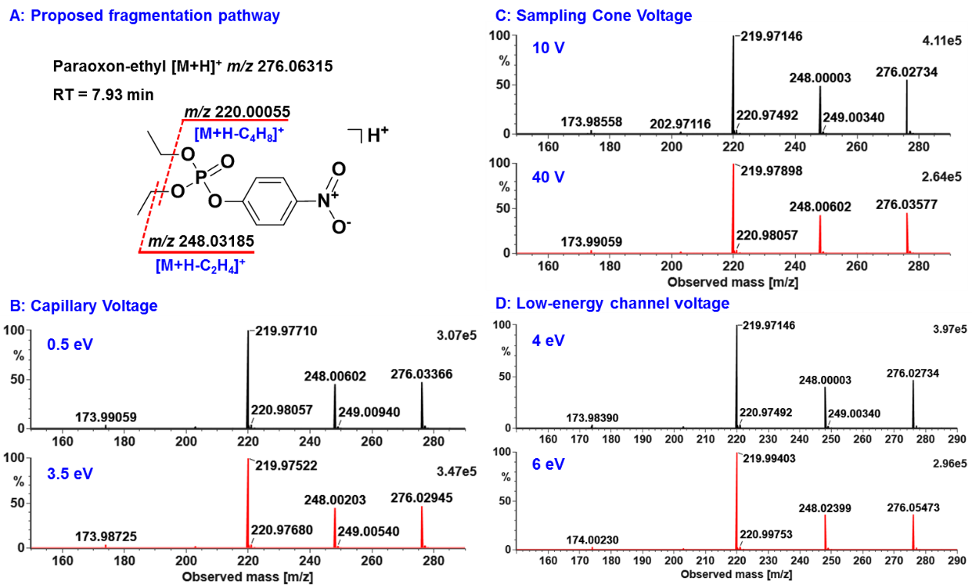

**Figure S1** Labile paraoxon-ethyl as an example for illustrating effects of the reduced capillary voltage, sampling cone voltage and low-energy channel voltage on fragmentations in the full scan.

(A: the proposed fragmentation pathway of paraoxon-ethyl; B: comparison of the low-energy channel spectra with the capillary voltage settings of 0.5 eV and 2.5 eV; C: comparison of the low-energy channel spectra with the sampling cone voltage settings of 10 V and 40 V; D: comparison of the low-energy channel spectra with the low-energy channel voltage settings of 4 eV and 6 eV)

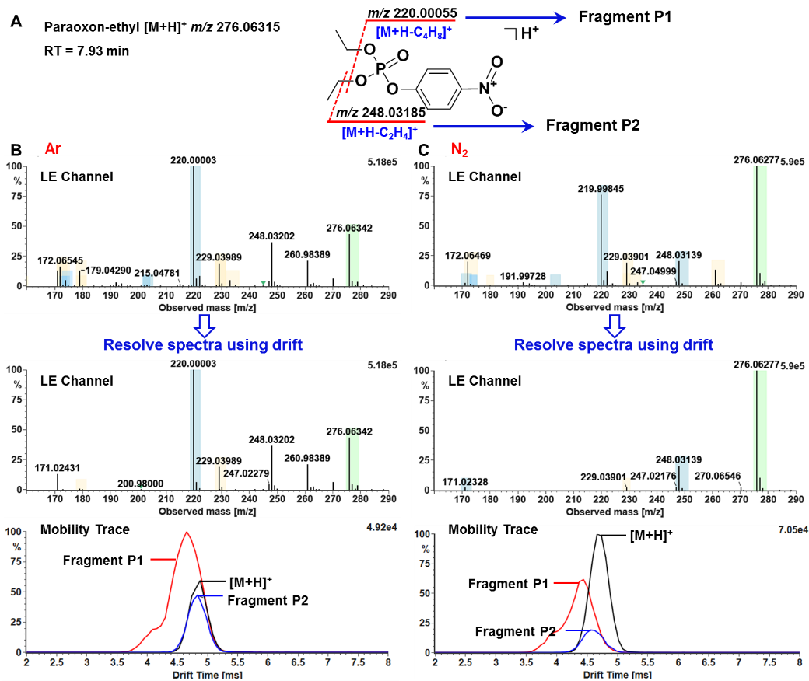

**Figure S2** Labile paraoxon-ethyl as an example for illustrating effects of collision gas on fragmentations in the full scan.

(The proposed fragmentation of paraoxon-ethyl to produce Fragment P1 (*m/z* 220.00055) and Fragment P2 (*m/z* 248.03185) (A); the low-energy (LE) spectra of *m/z* 276.06315 with argon (B) and nitrogen (C) as collision gas, respectively.)

The labile paraoxon-ethyl was easy to fragment into two intense ions of *m/z* 220.00055 (Fragment P1) and 248.03185 (Fragment P2), of which the proposed fragmentation pathway was depicted as Figure S2.A. From the low-energy spectra, there was an obvious decrease on dissociation of the protonated ion at *m/z* 276.06315 with nitrogen as the collision gas instead of argon (Figure S2.B and Figure S2.C). In particular, the abundant Fragment P1 was absent by resolving the spectra using drift when nitrogen was applied. It suggested that the Fragment P1 and Fragment P2 filtered out were not produced in the collision cell and that the post-mobility fragmentations of the protonated ion at *m/z* 276.06315 was obviously reduced with nitrogen compared to argon.

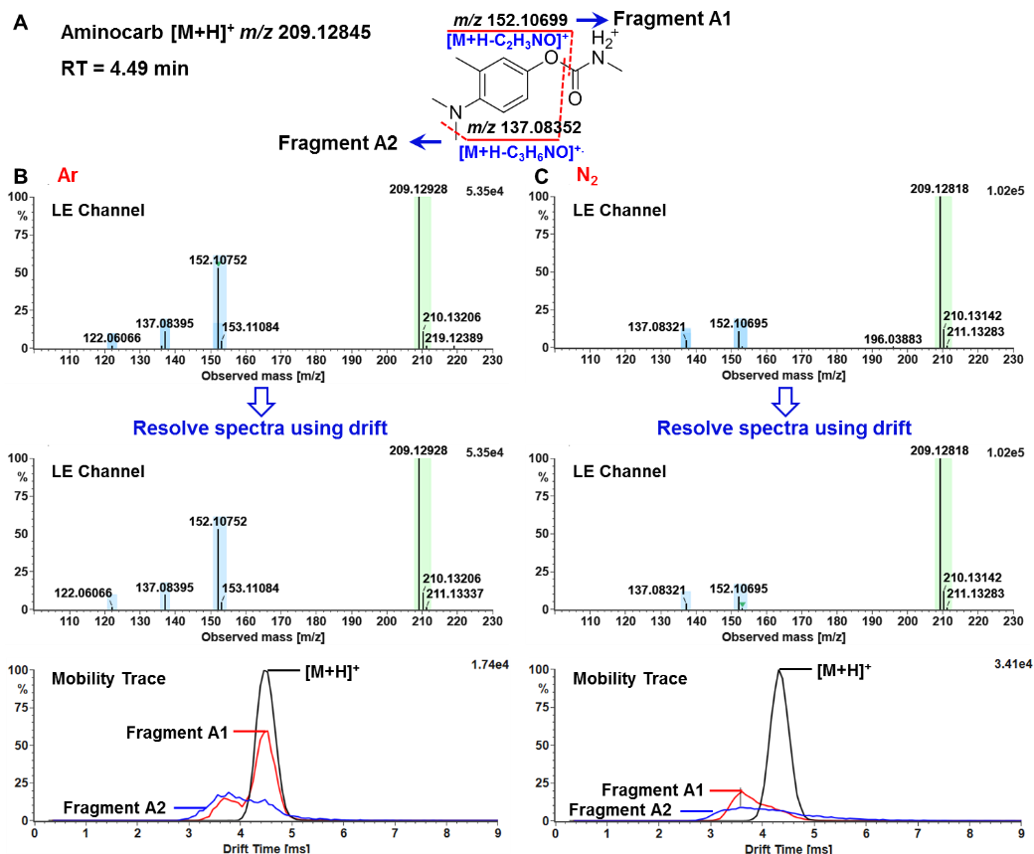

**Figure S3** Labile aminocarb as an example for illustrating effects of collision gas on fragmentations in the full scan.

(The proposed fragmentation of aminocarb to produce Fragment A1 (*m/z* 152.10699) and Fragment A2 (*m/z* 137.08352) (A); the low-energy (LE) spectra of *m/z* 209.12845 and the overlapped mobiligram of the extracted ions of *m/z* 209.12845, 152.10699 and 137.08352 with argon (B) and nitrogen (C) as collision gas, respectively.)

With argon as the collision gas, the protonated ion of aminocarb at *m/z* 209.12845 was visibly dissociated into Fragment A1 (*m/z* 152.10699) and Fragment A2 (*m/z* 137.08352) in the low-energy (LE) spectra. And the possible fragmentation pathway was proposed in Figure S3.A. When argon was replaced with nitrogen, the abundance of Fragment A1 and Fragment A2 in the low-energy (LE) spectra obviously reduced. Comparisons of the drift time-aligned low-energy spectra and the overlapped mobiligram in the two cases evidenced that nitrogen as the collision gas significantly improved unwanted fragmentations occurred in the collision cell.

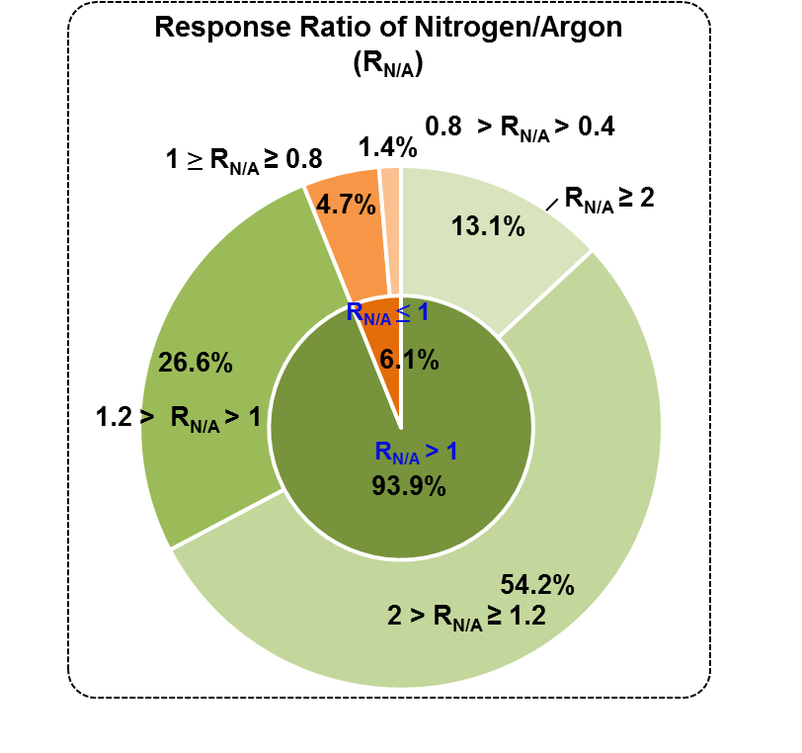

**Figure S4** Response ratio of 443 molecular ions detected with nitrogen as the collision gas to argon (RN/A)

**Figure S5** The response variations of eight representative pesticides from different sub-structure types at different capillary voltage settings (0.5, 1.0, 1.5, 2.0, 2.5, 3.0 and 3.5 kV)

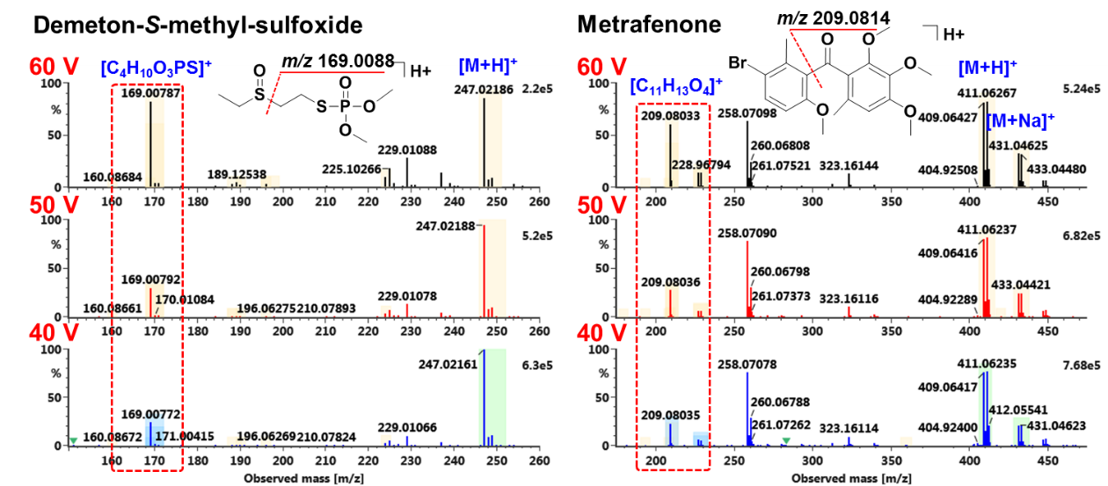

**Figure S6** The low-energy spectra of demeton-*S*-methyl-sulfoxide and metrafenone at different sampling cone voltage settings (40, 50 and 60 V)

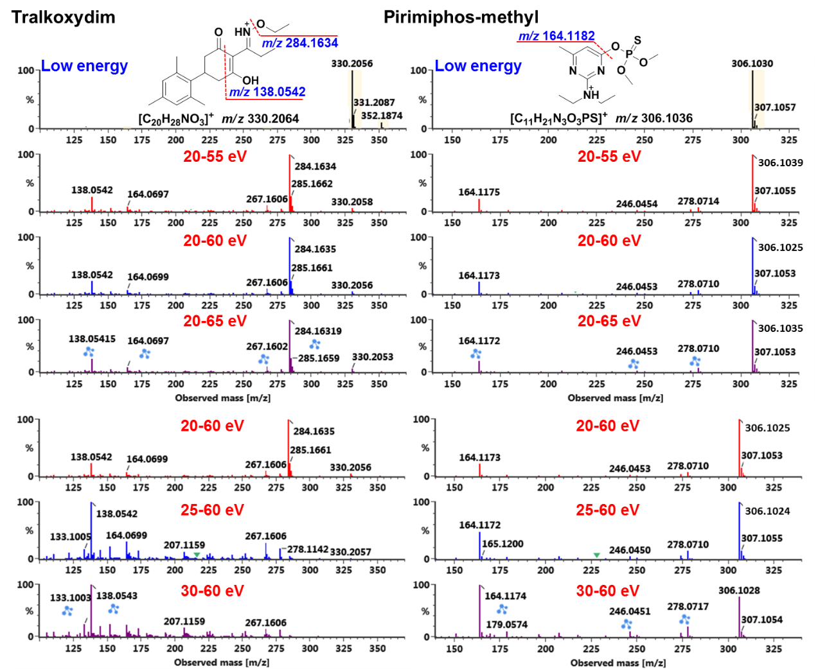

**Figure S7** The high-energy spectra of tralkoxydim and pirimiphos-methyl at different LME (20, 25 and 30 eV) and HME settings (55, 60 and 65 eV)

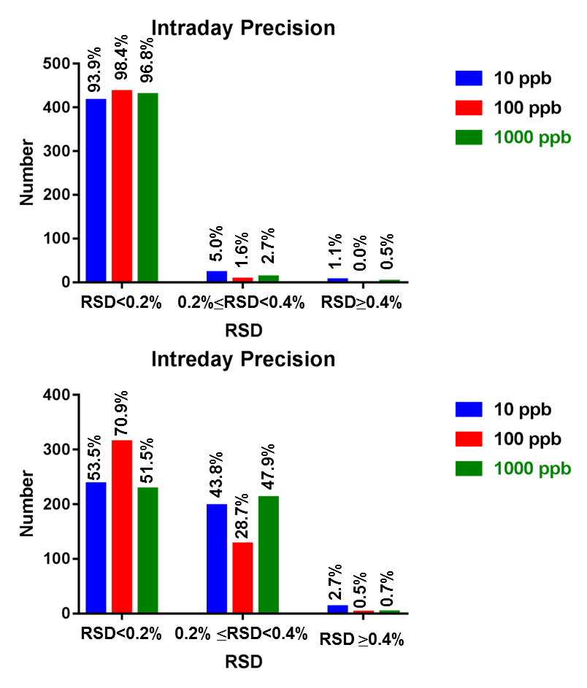

**Figure S8** The intraday precision (n=6) and interday precision (n=15) of CCS measurements

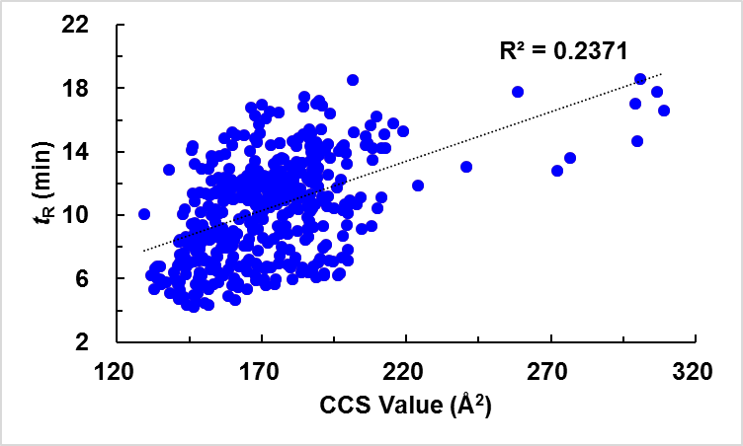

**Figure S9** A two-dimension distribution of CCS values against retention times for 443 pesticide entries (R2: linearity regression correlation coefficient)

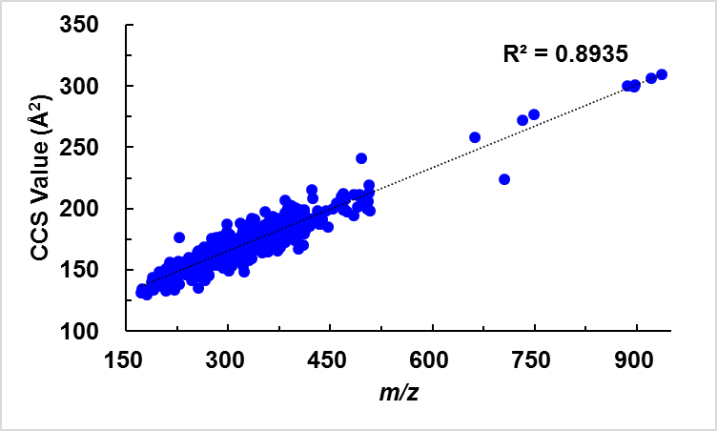

**Figure S10** A two-dimension distribution of CCS values against *m/z* for 443 pesticide entries (R2: linearity regression correlation coefficient)

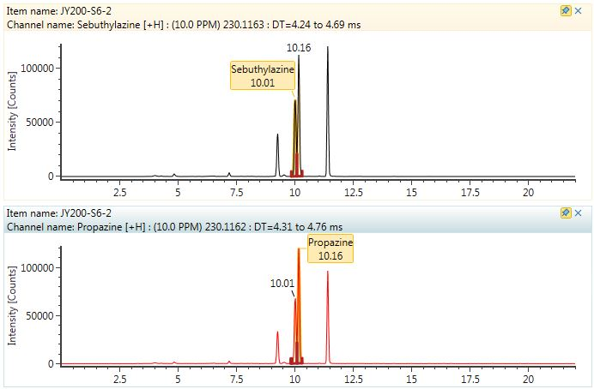

**Figure S11** The extracted ion chromatograms of sebuthylazine and propazine

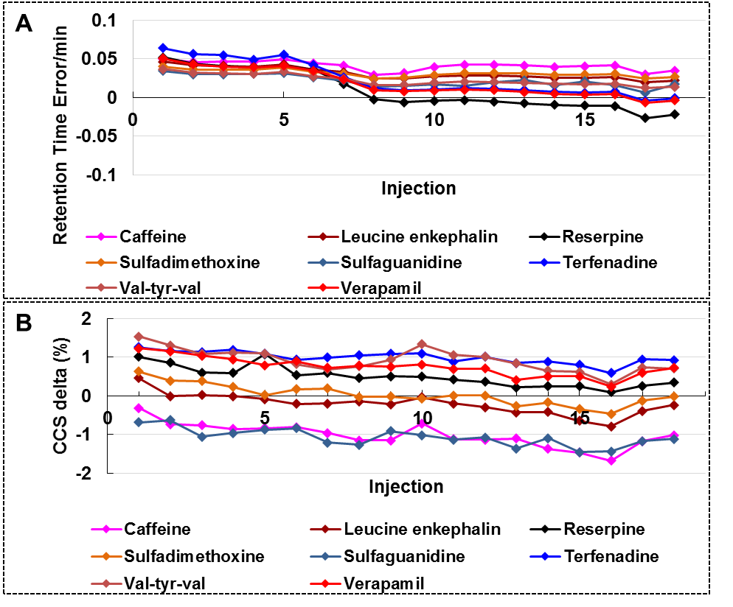

**Figure S12** The retention time derivations (A) and the CCS derivations (B) of the eight compounds from the QC