**SUPPLEMENTARY MATERIALS**

1. **Crystallites Size and Lattice Constant**

The average crystalline size of ZnO, TiO2 and TiO2/ZnO can be estimated using the following equation (**Equation A1**):

$d_{hkl}= \frac{kλ}{β\cos{θ}}$ (A1)

where D is the crystalline size, θ is Bragg’s angle, k is the Scherrer’s constant (k=0.9), λ is wavelength of incident X-ray (λ= 1.5406 Å) and β is full width at half maximum (FWHM) of the integral breadth of the most intense peak.

The *a*-lattice constant of ZnO thin films calculated from XRD peak corresponding to (100) plane using the following equation (**Equation A2-A4)**: [1]

$d_{hkl}= \frac{1}{\sqrt{\frac{4}{3} \left(\frac{h^{2}+ k^{2}+hk }{a^{2}}\right)+ \frac{l^{2}}{c^{2}}}}$ (A2)

$a= \frac{λ}{2\sin{θ_{(100)}}} \sqrt{\frac{4}{3}\left(h^{2}+hl+ k^{2}\right)+{\left(\frac{a}{c}\right)}^{2}l^{2}}$**(**A3)

$a= \frac{λ}{\sqrt{3} sin θ_{(100)}}$ (A4)

The *c*-lattice constants of the ZnO thin films are determined from the XRD peak corresponding to (002) plane, using the following equation (**Equation A5** and **A6**): [1]

$c= \frac{λ}{2\sin{θ_{(002)}}} \sqrt{\frac{4}{3}{\left(\frac{c}{a}\right)}^{2}\left(h^{2}+hl+ k^{2}\right)+l^{2}}$ (A5)

$c= \frac{λ}{ sin θ_{(002)}}$ (A6)

In the case of the TiO2 rutile tetragonal crystal structure (a=b≠c), the lattice constant is calculated from (110) and (101) plane using the following formula: (**Equation A7**)

$\frac{1}{d_{hkl}^{2}}=\frac{h^{2}+k^{2}}{a}+\frac{l^{2}}{c^{2}}$ (A7)

Where *h*, *k*, and *l* are the Miller indices. *dhkl* is the lattice spacing determined from Bragg's equation.

1. **Photocatalytic Activity (Photostability)**

A comparison of the XRD patterns of the initial and 5 times reused TiO2 and ZnO thin films is shown in **Fig. B1.** **Fig. B1a** indicates that there were no additional phases, and this result is almost similar to the initial TiO2 thin film. However, in ZnO thin films show there are decreasing peak intensity after 5 times used (**Fig. B1b**). This finding demonstrates that TiO2 films are photochemically stable even after being reused 5 times, since the crystalline structure of the films remains the same despite subsequent degradations, with the intensity of the peak only slightly increasing.

**Fig. B1** XRD patterns of initial and recycled thin film (after 5 times used) (a) TiO2 thin films (b) ZnO thin films.

1. **Antimicrobial activity**

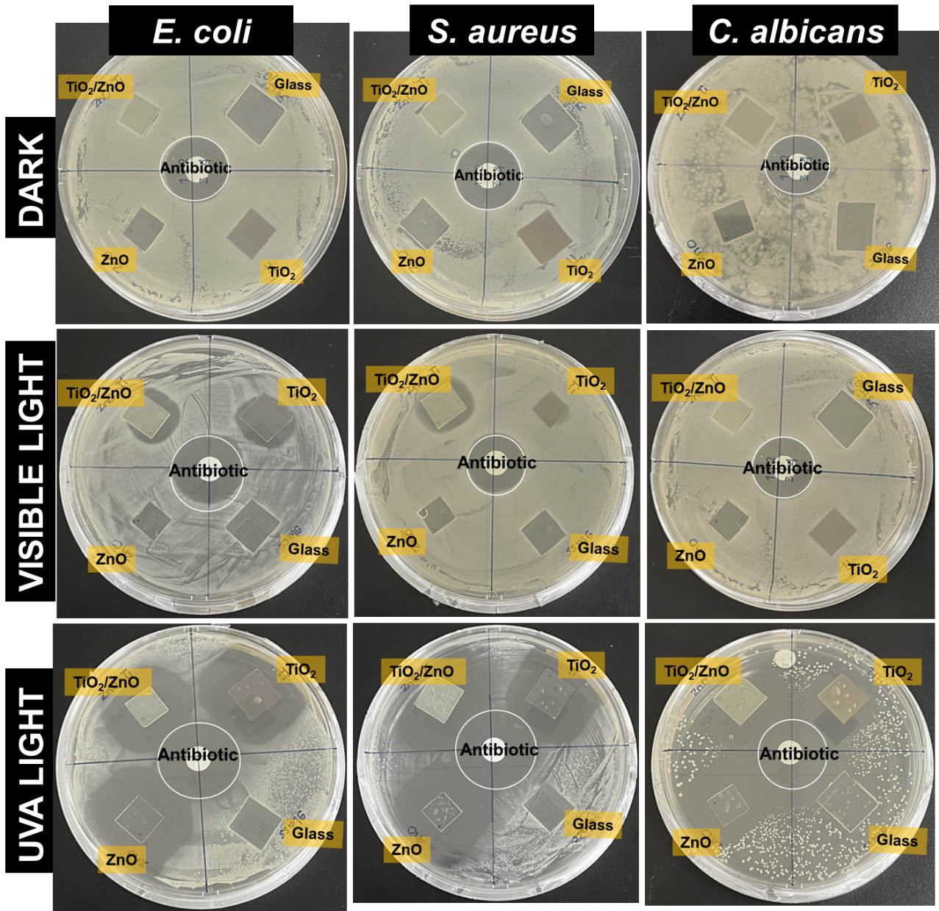

**Fig. C1** Antimicrobial activity of various samples against three different types of microbes. The zone of inhibition for various microbe strains treated with ZnO, TiO2, TiO2/ZnO, substrate (negative control) and antibiotic (positive control) under 30 min UV-irradiation, visible light, and dark conditions.

**Table C1** Zone inhibition for tested thin films under 30 min light exposures

|  |  |  |  |  |
| --- | --- | --- | --- | --- |
| **Light Source** | **Samples** | **Inhibition Zone (mm)** | | |
| ***E. coli*** | ***S. aureus*** | ***C. albicans*** |
| Visible Light | Antibiotic | 27.3 | 23.04 | 25.1 |
| ZnO | - | - | - |
| TiO2 | 19.7 | 12.4 | - |
| TiO2/ZnO | 22.7 | 19.6 | - |
| UVA light | Antibiotic | 30.3 | 34.4 | 35.1 |
| ZnO | 36.7 | 37.1 | 27.3 |
| TiO2 | 34.4 | 32.7 | 17.3 |
| TiO2/ZnO | 33.9 | 39.1 | 26.7 |

**Table C2** Comparison zone inhibition of TiO2/ZnO with previous reports

|  |  |  |  |  |  |  |
| --- | --- | --- | --- | --- | --- | --- |
| **Type** | **Fabrication** | **Irradiation time (min)** | **Microbial Inhibition zone (mm)** | | | **Ref.** |
| ***E. coli*** | ***S. aureus*** | ***C. albicans*** |
| Nanocomposite | Sol-gel | - | 25 | 27 | - | [2] |
| Nanoparticle  (1000 ug/uL) | Sol-gel | 180 min sunlight | - | 21.38 | - | [3] |
| Nanocomposite | Alkali precipitation | - | 18 | 19.0 | - | [4] |
| Powder | Hydrothermal |  | 15.33 | 17.67 | - | [5] |
| Nanocomposites | Sol-gel | - | 19.7 | - | - | [6] |
| Thin Film (298 nm) |  | 30 | 33.9 | 39.1 | 26.7 | This work |

**References**

[1] H. Ennaceri, M. Boujnah, D. Erfurt, J. Rappich, X. Lifei, A. Khaldoun, A. Benyoussef, A. Ennaoui, A. Taleb, Influence of stress on the photocatalytic properties of sprayed ZnO thin films, Sol. Energy Mater. Sol. Cells. 201 (2019) 110058. https://doi.org/10.1016/j.solmat.2019.110058.

[2] K. Vignesh, K.A. Vijayalakshmi, N. Karthikeyan, Sol-gel synthesis and antibacterial study on BC/ZnO/TiO2 nanocomposite treated by DC glow discharge plasma, J. Adhes. Sci. Technol. 31 (2017) 1075–1086. https://doi.org/10.1080/01694243.2016.1244036.

[3] N.H. Harun, R.B.S.M.N. Mydin, S. Sreekantan, K.A. Saharudin, Y.L. Khor, N. Basiron, A. Seeni, Antibacterial activity of heterogeneous TiO2 and ZnO nanoparticles against Gram-positive and Gram-negative bacterial pathogens, J. Biomed. Clin. Sci. 3 (2018) 75–78.

[4] C. Manoharan, V. Rajendran, R. Sivaraj, Synthesis, characterization and applications of ZnO/TiO2/SiO2 nanocomposite, Orient. J. Chem. 34 (2018) 1333.

[5] K. Siwińska-Stefańska, A. Kubiak, A. Piasecki, A. Dobrowolska, K. Czaczyk, M. Motylenko, D. Rafaja, H. Ehrlich, T. Jesionowski, Hydrothermal synthesis of multifunctional TiO2-ZnO oxide systems with desired antibacterial and photocatalytic properties, Appl. Surf. Sci. 463 (2019) 791–801. https://doi.org/10.1016/j.apsusc.2018.08.256.

[6] M.M. Ali, M.J. Haque, M.H. Kabir, M.A. Kaiyum, M.S. Rahman, Nano synthesis of ZnO–TiO2 composites by sol-gel method and evaluation of their antibacterial, optical and photocatalytic activities, Results Mater. 11 (2021) 100199. https://doi.org/10.1016/j.rinma.2021.100199.