Supplementary Information

Synthesis and biological evaluation of a peptide-remifentanil conjugate as a novel bifunctional mu/delta-opioid receptor agonist for the treatment of pain
Lu Wang^{a, b}, Jing Li^{b}, Fengxia Ren^{b}, Hongxin Jia^{b}, Zixing Yu^{b}, Jingchao Cheng^{b}, Tao Zhang^{b*}, Weiguo Shi^{b∗} and Xuesong Feng ^{a*}
ª School of Pharmacy, China Medical University, 77 Pu-He Road, Shenyang110122, China
^{b} State Key Laboratory of Toxicology and Medical Countermeasures, Beijing Institute of Pharmacology & Toxicology, 27 Tai-Ping Road, Beijing 100850, China

∗ Corresponding authors.
- mail address: voncedar@126.com (X. Feng); shiwg1988@126.com (W. Shi); believe890521@163.com (T. Zhang)

Abbreviations used
MOR, μ opioid receptor; DOR, δ opioid receptor; DAMGO, [D-Ala², N-MePhe⁴, Gly-ol⁵]-enkephalin; DPDPE, [D-Pen², D-Pen⁵]Enkephalin; DADLE ([D-Ala², D-Leu⁵]-enkephalin); Boc, tert-butyldicarbonate; Cbz, carbobenzoxy; DIPEA, N,N-diisopropylethylamine; HATU, 1-[bis(dimethylamino)methylene]-1H-1,2,3-triazolo[4,5-b]-pyridinium 3-oxid hexafluorophosphate; DMSO, dimethyl sulfoxide; THF, tetrahydrofuran; TFA, trifluoroacetic acid; DMF, N,N-Dimethylformamide; HEPES, 2-(4-(2-hydroxyethyl)piperazin-1-yl)ethane-1-sulfonic acid; Tris, Tris(hydroxymethyl)aminomethane; HPLC, High Performance Liquid Chromatography; MS, Mass Spectrometry; i.v., intravenous injection; i.p., intraperitoneal injection.

Scheme S1. Synthesis of BVD03. Reagents and conditions: (a) Gly-OEt·Cl, HATU, and DIPEA in CH₂Cl₂ at rt for 4 h; (b) HCl in acetone at 90℃ (reflux) for 20 h; (c) (CH₂O)_{n} and p-TsOH in Toluene at 125℃ (reflux) for 4h; (d) TiCl₄ in CH₂Cl₂ at rt for overnight; (e) N₂H₄·H₂O in ethanol at 90℃ (reflux) for 1.5h; (f) SOCl₂ in MeOH at 0℃ for 15 min then rt for 6 h; (g) HCl·N-Me-Ala-OMe, HATU and DIPEA in CH₂Cl₂ at rt for 4 h; (h) NaOH in MeOH at 0℃ for 1 h then rt for 4 h; (i) compound 7, HATU and DIPEA in CH₂Cl₂ at rt for 4 h; (j) NH₃·H₂O and NH₄OAc in MeOH at rt for overnight (k) 1:1 TFA : CH₂Cl₂ at rt for 2 h.

Table S1. The maximum possible effect (%MPE) of test compounds in different models.
compound | dose (mg/kg) | %MPEª | %MPE^{b} | %MPE^{c}
SW-WL-2 | 2 | 92.04% | 100% | 79.31%
BVD03 | 2 | 95.31% | 100% | 97.34%
Morphine | 2 | 80.07% | 100% | 41.51%
ª phase Ⅱ in formalin paw-licking test; ^{b} in the acetic acid-induced writhing test; ^{c} the 30 min point in hot-water tail withdrawal test.

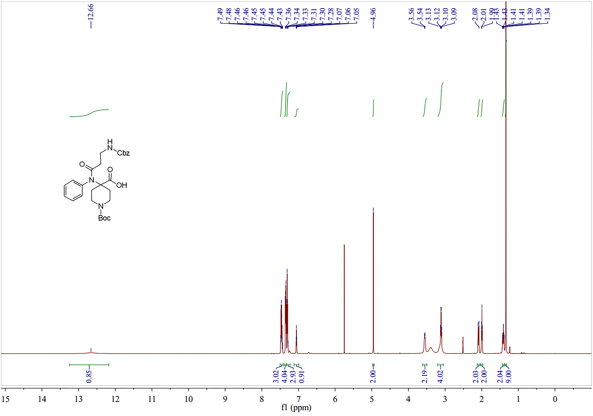
Fig.S1A. ¹H NMR spectra of compound 2a in DMSO-d6.

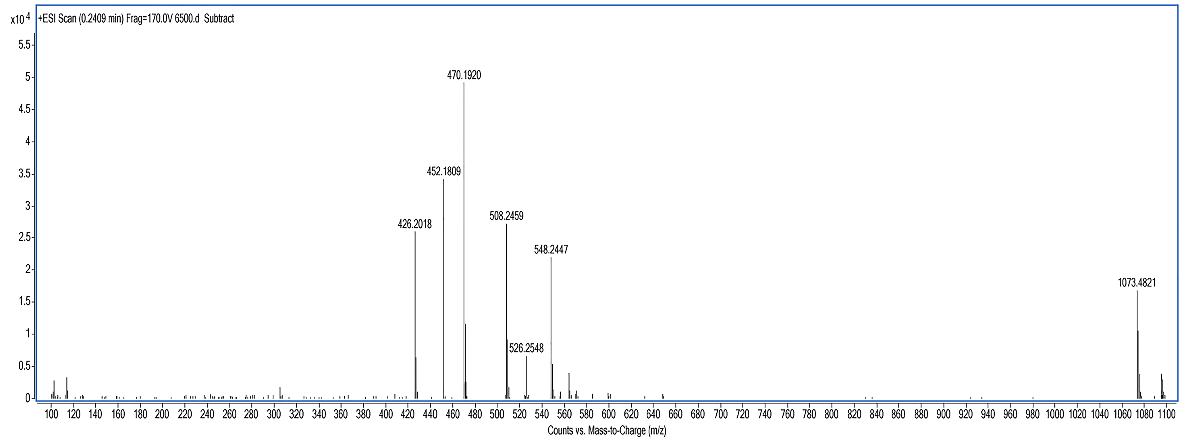
Fig.S1B. HR-ESI-MS of compound 2a.

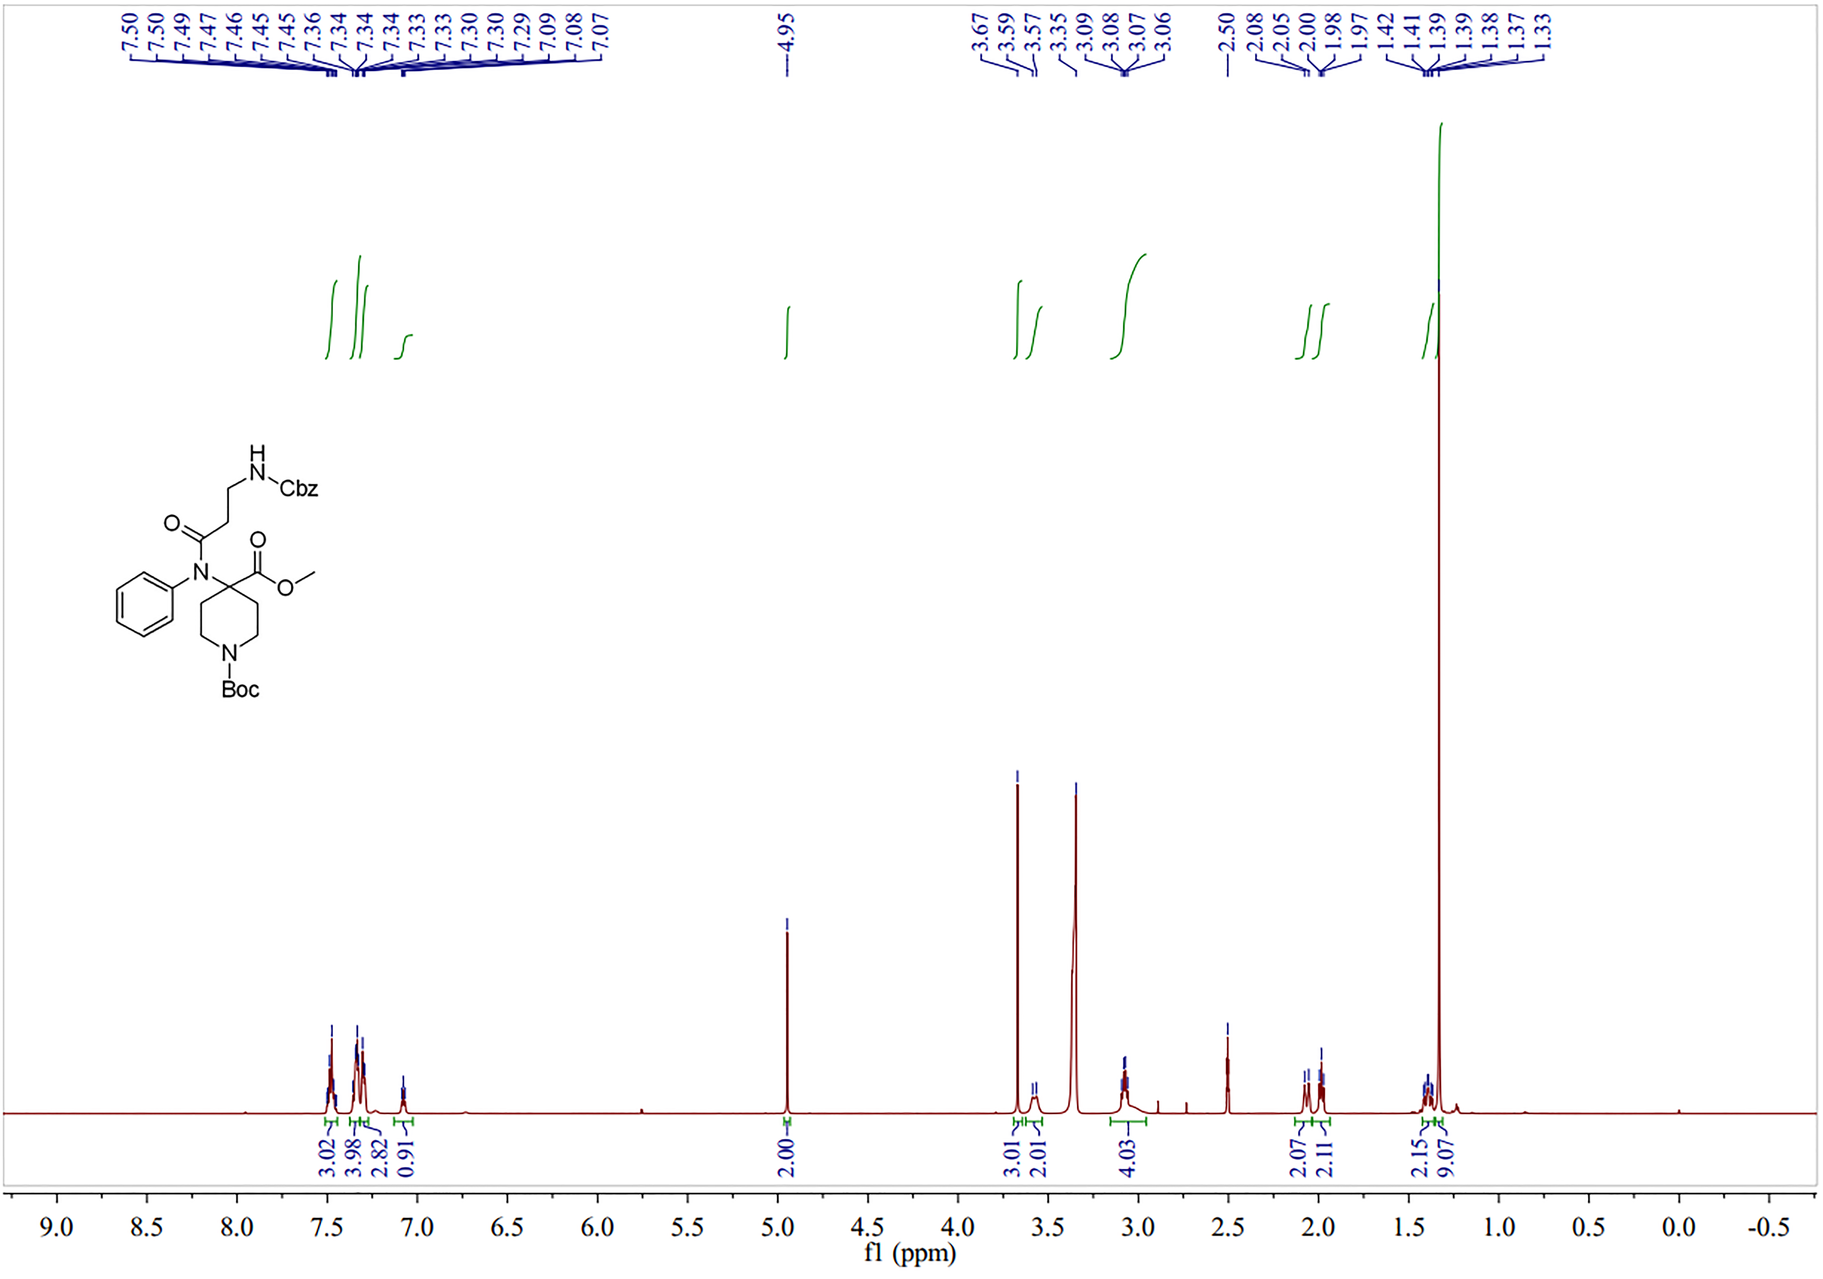
Fig.S2A. ¹H NMR spectra of compound 2b in DMSO-d6.

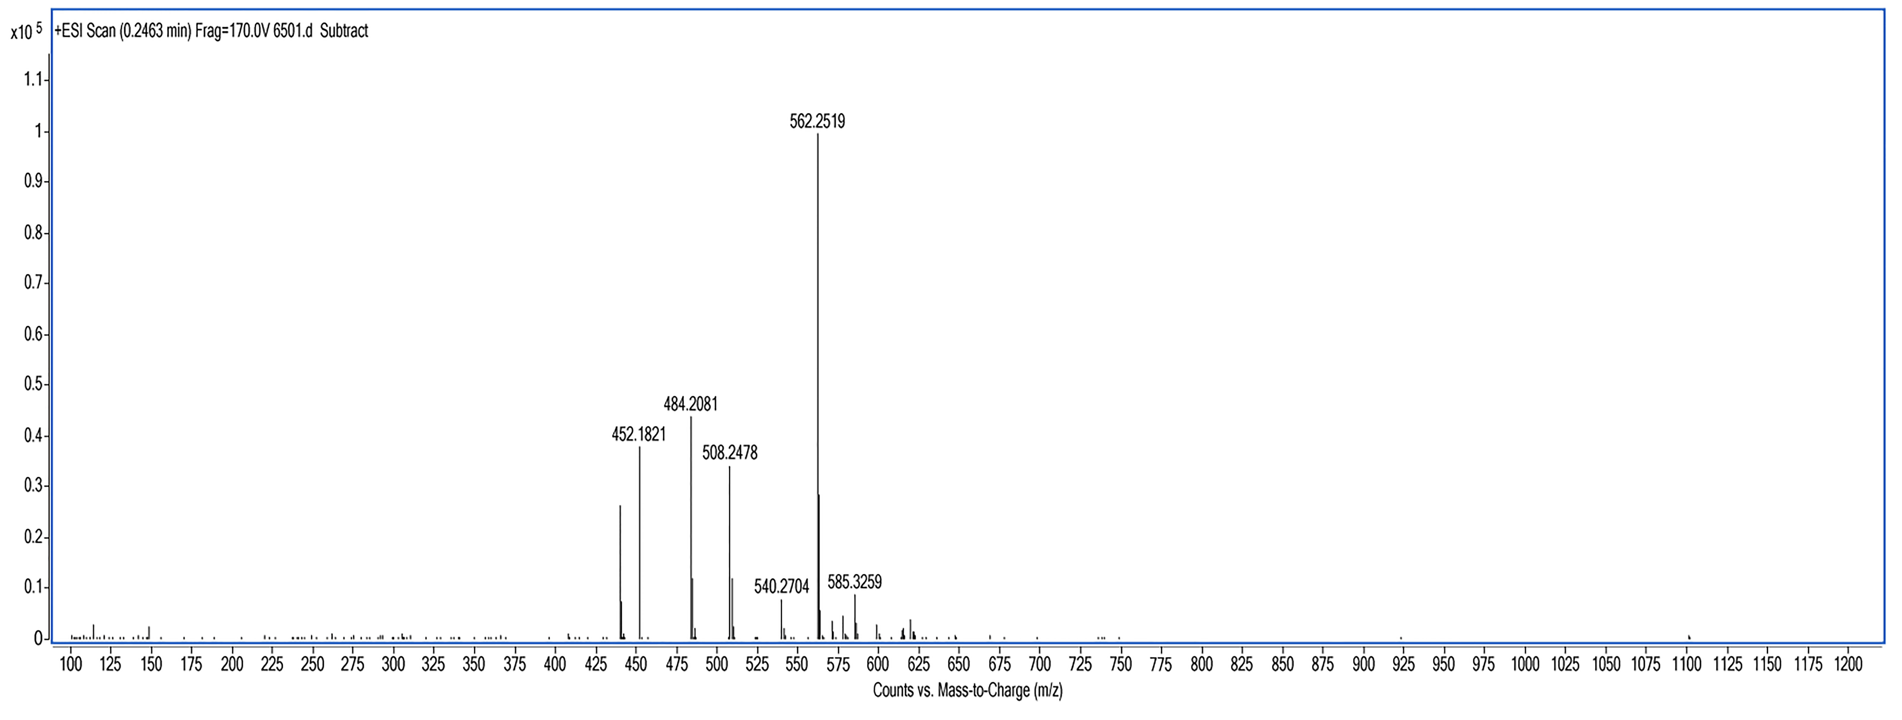
Fig.S2B. HR-ESI-MS of compound 2b.

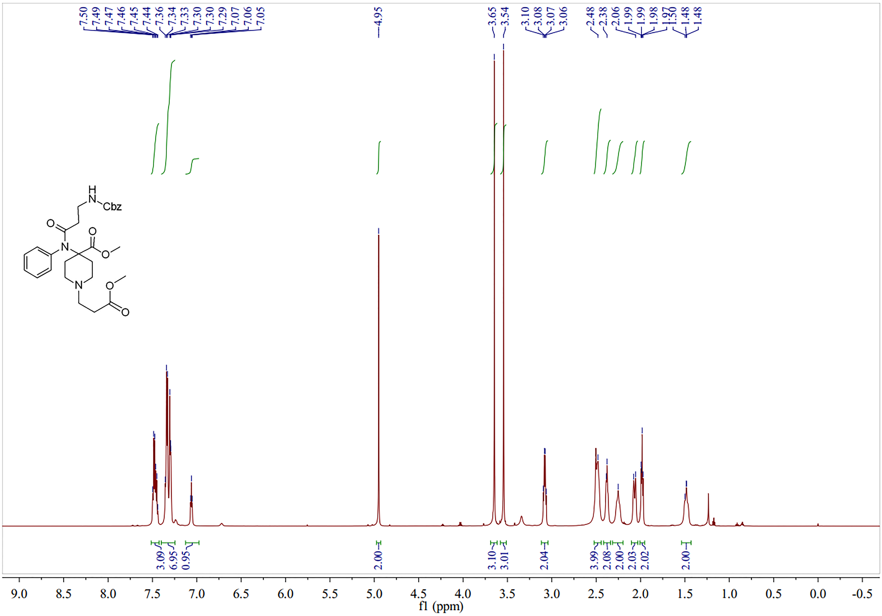
Fig.S3A. ¹H NMR spectra of compound 2c in DMSO-d6.

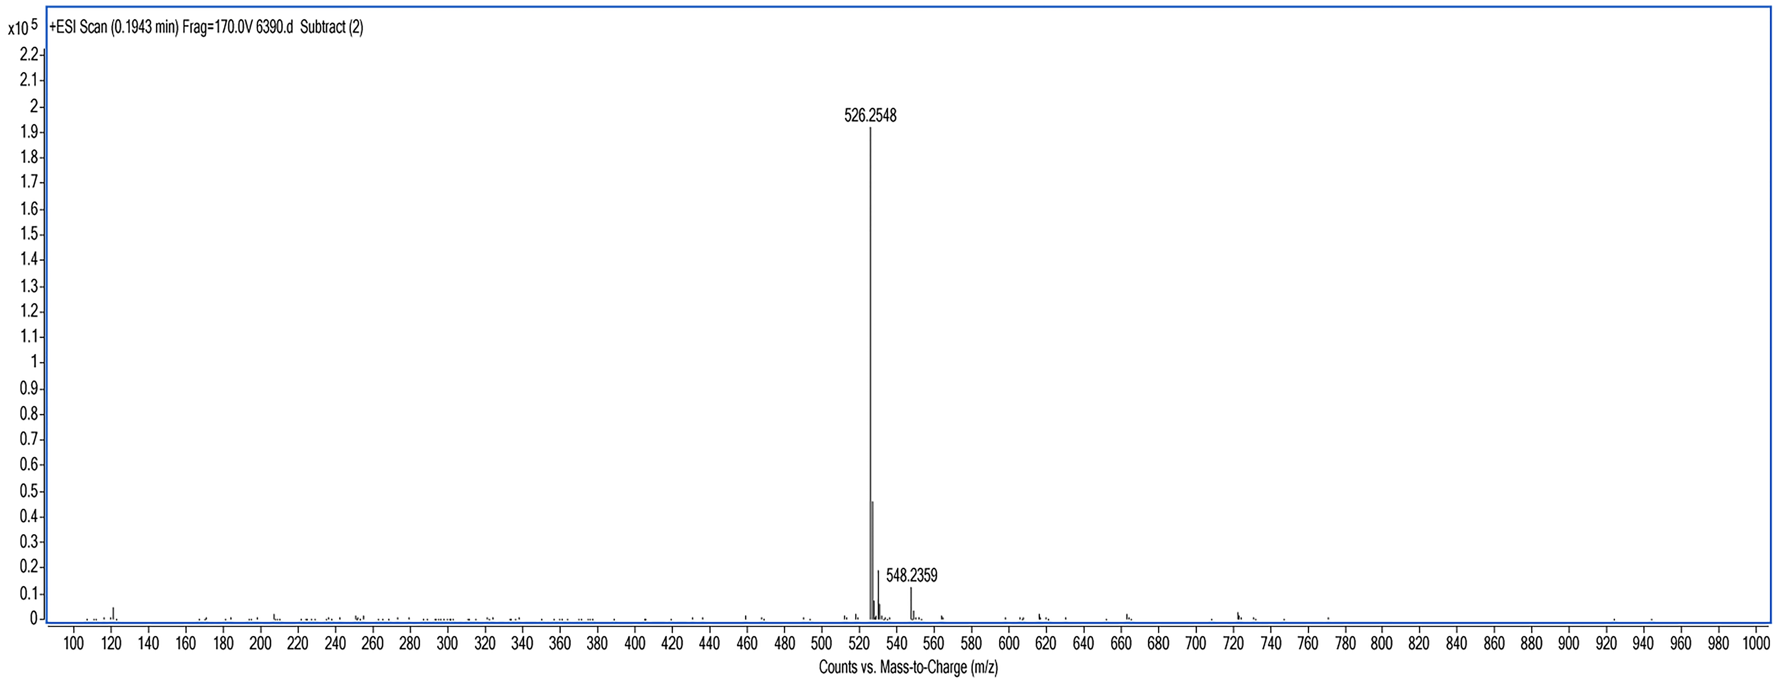
Fig.S3B. HR-ESI-MS of compound 2c.

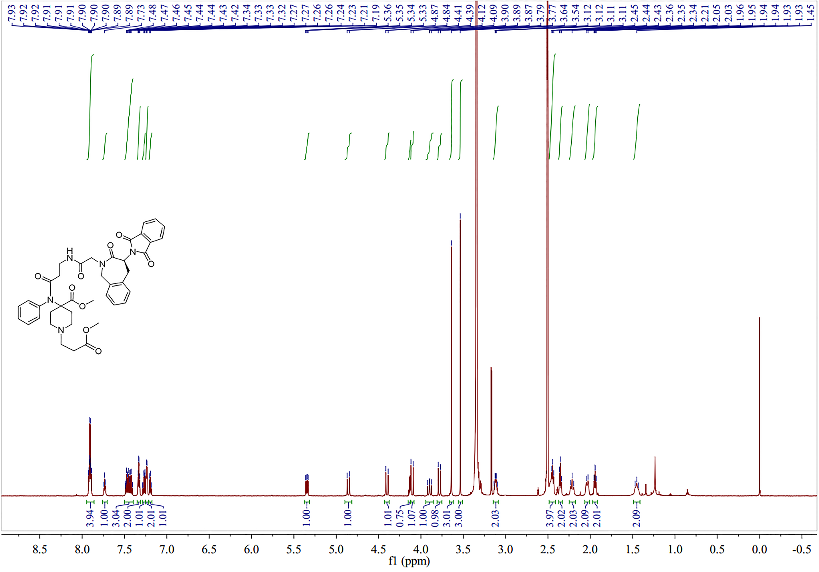
Fig.S4A. ¹H NMR spectra of compound 2d in DMSO-d6.

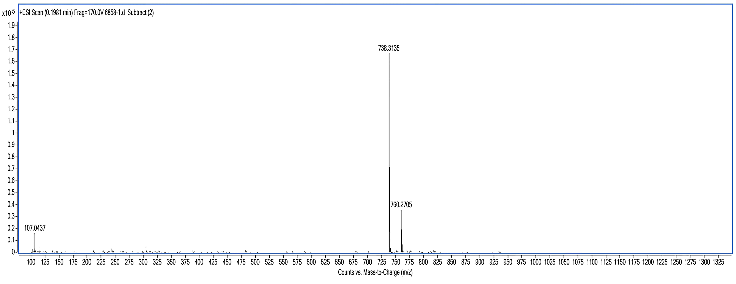
Fig.S4B. HR-ESI-MS of compound 2d.

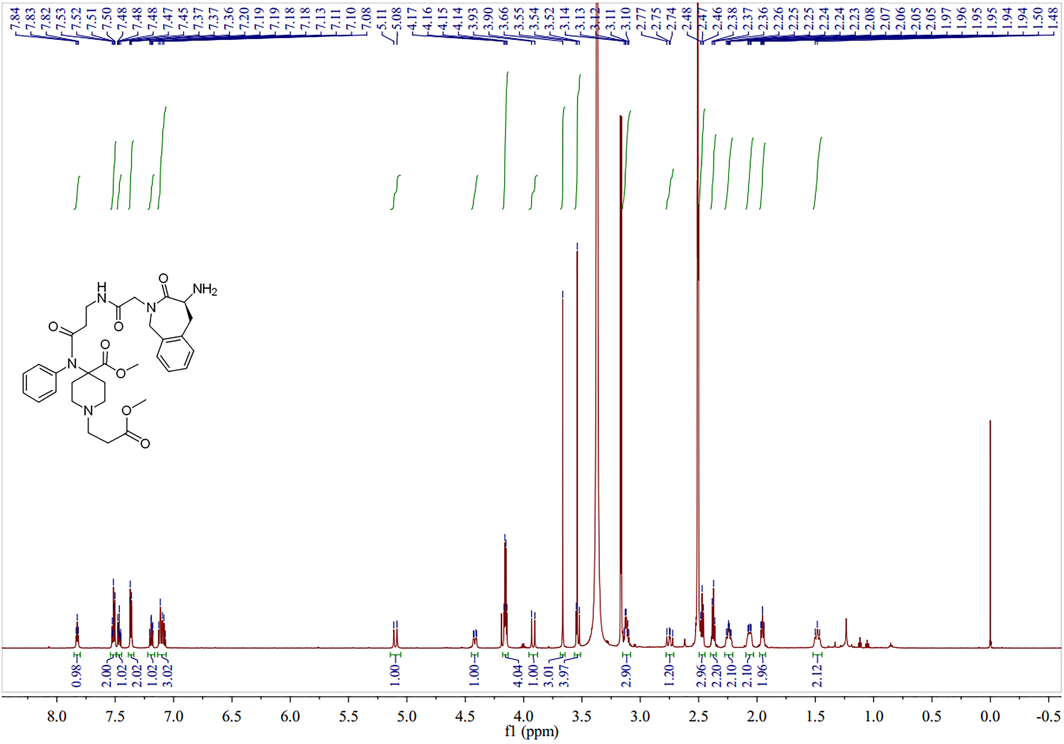
Fig.S5A. ¹H NMR spectra of compound 2e in DMSO-d6.

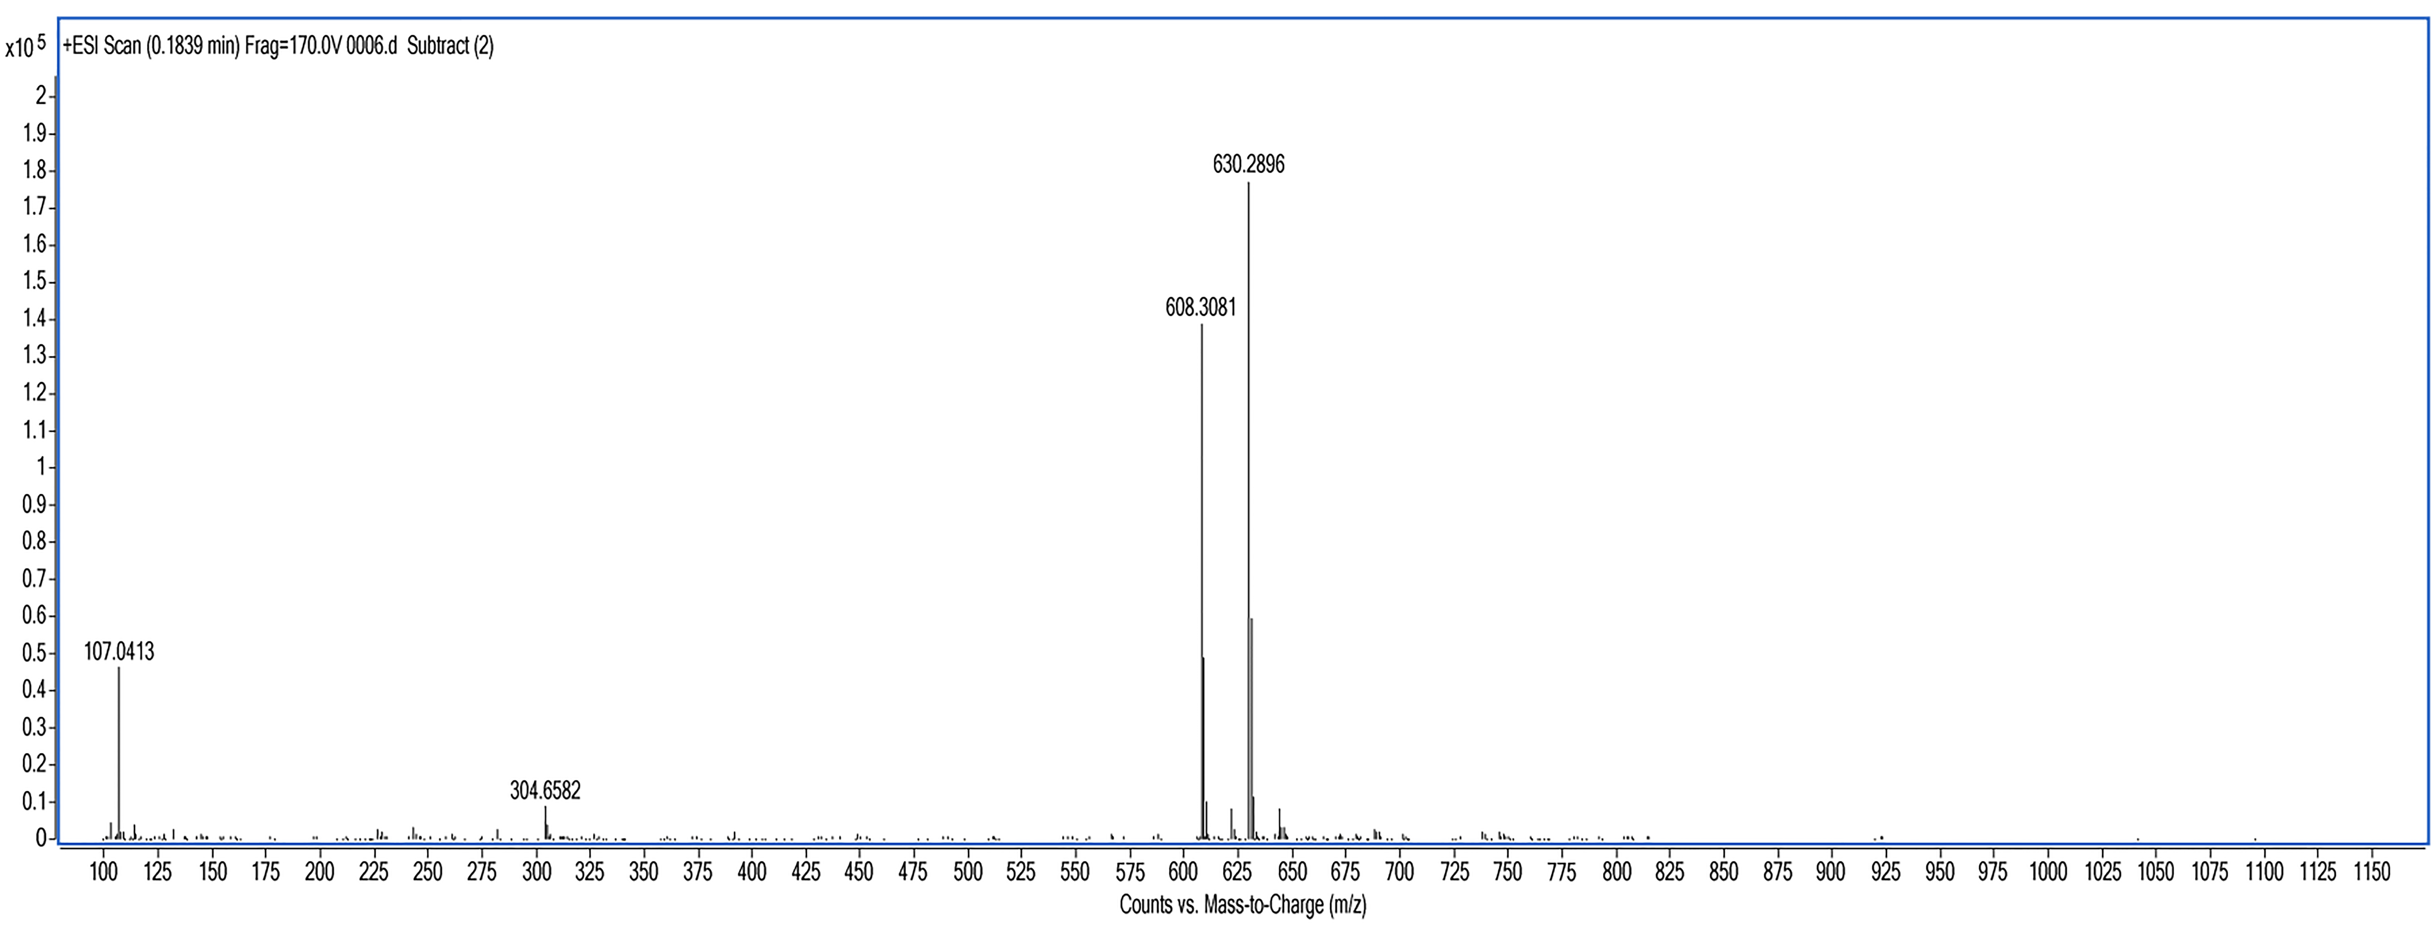
Fig.S5B. HR-ESI-MS of compound 2e.

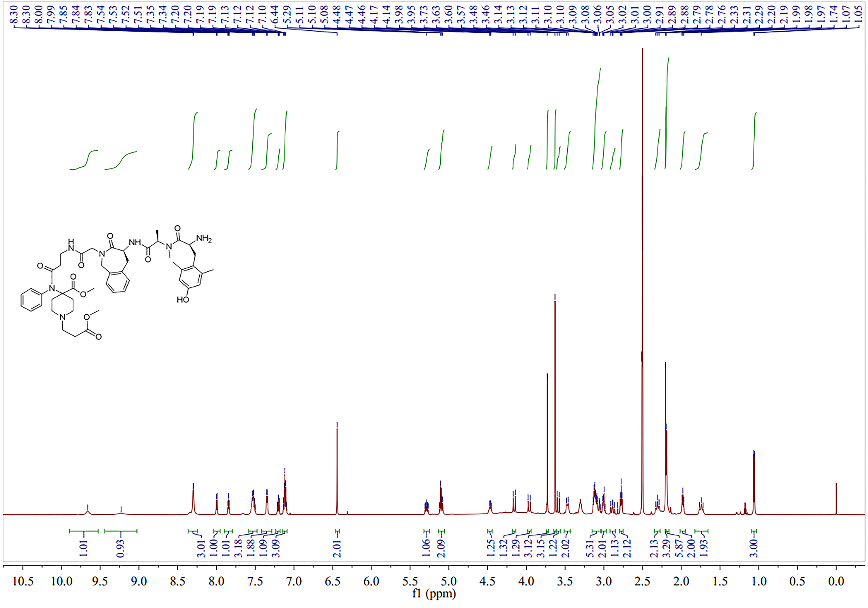
Fig.S6A. ¹H NMR spectra of compound SW-WL-2 in DMSO-d6.

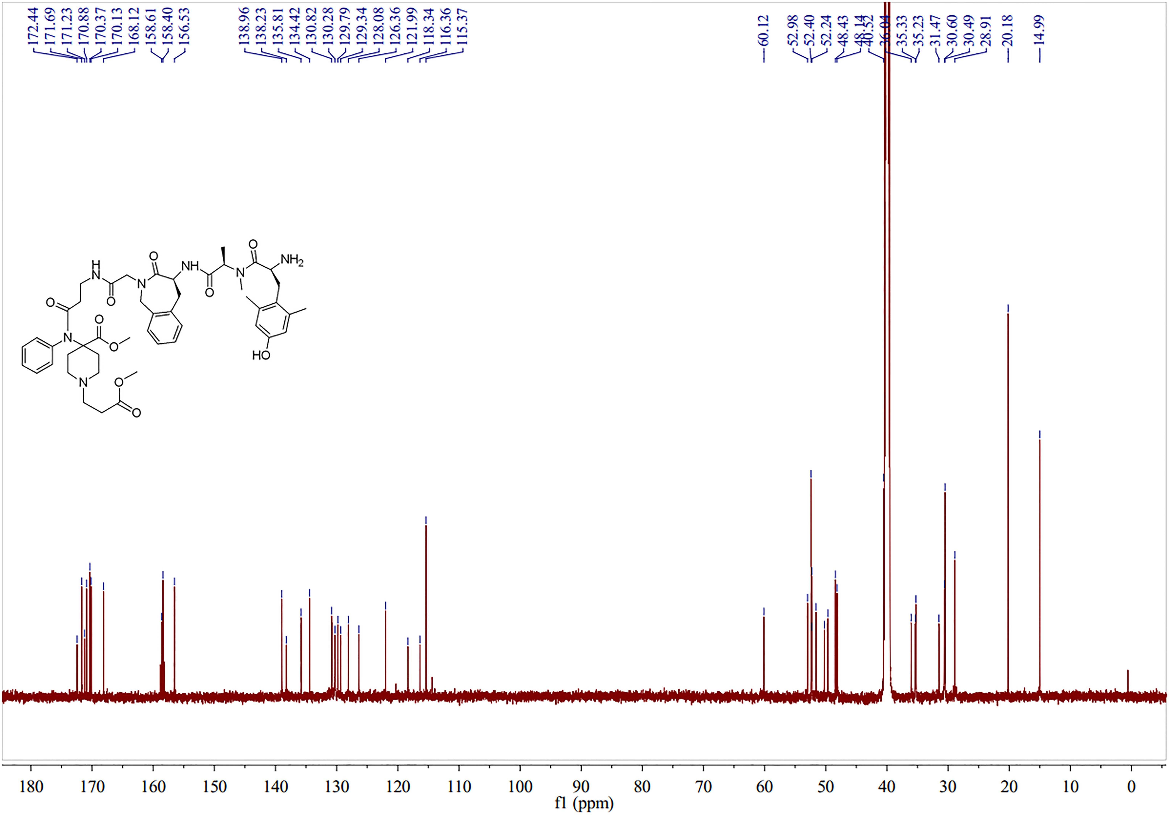
Fig.S6B. ¹³C NMR spectra of compound SW-WL-2 in DMSO-d6.

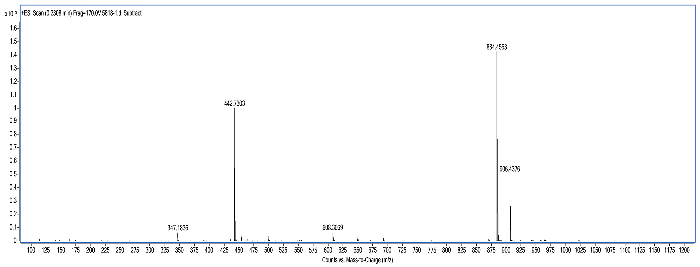
Fig.S6C. HR-ESI-MS of compound SW-WL-2.

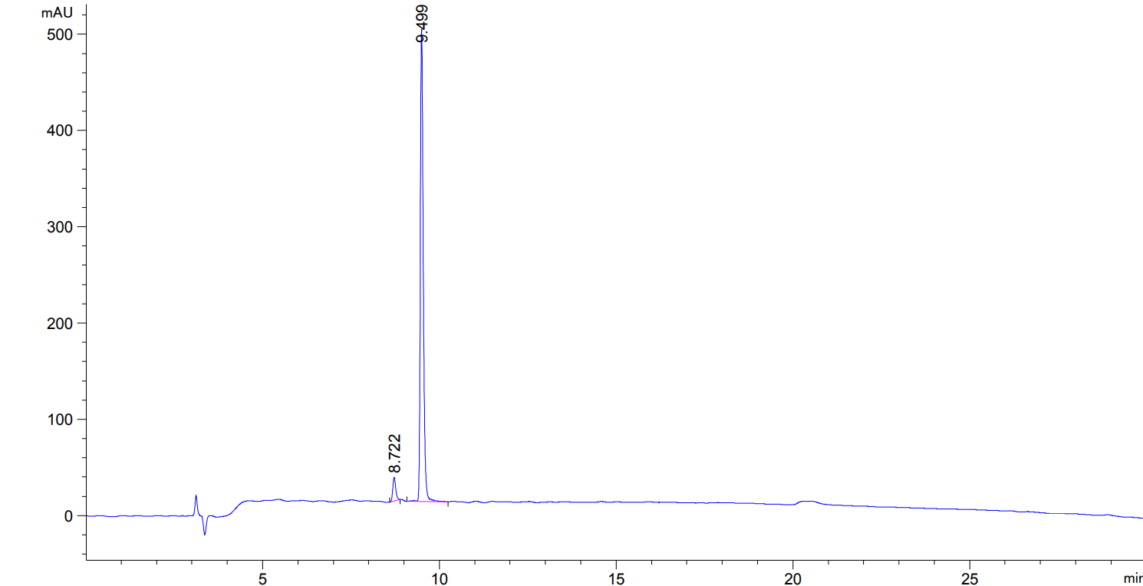
Fig.S6D. HPLC spectrum of SW-WL-2.

