**Supplementary Information**

**Optimization of lead (II) removal from water and wastewater using a novel magnetic nanocomposite of aminopropyl triethoxysilane coated with carboxymethyl cellulose cross-linked with chitosan nanoparticles**

Ahmad Abo Markeba,b, [Javier Moral-Vico](https://www.sciencedirect.com/science/article/abs/pii/S0043135419304038" \l "!)[a](https://www.sciencedirect.com/science/article/abs/pii/S0043135419304038" \l "!), [Antoni Sáncheza](https://www.sciencedirect.com/science/article/abs/pii/S0043135419304038#!), [Xavier Fonta](https://www.sciencedirect.com/science/article/abs/pii/S0043135419304038#!)

a *Department of Chemical, Biological and Environmental Engineering, Escola d’Enginyeria, Universitat Autònoma de Barcelona, 08193, Bellaterra, Spain*

b *Chemistry Department, Faculty of Science, Assiut University, 71516, Assiut, Egypt*

**S1. Materials and methods**

*S1.1. Materials*

Iron (II) chloride (FeCl2), iron (III) chloride hexahydrate (FeCl3·6H2O), sodium hydroxide (NaOH), ammonium hydroxide (NH4OH), dithizone, chloroform (CHCl3), potassium cyanide (KCN), hydroxylamine hydrochloride (NH2Cl·H2O), sodium sulfite (Na2SO3), chloroform (CHCl3), lead nitrate (Pb(NO3)2), cadmium nitrate (Cd(NO3)2), mercury sulfate (HgSO4), ammonium citrate, chitosan (Low Molecular weight), carboxymethylcellulose, 3-(aminopropyl)triethoxysilane (APTES), and sulfuric acid were purchased from Sigma-Aldrich, Germany. Sodium hydroxide pellets (NaOH), hydrochloric acid (HCl), and nitric acid (HNO3) were purchased from Alfa Aesar, Germany. All the chemicals were of analytical grade or higher, and all solutions were prepared with Milli-Q water and filtered using 0.45 µm Nylon membrane filter. Heavy metals stock solutions (1000 mg/L) were prepared by dissolving the appropriate amount in Milli-Q water containing 1 % HNO3.

*S1.2. Characterization of the nanocomposites*

The morphology, crystallinity, and the size of the Fe3O4@CS@CMC-SiNH2NC were investigated using High-Resolution Transmission Electron Microscopy (HR-TEM)*,* and Electron Diffraction (ED) Pattern, (JEOL JEM-2100, Japan) at Mansoura University, Egypt. The HR-TEM samples were prepared by their dispersion in ethanol and then deposited on a Cu grid. The phases of the synthesized nanocomposite were determined from the analysis of the X-ray diffraction (XRD), Philips PW 1700 diffractometer, using Cu Kα radiation and a step scan of 0.06o. In addition, the surface of the Fe3O4@CS@CMC-SiNH2NCs before and after lead ion adsorption was confirmed using Scanning Electron Microscope (SEM) with an Energy Dispersive Spectroscopy (EDS), Merlin FE-SEM Zeiss, Germany at Servei de Microscopia, Universitat Autònoma de Barcelona, Spain. The EDS measurements were acquired with an Oxford LINCA X-MAX detector. The functional groups of Fe3O4@CS@CMC-SiNH2NCs were determined using Fourier-transform Infrared Red (FTIR) spectroscopy, Nicolet Nexus 470 FTIR instrument, USA, with standard KBr method (Kesika, Prasanth et al. 2015) at Faculty of Science, Assiut University, Egypt. The Zeta potential was determined using Zeta sizer, Malvern, at Egyptian Petroleum Research Institute, Cairo, Egypt.

*S1.3. Adsorption experiments*

The removal efficiency (R, %), and the adsorption capacity (Q, mg/g) were calculated using the following equations:

$$R \left(\%\right)=\frac{( C_{o}- C_{e})x 100}{C_{o}}$$

$$Q \left({mg}/g\right)= \frac{( C_{o}- C_{e})x V_{L}}{m_{g}}$$

Where Co, Ce are the concentration of lead ion (Pb2+) before and after adsorption, respectively. VL, and mg are the volume of solution containing adsorbate in liters, and the weight of the adsorbent in grams.

*S1.4. Optimization of the lead removal using RSM*

|  |  |  |  |  |
| --- | --- | --- | --- | --- |
| **Table S1**. Design variables, and their coded and actual values for experimental Box-Behnken Design | | | | |
| Variables | Factor | Levels | | |
| -1 | 0 | +1 |
| pH | A | 2 | 6 | 10 |
| Dose (g/L) | B | 0.1 | 0.8 | 1.5 |
| Temperature (℃) | C | 20 | 35 | 50 |

*S1.5. Tap water and wastewater analysis*

Total nitrogen, total organic carbon, and inorganic anions such chloride, nitrate, sulfate, and nitrite are determined in tap water and wastewater using the appropriate analytical technique. For instance; chloride, nitrate, sulfate, and nitrite are determined using Ion Chromatography (Dionex Integrion HPIC, ThermoScientific) coupled to autosampler (Dionex AS-AP), and the samples after magnetic decantation were subjected to filtration using 0.45 µm Nylon membrane filter. Total nitrogen, and total organic carbon were determined using Multi nitrogen/ carbon analyzer (2100S, AnalytikJena), and the samples were direct analyzed after magnetic decantation to separate the adsorbents and water samples.

**S2. Results and discussion**

*S2.1. Characterization of the synthesized nanocomposites*

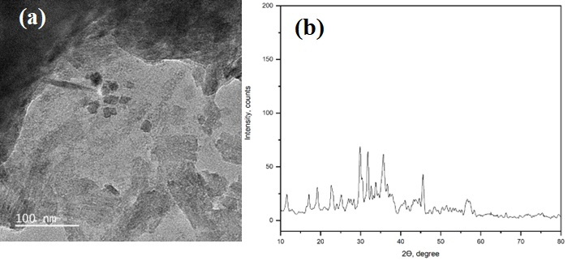

**Figure S1.** TEM image (a), and XRD pattern (b) of the Fe3O4@CS@CMC NCs.

**Figure S2.** FTIR spectra of Fe3O4@CS@CMC NCs (a), and Fe3O4@CS@CMC-SiNH2 NCs before lead (II) ion adsorption (b), and Fe3O4@CS@CMC-SiNH2 NCs after lead (II) ion adsorption (c).

*S2.2. Optimization of the lead (II) removal from aqueous solutions using RSM*

|  |  |  |  |  |  |  |  |  |  |  |  |  |  |  |  |  |  |  |  |  |  |  |  |  |  |  |  |  |  |  |  |
| --- | --- | --- | --- | --- | --- | --- | --- | --- | --- | --- | --- | --- | --- | --- | --- | --- | --- | --- | --- | --- | --- | --- | --- | --- | --- | --- | --- | --- | --- | --- | --- |
| **Table S2.** Experimental design for lead removal using Fe3O4@CS@CMC and Fe3O4@CS@CMC-SiNH2 NCs. | | | | | | | | | | | | | | | | | | | | | | | | | | | | | | | |
| No. | Coded Value | | | | | | | | Real Value | | | | | | | | | Fe3O4@CS@CMC | | | | | | | Fe3O4@CS@CMC-SiNH2 | | | | | | |
| Removal (%) | | | | Qe (mgPb(II)/gNC) | | | Removal (%) | | | | Qe  (mgPb(II)/gNC) | | |
| pH | Dose (g/L) | Temperature (℃) | | | | | | pH | | | Dose (g/L) | | | Temperature (℃) | | |
| 1 | 0 | -1 | -1 | | | | | | 6 | | | 0.1 | | | 20 | | | 53.27 | | | | 53.27 | | | 90.43 | | | | 90.43 | | |
| 2 | 0 | 0 | 0 | | | | | | 6 | | | 0.8 | | | 35 | | | 97.58 | | | | 12.2 | | | 94.34 | | | | 11.79 | | |
| 3 | -1 | -1 | 0 | | | | | | 2 | | | 0.1 | | | 35 | | | 55.27 | | | | 55.27 | | | 99.9 | | | | 99.9 | | |
| 4 | 0 | -1 | 1 | | | | | | 6 | | | 0.1 | | | 50 | | | 65.72 | | | | 65.72 | | | 89.79 | | | | 89.79 | | |
| 5 | -1 | 1 | 0 | | | | | | 2 | | | 1.5 | | | 35 | | | 74.98 | | | | 5 | | | 79.33 | | | | 5.29 | | |
| 6 | 0 | 0 | 0 | | | | | | 6 | | | 0.8 | | | 35 | | | 99.38 | | | | 12.42 | | | 93.63 | | | | 11.7 | | |
| 7 | 1 | -1 | 0 | | | | | | 10 | | | 0.1 | | | 35 | | | 99.12 | | | | 99.12 | | | 90.21 | | | | 90.21 | | |
| 8 | 1 | 0 | 1 | | | | | | 10 | | | 0.8 | | | 50 | | | 86.41 | | | | 10.8 | | | 88.47 | | | | 11.06 | | |
| 9 | 0 | 0 | 0 | | | | | | 6 | | | 0.8 | | | 35 | | | 98.83 | | | | 12.35 | | | 97.52 | | | | 12.19 | | |
| 10 | 0 | 0 | 0 | | | | | | 6 | | | 0.8 | | | 35 | | | 98.76 | | | | 12.34 | | | 93.52 | | | | 11.69 | | |
| 11 | 1 | 1 | 0 | | | | | | 10 | | | 1.5 | | | 35 | | | 97.49 | | | | 6.5 | | | 98.9 | | | | 6.59 | | |
| 12 | -1 | 0 | -1 | | | | | | 2 | | | 0.8 | | | 20 | | | 84.61 | | | | 10.58 | | | 69.91 | | | | 8.74 | | |
| 13 | 0 | 1 | -1 | | | | | | 6 | | | 1.5 | | | 20 | | | 99.04 | | | | 6.6 | | | 96.52 | | | | 6.43 | | |
| 14 | 0 | 0 | 0 | | | | | | 6 | | | 0.8 | | | 35 | | | 97.82 | | | | 12.23 | | | 93.7 | | | | 11.71 | | |
| 15 | 0 | 1 | 1 | | | | | | 6 | | | 1.5 | | | 50 | | | 91.38 | | | | 6.09 | | | 88.61 | | | | 5.91 | | |
| 16 | -1 | 0 | 1 | | | | | | 2 | | | 0.8 | | | 50 | | | 50.64 | | | | 6.33 | | | 63.26 | | | | 7.91 | | |
| 17 | 1 | 0 | -1 | | | | | | 10 | | | 0.8 | | | 20 | | | 80.11 | | | | 10.01 | | | 99.87 | | | | 12.48 | | |
| **Table S3.** ANOVA analysis of the quadratic polynomial and cubic models for lead removal efficiency and adsorption capacity, respectively using Fe3O4@CS@CMC nanocomposite. | | | | | | | | | | | | | | | | | | | | | | | | | | | | | | | |
| **Source** | | **Removal efficiency, %** | | | | | | | | | | | | | | | **Adsorption capacity, mg/g** | | | | | | | | | | | | | | |
| **Sum of Squares** | | **df** | **Mean Square** | | | **F-value** | | | **p-value** | | |  | | | **Source** | | | **Sum of Squares** | | **df** | **Mean Square** | | **F-value** | | | **p-value** | |  | |
| **Model** | | 14163.9 | | 9 | 1573.77 | | | 5.46 | | | 0.0179 | | | significant | | | **Model** | | | 7774.13 | | 12 | 647.84 | | 73447.53 | | | < 0.0001 | | significant | |
| A-pH | | 2502.61 | | 1 | 2502.61 | | | 8.68 | | | 0.0215 | | |  | | | A-pH | | | 3.82 | | 1 | 3.82 | | 432.99 | | | < 0.0001 | |  | |
| B-Dose | | 5838.68 | | 1 | 5838.68 | | | 20.25 | | | 0.0028 | | |  | | | B-Dose | | | 159.86 | | 1 | 159.86 | | 18123.18 | | | < 0.0001 | |  | |
| C-Temperature | | 13.64 | | 1 | 13.64 | | | 0.0473 | | | 0.834 | | |  | | | C-Temperature | | | 148.66 | | 1 | 148.66 | | 16854.04 | | | < 0.0001 | |  | |
| AB | | 1062.51 | | 1 | 1062.51 | | | 3.68 | | | 0.0964 | | |  | | | AB | | | 1857.97 | | 1 | 1857.97 | | 2.11E+05 | | | < 0.0001 | |  | |
| AC | | 405.42 | | 1 | 405.42 | | | 1.41 | | | 0.2744 | | |  | | | AC | | | 6.33 | | 1 | 6.33 | | 718.18 | | | < 0.0001 | |  | |
| BC | | 265.05 | | 1 | 265.05 | | | 0.9191 | | | 0.3696 | | |  | | | BC | | | 161.38 | | 1 | 161.38 | | 18296.21 | | | < 0.0001 | |  | |
| A² | | 101.47 | | 1 | 101.47 | | | 0.3519 | | | 0.5717 | | |  | | | A² | | | 222.04 | | 1 | 222.04 | | 25173.68 | | | < 0.0001 | |  | |
| B² | | 2275.77 | | 1 | 2275.77 | | | 7.89 | | | 0.0262 | | |  | | | B² | | | 464.3 | | 1 | 464.3 | | 52638.42 | | | < 0.0001 | |  | |
| C² | | 1382.79 | | 1 | 1382.79 | | | 4.8 | | | 0.0647 | | |  | | | C² | | | 433 | | 1 | 433 | | 49089.73 | | | < 0.0001 | |  | |
| **Residual** | | 2018.55 | | 7 | 288.36 | | |  | | |  | | |  | | | ABC | | | 0 | | 0 |  | |  | | |  | |  | |
| Lack of Fit | | 2016.29 | | 3 | 672.1 | | | 1190.58 | | | < 0.0001 | | | significant | | | A²B | | | 648.09 | | 1 | 648.09 | | 73475.76 | | | < 0.0001 | |  | |
| Pure Error | | 2.26 | | 4 | 0.5645 | | |  | | |  | | |  | | | A²C | | | 96.92 | | 1 | 96.92 | | 10987.79 | | | < 0.0001 | |  | |
| **Cor Total** | | 16182.5 | | 16 |  | | |  | | |  | | |  | | | AB² | | | 909.56 | | 1 | 909.56 | | 1.03E+05 | | | < 0.0001 | |  | |
|  | |  | |  |  | | |  | | |  | | |  | | | AC² | | | 0 | | 0 |  | |  | | |  | |  | |
|  | |  | |  |  | | |  | | |  | | |  | | | B²C | | | 0 | | 0 |  | |  | | |  | |  | |
| **Table S4.** ANOVA analysis of the cubic, and quadratic polynomial models for lead removal efficiency and adsorption capacity, respectively using Fe3O4@CS@CMC-SiNH2 nanocomposite. | | | | | | | | | | | | | | | | | | | | | | | | | | | | | | | |
|  |
| **Source** | | **Removal efficiency, %** | | | | | | | | | | | | | | **Adsorption capacity, mg/g** | | | | | | | | | | | | | | | |  |
| **Sum of Squares** | | **df** | | **Mean Square** | **F-value** | | | **p-value** | | |  | | | **Source** | | | **Sum of Squares** | | **df** | | | **Mean Square** | | **F-value** | **p-value** | | | |  |  |
| **Model** | | 1656.81 | | 12 | | 138.07 | 48.11 | | | 0.001 | | | significant | | | **Model** | | | 21233.8 | | 9 | | | 2359.31 | | 385.04 | < 0.0001 | | | | significant |  |
| A-pH | | 760.73 | | 1 | | 760.73 | 265.09 | | | < 0.0001 | | |  | | | A-pH | | | 0.277 | | 1 | | | 0.277 | | 0.0452 | 0.8377 | | | |  |  |
| B-Dose | | 6.01 | | 1 | | 6.01 | 2.09 | | | 0.2214 | | |  | | | B-Dose | | | 14974.3 | | 1 | | | 14974.3 | | 2443.81 | < 0.0001 | | | |  |  |
| C-Temperature | | 18.24 | | 1 | | 18.24 | 6.36 | | | 0.0653 | | |  | | | C-Temperature | | | 1.46 | | 1 | | | 1.46 | | 0.239 | 0.6399 | | | |  |  |
| AB | | 214.05 | | 1 | | 214.05 | 74.59 | | | 0.001 | | |  | | | AB | | | 30.22 | | 1 | | | 30.22 | | 4.93 | 0.0618 | | | |  |  |
| AC | | 5.63 | | 1 | | 5.63 | 1.96 | | | 0.2341 | | |  | | | AC | | | 0.0879 | | 1 | | | 0.0879 | | 0.0143 | 0.908 | | | |  |  |
| BC | | 13.19 | | 1 | | 13.19 | 4.6 | | | 0.0986 | | |  | | | BC | | | 0.0031 | | 1 | | | 0.0031 | | 0.0005 | 0.9826 | | | |  |  |
| A² | | 189.42 | | 1 | | 189.42 | 66.01 | | | 0.0012 | | |  | | | A² | | | 0.3621 | | 1 | | | 0.3621 | | 0.0591 | 0.8149 | | | |  |  |
| B² | | 76.2 | | 1 | | 76.2 | 26.55 | | | 0.0067 | | |  | | | B² | | | 6204.78 | | 1 | | | 6204.78 | | 1012.62 | < 0.0001 | | | |  |  |
| C² | | 234.02 | | 1 | | 234.02 | 81.55 | | | 0.0008 | | |  | | | C² | | | 17.93 | | 1 | | | 17.93 | | 2.93 | 0.1309 | | | |  |  |
| ABC | | 0 | | 0 | |  |  | | |  | | |  | | | **Residual** | | | 42.89 | | 7 | | | 6.13 | |  |  | | | |  |  |
| A²B | | 35.21 | | 1 | | 35.21 | 12.27 | | | 0.0248 | | |  | | | Lack of Fit | | | 42.71 | | 3 | | | 14.24 | | 317.53 | < 0.0001 | | | | significant |  |
| A²C | | 11.31 | | 1 | | 11.31 | 3.94 | | | 0.118 | | |  | | | Pure Error | | | 0.1794 | | 4 | | | 0.0448 | |  |  | | | |  |  |
| AB² | | 256.28 | | 1 | | 256.28 | 89.31 | | | 0.0007 | | |  | | | **Cor Total** | | | 21276.7 | | 16 | | |  | |  |  | | | |  |  |
| AC², B²C, and BC² | | 0 | | 0 | |  |  | | |  | | |  | | |  | | |  | |  | | |  | |  |  | | | |  |  |
| A³, B³, and C³ | | 0 | | 0 | |  |  | | |  | | |  | | |  | | |  | |  | | |  | |  |  | | | |  |  |
| **Pure Error** | | 11.48 | | 4 | | 2.87 |  | | |  | | |  | | |  | | |  | |  | | |  | |  |  | | | |  |  |
| **Cor Total** | | 1668.28 | | 16 | |  |  | | |  | | |  | | |  | | |  | |  | | |  | |  |  | | | |  |  |

*S2.3. Kinetic and Isotherm studies*

**Figure S3.** The linear plot for the Pseudo-first order, Pseudo-second order, and Intra-particle diffusion kinetic models using Fe3O4@CS@CMC (a-c) and Fe3O4@CS@CMC-SiNH2 (d-f)NCs.

**Figure S4.** The linear plot for the Langmuir, Freundlich, and DR isotherm models using Fe3O4@CS@CMC (a-c) and Fe3O4@CS@CMC-SiNH2 (d-f) NCs.

|  |  |  |  |  |  |  |  |  |  |  |  |
| --- | --- | --- | --- | --- | --- | --- | --- | --- | --- | --- | --- |
| **Table S5.** Parameters and equations of kinetic models: pseudo-first order, pseudo-second order and intra-particle diffusion | | | | | | | | | | | |
| **Kinetic model** | **Equation** | **Fe3O4@CS@CMC** | | | | | | **Fe3O4@CS@CMC-SiNH2** | | | |
| Rate constant | Calculated Qe (mgPb(II)/gNC) | | Experimental Qe (mgPb(II)/gNC) | | R2 | Rate constant | Calculated Qe (mgPb(II)/gNC) | Experimental Qe (mgPb(II)/gNC) | R2 |
| Pseudo-first order |  | K1 (min-1)  0.031 | 24.56 | | 90.23 | | 0.7183 | K1 (min-1)  0.080 | 143.37 | 97.34 | 0.9954 |
| Pseudo-second order |  | K2 (g.mg-1.min-1)  0.032 | 87.72 | | 0.9999 | K2 (g.mg-1.min-1)  0.0013 | 96.15 | 0.9995 |
| Intra-particle diffusion | $$Q_{t}=\left(K_{id}t^{1/2}\right)+Q$$ | Kid (mg.g-1.min-0.5)  1.29 | 76.00 | | 0.9986 | Kid (mg.g-1.min-0.5)  1.32 | 60.60 | 0.2748 |
| **Table S6.** Parameters and equations of isotherm models. | | | | | | | | | | | |
| **Isotherm model** | **Equation** | **Fe3O4@CS@CMC** | | | | | | **Fe3O4@CS@CMC-SiNH2** | | | |
| Constants | | | | | R2 | Constants | | | R2 |
| Langmuir | $$\frac{C_{e}}{Q_{e}}= \frac{1}{(K_{L}Q_{max})}+ \frac{C_{e}}{Q_{max}}$$ | Qmax (mgPb(II)/gNC)  384.62 | | KL (L/mg)  0.325 | | RL  0.03-0.97 | 0.9942 | Qmax (mgPb(II)/gNC)  555.56 | KL (L/mg)  0.353 | RL  0.02-0.96 | 0.9981 |
| Freundlich | $$LnQ_{e}=LnK_{F}+\left(1/n\right)LnC_{e}$$ | KF (mg(1-1/n).L^(1/n).g-1)  52.37 | | n  1.73 | |  | 0.9737 | KF  (mg(1-1/n).L^(1/n).g-1)  138.12 | n  2.84 |  | 0.9523 |
| DR* | $$LnQ_{e}=LnQ_{s}- βε^{2}$$ | Qs (mgPb(II)/gNC)  112.73 | | β (mol2/kJ2)  4E-09 | | E (kJ/mol)  11.18 | 0.9882 | Qs (mgPb(II)/gNC)  0.001 | β (mol2/kJ2)  3E-09 | E (kJ/mol)  12.91 | 0.9761 |
| $ε =RTLn[1+\frac{1}{C_{e}}]$* ; Ce (M), R = 8.314 J/ mol.K, and T = 298 K. | | | | | | | | | | | |

**Figure S5.** Reusability test of lead ion adsorption (Co = 1 mg/L) on Fe3O4@CS@CMC NCs.

**Figure S6.** Zeta potential of the Fe3O4@CS@CMC-SiNH2 NCs.

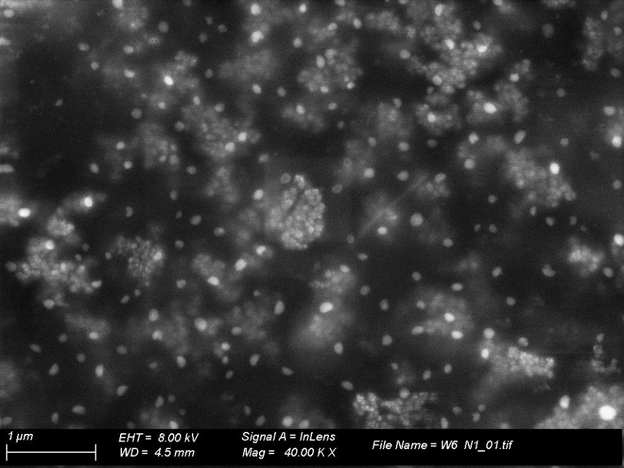

**a**

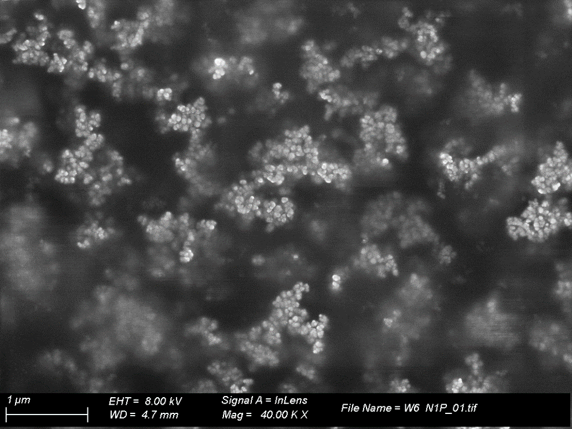

**b**

**Figure S7.** SEM image of the Fe3O4@CS@CMC-SiNH2 NCs before (a) and after (b) lead ion adsorption.

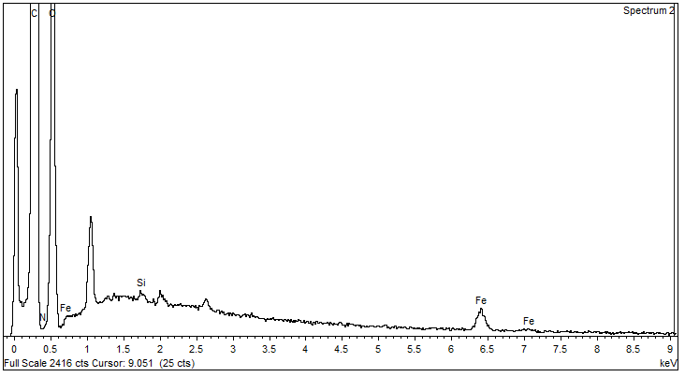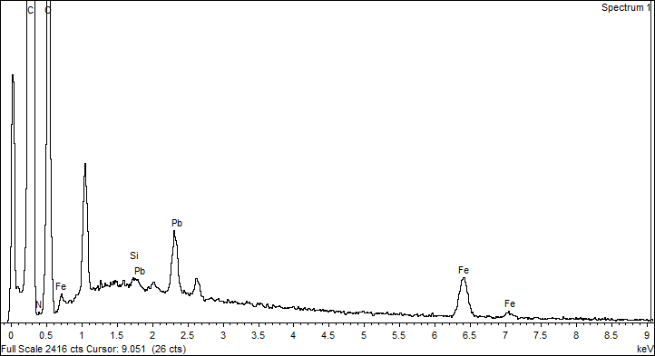

**a**

**b**

**Figure S8.** EDX image of the Fe3O4@CS@CMC-SiNH2 NCs before (a) and after (b) lead ion adsorption.

**Figure S9.** XRD pattern of the Fe3O4@CS@CMC-SiNH2 NCs after regeneration and reusability.

**References**

Kesika, P., M. I. Prasanth and K. Balamurugan (2015). "Modulation of *Caenorhabditis elegans* immune response and modification of *Shigella* endotoxin upon interaction." J. Basic Microbiol. **55**(4): 432-450. <https://doi.org/10.1002/jobm.201400511>.