**Development and Characterization of a Clay-HDTMABr Composite for the Removal of Cr(VI) from Aqueous Solutions with Special Emphasis on the Electrochemical Interface.**

Abderrazek El-Kordya.b, Abdelaziz Elgamouz b**,** Awad A. Alrashdic,Abderrahim Kalid**,** Ayman Abdelhamidb**,** Abdel-Nasser Kawdeb**,** NajibTijania

*aDepartment of Chemistry, Pure and Applied Chemistry Group, College of Sciences, University of Sharjah, P.O.Box:27272Sharjah, United Arab Emirates. emails:* *abderrazekelkordy@gmail.com(A. El Kordy)*, [*aelgamouz@sharjah.ac.ae*](mailto:aelgamouz@sharjah.ac.ae)*(A.Elgamouz)*.

*bMaterials, Membranes and Nanotechnology Laboratory, BP: 11201 Zitoune, university of myismail, Faculty of Sciences Meknes. emails: abderrazekelkordy@gmail.com(A. El Kordy),*[*najibtij@gmail.com*](mailto:najibtij@gmail.com) *(N. Tijani)*.

*c*Chemistry Department, Umm Al-Qura University, Al-Qunfudah University College, Al Qunfudah 21962, 11 Saudi Arabia; *aarashdi@uqu.edu.sa*

*dLaboratory of Chemistry, Biology Applied to the Environment, Faculty of Sciences, MoulayIsmaïl University, BP 11201-Zitoune, Meknes, 50060, Morocco.emails:* [*Kaliabdrahim@yahoo.fr*](mailto:Kaliabdrahim@yahoo.fr) *(A.Kali).*

*Corresponding authors: [abderrazekelkordy@gmail.com](mailto:abderrazekelkordy@gmail.com), [*aelgamouz@sharjah.ac.ae*](mailto:aelgamouz@sharjah.ac.ae)

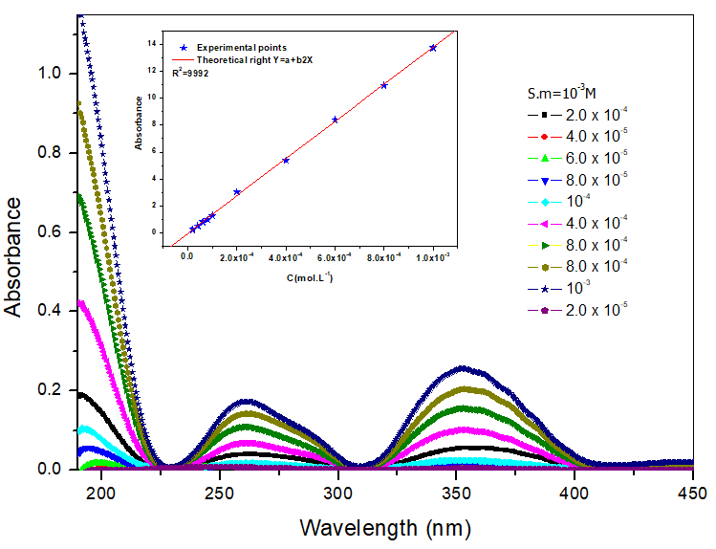

**Fig. S1** UV Spectra of Cr(VI) calibration solutions from 2.0×10-5 to 2.0×10-4.

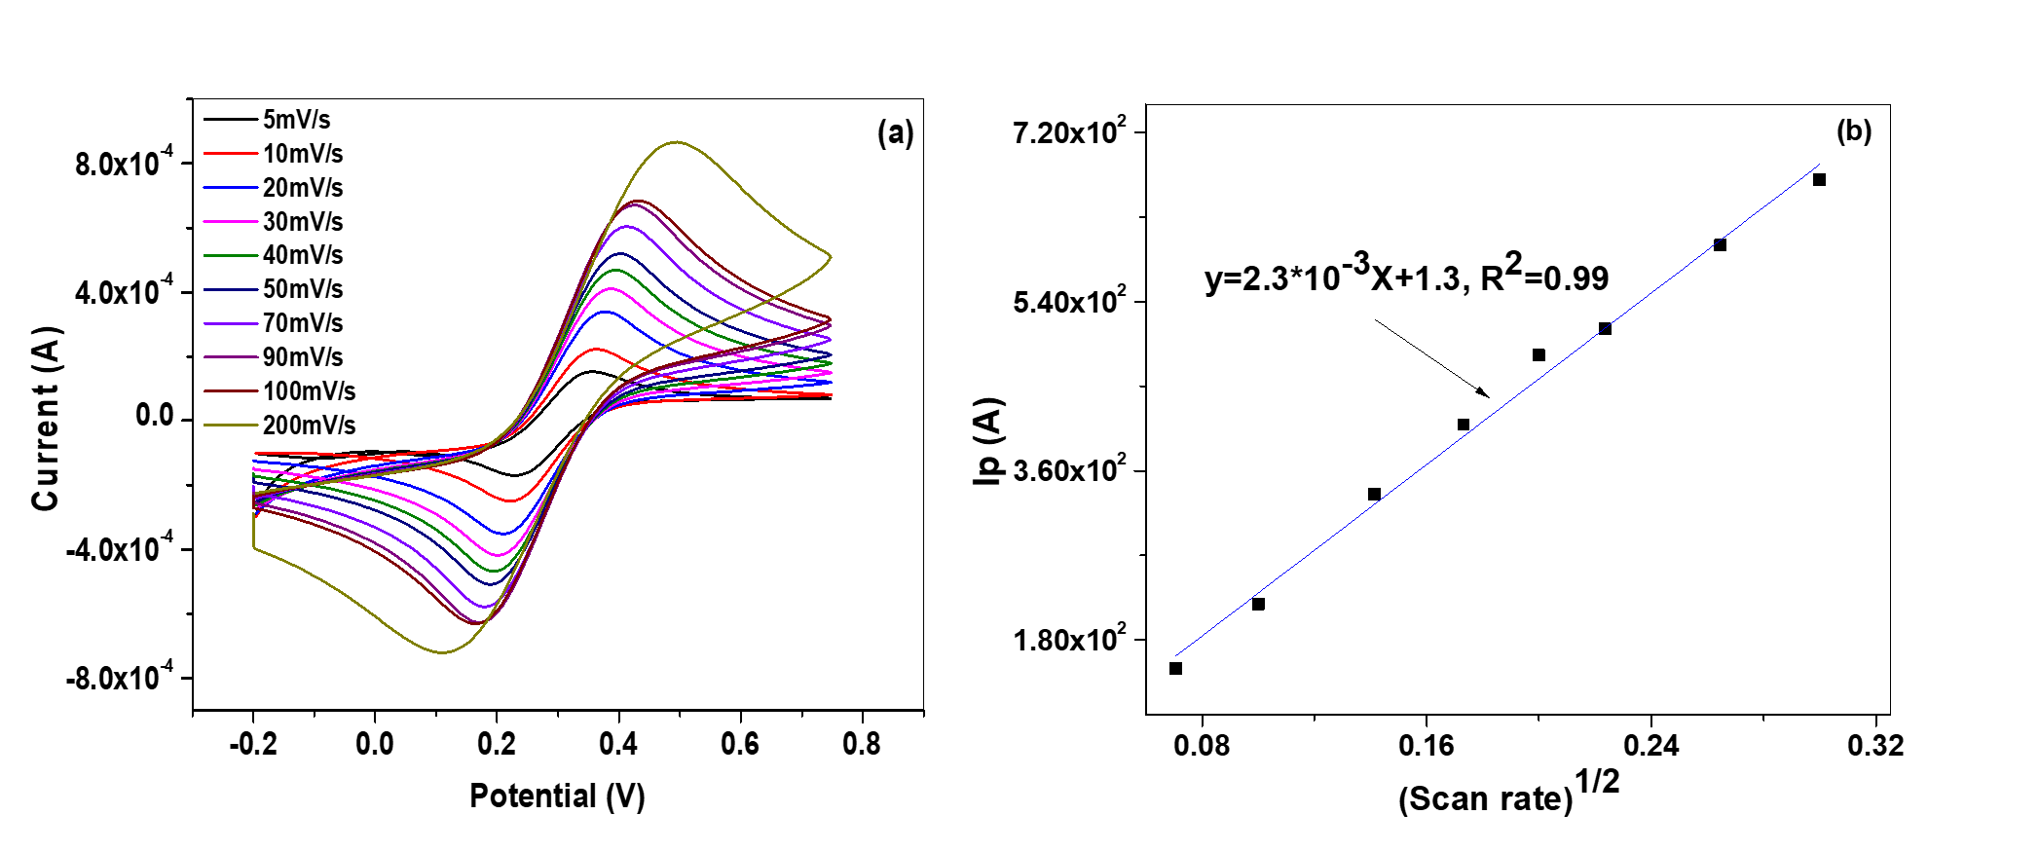

**Fig. S2** (a) CV of 5.0 mM of Fe(CN)6]3-/4-/ 0.1 M KCl solution and corresponding slope (b) of CPE-0wt.% Clay.

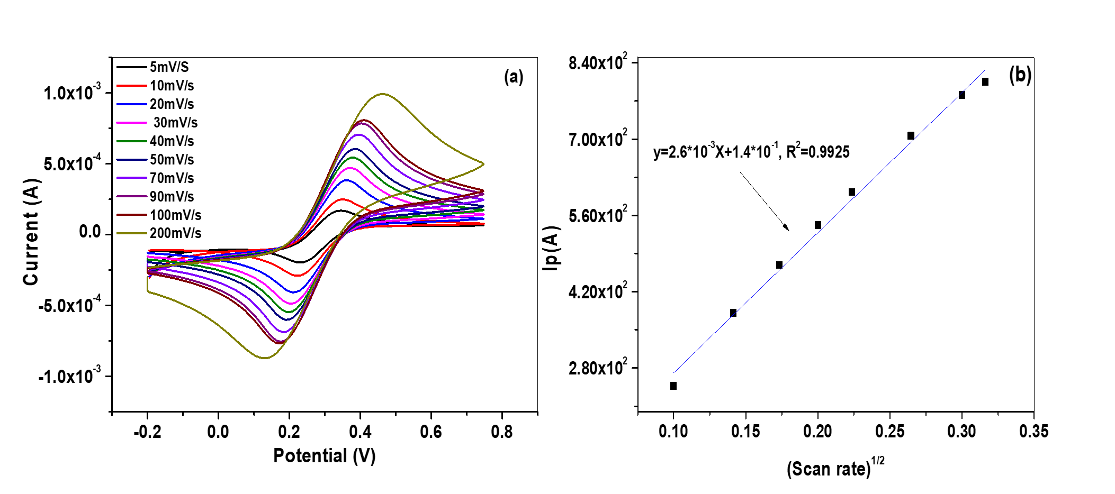

**Fig. S3** (a) CV of 5.0 mM of Fe(CN)6]3-/4-/ 0.1 M KCl solution and corresponding slope (b) of CPE-10wt.% Clay.

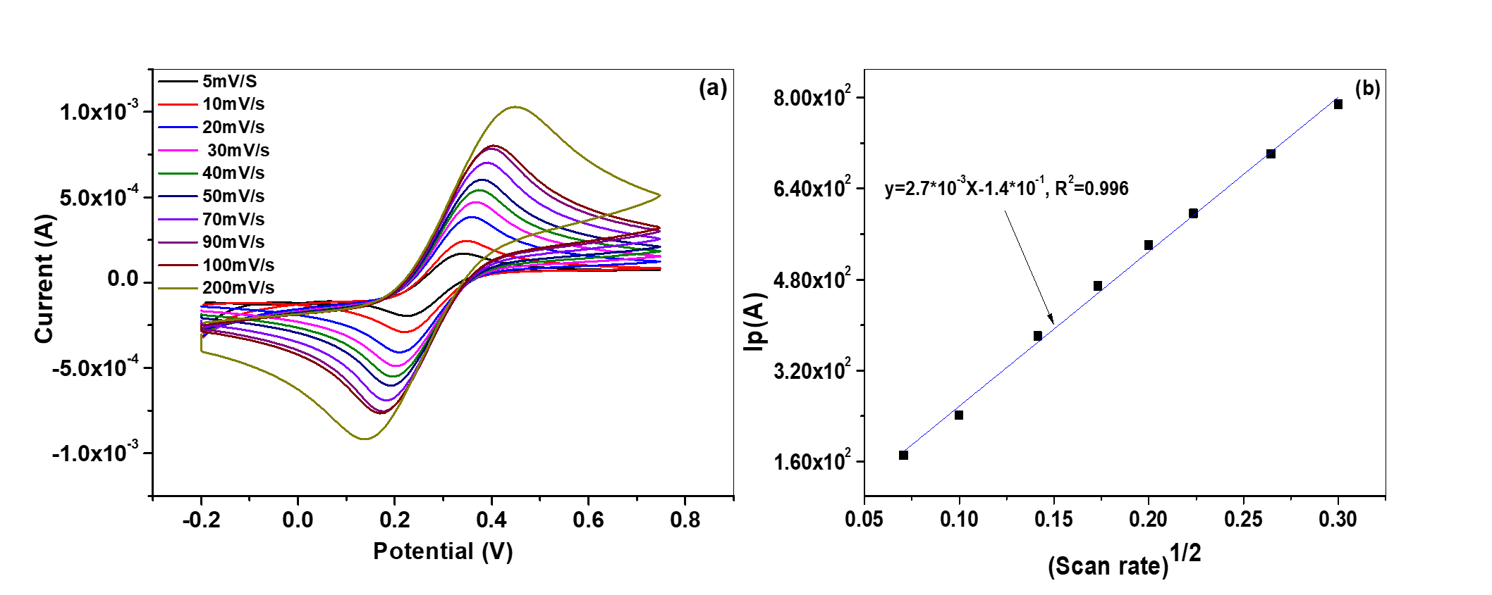

**Fig. S4** (a) CV of 5.0 mM of Fe(CN)6]3-/4-/ 0.1 M KCl solution and corresponding slope (b) of CPE-20wt.% Clay.

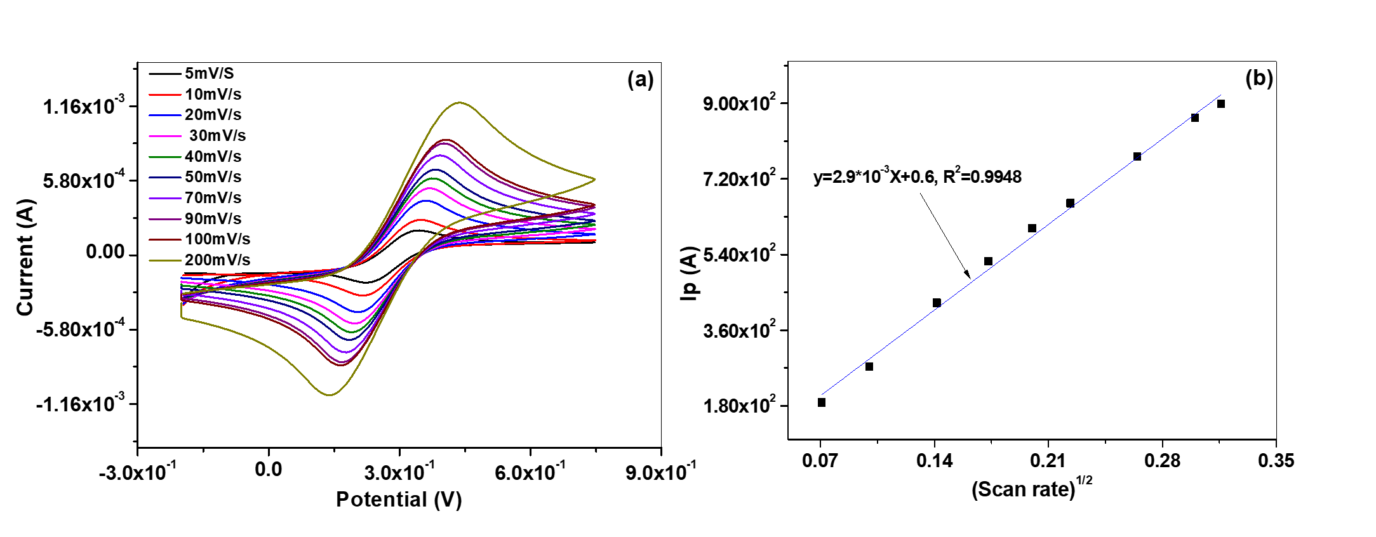

**Fig. S5** (a) CV of 5.0 mM of Fe(CN)6]3-/4-/ 0.1 M KCl solution and corresponding slope (b) of 30 wt.% Clay.

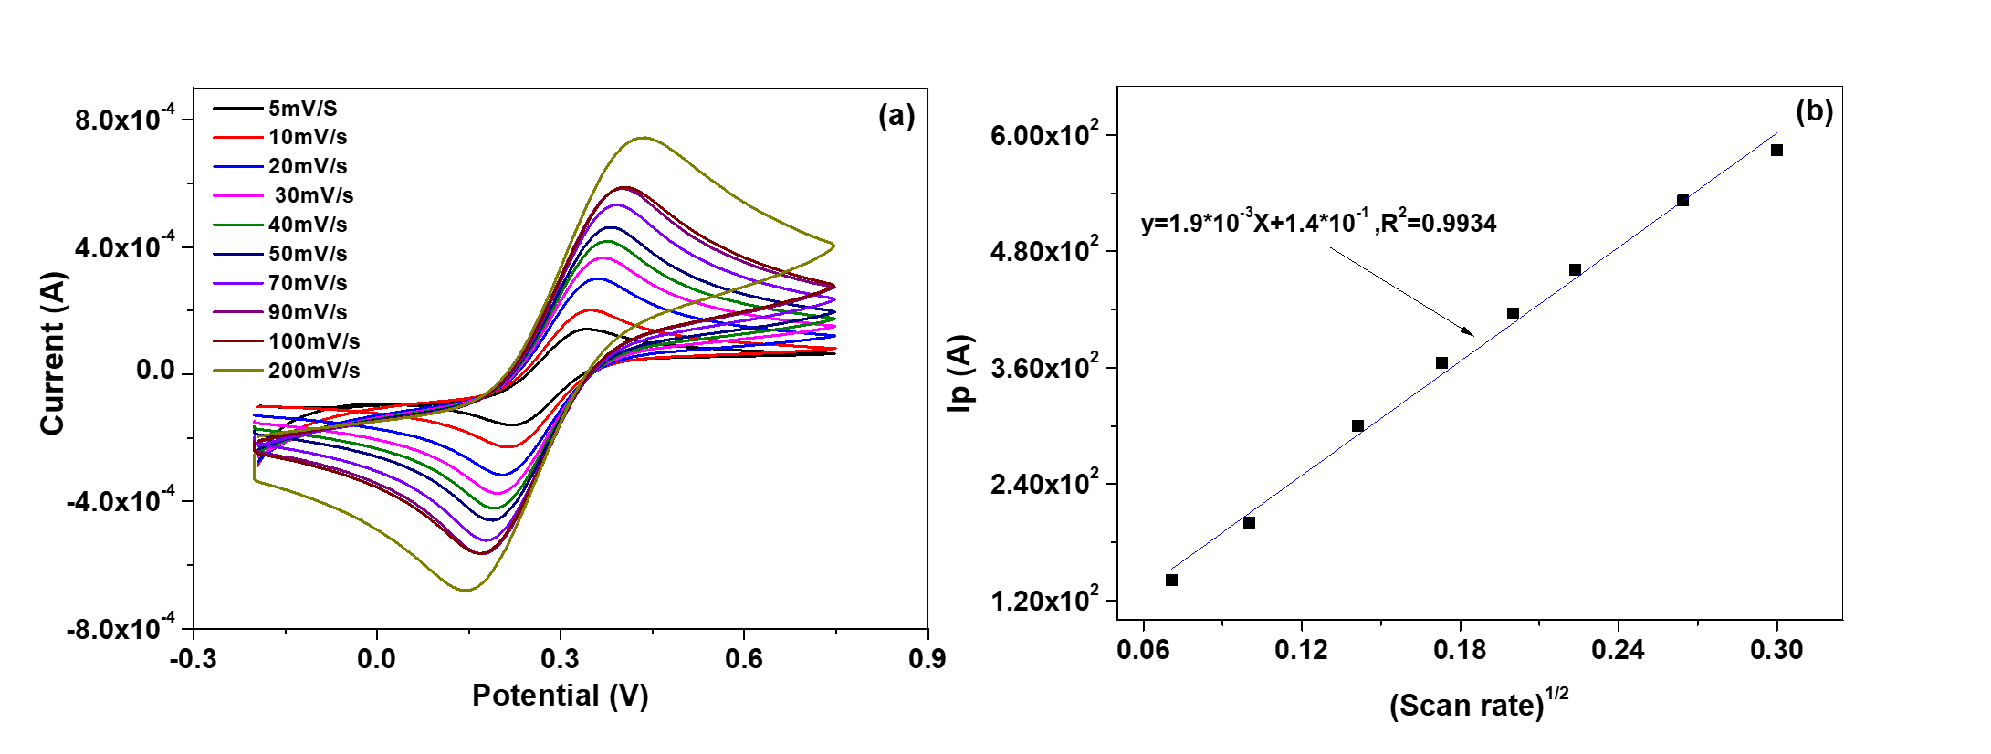

**Fig. S6** (a) CV of 5.0 mM of Fe(CN)6]3-/4-/ 0.1 M KCl solution and corresponding slope (b) of 40wt.% clay.

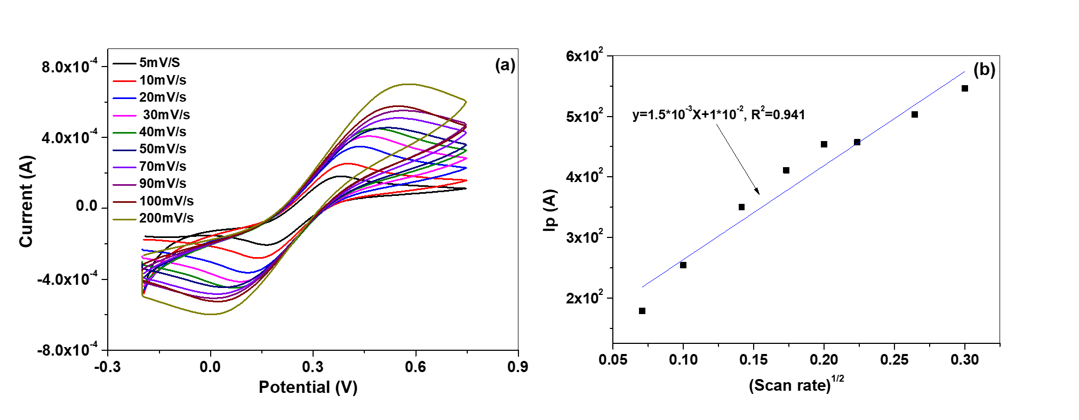

**Fig. S7** (a) CV of 5.0 mM of Fe(CN)6]3-/4-/ 0.1 M KCl solution and corresponding slope (b) of 50wt.% clay.

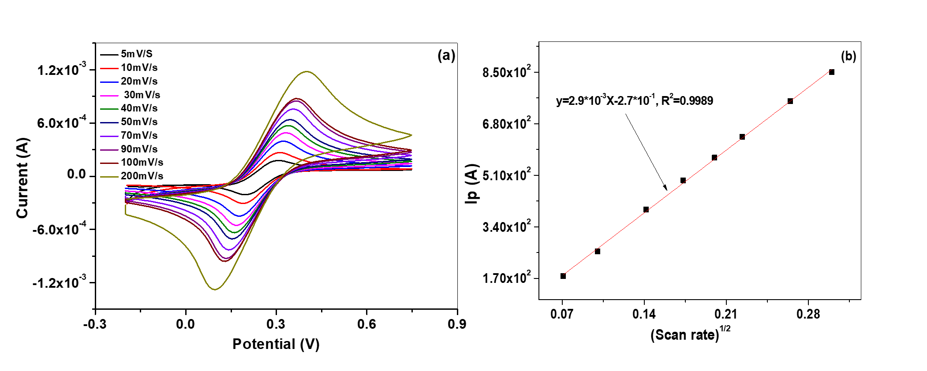

**Fig. S8** (a) CV of 5.0 mM of Fe(CN)6]3-/4-/ 0.1 M KCl solution and corresponding slope (b) of 10wt.% clay-HDTMABr.

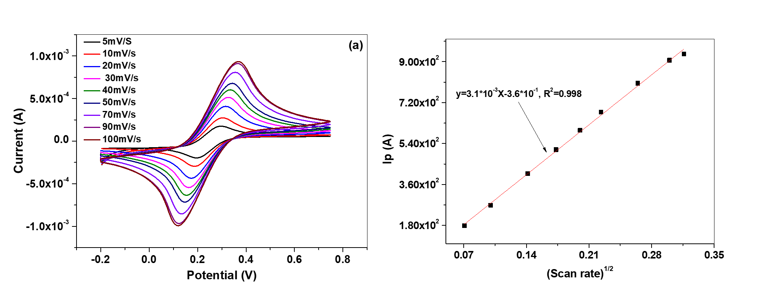

**Fig. S9** (a) CV of 5.0 mM of Fe(CN)6]3-/4-/ 0.1 M KCl solution and corresponding slope (b) of 20wt.% clay-HDTMABr.

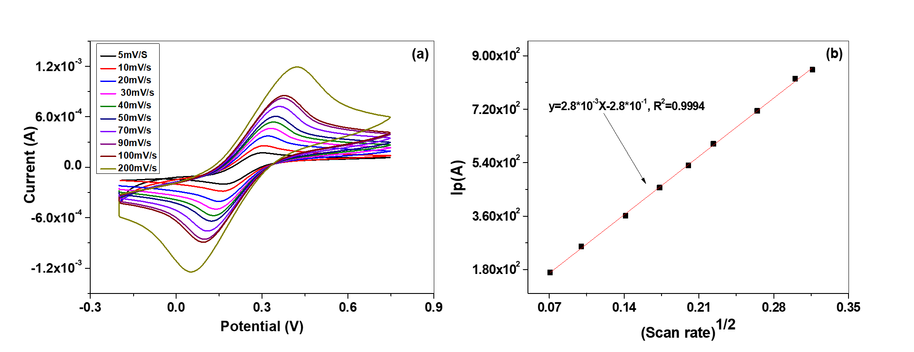

**Fig. S10** (a) CV of 5.0 mM of Fe(CN)6]3-/4-/ 0.1 M KCl solution and corresponding slope (b) of 30wt.% clay-HDTMABr.

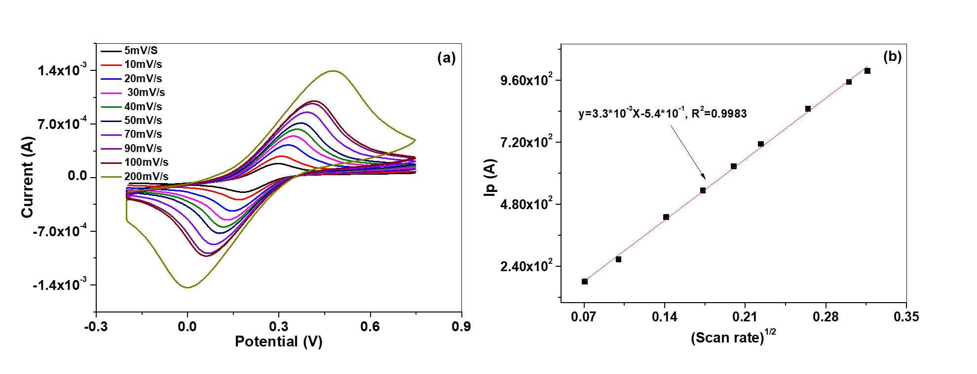

**Fig. S11** (a) CV of 5.0 mM of Fe(CN)6]3-/4-/ 0.1 M KCl solution and corresponding slope (b) of 40wt.% clay-HDTMABr.

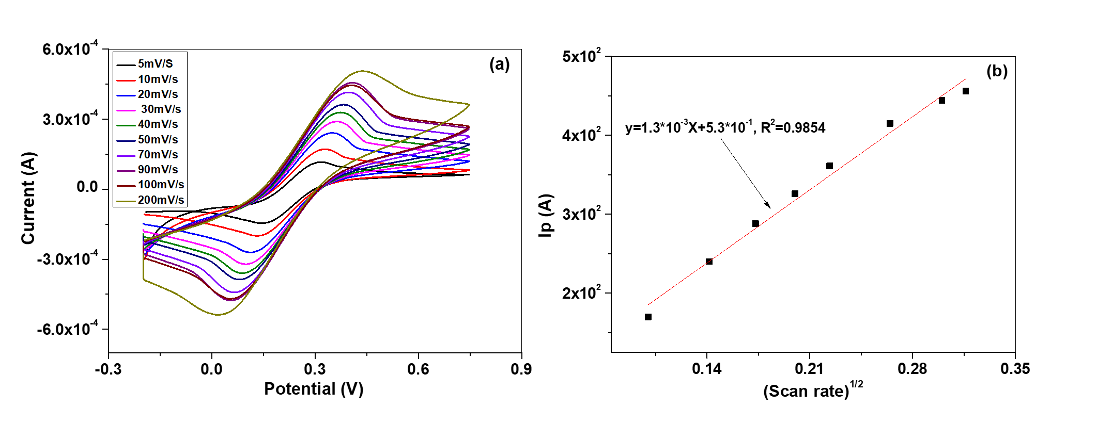

**Fig. S12** (a) CV of 5.0 mM of Fe(CN)6]3-/4-/ 0.1 M KCl solution and corresponding slope (b) of 50wt.% clay-HDTMABr