HADDOCK 2.4

@Bonvinlab

WELCOME TO THE UTRECHT BIOMOLECULAR INTERACTION WEB PORTAL >>



**HADDOCK server status for job "Ulang_PPI_SpikeOmicron-TMPRSS2"**

**Status: FINISHED**

Your HADDOCK run has successfully completed. The complete run can be downloaded as a gzipped tar file **h** [**ere**](https://wenmr.science.uu.nl/haddock2.4/run/6284056061/163595-Ulang_PPI_SpikeOmicron-TMPRSS2.tgz). The file containing your docking parameters is **h** [**ere**](https://wenmr.science.uu.nl/haddock2.4/run/6284056061/163595-Ulang_PPI_SpikeOmicron-TMPRSS2/job_params.json?download=True).

Please cite the following paper in your work:

R.V. Honorato, P.I. Koukos, B. Jimenez-Garcia, A. Tsaregorodtsev, M. Verlato, A. Giachetti, A. Rosato and

A.M.J.J. Bonvin (2021). "[Structural biology in the clouds: The WeNMR-EOSC Ecosystem](https://doi.org/10.3389/fmolb.2021.729513)." *Frontiers Mol. Biosci.*, **8**, fmolb.2021.729513.

G.C.P van Zundert, J.P.G.L.M. Rodrigues, M. Trellet, C. Schmitz, P.L. Kastritis, E. Karaca, A.S.J. Melquiond, M. van Dijk, S.J. de Vries and A.M.J.J. Bonvin (2016). "The HADDOCK2.2 webserver: User-friendly integrative

m odeling of biomolecular complexes." *J. Mol. Biol.*, **428**, 720-725 (2015).

and add the following acknowledgment:

The FP7 WeNMR (project# 261572), H2020 West-Life (project# 675858), the EOSC-hub (project# 777536) and the EGI-ACE (project# 101017567) European e-Infrastructure projects are acknowledged for the use of their web

portals, which make use of the EGI infrastructure with the dedicated support of CESNET-MCC, INFN-PADOVA- STACK, INFN-LNL-2, NCG-INGRID-PT, TW-NCHC, CESGA, IFCA-LCG2, UA-BITP, SURFsara and NIKHEF, and the

additional support of the national GRID Initiatives of Belgium, France, Italy, Germany, the Netherlands, Poland, Portugal, Spain, UK, Taiwan and the US Open Science Grid.

**How would you rate your experience with our portal?**     

**Questions / feedback ?** [a sk.bioexcel.eu](http://ask.bioexcel.eu/)

**Do check up the** [**H ADDOCK best practice guide**](https://www.bonvinlab.org/software/bpg/)**!** There you can learn more about which settings are best used in

which scenario and use HADDOCK in its full potential!

In the aim to improve our new web portal, we would really appreciate 2 min of your time to complete a short survey [h ere!](https://goo.gl/forms/KGSyAaATfpeeCUXh1) Thanks!

**Post-processing: SUCCESS Summary**

HADDOCK clustered **161** structures in **10** cluster(s), which represents **80 %** of the water-refined models HADDOCK generated. Note that currently the maximum number of models considered for clustering is 200.

The statistics of the top 10 clusters are shown below. The top cluster is the most reliable according to HADDOCK. Its Z-score indicates how many standard deviations from the average this cluster is located in terms of score (the more negative the better).

A graphical representation of the results is also provided at the bottom of the page. You can also [d ownload all cluster files](https://wenmr.science.uu.nl/haddock2.4/run/6284056061/163595-Ulang_PPI_SpikeOmicron-TMPRSS2_summary.tgz) (best 4 of the top 10 cluster(s)).

|  |  |
| --- | --- |
| **Cluster 7** |  |
| HADDOCK score | -73.5 +/- 5.8 |
| Cluster size | 10 |
| RMSD from the overall lowest-energy structure | 16.1 +/- 0.2 |
| Van der Waals energy | -26.8 +/- 3.4 |
| Electrostatic energy | -259.8 +/- 21.1 |
| Desolvation energy | 5.2 +/- 2.2 |
| Restraints violation energy | 0.1 +/- 0.1 |
| Buried Surface Area | 1353.3 +/- 70.5 |
| Z-Score | -1.1 |

# Nr 1 best structure  Nr 2 best structure  Nr 3 best structure 

Download file

Download file

Download file

Nr 4 best structure



Download file

|  |  |
| --- | --- |
| **Cluster 1** |  |
| HADDOCK score | -69.3 +/- 4.0 |
| Cluster size | 38 |
| RMSD from the overall lowest-energy structure | 20.1 +/- 0.3 |
| Van der Waals energy | -42.6 +/- 2.2 |
| Electrostatic energy | -135.2 +/- 7.4 |
| Desolvation energy | 0.3 +/- 1.3 |
| Restraints violation energy | 0.8 +/- 0.8 |
| Buried Surface Area | 1295.0 +/- 54.8 |
| Z-Score | -0.8 |

Nr 1 best structure  Nr 2 best structure







Download file

Download file

Download file

Nr 3 best structure Nr 4 best structure



Download file

|  |  |
| --- | --- |
| **Cluster 5** |  |
| HADDOCK score | -68.5 +/- 1.8 |
| Cluster size | 14 |
| RMSD from the overall lowest-energy structure | 23.3 +/- 0.2 |
| Van der Waals energy | -41.2 +/- 1.6 |
| Electrostatic energy | -136.1 +/- 8.3 |
| Desolvation energy | -0.0 +/- 3.6 |
| Restraints violation energy | 0.0 +/- 0.0 |
| Buried Surface Area | 1346.2 +/- 23.8 |
| Z-Score | -0.7 |

Nr 1 best structure  Nr 2 best structure







Download file

Download file

Download file

Nr 3 best structure Nr 4 best structure



Download file

|  |  |
| --- | --- |
| **Cluster 8** |  |
| HADDOCK score | -68.0 +/- 4.6 |
| Cluster size | 9 |
| RMSD from the overall lowest-energy structure | 20.8 +/- 0.2 |
| Van der Waals energy | -27.1 +/- 5.4 |
| Electrostatic energy | -140.2 +/- 17.1 |
| Desolvation energy | -14.6 +/- 2.2 |
| Restraints violation energy | 17.5 +/- 12.2 |
| Buried Surface Area | 1298.4 +/- 73.2 |
| Z-Score | -0.7 |

Nr 1 best structure  Nr 2 best structure







Download file

Download file

Download file

Nr 3 best structure Nr 4 best structure



Download file

|  |  |
| --- | --- |
| **Cluster 2** |  |
| HADDOCK score | -65.9 +/- 1.2 |
| Cluster size | 27 |
| RMSD from the overall lowest-energy structure | 16.2 +/- 0.1 |
| Van der Waals energy | -33.8 +/- 4.7 |
| Electrostatic energy | -177.1 +/- 19.2 |
| Desolvation energy | 2.8 +/- 0.8 |
| Restraints violation energy | 5.2 +/- 8.2 |
| Buried Surface Area | 1451.6 +/- 68.2 |
| Z-Score | -0.5 |

Nr 1 best structure  Nr 2 best structure







Download file

Download file

Download file

Nr 3 best structure Nr 4 best structure



Download file

|  |  |
| --- | --- |
| **Cluster 3** |  |
| HADDOCK score | -62.8 +/- 2.8 |
| Cluster size | 26 |
| RMSD from the overall lowest-energy structure | 17.1 +/- 0.1 |
| Van der Waals energy | -32.6 +/- 3.8 |
| Electrostatic energy | -158.5 +/- 11.2 |
| Desolvation energy | 0.8 +/- 1.8 |
| Restraints violation energy | 7.0 +/- 3.2 |
| Buried Surface Area | 1095.1 +/- 48.3 |
| Z-Score | -0.3 |

Nr 1 best structure  Nr 2 best structure







Download file

Download file

Download file

Nr 3 best structure Nr 4 best structure



Download file

|  |  |
| --- | --- |
| **Cluster 9** |  |
| HADDOCK score | -58.6 +/- 5.6 |
| Cluster size | 5 |
| RMSD from the overall lowest-energy structure | 6.3 +/- 1.0 |
| Van der Waals energy | -29.8 +/- 11.2 |
| Electrostatic energy | -145.2 +/- 40.0 |
| Desolvation energy | -0.1 +/- 2.6 |
| Restraints violation energy | 3.3 +/- 1.6 |
| Buried Surface Area | 1183.8 +/- 98.5 |
| Z-Score | 0.1 |

Nr 1 best structure  Nr 2 best structure







Download file

Download file

Download file

Nr 3 best structure Nr 4 best structure



Download file

**Cluster 4**

HADDOCK score -52.5 +/- 3.3

Cluster size 18

RMSD from the overall lowest-energy structure

21.2 +/- 0.2

Van der Waals energy -22.7 +/- 4.3 Electrostatic energy -157.9 +/- 31.4

Desolvation energy -0.9 +/- 0.8

Restraints violation energy 26.6 +/- 0.8

Buried Surface Area 869.1 +/- 28.3

Z-Score 0.6

Nr 1 best structure  Nr 2 best structure







Download file

Download file

Download file

Nr 3 best structure Nr 4 best structure



Download file

**Cluster 10**

HADDOCK score -43.2 +/- 3.8

Cluster size 4

RMSD from the overall lowest-energy structure

10.6 +/- 0.3

Van der Waals energy -25.7 +/- 3.1 Electrostatic energy -85.9 +/- 26.8

Desolvation energy -0.7 +/- 2.5

Restraints violation energy 2.9 +/- 0.7

Buried Surface Area 911.9 +/- 86.0

Z-Score 1.3

Nr 1 best structure  Nr 2 best structure







Download file

Download file

Download file

Nr 3 best structure Nr 4 best structure



Download file

**Cluster 6**

HADDOCK score -33.4 +/- 3.1

Cluster size 10

RMSD from the overall lowest-energy structure

17.7 +/- 0.2

Van der Waals energy -10.7 +/- 4.0 Electrostatic energy -99.2 +/- 24.2

Desolvation energy -3.9 +/- 1.6

Restraints violation energy 9.5 +/- 9.4

Buried Surface Area 659.8 +/- 63.2

Z-Score 2.1

Nr 1 best structure  Nr 2 best structure







Download file

Download file

Download file

Nr 3 best structure Nr 4 best structure



Download file

**Model Analysis** ([Download all plots](https://wenmr.science.uu.nl/haddock2.4/run/6284056061/163595-Ulang_PPI_SpikeOmicron-TMPRSS2/plots.tgz))

All

None

Cluster 7

Cluster 1

Cluster 5

Cluster 8

Cluster 2

Cluster 3

Cluster 9

Cluster 4

Cluster 10

Cluster 6 Ot

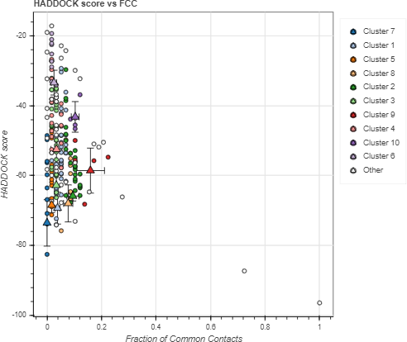

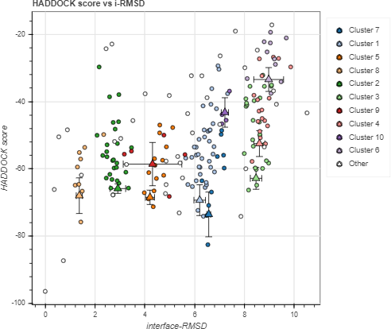

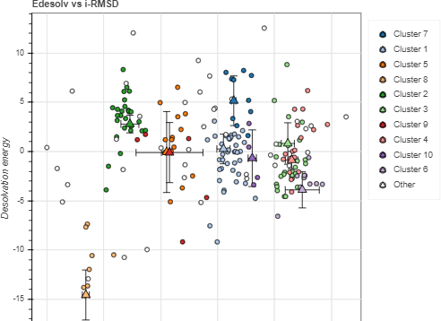

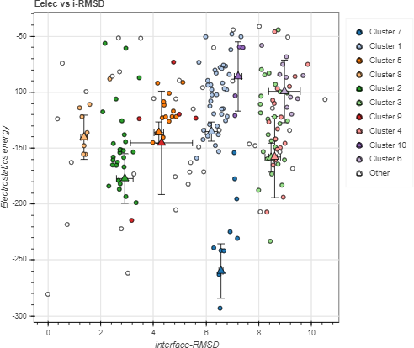

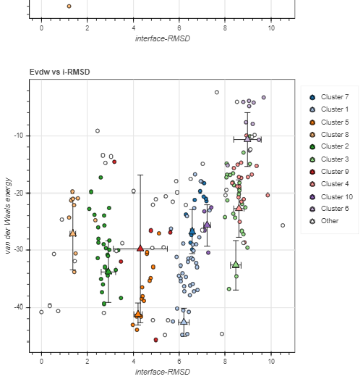

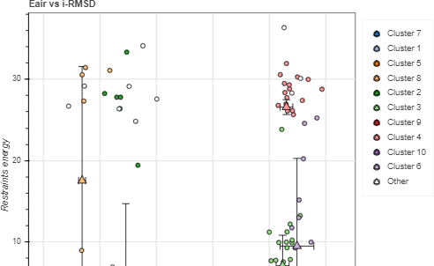

**Cluster Analysis**

All

None

Cluster 7

Cluster 1

Cluster 5

Cluster 8

Cluster 2

Cluster 3

Cluster 9

Cluster 4

Cluster 10

Cluster 6 Ot

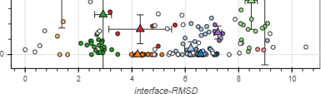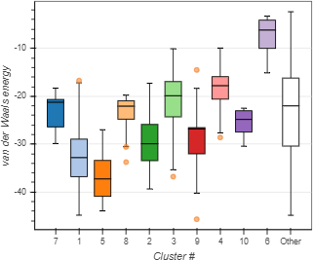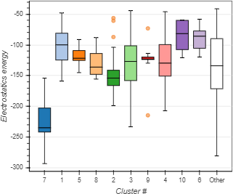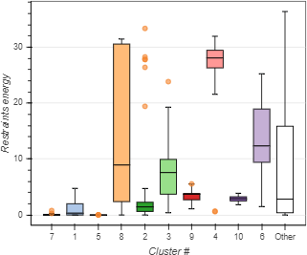

**Proudly powered by:**

This work is co-funded by the Horizon 2020 projects [E OSC-hub](https://www.eosc-hub.eu/) and [E GI-ACE](https://www.egi.eu/projects/egi-ace) (grant numbers 7 [77536](https://cordis.europa.eu/project/id/777536) and [1 01017567](https://cordis.europa.eu/project/id/101017567)), B [ioExcel](http://www.bioexcel.eu/) (grant numbers [8 23830](https://cordis.europa.eu/project/id/823830) and 6 [75728](https://cordis.europa.eu/project/id/675728)) and by a computing grant from N [WO-ENW](https://www.nwo.nl/) (project number 2019.053).



2008-2022 © Computational Structural Biology group. All rights reserved.

Webdesign by Marc van Dijk, Mikael Trellet, Jörg Schaarschmidt, Brian Jiménez-García & Rodrigo Vargas Honorato

T [erms of use |](https://wenmr.science.uu.nl/conditions) [P rivacy](https://wenmr.science.uu.nl/privacy)