**Supporting Information**

**Structural modifications and biomedical applications of π-extended, π-fused, and non-fused tetra-substituted imidazole derivatives**

Sivaraman Somasundarama#, Sri Renukadevi Balusamyb#**\***, Haribalan Perumalsamyc,d, Anuj Ranjane**,** Qamar Abbasf, Navabshan Irfang, Rajeshkumar Shunmugamh and Sanghyuk Parka,**\***

*aDepartment of Chemistry, Kongju National University, 56 Gongjudaehak-ro, Gongju, Chungnam 32588, Republic of Korea.*

*bDepartment of Food Science and Biotechnology, Sejong University, Gwangjin-gu, Seoul 05006, Republic of Korea.*

*cCenter for Creative Convergence Education, Hanyang University, Seoul 04763, Republic of Korea.*

*dResearch Institute for Next Generation Material Design, Hanyang University, Seoul 04763, Republic of Korea.*

*eAcademy of Biology and Biotechnology, Southern Federal University, Stachki 194/1, Rostov-on-Don, 344090, Russia.*

*fDepartment of Biological Sciences, Kongju National University, 56 Gongjudaehak-ro, Gongju, Chungnam 32588, Republic of Korea.*

*gCrescent School of Pharmacy, Crescent Institute of Science and Technology, Vandalur, Chennai-48, Tamilnadu, India.*

*hDepartment of Pharmacology, Saveetha Dental College & Hospitals, Saveetha Institute of Medical and Technical Sciences (SIMATS), Chennai, Tamilnadu, India.*

# These authors contributed equally to this manuscript.

\***Corresponding Author**

Prof. Sri Renukadevi Balusamy, [renubalu@sejong.ac.kr](mailto:renubalu@sejong.ac.kr), 02-6935-2611

Prof. Sanghyuk Park, Email: [spark0920@kongju.ac.kr](mailto:spark0920@kongju.ac.kr), Mobile: +82-10-2565-5354,

Fax: +82-41-856-8613.

**Spectral data of synthesized compounds**

**Figure S1. 1H NMR spectrum of compound 7,8-diphenyl-7H-acenaphtho[1,2-d]imidazole (ATPI-F)**

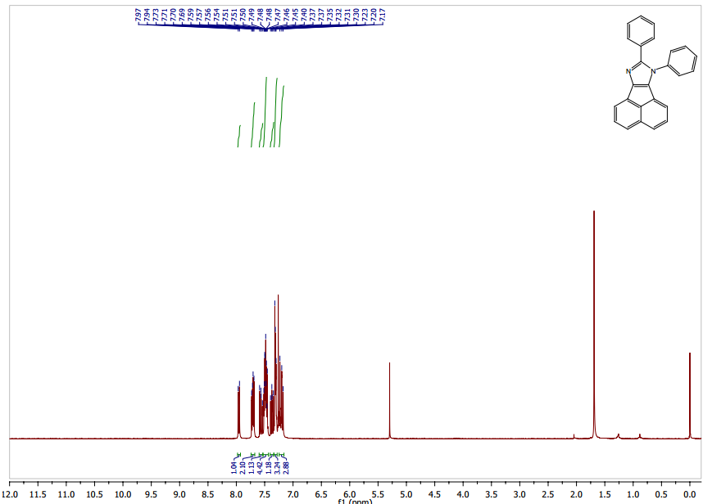

**Figure S2. 13C NMR spectrum of compound 7,8-diphenyl-7H-acenaphtho[1,2-d]imidazole (ATPI-F)**

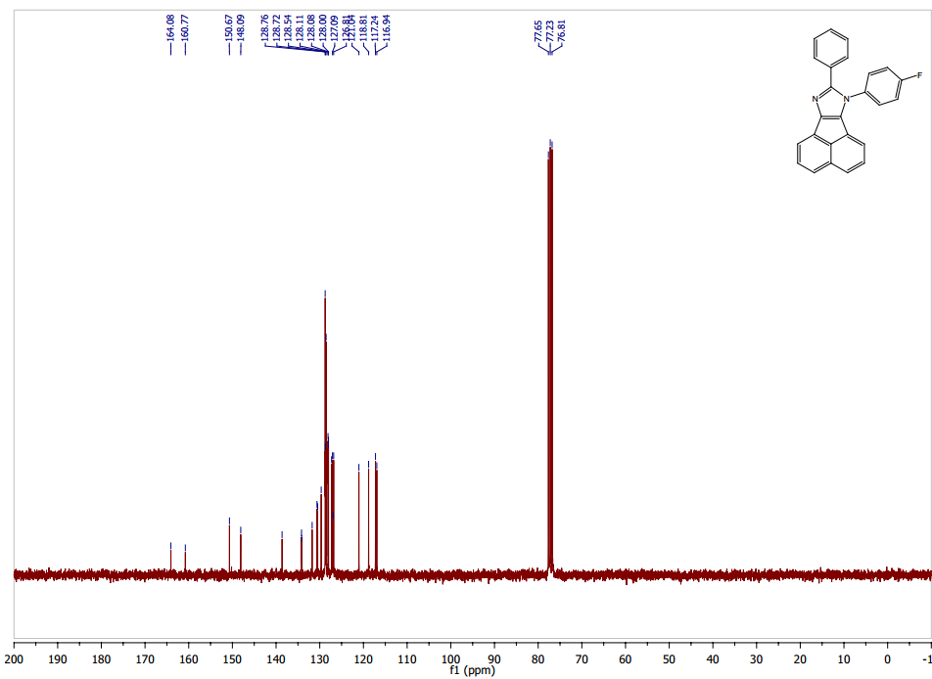

**Figure S3. 1H NMR spectrum of compound 7-(4-fluorophenyl)-8-(2-methoxyphenyl)-7H-acenaphtho[1,2-d]imidazole (AOMPI-F)**

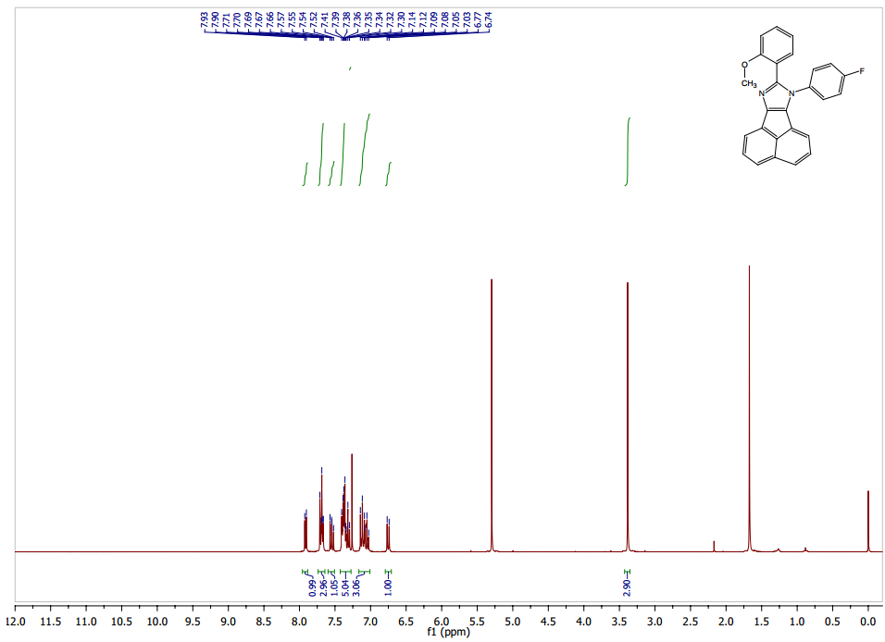

**Figure S4. 13C NMR spectrum of compound 7-(4-fluorophenyl)-8-(2-methoxyphenyl)-7H-acenaphtho[1,2-d]imidazole (AOMPI-F)**

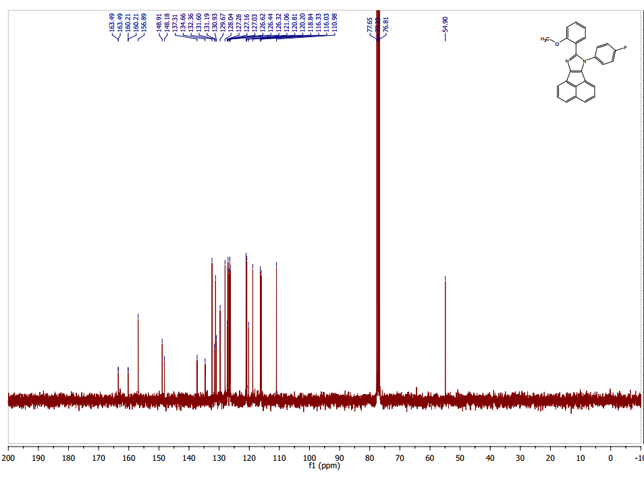

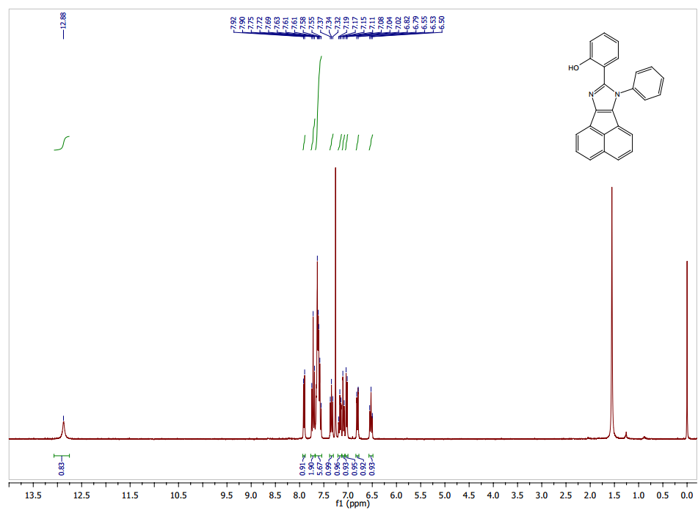**Figure S5. 1H NMR spectrum of compound 2-(7-phenyl-7H-acenaphtho[1,2-d]imidazol-8-yl)phenol (AHPI)**

**Figure S6. 13C NMR spectrum of compound 2-(7-phenyl-7H-acenaphtho[1,2-d]imidazol-8-yl)phenol (AHPI)**

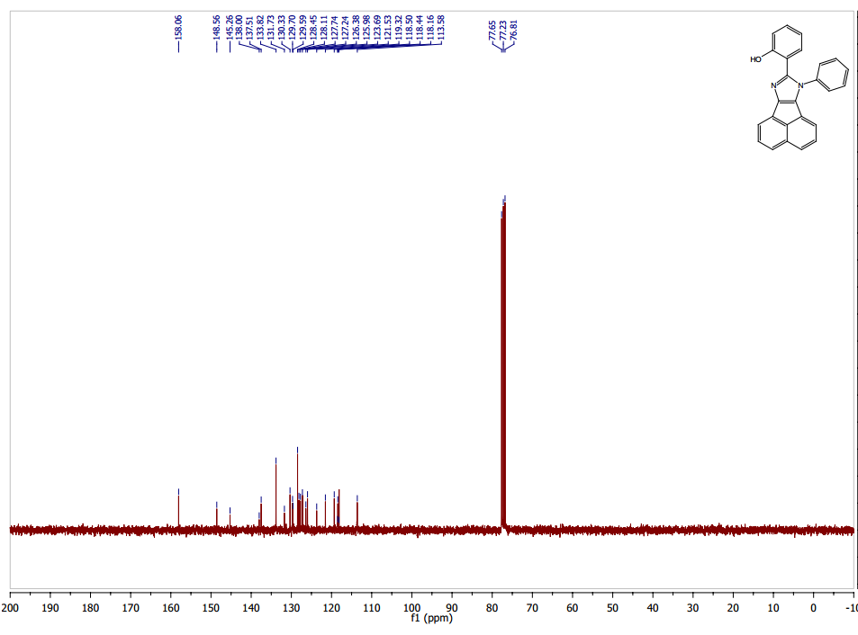

**Figure S7. 1H NMR spectrum of compound 2-(7-(4-fluorophenyl)-7H-acenaphtho[1,2-d]imidazol-8-yl)phenol (AHPI-F)**

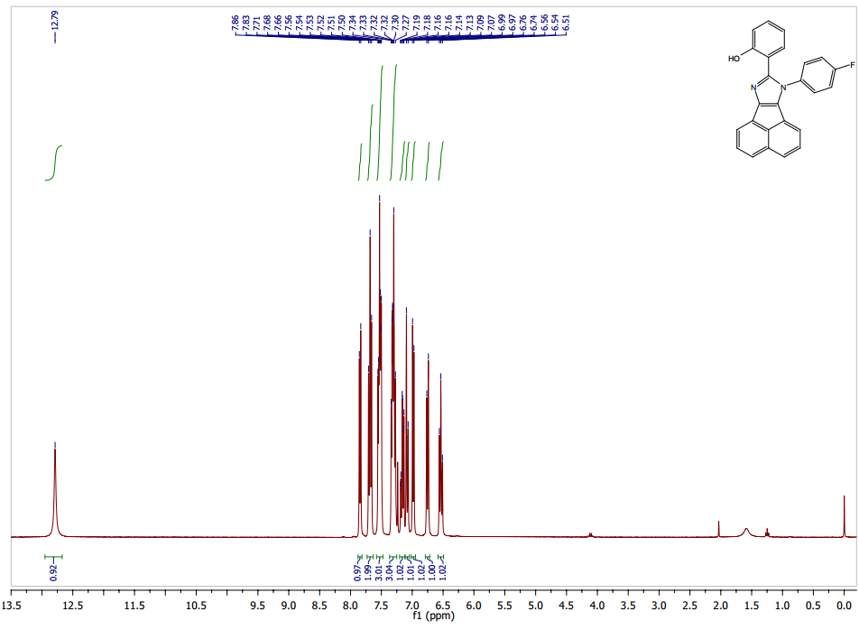

**Figure S8 .13C NMR spectrum of compound 2-(7-(4-fluorophenyl)-7H-acenaphtho[1,2-d]imidazol-8-yl)phenol (AHPI-F)**

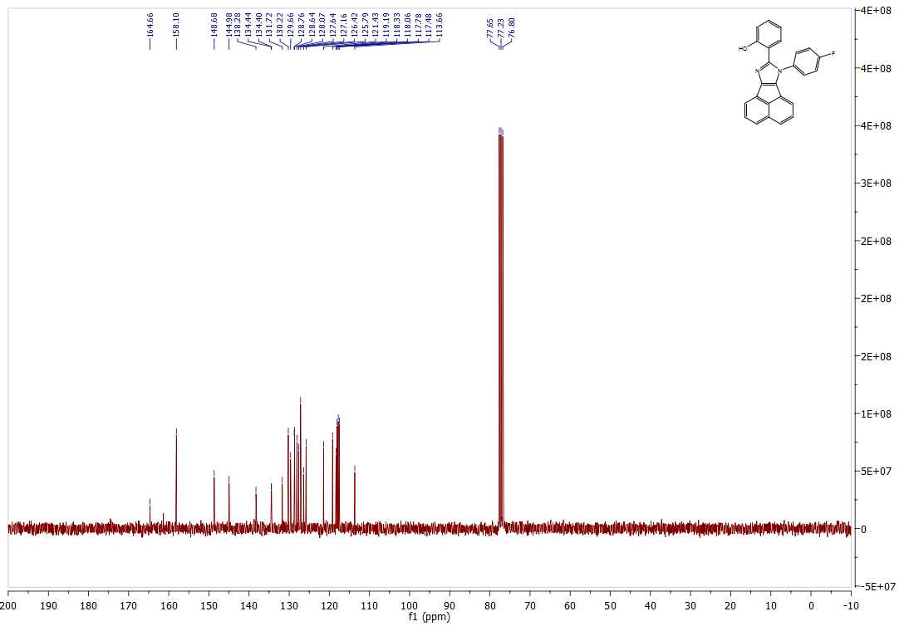

**Figure S9. 1H NMR spectrum of compound 2-(7-(4-chlorophenyl)-7H-acenaphtho[1,2-d]imidazol-8-yl)phenol (AHPI-Cl)**

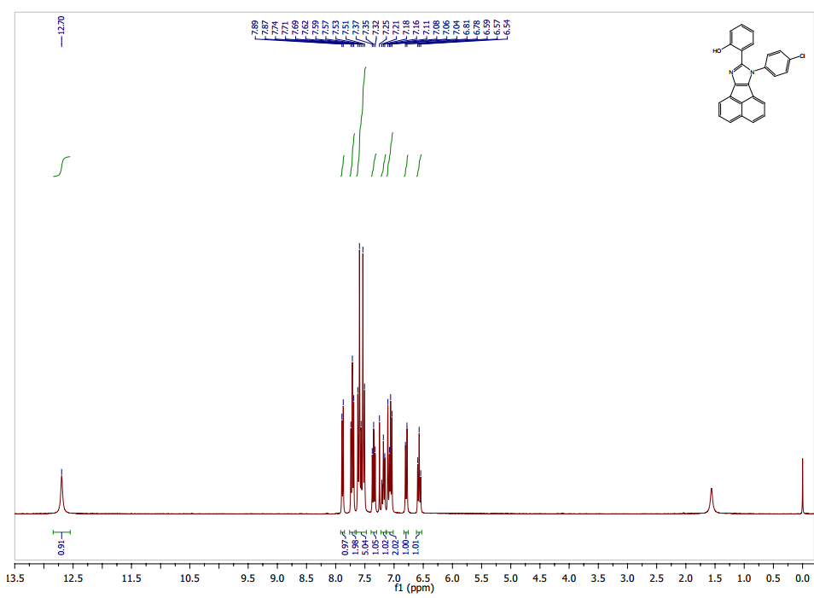

**Figure S10. 13C NMR spectrum of compound 2-(7-(4-chlorophenyl)-7H-acenaphtho[1,2-d]imidazol-8-yl)phenol (AHPI-Cl)**

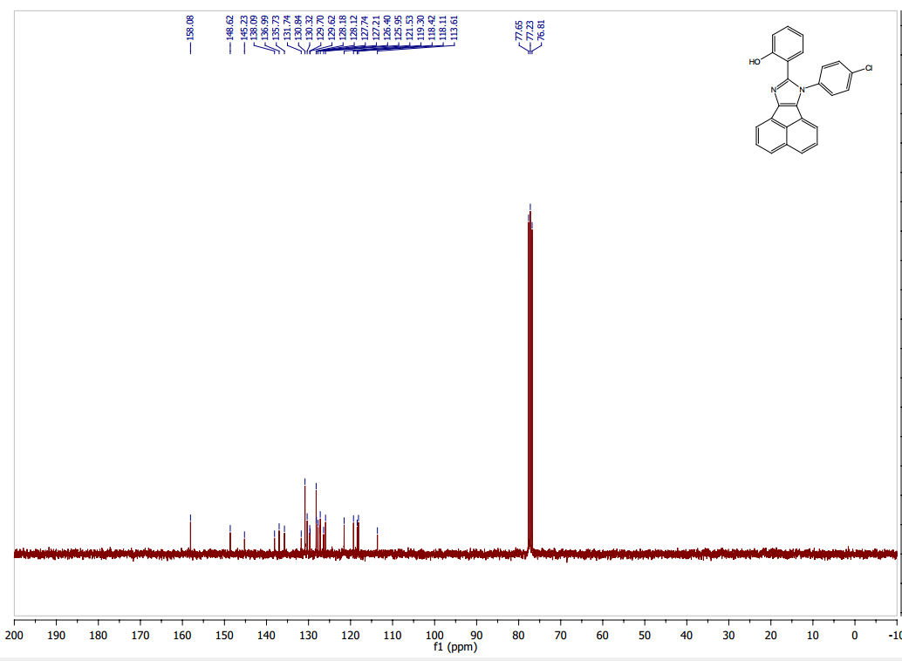

**Figure S11. 1H NMR spectrum of compound 2-(7-(4-bromophenyl)-7H-acenaphtho[1,2-d]imidazol-8-yl)phenol (AHPI-Br)**

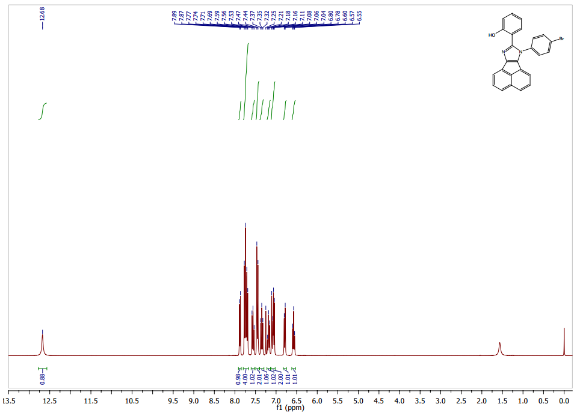

**Figure S12. 13C NMR spectrum of compound 2-(7-(4-bromophenyl)-7H-acenaphtho[1,2-d]imidazol-8-yl)phenol (AHPI-Br)**

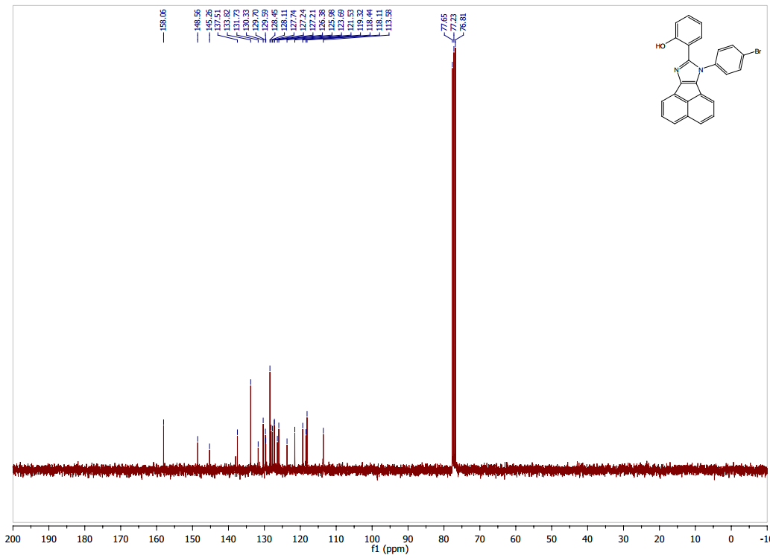

**Figure S13. 1H NMR spectrum of compound 2-(7-(4-iodophenyl)-7H-acenaphtho[1,2-d]imidazol-8-yl)phenol (AHPI-I)**

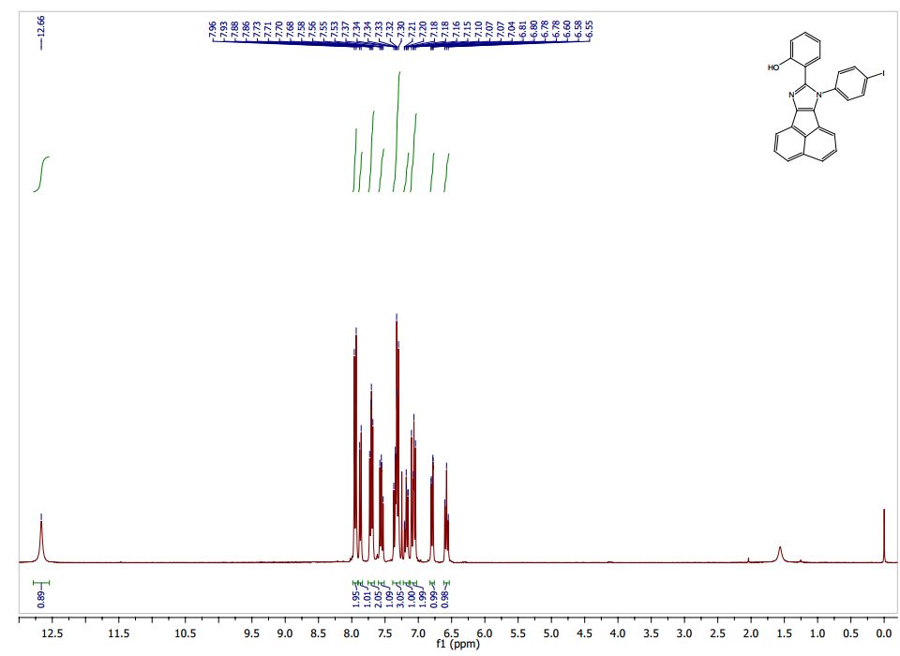

**Figure S14. 13C NMR spectrum of compound 2-(7-(4-iodophenyl)-7H-acenaphtho[1,2-d]imidazol-8-yl)phenol (AHPI-I)**

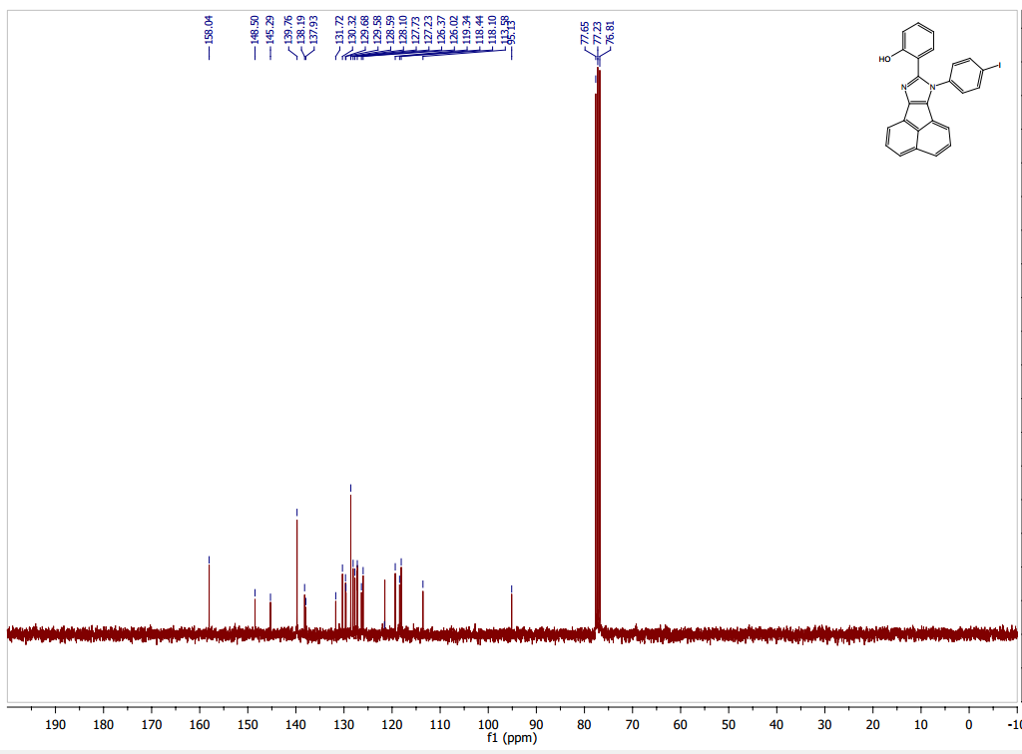

**Figure S15. 1H NMR spectrum of compound 4-(8-(2-hydroxyphenyl)-7H-acenaphtho[1,2-d]imidazol-7-yl)phenethyl acetate (AHPI- EtOAc)**

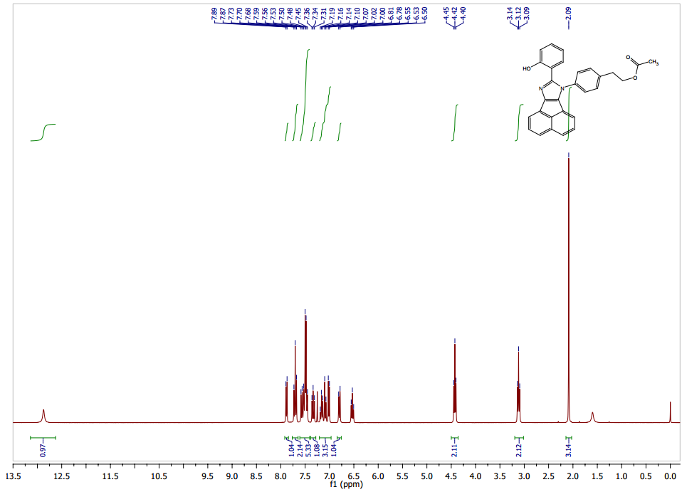

**Figure S16. 13C NMR spectrum of compound 4-methoxy-2-(7-phenyl-7H-acenaphtho[1,2-d]imidazol-8-yl)phenol (AMHPI)**

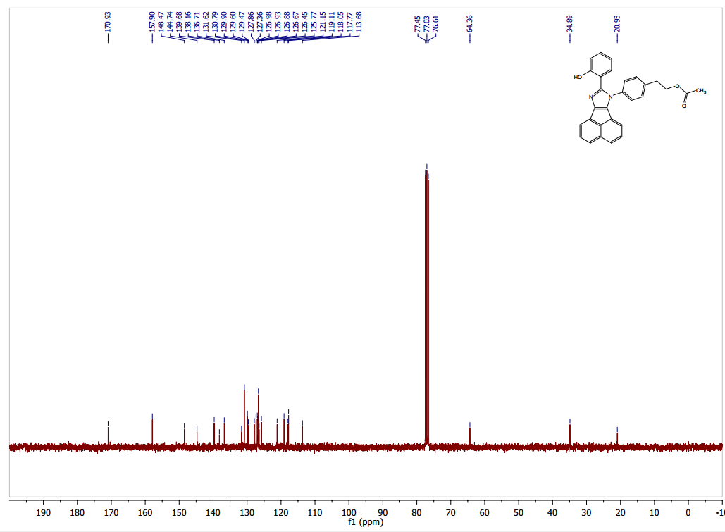

**Figure S17. 1H NMR spectrum of compound 4-methoxy-2-(7-phenyl-7H-acenaphtho[1,2-d]imidazol-8-yl)phenol (AMHPI)**

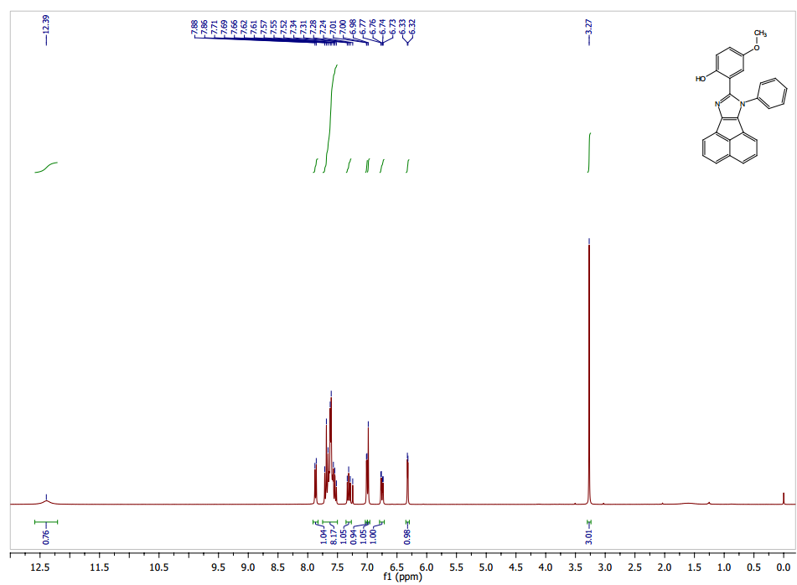

**Figure S18. 13C NMR spectrum of compound 4-methoxy-2-(7-phenyl-7H-acenaphtho[1,2-d]imidazol-8-yl)phenol (AMHPI)**

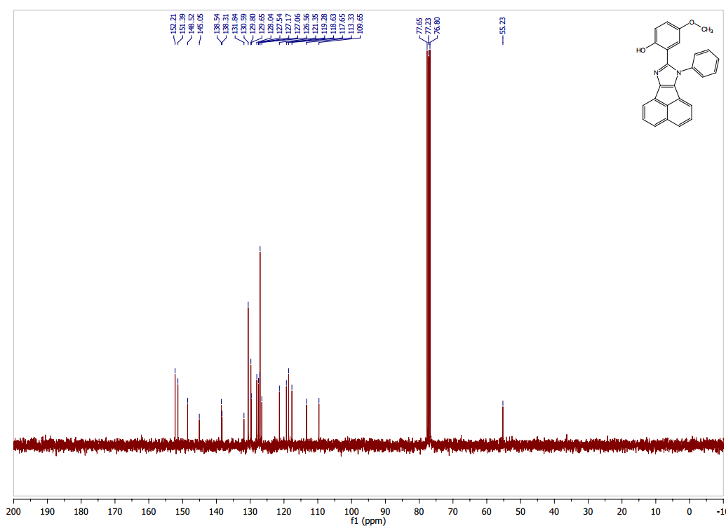

**Figure S19. 1H NMR spectrum of compound 1-(4-fluorophenyl)-2,4,5-triphenyl-1H-imidazole (BTPI-F)**

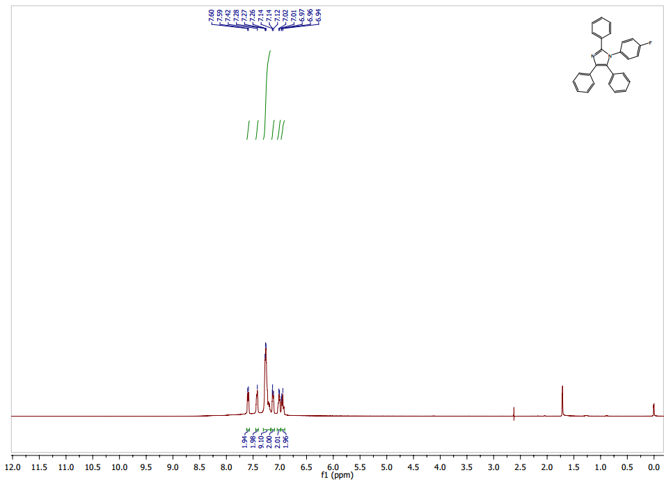

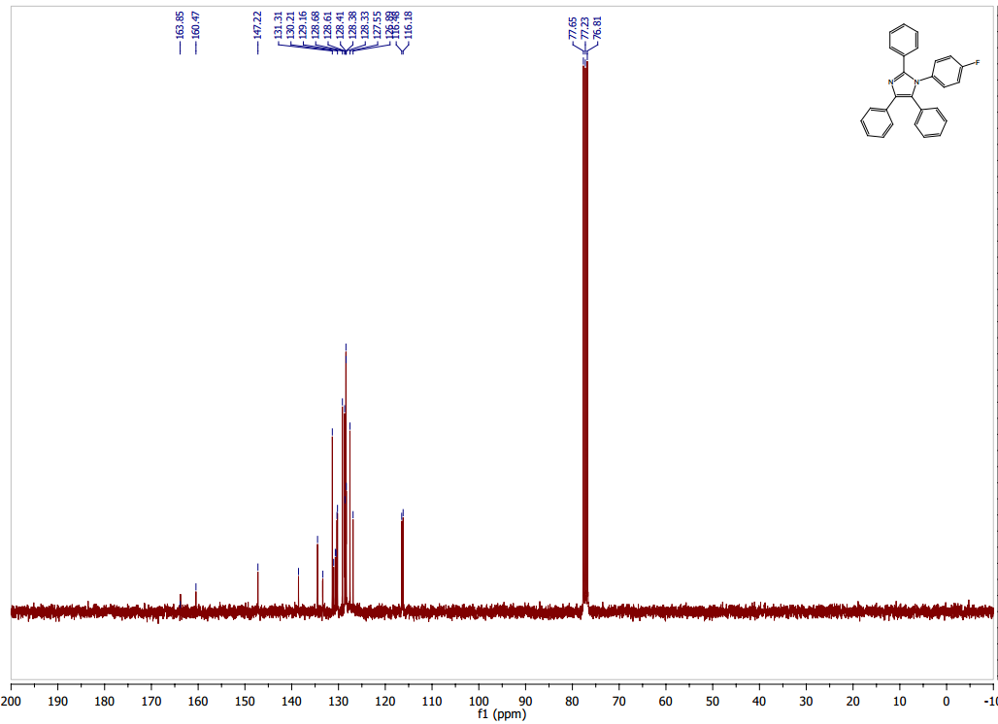**Figure S20. 13C NMR spectrum of compound 1-(4-fluorophenyl)-2,4,5-triphenyl-1H-imidazole (BTPI-F)**

**Figure S21. 1H NMR spectrum of compound 1-(4-fluorophenyl)-2-(2-methoxyphenyl)-4,5-diphenyl-1H-imidazole (BOMPI-F)**

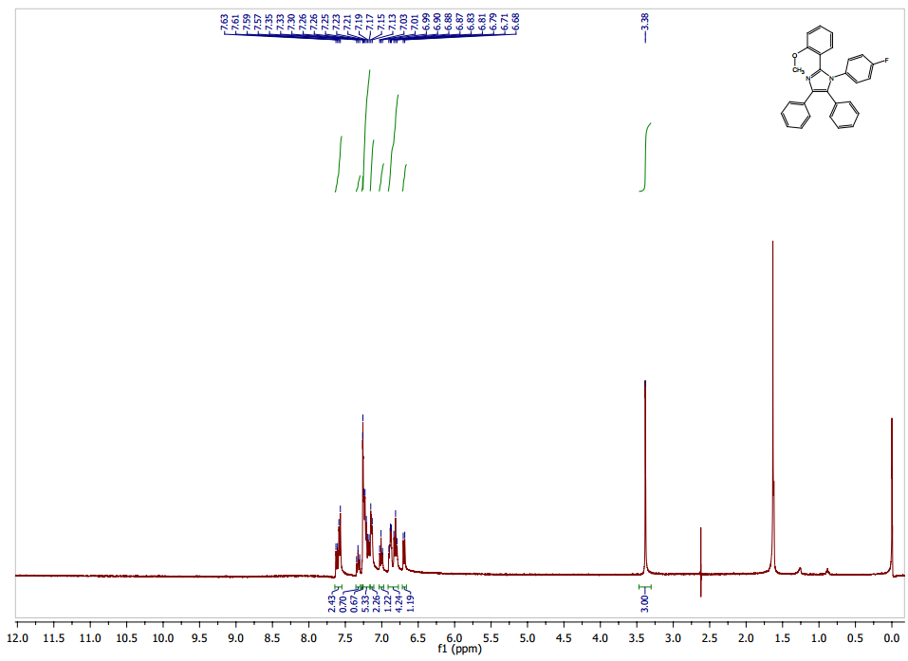

**Figure S22. 13C NMR spectrum of compound 1-(4-fluorophenyl)-2-(2-methoxyphenyl)-4,5-diphenyl-1H-imidazole (BOMPI-F)**

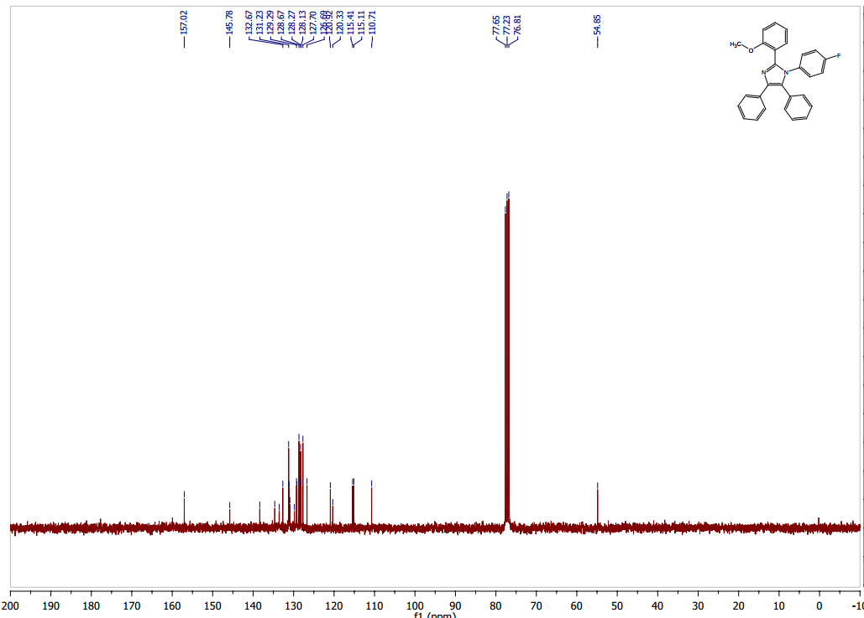

**Figure S23. 1H NMR spectrum of compound 2-(1,4,5-triphenyl-1H-imidazol-2-yl)phenol (BHPI)**

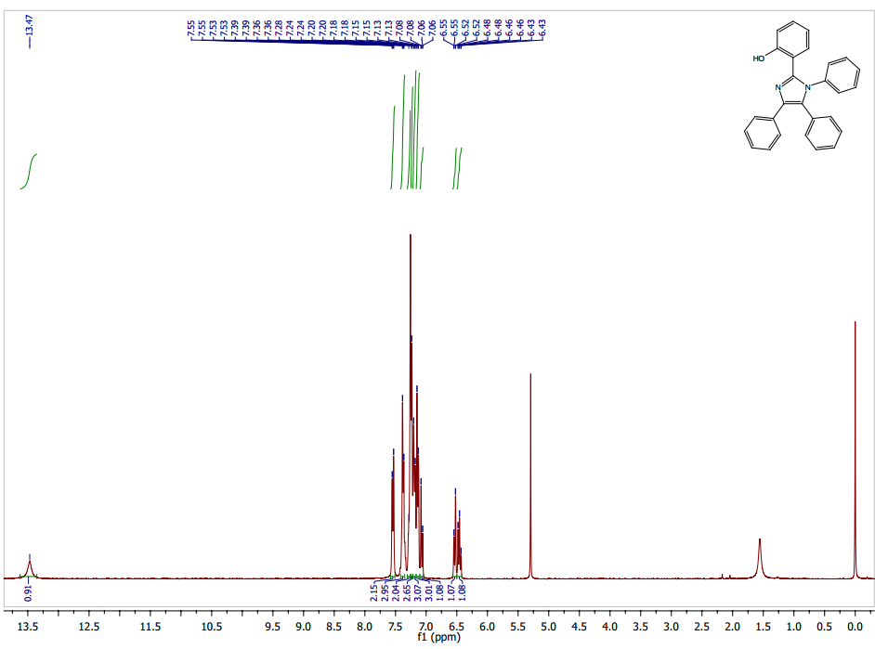

**Figure S24. 13C NMR spectrum of compound 2-(1,4,5-triphenyl-1H-imidazol-2-yl)phenol (BHPI)**

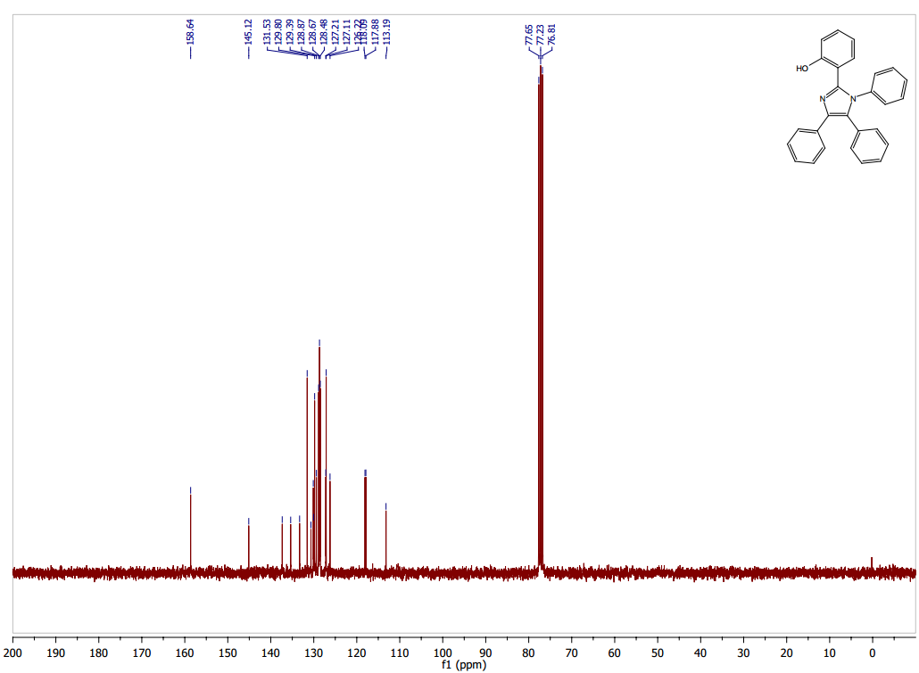

**Figure S25. 1H NMR spectrum of compound 2-(1-(4-fluorophenyl)-4,5-diphenyl-1H-imidazol-2-yl)phenol (BHPI-F)**

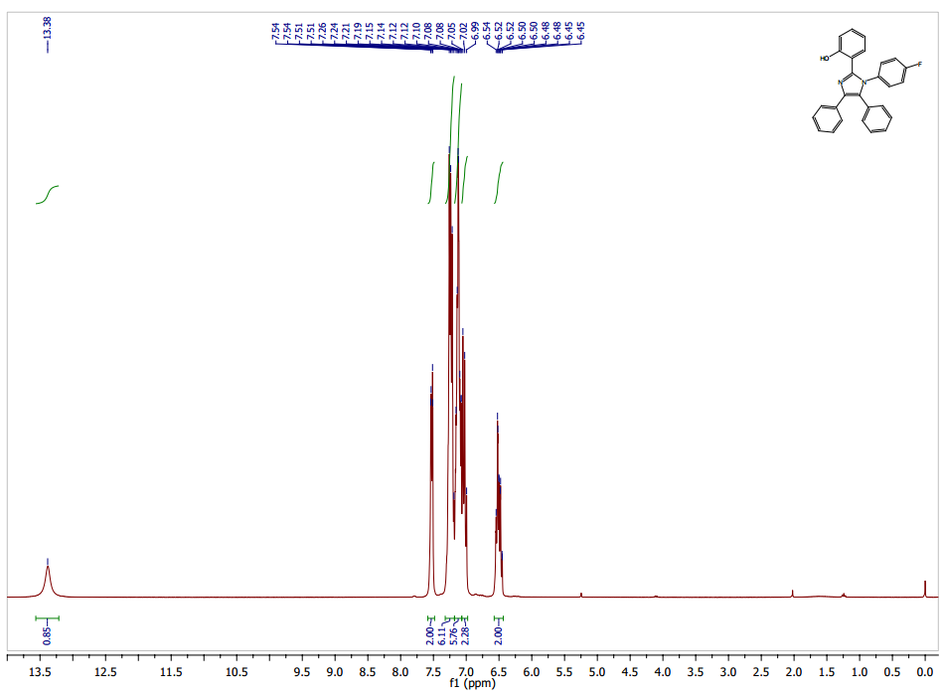

**Figure S26. 13C NMR spectrum of compound 2-(1-(4-fluorophenyl)-4,5-diphenyl-1H-imidazol-2-yl)phenol (BHPI-F)**

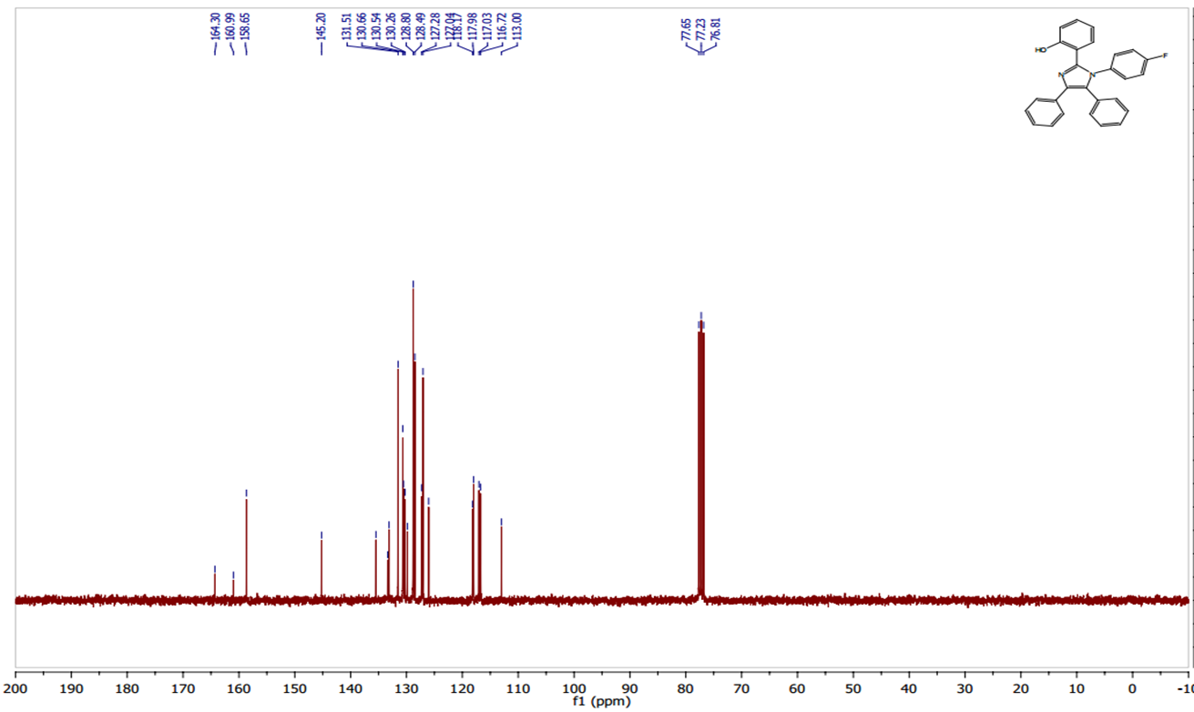

**Figure S27. 1H NMR spectrum of compound (2-(1-(4-chlorophenyl)-4,5-diphenyl-1H-imidazol-2-yl)phenol (BHPI-Cl)**

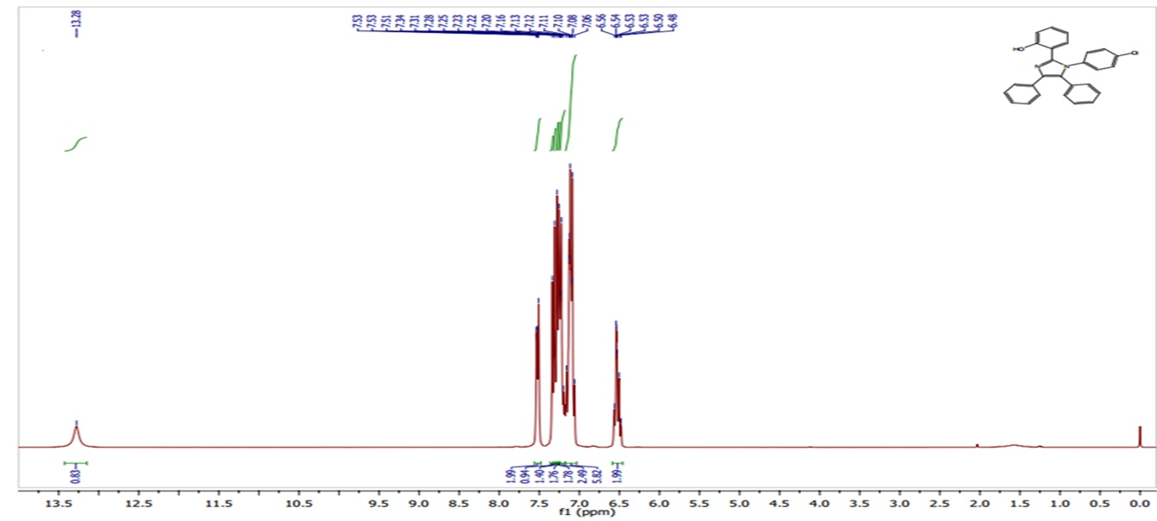

**Figure S28. 13C NMR spectrum of compound (2-(1-(4-chlorophenyl)-4,5-diphenyl-1H-imidazol-2-yl)phenol (BHPI-Cl)**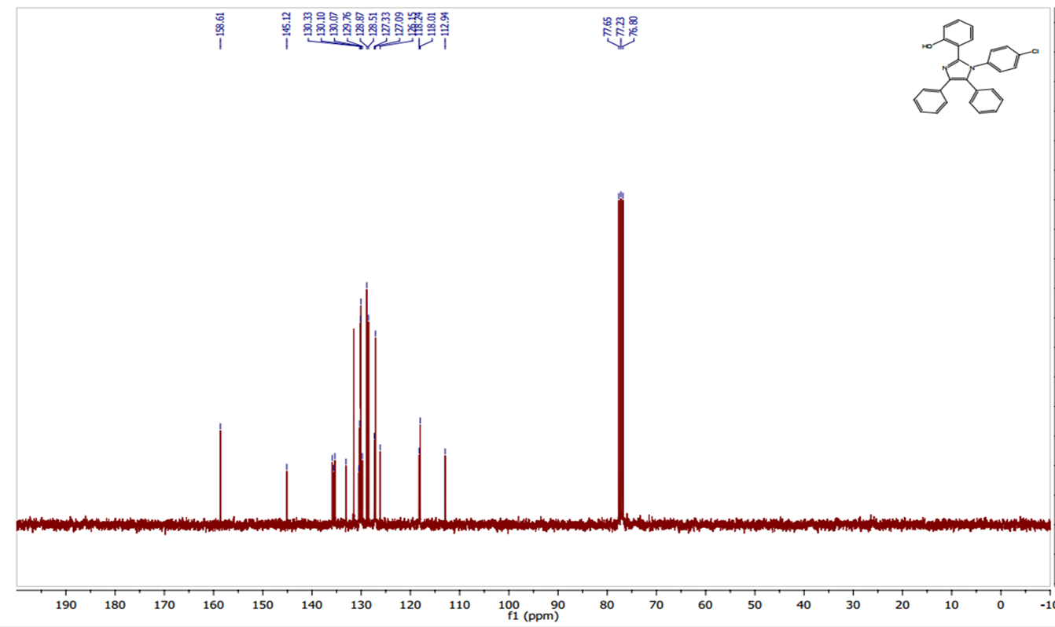

**Figure S29. 1H NMR spectrum of compound 2-(1-(4-bromophenyl)-4,5-diphenyl-1H-imidazol-2-yl)phenol (BHPI-Br)**

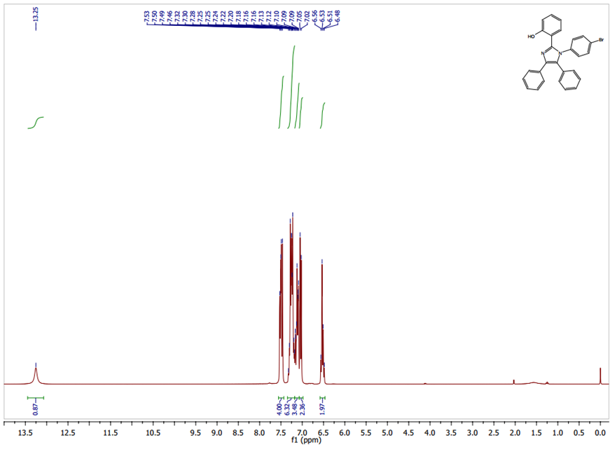

**Figure S30. 13C NMR spectrum of compound 2-(1-(4-bromophenyl)-4,5-diphenyl-1H-imidazol-2-yl)phenol (BHPI-Br)**

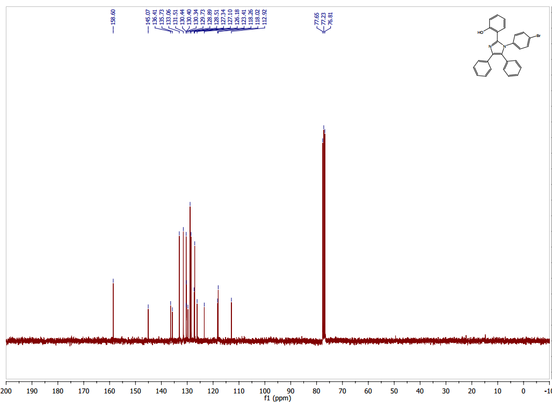

**Figure S31. 1H NMR spectrum of compound 2-(1-(4-iodophenyl)-4,5-diphenyl-1H-imidazol-2-yl)phenol (BHPI-I)**

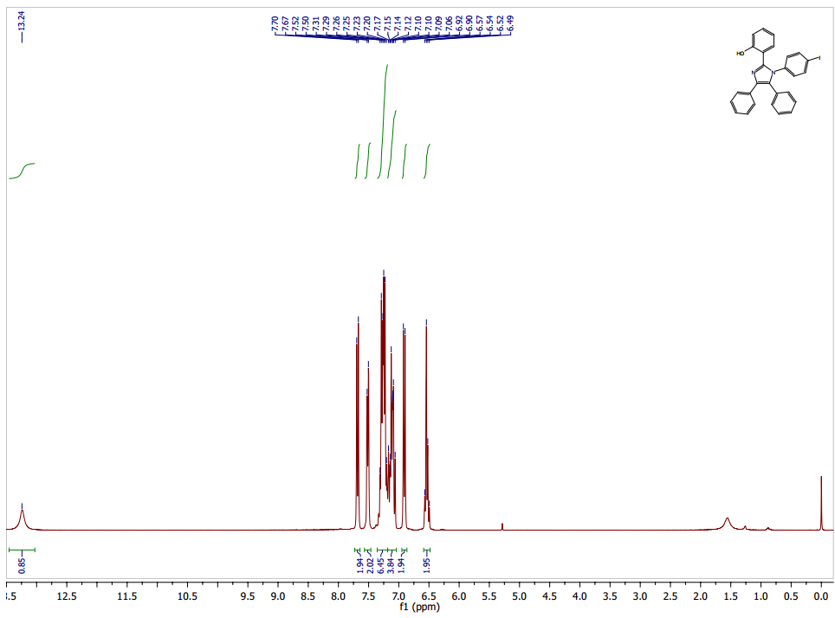

**Figure S32. 13C NMR spectrum of compound 2-(1-(4-iodophenyl)-4,5-diphenyl-1H-imidazol-2-yl)phenol (BHPI-I)**

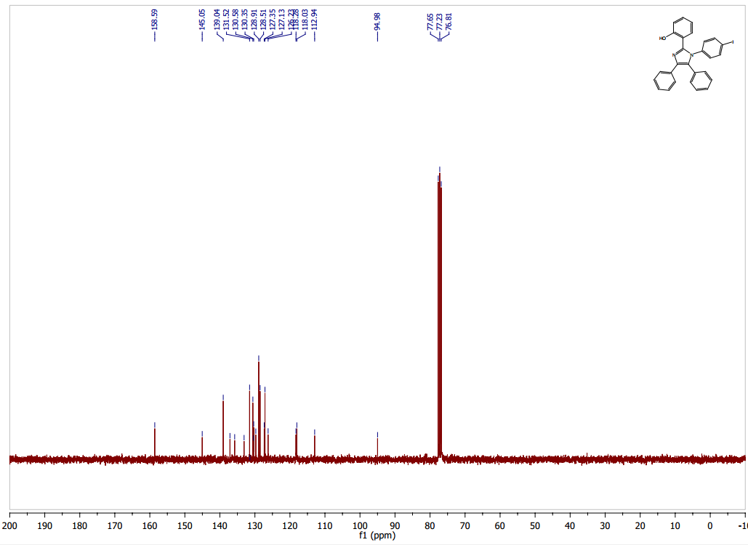

**Figure S33. 1H NMR spectrum of compound 1-(4-fluorophenyl)-2-phenyl-1H-phenanthro[9,10-d]imidazole (PTPI-F)**

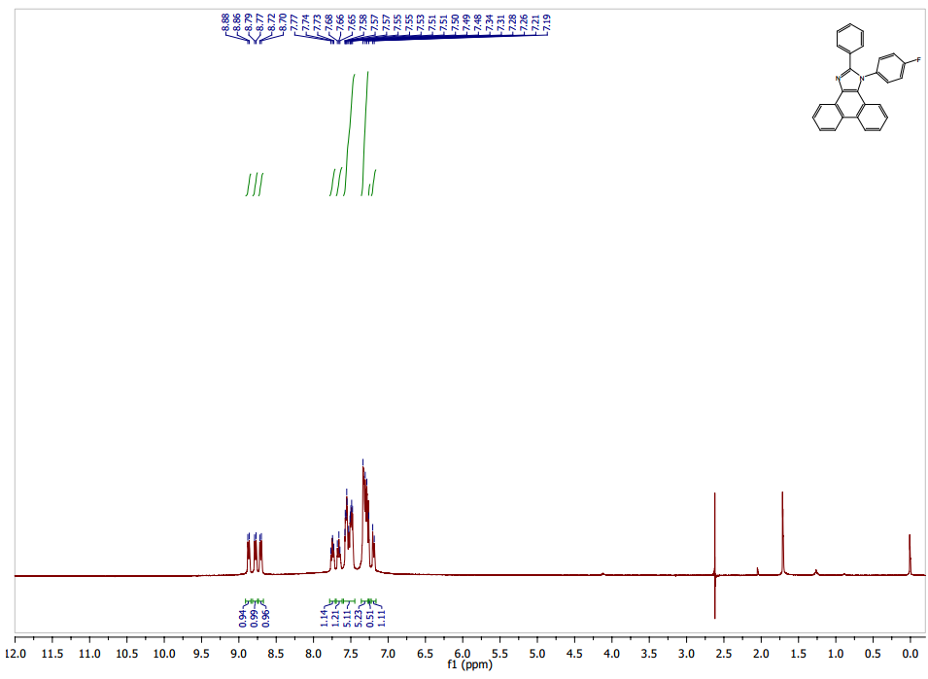

**Figure S34. 13C NMR spectrum of compound 1-(4-fluorophenyl)-2-phenyl-1H-phenanthro[9,10-d]imidazole (PTPI-F)**

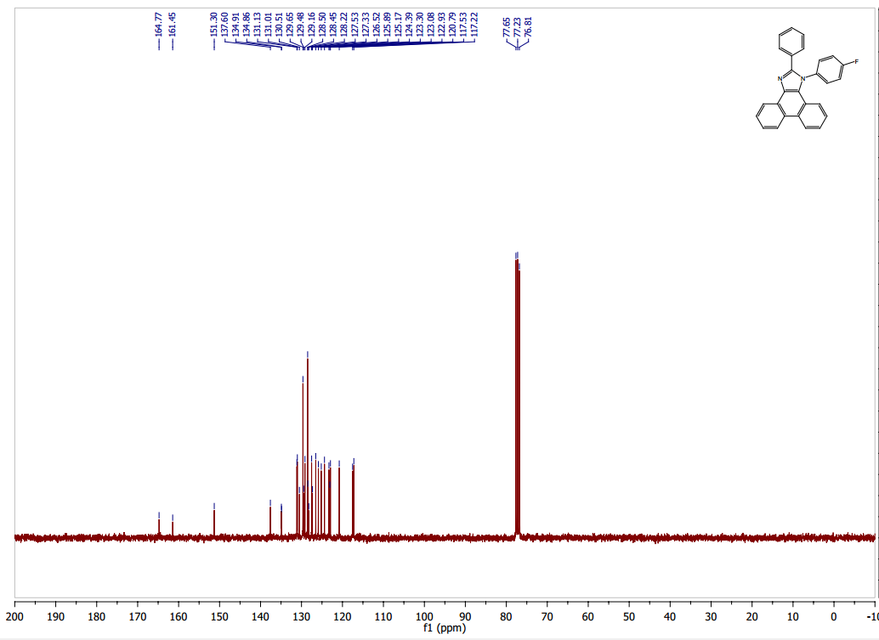

**Figure S35. 1H NMR spectrum of compound 1-(4-fluorophenyl)-2-(2-methoxyphenyl)-1H-phenanthro[9,10-d]imidazole (POMPI-F)**

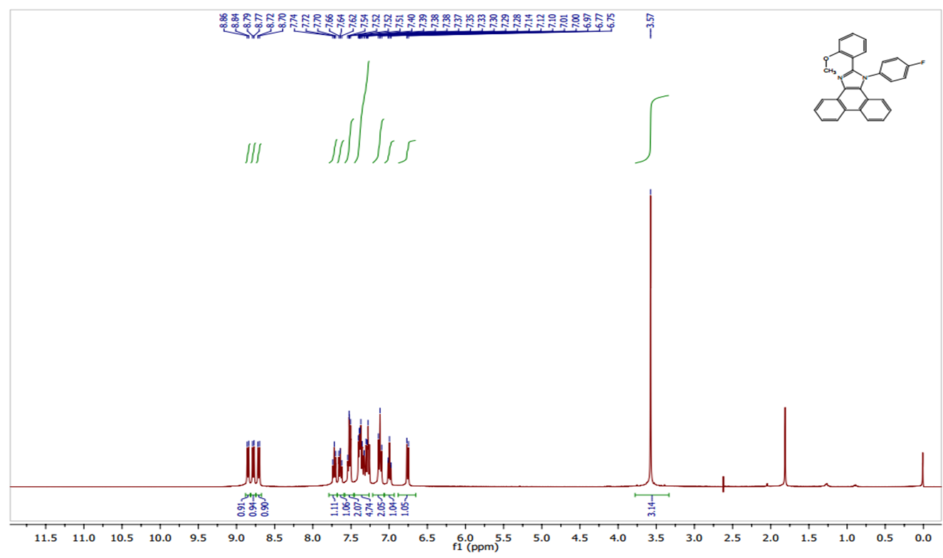

**Figure S36. 13C NMR spectrum of compound 1-(4-fluorophenyl)-2-(2-methoxyphenyl)-1H-phenanthro[9,10-d]imidazole (POMPI-F)**

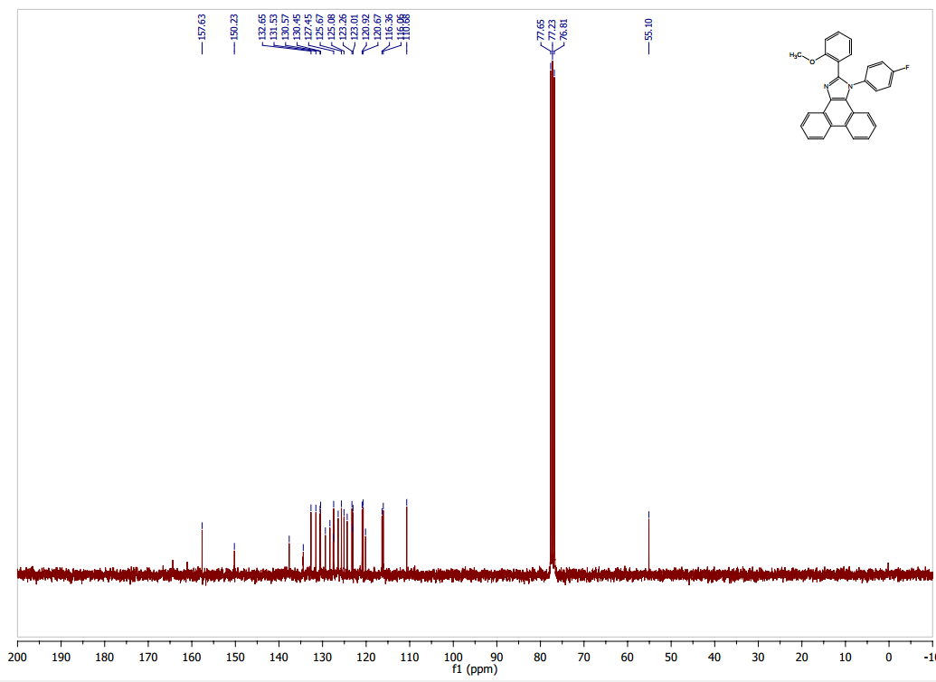

**Figure S37. 1H NMR spectrum of compound 2-(1-phenyl-1H-phenanthro[9,10-d]imidazol-2-yl)phenol (PHPI)**

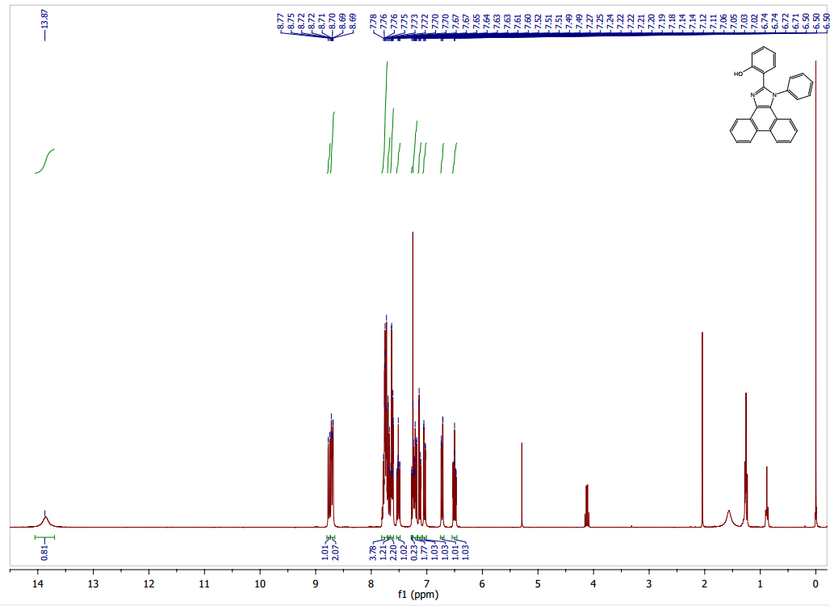

**Figure S38. 13C NMR spectrum of compound 2-(1-phenyl-1H-phenanthro[9,10-d]imidazol-2-yl)phenol (PHPI)**

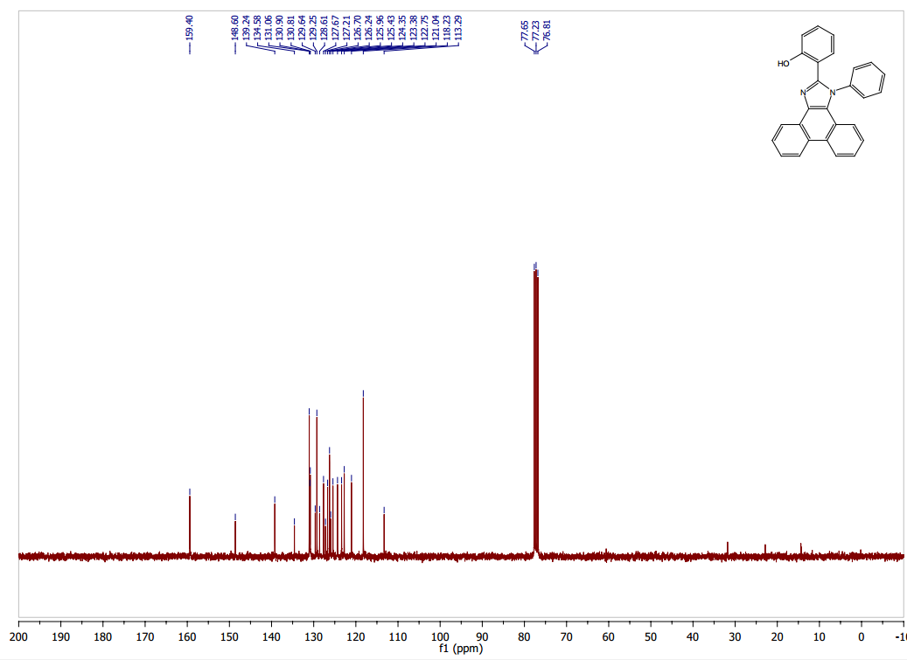

**Figure S39. 1H NMR spectrum of compound 2-(1-(4-fluorophenyl)-1H-phenanthro[9,10-d]imidazol-2-yl)phenol (PHPI-F)**

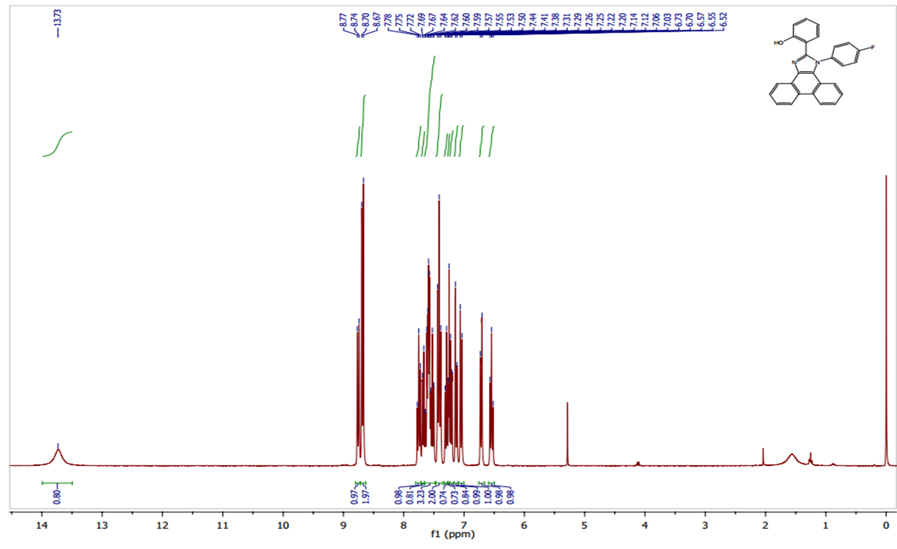

**Figure S40. 13C NMR spectrum of compound 2-(1-(4-fluorophenyl)-1H-phenanthro[9,10-d]imidazol-2-yl)phenol (PHPI-F)**

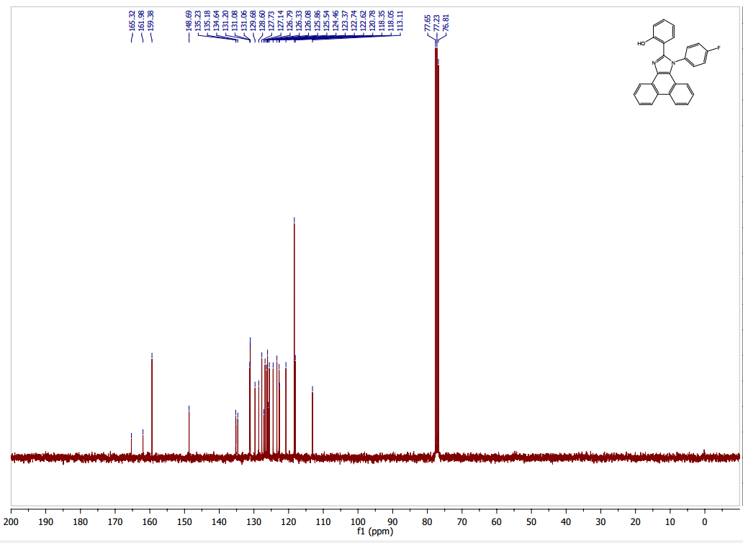

**Figure S41. 1H NMR spectrum of compound 2-(1-(4-chlorophenyl)-1H-phenanthro[9,10-d]imidazol-2-yl)phenol (PHPI-Cl)**

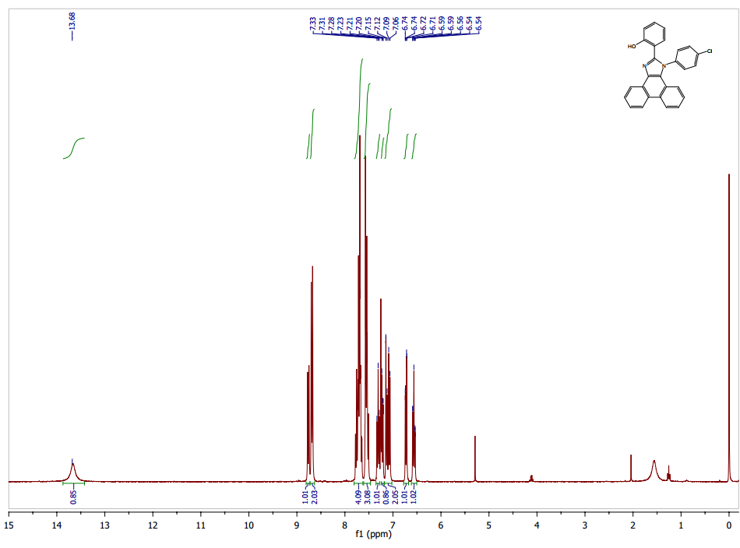

**Figure S42. 13C NMR spectrum of compound 2-(1-(4-chlorophenyl)-1H-phenanthro[9,10-d]imidazol-2-yl)phenol (PHPI-Cl)**

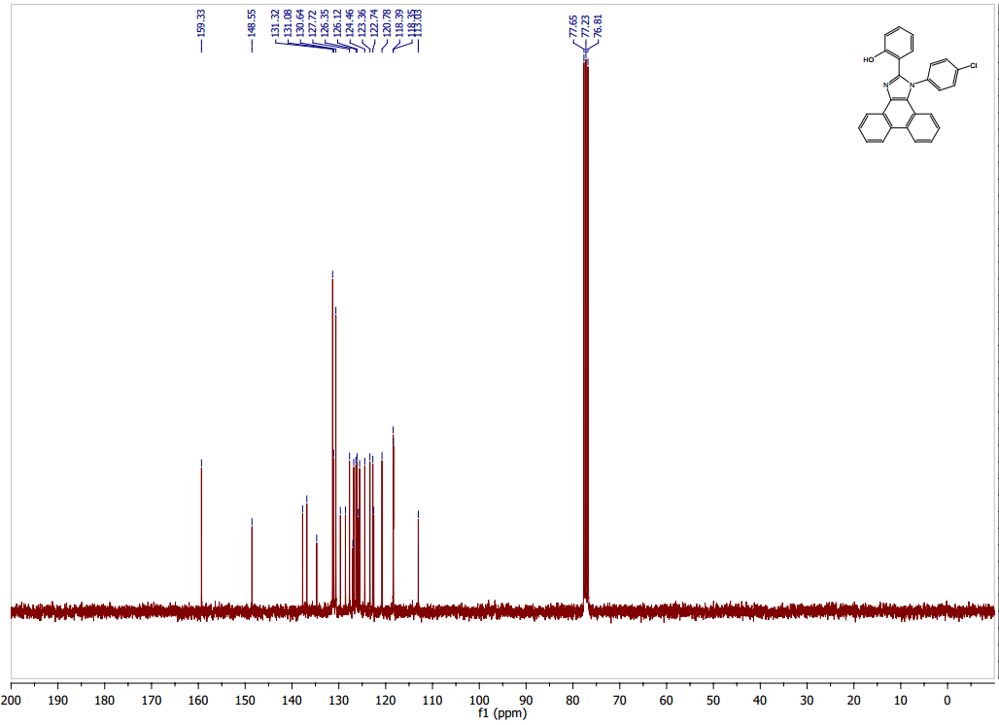

**Figure S43. 1H NMR spectrum of compound 2-(1-(4-bromophenyl)-1H-phenanthro[9,10-d]imidazol-2-yl)phenol (PHPI-Br)**

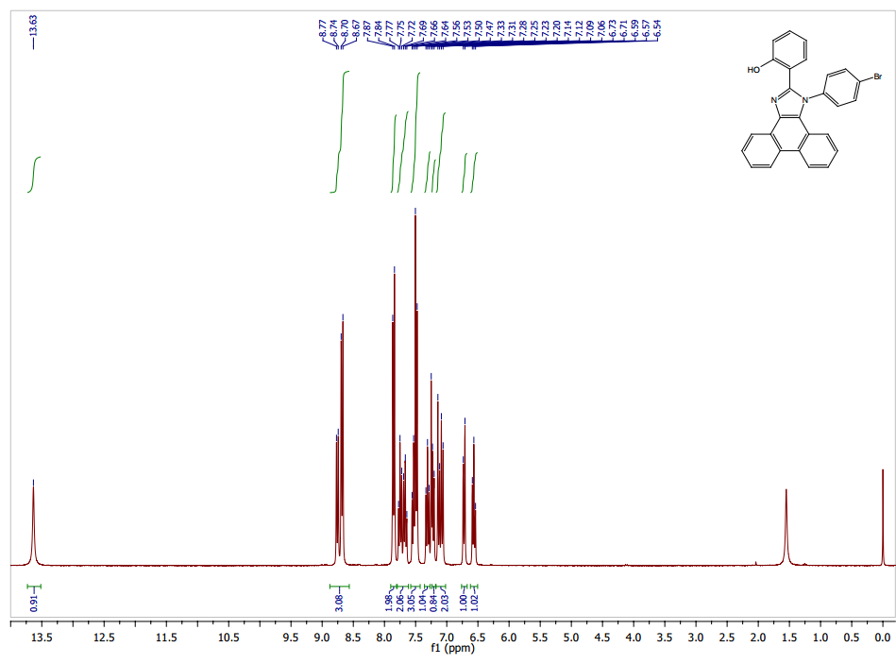

**Figure S44. 13C NMR spectrum of compound 2-(1-(4-bromophenyl)-1H-phenanthro[9,10-d]imidazol-2-yl)phenol (PHPI-Br)**

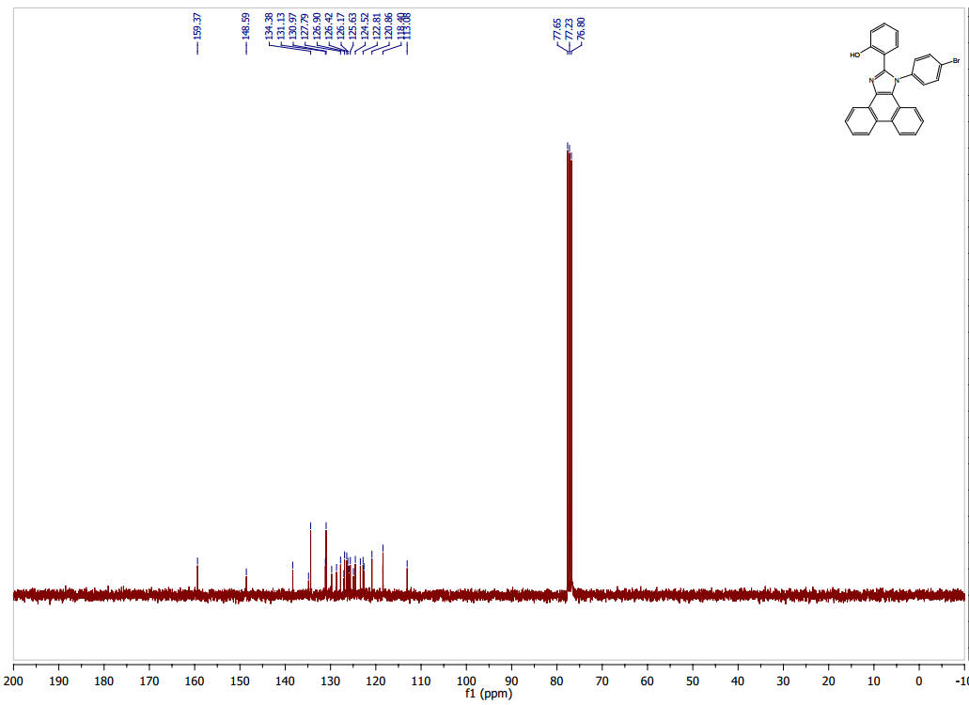

**Figure S45. 1H NMR spectrum of compound 2-(1-(4-iodophenyl)-1H-phenanthro[9,10-d]imidazol-2-yl)phenol (PHPI-I)**

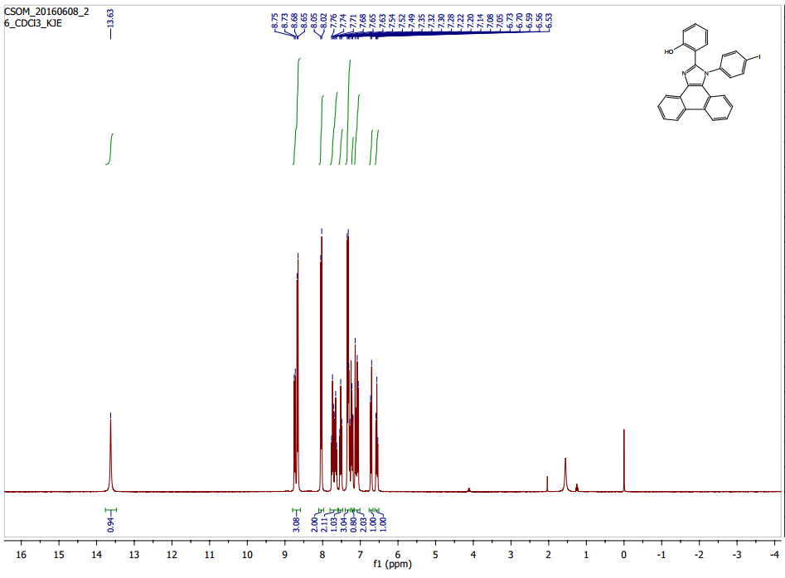

**Figure S46. 13C NMR spectrum of compound 2-(1-(4-iodophenyl)-1H-phenanthro[9,10-d]imidazol-2-yl)phenol (PHPI-I)**

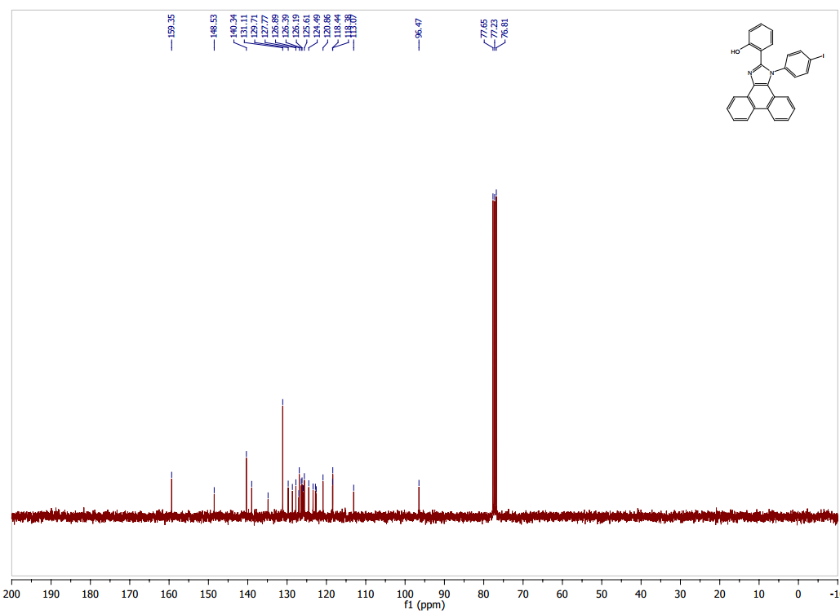

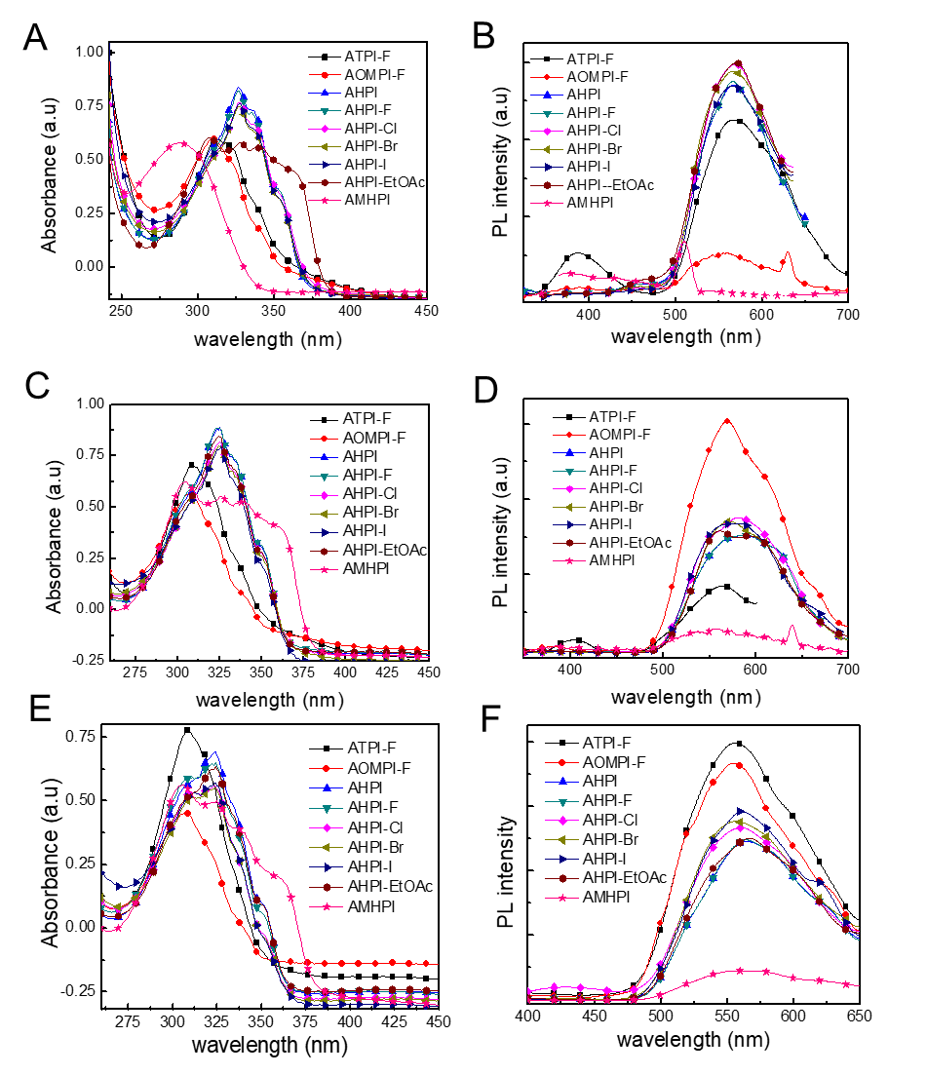

**Figure. S47**. Absorption (A, C, E) and emission (B, D, F) spectra of compound *π*-fused acenaphtho[1,2-d] imidazole using solvents (A, B) CHCl3, (C, D) MeCN and (E, F) EtOH.

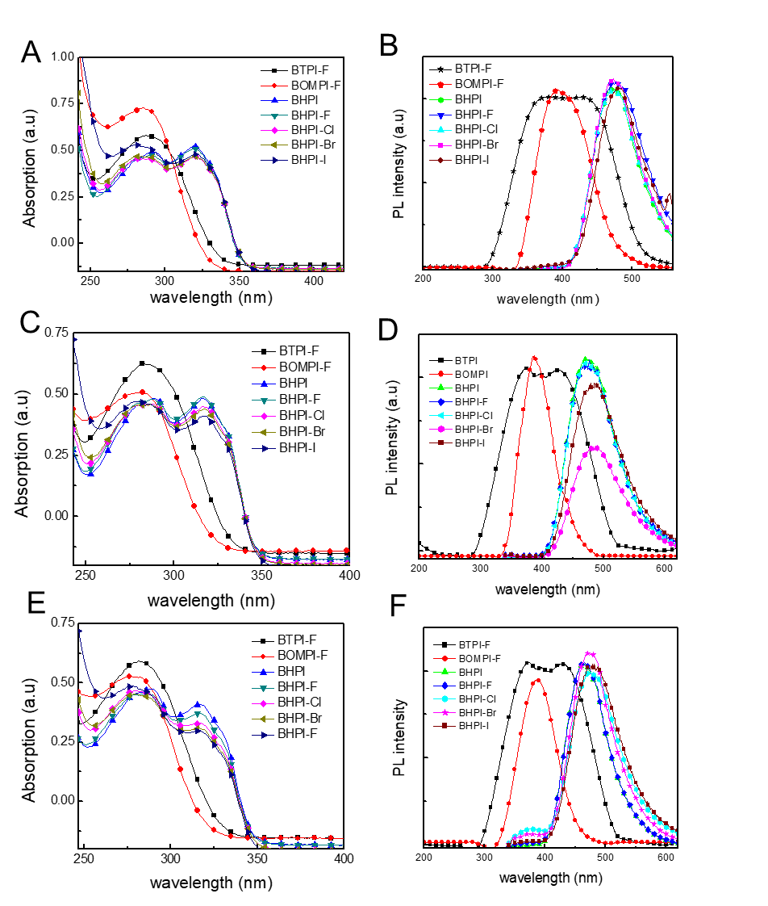

**Figure. S 48**. Absorption (A, C, E) and emission (B, D, F) spectra of compound *π*-expanded phenanthro [9,10-d] imidazole using solvents (A, B) CHCl3, (C, D) MeCN and (E, F) EtOH.

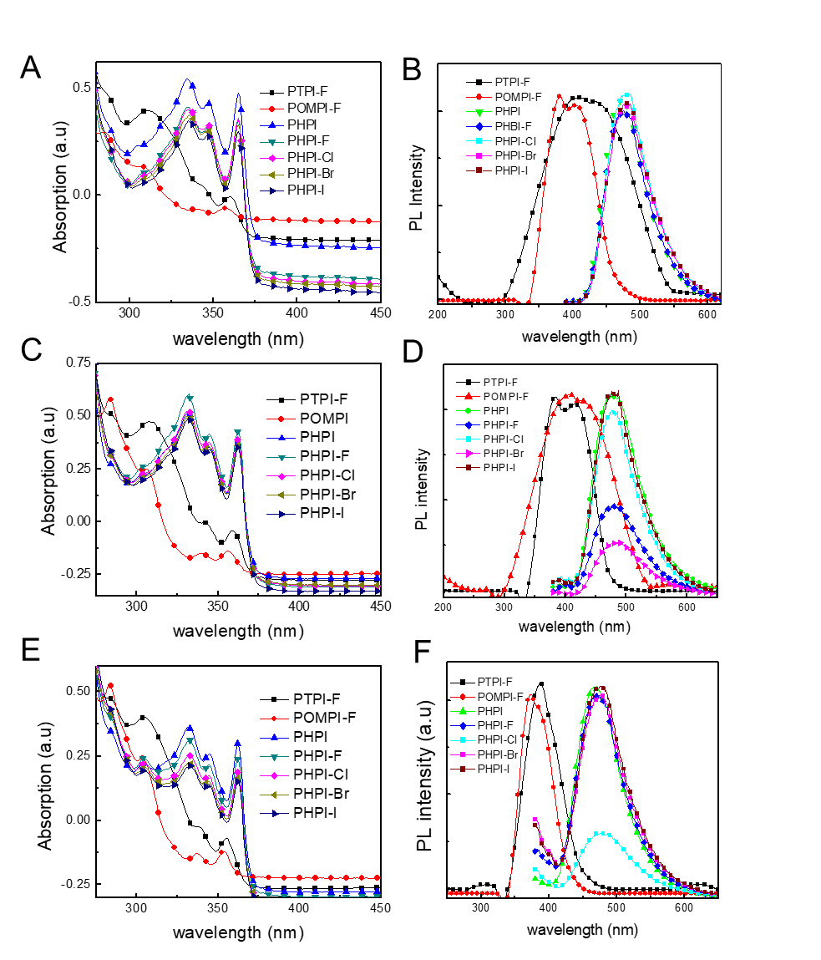

**Figure. S49**. Absorption (A, C, E) and emission (B, D, F) spectra of compound tetrasubstituted imidazole using solvents (A, B) CHCl3, (C, D) MeCN and (E, F) EtOH.

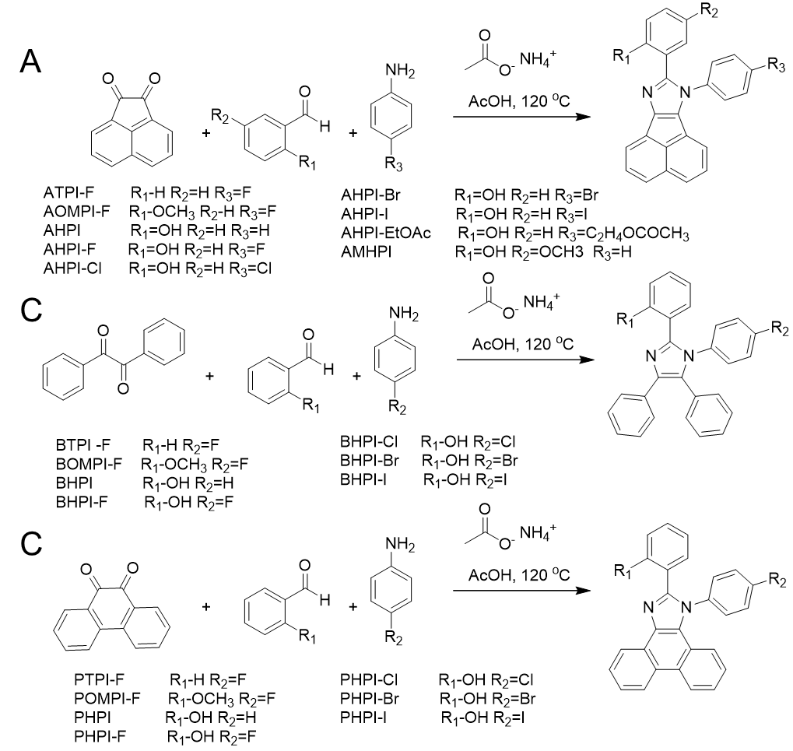

**Figure S50:** Lineweaver–Burk plots for inhibition of urease in the presence of AHPI-Br and POMPI-F (A, D). Concentrations of AHPI-Br and POMPI-F were 0.0, 0.0145 and 0.029 µM. Substrate urea concentrations were 100, 50, 25, 12.5, 6.25, and 3.125 mM. (B, E) The insets represent the plot of the slope. (C, F) the vertical intercepts versus inhibitors concentrations to determine inhibition constants

**Table S1.** Computed and experimental photophysical data of π-fused acenaphtho[1,2-d] imidazole.

|  |  |  |  |  |  |  |  |  |  |  |  |
| --- | --- | --- | --- | --- | --- | --- | --- | --- | --- | --- | --- |
| **Compound** | **Experimental data** | | | | | | **Theoretical data** | | | | |
| **Solvent** | **λabs  (nm)** | **εmax  (M-1 cm-1x103)** | **λem  (nm)** | **φfl** | **Stock shift (nm)** | **MO contribution** | **λabs (nm)** | **Oscillator strength** | **Molecular contribution** | **∆*Eg*  (eV)** |
| ATPI-F | CHCl3 | 34410 | 58.33 | 569 | 0.10 | 259 | HOMO → LUMO | 466 | 0.0708 | 95.80% | 2.6552 |
|  | MeCN | 309 | 70.57 | 562 | 0.20 | 253 | HOMO -1 → LUMO | 334 | 0.1181 | 79.98% | 3.7106 |
|  | EtOH | 308 | 78.02 | 555 | 0.12 | 247 | HOMO → LUMO +1 | 322 | 0.4431 | 77.25% | 3.8486 |
| AOMPI-F | CHCl3 | 33410 | 61.11 | 555 | 0.28 | 245 | HOMO→LUMO | 465 | 0.0706 | 96.03% | 2.6637 |
|  | MeCN | 306 | 55.64 | 568 | 0.18 | 259 | HOMO -1 → LUMO | 342 | 0.0784 | 63.35% | 3.6225 |
|  | EtOH | 308 | 44.33 | 556 | 0.15 | 253 |  |  |  |  |  |
| AHPI | CHCl3 | 326 | 84.19 | 569 | 0.16 | 243 | HOMO → LUMO | 480 | 0.066 | 96.27% | 2.5807 |
|  | MeCN | 324 | 88.64 | 578 | 0.07 | 254 | HOMO -1 → LUMO | 351 | 0.0261 | 97.37% | 3.5225 |
|  | EtOH | 323 | 69.17 | 560 | 0.10 | 259 | HOMO → LUMO +1 | 331 | 0.0794 | 72.66% | 3.7369 |
| AHPI-F | CHCl3 | 326 | 81.87 | 569 | 0.24 | 253 | HOMO → LUMO | 478 | 0.0671 | 96.90% | 2.5895 |
|  | MeCN | 324 | 88.64 | 578 | 0.08 | 254 | HOMO -1 → LUMO | 351 | 0.0289 | 96.90% | 3.5278 |
|  | EtOH | 323 | 64.14 | 564 | 0.10 | 241 | HOMO → LUMO +1 | 332 | 0.0672 | 66.55% | 3.7333 |
| AHPI-Cl | CHCl3 | 326 | 76.51 | 569 | 0.23 | 259 | HOMO → LUMO | 479 | 0.0717 | 96.13% | 2.5841 |
|  | MeCN | 324 | 81.23 | 578 | 0.09 | 253 | HOMO -1 → LUMO | 353 | 0.0312 | 96.79% | 3.5072 |
|  | EtOH | 323 | 55.54 | 559 | 0.14 | 236 | HOMO → LUMO +1 | 338 | 0.1084 | 88.35% | 3.6617 |
| AHPI-Br | CHCl3 | 326 | 74.71 | 569 | 0.20 | 243 | HOMO → LUMO | 480 | 0.0721 | 96.15% | 2.5827 |
|  | MeCN | 324 | 80.16 | 578 | 0.11 | 259 | HOMO -1 → LUMO | 353 | 0.0323 | 96.74% | 3.5046 |
|  | EtOH | 323 | 54.58 | 559 | 0.11 | 253 | HOMO → LUMO +1 | 339 | 0.1076 | 87.64% | 3.6546 |
| AHPI-I | CHCl3 | 326 | 75.73 | 569 | 0.15 | 243 | HOMO → LUMO | 438 | 0.0446 | 95.20% | 2.8248 |
|  | MeCN | 324 | 78.56 | 576 | 0.08 | 252 | HOMO -1 → LUMO | 339 | 0.024 | 91.20% | 3.6472 |
|  | EtOH | 323 | 56.97 | 559 | 0.11 | 259 | HOMO → LUMO +1 | 328 | 0.1131 | 87.81% | 3.779 |
| AHPI-EtOAc | CHCl3 | 310 | 57.82 | 569 | 0.15 | 253 | HOMO → LUMO | 480 | 0.0644 | 96.28% | 2.5778 |
|  | MeCN | 324 | 83.65 | 561 | 0.07 | 237 | HOMO -1 → LUMO | 351 | 0.0295 | 96.94% | 3.5226 |
|  | EtOH | 323 | 62.96 | 556 | 0.10 | 233 |  |  |  |  |  |
| AMHPI | CHCl3 | 288 | 58.09 | 508 | 0.15 | 259 | HOMO → LUMO | 486 | 0.0723 | 94.19% | 2.5478 |
|  | MeCN | 304 | 62.32 | 555 | 0.05 | 253 | HOMO -1 → LUMO | 399 | 0.0047 | 95.04% | 3.1058 |
|  | EtOH | 305 | 56.02 | 555 | 0.05 | 250 | HOMO → LUMO +1 | 335 | 0.1348 | 86.86% | 3.6951 |

**Table S2.** Computed and experimental photophysical data of π-expanded phenanthro[9,10-d] imidazole.

|  |  |  |  |  |  |  |  |  |  |  |  |
| --- | --- | --- | --- | --- | --- | --- | --- | --- | --- | --- | --- |
| **Compound** | **Experimental data** | | | | | | **Theoretical data** | | | | |
| **Solvent** | **λabs  (nm)** | **εmax  (M-1 cm-1x103)** | **λem  (nm)** | **φfl** | **Stock shift (nm)** | **MO contribution** | **λabs (nm)** | **Oscillator strength** | **Molecular contribution** | **∆*Eg*  (eV)** |
| BTPI-F | CHCl3 | 287 | 73.41 | 394 | 0.09 | 107 | HOMO → LUMO | 367 | 0.2111 | 97.17% | 3.3776 |
|  | MeCN | 284 | 62.32 | 424 | 0.12 | 259 | HOMO → LUMO +1 | 310 | 0.086 | 95.53% | 3.995 |
|  | EtOH | 282 | 58.71 | 429 | 0.12 | 253 |  |  |  |  |  |
| BOMPI-F | CHCl3 | 285 | 57.98 | 392 | 0.10 | 107 | HOMO → LUMO | 359 | 0.2193 | 97.32% | 3.4462 |
|  | MeCN | 281 | 50.61 | 388 | 0.02 | 107 | HOMO -1 → LUMO | 314 | 0.0113 | 91.18% | 3.9484 |
|  | EtOH | 278 | 52.45 | 386 | 0.03 | 259 | HOMO → LUMO +1 | 302 | 0.0436 | 94.67% | 4.0923 |
| BHPI | CHCl3 | 286, 320 | 48.40, 52.06 | 471 | 0.19 | 185 | HOMO → LUMO | 357 | 0.3212 | 98.52% | 3.467 |
|  | MeCN | 281, 315 | 48.18, 48.40 | 474 | 0.36 | 156 | HOMO -1 → LUMO | 309 | 0.0064 | 96.34% | 4.0016 |
|  | EtOH | 278, 317 | 47.37, 41.11 | 474 | 0.97 | 159 | HOMO → LUMO +1 | 293 | 0.0928 | 93.11% | 4.2296 |
| BHPI-F | CHCl3 | 290, 320 | 47.64, 50.59 | 474 | 0.20 | 154 | HOMO → LUMO | 359 | 0.3209 | 98.47% | 3.452 |
|  | MeCN | 288, 315 | 47.99, 48.99 | 474 | 0.31 | 159 | HOMO -1 → LUMO | 306 | 0.0035 | 94.42% | 4.0443 |
|  | EtOH | 282, 316 | 45.16, 36.62 | 462 | 0.38 | 146 | HOMO → LUMO +1 | 302 | 0.0688 | 93.38% | 4.0965 |
| BHPI-Cl | CHCl3 | 280, 320 | 45.45, 45.94 | 469 | 0.10 | 149 | HOMO → LUMO | 366 | 0.2994 | 98.38% | 3.3819 |
|  | MeCN | 279, 315 | 46.15, 44.94 | 474 | 0.32 | 159 | HOMO -1 → LUMO | 311 | 0.0063 | 96.02% | 3.9829 |
|  | EtOH | 282, 317 | 45.16, 32.98 | 475 | 0.39 | 158 | HOMO → LUMO +1 | 303 | 0.0607 | 93.98% | 4.0861 |
| BHPI-Br | CHCl3 | 280, 320 | 46.93, 45.94 | 472 | 0.06 | 152 | HOMO → LUMO | 367 | 0.3001 | 98.38% | 3.376 |
|  | MeCN | 282,315 | 45.34, 43.54 | 485 | 0.28 | 170 | HOMO -1 → LUMO | 311 | 0.0068 | 96.03% | 3.9781 |
|  | EtOH | 277, 316 | 44.35, 30.95 | 474 | 0.34 | 158 | HOMO → LUMO +1 | 302 | 0.0604 | 93.27% | 4.0943 |
| BHPI-I | CHCl3 | 283, 320 | 52.34, 48.14 | 483 | 0.05 | 163 | HOMO → LUMO | 365 | 0.3099 | 98.38% | 3.3907 |
|  | MeCN | 289, 315 | 46.56, 40.89 | 482 | 0.25 | 167 | HOMO -1 → LUMO | 326 | 0.0011 | 98.97% | 3.7954 |
|  | EtOH | 278, 316 | 48.59, 29.74 | 477 | 0.34 | 161 | HOMO → LUMO +1 | 315 | 0.0104 | 96.75% | 3.9324 |

**Table S3.** Computed and experimental photophysical data of tetrasubstituted imidazole.

|  |  |  |  |  |  |  |  |  |  |  |  |
| --- | --- | --- | --- | --- | --- | --- | --- | --- | --- | --- | --- |
| **Compound** | **Experimental data** | | | | | | **Theoretical data** | | | | |
| **Solvent** | **λabs  (nm)** | **εmax  (M-1 cm-1x103)** | **λem  (nm)** | **φfl** | **Stock shift (nm)** | **MO contribution** | **λabs (nm)** | **Oscillator strength** | **Molecular contribution** | **∆*Eg*  (eV)** |
| PTPI-F | CHCl3 | 311 | 39.78 | 422 | 0.47 | 111 | HOMO → LUMO | 336 | 0.0781 | 86.65% | 3.6817 |
|  | MeCN | 307 | 47.47 | 408 | 0.25 | 101 | HOMO → LUMO +1 | 322 | 0.1348 | 71.01% | 3.8418 |
|  | EtOH | 303 | 39.96 | 390 | 0.30 | 87 |  |  |  |  |  |
| POMPI-F | CHCl3 | 308 | 13.4 | 380 | 0.98 | 72 | HOMO → LUMO | 569 | 0.065 | 99.11% | 2.1778 |
|  | MeCN | 284, 305 | 57.79, 24.70 | 384 | 0.74 | 79 | HOMO → LUMO +1 | 503 | 0.0177 | 98.58% | 2.4624 |
|  | EtOH | 283, 304, | 52.06, 24.60 | 372 | 0.91 | 68 |  |  |  |  |  |
| PHPI | CHCl3 | 335, 347, 365 | 53.81, 43.05, 47.09 | 477 | 0.27 | 130 | HOMO → LUMO | 341 | 0.0964 | 93.10% | 3.6345 |
|  | MeCN | 331, 344, 362 | 50.51, 34.55, 35.74 | 478 | 0.33 | 134 | HOMO → LUMO +1 | 324 | 0.0928 | 74.54% | 3.8238 |
|  | EtOH | 332, 343, 362 | 35.94, 25.76, 29.59 | 468 | 0.35 | 125 |  |  |  |  |  |
| PHPI-F | CHCl3 | 335, 347, 365 | 40.88, 31.58, 33.02 | 477 | 0.19 | 130 | HOMO → LUMO | 341 | 0.0922 | 92.48% | 3.6248 |
|  | MeCN | 331, 344, 362 | 59.67, 41.37, 43.25 | 479 | 0.23 | 135 | HOMO → LUMO +1 | 324 | 0.1012 | 73.76% | 3.8233 |
|  | EtOH | 332, 343, 362 | 30.75, 20.94, 23.63 | 477 | 0.30 | 134 |  |  |  |  |  |
| PHPI-Cl | CHCl3 | 335, 347, 365 | 39.70, 31.80, 35.15 | 477 | 0.14 | 130 | HOMO → LUMO | 341 | 0.0922 | 92.48% | 3.6284 |
|  | MeCN | 331, 344, 362 | 52.38, 37.37, 39.25 | 478 | 0.16 | 134 | HOMO → LUMO +1 | 324 | 0.1012 | 73.76% | 3.8233 |
|  | EtOH | 332, 343, 362 | 25.37, 16.93, 19.03 | 477 | 0.21 | 134 |  |  |  |  |  |
| PHPI-Br | CHCl3 | 335, 347, 365 | 36.58, 29.67, 34.19 | 477 | 0.12 | 130 | HOMO → LUMO | 351 | 0.08 | 95.41% | 3.5243 |
|  | MeCN | 331, 344, 362 | 50.51, 35.02, 36.68 | 480 | 0.14 | 136 | HOMO → LUMO +1 | 325 | 0.0653 | 71.78% | 3.8131 |
|  | EtOH | 332, 343, 362 | 22.28, 14.80, 16.54 | 477 | 0.19 | 134 |  |  |  |  |  |
| PHPI-I | CHCl3 | 335, 347, 365 | 33.49, 27.03, 29.19 | 477 | 0.11 | 130 | HOMO → LUMO | 341 | 0.0922 | 92.48% | 3.6284 |
|  | MeCN | 331, 344, 362 | 47.69, 32.46, 35.27 | 478 | 0.07 | 134 | HOMO → LUMO +1 | 324 | 0.1012 | 73.76% | 3.8233 |
|  | EtOH | 332, 343, 362 | 21.53, 15.01, 16.93 | 477 | 0.29 | 134 |  |  |  |  |  |

**Table. S4.** Kinetic parameters of the jack bean urease for urea activity in the presence of different concentration of AHPI-Br and POMPI-F

|  |  |  |  |  |  |  |  |  |  |  |  |  |  |
| --- | --- | --- | --- | --- | --- | --- | --- | --- | --- | --- | --- | --- | --- |
| **Code** | | **Dose (μM)** | | **Vmax ∆A/min** | | **Km (mM)** | | **Inhibition type** | | **Ki (μM)** | | **Ki' (μM)** | |
| **AHPI-Br** | 0 | | 0.00029 | | 1.0362 | |  | |  | |  | |
|  | 0.0145 | | 0.00255 | | 1.9417 | | Mixed inhibition | | 0.021 | | 0.168 | |
|  | 0.029 | | 0.00246 | | 2.2421 | |  | |  | |  | |
| **POMPI-F** | 0 | | 0.00296 | | 0.505 | |  | |  | |  | |
|  | 0.0145 | | 0.00256 | | 1.923 | | Mixed inhibition | | 0.0087 | | 0.133 | |
|  | 0.029 | | 0.00241 | | 2.325 | |  | |  | |  | |

V max = the reaction velocity; Km = Michaelis-Menten constant; Ki =EI dissociation constant; Kiʹ = ESI dissociation constant; --- Not calculated.