Supporting Information
for
Endoplasmic reticulum-targetable selenium-doped carbon nanodots with redox-responsive fluorescence for in situ free-radical scavenging in cells and mice
Lei Yang ¹, Hong Huang ³, Ting Wang ¹, Danling Zhou ^{1,} *, Qing Chen ², Dan Li ², Shuzi Chen ², Ping Lin ^{2,} *
¹ School of Health & Social Care, Shanghai Urban Construction Vocational College, Shanghai, 201415, China
² Clinical laboratory, Shanghai Mental Health Center, Shanghai, 200030, China
³ College of Biological Chemical Sciences and Engineering, Jiaxing University, Jiaxing 314001, China.

*Corresponding author: zhoudanling510@163.com (D.L. Zhou); linpingsun2000@aliyun.com (P. Lin).

Figure S1 FTIR spectra of (a) Se-CDs, (b) MOA, and (c) ER-Se-CDs.

Figure S2 Absorption spectrum of Se-CDs.

Figure S3 Synthesis route of MOA.

Figure S4 ¹H NMR spectrum of MOA in CDCl₃.

Figure S5 ¹³C NMR spectrum of MOA in CDCl₃.

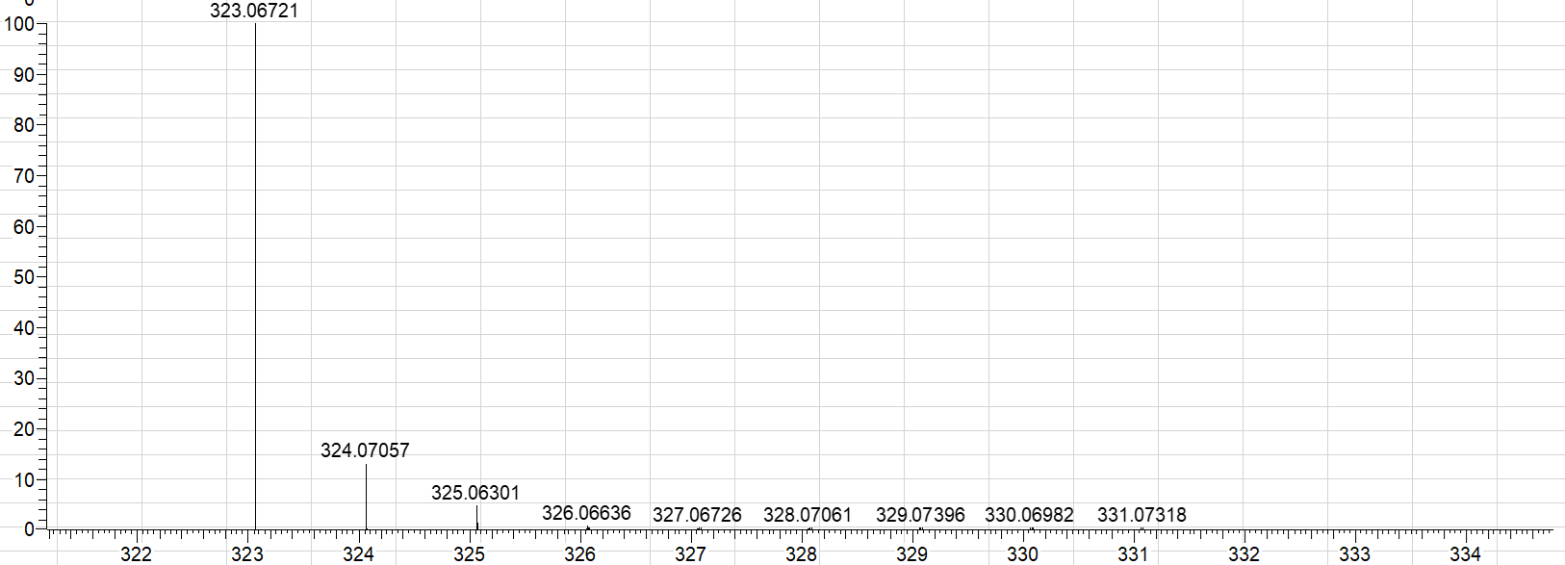
Figure S6 HRMS data of MOA.

Figure S7 Hydrodynamic size of (A) Se-CDs and (B) ER-Se-CDs determined by DLS.

Figure S8 (A) TEM image of ER-Se-CDs. (B) The corresponding size distribution.

Figure S9 Fluorescence spectra of Se-CDs and ER-Se-CDs.

Figure S10 Co-localization investigations in living astrocytes that were co-labeled with ER-Se-CDs (20 μg mL⁻¹) and ER-Tracker Red (50 nM): (A) fluorescence image from ER-Se-CDs (λ_{em} = 410-480 nm, λ_{ex} = 405 nm); (B) fluorescence image from ER-Tracker Red (λ_{em} = 570-650 nm, λ_{ex} = 552 nm); (C) the merged image of (A) and (B); (D) the bright field image; (E) the corresponding intensity correlation plot of the blue channel with red channel; (F) intensity profiles of ER-Se-CDs and ER-Tracker Red along the line across the cell. Scale bar: 25 μm.

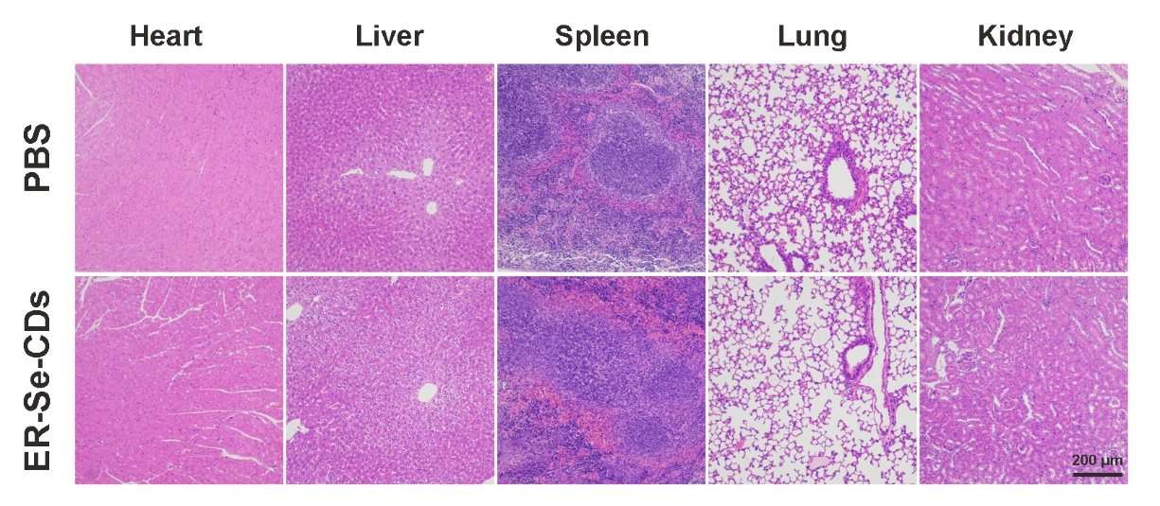
Figure S11 H&E stained histological images of main organs (heart, liver, spleen, lung, and kidney) from mice intravenously treated with PBS (1.0 mM, 100 μL) versus ER-Se-CDs (80 μg mL⁻¹, 100 μL) after 7 days.

