**Supplementary Methods**

***The qualitative analysis of the components of the CT water extract***

Ultra high performance liquid chromatography was used. Chromatographic column was Shim-pack GIST C18 column (2.1×100 mm, 1.9 μm). The protective column was Shim-pack GIST-HP (G) (2.1×10 mm, 1.9 μm C18). Gradient elution was performed using 0.1% formic acid water (A) and acetonitrile (B). For sample analysis, the optimized UPLC elution conditions were as follows: 0-1 min, 5-45% B; 1-2 min, 45-95% B; 2-3 min, 95-95% B; 3-5 min, 95-5% B; 5-11 min, 5-5% B. The flow rate was set constant at 0.3 mL·min-1, and the column temperature was maintained at 40°C for all separations. The injection volume was 2 μL.

The detection parameters of mass spectrometry are as follows: ion source: electrospray ion source (ESI); ion polarity: negative ion mode; capillary voltage: 2.5 kV; cone hole voltage: 40 V; ion source temperature: 100℃; desolvent temperature: 400℃; cone hole gas: 50L/h; desolvent gas: 800 L/h; ion scanning range: 50-1000 eV; primary cracking energy: 6 eV; secondary pyrolysis energy: 10-40 eV.

***The quantitative analysis of the components of the CT water extract***

HPLC consists of Waters e2695 separation unit (quaternary gradient elution solvent delivery system, online vacuum degasser, automatic sampling system, column thermostat, built-in plunger seal cleaning system, etc.), 2998 diode array detector (PDA detection device), Empower chromatography workstation, etc. The column was an Agilent Eclipse Plus C18 column (250 mm×4.6 mm, 5 µm); the column temperature was 30 °C; the mobile phase A was 0.1% formic acid water, B was acetonitrile, and the elution program was 0-5 min, 12-17% B; 5-11 min, 17-18% B; 11-15 min, 18-20% B; 15-20 min, 20-23% B; 20-28 min, 23-28% B; 28-30 min, 28-65% B; 30-36 min, 65-75% B, 36-38 min, 75-95% B; flow rate was 0.8 mL•min-1, detection wavelength was 291 nm; injection volume was 10 μL.

***Construction of 16S rDNA gene amplicon sequence library and data manipulation***

Using Uparse algorithm to cluster, the sequence is clustered into OTUs with 97% consistency by default. At the same time, the representative sequence of OTUs is selected, and the sequence with the highest occurrence frequency is selected as the representative sequence of OTUs according to the principle of the algorithm. The OTUs sequence was annotated, and the Mothur method was used to analyze the species annotation with the SSUrRNA database of SILVA138 (the threshold is set to 0.8:1). The taxonomic information was obtained and the community composition of each sample was calculated at different classification levels: kingdom, phylum, class, order, family, genus and species. Using MUSCLE software for fast multi-sequence alignment, all the phylogenetic relationships of OTUs representative sequences were obtained. Finally, the data of each sample is homogenized, and the data with the least amount of data in the sample is homogenized as the standard, which is used for subsequent Alpha and Beta diversity analysis.

The Shannon, Simpson, Goods-coverage, Chao1, ace, and Observed-species indices were calculated by Qiime software (Version 1.9.1). The Alpha diversity index was tested by R software (Version 2.15.3). The differences between groups were analyzed, and dilution curves, hierarchical clustering curves and species accumulation curves were drawn to reflect the richness and diversity of microbial communities in each sample. To evaluate the differences in species richness and diversity, the Qiime software (Version 1.9.1) was used to calculate the Unifrac distance and construct the UPGMA sample cluster tree. Using R software (Version 2.15.3), the abundance information of OTUs was analyzed by principal component analysis (PCA), principal co-ordinates analysis (PCoA) and non-metric multi-dimensional scaling (NMDS). The corresponding graphs were drawn, and the differences of Beta diversity index between groups were analyzed to make a further comparative analysis of the microbial community composition of different samples. LEfSe was used to analyze the samples of different groups by linear discriminant analysis (LDA), and the species with significant differences in sample classification were found. The significant difference between groups was tested by analysis of variance. The 16s rRNA gene sequences of the whole genome of prokaryotes in KEGG database are extracted and compared to SILVA SSU Ref NR database by BLASTN algorithm to establish a correlation matrix. The functional information of prokaryotes in KEGG database annotated by UProC and PAUDA corresponds to SILVA database, thus realizing the functional annotation of SILVA database.

***Metabolomics data collection and analysis conditions***

Chromatographic column: Shim-pack GIST C18 column (2.1×100 mm, 1.9 μm); protective column: Shim-pack GISTHP (G) (2.1×10mm, 1.9 μm C18); column temperature: 35°C; mobile phase: 0.1% formic acid water, B is acetonitrile, using gradient elution, the optimized UHPLC elution conditions were as follows: 0-7 min, 5-45% B; 7-14 min, 45-95% B; 14-15.5 min, 95-95% B; 15.5-16 min, 95-5% B; 16-20 min, 5-5% B. The flow rate was set constant at 0.2 mL·min-1, and the injection volume was 2 μL.

Ion source: electrospray ion source; data acquisition mode: positive and negative ion full scan, data dependent acquisition (DDA) mode; ion source interface voltage: -3.0 kV; dry gas and atomized gas are served by nitrogen, dry gas flow rate: 10 L·min-1, atomized gas flow rate: 3.0 L·min-1; using air as heating gas, flow rate: 10 L·min-1; argon as collision gas; desolvent tube temperature is 250°C. The temperature of the heating block is 400°C, the interface temperature is 300°C, the scanning mode is MS Scan (*m/z* 100-500; 500-1000), MS/MS (*m/z* 50-500; 50-1000), and the collision energy is 35±17V. Calibration method: external standard method calibration mass number (tuning solution is NaI, concentration 400mg·L-1), resolution > 30000, quality error < 2×10-6.

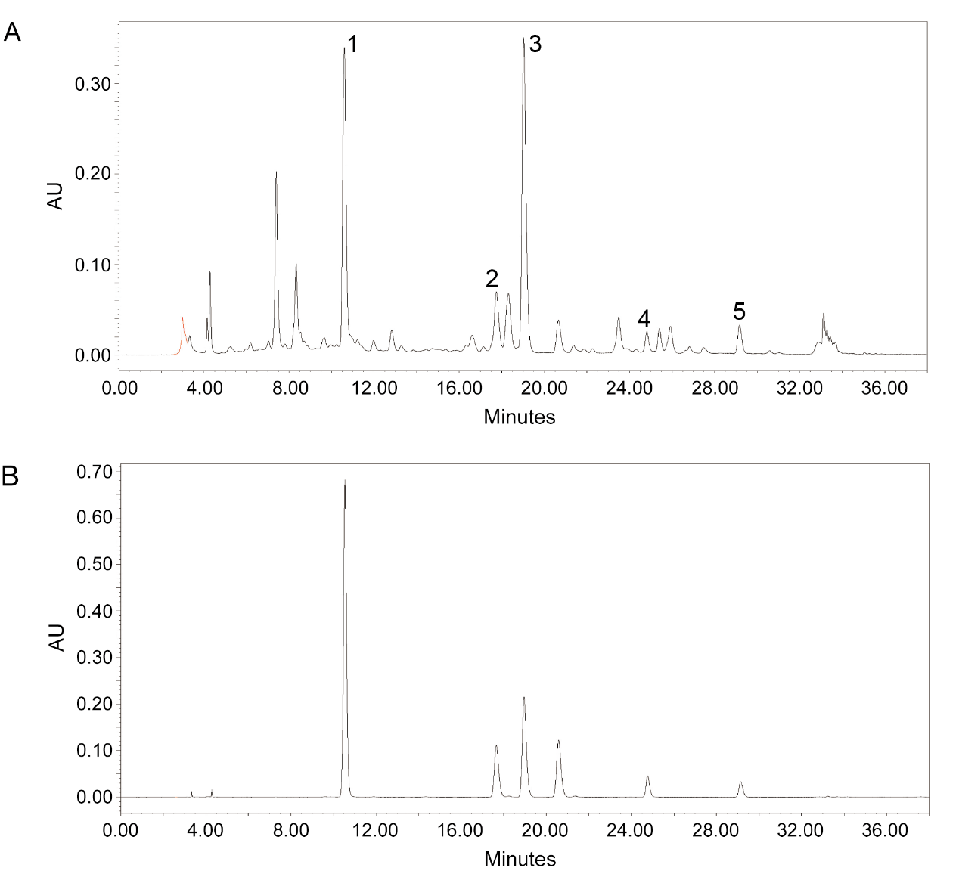

**Figure A1.** HPLC-PDA chromatogram of CT extract (A) and HPLC-PDA chromatogram of flavanomarein-1, isookanin-2, marein-3, coreopsin-4 and okanin-5 references (B)

**Table A1.** The investigation of the linear relationship, LOQ and LOD

|  |  |  |  |  |  |
| --- | --- | --- | --- | --- | --- |
| Compounds | Regression equation | r2 | Linear range/（mg/mL） | LOQ a (ng/mL) | LOD b (ng/mL) |
| Flavanomarein | y=19,701,731.89x+27,282.22 | 1 | 0.03～1 | 0.733 | 0.244 |
| Isookanin | y=27,017,390.21x-44,208.58 | 1 | 0.015～0.5 | 0.375 | 0.125 |
| Marein | y=10,967,278.28x-15,735.69 | 0.9999 | 0.03～1 | 5.369 | 1.790 |
| Coreopsin | y=11,144,389.29x+1,305.51 | 0.9997 | 0.009～0.3 | 0.093 | 0.031 |
| Okanin | y=3,125,747.15x-25,560.30 | 0.9998 | 0.018～0.6 | 3.287 | 1.096 |

a LOQ=Limit of quantity

b LOD=Limit of detection

**Table A2.** Precision, repeatability, stability and recovery (n=6)

|  |  |  |  |  |  |  |
| --- | --- | --- | --- | --- | --- | --- |
| Analytes | Precision（RSD/%） | | Repeatability (RSD/%,n=6) | Stability (RSD/%, n=6) | Recovery (%, n=6) | |
| Intraday (n=6) | Interday (n=6) | Mean | RSD/% |
| Flavanomarein | 1.03 | 2.45 | 2.20 | 2.59 | 99.67 | 1.97 |
| Isookanin | 2.12 | 3.52 | 1.06 | 2.97 | 101.47 | 2.45 |
| Marein | 0.58 | 1.23 | 1.85 | 1.02 | 98.16 | 1.01 |
| Coreopsin | 1.23 | 4.32 | 0.27 | 1.59 | 98.87 | 3.17 |
| Okanin | 0.96 | 1.67 | 2.17 | 2.05 | 98.53 | 3.04 |