**Supplementary Information**



**Figure S1** Representative MRM chromatograms of 4-CEC and IS in plasma and liver tissue homogenate: blank plasma sample (a,c), liver tissue homogenate (b,d), blank plasma sample spiked with 4-CEC(e) at 5 ng/mL and IS (g) at 50 ng/mL, liver tissue homogenate spiked with 4-CEC (f) at 5 ng/mL and IS (h) at 50 ng/mL, the plasma sample (i, k) and liver tissue homogenate (j, l) obtained from a mouse.

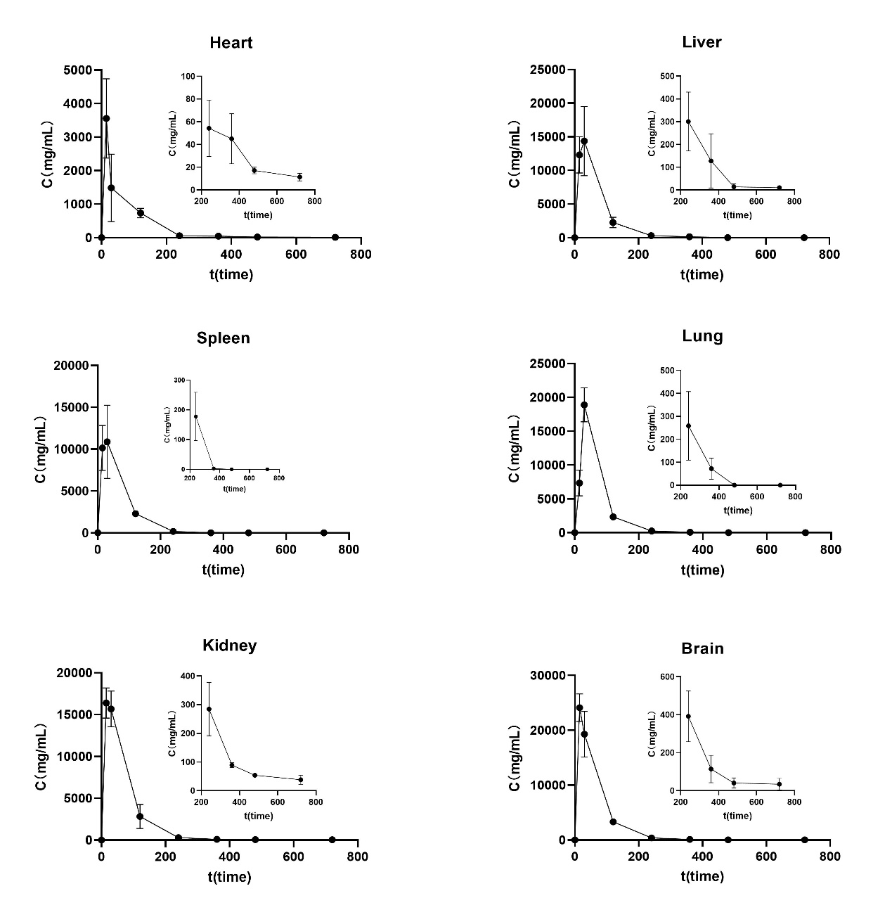**Figure S2** Tissue drug concentration-time profiles after intraperitoneal administration of 4-CEC in mice (a:lung, b:liver, c:spleen, d:kidney, e:heart, f:brain tissues)



**Figure S3** Typical chromatogram of UPLC-Q Exactive-MS(a) TIC of serum QC sample (b) Internal standard extraction chromatogram (c) Internal standard ion scan

**Table S1.** Standard curves for the determination of 4-CEC in plasma and tissue homogenates

|  |  |  |  |
| --- | --- | --- | --- |
| Sample | Standard curves | R2 | Linear range（ng/ml） |
| Plasma | y=0.0394x-0.4243 | 0.9979 | 1.000-1000 |
| Brain | y=0.0410x+0.0322 | 0.9986 | 1.000-1000 |
| Heart | y=0.0045x+0.3626 | 0.9971 | 1.000-1000 |
| Liver | y=0.0015x+0.1639 | 0.9972 | 1.000-1000 |
| Spleen | y=0.0040x+0.2472 | 0.9926 | 1.000-1000 |
| Lung | y=0.0026x+0.1080 | 0.9990 | 1.000-1000 |
| Kidney | y=0.0398x +0.0499 | 0.9947 | 1.000-1000 |

**Table S2** Extraction recoveries of 4-CEC and internal standard

|  |  |  |  |  |
| --- | --- | --- | --- | --- |
| Samlpe | Compound | QC  （ng/ml） | Extraction recovery（%） | Matrix effect  （%） |
| Plasma | 4-CEC | 5.000 | 80.47±8.69 | 86.85±6.61 |
| 40.00 | 81.54±7.36 | 95.43±2.32 |
| 250.0 | 95.72±4.74 | 104.37±8.54 |
| 800.0 | 96.39±5.14 | 85.47±2.94 |
| IS | 500.0 | 85.47±2.94 | 90.90±8.76 |
| Liver | 4-CEC | 5.000 | 87.43±6.76 | 88.40±9.61 |
| 40.00 | 98.28±5.63 | 101.39±5.61 |
| 250.0 | 92.38±5.11 | 86.68±5.80 |
| 800.0 | 99.25±3.64 | 92.06±3.87 |
| IS | 500.0 | 89.74±2.56 | 103.87±8.59 |

**Table S3** 4-CEC stability results

|  |  |  |  |  |  |  |  |  |
| --- | --- | --- | --- | --- | --- | --- | --- | --- |
| Con.（ng/ml） | Room temperature for 8 h | | Freeze and thaw 3 times | | -70℃ for one week | | 4℃ f for 12 h | |
| RE  (%) | RSD (%) | RE  (%) | RSD (%) | RE  (%) | RSD (%) | RE  (%) | RSD (%) |
| 5.000 | -0.45 | 3.57 | -0.47 | 3.49 | 4.7 | 6.56 | 5.60 | 3.48 |
| 800.0 | -2.12 | 1.28 | 1.28 | 1.34 | 6.15 | 4.38 | 1.91 | 4.56 |

**Table S4** Results of 4-CEC dilution effect

|  |  |  |  |  |  |  |
| --- | --- | --- | --- | --- | --- | --- |
|  | Concentration（μg/ml） | Detection Con.（μg/ml） | Mean  （μg/ml） | $Mean$ ×D | RE(%) | RSD(%) |
| 4-CEC | 10.00 | 0.9739 | 0.9597 | 9.597 | 4.0 | 2.2 |
| 0.9332 |
| 0.9826 |
| 0.9398 |
| 0.9692 |

**Table S5** Mean tissue drug concentrations after intraperitoneal administration in mice (n=5, Mean ± SEM)

|  |  |  |  |  |  |  |  |
| --- | --- | --- | --- | --- | --- | --- | --- |
| Sample | Tissue concentration（ng/g） | | | | | | |
| 15min | 30min | 120min | 240min | 360min | 480min | 720min |
| Lung | 5597.2± 2834.4 | 17593±2657 | 2851.4± 800.5 | 230.09±139.80 | 72.03±45.82 | \ | \ |
| Liver | 123024± 26814 | 14385±4213 | 2308.3± 598.0 | 282.82±105.95 | 98.65±19.52 | 12.45±11.25 | \ |
| Spleen | 10623± 2303 | 9974.3±3334.0 | 2258.1± 192.1 | 143.04±89.4 | 4.05±4.77 | \ | \ |
| Kidney | 17413± 2363 | 16560±1936 | 2613.0± 1052.1 | 284.38±75.9 | 78.58±22.21 | 48.40±7.57 | 42.84±8.0 |
| Heart | 3127.9± 1074.6 | 2328.9±1465.3 | 733.61± 104.18 | 49.7±20.3 | 39.32±17.53 | 16.7±2.4 | 12.4±3.5 |
| Brain | 24585± 2818 | 19540±2956 | 3580.4± 566.5 | 357.01±129.71 | 156.21±111.7 | 71.71±29.84 | 58.98±36.5 |
| Plasma | 790.76± 467.32 | 1047.2±512.3 | 129.5±95.0 | 19.83±3.7 | 12.96±4.2 | 11.35±1.9 | 13.9+2.5 |

**Table S6** Differential metabolites in the serum of 4-chloroethycathinone-exposed mice.

|  |  |  |  |  |  |  |  |  |  |  |  |  |  |  |
| --- | --- | --- | --- | --- | --- | --- | --- | --- | --- | --- | --- | --- | --- | --- |
| Metabolites | | Mass-to-Charge Ratio | Retention time  （min） | | Molecular formula | | Adduct ion | | Adduct mass | | Delta (ppm) | | MS fragments | |
|
| L-Alanine | | 90.0554 | 0.69 | | C3H7NO2 | | [M+H]+ | | 90.0550 | | 4 | | 73.05, 72.08 | |
| N, N-Dimethylglycine | | 104.1072 | 0.68 | | C4H9NO2 | | [M+H]+ | | 104.1075 | | 3 | | 104.11, 86.06, 60.08 | |
| Valine | | 118.0863 | 0.73 | | C5H11NO2 | | [M+H]+ | | 118.0863 | | 0 | | 118.09, 72.08 | |
| Niacinamide | | 123.0553 | 1.00 | | C6H6N2O | | [M+H]+ | | 123.0553 | | 0 | | 123.06, 80.05 | |
| Pyroglutamic acid | | 130.0498 | 0.65 | | C5H7NO3 | | [M+H]+ | | 130.0499 | | 1 | | 130.05, 84.04 | |
| L-Glutamic γ-semialdehyde | | 132.0656 | 0.65 | | C5H9NO3 | | [M+H]+ | | 132.0655 | | 1 | | 90.06 | |
| Isoleucine/leucine | | 132.1018 | 0.76 | | C6H13NO2 | | [M+H]+ | | 132.1019 | | 1 | | 86.09, 69.07 | |
| Ornithine | | 133.0970 | 0.60 | | C5H12N2O2 | | [M+H]+ | | 133.0972 | | 2 | | 133.10, 97.08, 79.02 | |
| L-Glutamine | | 147.0762 | 0.65 | | C5H10N2O3 | | [M+H]+ | | 147.0764 | | 2 | | 130.05, 102.06 | |
| L-Tyrosine | | 182.0810 | 1.11 | | C9H11NO3 | | [M+H]+ | | 182.0812 | | 1 | | 165.05, 136.07, 123.04 | |
| 5-Hydroxyindoleacetic acid | | 192.0653 | 2.07 | | C10H9NO3 | | [M+H]+ | | 192.0655 | | 1 | | 146.06, 128.02 | |
| L-Kynurenine | | 209.0917 | 1.97 | | C10H12N2O3 | | [M+H]+ | | 209.0921 | | 2 | | 192.07, 120.04, 94.07 | |
| 5-Hydroxy-L-tryptophan | | 221.0914 | 4.51 | | C11H12N2O3 | | [M+H]+ | | 221.0921 | | 3 | | 162.05, 134.06 | |
| Formylkynurenine | | 237.0865 | 4.51 | | C11H12N2O4 | | [M+H]+ | | 237.0870 | | 2 | | 191.08, 148.04, 74.02 | |
| 3-Hydroxybutyrylcarnitine | | 248.1488 | 1.11 | | C11H21NO5 | | [M+H]+ | | 248.1492 | | 2 | | 189.08, 135.00, 85.03 | |
| Glycerophosphocholine | | 258.1095 | 0.70 | | C8H20NO6P | | [M+H]+ | | 258.1101 | | 2 | | 140.07, 104.11 | |
| Retinyl ester | | 303.2311 | 15.35 | | C20H30O2 | | [M+H]+ | | 303.2319 | | 3 | | 303.23, 285.22, 131.09 | |
| Sphingosine 1-phosphate | | 351.2178 | 11.62 | | C18H38NO5P | | [M+H]+ | | 351.2175 | | 1 | | 264.28, 247.24 | |
| Cervonoyl ethanolamide | | 373.2728 | 11.07 | | C24H36O3 | | [M+H]+ | | 373.2737 | | 2 | | 373.27, 355.26 | |
| Sphinganine 1-phosphate | | 382.2708 | 13.43 | | C18H40NO5P | | [M+H]+ | | 382.2717 | | 2 | | 284.29, 266.28 | |
| LysoPE(18:2) | | 478.2918 | 14.00 | | C23H44NO7P | | [M+H]+ | | 478.2928 | | 2 | | 279.23, 196.04 | |
| LysoPC(16:0) | 496.3387 | | | 14.26 | | C24H50NO7P | | [M+H]+ | | 496.3398 | | 2 | | 496.34, 184.07, 258.11 | |
| LysoPC(O-18:0) | 510.3910 | | | 16.72 | | C26H56NO6P | | [M+H]+ | | 510.3918 | | 2 | | 492.34, 184.07, 104.11 | |
| LysoPC(18:0) | 524.3699 | | | 15.76 | | C26H54NO7P | | [M+H]+ | | 524.3711 | | 2 | | 506.36, 184.07, 104.11 | |
| LysoPC(22:6) | 568.3384 | | | 14.25 | | C30H50NO7P | | [M+H]+ | | 568.3398 | | 2 | | 550.33, 184.07, 104.11 | |