The root essential oil from the Tunisian endemic plant Ferula tunetana: Chemical composition, biological evaluation, molecular docking analysis and drug-likeness prediction
Wiem Baccariª, Ilyes Saidiª, Insaf Filali^{b,}*, Mansour Znatiª, Moncef Tounsi^{c}, Roberta Ascrizzi^{d}, Guido Flamini^{d,e}, Hichem Ben Jannet^{a,}*

ªUniversity of Monastir, Faculty of Science of Monastir, Laboratory of Heterocyclic Chemistry, Natural Products and Reactivity (LR11ES39), Team: Medicinal Chemistry and Natural Products, Avenue of Environment, 5019 Monastir, Tunisia
^{b}Department of Chemistry, College of Science and Humanities in Al-Kharj, Prince Sattam bin Abdulaziz University, Al-Kharj 11942, Saudi Arabia
^{c}Preparatory Year Deanship, Basic Science Department, Prince Sattam Bin Abdulaziz University, Alkharj 11942, Saudi Arabia
^{d}Dipartimento di Farmacia, Università di Pisa, Via Bonanno 6, 56126 Pisa, Italy
^{e}Centro Interdipartimentale di Ricerca "Nutraceutica e Alimentazione per la Salute" Nutrafood, Via del Borghetto 80, 56124 Pisa, Italy

*Corresponding author: Insaf FILALI (Tel.: +966501928314; E-mail: insaf_filali@yahoo.fr); Hichem BEN JANNET (Tel.: +21673500279; Fax: +21673500278; E-mail: hichem.bjannet@gmail.com)

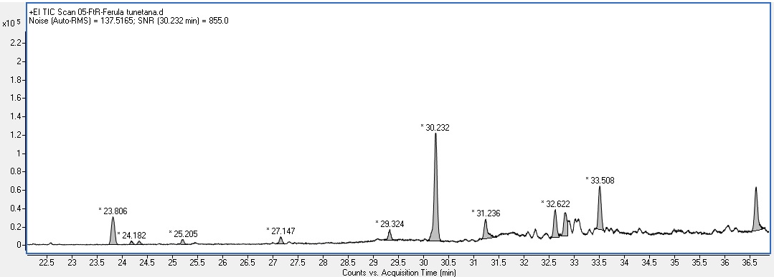
Figure S1. GC-MS chromatogram of the essential oil from the roots of the plant Ferula tunetana.

