**Fabrication and characterization of magnetic eucalyptus biochar and its efficient removal of** **Cr(VI) in aqueous solution**

Hua Zhanga,b, Zhenyu Wua, Qingliang Shia*, Awais Khanc, Saeed Rada,b, Asfandyar Shahaba,b*, Habib Ullahd, Enas Alie., Ahmed A. Arafatf., Honghu Zenga,b, Liudan Luoa,b

aGuangxi Key Laboratory of Environmental Pollution Control Theory and Technology,

Guilin University of Technology, Guilin 541004, China

bCollaborative Innovation Center for Water Pollution Control and Water Safety in Karst

Area, Guilin University of Technology, Guilin 541004, China

cDepartment of Electrical Engineering, University of Engineering and Technology, Peshawar, Pakistan, 25000

dInnovation Center of Yangtze River Delta, Zhejiang University, Zhejiang 311400, China

eFaculty of Engineering and Technology, Future University in Egypt, New Cairo 11835, Egypt

fDepartment of Civil Engineering, College of Engineering, Taif University, P.O. BOX 11099, Taif 21944, Saudi Arabia

*Corresponding author.

Shi Qingliang: [shiqingliang_es@163.com](mailto:shiqingliang_es@163.com); Asfandyar Shahab: 2017022@glut.edu.cn

Number of pages: 10 (including cover page)

Number of tables: 8

Number of figures: 8

1. **Material and Methods**

**1.1** **Batch adsorption experiment**

A series of 100 mL centrifuge tubes containing 50 mL simulated Cr(VI) solution with a certain concentration was transferred to a constant temperature oscillation chamber to be agitated for a predetermined time to observe the removal influence from pH (1.0-10.0), initial Cr(VI) concentration (100 – 450 mg/L), MBC dosage (0.025 – 0.150 g), adsorption time (0.1 – 12 h) and adsorption temperature (25 – 65 ℃). Based on batch adsorption test, three initial concentration of Cr(VI) (150, 200, 250 mg/L) and three adsorbent dosage (0.05 – 0.10 g) was considered as the parallel variates for the conduction of kinetics study and isotherm study, respectively. While for thermodynamics study, initial concentration of Cr(VI) was 100, 200, 300 and 400 mg/L and reaction temperature was 25, 35, 45 and 55 ℃. To further observe the Cr(VI) removal performance of MBC at harsh conditions, the experiments were conducted with the interfering of different ions, including Mg2+, Ca2+, Al3+, Cl-, SO42-, CO32- and PO43- at 0.1 mol/L and 1 mol/L. Upon removal, the residual concentration of Cr(VI) in solution was determined by UV spectrophotometry, and the removed amount by MBC and removal efficiency could be calculated as follow:

 (S1)

 (S2)

 (S3)

Where, *qe*, and *qt* was to measure adsorbing amount of MBC at equilibrium and given time, mg/g. *η* was represented the removal efficiency of MBC, %. *C0*, *Ce* and *Ct* were marked as the residual Cr(VI) concentration in the solution at initial, equilibrium, and given time (*t*, min), mg/L. *m* was indicated the added mass of MBC in solution, g. *V* was signified the volume of solution, L.

After the adsorption for 200 mg/L Cr(VI), MBC was filtered and washed with deionized water. After drying, the absorbent was added to 100 mL of desorbent solutions: 0.1, 0.2 and 0.5 mol/L NaOH. The regeneration experiment oscillated for 24 h at 200 rpm at 25℃ under the same conditions as the adsorption experiment. The regeneration percentage can be calculated as the following

 (S4)

Where, Cd is marked as the desorption Cr(VI) concentration, mg/L.

* 1. **Characterization techniques**

The specific surface area and pore size structure of biochar sample was analyzed by NOVA4200e analyzer produced by Quantachrome. The specific surface area of the samples was calculated by multi-point Brunauer-Emmett-Teller (BET) method and the pore volume of MBC was calculated according to the adsorption capacity of Barrett Joyner and Halenda (BJH) model at relative pressure P/P0=0.974. A Bruker-AXS D8ADVANCE X-ray diffractometer manufactured by A German company was applied for X-ray diffraction (XRD) pattern record. The scanning range was 2θ=5~80°. Fourier transform infrared spectroscopy (FT-IR, NEXUS470) was used to identify the surface organic functional groups of biochar samples by using KBr as background within the 4000 – 50 cm−1 wavenumber range with a 10 scanning times and 4 cm-1 resolution. The surface chemical composition and element valence states of biochar samples were analyzed via X-ray photoelectron spectroscopy (XPS) (Thermo Fisher) equipped with Al Kα X-ray as the excitation source. Vibrating sample magnetometer (VSM) was applied for the test of magnetic properties for biochar sample. The coercivity, saturation magnetization and remanence can be obtained by testing the hysteresis loop under the relatively low external magnetic field intensity. The scanning electron microscope equipped with element analyzer (SEM, Hitachi SU5000, Japan) was applied for the observation of surface morphologies and elemental composition for the biochar sample.

**1.3** **Statistical analysis**

The equation for the coefficient of determination (*R2*) and nonlinear chi-square (*χ2*) could be expressed as follow:

 (S5)

 (S6)

where, *qe,exp*, *qc* and *qc,avg,* denote the measured, model estimated, and the average of estimated amount of sorbed Cr(VI) at equilibrium, respectively. n is the number of observations.

1. **Result and discussion**

**2.1 Elemental mapping and EDS mass spectrum analysis for BC and FBC**

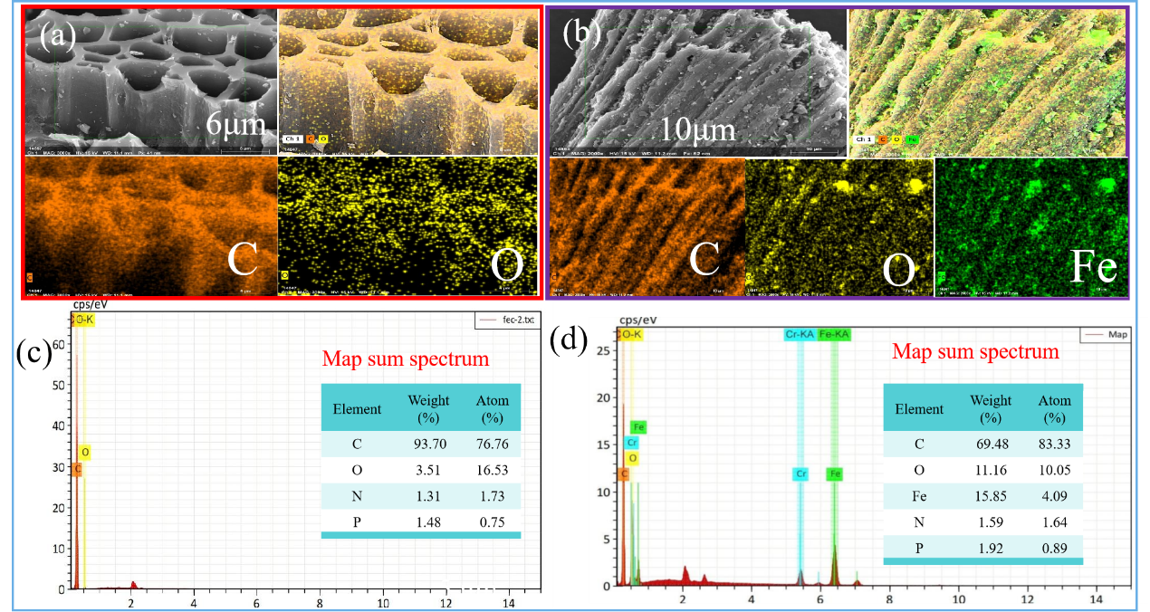

**Fig. S1.** The elemental mapping for BC (a) and FBC after adsorption (b); EDS mass spectrum of BC (c) and FBC (d).

**2.2 Magnetic hysteresis curves analysis**

It can be seen from Figure S2a that saturation magnetization Ms=28.67 emu/g, remanence Ms=3.13 emu/g, and coercivity Hc=130.81 Oe, indicating excellent magnetic property and super-paramagnet nature of MBC before adsorption. In Figure S2c (a) and (b) is denoted as pH value in aqueous solution was 2 and 3 for Cr(VI) removal. It can be observed that MBC would be speedily aggregated on the right side of the beaker in a short time due to the existence of magnetic field, suggesting that magnetic separation effect was highly efficient for the fast separation. This can be concluded that MBC has good magnetism effect and can be rapidly recovered through magnetic separation after wastewater treatment. Encouragingly, the magnetic property underwent a mild reduction but maintained for a relative high level, determining saturation magnetization Ms=24.32 emu/g, remanence Ms=3.22 emu/g and coercivity Hc=129.87 Oe upon removal. The decline of saturation magnetization after adsorption of Cr(VI), indicating that the chemical participation of pollutants degradation and the limited weakened magnetism of MBC after adsorption but a small demagnetization can still guarantee the magnetic separation of biochar from aqueous solution.

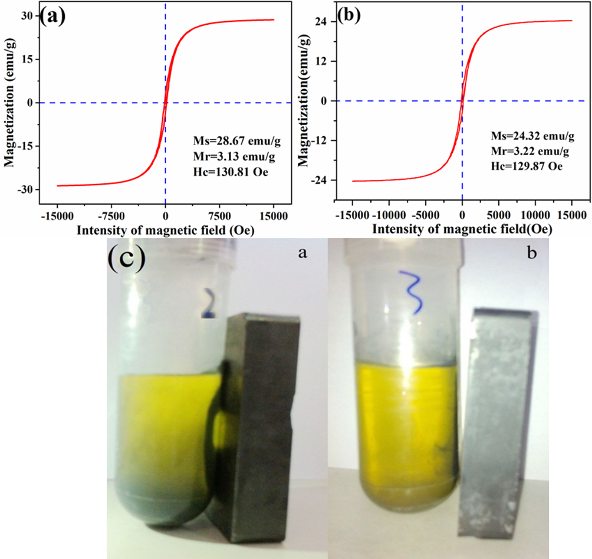

**Fig. S2.** Magnetic hysteresis loops of MBC before (a) and after (b) adsorption, and separation of MBC by magnetic effect (c).

**2.3 Kinetic equations:**

Pseudo-first-order model, pseudo-second-order model, and elovich model are expressed as follow:

 (S7)

 (S8)

 (S9)

Where, *qe*and *qt* (mg/g) are the adsorbed amount at equilibrium and given time t (min), respectively; *k1* (min-1) and *k2* (g mg-1 min-1) are concerned to the rate constant of pseudo-first-order model and pseudo-second-order model; *β* (g mg−1) is the desorption coefficient. *α* (mg g−1 min−1) presents the initial adsorption coefficient for the surface coverage.

* 1. **Analysis of diffusion mechanisms**

Intraparticle model is expressed as follow:

 (S10)

Where, *kdi* (mg g−1 min−1/2) are relative with the rate constant of intraparticle diffusion model; *Ci* (dimensionless constant) is a constant, concerned about the boundary layer thickness.

It can be seen from Fig. S3 and Table S2, three sorption stages were occurred during MBC removal. The first process was external mass transport of the metal solute across the boundary layer surrounding the biochar, which occurred instantaneously after the biochar was transferred into the adsorbate solution. The second stage was pore diffusion of Cr(VI) within the interior surface and pores of MBC due to the increase of diffusion resistance of adsorbate, this stage was obviously slower than that of the early stage. The third region represented the equilibrium stage resulting from the saturation of binding sites of MBC.

|  |
| --- |
|  |
| **Fig. S3.** Linear fitting of Intraparticle model for Cr(VI) removal. |

**2.5 Isotherm equations:**

The non-linearized form of four typical adsorption isotherm model, including Langmuir, Freundlich, Temkin and Redliche Peterson, was written as follow (Chandarana et al., 2021; Tran et al., 2017):

 (S11)

 (S12)

 (S13)

 (S14)

Where, *Ce* is the equilibrium concentration of adsorbates (mg/L), *qm* represents the theoretical maximum adsorption capacity (mg/g). *KL* and *KF* is the Langmuir isotherm constant (L/mg) and Freundlich isotherm constant ((mg/g)/ (mg/L)n). *n* (dimensionless) is a heterogeneity factor related to the adsorption intensity. B is the constant related to heat of sorption (J/mol) and A is the equilibrium binding constant (L/g). *KRP* (L/g) and *aRP* (mg/L)-g are the Redliche-Peterson constants and g (dimensionless) is an exponent whose value must lie between 0 and 1.

**2.6** **Vant Hoff equations:**

The Vant Hoff equation can be expressed as follow (Zhong et al., 2018):

 (S15)

 (S16)

 (S17)

 (S18)

Where,*Kc* is the thermodynamic equilibrium constant. As for *ΔH* and *ΔS*, it could be estimated from slopes and intercepts of linear fitting plots of *lnKc* versus *1/T*, and resulting parameters were summarized in Table S5.



**Fig. S4.** Fitting curves of thermodynamic parameters of Cr(VI) adsorption by MBC

**2.7** **Analysis for** **desorption and regeneration experiments and effect of coexisting ions on Cr(VI) removal by MBC**

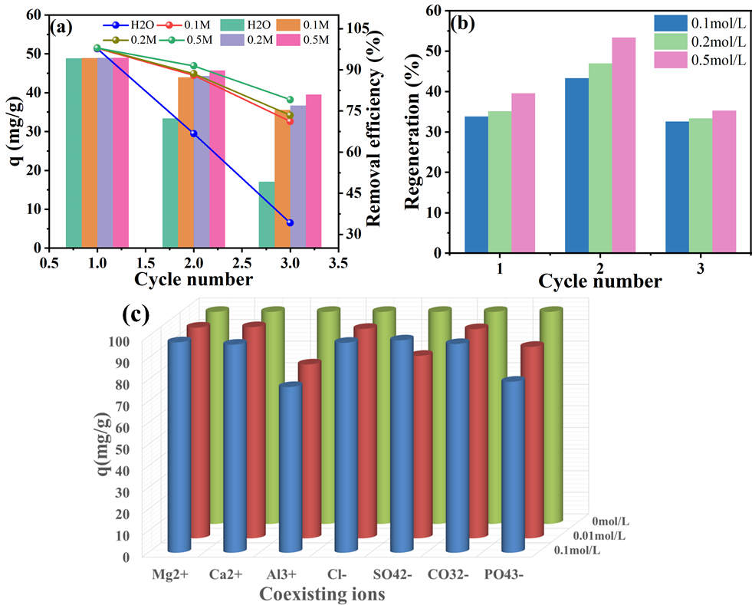

**Fig. S5.** Three cycles of reuse (a) and desorption (b) performance of MBC and effect of coexisting ions on Cr(VI) removal by MBC (c)

**2.8** **Analysis for XPS plots of O1s**



**Fig. S6.** XPS high-resolution for O1s

**2.9 Analysis of the stability of MBC**



**Fig. S7.** Effect of pH on the dissolution of iron from MBC

**Table S1.** Nonlinear fitting parameter of adsorption kinetics model for the adsorption of MBC towards Cr(VI)

|  |  |  |  |  |  |  |  |  |  |  |  |  |  |  |
| --- | --- | --- | --- | --- | --- | --- | --- | --- | --- | --- | --- | --- | --- | --- |
| Concentration of Cr(VI) | Experimental results  qe,exp | Pseudo-first order model | | | | Pseudo-second order model | | | | Elovich model | | | | |
| qe | k1 | R2 | *χ2* | qe | k2 | R2 | *χ2* | qe | α | β | R2 | *χ2* |
| (mg/L) | (mg/g) | (mg/g) | (1/min) |  |  | (mg/g) | (g/mgmin) |  |  | (mg/g) | (mg/gmin) | (g/mg) |  |  |
| 150 | 65.29 | 54.31 | 11.82 | 0.9274 | 2.2199 | 60.82 | 0.0042 | 0.9694 | 0.3285 | 66.75 | 4362.90 | 0.20 | 0.9977 | 0.0319 |
| 200 | 75.63 | 61.02 | 12.41 | 0.7851 | 3.4981 | 68.92 | 0.0034 | 0.9437 | 0.6533 | 72.79 | 1934.58 | 0.17 | 0.9970 | 0.1108 |
| 250 | 80.85 | 62.96 | 12.62 | 0.7275 | 5.083 | 72.90 | 0.0025 | 0.9274 | 0.8670 | 77.92 | 541.91 | 0.14 | 0.9958 | 0.1101 |

**Table S2.** Linear fitting parameters of Intraparticle model for the adsorption of Cr(VI) onto MBC

|  |  |  |  |  |  |  |  |  |  |
| --- | --- | --- | --- | --- | --- | --- | --- | --- | --- |
| Concentration Intraparticle diffusion model | | | | | | | | | |
| (mg/L) Kd1 C1 R12 Kd2 C2 R22 Kd3 C3 R32 | | | | | | | | | |
| 150  200  250 | 13.75  15.18  15.29 | 1.63  2.43  2.27 | 0.9606  0.9304  0.9398 | 1.53  1.89  2.14 | 41.30  43.79  42.84 | 0.9412  0.9150  0.9770 | 0.58  0.83  1.06 | 50.26  53.97  53.51 | 0.9824  0.9757  0.9753 |

**Table S3.** Nonlinear fitting parameter of adsorption kinetics model for the adsorption of MBC towards Cr(VI)

|  |  |  |  |  |  |  |  |  |  |  |  |  |  |  |  |
| --- | --- | --- | --- | --- | --- | --- | --- | --- | --- | --- | --- | --- | --- | --- | --- |
|  |  | Langmuir Model | | | | Freundlich Model | | | Temkin Model | | | Redliche Peterson Model | | | |
| Adsorbent dosage (g) | qe,exp  (mg/g) | qm (mg/g) | KL  (L/mg) | R2 | RL | KF  (mg/g)/(mg/L)n | n | R2 | A  L/g | B  J/mol | R2 | KRP  (L/g) | aRP  (mg/L)-g | g | R2 |
| 0.05 | 134.36 | 132.00 | 0.062 | 0.9649 | 0.03 -0.13 | 44.31 | 0.19 | 0.9945 | 2.70 | 19.44 | 0.9901 | 1.19×1010 | 2.69×108 | 0.81 | 0.9926 |
| 0.075 | 108.27 | 105.67 | 0.20 | 0.9757 | 0.01-0.05 | 50.93 | 0.14 | 0.9934 | 29.20 | 12.21 | 0.9956 | 76.98 | 1.29 | 0.89 | 0.9936 |
| 0.1 | 93.16 | 90.56 | 0.48 | 0.9644 | 0.005-0.02 | 48.07 | 0.13 | 0.9917 | 87.28 | 9.66 | 0.9906 | 134.81 | 2.40 | 0.90 | 0.9916 |

**Table S4**. Comparison of maximum adsorption capacity of MBC at 25 ℃ with other adsorbents for Cr(VI) in aqueous solution.

|  |  |  |  |  |  |  |
| --- | --- | --- | --- | --- | --- | --- |
| Biochar | Modification agent | pH | qm (mg/g) | Kinetic model | Isotherm model | Ref. |
| Eucalyptus sawdust | KOH | 2 | 45.88 | Pseudo-second-order | Freundlich | (Zhang et al., 2018) |
| raw corncob | FeCl3 | 2 | 25.94 | Pseudo-second-order | Sips | (Hoang et al., 2019) |
| sugarcane bagasse | FeCl3 | 2 | 55 | Pseudo-second-order | Langmuir | (Bai et al., 2021) |
| Rice husk | FeSO4 | 2 | 8.35 | / | / | (Zhong et al., 2018) |
| Peanut hull | FeCl3 | 2 | 77.54 | Elovich | Langmuir | (Han et al., 2016) |
| Phoenix tree leaves | FeCl3 | 2 | 55.0 | Pseudo-second-order | Freundlich | (Liang et al., 2019) |
| Poplar Branches | FeCl3 | 2 | 66.6 | Pseudo-second-order | Freundlich | (Su et al., 2021) |
| Enteromorpha prolifera | FeCl3 | 2 | 95.23 | Pseudo-second-order | Langmuir | (Wang et al., 2020) |
| Chinese medicine residual/iron based  waterworks sludge | ZnCl2 | 2 | 27.04 | Pseudo-second-order | Langmuir | (Zheng et al., 2022) |
| Bamboo | Fe2(SO4)3/FeSO4/Chitosan | 2 | 127 | Pseudo-second-order | Langmuir | (Zhang et al., 2020) |
| Enteromorpha prolifera | FeCl3 | 2 | 88.17 | Elovich | Langmuir | (Chen et al., 2018) |
| Litchi chinensis peel | NaBH4/ FeCl3 | 2 | 98.36 | Pseudo-second-order | Langmuir | (Sahu et al., 2022) |
| Eucalyptus | FeCl3/K2CO3 | 2 | 132.18 | Elovich | Freundlich | This study |

**Table S5** Thermodynamic parameters of Cr(VI) adsorption on MBC

|  |  |  |  |  |  |
| --- | --- | --- | --- | --- | --- |
| Concentration  (mg/L) | Temperature  (K) | *Kc* | *ΔG*  （kJ/mol） | *ΔH*  （kJ/mol） | *ΔS*  kJ/(mol·K) |
| 100 | 298.15 | 50.98 | -9.74569 | 62.5605 | 0.2437 |
| 308.15 | 175.04 | -13.233 |
| 318.15 | 258.91 | -14.6979 |
| 328.15 | 576.26 | -17.3427 |
| 200 | 298.15 | 3.86 | -3.3494 | 77.4040 | 0.2698 |
| 308.15 | 8.53 | -5.4913 |
| 318.15 | 19.86 | -7.9053 |
| 328.15 | 70.32 | -11.6038 |
| 300 | 298.15 | 1.40 | -0.8348 | 17.0572 | 0.0602 |
| 308.15 | 1.83 | -1.5470 |
| 318.15 | 2.24 | -2.1281 |
| 328.15 | 2.63 | -2.6383 |
| 400 | 298.15 | 1.01 | -0.0365 | 12.3345 | 0.0413 |
| 308.15 | 1.12 | -0.2914 |
| 318.15 | 1.40 | -0.8842 |
| 328.15 | 1.56 | -1.2204 |

**Table S6.** Elemental compositions of MBC before and after adsorption of Cr(VI) determined by XPS analysis.

|  |  |  |
| --- | --- | --- |
| Element | Average atomic concentration (%) | |
|  | MBC | MBC after adsorption Cr(VI) |
| C1s | 82.33 | 78.62 |
| O1s | 15.75 | 17.89 |
| Fe2p | 1.92 | 2.27 |
| Cr2p | - | 1.22 |

**Table S7.** Content change of functional groups on MBC surface before and after adsorption of Cr(VI) in XPS analysis.

|  |  |  |  |  |
| --- | --- | --- | --- | --- |
| Functional Groups | Peaks Position (eV) | | Average atomic concentration (%) | |
|  | Before | After | Before | After |
| C-C | 284.75 | 284.78 | 62.52 | 68.56 |
| C-OH | 285.47 | 285.367 | 17.51 | 12.25 |
| C-O-C | 286.48 | 286.40 | 16.17 | 13.85 |
| O-C=O | 288.55 | 288.53 | 3.81 | 5.34 |
| M-O | 530.55 | 530.45 | 13.56 | 14.20 |
| C-O | 531.89 | 531.87 | 77.79 | 70.74 |
| C=O | 533.80 | 533.55 | 8.64 | 15.06 |

**Table S8.** Content of Fe/Cr element in MBC before and after adsorption of Cr(VI) in XPS analysis.

|  |  |  |  |  |  |  |  |  |
| --- | --- | --- | --- | --- | --- | --- | --- | --- |
| Element | Peaks Position (eV) | | | | Average atomic concentration (%) | | | |
| Peak1 (Before) | Peak1 (After) | Peak2 (Before) | Peak2 (After) | Peak1 (Before) | Peak1 (After) | Peak2 (Before) | Peak2 (After) |
| Fe2O3 | 711.51 | 712.06 | 725.20 | 725.98 | 30.05 | 21.22 | 15.49 | 6.99 |
| Fe2O3 | 719.17 | 719.51 | 733.51 | 733.43 | 16.81 | 8.90 | 4.61 | 4.02 |
| Fe3O4 | 713.95 | 714.37 | 728.37 | 728.45 | 25.43 | 21.55 | 7.61 | 7.70 |
| FeCr2O4 | - | 710.78 | - | 724.45 | - | 10.95 | - | 18.67 |
| Cr(III) | - | 577.12 | - | 587.06 | - | 34.30 | - | 28.68 |
| Cr(VI) | - | 578.64 | - | 588.85 | - | 31.11 | - | 5.91 |

**Reference**

Bai, L., Su, X., Feng, J., Ma, S. 2021. Preparation of sugarcane bagasse biochar/nano-iron oxide composite and mechanism of its Cr (VI) adsorption in water. J. Clean. Prod., 320.

Chandarana, H., Senthil Kumar, P., Seenuvasan, M., Anil Kumar, M. 2021. Kinetics, equilibrium and thermodynamic investigations of methylene blue dye removal using Casuarina equisetifolia pines. Chemosphere, 285, 131480.

Chen, Y., Wang, B., Xin, J., Sun, P., Wu, D. 2018. Adsorption behavior and mechanism of Cr(VI) by modified biochar derived from Enteromorpha prolifera. Ecotoxicol. Environ. Saf., 164, 440-447.

Duranoğlu, D., Trochimczuk, A.W., Beker, U. 2012. Kinetics and thermodynamics of hexavalent chromium adsorption onto activated carbon derived from acrylonitrile-divinylbenzene copolymer. Chem. Eng. J., 187, 193-202.

Han, Y., Cao, X., Ouyang, X., Sohi, S.P., Chen, J. 2016. Adsorption kinetics of magnetic biochar derived from peanut hull on removal of Cr (VI) from aqueous solution: Effects of production conditions and particle size. Chemosphere, 145, 336-41.

Hoang, L.P., Van, H.T., Nguyen, L.H., Mac, D.-H., Vu, T.T., Ha, L.T., Nguyen, X.C. 2019. Removal of Cr(vi) from aqueous solution using magnetic modified biochar derived from raw corncob. New J. Chem., 43(47), 18663-18672.

Liang, S., Shi, S., Zhang, H., Qiu, J., Yu, W., Li, M., Gan, Q., Yu, W., Xiao, K., Liu, B., Hu, J., Hou, H., Yang, J. 2019. One-pot solvothermal synthesis of magnetic biochar from waste biomass: Formation mechanism and efficient adsorption of Cr(VI) in an aqueous solution. Sci. Total Environ., 695, 133886.

Lin, C., Luo, W., Luo, T., Zhou, Q., Li, H., Jing, L. 2018. A study on adsorption of Cr (VI) by modified rice straw: Characteristics, performances and mechanism. J. Clean. Prod., 196, 626-634.

Qu, J., Liu, Y., Cheng, L., Jiang, Z., Zhang, G., Deng, F., Wang, L., Han, W., Zhang, Y. 2021. Green synthesis of hydrophilic activated carbon supported sulfide nZVI for enhanced Pb(II) scavenging from water: Characterization, kinetics, isotherms and mechanisms. J. Hazard. Mater., 403, 123607.

Sahu, U.K., Ji, W., Liang, Y., Ma, H., Pu, S. 2022. Mechanism enhanced active biochar support magnetic nano zero-valent iron for efficient removal of Cr(VI) from simulated polluted water. J. Environ. Chem. Eng., 10(2).

Song, J., Huang, Z., Gamal El-Din, M. 2021. Adsorption of metals in oil sands process water by a biochar/iron oxide composite: Influence of the composite structure and surface functional groups. Chem. Eng. J., 421.

Su, C., Wang, S., Zhou, Z., Wang, H., Xie, X., Yang, Y., Feng, Y., Liu, W., Liu, P. 2021. Chemical processes of Cr(VI) removal by Fe-modified biochar under aerobic and anaerobic conditions and mechanism characterization under aerobic conditions using synchrotron-related techniques. Sci. Total Environ., 768, 144604.

Tran, H.N., You, S.J., Hosseini-Bandegharaei, A., Chao, H.P. 2017. Mistakes and inconsistencies regarding adsorption of contaminants from aqueous solutions: A critical review. Water Res., 120, 88-116.

Wang, Y., Yang, Q., Chen, J., Yang, J., Zhang, Y., Chen, Y., Li, X., Du, W., Liang, A., Ho, S.H., Chang, J.S. 2020. Adsorption behavior of Cr(VI) by magnetically modified Enteromorpha prolifera based biochar and the toxicity analysis. J. Hazard. Mater., 395, 122658.

Xing, X., Ren, X., Alharbi, N.S., Chen, C. 2022. Biochar-supported Fe/Ni bimetallic nanoparticles for the efficient removal of Cr(VI) from aqueous solution. J. Mol. Liq., 359.

Zhang, H., Xiao, R., Li, R., Ali, A., Chen, A., Zhang, Z. 2020. Enhanced aqueous Cr(VI) removal using chitosan-modified magnetic biochars derived from bamboo residues. Chemosphere, 261, 127694.

Zhang, S., Lyu, H., Tang, J., Song, B., Zhen, M., Liu, X. 2019. A novel biochar supported CMC stabilized nano zero-valent iron composite for hexavalent chromium removal from water. Chemosphere, 217, 686-694.

Zhang, X., Zhang, L., Li, A. 2018. Eucalyptus sawdust derived biochar generated by combining the hydrothermal carbonization and low concentration KOH modification for hexavalent chromium removal. J. Environ. Manage., 206, 989-998.

Zhao, N., Tan, X., Xiong, J., Chen, N., Gao, J., Wang, R., Yang, X., Zhang, W., Zhang, W., Qiu, R. 2022. Quantitative analysis on the redox conversion mechanism of Cr(VI) and As(III) by iron carbide based biochar composites. Chem. Eng. J., 446.

Zheng, Z., Duan, X., Tie, J. 2022. One-pot synthesis of a magnetic Zn/iron-based sludge/biochar composite for aqueous Cr(VI) adsorption. Environ. Technol. Innov., 28.

Zhong, D., Zhang, Y., Wang, L., Chen, J., Jiang, Y., Tsang, D.C.W., Zhao, Z., Ren, S., Liu, Z., Crittenden, J.C. 2018. Mechanistic insights into adsorption and reduction of hexavalent chromium from water using magnetic biochar composite: Key roles of Fe3O4 and persistent free radicals. Environ. Pollut., 243(Pt B), 1302-1309.