**Supplementary materials**

**Degradation of salicylhydroxamic acid in mineral beneficiation wastewater by dielectric barrier discharge and La-Fe3O4-doped activated carbon：Parametric optimization, Kinetics, activation process and transformation pathway**

Bingyan Dong*,1, Peixiang Wang1, Zhendong Li1, Yanwen Tan1

1College of Resources and Environmental Engineering, Jiangxi University of Science and Technology, Ganzhou 341000, China

*Corresponding author. E-mail:dongbingyan1@sina.com

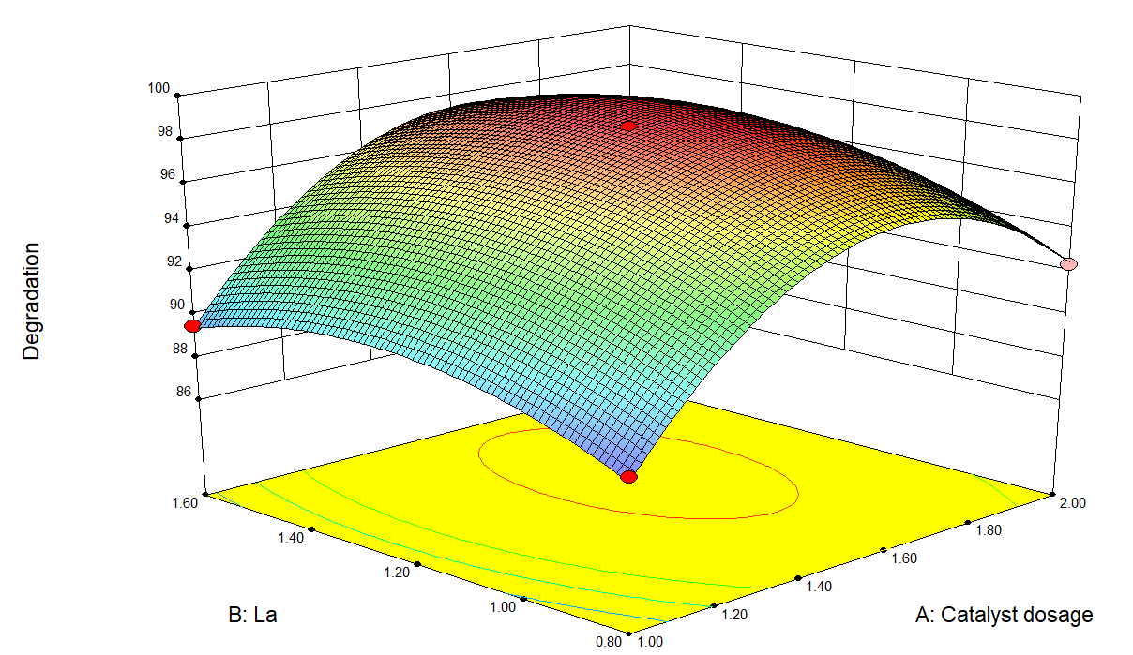

(a)

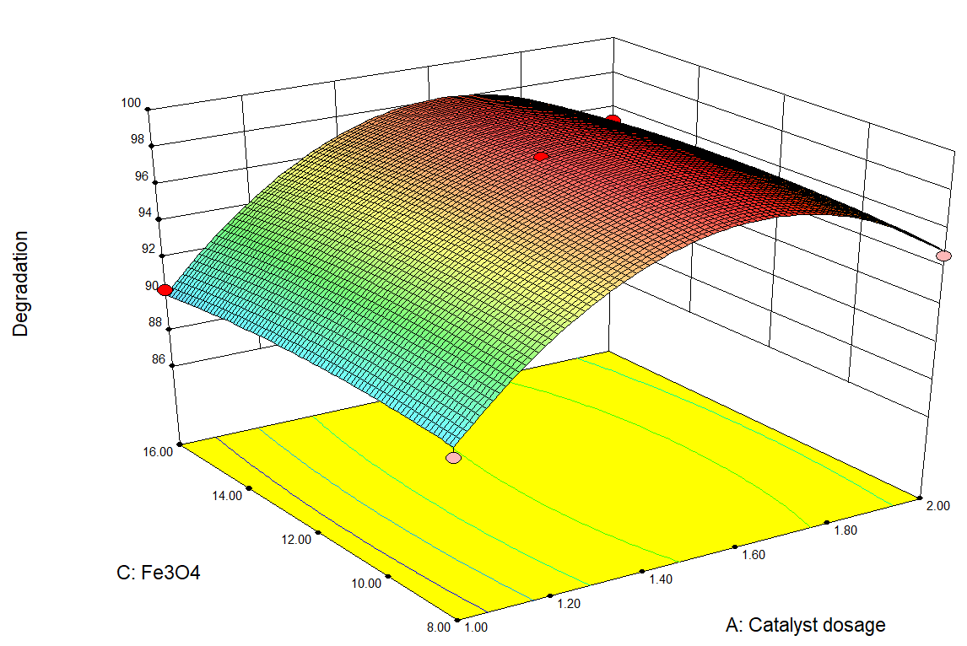

(b)

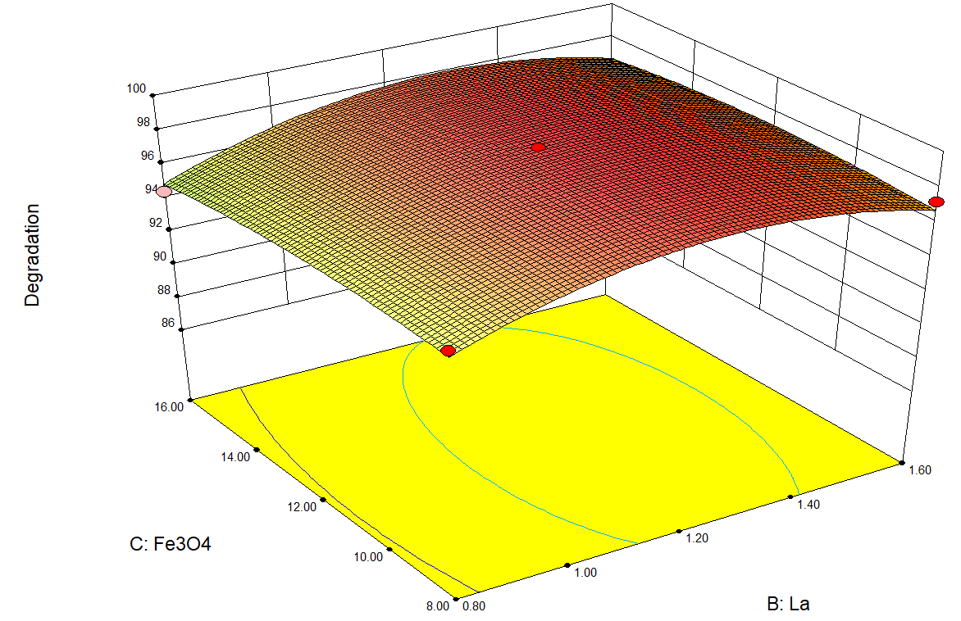

(c)

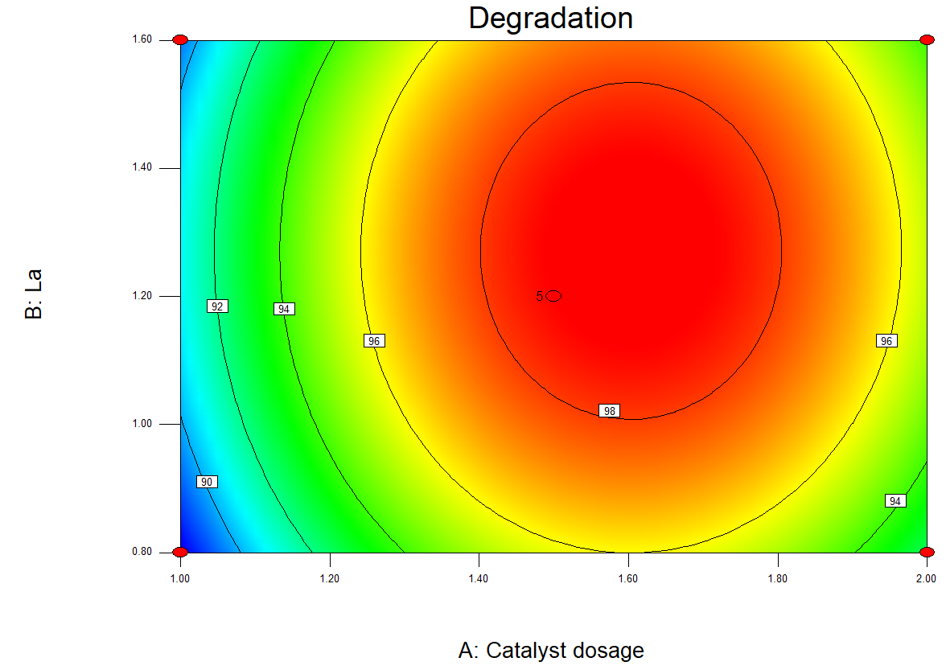

(d)

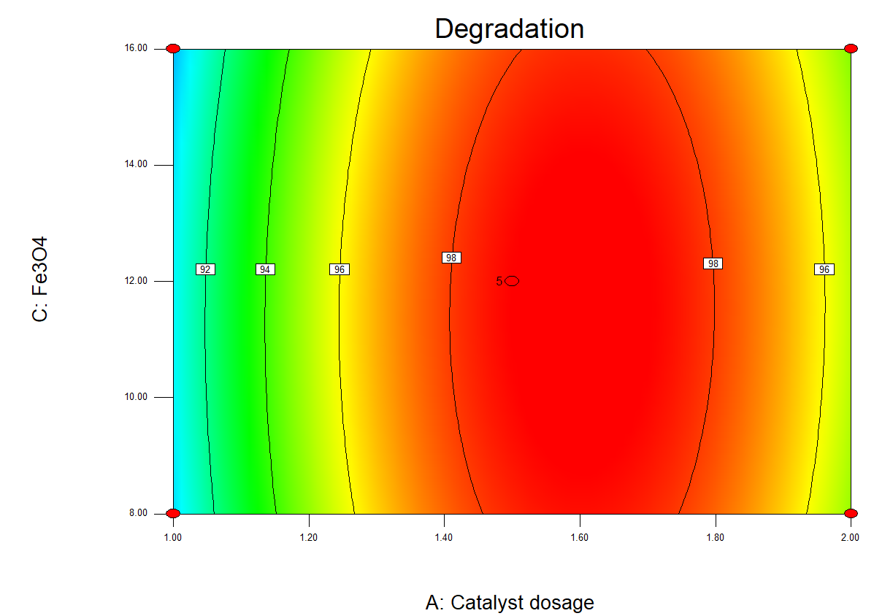(e)

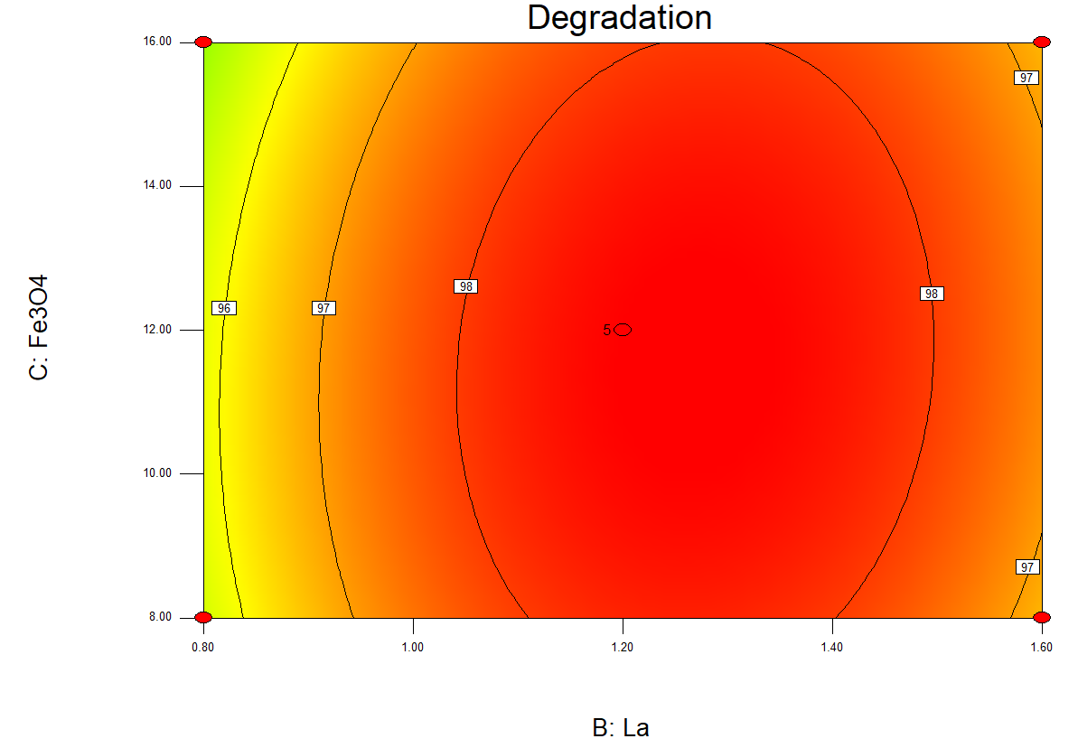

(f) Fig. S1 Response surfaces for the Box-Behnken :(a)-(f)

The table S1: Comparison of SHA degradation effects by different methods

|  |  |  |  |  |
| --- | --- | --- | --- | --- |
| method | Concentration | Treatment time | Degradation efficiency | References |
| DBD | 80ug/L | 18min | 83.6% | This study |
| DBD+La-Fe3O4/AC | 80ug/L | 18min | 99.8% | This study |
| O3 | 50mg/L | 15min | 93.94% | L.Zhang et al.2019 |
| UV | 60umol/L | 20min | 85% | W.Pang et al.2019 |
| UV/PDS | 60umol/L | 20min | 97.94% | W.Pang et al.2019 |