**Supplementary information**

**ADSORPTION AND DEGRADATION OF RHODAMINE B AND BROMOCRESOL GREEN BY FeOCl UNDER FENTON, PHOTO-FENTON AND PHOTOCATALYSIS PROCESSES**

Claudia Revilla Pacheco, Melani Ruth Riveros Cruz, Jaime Cárdenas Garcia, Ruly Terán-Hilares*, Gilberto de Jesus Colina Andrade, David A. Pacheco Tanaka, Alejandra Mogrovejo-Valdivia.

Laboratorio de Materiales, Facultad de Ciencias Farmacéuticas, Bioquímicas y Biotecnológicas, Universidad Católica de Santa María—UCSM, Urb. San José s/n—Umacollo, Arequipa 04000, Peru.

* Corresponding author: [rteran@ucsm.edu.pe](mailto:rteran@ucsm.edu.pe), Phone: +51-054-382038

**Figure S1**. Turnover of Fe(II)−Fe(III) in FeOCl upon Reaction with H2O2 adapted from [7].

**Figure S2.** First derivative of the potentiometric titration of FeOCl.

**Figure S3.** RhB (a) and BCG (b) structures.

**Figure S4.** RhB (a) and BCG (b) species at various pH.

**Figure S5**. Kinetics of Fenton degradation for RhB. Conditions: 30 mg of FeOCl, 49.0 mM of H2O2, initial concentration of RhB 0.0104mM.

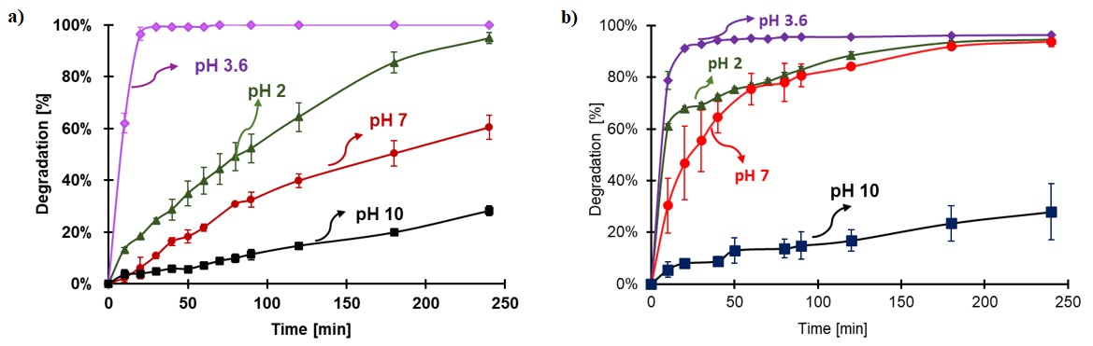

**Figure S6:** Percentage of dye degradation in the Fenton process for a) RhB and b) BCG. Conditions: 30 mg of FeOCl, 49.0 mM of H2O2, initial concentration of RhB 0.0104 mM and 0.0573 mM of BCG.

**Figure S7.** Percentage of degradation of RhB and BCG by FeOCl humidified for 24h under the same conditions. Conditions: pH 3.6, 30 mg of FeOCl, 0.520 mM for the initial concentration of RhB and BCG and 49.0 mM of H2O.

**Figure S8.** Degradation of RhB under 0.178 and 0.652 sun with respect to time.

**Table S1.** Percentages of the species present in solution at various pH

|  |  |  |  |  |  |  |
| --- | --- | --- | --- | --- | --- | --- |
| **pH** | **FeOCl (+)** | **FeOCl (0)** | **RhB (+)** | **RhB (0)** | **BCG (-)** | **BCG (-2)** |
| 2 | 86.3 | 1.6 | 99.4 | 0.06 | 99.8 | 0.16 |
| 3.6 | 13.7 | 86.3 | 81.0 | 19.0 | 93.9 | 6.1 |
| 7 | 0.01 | 100.0 | 0.16 | 99.8 | 0.61 | 99.4 |
| 10 | 0 | 100.0 | 0 | 100.0 | 0 | 100.0 |

*In brackets, the charge of the compound*

**Table S2.** Percentages of humidity of the FeOCl catalyst at different humectation times.

|  |  |
| --- | --- |
| **Hours of humectation** | **Percentage of humidity** |
| 2 | 6.7% |
| 6 | 7.4% |
| 24 | 9.9% |

**Table S3:** Degradation rate constants of RhB with various concentrations of H2O2 for Fenton reaction. Conditions: Conditions: pH 3.6, 30 mg of FeOCl, initial concentration of RhB 0.0104mM.

|  |  |  |  |  |
| --- | --- | --- | --- | --- |
| H2O2 [mM] | 16.3 | 24.5 | 32.7 | 49.0 |
| Reaction rate **[min-1 x 10-2]** | 1.9 | 2.9 | 2.6 | 16.6 |