**Supporting material**

**Corrosion inhibition properties of spinach extract on carbon steel in a hydrochloric acid medium**





Fig.S1 Plots of ( a) Arrhenius plots and (b) transition-state plots for Q235 steel dissolution reaction in a 0.5M of hydrochloric acid with and without AESPE



Fig. S2 Langmuir isotherm for AESPE adsorption of Q235 steel in a 0.5M of hydrochloric acid



Fig.S3 Plot of lnKads versus T-1 for adsorption of AESPE of Q235 Steel in a 0.5M of hydrochloric acid



Fig. S4 Temkin isotherm for AESPE adsorption of Q235 steel in a 0.5M of hydrochloric acid

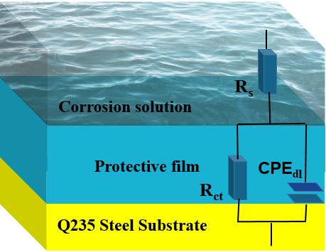

Figure S5 Equivalent circuit

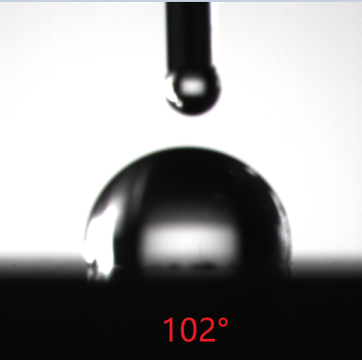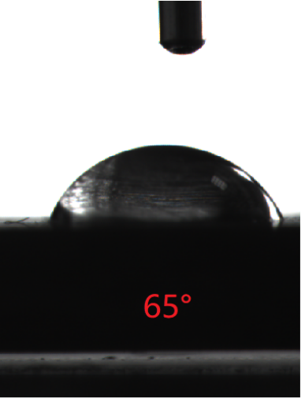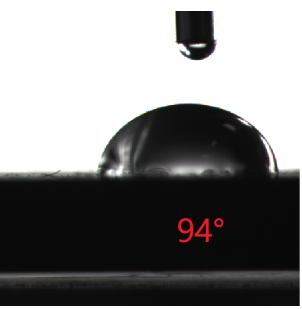

(a)

(c)

(b)

Figure S6 contact angle on the Q235 steel surface

（a）The newly uncorroded sample (102°)，（b）The sample in the 0.5M of hydrochloric acid (65°)，（c）The sample in the 0.5M of hydrochloric acid with AESPE (94°)

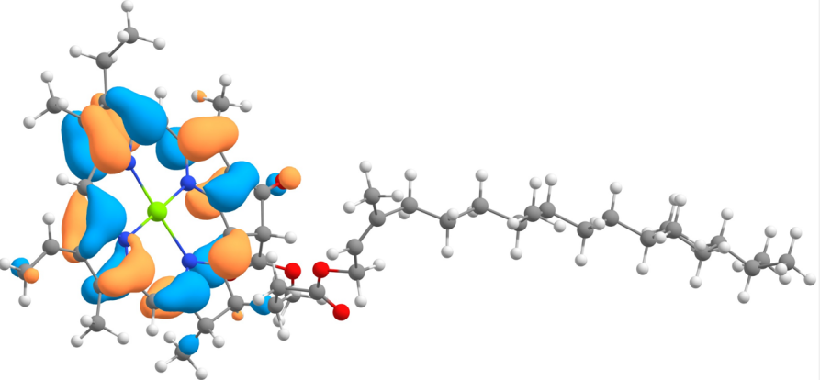

HOMO

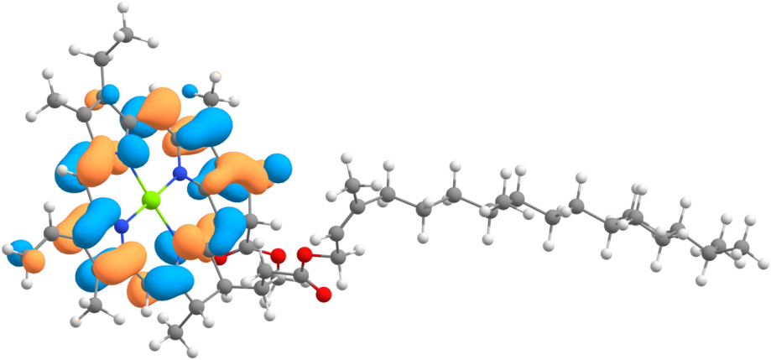

LUMO

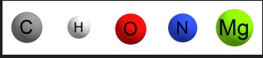

Fig. S7 HOMO and LUMO orbitals of chlorophyll