**Synthesis, In Vitro Biological analysis and Molecular Docking Studies of New Thiadiazole-Based Thiourea Derivatives as Dual Inhibitors of *a*-Amylase and *a*-Glucosidase**

* 1. *Spectral analysis*
     1. *1-(4-bromophenyl)-3-(5-((4-chlorophenyl)amino)-1,2,4-thiadiazol-3-yl)thiourea (1)*

Mp. 184-185 °C; 1H NMR (600 MHz DMSO-*d6*): *δ* 10.64 (s, 1H, NH), 10.48 (s, 1H, NH), 9.63 (s, 1H, NH), 8.01 (d, J = 9.8 Hz, 2H, H-2/6), 7.81 (d, *J* = 9.5 Hz, 2H, H-2′/6′), 7.37 (d, *J* = 6.3 Hz, 2H, H-3′/5′), 7.27 (d, *J* = 9.4 Hz, 2H, H-3/5); 13C-NMR (150 MHz, DMSO-*d6*): *δ*181.8, 138.0, 133.0, 132.5, 132.3, 130.6, 128.7, 128.5, 128.2, 126.6, 126.4, 124.8, 121.8, 121.3, 112.9; HR-ESI-MS: m/z calcd for C15H11BrClN5S2, [M]+ 438.9328; Found: 439.7620.

* + 1. *1-(5-((4-chlorophenyl)amino)-1,2,4-thiadiazol-3-yl)-3-(4-nitrophenyl)thiourea (2)*

Mp. 171-172 °C; 1H NMR (600 MHz DMSO-*d6*): *δ* 10.70 (s, 1H, NH), 10.54 (s, 1H, NH), 10.28 (s, 1H, NH), 8.24 (d, J = 10.3 Hz, 2H, H-2/6), 7.69 (d, *J* = 10.4 Hz, 2H, H-2′/6′), 7.62 (d, *J* = 10.6 Hz, 2H, H-3′/5′), 7.45 (d, *J* = 7.5 Hz, 2H, H-3/5); 13C-NMR (150 MHz, DMSO-*d6*): *δ*180.0, 168.8, 140.2, 139.9, 129.8, 129.5, 129.2, 129.1, 128.8, 124.8, 124.0, 123.4, 122.2, 119.4, 118.6; HR-ESI-MS: m/z calcd for C15H11ClN6O2S2, [M] + 406.0073; Found: 406.8630.

* + 1. *1-(5-((4-chlorophenyl)amino)-1,2,4-thiadiazol-3-yl)-3-(p-tolyl)thiourea (3)*

Mp. 158-159 °C; 1H NMR (600 MHz DMSO-*d6*): *δ* 13.21 (s, 1H, NH), 11.28 (s, 1H, NH), 10.61 (s, 1H, NH), 7.59 (d, *J* = 6.5 Hz, 2H, H-2/6), 7.36 (m, 2H, H-2′/6′), 7.35 (m, 2H, H-3′/5′), 7.28 (d, *J* = 6.3 Hz, 2H, H-3/5), 2.31 (s, 3H, CH3); 13C-NMR (150 MHz, DMSO-*d6*): *δ* 179.3, 173.1, 156.1, 141.4, 137.2, 135.5, 131.8, 129.4, 129.4, 129.2, 126.4, 126.4, 123.4, 121.2, 120.2, 21.5; HR-ESI-MS: m/z calcd for C16H14ClN5S2, [M] + 375.0379; Found: 375.8930.

* + 1. *1-(5-((3,4-dichlorophenyl)amino)-1,2,4-thiadiazol-3-yl)-3-(2-nitrophenyl)thiourea (4)*

Mp. 185-186 °C; 1H NMR (600 MHz DMSO-*d6*): *δ* 13.26 (s, 1H, NH), 10.78 (s, 1H, NH), 10.63 (s, 1H, NH), 8.42 (dd, *J* = 7.5, 2.6 Hz, 1H, H-6′) , 8.31 (dd, *J* = 7.1, 3.5 Hz, 1H, H-3′), 7.87 (m, 1H, H-5′), 7.59 (m, 1H, H-4′), 7.55 (d, *J* = 7.3Hz, 1H, H-6), 7.38 (d, *J* = 7.1Hz, 1H, H-5), 7.35 (s, 1H, H-2); 13C-NMR (150 MHz, DMSO-*d6*): *δ* 180.0, 173.0, 156.1, 141.8, 137.3, 135.5, 131.8, 129.3, 129.3, 129.1, 125.4, 125.4, 123.4, 121.3, 120.3;HR-ESI-MS: m/z calcd for C15H10Cl2N6O2S2, [M]+ 439.9684; Found: 440.3050.

* + 1. *1-(5-((3,4-dichlorophenyl)amino)-1,2,4-thiadiazol-3-yl)-3-(3-methoxyphenyl)thiourea (5)*

Mp. 178-179 °C; 1H NMR (600 MHz DMSO-*d6*): *δ* 13.24 (s, 1H, NH), 11.33 (s, 1H, NH), 10.64 (s, 1H, NH), 7.63 (d, *J* = 7.3 Hz, 1H, H-6), 7.36 (d, *J* = 7.1Hz, 1H, H-5), 7.33 (s, 1H, H-2), 7.21 (s, 1H, H-2′), 7.18 (dd, *J* = 6.6, 2.4 Hz, 1H, H-5′), 7.14 (dd, *J* = 6.5, 2.5 Hz, 1H, H-6′), 6.69 (dd, *J* = 6.7, 2.3 Hz, 1H, H-4′), 3.73 (s, 3H, OCH3); 13C-NMR (150 MHz, DMSO-*d6*): *δ* 179.4, 173.0, 156.0, 141.5, 137.0, 135.5, 131.8, 129.4, 129.4, 129.1, 126.6, 126.6, 123.4, 121.0, 120.0, 21.3; HR-ESI-MS: m/z calcd for C16H13Cl2N5OS2, [M] + 424.9939; Found: 425.5338.

* + 1. *1-(3,4-dichlorophenyl)-3-(5-((3,4-dichlorophenyl)amino)-1,2,4-thiadiazol-3-yl) thiourea (6)*

Mp. 195-196 °C; 1H-NMR (600 MHz DMSO-*d6*): *δ* 13.20 (s, 1H, NH), 11.29 (s, 1H, NH), 10.58 (s, 1H, NH), 7.82 (s, 1H, H-2′), 7.65 (s, 1H, H-2), 7.55 (d, *J* = 7.5 Hz, 1H, H-6), 7.50 (d, *J* = 7.3 Hz, 1H, H-6′), 7.48 (d, *J* = 7.1 Hz, 1H, H-5′), 7.38 (d, *J* = 7.1Hz, 1H, H-5); 13C-NMR (150 MHz, DMSO-*d6*): *δ* 179.9, 173.0, 156.1, 141.9, 137.2, 135.5, 131.8, 129.3, 129.3, 129.1, 126.4, 126.4, 123.4, 121.2, 120.2; HR-ESI-MS: m/z calcd for C15H9Cl4N5S2, [M] + 464.9024; Found: 462.9053.

* + 1. *1-(5-((3,4-dichlorophenyl)amino)-1,2,4-thiadiazol-3-yl)-3-(2-fluorophenyl)thiourea (7)*

Mp. 173-174 °C; 1H NMR (600 MHz DMSO-*d6*): *δ* 13.25 (s, 1H, NH), 10.78 (s, 1H, NH), 10.64 (s, 1H, NH), 8.42 (dd, *J* = 7.5, 2.6 Hz, 1H, H-6′) , 8.30 (dd, *J* = 7.1, 3.5 Hz, 1H, H-3′), 7.88 (m, 1H, H-5′), 7.59 (m, 1H, H-4′), 7.54 (d, *J* = 7.3 Hz, 1H, H-6), 7.37 (d, *J* = 7.1 Hz, 1H, H-5), 7.34 (s, 1H, H-2); 13C-NMR (150 MHz, DMSO-*d6*): *δ* 178.9, 173.0, 156.1, 142.9, 137.2, 135.5, 131.8, 129.3, 129.3, 129.1, 126.4, 126.4, 123.4, 121.3, 120.3; HR-ESI-MS: m/z calcd for C15H10Cl2FN5S2, [M]+ 412.9779; Found: 412.9772.

* + 1. *1-(5-((3,4-dichlorophenyl)amino)-1,2,4-thiadiazol-3-yl)-3-(2-methoxyphenyl)thiourea (8)*

Mp. 178-179 °C; 1H NMR (600 MHz DMSO-*d6*): *δ* 13.23 (s, 1H, NH), 10.75 (s, 1H, NH), 10.61 (s, 1H, NH), 7.71 (dd, *J* = 6.5, 2.5 Hz, 1H, H-6′), 7.51 (d, *J* = 7.3 Hz, 1H, H-6), 7.46 (m, 1H, H-4′), 7.34 (d, *J* = 7.1 Hz, 1H, H-5), 7.31 (s, 1H, H-2), 7.05 (m, 1H, H-5′), 7.03 (dd, *J* = 6.9, 2.6 Hz, 1H, H-3′), 3.84 (s, 3H, OCH3); 13C-NMR (150 MHz, DMSO-*d6*): *δ* 179.9, 173.0, 156.1, 141.9, 137.2, 135.5, 131.8, 129.3, 129.3, 129.1, 126.4, 126.4, 123.4, 121.2, 120.2, 21.3; HR-ESI-MS: m/z calcd for C16H13Cl2N5OS2, [M]+ 424.9939; Found: 425.5338.

* + 1. *1-(5-((4-fluorophenyl)amino)-1,2,4-thiadiazol-3-yl)-3-(3-nitrophenyl)thiourea (9)*

Mp. 164-165 °C; 1H NMR (600 MHz DMSO-*d6*): *δ* 13.24 (s, 1H, NH), 11.30 (s, 1H, NH), 10.63 (s, 1H, NH), 8.56 (s, 1H, H-2′), 7.94 (dd, *J* = 7.4, 2. 5Hz, 1H, H-4′), 7.85 (dd, *J* = 7.2, 3.5 Hz, 1H, H-6′), 7.58 (dd, *J* = 7.5, 3.1 Hz, 1H, H-5′), 7.42 (d, *J* = 6.5 Hz, 2H, H-2/6), 7.32 (d, *J* = 6.3 Hz, 2H, H-3/5); 13C-NMR (150 MHz, DMSO-*d6*): *δ* 179.6, 173.0 , 156.2, 147.3, 138.6, 132.4, 131.2 , 129.6, 129.6, 127.7, 125.6, 125.4, 123.3, 122.2, 122.2;, HR-ESI-MS: m/z calcd for C15H11FN6O2S2, [M]+ 390.0369; Found: 390.4114.

* + 1. *1-(3-nitrophenyl)-3-(5-((3-nitrophenyl)amino)-1,2,4-thiadiazol-3-yl)thiourea (10)*

Mp. 175-176 °C; 1H NMR (600 MHz DMSO-*d6*): *δ* 13.23 (s, 1H, NH), 11.29 (s, 1H, NH), 10.59 (s, 1H, NH), 8.54 (s, 1H, H-2′), 8.12 (s, 1H, H-2), 8.02 (dd, *J* = 7.4, 2.5 Hz, 1H, H-6), 7.95 (dd, *J* = 7.4, 2.5 Hz, 1H, H-4′), 7.85 (dd, *J* = 7.2, 3.5 Hz, 1H, H-6′), 7.76 (dd, *J* = 7.2, 3.5 Hz, 1H, H-4), 7.59 (dd, *J* = 7.5, 3.1 Hz, 1H, H-5′), 7.49 (dd, *J* = 7.5, 3.1 Hz, 1H, H-5); 13C-NMR (150 MHz, DMSO-*d6*): *δ* 179.5, 173.0 , 156.1, 147.3, 138.6, 132.4, 131.2 , 129.5, 129.5, 127.7, 125.6, 125.4, 123.2, 122.1, 122.1; HR-ESI-MS: m/z calcd for C15H11N7O4S2, [M] + 417.0314; Found: 417.4180.

* + 1. *1-(4-nitrophenyl)-3-(5-((3-nitrophenyl)amino)-1,2,4-thiadiazol-3-yl)thiourea (11)*

Mp. 175-176 °C; 1H NMR (600 MHz DMSO-*d6*): *δ* 13.26 (s, 1H, NH), 11.31 (s, 1H, NH), 10.65 (s, 1H, NH), 8.13 (dd, *J* = 7.4, 2. 5Hz, 2H, H-3′/5′), 8.11 (s, 1H, H-2), 8.01 (dd, *J* = 7.4, 2.5 Hz, 1H, H-6), 7.77 (dd, *J* = 7.2, 3.5 Hz, 1H, H-4), 7.72 (dd, *J* = 7.2, 3.5 Hz, 2H, H-2′/6′), 7.50 (dd, *J* = 7.5, 3.1 Hz, 1H, H-5); 13C-NMR (150 MHz, DMSO-*d6*): *δ* 179.8, 173.0 , 156.1, 147.3, 138.6, 132.4, 131.2 , 129.6, 129.6, 127.7, 125.6, 125.4, 123.3, 122.0, 122.0; HR-ESI-MS: m/z calcd for C15H11N7O4S2, [M]+ 417.0314; Found: 417.4180.

* + 1. *1-(2,4-dichlorophenyl)-3-(5-((3-nitrophenyl)amino)-1,2,4-thiadiazol-3-yl)thiourea (12)*

Mp. 185-186 °C; 1H NMR (600 MHz DMSO-*d6*): *δ* 14.29 (s, 1H, NH), 13.21 (s, 1H, NH), 10.63 (s, 1H, NH), 8.62 (s, 1H, H-3′), 8.13 (s, 1H, H-2), 8.03 (dd, *J* = 7.4, 2.5 Hz, 1H, H-6), 7.76 (dd, *J* = 7.2, 3.5 Hz, 1H, H-4), 7.53 (d, *J* = 6.7 Hz, 1H, H-6′), 7.50 (dd, *J* = 7.5, 3.1 Hz, 1H, H-5), 7.24 (d, *J* = 6.5 Hz, 1H, H-5′); 13C-NMR (150 MHz, DMSO-*d6*): *δ* 180.0, 173.1 , 156.2, 147.4, 138.7, 132.5, 131.3 , 129.7, 129.7, 127.8, 125.7, 125.5, 123.4, 122.2, 122.2;HR-ESI-MS: m/z calcd for C15H10Cl2N6O2S2, [M]+ 439.9684; Found: 440.9654.

* + 1. *1-phenyl-3-(5-((3-(trifluoromethyl)phenyl)amino)-1,2,4-thiadiazol-3-yl)thiourea (13)*

Mp. 166-167 °C; 1H NMR (600 MHz DMSO-*d6*): *δ* 13.24 (s, 1H, NH), 11.31 (s, 1H, NH), 10.60 (s, 1H, NH), 7.70 (dd, *J* = 7.4, 2.5 Hz, 2H, H-2′/6′), 7.65 (dd, *J* = 7.4, 2.5 Hz, 1H, H-6), 7.52 (s, 1H, H-2), 7.41 (m, 2H, H-3′/5′), 7.21 (dd, *J* = 7.2, 3.5 Hz, 1H, H-4), 7.11 (dd, *J* = 7.5, 3.1 Hz, 1H, H-5), 7.07 (m, 1H, H-4′); 13C-NMR (150 MHz, DMSO-*d6*): *δ* 179.9, 173.0 , 156.1, 147.3, 138.6, 132.4, 131.2 , 129.6, 129.6, 127.7, 125.6, 125.4, 124.1, 123.1, 122.0, 122.0; HR-ESI-MS: m/z calcd for C16H12F3N5S2, [M]+ 395.0486; Found: 395.4222.

* + 1. *1-(4-chlorophenyl)-3-(5-((3-(trifluoromethyl)phenyl)amino)-1,2,4-thiadiazol-3-yl)thiourea (14)*

Mp. 181-182 °C; 1H NMR (600 MHz DMSO-*d6*): *δ* 13.22 (s, 1H, NH), 11.30 (s, 1H, NH), 10.62 (s, 1H, NH), 7.63 (dd, *J* = 7.4, 2.5 Hz, 1H, H-6), 7.61 (d, *J* = 6.5 Hz, 2H, H-2′/6′), 7.55 (s, 1H, H-2), 7.35 (d, *J* = 6.6 Hz, 2H, H-3′/5′), 7.22 (dd, *J* = 7.2, 3.5 Hz, 1H, H-4), 7.12 (dd, *J* = 7.5, 3.1 Hz, 1H, H-5); 13C-NMR (150 MHz, DMSO-*d6*): *δ* 179.8, 172.9 , 155.9, 147.1, 138.4, 132.1, 131.1 , 129.6, 129.6, 127.6, 125.5, 125.4, 124.1, 123.3, 122.1, 122.1; HR-ESI-MS: m/z calcd for C16H11ClF3N5S2, [M]+ 429.0096; Found: 429.8642.

* + 1. *1-(2-nitrophenyl)-3-(5-((3-(trifluoromethyl)phenyl)amino)-1,2,4-thiadiazol-3-yl)thiourea (15)*

Mp. 186-187 °C; 1H NMR (600 MHz DMSO-*d6*): *δ* 13.21 (s, 1H, NH), 10.74 (s, 1H, NH), 10.62 (s, 1H, NH), 8.42 (dd, *J* = 7.5, 2.6 Hz, 1H, H-6′), 8.31 (dd, *J* = 7.1, 3.5 Hz, 1H, H-3′), 7.86 (m, 1H, H-5′), 7.65 (dd, *J* = 7.4, 2.5 Hz, 1H, H-6), 7.59 (m, 1H, H-4′), 7.54 (s, 1H, H-2), 7.23 (dd, *J* = 7.2, 3.5 Hz, 1H, H-4), 7.13 (dd, *J* = 7.5, 3.1 Hz, 1H, H-5); 13C-NMR (150MHz, DMSO-*d6*): *δ* 179.9, 173.0, 156.1, 147.3, 138.6, 132.4, 131.2 , 129.6, 129.6, 127.7, 125.6, 125.4, 124.1, 123.3, 122.1, 122.1; HR-ESI-MS: m/z calcd for C16H11F3N6O2S2, [M] + 440.0337; Found: 440.4192.

* 1. *Assay protocol for alpha-amylase inhibition*

For the determination of alpha-amylase inhibition, Kwon and Apostolidis method were used. Alpha-amylase was prepared in the phosphate buffer having 500 *µ*L (0.5 mg/mL) and sample were also prepared in various concentration (100, 200, 400, 800 and 1000 *µ*g/mL) and incubated for 10 minutes at 25 °C. 500 *µ*L of starch solution and 0.02M sodium phosphate buffer were added and incubated for 10 minutes. DNSA was added as a coloring agent and incubated in boiling water for 5 minutes, cooled and diluted by using the distill water. The percentage of inhibition was calculated by using the formula.

* 1. *Assay protocol for alpha-glucosidase inhibition*

Kinetic studies were carried out to find the inhibition of alpha-glucosidase by using the different concentration of inhibitors such as 0.0624, 0.3, 0.125, 0.4 mM as well as different concentration of substrate (para-nitrophenol R-D maltose NMP) prepared by using the various concentration 0.1, 0.2, 0.4, 0.8 and 1.0 mM (0.2 mg/mL) was prepared in de-ionized water with enzymes. The pH of the buffer was adjusted by using the PIPES solution. This solution was incubated for 30 minutes at 25 °C, while the absorbance was recorded by using the ELISA reader in 96 well plates. Kinetic parameters (Vmax, Km, R2 and AICs) were calculated using sigma plot enzyme kinetic study.

* 1. *Assay protocol for molecular docking study*

By using the discovery studio visualizer and autodoc tools 1.5.7. The potent synthesized compounds were docked against alpha-amylase and alpha-glucosidase and their structure were collected from protein data bank by using the codes such as 1b2y and 3w37. Through DSV proteins were prepared to maintain the structures by removing the water and proteins and saved in the PDB format. Through the addition of polar hydrogen bonding as well as kollman and gasteiger charges, both the structures are open by using autodoc tools. Ligand preparation was done by using the torsion tree to detect to root and saved in PDBQT format. Configured file was generated along the three dimensions (X, Y and Z) and save the proteins structure in PDBQT. Different energy prompt code was employed to generate different poses of molecules.

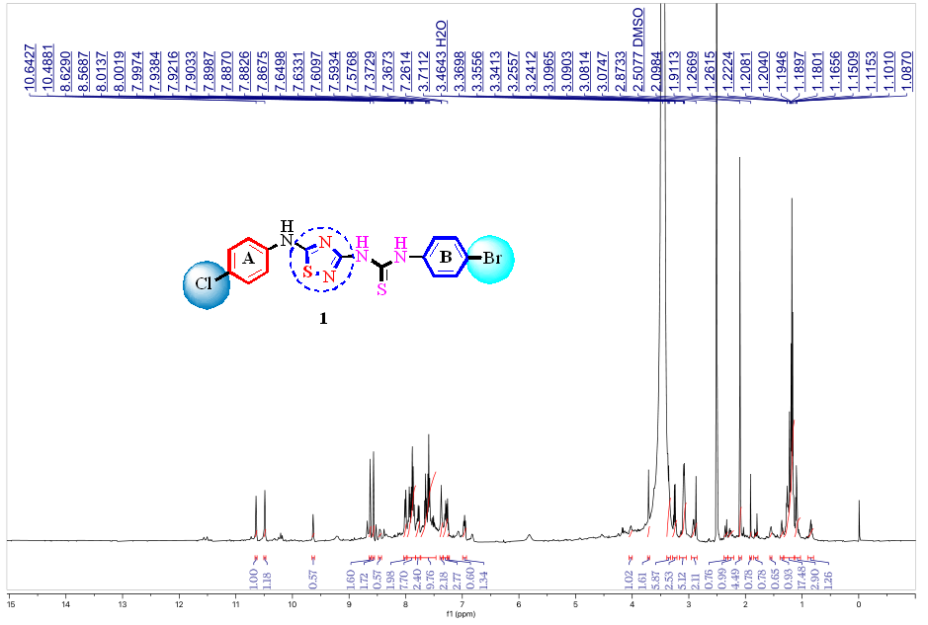Figure-1: 1H-NMR spectra of *1-(4-bromophenyl)-3-(5-((4-chlorophenyl)amino)-1,2,4-thiadiazol-3-yl)thiourea (1)*

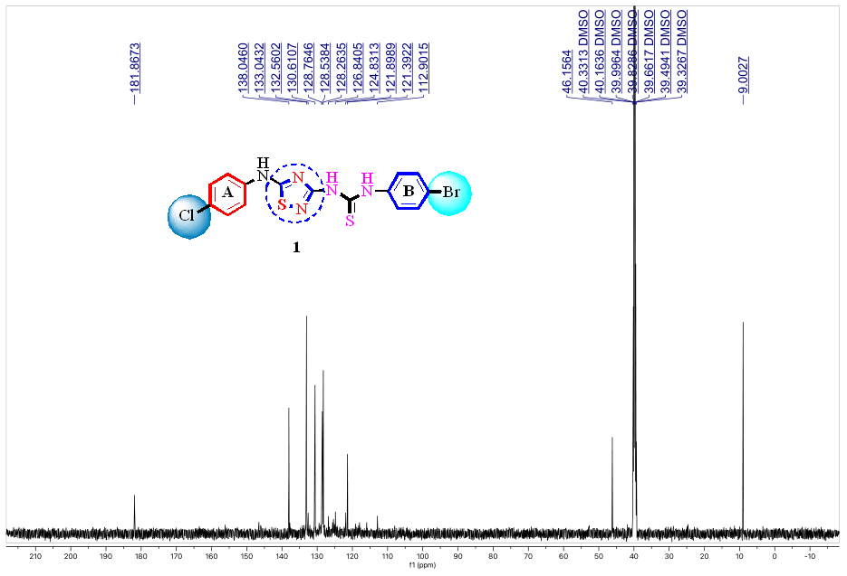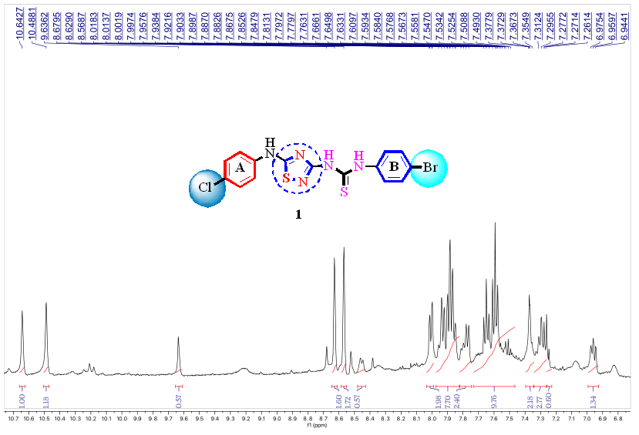Figure-2: 1H-NMR (HR) spectra of *1-(4-bromophenyl)-3-(5-((4-chlorophenyl)amino)-1,2,4-thiadiazol-3-yl)thiourea (1)*

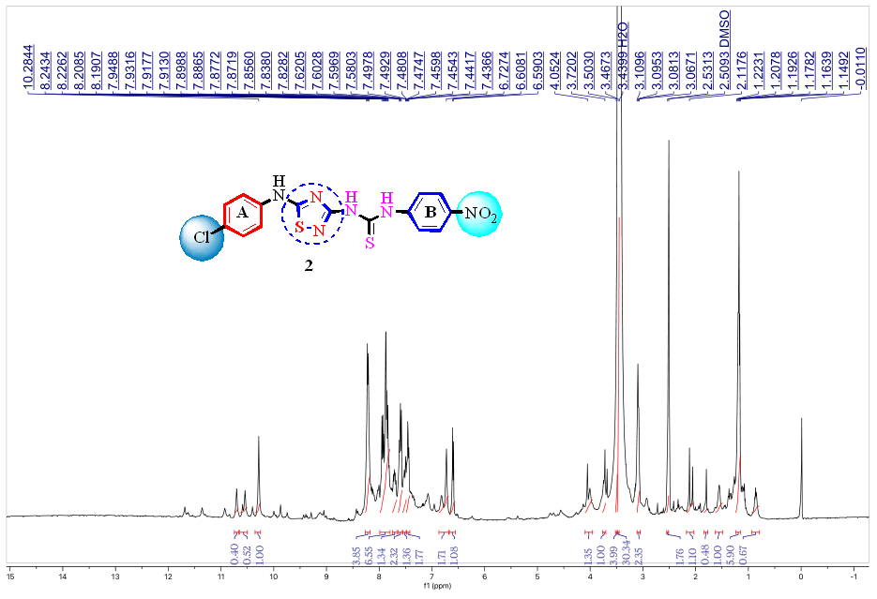Figure-3: 13C-NMR spectra of *1-(4-bromophenyl)-3-(5-((4-chlorophenyl)amino)-1,2,4-thiadiazol-3-yl)thiourea (1)*

Figure-4:1H-NMR spectra of *1-(5-((4-chlorophenyl)amino)-1,2,4-thiadiazol-3-yl)-3-(4-nitrophenyl)thiourea (2)*

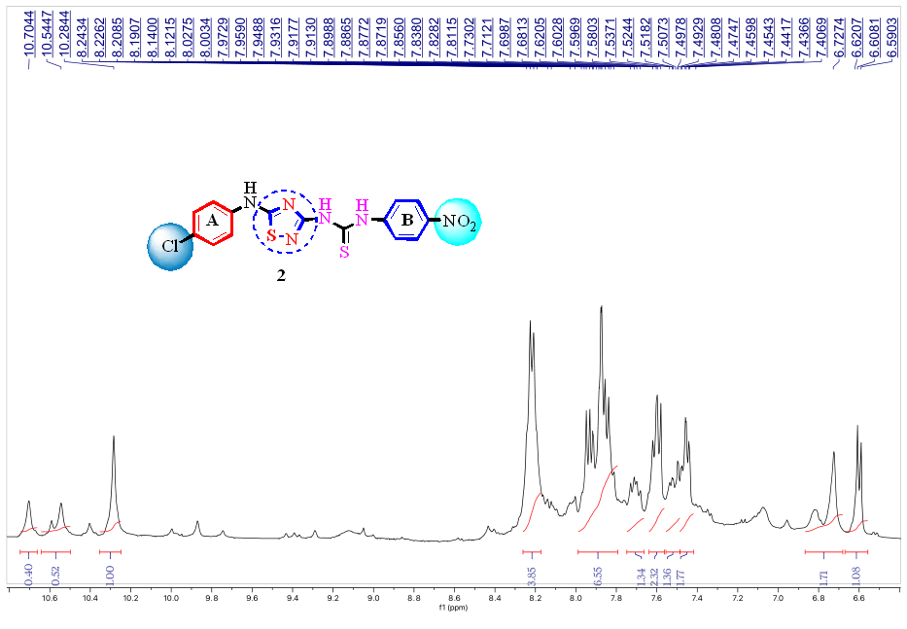Figure-5: 1H-NMR (HR) spectra of *1-(5-((4-chlorophenyl)amino)-1,2,4-thiadiazol-3-yl)-3-(4-nitrophenyl)thiourea (2)*

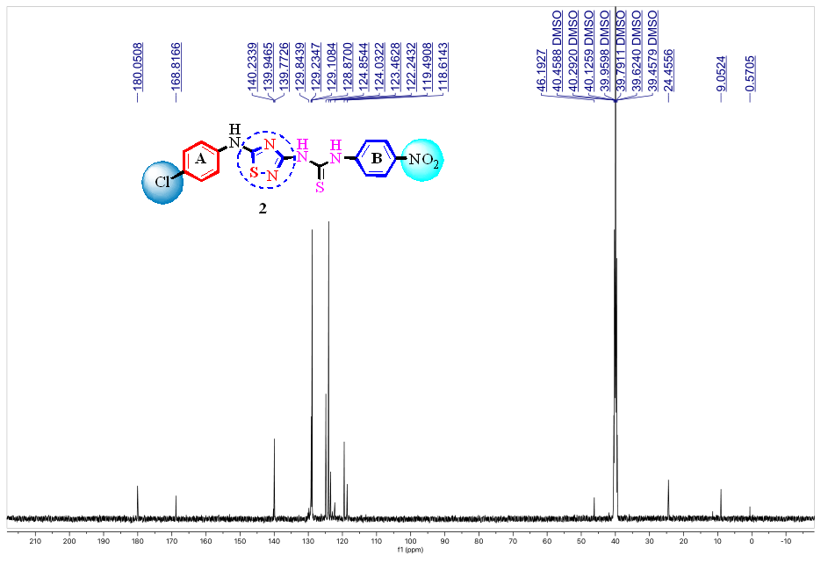Figure-6:13C-NMR spectra of *1-(5-((4-chlorophenyl)amino)-1,2,4-thiadiazol-3-yl)-3-(4-nitrophenyl)thiourea (2)*