**Supporting Information**

**Novel 2D/2D S-scheme Ni doped SnS2/BiOBr heterostructures with** **enhanced photocatalytic activity**

Qiang Li,a,b,* Lijie Wang,a Jupu Song,a Yajing Huang,a Guoyu Xie,a Yi Liua and Hong Lia

*aAnhui Province Key Laboratory of Pollutant Sensitive Materials and Environmental Remediation, College of Physics and Electronic Information, Huaibei Normal University, Huaibei, 235000, PR China*

*bAnhui Province Industrial Generic Technology Research Center for Alumics Materials, Huaibei Normal University, Huaibei, Anhui 235000, PR China*

1. **Characterization**

The X-ray diffraction (XRD) pattern of catalyst was obtained on a PANalytical Empyrean diffractometer. The Fourier transform infrared (FTIR) spectra were recorded on a spectrometer (Thermo Scientific Nicolet, USA). The morphologies of catalyst were analyzed using SU8220 field emission scanning electron microscope (FESEM, Japan). The transmission electron microscopy (TEM) and the high-resolution TEM (HRTEM) images were obtained with a FEI Talos F200x microscope. UV-visible diffuse reflection spectra (UV-vis DRS) were tested on the Lambda 950 (Perking Elmer) spectrophotometer. The compositions and valence states of sample were investigated using an X-ray photoelectron spectrometer (XPS, Thermo Scientific ESCALAB Xi+). The photoluminescence (PL) investigation was performed on the Edinburgh FLS1000 fluorescence spectrometer. The zeta potential measurement was performed on Malvern Zetasizer Nano ZS90. Brunauer‐Emmett‐Teller (BET) specific surface area was obtained on Japan BELSORP-max II. The electron spin resonance (ESR) was determined by a Bruker EMXplus-6/1. Photoelectrochemical analysis was performed on a CHI760E workstation. The Pt wire, Ag/AgCl electrode and catalyst-modified FTO were applied as reference; counter electrodes as well as working electrode in a three-electrode cell, respectively. The working electrode was synthesized as follows: 30 mg catalyst was taken in a quartz mortar and ground into slurry by adding 20 µl of Nafion binder and 100 µl of absolute ethanol. Eventually, the slurry was spread uniformly on the FTO glass.

**2. Photocatalytic measurements**

The decomposition rates of TC (15 mg/L) and RhB (15 mg/L) over photocatalysts were analyzed to estimate the photoactivity of as-prepared catalysts. A 500 W Xenon arc lamp equipped with a 400 nm cut-off filter was selected as a visible light source (120 mW/cm2) and was placed above 13 cm away from the reactor in system. Before irradiation, the suspension containing 30 mg catalysts and 100 mL pollutants solution was magnetically stirred in darkness for one hour to achieve adsorption-desorption equilibrium. At the given illumination time, 4 mL suspension was sampled and centrifuged at high speed to filtrate solid catalyst. The concentration of RhB and TC was studied by a spectrophotometer at wavelength of 554 and 350 nm, respectively. Cycling tests were performed under the same conditions. In each cycle experiment, the photocatalysts were centrifuged and washed with deionized water before reuse. The mineralization rate (η) of pollutants was computed as follows (Vinesh, V. et al., 2022):

*η*(%) = (1- *C*t/*C*0) × 100%

where *C*0 and *C*t were the concentration of pollutants in aqueous solution at time 0 and t, respectively.

**3. Computational details**

Density function theory (DFT) calculations were performed by using the CP2K-9.1 package. Perdew-Burke-Ernzerh (PBE) of functional was adopted to describe the system. Unrestricted Kohn-Sham DFT was adopted as the electronic structure method in the framework of the Gaussian and plane waves (GPW) way. The Goedecker-Teter-Hutter (GTH) pseudopotentials and Double-ζ molecularly optimized basis sets (DZVP-MOLOPT-GTH) was used for all elements. The Brillouin zone was sampled with gamma points for surface calculation. A plane-wave energy cutoff of 400 Ry (1Ry = 13.606 eV) was employed. The geometries were optimized using the Broyden-Fletcher-Goldfarb-Shanno (BFGS) algorithm. The convergence threshold of density matrix during self-consistent field (SCF) method was 1*10–5 Hartree, and convergence criterion for the forces was set to 4.5*10–4 Bohr/Hartree. A vacuum layer of 15 Å was constructed to eliminate interactions between periodic structures of surface models. The van der Waals interaction was amended by the DFT-D3 method of Grimme.

The work function (Φ) of surface was defined as

Φ = Evac - Ef

Where Evac and Ef denoted the vacuum level and Fermi energy, respectively (Di, T. et al., 2017).

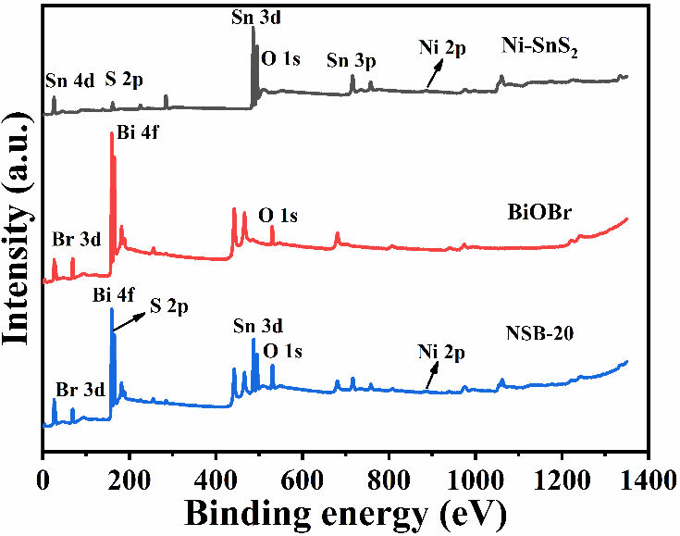

Fig. S1. XPS survey spectra of Ni-SnS2, BiOBr and NSB-20 composites.

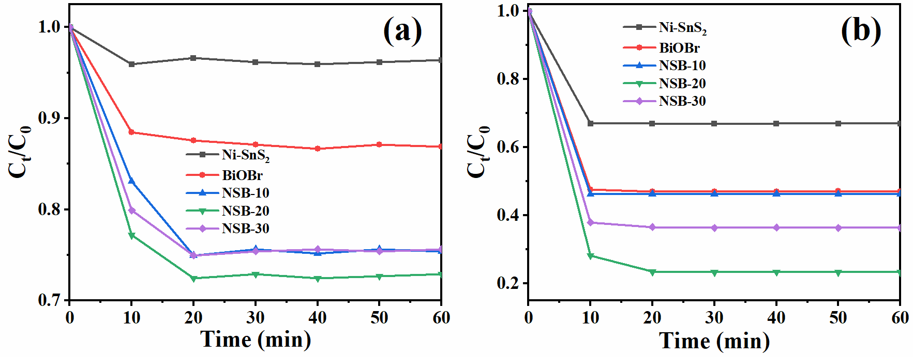

Fig. S2. Absorption ability evaluation of the as-prepared samples for TC (a) and RhB (b) in dark.

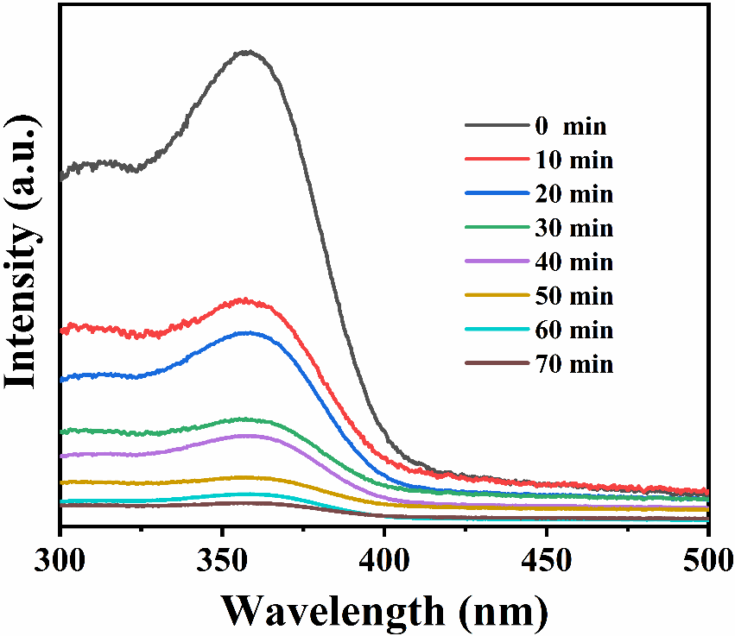

Fig. S3. Time-dependent UV-vis absorption spectra of TC over NSB-20.

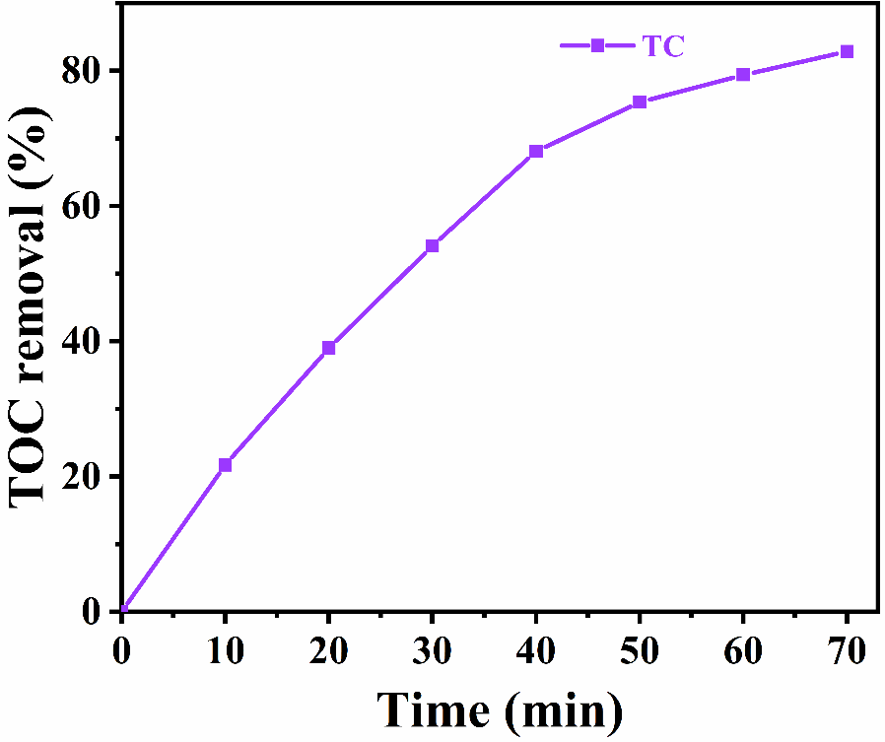

Fig. S4. TOC removal efficiencies of the degraded TC solution over NSB-20 composite.

**Table S1**

Comparison of photodegradation performances of pollutants over various BiOBr-based photocatalysts.

|  |  |  |  |  |  |  |
| --- | --- | --- | --- | --- | --- | --- |
| Photocatalysts | Pollutants | Catalyst amount | Reaction time | Efficiency | Degradation rate | Ref. |
| BiSbO4/BiOBr | RhB=10 mg/L | 30 mg | 45 min | 96.0% | 0.073 min-1 | (Wang, Z. et al., 2019) |
| LaFeO3/BiOBr | RhB=5 mg/L | 100 mg | 30 min | 98.2% | 0.1309 min-1 | (Guan, S. et al., 2020) |
| NiFe2O4/BiOBr | RhB=10 mg/L | 100 mg | 120 min | 96% |  | (Lv, D. et al., 2016) |
| Bi2O2CO3/BiOBr | RhB=10 mg/L | 25 mg | 45 min | 92.83% | 0.0495 min-1 | (Cheng, L. et al., 2018) |
| BiOBr/Ni2P/g-C3N4 | RhB=10 mg/L | 20 mg | 120 min | 98.9% | 0.0260 min-1 | (Chen, N. et al., 2022) |
| BiOBr/pCN | RhB=10 mg/L | 20 mg | 30 min | 95.32% | 0.083 min-1 | (zhang, T. et al., 2021) |
| BiOBr/g-C3N4 | RhB=10 mg/L | 30 mg | 30 min | 99% | 0.0127 min-1 | (Zhang, B. et al., 2021) |
| CuO2/BiOBr | TC=10 mg/L | 40 mg | 100 min | 78.27% | 0.0173 min-1 | (Dou, X. et al., 2022) |
| Bi2WO6/BiOBr | TC=10 mg/L | 25 mg | 120 min | 96% | 0.014 min-1 | (Liu, K. et al., 2021) |
| Bi5O7Br/BiOBr | TC=10 mg/L | 50 mg | 90 min | 81.4% |  | (Zhang, L. et al., 2020) |
| MoS2/BiOBr | TC=20 mg/L | 50 mg | 120 min | 68% | 0.6348 h-1 | (Yin, W. et al., 2021) |
| BiOBr/g-C3N4 | TC=20 mg/L | 50 mg | 150 min | 81.1% | 0.0118 min-1 | (Li, H. et al., 2020) |
| BiOBr/MnFe2O4 | TC=20 mg/L | 100 mg | 90 min | 76.5% | 0.0165 min-1 | (He, Q. andGe, M., 2022) |
| Ni-SnS2/BiOBr | RhB=15 mg/L | 30 mg | 25 min | 99.75% | 0.1897 min-1 | This work |
| Ni-SnS2/BiOBr | TC=15 mg/L | 30 mg | 70 min | 96.18% | 0.0488 min-1 | This work |

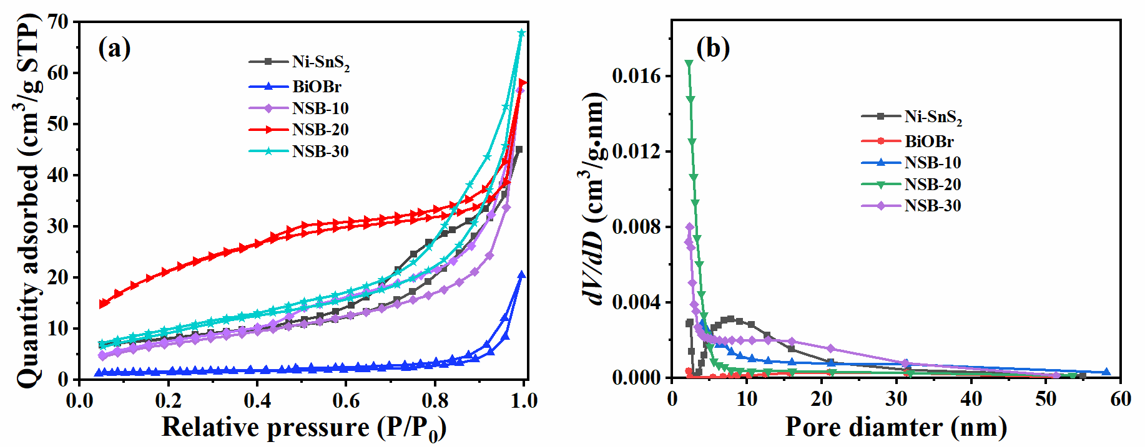

Fig. S5. Nitrogen adsorption-desorption isotherms (a) and pore volume distribution curves (b) of Ni-SnS2, BiOBr, and NSB composites.

|  |  |  |  |
| --- | --- | --- | --- |
| Sample | SBET/(m2g-1) | Pore volume/(cm3g-1) | Average pore size/nm |
| Ni-SnS2 | 28.2069 | 0.011928 | 0.7303 |
| BiOBr | 5.8411 | 0.002452 | 0.7494 |
| NSB-10 | 25.8461 | 0.017774 | 0.9050 |
| NSB-20 | 79.5125 | 0.030730 | 0.7517 |
| NSB-30 | 35.0179 | 0.013141 | 0.7377 |

**Table S2**

Physical properties of samples by N2 adsorption-desorption tests.

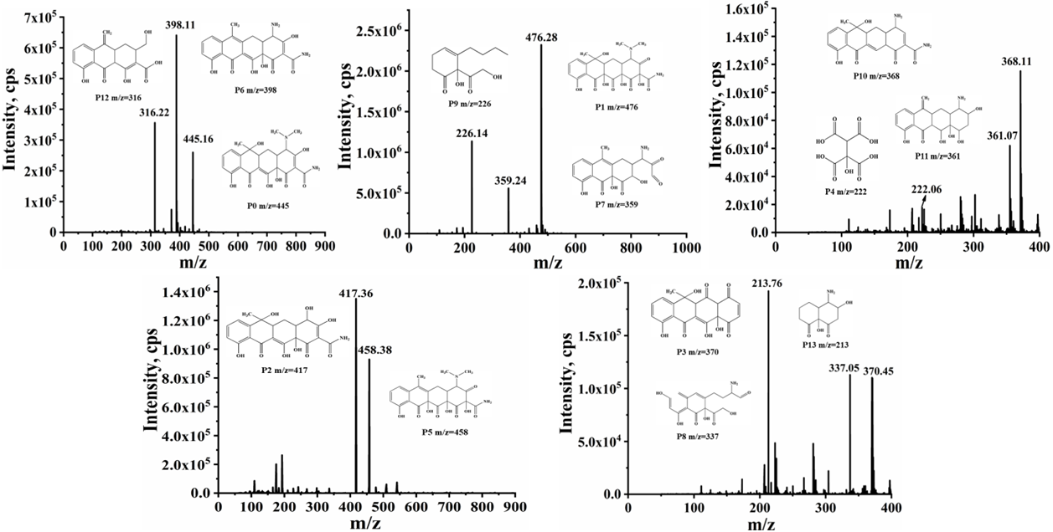

Fig. S6. MS spectra of the possible intermediates during TC degradation.

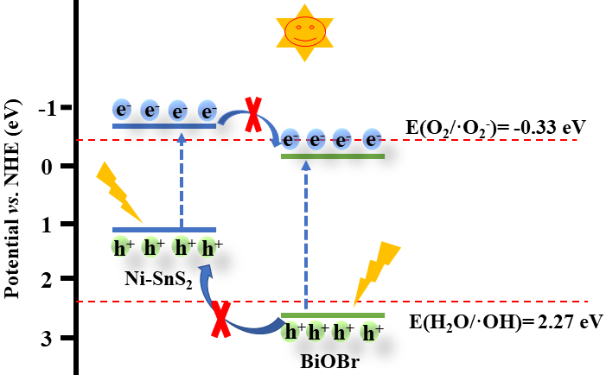

Fig. S7. Type-II charge separation route in NSB system.

**References**

Chen, N., Jia, X., He, H., Lin, H., Guo, M., Cao, J., Zhang, J. and Chen, S., 2022. Promoting photocarriers separation in S-scheme system with Ni2P electron bridge: The case study of BiOBr/Ni2P/g-C3N4. Chin. J. Catal. 43, 276-287. <https://dx.doi.org/10.1016/s1872-2067(21)63817-2>.

Cheng, L., Hu, X. and Hao, L., 2018. Ultrasonic-assisted in-situ fabrication of BiOBr modified Bi2O2CO3 microstructure with enhanced photocatalytic performance. Ultrason. Sonochem. 44, 137-145. <https://dx.doi.org/10.1016/j.ultsonch.2018.02.023>.

Di, T., Zhu, B., Cheng, B., Yu, J. and Xu, J., 2017. A direct Z-scheme g-C3N4/SnS2 photocatalyst with superior visible-light CO2 reduction performance. J. Catal. 352, 532-541. <https://dx.doi.org/10.1016/j.jcat.2017.06.006>.

Dou, X., Zhang, C. and Shi, H., 2022. The simultaneous promotion of Cr (VI) photoreduction and tetracycline removal over 3D/2D Cu2O/BiOBr S-scheme nanostructures. Sep. Purif. Technol. 282, 120023. <https://dx.doi.org/10.1016/j.seppur.2021.120023>.

Guan, S., Yang, H., Sun, X. and Xian, T., 2020. Preparation and promising application of novel LaFeO3/BiOBr heterojunction photocatalysts for photocatalytic and photo-Fenton removal of dyes. Opt. Mater. 100, 109644. <https://dx.doi.org/10.1016/j.optmat.2019.109644>.

He, Q. and Ge, M., 2022. Visible-light activation of peroxydisulfate by magnetic BiOBr/MnFe2O4 nanocomposite toward degradation of tetracycline. J. Mater Sci-Mater El. 33, 5859-5877. <https://dx.doi.org/10.1007/s10854-022-07768-y>.

Li, H., Ma, A., Zhang, D., Gao, Y. and Dong, Y., 2020. Rational design direct Z-scheme BiOBr/g-C3N4 heterojunction with enhanced visible photocatalytic activity for organic pollutants elimination. RSC Adv. 10, 4681-4689. <https://dx.doi.org/10.1039/c9ra10146b>.

Liu, K., Zhang, H., Muhammad, Y., Fu, T., Tang, R., Tong, Z. and Wang, Y., 2021. Fabrication of n-n isotype BiOBr-Bi2WO6 heterojunctions by inserting Bi2WO6 nanosheets onto BiOBr microsphere for the superior photocatalytic degradation of Ciprofloxacin and tetracycline. Sep. Purif. Technol. 274, 118992. <https://dx.doi.org/10.1016/j.seppur.2021.118992>.

Lv, D., Zhang, D., Liu, X., Liu, Z., Hu, L., Pu, X., Ma, H., Li, D. and Dou, J., 2016. Magnetic NiFe2O4/BiOBr composites: One-pot combustion synthesis and enhanced visible-light photocatalytic properties. Sep. Purif. Technol. 158, 302-307. <https://dx.doi.org/10.1016/j.seppur.2015.12.032>.

Vinesh, V., Preeyanghaa, M., Kumar, T. R. N., Ashokkumar, M., Bianchi, C. L. and Neppolian, B., 2022. Revealing the stability of CuWO4/g-C3N4 nanocomposite for photocatalytic tetracycline degradation from the aqueous environment and DFT analysis. Environ. Res. 207, 112112. <https://dx.doi.org/10.1016/j.envres.2021.112112>.

Wang, Z., Wang, K., Li, Y., Jiang, L. and Zhang, G., 2019. Novel BiSbO4/BiOBr nanoarchitecture with enhanced visible-light driven photocatalytic performance: Oxygen-induced pathway of activation and mechanism unveiling. Appl. Surf. Sci. 498, 143850. <https://dx.doi.org/10.1016/j.apsusc.2019.143850>.

Yin, W., Cao, X., Wang, B., Jiang, Q., Chen, Z. and Xia, J., 2021. In‐situ synthesis of MoS2/BiOBr material via mechanical ball milling for boosted photocatalytic degradation pollutants performance. ChemistrySelect. 6, 928-936. <https://dx.doi.org/10.1002/slct.202004316>.

Zhang, B., Hu, X., Liu, E. and Fan, J., 2021. Novel S-scheme 2D/2D BiOBr/g-C3N4 heterojunctions with enhanced photocatalytic activity. Chin. J. Catal. 42, 1519-1529. <https://dx.doi.org/10.1016/s1872-2067(20)63765-2>.

Zhang, L., Yue, X., Liu, J., Feng, J., Zhang, X., Zhang, C., Li, R. and Fan, C., 2020. Facile synthesis of Bi5O7Br/BiOBr 2D/3D heterojunction as efficient visible-light-driven photocatalyst for pharmaceutical organic degradation. Sep. Purif. Technol. 231, 115917. <https://dx.doi.org/10.1016/j.seppur.2019.115917>.

Zhang, T., Maihemllti, M., Okitsu, K., Talifur, D., Tursun, Y. and Abulizi, A., 2021. In situ self-assembled S-scheme BiOBr/pCN hybrid with enhanced photocatalytic activity for organic pollutant degradation and CO2 reduction. Appl. Surf. Sci. 556, 149828. <https://dx.doi.org/10.1016/j.apsusc.2021.149828>.