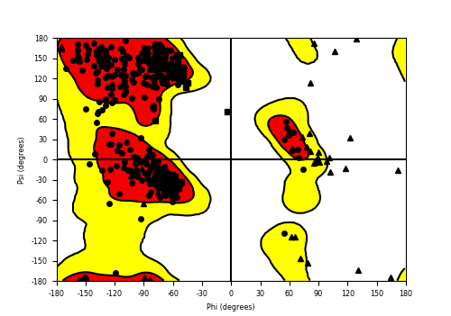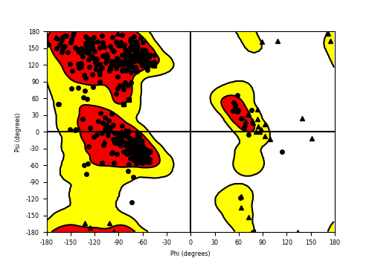

**Supplementary Fig. 1**. Ramachandran plot of the processed crystal protein structures of acetyl cholinesterase (a) and butyrl cholinesterase (b). The circular dots represent different amino acid residues, while their positions in the red (favourable) and yellow (allowed) patches showed that overall protein structure is of good quality. The triangle and rectangle black dots represents glycine and proline amino acid residues and their appearance in the white (disallowed) sector of the plots do not affect the quality of the overall structural quality.

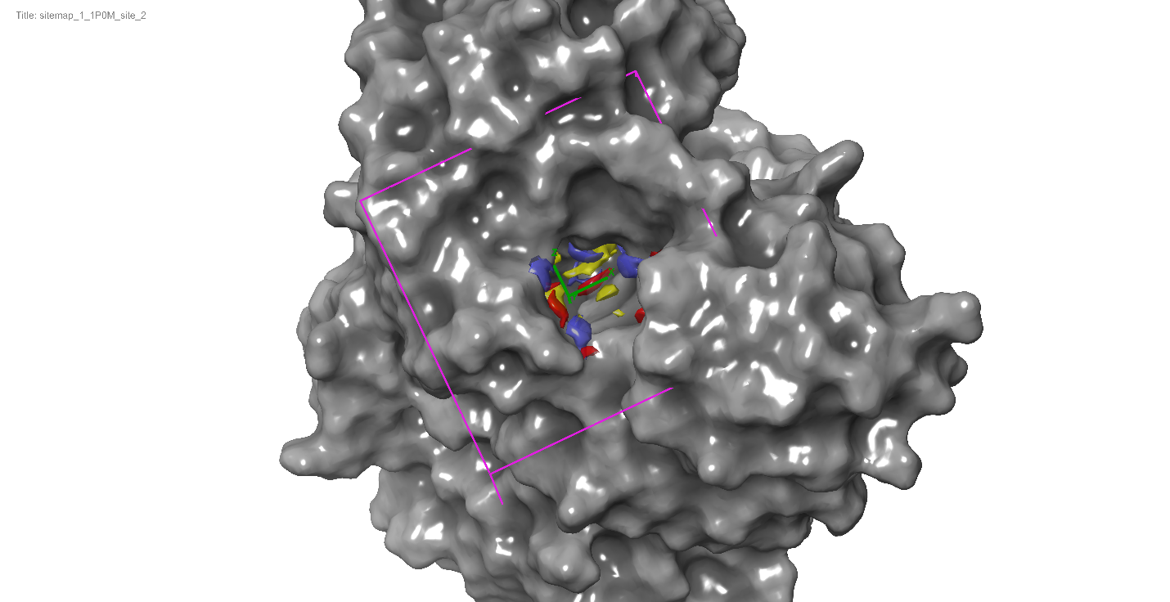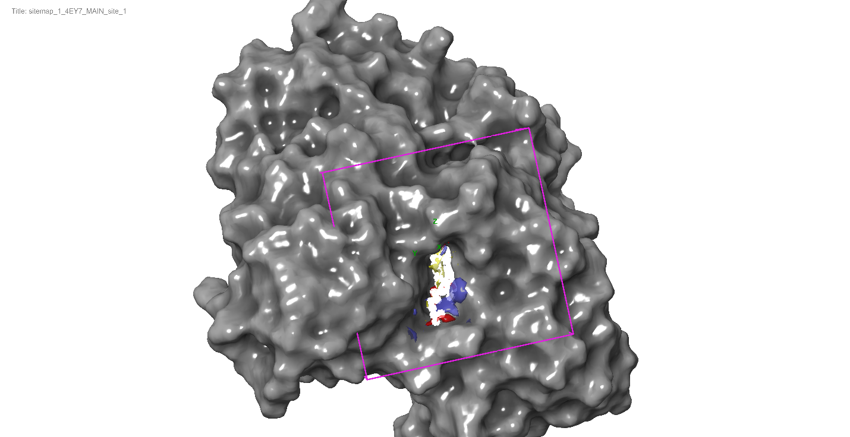

Supplementary Fig. 2. Purple Grid highlighting most probable binding pocket of the protein, acetylcholinesterase (left) and butyrl cholinesterase (right) for site-directed ligand docking

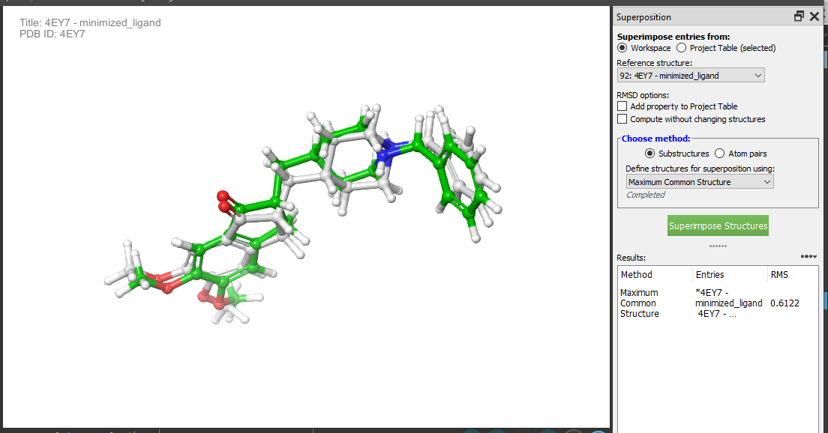

**Supplementary Fig. 3**. Evaluating the reliability of the docking program by estimating the root mean square deviation (RMSD) value of the co-crystallized ligand (donepezil) in the binding pocket, when compared to the docked pose of the this same co-crystallized ligand docked the binding pocket set of the apo-protein (protein structure without any ligand). The RMSD was 0.6122 A (less than 2.0 A), which shows that the docking program is of excellent reliability.

**Supplementary Table 1**: Sitemap score annotation of probable binding sites of AChE (4EY7)

|  |  |  |  |  |  |
| --- | --- | --- | --- | --- | --- |
| **Title** | **SiteScore** | **size** | **Dscore** | **volume** | **Residues position** |
| 4EY7 _site_1 | 1.124 | 209 | 1.145 | 434.924 | Chain A: 71,72,73,74,83,86,87,88,120,121,122,124,125,126,130, 133,202,203,204,236,286,289,291,292,293,294,295,296,  297,337,338,341,447,448,451 |
| 4EY7_ site_2 | 1.044 | 164 | 1.029 | 511.756 | Chain A: 233,234,235,236,238,239,240,243,247,289,290,291,  293,296,297,300,303,311,312,313,368,369,370,405,409,410,  412,413,416,417,503,505,508,529,532,533,534,536,537,540,606 |
| 4EY7_ site_5 | 0.921 | 78 | 0.847 | 214.718 | Chain A: 330,331,332,333,334,335,336,396,399,400,403,404,  408,429,431,442,444,510,521,523,524,525 |
| 4EY7_ site_3 | 0.898 | 75 | 0.891 | 181.79 | Chain A: 81,82,84,85,87,89,130,131,132,436,437,438,449,452,  457,463,464,465 |
| 4EY7 _site_4 | 0.846 | 65 | 0.835 | 152.978 | Chain A: 12,13,14,36,37,50,52,53,55,56,174,177,178,181,182,  185,186 |

*\*Site_1 was chosen as the probable binding site for the molecular docking studies*

**Supplementary Table 2**: Sitemap score annotation of probable binding sites of BChE (1P0M)

|  |  |  |  |  |  |
| --- | --- | --- | --- | --- | --- |
| Title | SiteScore | size | Dscore | volume | **Residues position** |
| 1P0M_site_2 | 1.164 | 172 | 1.23 | 620.487 | Chain A: 67,68,69,70,71,72,79,82,83,84,115,116,117,119,  120,121,125,128,149,197,198,231,273,276,277,285,286,  287,288,289,328,329,332,398,430,437,438,439,440,442 |
| 1P0M_site_1 | 1.039 | 186 | 1.098 | 549.829 | Chain A: 227,228,229,230,231,232,233,235,236,237,238,  241,242, 245,279,280,281,282,283,284,286,287,288,294,302,  303,304, 307,308,357,358,359,360,361,393,396,397,400,  401,404,408, 522,523,526,527,603 |
| 1P0M_site_3 | 0.998 | 110 | 0.952 | 352.947 | Chain A: 323,324,325,326,327,372,373,375,376,377,378,  379,380, 381,383,384,386,387,388,390,391,394,399,433,  435,436,515, 517,518,606 |
| 1P0M_site_5 | 0.854 | 70 | 0.784 | 146.461 | Chain A: 9,10,33,34,45,46,47,48,49,169,172,173,176,177,180,181,216 |
| 1P0M_site_4 | 0.85 | 76 | 0.841 | 179.046 | Chain A: 9,10,33,34,45,46,47,48,49,169,172,173,176,177,180,181,216 |

*\*Site_2 was chosen as the probable binding site for the molecular docking studies*