**Supplementary Materials**

**Copper Enhanced Guanine Electrochemical Signal for Nucleic Acids Detection in Municipal Tertiary Wastewater**

*Ayat Al Nimer, Abdel-Nasser Kawde, Abdelaziz Elgamouz, Ihsan Shehadi, Ayman AbdelHamid*

1Applied Chemistry Group, Department of Chemistry, College of Sciences, University of Sharjah, P.O. Box 27272, Sharjah, United Arab Emirates

*E-mail: akawde@sharjah.ac.ae

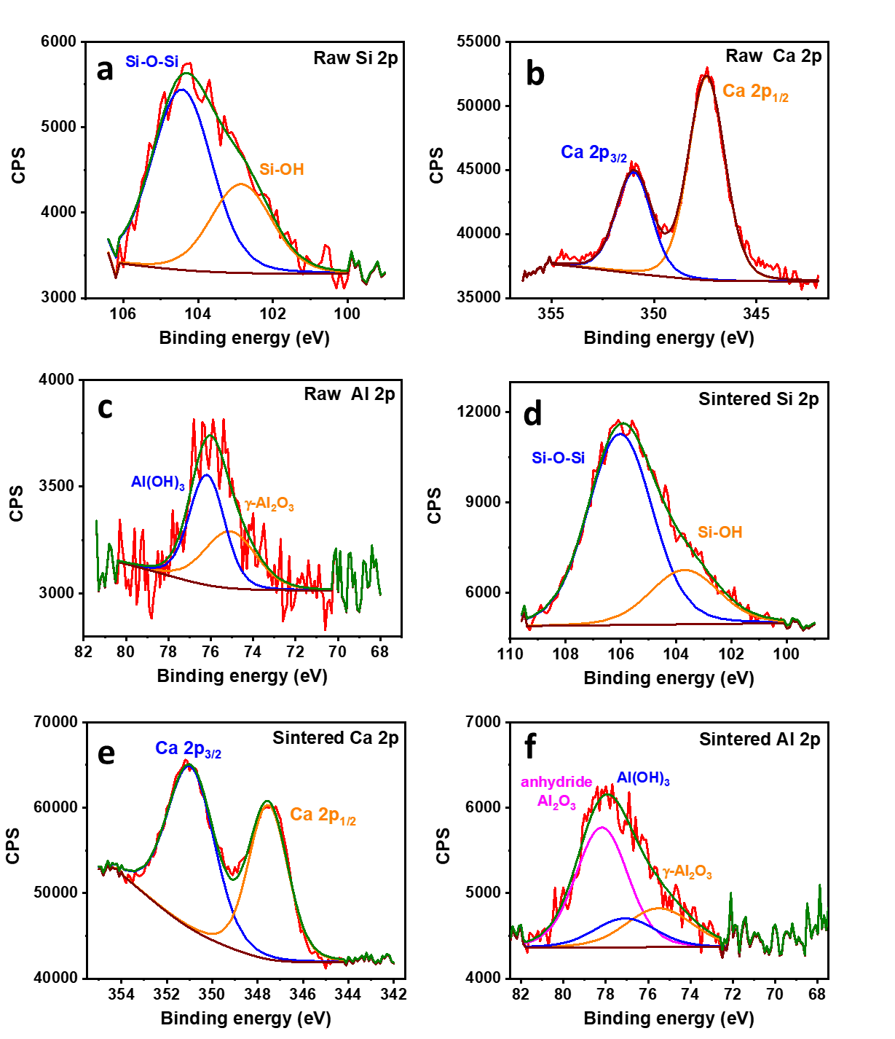

**Figure S1.** XPS (a, d) Si 2p, (b, e) Ca 2p, and (c, f) Al 2p core-level spectra of (a–c) raw and (d–f) sintered clay.

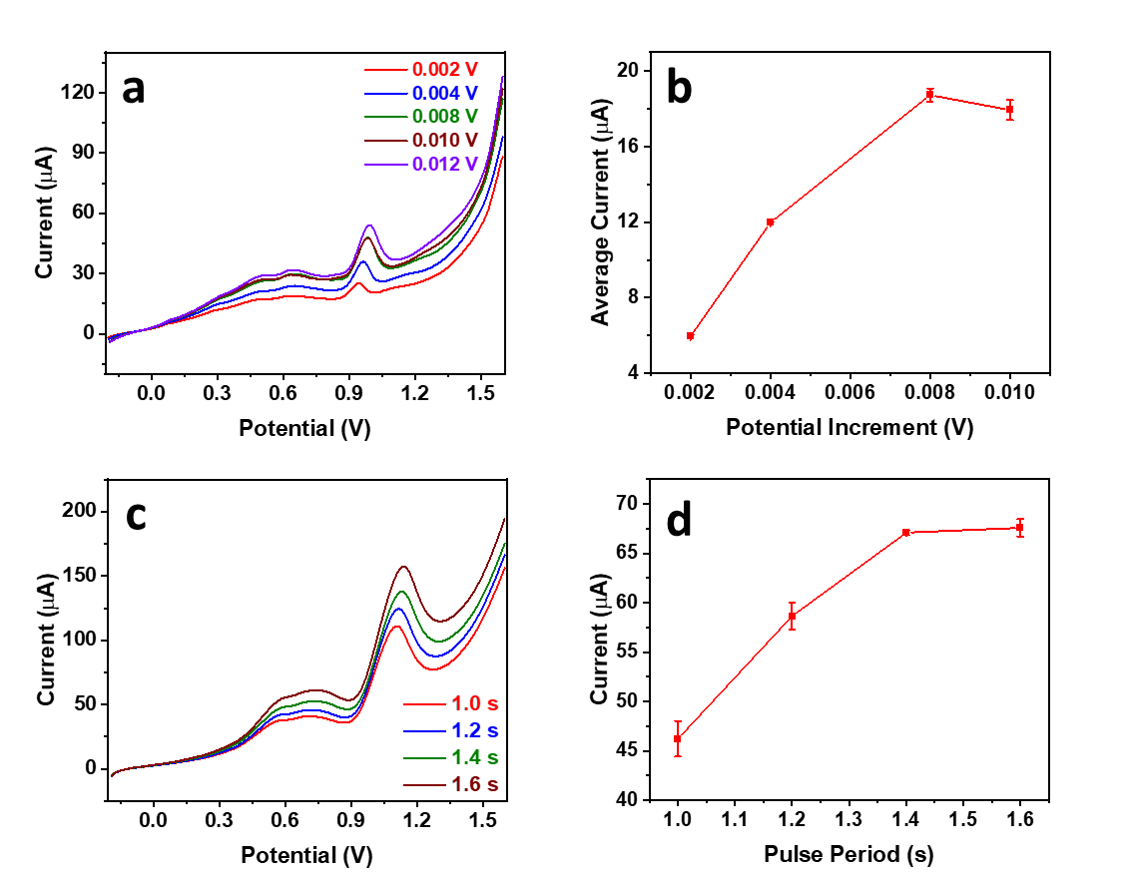

**Figure S2.** (a, c) NPV profiles of 50 µM guanine in the presence of 25 µM Cu2+ in 0.1 M acetate buffer (pH 4.5) at different (a) potential increments and (c) pulse periods, and (b, d) their corresponding current response analysis.

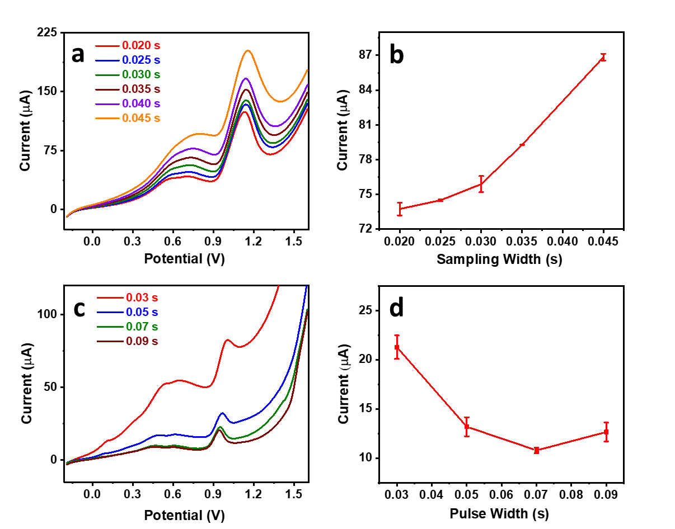

**Figure S3.** (a, c) NPV profiles of 50 µM guanine in the presence of 25 µM Cu2+ in 0.1 M acetate buffer (pH 4.5) at different (a) sampling widths and (c) pulse widths, and (b, d) their corresponding current response analysis.

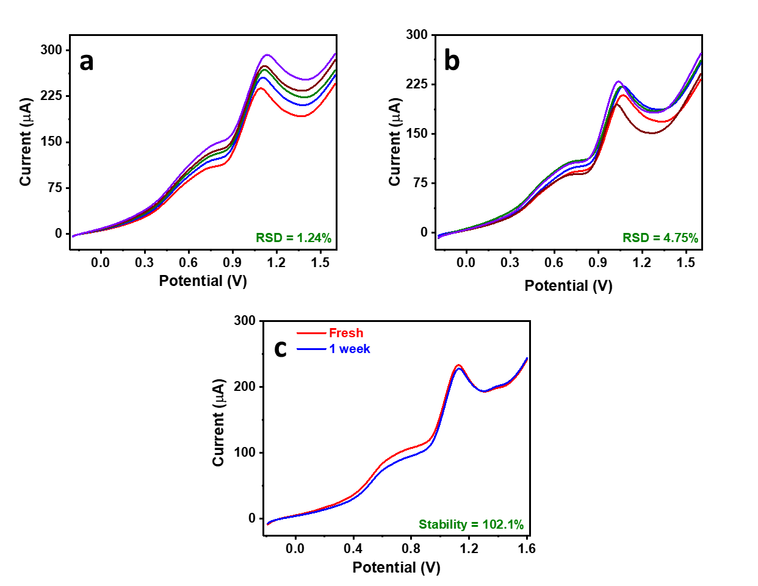

**Figure S4.** NPV profiles of 50 µM guanine in the presence of 25 µM Cu2+ in 0.1 M acetate buffer (pH 4.5) conducted (a) multiple times using the same electrode (repeatability), (b) multiple times using different electrodes (reproducibility), and (c) one week apart (stability).