Supplementary information for

Cyclohexylethanoid derivative and rearranged abietane diterpenoids with anti-inflammatory activities from Clerodendrum bungei and C. inerme

Contents
S1. ¹H NMR spectrum of compound 1 (δ ppm in MeOD)
S2. ¹³C NMR spectrum of compound 1
S3. DEPT (θ = 135°) NMR spectrum of compound 1
S4. HMQC spectrum of compound 1
S5. HMBC spectrum of compound 1
S6. ¹H-¹H COSY spectrum of compound 1
S7. ¹H NMR spectrum of compound 1 (δ ppm in DMSO-d₆)
S8. NOESY spectrum of compound 1 (δ ppm in DMSO-d₆)
S9. HR-ESIMS spectrum of compound 1
S10. Calculated and experimental ECD spectra of 1
S11. ¹H NMR spectrum of compound 2
S12. ¹³C NMR spectrum of compound 2
S13. DEPT (θ = 135°) NMR spectrum of compound 2
S14. HMQC spectrum of compound 2
S15. HMBC spectrum of compound 2
S16. ¹H-¹H COSY spectrum of compound 2
S17. NOESY spectrum of compound 2
S18. HR-ESIMS spectrum of compound 2
S19. ¹H NMR spectrum of compound 3
S20. ¹³C NMR spectrum of compound 3
S21. ¹H NMR spectrum of compound 4
S22. ¹³C NMR spectrum of compound 4
S23. ¹H NMR spectrum of compound 5
S24. ¹³C NMR spectrum of compound 5
S25. ¹H NMR spectrum of compound 6
S26. ¹³C NMR spectrum of compound 6
S27. ¹H NMR spectrum of compound 7
S28. ¹³C NMR spectrum of compound 7
S29. ¹H NMR spectrum of compound 8
S30. ¹³C NMR spectrum of compound 8
S31. ¹H NMR spectrum of compound 9
S32. ¹³C NMR spectrum of compound 9
S33. ¹H NMR spectrum of compound 10
S34. ¹³C NMR spectrum of compound 10
S35. ¹H NMR spectrum of compound 11
S36. ¹³C NMR spectrum of compound 11
S37. ¹H NMR spectrum of compound 12
S38. ¹³C NMR spectrum of compound 12
S39. ¹H NMR spectrum of compound 13
S40. ¹³C NMR spectrum of compound 13
S41. Effect of compound 1 on the viability in RAW 264.7 cells.

S1. ¹H NMR spectrum of compound 1
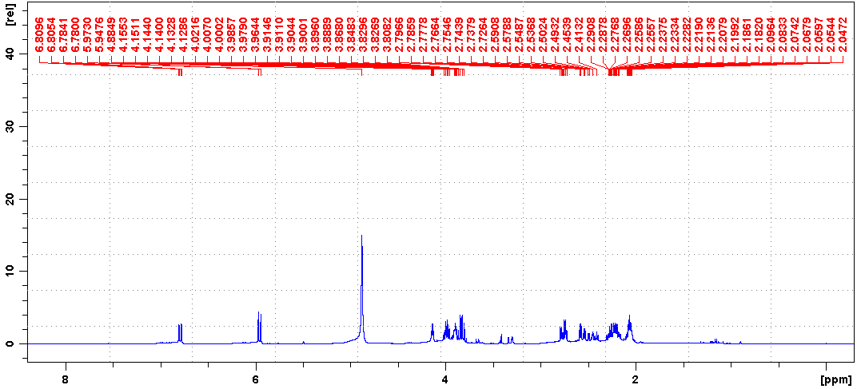
S2. ¹³C NMR spectrum of compound 1
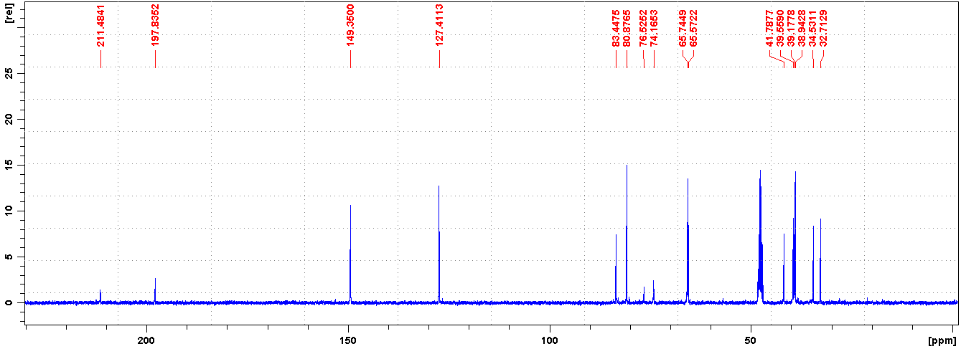
S3. DEPT (θ = 135°) NMR spectrum of compound 1
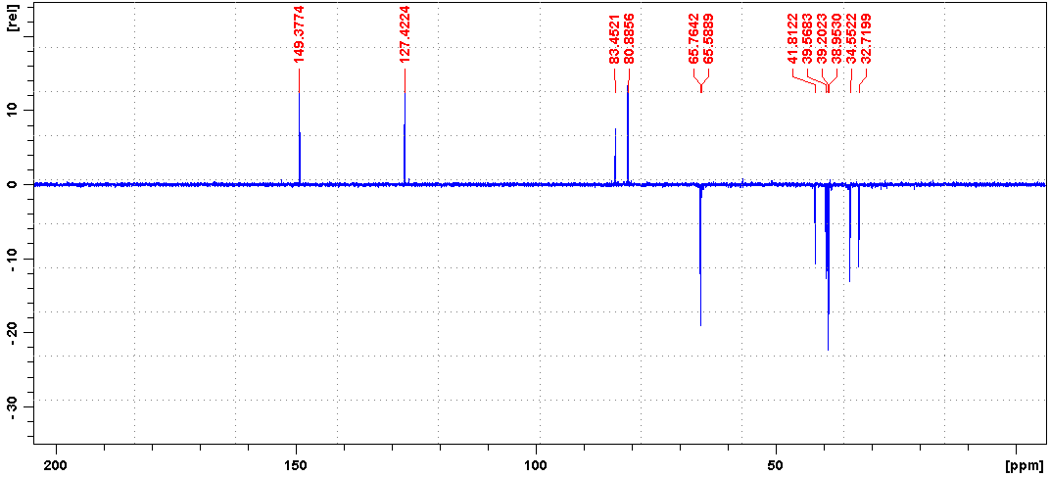
S4. HMQC spectrum of compound 1
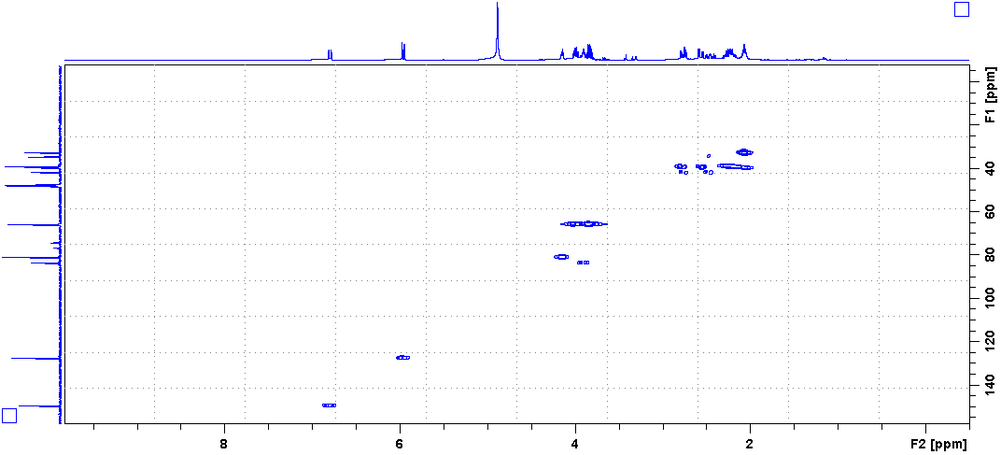
S5. HMBC spectrum of compound 1
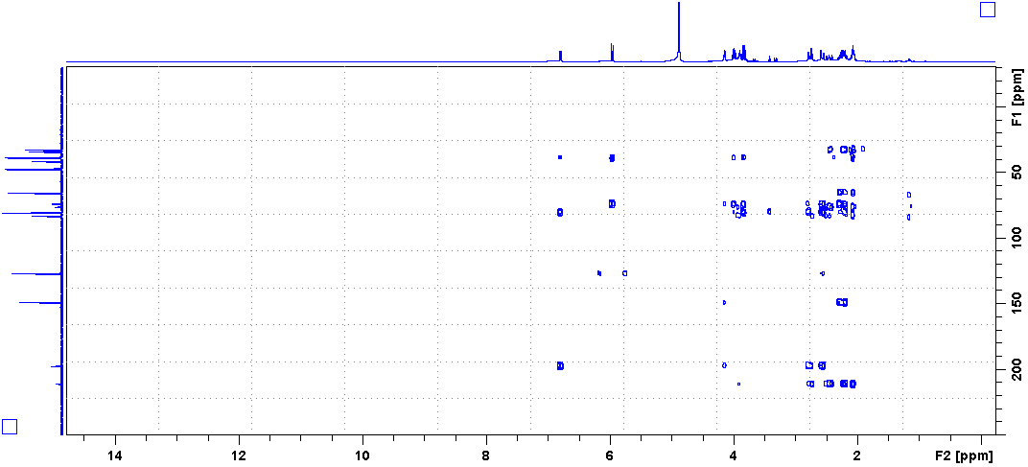
S6. ¹H-¹H COSY spectrum of compound 1
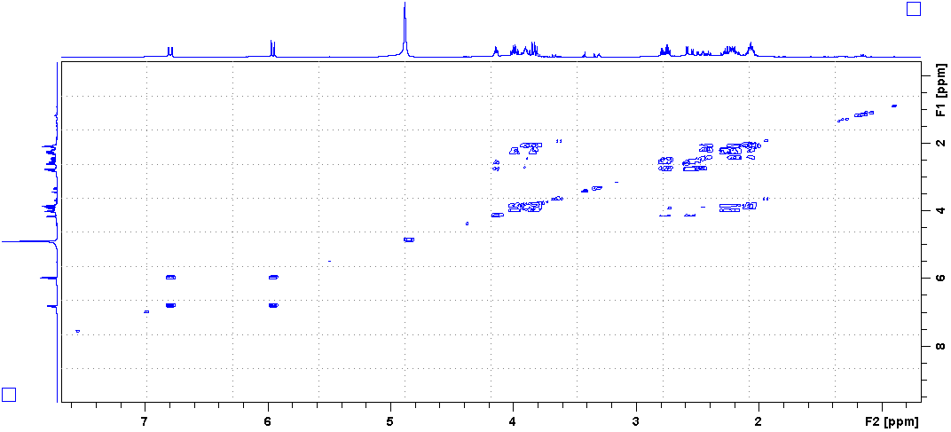
S7. ¹H NMR spectrum of compound 1 (δ ppm in DMSO-d₆)
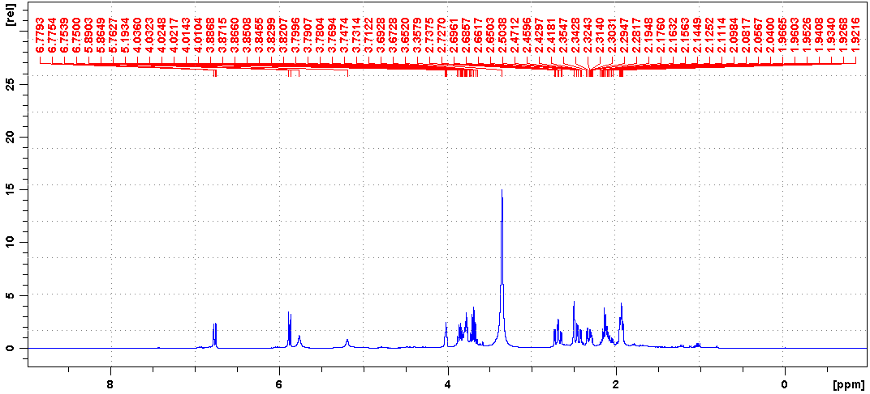S8. NOESY spectrum of compound 1 (δ ppm in DMSO-d₆)
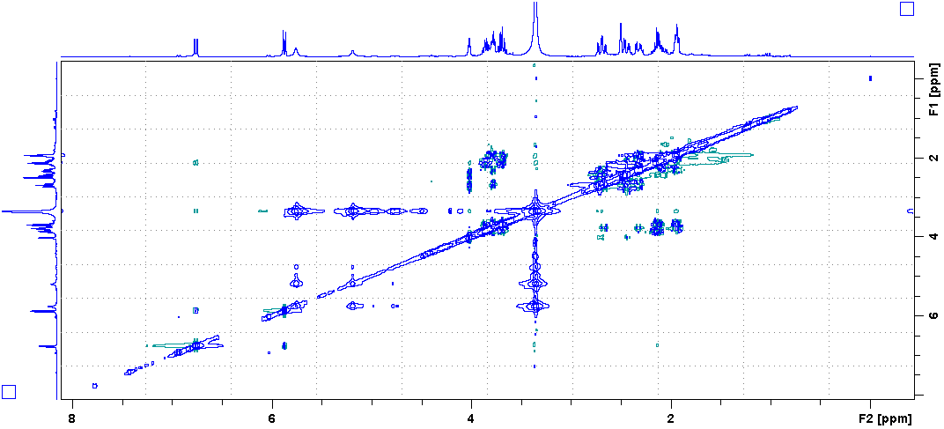
S9. HR-ESIMS spectrum of compound 1
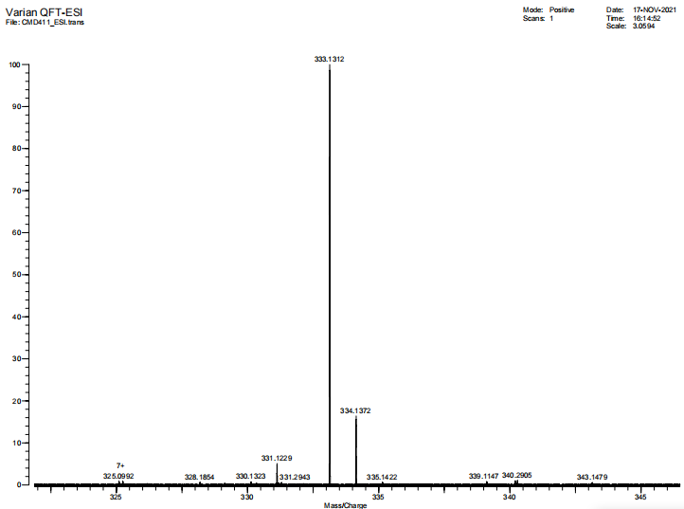
S10. Calculated and experimental ECD spectra of 1
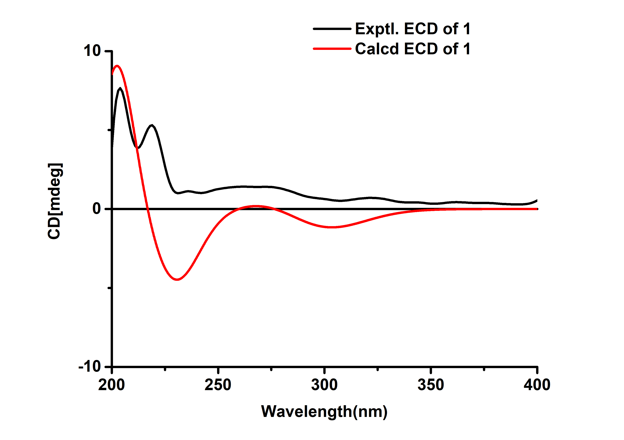
S11. ¹H NMR spectrum of compound 2
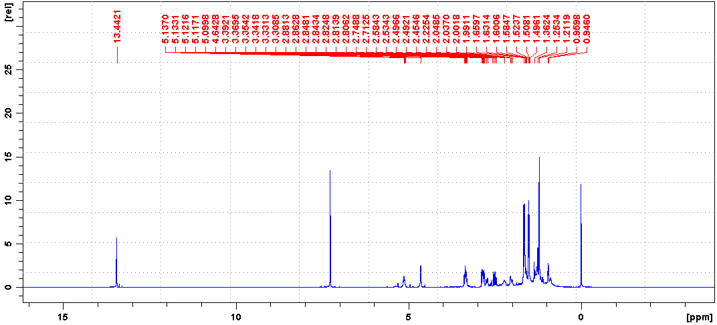
S12. ¹³C NMR spectrum of compound 2
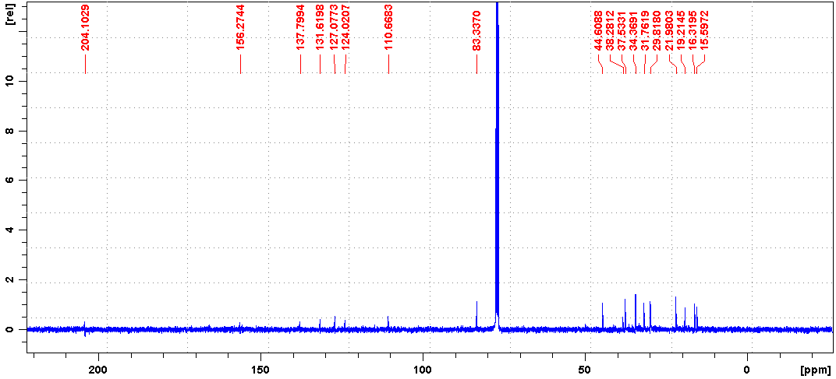
S13. DEPT (θ = 135°) NMR spectrum of compound 2
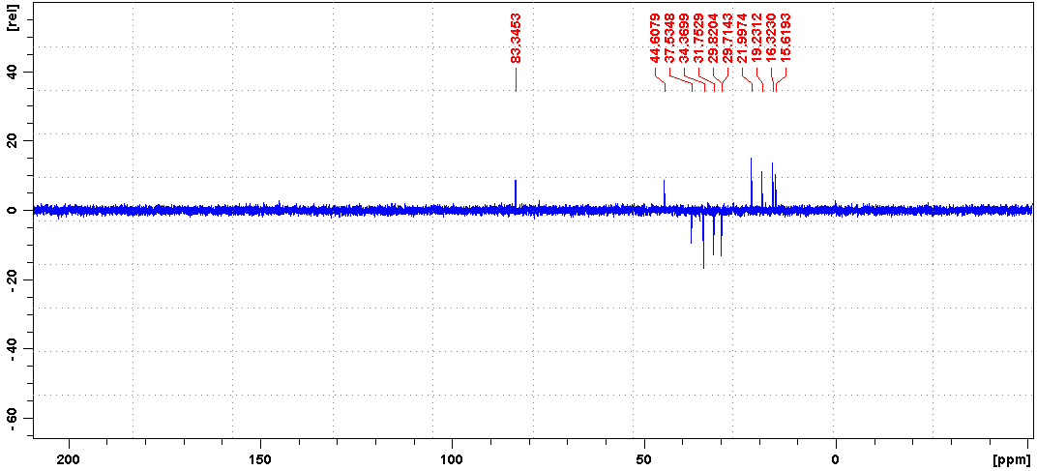
S14. HMQC spectrum of compound 2
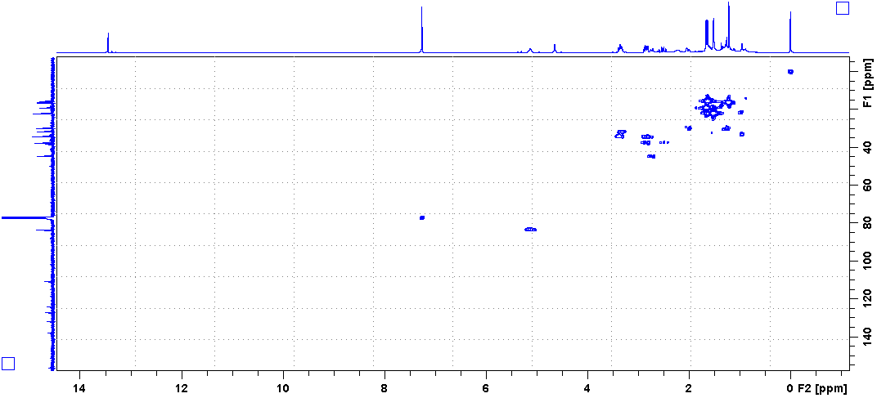
S15. HMBC spectrum of compound 2
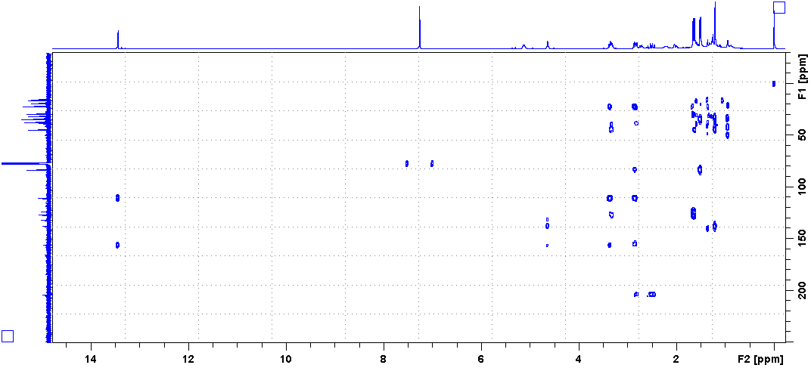
S16. ¹H-¹H COSY spectrum of compound 2
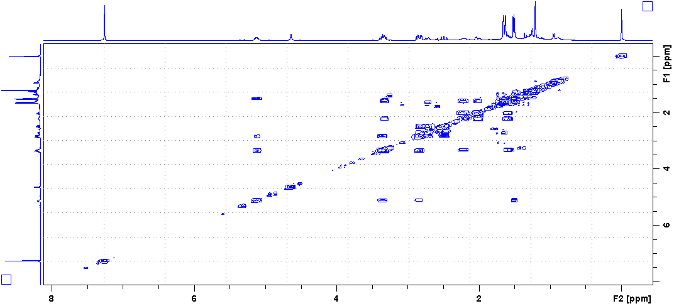
S17. NOESY spectrum of compound 2
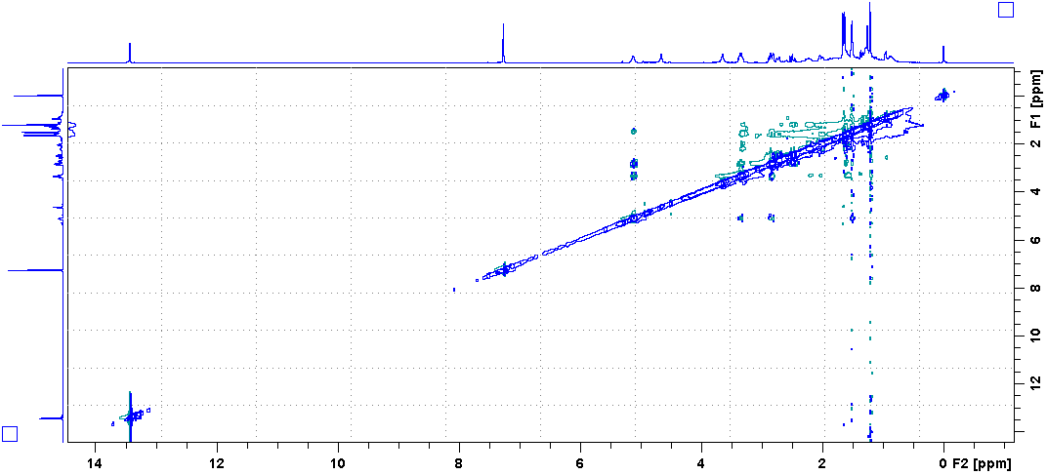
S18. HR-ESIMS spectrum of compound 2
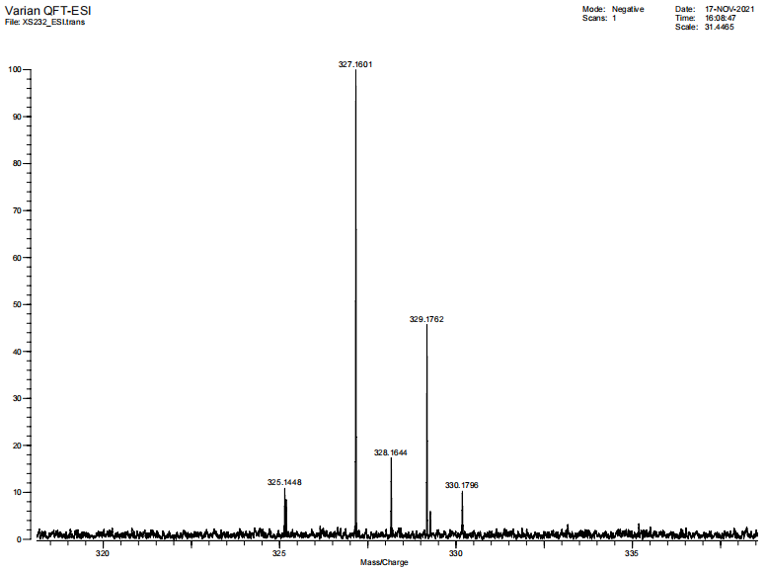
S19. ¹H NMR spectrum of compound 3
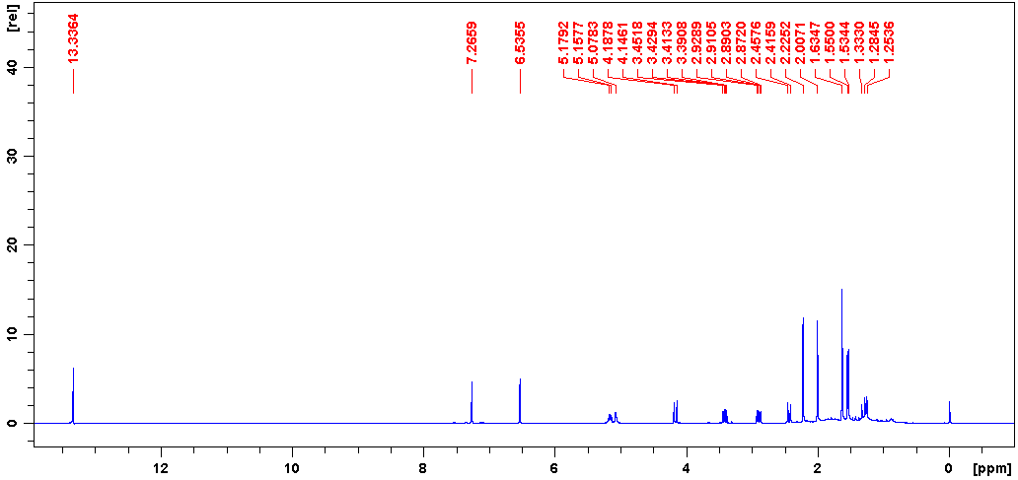
S20. ¹³C NMR spectrum of compound 3
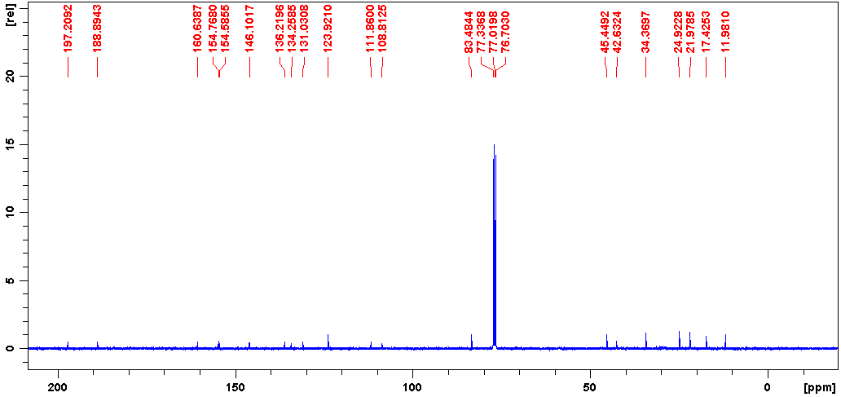
S21. ¹H NMR spectrum of compound 4
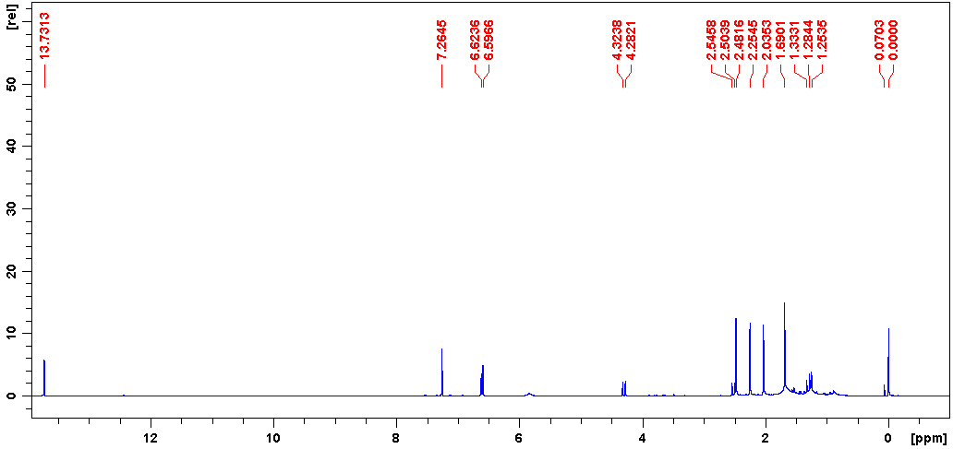
S22. ¹³C NMR spectrum of compound 4
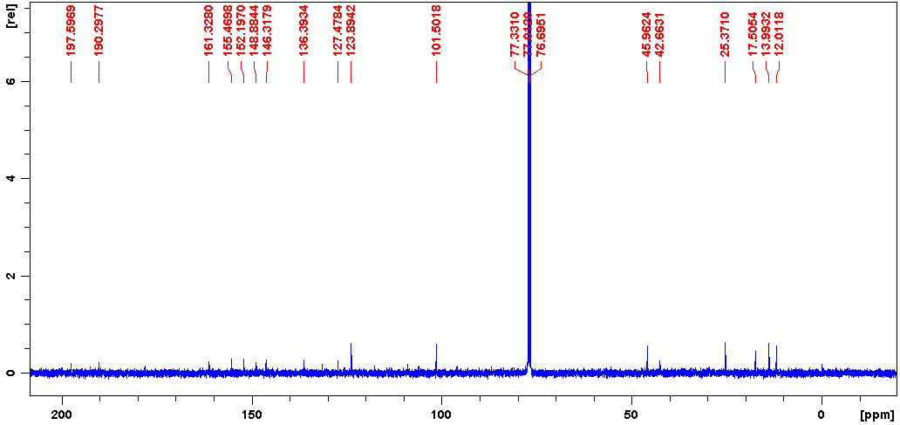
S23. ¹H NMR spectrum of compound 5
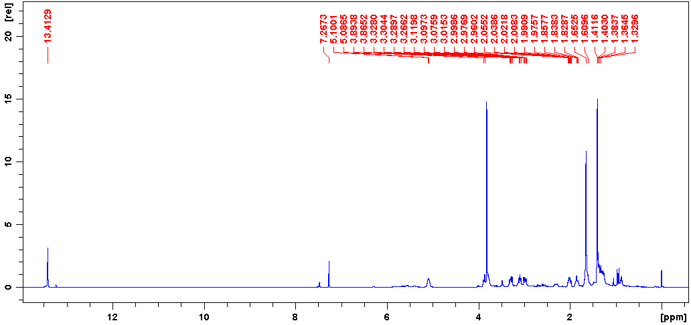
S24. ¹³C NMR spectrum of compound 5
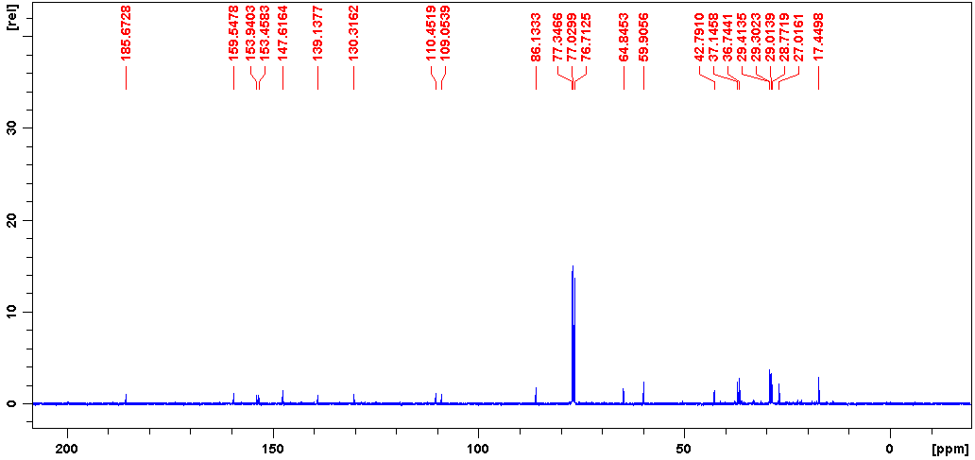
S25. ¹H NMR spectrum of compound 6
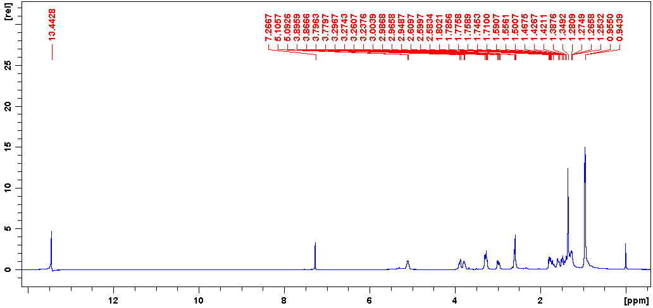
S26. ¹³C NMR spectrum of compound 6
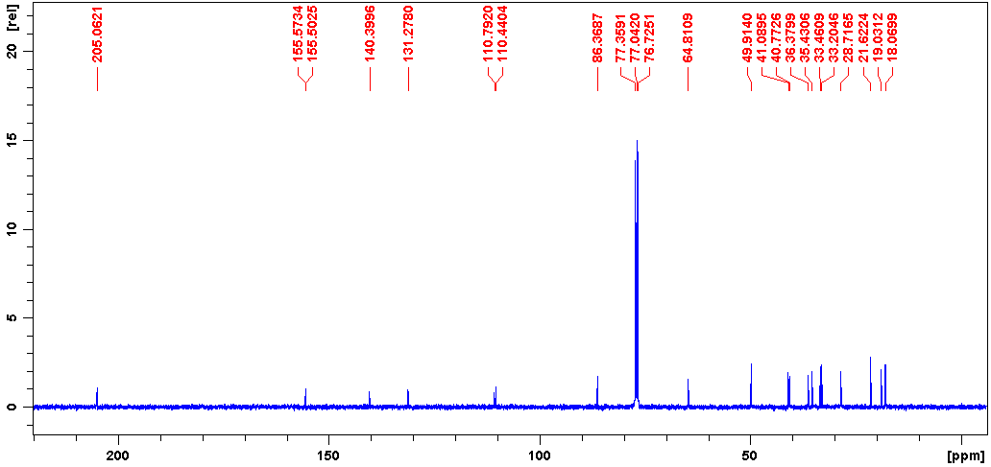
S27. ¹H NMR spectrum of compound 7
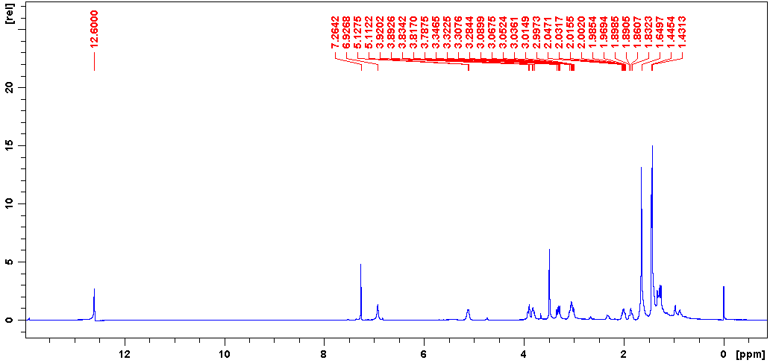
S28. ¹³C NMR spectrum of compound 7
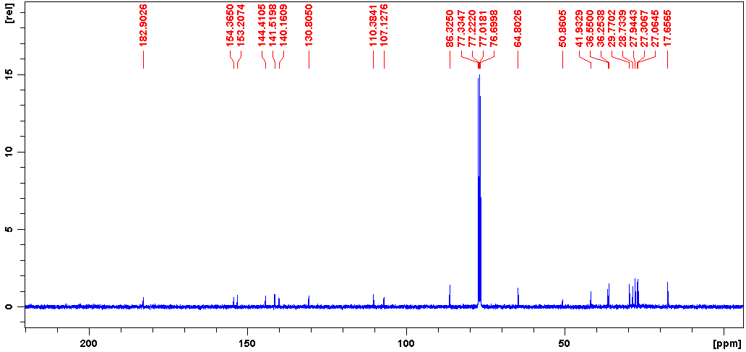
S29. ¹H NMR spectrum of compound 8
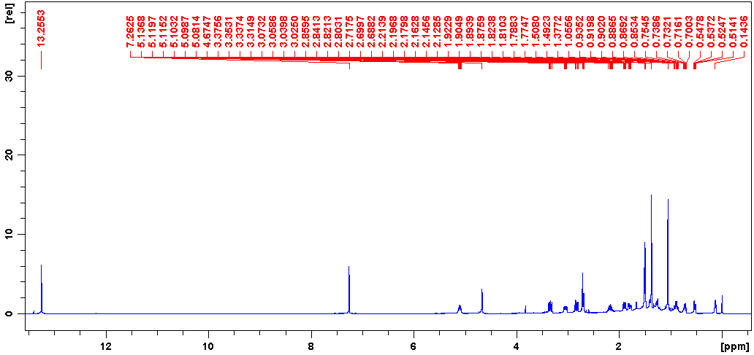
S30. ¹³C NMR spectrum of compound 8
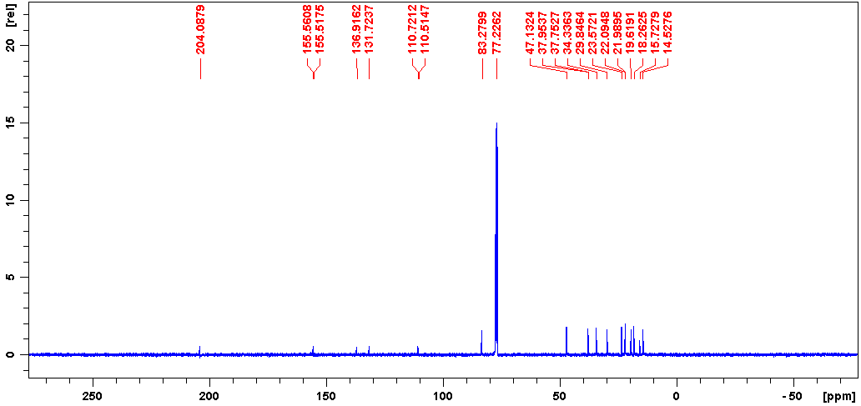
S31. ¹H NMR spectrum of compound 9
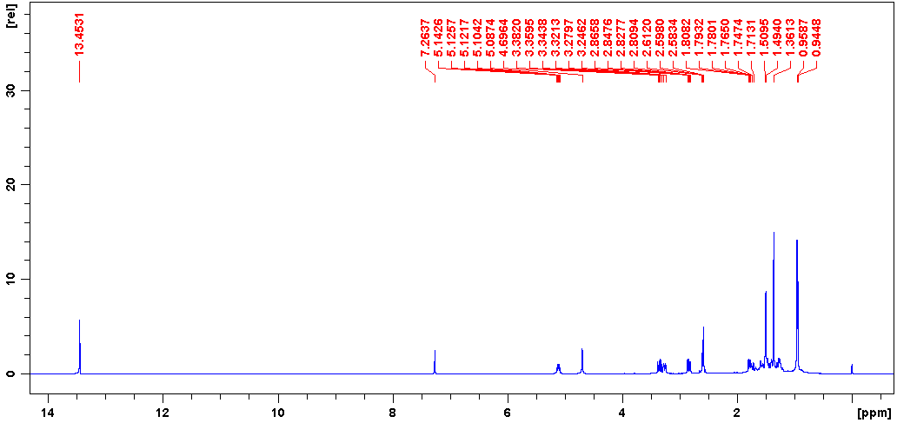
S32. ¹³C NMR spectrum of compound 9
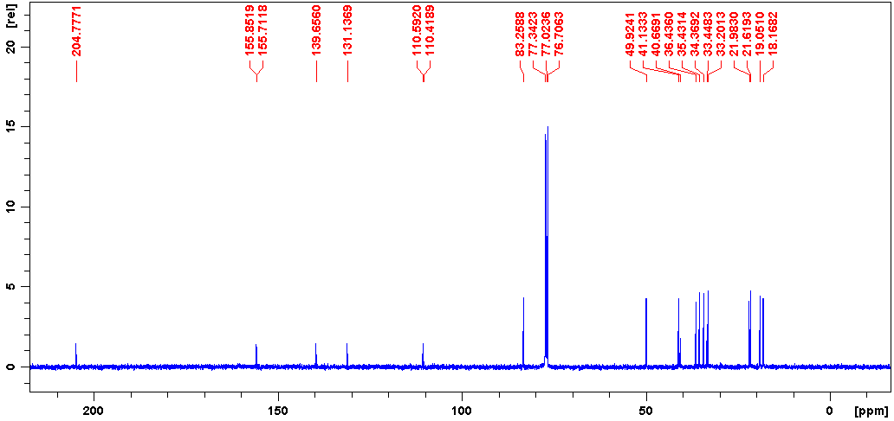
S33. ¹H NMR spectrum of compound 10
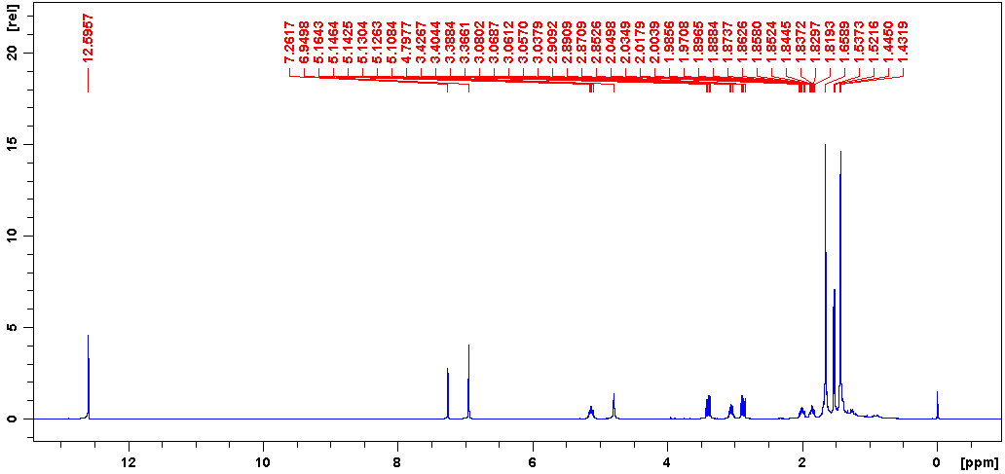
S34. ¹³C NMR spectrum of compound 10
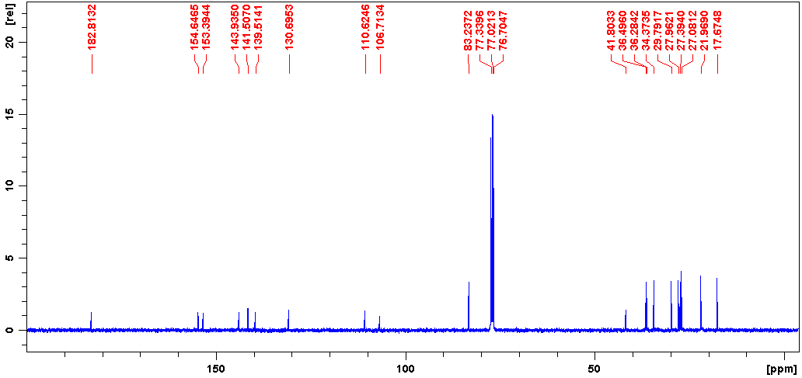
S35. ¹H NMR spectrum of compound 11
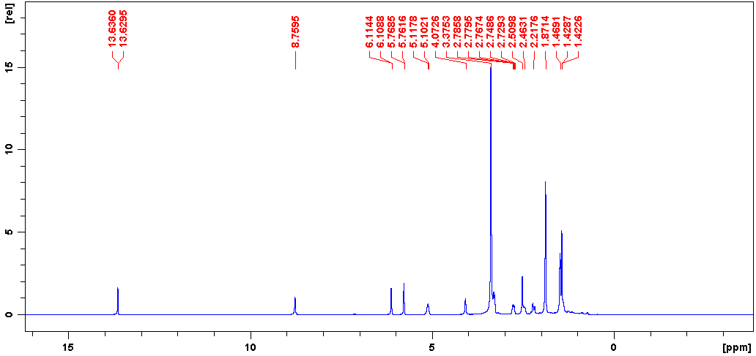
S36. ¹³C NMR spectrum of compound 11
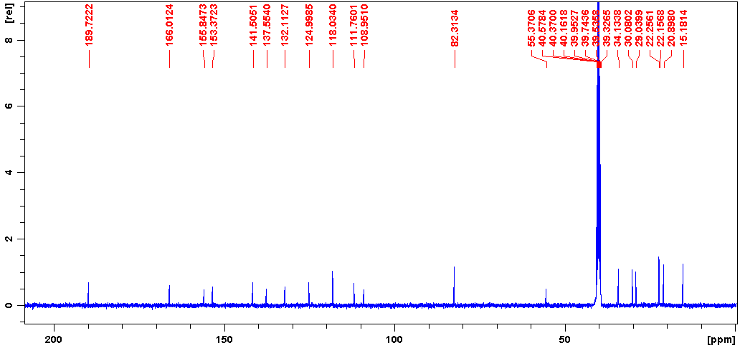
S37. ¹H NMR spectrum of compound 12
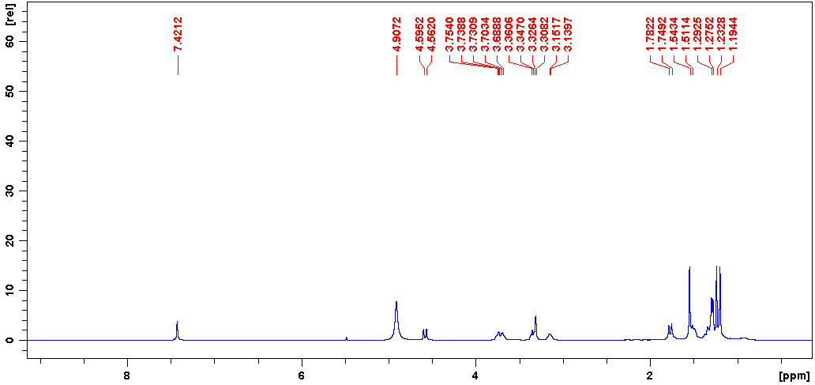
S38. ¹³C NMR spectrum of compound 12
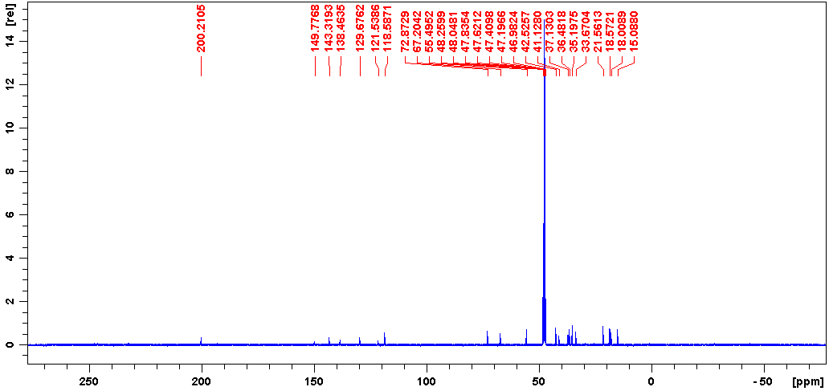
S39. ¹H NMR spectrum of compound 13
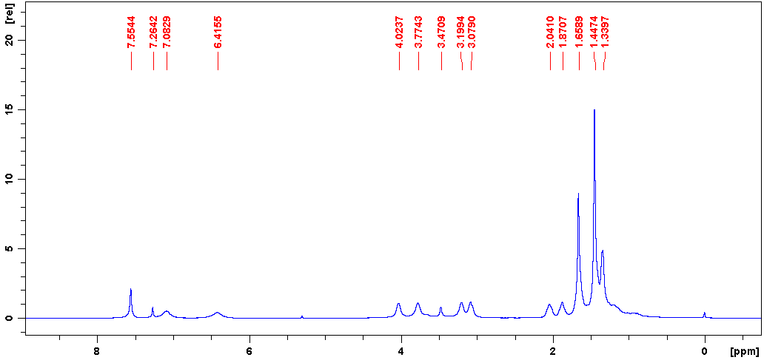
S40. ¹³C NMR spectrum of compound 13
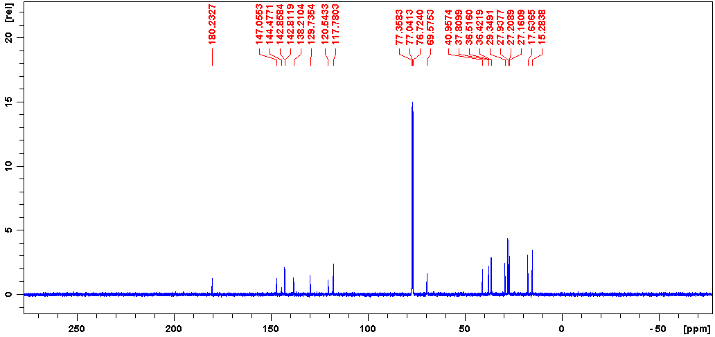
S41. Effect of compound 1 on the viability in RAW 264.7 cells.
The viability of the cells was assessed by Cell Counting Kit-8 (CCK8) assay. Briefly, 1 × 10⁴ cells/well lymphocytes were dispensed within 96-well culture plates (Costar, USA) in 100 µL. Then different concentrations of compounds were put in different wells. Each of the treated or nontreated groups contained three parallel wells. Culture plates were then incubated for 12, 24 or 48 h prior to the addition of 10 µL of Cell Counting Kit-8 (Beyotime, Shanghai, China) to each well. Cells were incubated for 1 h at 37 °C. The optical density was measured at a wavelength of 450 nm. Results were represented as percentage viability of control cells.
