**Supporting Information**

**A comprehensive strategy combined chemical spectrum with anti-inflammatory activity for screening combinatorial quality markers of *Valeriana jatamansi* Jones**

Chunxiao Liang1,2, Kunze Du1,2#, Shujing Chen1, Ye Shang1, Lirong Wang1, Shuangqi Wang1, Jin Li1, Yanxu Chang1, 2*

1 State Key Laboratory of Component-based Chinese Medicine, Tianjin University of Traditional Chinese Medicine, Tianjin 301617, China

2Tianjin Key Laboratory of Phytochemistry and Pharmaceutical Analysis, Tianjin University of Traditional Chinese Medicine, Tianjin 301617, China

# Chunxiao Liang and Kunze Du contributed equally to this study.

*Corresponding author

Yanxu Chang, State Key Laboratory of Component-based Chinese Medicine, Tianjin University of Traditional Chinese Medicine

Tel.: +86-22-59596163

Fax: +86-25-59596163

E-mail address: Tcmcyx@tjutcm.edu.cn (Y. x. Chang)

## 1.Identification of the chemical components of *V. jatamansi*

## 1.1 Identification of iridoids

Iridoids compounds are considered to be the active constituents of *V. jatamansi* with anti-inflammatory, anti-tumour and other activities. The structure of the parent nucleus was mainly cyclopentane-[C]-pyran, which can be divided into three main types according to the number of double bonds, including monoene-type iridoids (P5, P12, P14, P17, P18, P20, P25-P27, P33, P35), diene-type iridoids (P13, P15, P16, P19, P21-P24, P28, P29, P32, P34, P36) and tetraterpene-type iridoids (P4, P9, P30).

Diene-type iridoids are major components of *V. jatamansi*, whose fragmentation regularities are characterized by the formation of fragment ions after the loss of ester groups. Compound P32 appeared parent ion [M+Na] + at *m/z* 445.1821. When it was fragmented, it lost a C5H10O2 unit and produced a peak at *m/z* 321.1324. Another peak at *m/z* 219.0640 was due to the further loss of another C5H10O2 unit. It was confirmed as valtrate by comparing it with a reference standard. Compound P23 generated parent ion [M+Na] + at *m*/*z* 503.1884 with an error value of 0.77 ppm, which was according with chemical formula C24H32O10. The fragmentation pathways are as follows: *m/z* 401.1216 was formed due to loss of C5H10O2 fragment ion. The *m/z* 219.0634 was formed due to loss of C7H12O4 from *m/z* 401.1216, which was identified as baldrinal (Compound P09). Compound P23 was confirmed as acevaltrate by comparison with the standard substance.

The tetraterpene-type iridoids could be regarded as fragments with high intermediate stability after the loss of ester groups, formed by diene-type iridoids. Fragment ions from tetraterpene-type iridoids were all formed [M+H]+, and the proton is most likely to lost the fragment ions C2H2O, CO, H2O etc. Baldrinal was the degradation products of valtrate and acevaltrate (Wang et al., 2017), which mainly has the parent ion [M+H] + at *m*/*z* 219.0658. *m*/*z* 177.0550 was obtained by *m*/*z* 219 loss of acetyl group, followed by loss of H2O to form *m*/*z* 159.0431 fragment ion, and further loss of CO to form *m*/*z* 131.0480 fragment ion.

The monoene-type iridoids MS2 fragmental ions is often accompanied by the loss of fragment ions H2O to occur rearrangement reaction and formed double bonds. Also, similarly to diene-type iridoids, fragmentation regularities of fragment ions after ester group loss also exists.

## 1.2 Identification of flavonoids

Besides, two flavonoids were also identified in *V. jatamansi* Jones. The molecular ion peak of compound P7 was *m/z* 611.1997 [M+H] +. In MS/MS, *m/z* 465.1375 fragment ion was obtained by losing one molecule of rhamnose from *m/z* 611.1997. The *m/z* 303.0850 was the flavanone fragment ion obtained from the loss of one molecule of glucose at *m/z* 465.1375. Compound 7 was identified as hesperidin by comparison of standards. The parent ion [M+H] + of compound P08 appeared at *m/z* 593.1892. Compound 8, which has a rutinose structure, has lost one rhamnose to yield the *m/z* 447.1311 fragment ion and one glucose to yield the *m/z* 285.0770 fragment ion, respectively. Compound 7 was identified as linarin by comparison of standards.

## 1.3 Identification of phenolic acids

Phenolic acids components are prone to fracture at the carbonyl group to form fragment ions, accompanied by the loss of feruloyl C7H10O5 or cafeoyl C9H6O3. The molecular ion peak of compound P2 was *m/z* 355.1026 [M+H] +. The *m/z* 181.0482 was obtained from the loss of C7H10O5 at *m/z* 355.1026. The *m/z* 193.0696 was obtained from the loss of C9H6O3 at *m/z* 355.1026. Compound P2 was identified as neochlorogenic acid by comparison of standards. Compound P06 appeared parent ion [M+H] + at *m/z* 517.1346. *m/z* 355.10 was generated by *m/z* 517.1346 losing one molecule of cafeoyl C9H6O3. Meanwhile, *m/z* 337.09 was generated by the loss of one molecule of H2O and one molecule of cafeoyl C9H6O3 from *m/z* 517.1346. Compound P06 was identified as isochlorogenic acid B by comparison of standards.

**Figure captions**

**Fig. S1** Mass fragmentation pathways of iridoids in the (+) ESI mode.

(A) The MS/MS spectra (a), EIC (b) of valtrate; The MS/MS spectra (c), EIC (d) of acevaltrate; The MS/MS spectra (e), EIC (f) of baldrinal in the; (B) The mass fragmentation pathways of valtrate, acevaltrate and baldrinal in the (+) ESI mode.

**Fig. S2** Mass fragmentation pathways of flavonoids in the (+) ESI mode.

(A) The MS/MS spectra (a), EIC (b) of hesperidin; (B) The mass fragmentation pathways of hesperidin; (C) The MS/MS spectra (a), EIC (b) of linarin; (D) The mass fragmentation pathways of linarin.

**Fig. S3** Mass fragmentation pathways of phenolic acids in the (+) ESI mode.

(A) The MS/MS spectra (a), EIC (b) of neochlorogenic acid; (B) The mass fragmentation pathways of neochlorogenic acid; (C) The MS/MS spectra (a), EIC (b) of isochlorogenic acid B; (D) The mass fragmentation pathways of isochlorogenic acid B.

**Fig. S4** Anti-inflammatory effects of isochlorogenic acid B on RAW264.7 cells.

(A) Cell viability of isochlorogenic acid B. (B) NO Inhibition rate (%) of isochlorogenic acid B in cell supernatant. Data are shown as mean ± SD. ns, no significant.

**Table captions**

Table S1. Cultivation area of 24 batches of dry roots and rhizomes of *V. jatamansi*.

Table S2 Sequences of PCR primers used for qRT-PCR.

Table S3 The top 20 targets of CytoHubba plug calculation

Table S4 The top 20 pathways of KEGG enrichment analysis

Table S5 Method validation results of HPLC fingerprints analysis

Table S6 Sample similarity analysis

Table S7 Physicochemical parameters and druglikeness of acevaltrate and valtrate

Table S8 Linear equations and method validation

Table S9 Comparison of HPLC methods with other quantification methods

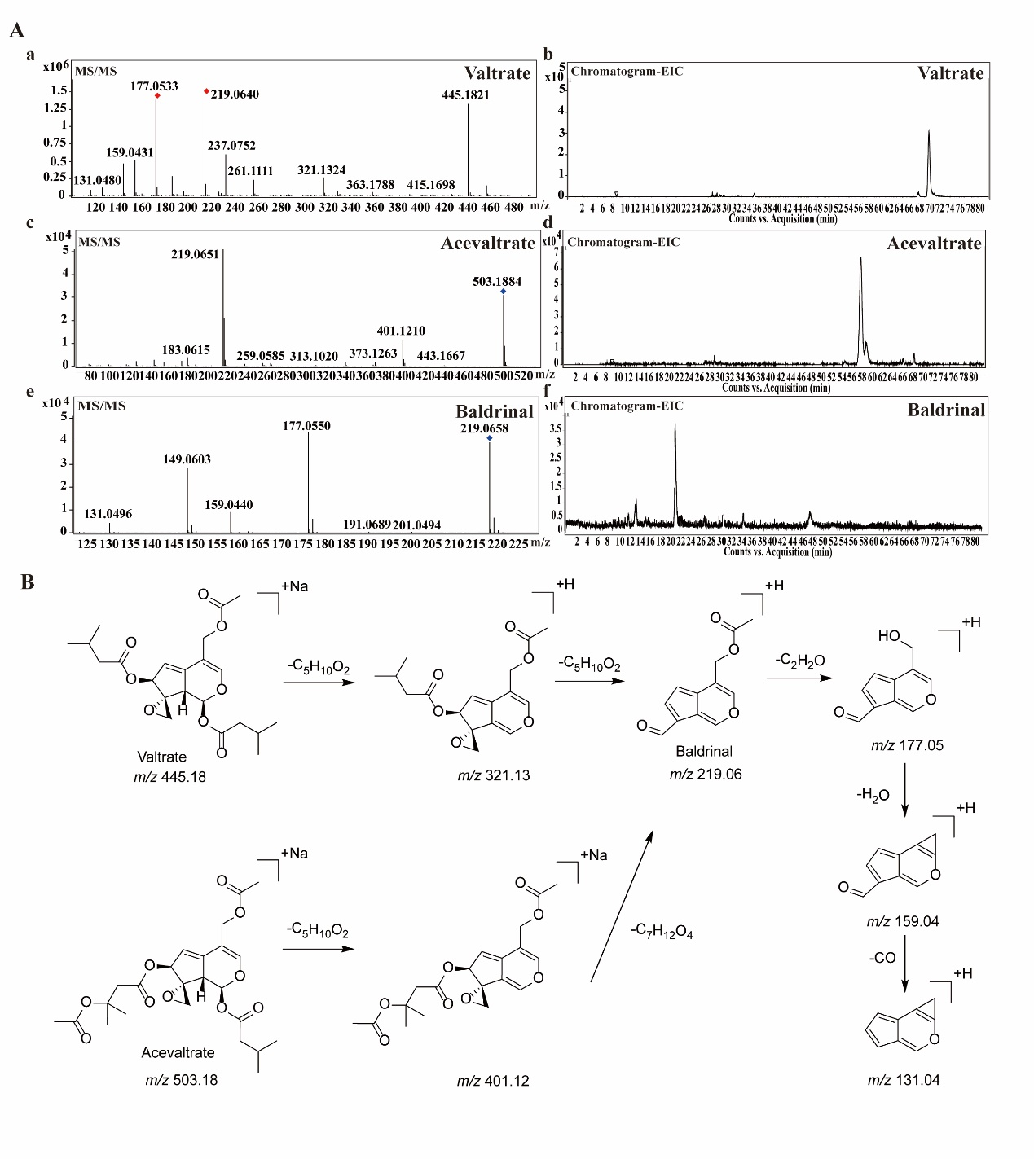

**Figure S1**

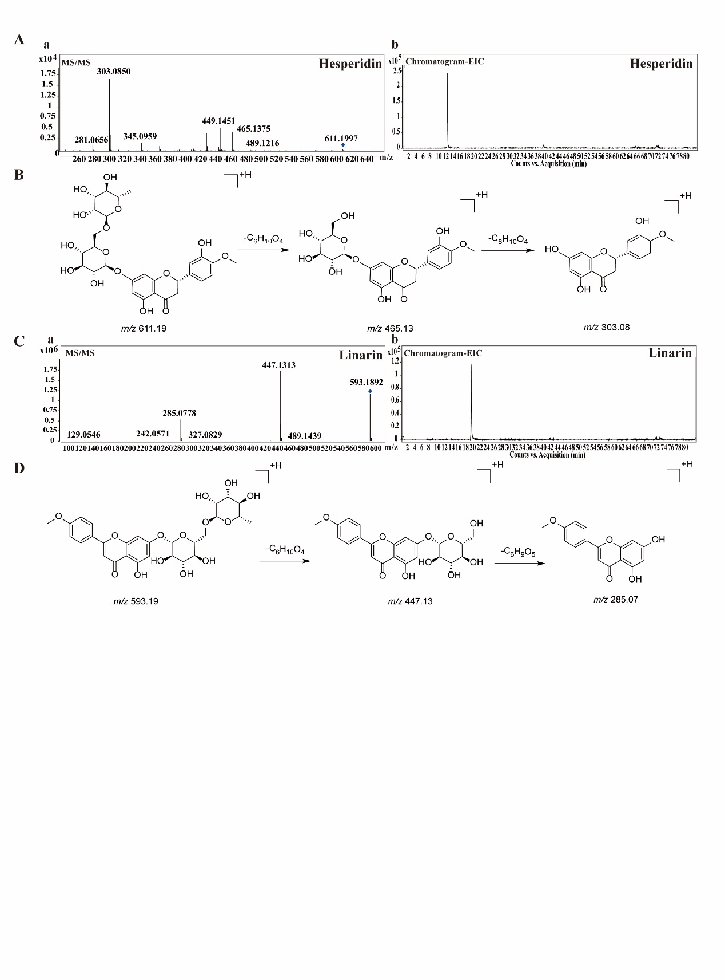

**Figure S2**

\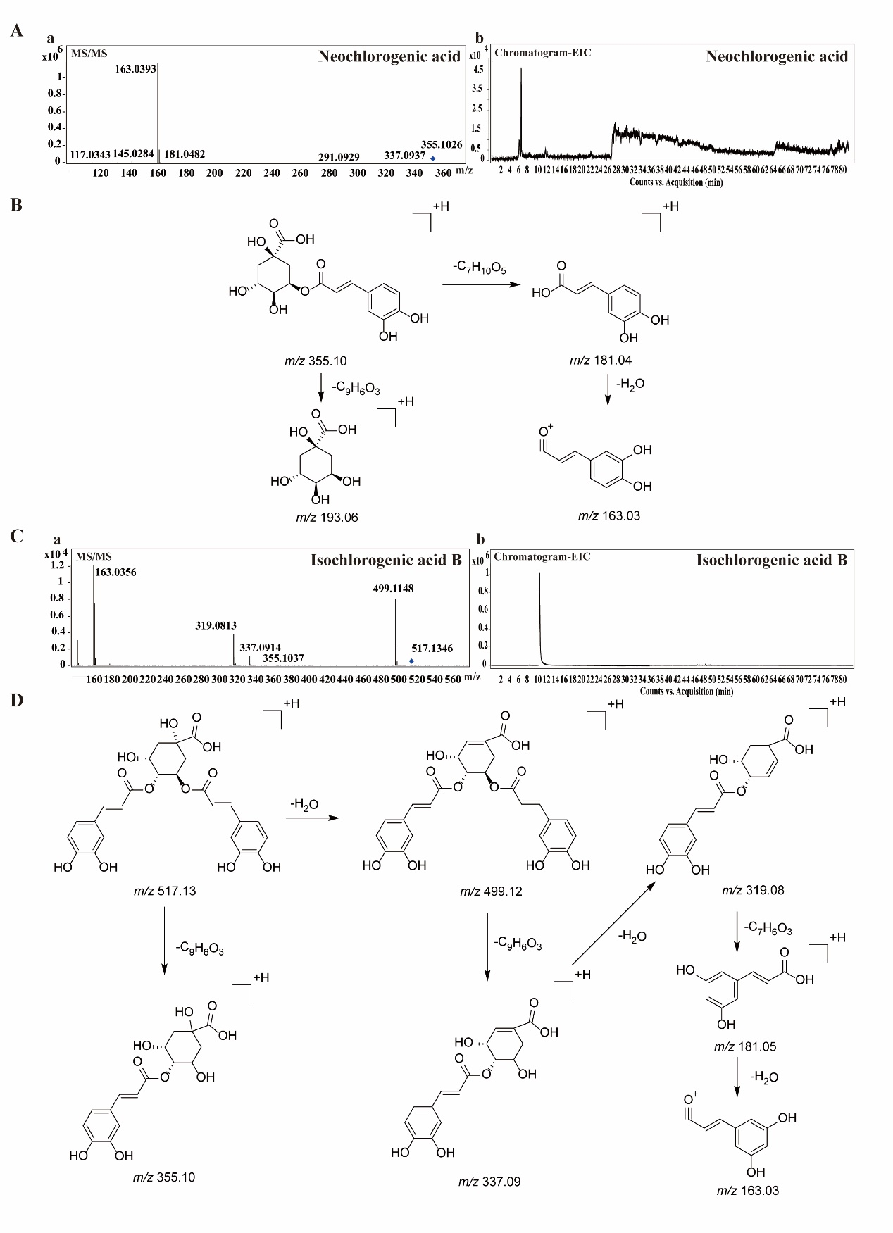

**Figure S3**

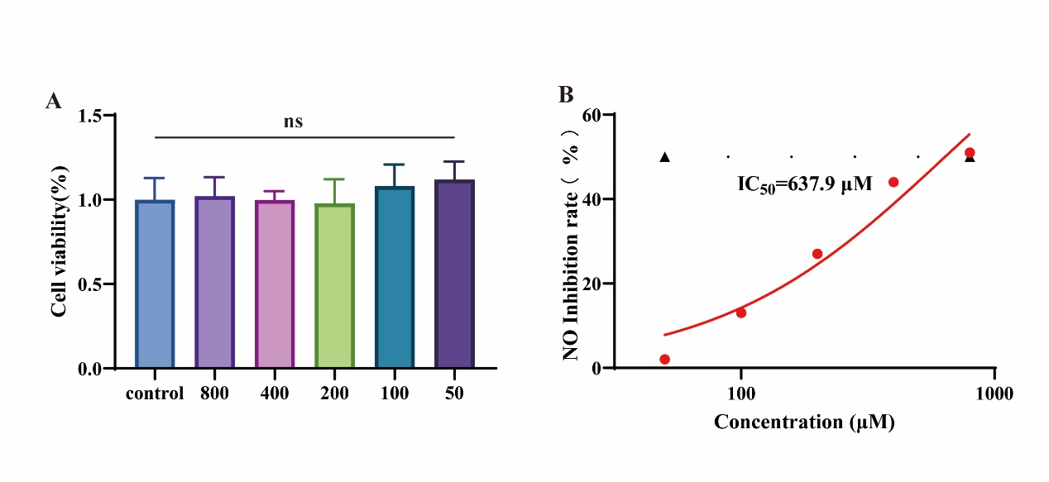

**Figure S4**

Table S1 Cultivation area of 24 batches of dry roots and rhizomes of *V. jatamansi.*

|  |  |  |  |  |
| --- | --- | --- | --- | --- |
| Sample | Cultivation area | Source | Harvesting time | Batch number |
| S1 | Yunnan, China | Roots and rhizomes | 08/2019 | 2019001 |
| S2 | Yunnan, China | Roots and rhizomes | 09/2019 | 2019002 |
| S3 | Yunnan, China | Roots and rhizomes | 09/2019 | 2019003 |
| S4 | Yunnan, China | Roots and rhizomes | 10/2019 | 2019004 |
| S5 | Yunnan, China | Roots and rhizomes | 10/2019 | 2019005 |
| S6 | Yunnan, China | Roots and rhizomes | 10/2019 | 2019006 |
| S7 | Yunnan, China | Roots and rhizomes | 10/2019 | 2019007 |
| S8 | Yunnan, China | Roots and rhizomes | 08/2020 | 2020001 |
| S9 | Yunnan, China | Roots and rhizomes | 08/2020 | 2020002 |
| S10 | Guizhou, China | Roots and rhizomes | 08/2020 | 2020003 |
| S11 | Guizhou, China | Roots and rhizomes | 09/2020 | 2020004 |
| S12 | Guizhou, China | Roots and rhizomes | 09/2019 | 2020005 |
| S13 | Guizhou, China | Roots and rhizomes | 09/2019 | 2020006 |
| S14 | Guizhou, China | Roots and rhizomes | 09/2020 | 2020007 |
| S15 | Guizhou, China | Roots and rhizomes | 09/2020 | 2020008 |
| S16 | Guizhou, China | Roots and rhizomes | 10/2020 | 2020009 |
| S17 | Guizhou, China | Roots and rhizomes | 10/2020 | 2020010 |
| S18 | Guizhou, China | Roots and rhizomes | 10/2020 | 2020011 |
| S19 | Guizhou, China | Roots and rhizomes | 08/2020 | 2020012 |

Continued Table S1

|  |  |  |  |  |
| --- | --- | --- | --- | --- |
| Sample | Cultivation area | Source | Harvesting time | Batch number |
| S20 | Guizhou, China | Roots and rhizomes | 08/2020 | 2020013 |
| S21 | Guizhou, China | Roots and rhizomes | 08/2020 | 2020014 |
| S22 | Guizhou, China | Roots and rhizomes | 08/2020 | 2020015 |
| S23 | Guizhou, China | Roots and rhizomes | 08/2020 | 2020016 |
| S24 | Guizhou, China | Roots and rhizomes | 08/2020 | 2020017 |

Table S2. Sequences of PCR primers used for qRT-PCR.

|  |  |  |  |
| --- | --- | --- | --- |
| Gene | Forward primer (Sequence 5′-3′) | Reverse primer (Sequence 5′-3′) | |
| IL-1β | TCGCAGCAGCACATCAACAAGAG | AGGTCCACGGGAAAGACACAGG |
| IL-6 | CTTCTTGGGACTGATGCTGGTGAC | AGGTCTGTTGGGAGTGGTATCCTC | |

Table S3 The top 20 targets of CytoHubba plug calculation

|  |  |  |  |  |
| --- | --- | --- | --- | --- |
| Name | Degree | EPC | MCC | MNC |
| SRC | **142** | **57.699** | **529576** | **69** |
| HRAS | **122** | **55.378** | **96019** | **58** |
| TP53 | **120** | **49.691** | 7998 | **50** |
| STAT3 | **108** | **54.775** | **378742** | **52** |
| MAPK1 | **108** | **54.011** | **56178** | **54** |
| PIK3R1 | **100** | **54.793** | **195580** | **50** |
| PIK3CA | **94** | **55.008** | **194934** | **47** |
| EGFR | **76** | **49.775** | **230938** | **36** |
| LCK | **74** | **51.77** | **612656** | **37** |
| AKT1 | **72** | **47.638** | 12301 | **35** |
| FYN | **68** | **51.123** | **538950** | **34** |
| PTK2 | **68** | **49.426** | **232402** | **34** |
| MAPK14 | **62** | **47.423** | **103199** | **30** |
| STAT5B | **58** | **46.562** | 27350 | **29** |
| MAPK8 | **58** | **44.799** | 13165 | **28** |
| CDK1 | **56** | 33.574 | **422244** | **28** |
| JAK1 | **56** | **48.945** | **140550** | **28** |
| JAK2 | **56** | **46.15** | **69969** | **27** |
| VEGFA | **54** | 41.416 | 22581 | **26** |
| PTK2B | 50 | 44.596 | **139466** | **25** |
| ESR1 | **50** | 39.887 | 1558 | 21 |
| CCNA2 | 48 | 31.047 | **417918** | 24 |
| YES1 | 48 | **45.851** | **405960** | 24 |
| ABL1 | 48 | 41.595 | 7326 | 24 |
| JAK3 | 46 | **45.02** | **129846** | 23 |
| MAP2K1 | 44 | 44.315 | 26194 | 22 |
| PAK1 | 44 | 38.671 | 2966 | 22 |
| PRKCD | 42 | **45.065** | **28290** | 21 |
| CDK4 | 40 | 33.148 | **418010** | 20 |

Table S4 The top 20 pathways of KEGG enrichment analysis

|  |  |  |  |
| --- | --- | --- | --- |
| Term | Count | PValue | Fold Enrichment |
| JAK-STAT signaling pathway | 53 | 1.82E-31 | 7.338007 |

|  |  |  |  |
| --- | --- | --- | --- |
| NOD-like receptor signaling pathway | 47 | 3.02E-23 | 5.870707 |
| PI3K-Akt signaling pathway | 47 | 1.23E-11 | 3.051441 |
| Chemokine signaling pathway | 46 | 1.6E-21 | 5.50639 |
| TNF signaling pathway | 44 | 2.58E-30 | 9.029112 |
| IL-17 signaling pathway | 43 | 6.53E-33 | 10.51359 |
| Toll-like receptor signaling pathway | 42 | 1.76E-29 | 9.281674 |
| AGE-RAGE signaling pathway in diabetic complications | 37 | 2.31E-24 | 8.503782 |
| MAPK signaling pathway | 37 | 1.26E-08 | 2.892443 |
| NF-kappa B signaling pathway | 34 | 1.96E-20 | 7.513736 |
| C-type lectin receptor signaling pathway | 31 | 2.26E-17 | 6.85076 |
| T cell receptor signaling pathway | 27 | 1.55E-13 | 5.966791 |
| FoxO signaling pathway | 25 | 1.45E-09 | 4.386106 |
| HIF-1 signaling pathway | 24 | 1.71E-10 | 5.06052 |
| Relaxin signaling pathway | 21 | 6.08E-07 | 3.74145 |
| RIG-I-like receptor signaling pathway | 18 | 4.5E-09 | 5.909964 |
| Prolactin signaling pathway | 17 | 3.28E-08 | 5.581633 |
| Adipocytokine signaling pathway | 15 | 1.14E-06 | 4.996346 |
| Fc epsilon RI signaling pathway | 14 | 5.57E-06 | 4.731834 |
| B cell receptor signaling pathway | 14 | 4.57E-05 | 3.92396 |

Table S5 Method validation results of HPLC fingerprints analysis.

|  |  |  |  |  |
| --- | --- | --- | --- | --- |
| Peaks | Retention time (min) | RSD% | | |
| Repeatability | Precision | Stability(24 h) |
| P04 | 11.13 | 2.31% | 3.07% | 3.27% |
| P06 | 11.85 | 4.68% | 4.30% | 3.67% |
| P07 | 13.79 | 4.38% | 2.41% | 4.45% |
| P11 | 29.04 | 2.04% | 2.04% | 3.27% |
| P12 | 30.59 | 2.76% | 4.09% | 4.63% |
| P13 | 31.02 | 3.94% | 2.61% | 3.51% |
| P14 | 32.23 | 2.76% | 3.97% | 4.49% |
| P15 | 35.65 | 4.36% | 2.46% | 4.17% |
| P17 | 42.12 | 4.18% | 1.12% | 3.18% |
| P20 | 48.75 | 4.73% | 1.34% | 3.22% |
| P21 | 54.45 | 3.53% | 1.72% | 3.62% |
| P23 | 60.32 | 4.25% | 0.63% | 3.61% |
| P26 | 66.10 | 4.26% | 2.56% | 3.67% |
| P28 | 69.41 | 3.09% | 0.92% | 3.89% |
| P30 | 70.40 | 3.64% | 0.86% | 3.07% |
| P32 | 72.60 | 3.82% | 0.67% | 1.91% |
| P36 | 80.58 | 3.91% | 0.83% | 2.06% |

Table S6 Sample similarity analysis.

|  |  |  |  |  |  |
| --- | --- | --- | --- | --- | --- |
| Sample | Similarity | | Sample | Similarity | |
| S1 | | 0.995 | S13 | 0.73 |
| S2 | | 0.995 | S14 | 0.989 |
| S3 | | 0.9 | S15 | 0.969 |
| S4 | | 0.923 | S16 | 0.995 |
| S5 | | 0.997 | S17 | 0.975 |
| S6 | | 0.979 | S18 | 0.985 |
| S7 | | 0.935 | S19 | 0.992 |
| S8 | | 0.996 | S20 | 0.992 |
| S9 | | 0.994 | S21 | 0.992 |
| S10 | | 0.993 | S22 | 0.993 |
| S11 | | 0.996 | S23 | 0.992 |
| S12 | | 0.705 | S24 | 0.989 |
|  | |  | R | 1 |

Table S7. Physicochemical parameters and druglikeness of acevaltrate and valtrate

|  |  |  |  |
| --- | --- | --- | --- |
| Molecule | Parameters Standards | acevaltrate | valtrate |
| Formula |  | C24H32O10 | C22H30O8 |
| MW | 100.0–600.0 | 480.5 | 422.47 |
| TPSA | <131.6 | 126.96 | 100.66 |
| WLOGP | −3.0–6.0 | 2.35 | 2.66 |
| Water Solubility  Class |  | Soluble | Soluble |
| GI absorption |  | High | High |
| BBB permeant |  | No | No |
| Pgp substrate |  | No | No |
| CYP1A2 inhibitor |  | No | No |
| CYP2C19 inhibitor |  | No | No |
| CYP2C9 inhibitor |  | No | No |
| CYP2D6 inhibitor |  | Yes | Yes |
| CYP3A4 inhibitor |  | No | No |
| Lipinski |  | YES | YES |
| Ghose |  | NO; 1violation: MW>480 | YES |
| Veber |  | NO; 1violation: Rotors>10 | NO; 1violation: Rotors>10 |
| Egan |  | YES | YES |
| Muegge |  | YES | YES |
| Bioavailability Score |  | 0.55 | 0.55 |

Table S8 Linear equations and method validation

|  |  |  |  |  |  |  |  |  |  |  |
| --- | --- | --- | --- | --- | --- | --- | --- | --- | --- | --- |
| Compounds | Standard curve | Linear range | R2 | LOD | LOQ | Precision | Repeatability | Stability (24 h) | Recovery | |
| (µg/mL) | (µg/mL) | (µg/mL) | RSD% | RSD% | RSD% | Accuracy (%) | RSD% |
| hesperidin | y = 0.0432x + 0.038 | 0.8-500 | 0.9996 | 0.24 | 0.8 | 1.40% | 3.28% | 2.86% | 103% | 2.84% |
| acevaltrate | y = 0.3094x + 0.0999 | 0.8-500 | 0.9995 | 0.24 | 0.8 | 0.63% | 2.47% | 3.61% | 95.2% | 2.76% |
| valtrate | y = 1.7208x + 1.4009 | 4-500 | 1 | 0.6 | 2 | 0.67% | 2.85% | 2.10% | 98.5% | 3.84% |

R2 is the square of the correlation coefficient, which can judge the fitting degree of the linear regression line.

Table S9 Comparison of HPLC methods with other quantification methods

|  |  |  |  |  |  |  |  |  |  |  |  |
| --- | --- | --- | --- | --- | --- | --- | --- | --- | --- | --- | --- |
| Compounds | Methods | Linear range | LOD | LOQ | Precision | Repeatability | Stability (24 h) | Recovery | | Reference | |
| (µg/mL) | (µg/mL) | (µg/mL) | RSD% | RSD% | RSD% | Mean | RSD | |  |
| Hesperidin; acevaltrate;valtrate | HPLC | 0.8-500;0.8-500;4-500 | 0.24-0.6 | 0.8-2 | 0.63-1.4% | 2.47-3.28% | 2.10-3.61% | 95.2-103% | 2.76-3.84% | | This paper |
| Hesperidin; acevaltrate;valtrate | HPLC | 2.20-220; 2.50-200; 10.0-800 | —— | —— | 0. 52-2.02% | 0.87-2. 18% | 0. 80-2.35% | 101-107 | 0.57-2. 36% | | (Cheng et al., 2019) |
| Hesperidin | HPLC | 8.75-70 | —— | —— | 0. 57% | 1. 6% | 1. 06% | 97. 01% | 1. 80% | | (Liu et al., 2018) |

|  |  |  |  |  |  |  |  |  |  |  |
| --- | --- | --- | --- | --- | --- | --- | --- | --- | --- | --- |
| Acevaltrate; valtrate | HPLC | 8.10-1539; 20.5-4213 | —— | —— | 0.43-0.65% | 1.60-1.67% | 0.73-1.89% | 99.9-100% | 1.12-1.13% | (Di et al., 2007) |

|  |  |  |  |  |  |  |  |  |  |  |
| --- | --- | --- | --- | --- | --- | --- | --- | --- | --- | --- |
| Quinic acid; caffeic acid; orientin; kaempferol-3-*O*-rutinoside; luteolin; isoeugenol; valerenic acid, *ect* | UPLC-ESI-QqQ LIT-MS/MS | 0.1-3 | 0.003-0.01 | 0.01-0.04 | 0.74-2.49% | —— | 0.69-1.85 | 98.2-104% | 0.95-2.41% | (Shukla et al., 2021) |

# References

Cheng, S. Y., Fu, Y., Yu, L. N., Lv, Q. W., Huang, J., Luo, R. X., and Yang, J., 2019. Simultaneous Determination of Nine Components in Valeriana jatamansi Jones by HPLC. J. Guizhou Med. Univ. 44(12), 1413-1418. <https://doi.org/10.19367/j.cnki.1000-2707.2019.12.009>

Di, H. Y., Shi, J. L., Yan, X. L., Zhao, R., Liu, Y., and Xiao, P. G., 2007. Determination of valtrate, acevaltrate, and their degradation product-baldrinal in Valeriana walichi by HPLC analysis. Zhong Cao Yao.(12), 1892-1894

Liu, K. P., Yang, j., Cheng, S. Y., Luo, X. R., Liu, X. F., and Yin, H., 2018. Simultaneous Determination of Seven Components in Valeriana jatamansi Jones by HPLC. Zhong Yao Cai. 41(04), 922-924. <https://doi.org/10.13863/j.issn1001-4454.2018.04.031>

Shukla, V., Singh, P., kumar, D., Konwar, R., Singh, B., and Kumar, B., 2021. Phytochemical analysis of high value medicinal plant Valeriana jatamansi using LC-MS and it's in-vitro anti-proliferative screening. Phytomedicine Plus. 1(2), 100025. <https://doi.org/10.1016/j.phyplu.2021.100025>

Wang, C., Zheng, Z., Deng, X., Ma, X., Wang, S., Liu, J., Liu, Y., and Shi, J., 2017. Flexible and powerful strategy for qualitative and quantitative analysis of valepotriates in Valeriana jatamansi Jones using high-performance liquid chromatography with linear ion trap Orbitrap mass spectrometry. Journal of Separation Science. 40(9), 1906-1919. <https://doi.org/10.1002/jssc.201601406>