Supporting information

Effect of sintering temperature and time on the microstructure, density, phase, selected mechanical and tribological properties of $C_{f}/{Si}_{3}N_{4}$ composite produced by the spark plasma sintering

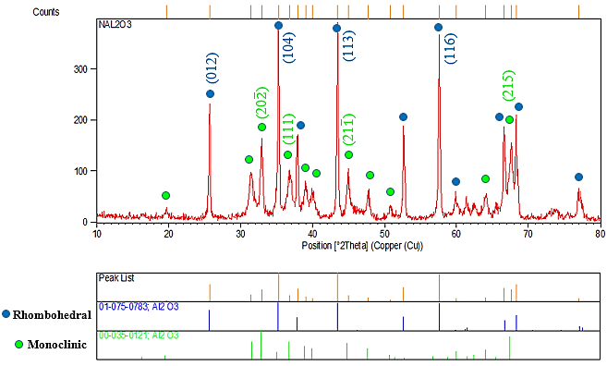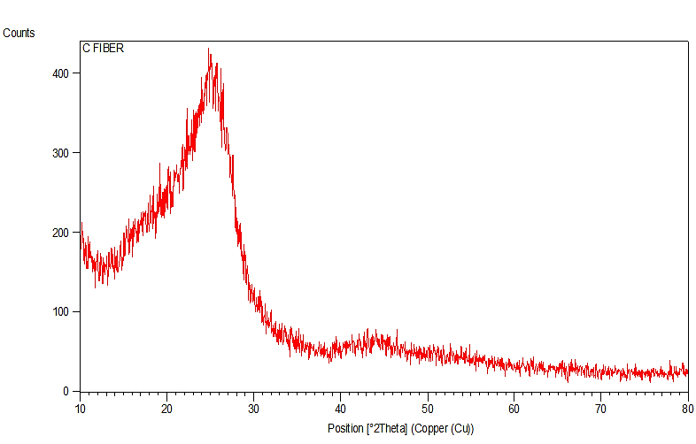Fig. S1. XRD results of carbon fiber

Fig. S2. XRD results of Al2O3 powder

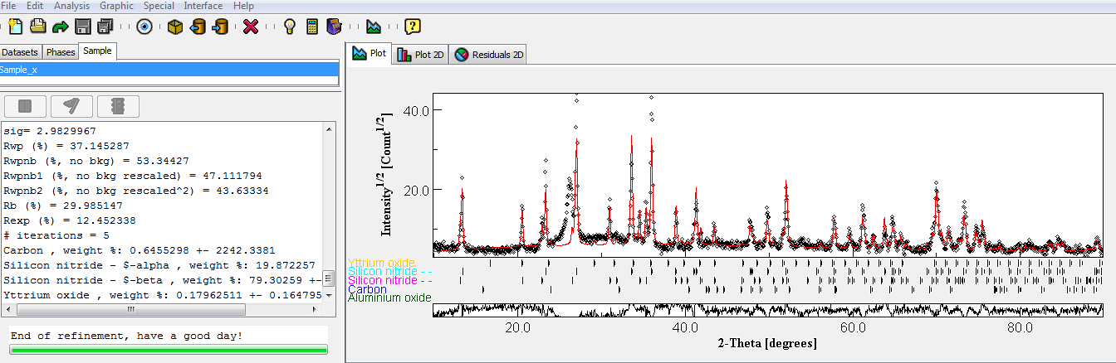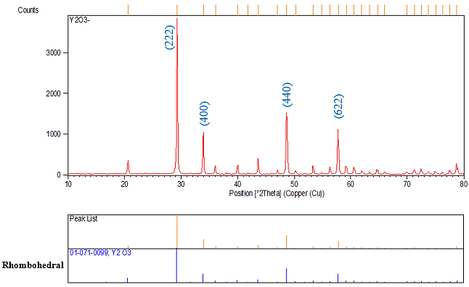Fig. S3. XRD results of Y2O3 powder

Figure S4. Quantitative analysis results of sample 5 using MAUD software

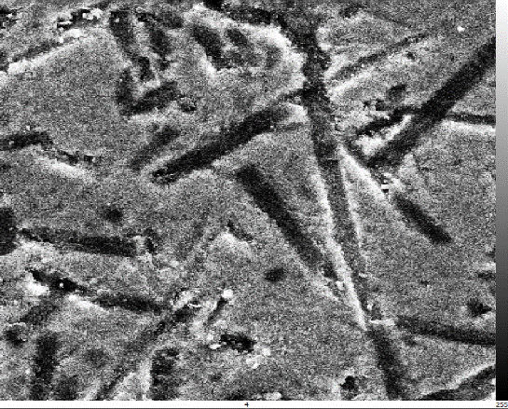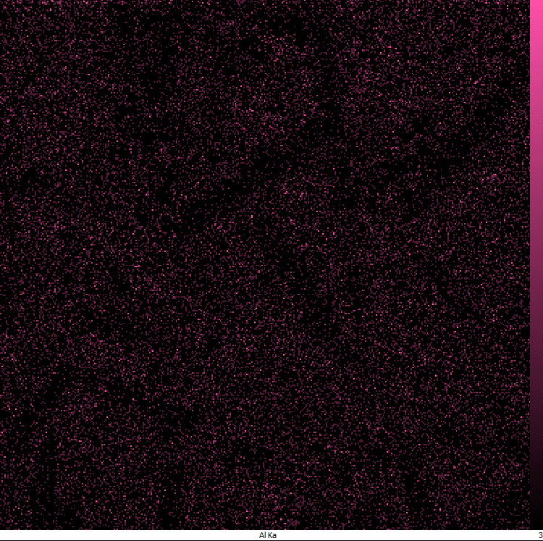

**Al**

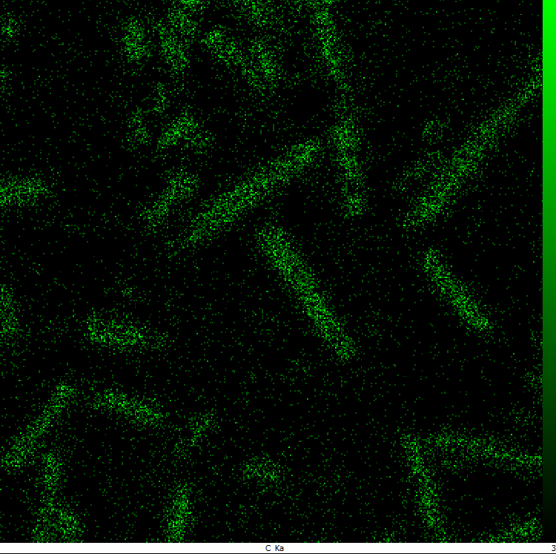

**C**

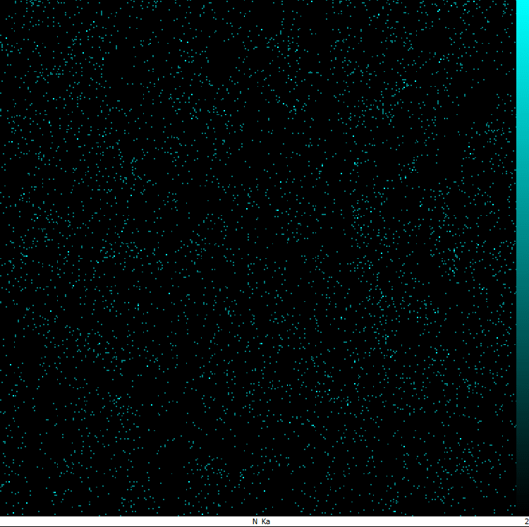

**N**

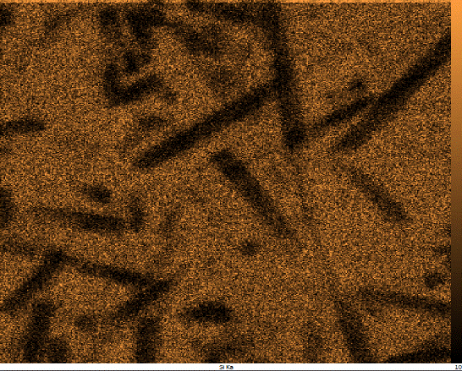

**Si**

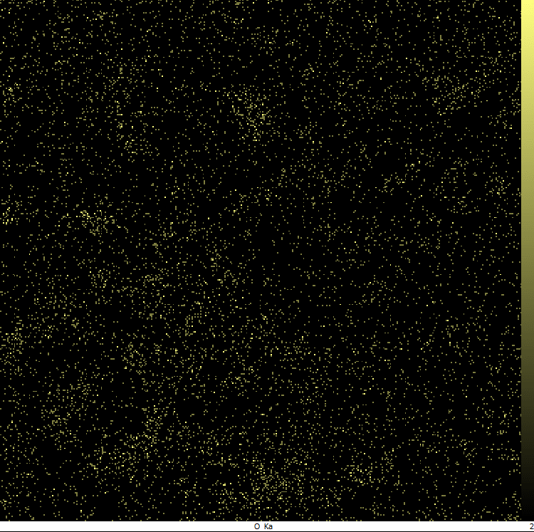

**O**

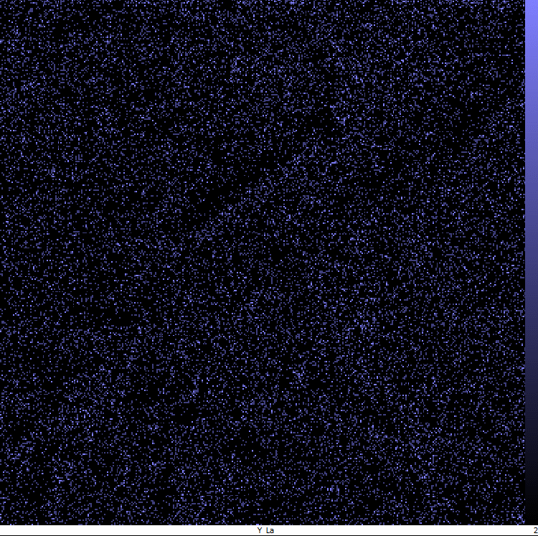

**Y**

Fig. S6. SEM images and X-ray mapping from the distribution of elements in sample 5.

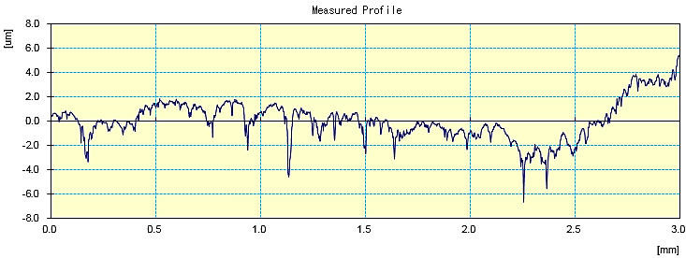

**a**

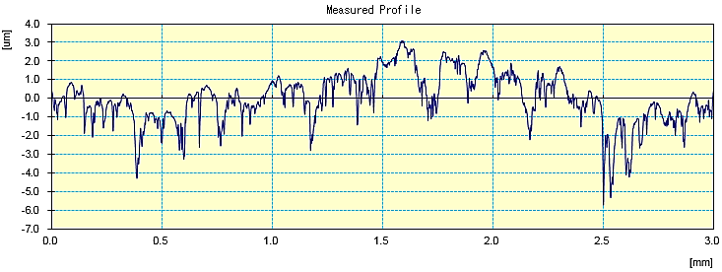

**c**

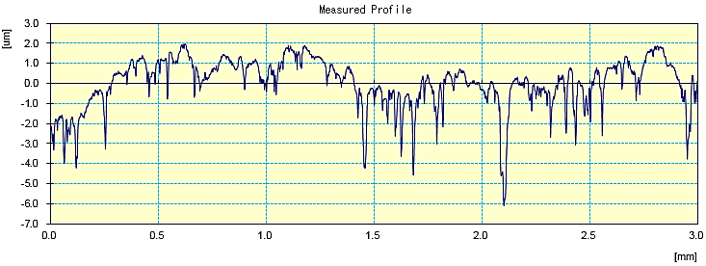

**b**

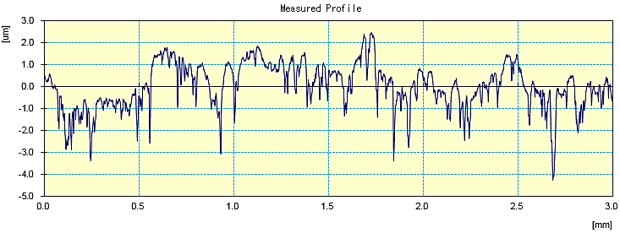

**d**

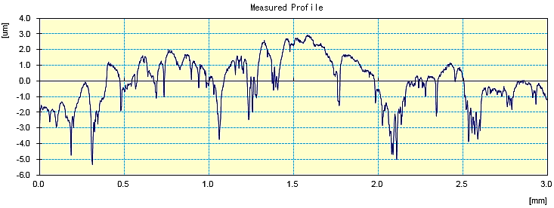

**e**

Fig. S7. Surface roughness profile curves of sintered samples a) sample 1, b) sample 2, c) sample 3, d) sample 4, e) sample 5

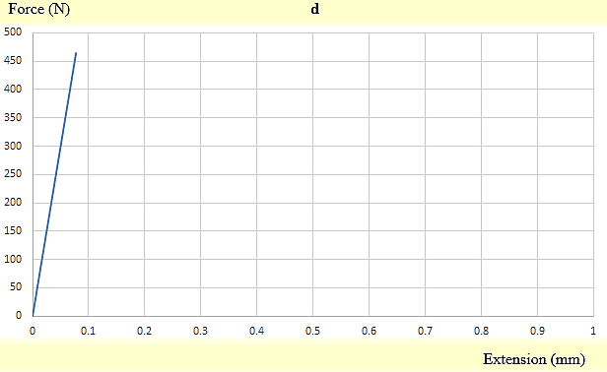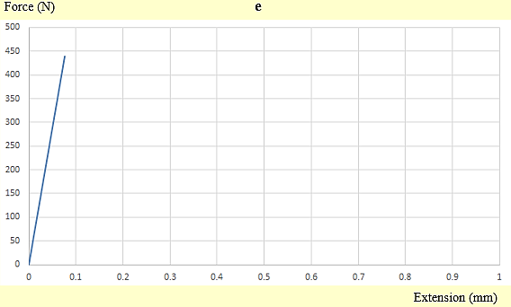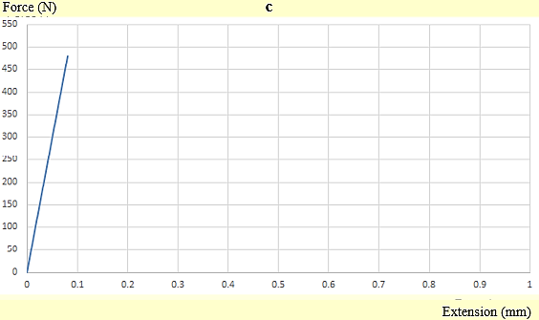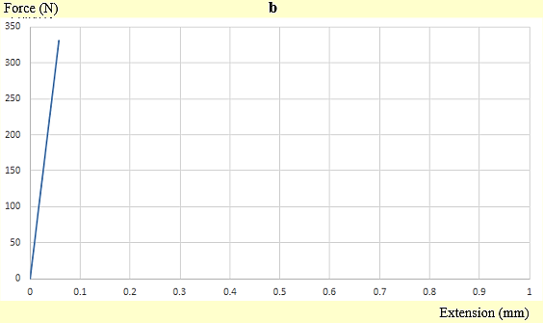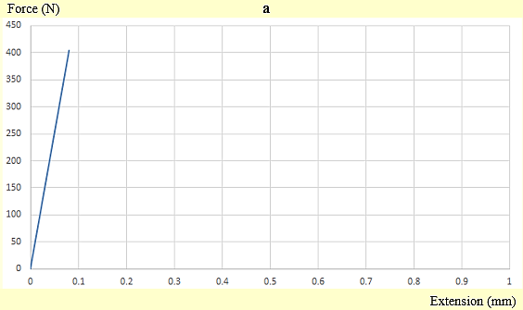

Fig. S8. The force displacement curve of the sintered samples: a) sample 1, b) sample 2, c) sample 3, d) sample 4, and e) sample 5.

**a**

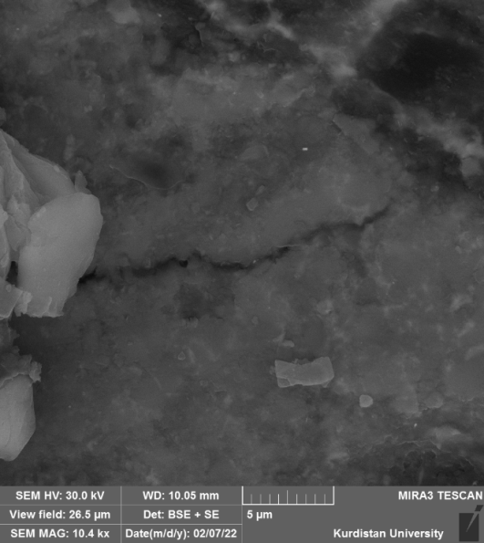

**b**

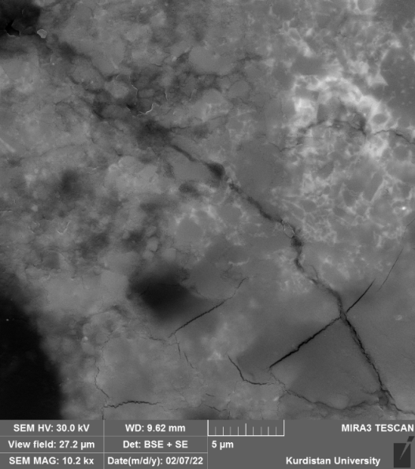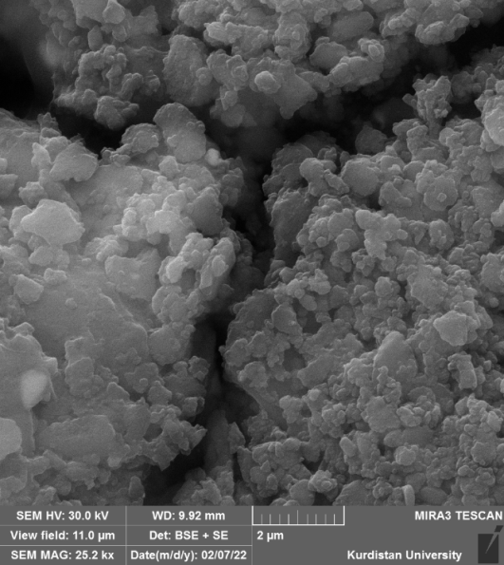

**c**

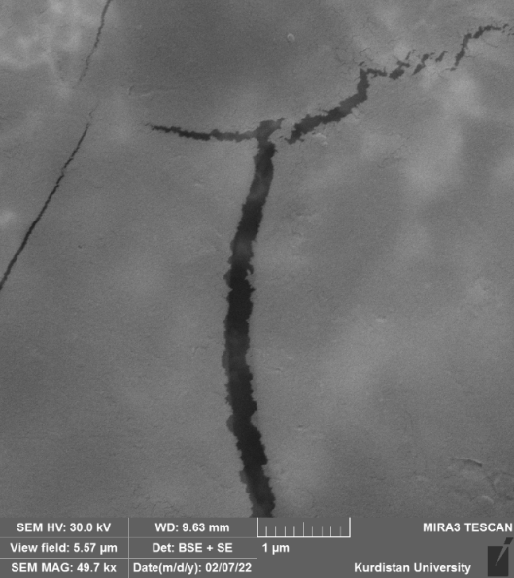

**d**

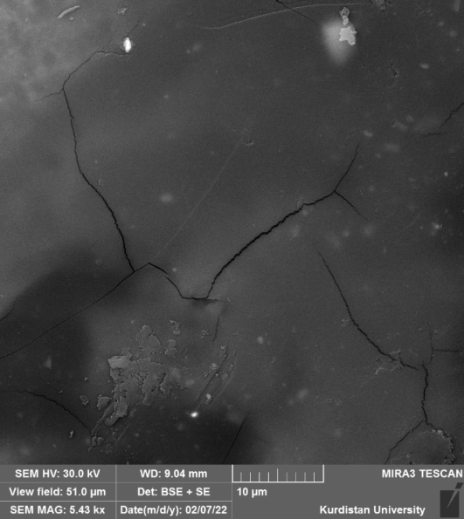

**e**

Fig. S9. FESEM images of the crack created by the Vickers indenter on the sintered samples: a) sample 1, b) sample 2, c) sample 3, d) sample 4, and e) sample 5.