**Supplementary data**

**CeO2**-**CePO4 and Ag@CeO2**-**CePO4 nanocomposites from *Penaeus semisulcatus* for heavy metals sensing, UV shielding and cytotoxic applications**

Rajendran Muthukumar Sivaramana,1, Kirubaharan Daphne Jacinth Graciaa, Seth Sheeba Thavamania, Thomas Peter Amaladhasa*, Sandhanasamy Devanesanb, Mohamad S AlSalhib, Nassar N. Asemib, Srinivasaprabhu Natarajanc

aPost Graduate and Research Department of Chemistry, V.O. Chidambaram College (Affiliated to Manonmaniam Sundaranar University, Tirunelveli-627012), Tuticorin, 628008, Tamil Nadu, India

bDepartment of Physics and Astronomy, College of Science, King Saud University, P. O. Box 2455, Riyadh 11451, Saudi Arabia

cInstitute of Biological, Environmental, and Rural sciences (IBERS), Aberystwyth University, SY233EB, United Kingdom

1Research Scholar, Reg. No 18122232031001

*\*Corresponding author: E-mail:* [*peteramaladhas@gmail.com*](mailto:peteramaladhas@gmail.com)*; sheeba_tuty@yahoo.com*

Tel: (+91) 461-2310175; Fax: (+91) 461-2310275

Orcid: 0000-0002-4469-0643

**S1. Sun Protection Factor (SPF)**

For the analysis, 96-well plates were seeded with Human Melanoma Cell Line (SK-MEL cells) in the number of 2500 cells per well and allowed for 24 hours to acclimate to the culture conditions of 37 °C and 5% CO2 inside the incubator. The test samples were prepared in DMEM medium (100 mg/mL) and filtered through a 0.2-micron millipore syringe filter before being sterile. Further diluted in DMEM medium, the samples were added to the wells containing the cultured cells at final concentrations of 6.25, 12.5, 25, 50, and 100 µg/mL, respectively. Untreated wells were considered as control. To reduce errors, each experiment was performed in triplicate, and average results were finalised. After treatment with the test samples, the plates were further incubated for 24 h. The incubated cells with test samples were subjected to the detection of the SPF using the method of Khan et al. The observed absorbance in the range of 290-320 nm were further processed using the equation,

SPFspectrophotometric = CF x 290∑320 EE (λ) x I (λ) x Abs (λ)

where CF is a correction factor (10), EE (λ) is the erythmogenic effect of radiation with wavelength (λ) and Abs (λ) is the absorbance of the wavelength λ. The values of EE (λ) × I (λ) are constants and were formulated by Sayre et al. The normalized values of EE (λ) × I (λ) are 0.0150 (290 nm), 0.0817 (295 nm), 0.2874 (300 nm), 0.3278 (305 nm), 0.1864 (310 nm), 0.0837 (315 nm), and 0.0180 (320 nm).

**S2. Evaluation of the cytotoxic effect of CeNC@T1 and CeNC@T2**

The *in vitro* screening of cytotoxicity of CeNC@1 and CeNC@T2 was by 3-(4,5-dimethylthiazol-2-yl)-2,5-diphenyltetrazolium bromide (MTT) assay. Cell culture incubator was maintained at 37 °C, 5% CO2, and humidity condition to incubate the cell containing TC flasks. Trypsinization was performed with 80–90% confluent cells that were kept in TC flasks. In order to do this, trypsin/EDTA solution (0.025% of trypsin and 0.01% of EDTA in phosphate-buffered saline) was applied to a monolayer of cells grown in TC flask. At a concentration of 5x103 cells/well (in 100 μL), the trypsinized cells were diluted in the cell culture medium. Cells were seeded onto the 96-well plates, which were then placed in a cell culture incubator for 3–4 days. The test samples were made in DMEM medium (100 mg/mL) and filtered using 0.2 µm millipore syringe filter. The samples were further diluted in DMEM media and seeded to the wells containing cultured cells at final concentrations of 6.25 µg, 12.5 µg, 25 µg, 50 µg and 100 µg respectively. After sample treatment and incubation for 24 hours, the media from the wells were aspirated and discarded. The wells were added with 100 μL of 0.5 mg/mL MTT solution in DMEM medium. For the formation of formazan crystals by metabolically active cells, the plates were then incubated for a further 2-4 hours. After removing the supernatant, 100 μL of 100% DMSO were added to dissolve the formazan crystals each well and the resulting purple coloured solution was quantified by measuring absorbance at 570 nm using an ELISA plate reader. Two wells per plate without cells served as blank. In order to reduce errors, each experiment was performed in triplicate and the average values were taken. After sample addition, the treated and control wells were viewed in an inverted phase contrast tissue culture microscope at regular intervals up to 24 hours and the observations were photographed.

**Table S1. 2𝜃 values along with crystallographic (hkl) planes of NCs (Planes of CePO4 are denoted in red colour)**

|  |  |  |  |  |
| --- | --- | --- | --- | --- |
| CeNC@T1 | CeNC@T2 | CeNC@T3 | Ag-CeNC@T3 | Phase Assignment |
| 13.71 |  | 12.31 (100) | 12.03 (100) | CePO4 |
| 23.65 |  | 21.44 -(111) | 21.21 -(111) | CePO4 |
|  |  | 26.99 (120) | 26.95 (120) | CePO4 |
| 27.86 (111) | 29.05 (111) | 28.53 (111) | 28.55 (111) | CeO2 |
| 30.44 | 31.63 (102) |  | 31.15 (102) | CePO4 |
| 32.40 | 33.59 (200) | 33.06 (200) | 33.09 (200) | CeO2 |
|  |  | 42.02 -(103) | 42.22 -(103) | CePO4 |
| 44.86 |  | 45.96 (212) | 46.06 (212) | CePO4 |
| 46.93 (220) | 47.96 (220) | 47.46 (220) | 47.50 (220) | CeO2 |
| 75.8 |  |  | 48.56 (103) | CePO4 |
|  |  | 52.65 -(232) | 51.81 -(232) | CePO4 |
| 55.76 (311) | 56.87 (311) | 56.33 (311) | 56.39 (311) | CeO2 |
| 58.93 (222) | 59.59 (222) | 59.08 (222) | 59.19 (222) | CeO2 |
| 69.50 (400) | 69.79 (400) | 69.42 (400) | 69.43 (400) | CeO2 |
| 64.53 | 77.12 (331) | 76.61 (331) | 76.33 (331) | CeO2 |
| 67.96 | 79.55 (420) | 79.09 (420) | 79.17 (420) | CeO2 |

**S3 EDX spectra of nanocomposites**

D:\Sir Asked Application File copy\PAPER 1-PNG\TIFF IMAGES\EDAX- ARIAL.tif

**Fig. S1** EDX spectra of (a) CeNC@T1, (b) CeNC@T2, (c) CeNC@T3 and (d) Ag-CeNC@T3.

**S4 CIE diagram of nanocomposites**

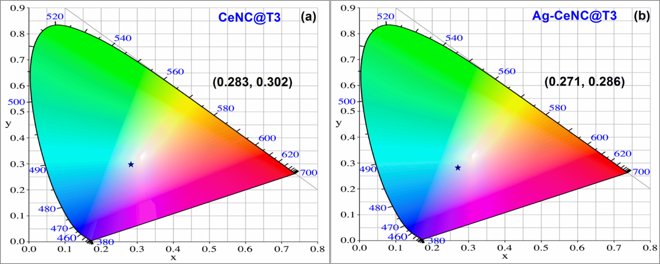

**Fig. S2** CIE diagram of (a) CeNC@T3 and (b) Ag-CeNC@T3 (λex= 220 nm).

**S5 Selectivity of CeNC@T3 to various metal ions at 0.05 M concentration**

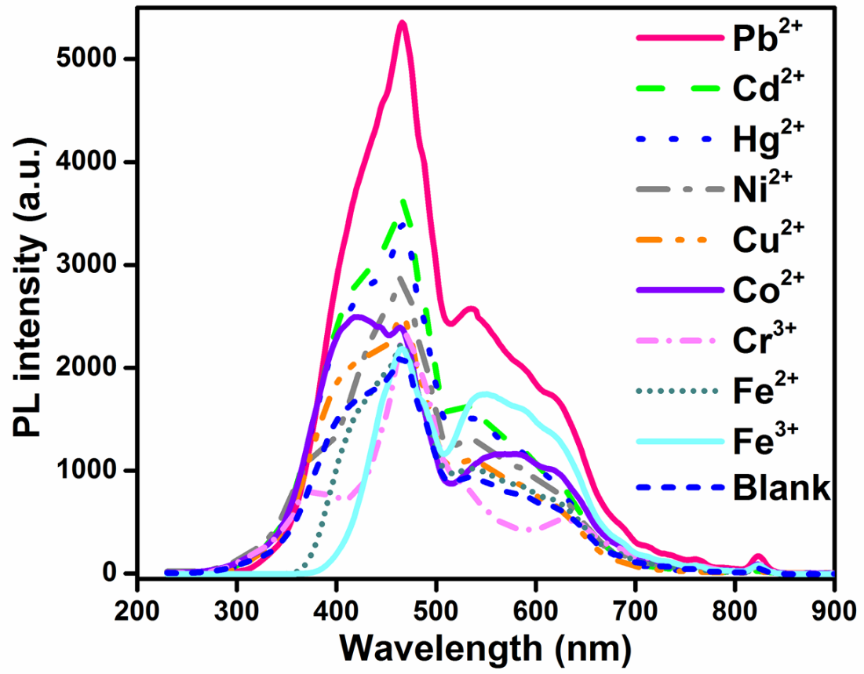

**Fig. S3.** Selectivity of CeNC@T3 to various metal ions at 0.05 M concentration.

**S6. Sensing of different metal by CeNC@T3**

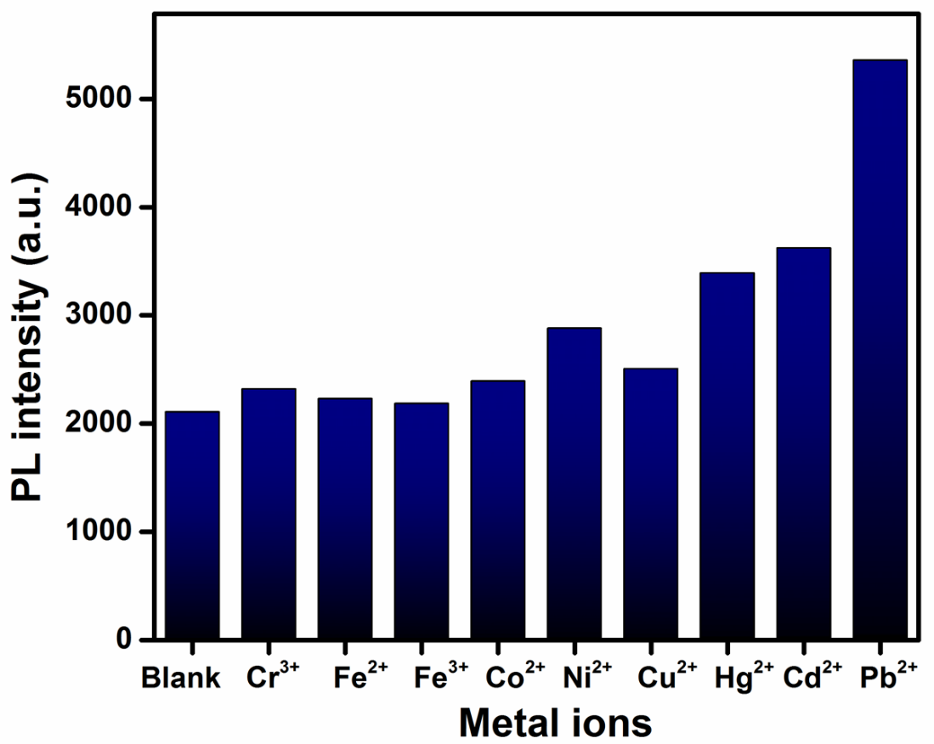

**Fig. S4.** Sensing of different metal ions (0.05 M) by CeNC@T3.

**S7. Emission spectra of CeNC@T3 with Pb2+ ions**

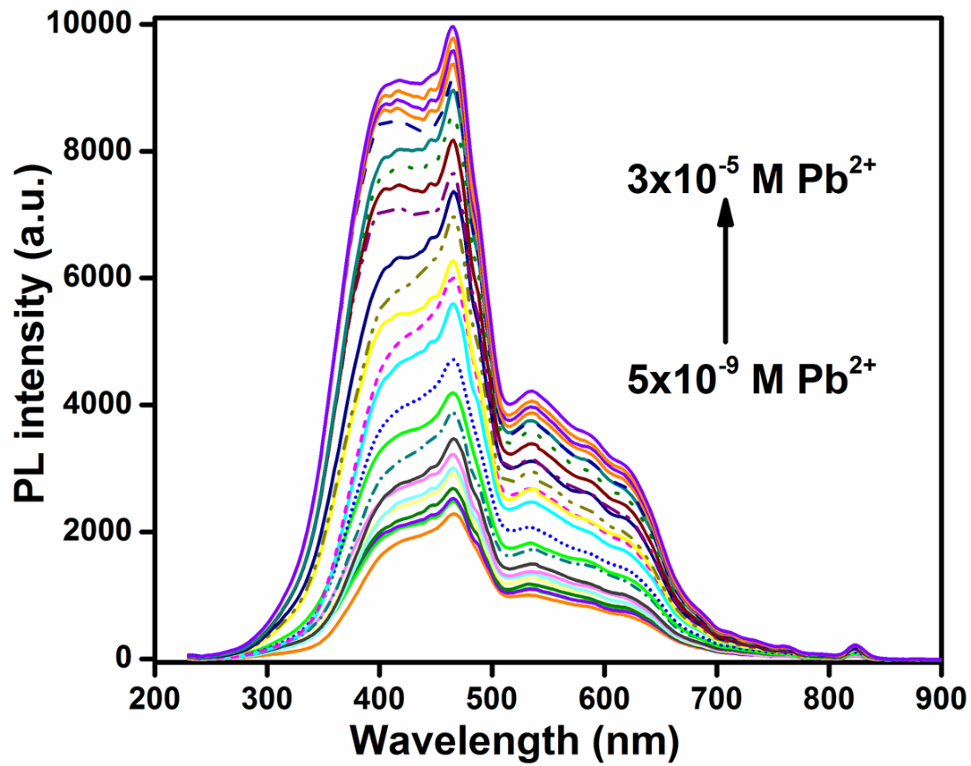

**Fig. S5.** Emission spectra of CeNC@T3 with Pb2+ ions in the range of 5x10-9 M to 3x10-5 M (λex= 220 nm).

**S8. Emission spectra of CeNC@T3 with Cd2+ ions**

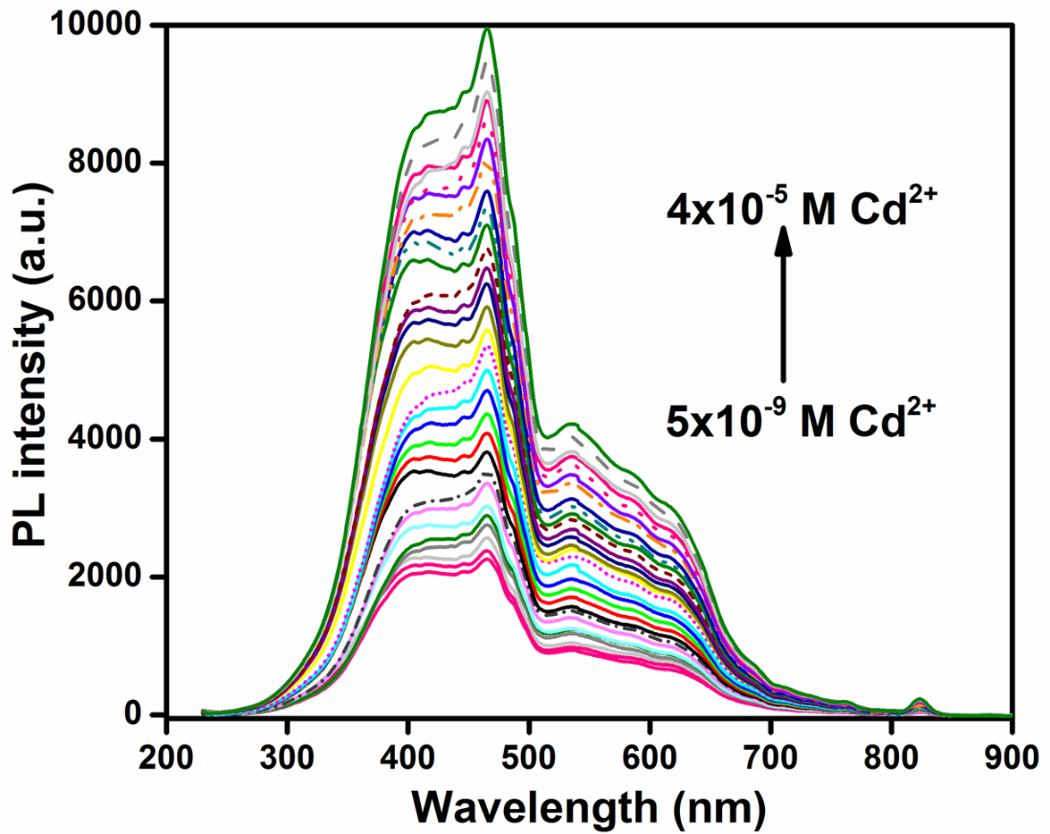

**Fig. S6.** Emission spectra of CeNC@T3 with Cd2+ ions in the range of 5x10-9 M to 4x10-5 M (λex= 220 nm).

**S9. Emission spectra of CeNC@T3 with Hg2+ ions**

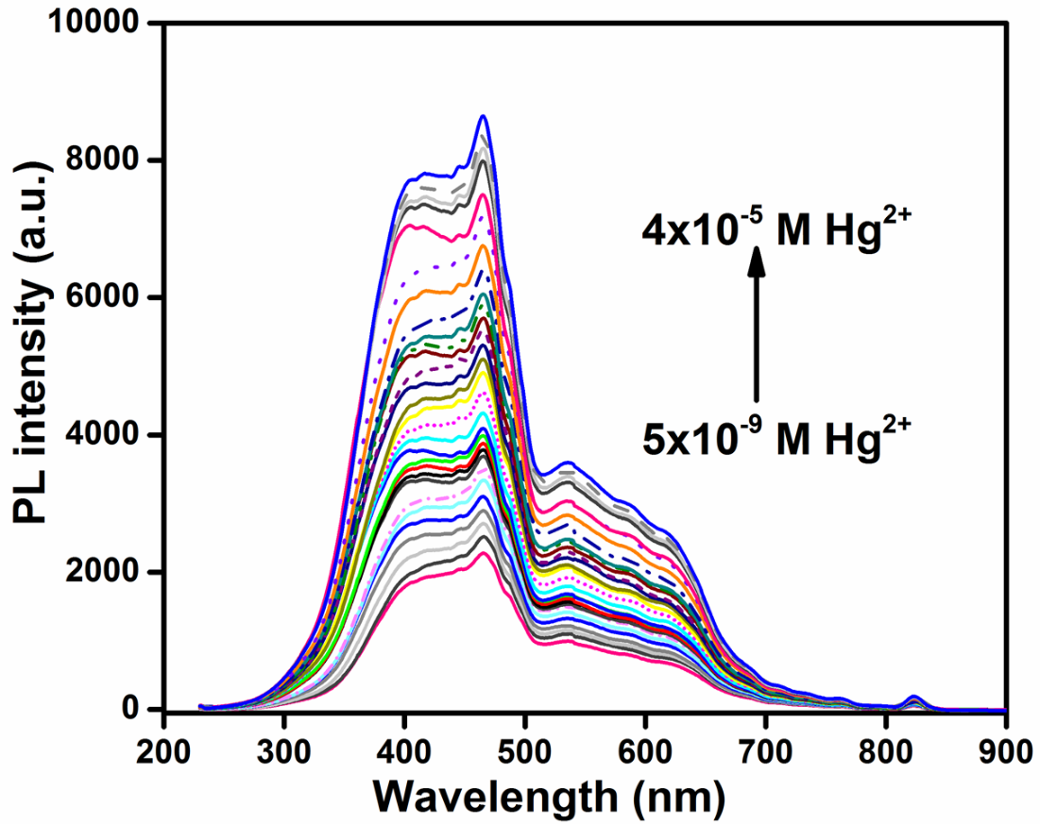

**Fig. S7.**  Emission spectra of CeNC@T3 with Hg2+ ions in the range of 5x10-9 M to 4x10-5 M (λex= 220 nm).

**S10. Turn off sensor: Emission spectra of CeNC@T3 at fixed [Pb2+]=5x10-6 M and different EDTA concentrations**

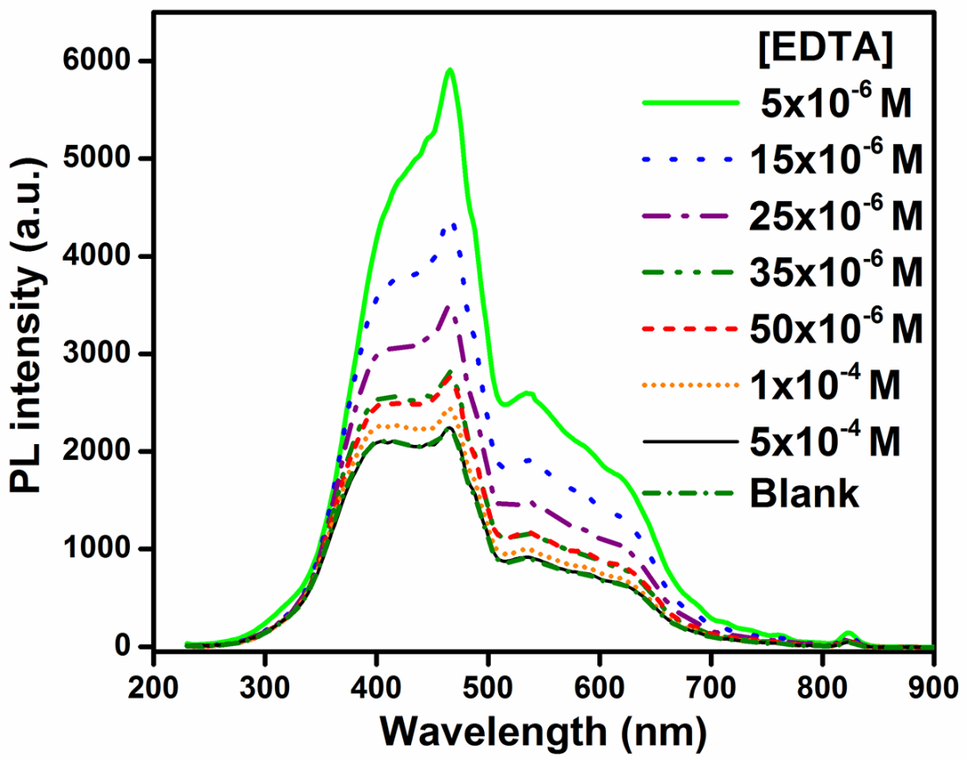

**Fig. S8.** Turn off sensor: Emission spectra of CeNC@T3 at fixed [Pb2+] = 5x10-6 M and different EDTA concentrations. 

**S11. Turn on sensor: Emission spectra of CeNC@T3 adding [Pb2+] = 5x10-4 M**

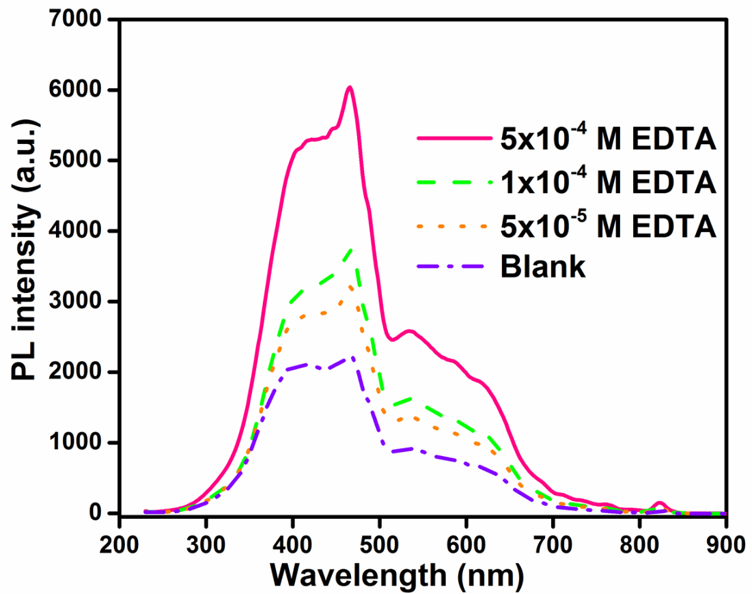

**Fig. S9.** Turn on sensor: Emission spectra of CeNC@T3 adding [Pb2+]=5x10-4 M after quenched with three different concentrations of EDTA in turn-off experiments.

**S12. Emission spectra of CeNC@T3 with a mixture of three metals (Pb2+,Cd2+ and Hg2+)**

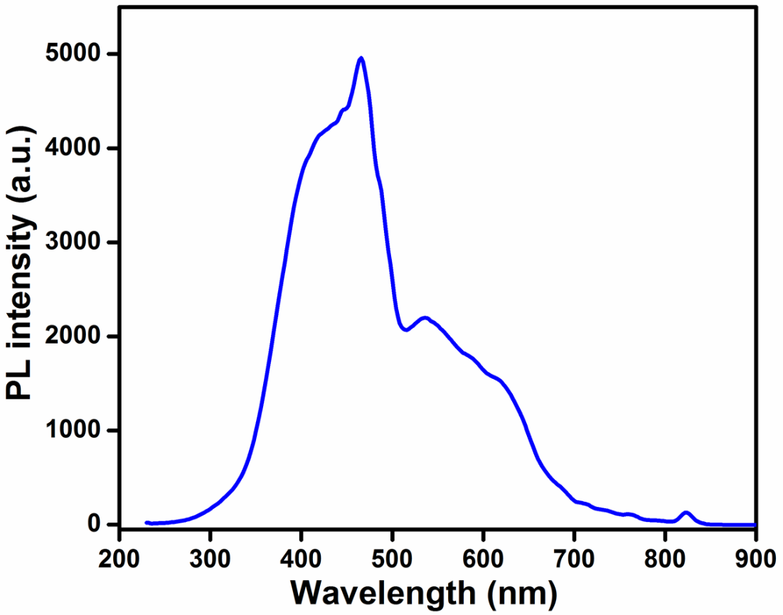

**Fig. S10.** Emission spectrum of CeNC@T3 with a mixture of three metals (Pb2+,Cd2+ and Hg2+) at 5x10-8 M concentration.