Supplementary Materials
2.1.2.1. 2-(2-nitrophenyl)-5-phenyl-1,3,4-oxadiazole (3aa). Yield: 92%, White solid, M.p.: 125-126 ℃; ¹H NMR (600 MHz, CDCl₃) δ 8.09 – 8.03 (m, 4H), 7.80 – 7.74 (m, 2H), 7.57 – 7.50 (m, 3H); ¹³C NMR (101 MHz, CDCl₃) δ 165.7, 161.2, 148.2, 133.1, 132.5, 132.1, 131.6, 129.1×2, 127.1×2, 124.6, 123.3, 118.6.
2.1.2.2. 2-(4-fluorophenyl)-5-(2-nitrophenyl)-1,3,4-oxadiazole (3ab). Yield: 92%, White solid, M.p.: 128-129 ℃; ¹H NMR (600 MHz, CDCl₃) δ 8.08 – 8.03 (m, 4H), 7.80 – 7.74 (m, 2H), 7.21 (t, J = 8.4 Hz, 2H); ¹³C NMR (101 MHz, CDCl₃) δ 166.4, 165.0, 163.9, 161.4, 148.3, 133.2, 132.7, 131.8, 129.6 , 124.8, 119.8, 118.6, 116.8, 116.5.
2.1.2.3. 2-(4-chlorophenyl)-5-(2-nitrophenyl)-1,3,4-oxadiazole (3ac). Yield: 98%, White solid, M.p.: 176-177 ℃; ¹H NMR (600 MHz, CDCl₃) δ 8.08 – 8.04 (m, 2H), 7.99 (d, J = 8.6 Hz, 2H), 7.81 – 7.75 (m, 2H), 7.50 (d, J = 8.6 Hz, 2H); ¹³C NMR (101 MHz, CDCl₃) δ 165.0, 161.5, 148.3, 138.6, 133.3, 132.7, 131.8, 129.7×2, 128.5×2, 124.8, 121.9, 118.5.
2.1.2.4. 2-(2-nitrophenyl)-5-(m-tolyl)-1,3,4-oxadiazole (3ad). Yield: 92%, White solid, M.p.: 125-126 ℃; ¹H NMR (600 MHz, CDCl₃) δ 8.08 (dd, J = 7.6, 1.6 Hz, 1H), 8.05 (dd, J = 8.0, 1.4 Hz, 1H), 7.88 (s, 1H), 7.85 (d, J = 7.7 Hz, 1H), 7.79 (td, J = 7.6, 1.4 Hz, 1H), 7.75 (td, J = 7.8, 1.6 Hz, 1H), 7.40 (t, J = 7.6 Hz, 1H), 7.37 (d, J = 7.7 Hz, 1H), 2.44 (s, 3H); ¹³C NMR (101 MHz, CDCl₃) δ 165.3, 160.6, 147.6, 138.5, 132.5, 132.4, 131.9, 131.1, 128.5, 127.0, 124.1, 123.7, 122.6, 118.1, 20.7.
2.1.2.5. 2-(3-methoxyphenyl)-5-(2-nitrophenyl)-1,3,4-oxadiazole (3ae). Yield: 87%, White solid, M.p.: 147-148 ℃; ¹H NMR (400 MHz, CDCl₃) δ 8.08 (dd, J = 7.5, 1.6 Hz, 1H), 8.05 (dd, J = 7.9, 1.4 Hz, 1H), 7.81 – 7.73 (m, 2H), 7.63 – 7.59 (m, 2H), 7.41 (t, J = 12.0 Hz, 1H), 7.10 – 7.08 (m, 1H), 3.88 (s, 3H); ¹³C NMR (101 MHz, CDCl₃) δ 165.8, 161.4, 160.1, 148.3, 133.2, 132.6, 131.8, 130.4, 124.8, 124.5, 119.6, 118.8, 118.7, 111.7, 55.6.
2.1.2.6. 2-(benzo[d][1,3]dioxol-5-yl)-5-(2-nitrophenyl)-1,3,4-oxadiazole (3af). Yield: 73%, Yellow solid, M.p.: 149-150 ℃; ¹H NMR (400 MHz, CDCl₃) δ 8.07 (dd, J = 7.4, 1.8 Hz, 1H), 8.02 (dd, J = 7.9, 1.6 Hz, 1H), 7.810 – 7.71 (m, 2H), 7.59 (dd, J = 8.2, 1.7 Hz, 1H), 7.49 (d, J = 1.8 Hz, 1H), 6.92 (d, J = 8.1 Hz, 1H), 6.07 (s, 2H); ¹³C NMR (101 MHz, CDCl₃) δ 165.6, 160.9, 151.1, 148.4, 148.3, 133.1, 132.5, 131.7, 124.7, 122.5, 118.7, 117.1, 109.0, 107.2, 102.0.
2.1.2.7. 2-(2-nitrophenyl)-5-(pyridin-4-yl)-1,3,4-oxadiazole (3ag). Yield: 61%, White solid, M.p.: 129-130 ℃; ¹H NMR (400 MHz, CDCl₃) δ 9.28 (d, J = 2.2 Hz, 1H), 8.79 (d, J = 4.9 Hz, 1H), 8.34 (d, J = 8.1 Hz, 1H), 8.08 – 8.05 (m, 2H), 7.83 – 7.76 (m, 2H), 7.49 – 7.46 (m, 1H); ¹³C NMR (101 MHz, CDCl₃) δ 163.7, 161.9, 152.9, 148.1, 148.1, 134.4, 133.4, 132.9, 131.9, 124.9, 123.9, 120.0, 118.4.
2.1.2.8. 2-(5-methoxy-2-nitrophenyl)-5-phenyl-1,3,4-oxadiazole (3ba). Yield: 87%, Yellow solid, M.p.: 183-184 ℃; ¹H NMR (400 MHz, CDCl₃) δ 8.16 (d, J = 9.2 Hz, 1H), 8.06 – 8.04 (m, 2H), 7.55 – 7.49 (m, 3H), 7.40 (d, J = 2.8 Hz, 1H), 7.17 (dd, J = 9.1, 2.8 Hz, 1H), 3.96 (s, 3H); ¹³C NMR (101 MHz, CDCl₃) δ 165.9, 163.2, 161.8, 141.1, 132.2, 129.2×2, 127.6, 127.2×2, 123.5, 121.6, 117.3, 117.1, 56.5.
2.1.2.9. 2-(4-fluorophenyl)-5-(5-methoxy-2-nitrophenyl)-1,3,4-oxadiazole (3bb). Yield: 94%, Brown solid, M.p.: 180-181 ℃; ¹H NMR (400 MHz, CDCl₃) δ 8.17 (d, J = 9.1 Hz, 1H), 8.08 – 8.04 (m, 2H), 7.40 (d, J = 2.8 Hz, 1H), 7.22 – 7.15 (m, 3H), 3.97 (s, 3H); ¹³C NMR (101 MHz, CDCl₃) δ 166.4, 165.1, 163.8, 163.3, 161.9, 141.1, 129.6, 127.6, 121.5, 119.8, 117.4, 117.1, 116.7, 116.5, 56.5.
2.1.2.10. 2-(4-chlorophenyl)-5-(5-methoxy-2-nitrophenyl)-1,3,4-oxadiazole (3bc). Yield: 84%, White solid, M.p.: 185-186 ℃; ¹H NMR (400 MHz, CDCl₃) δ 8.16 (d, J = 9.1 Hz, 1H), 7.99 (d, J = 8.7 Hz, 2H), 7.49 (d, J = 8.7 Hz, 2H), 7.39 (d, J = 2.8 Hz, 1H), 7.17 (dd, J = 9.1, 2.8 Hz, 1H), 3.94 (s, 3H); ¹³C NMR (101 MHz, CDCl₃) δ 165.0, 163.3, 162.0, 141.0, 138.5, 129.6×2, 128.5×2, 127.7, 121.9, 121.4, 117.4, 117.2, 56.5.
2.1.2.11. 2-(5-methoxy-2-nitrophenyl)-5-(m-tolyl)-1,3,4-oxadiazole (3bd). Yield: 88%, Yellow solid, M.p.: 147-148 ℃; ¹H NMR (400 MHz, CDCl₃) δ 8.16 (d, J = 9.1 Hz, 1H), 7.88 (s, 1H), 7.84 (d, J = 7.9 Hz, 1H), 7.41 – 7.34 (m, 3H), 7.16 (dd, J = 9.1, 2.8 Hz, 1H), 3.96 (s, 3H), 2.42 (s, 3H); ¹³C NMR (101 MHz, CDCl₃) δ 166.0, 163.2, 161.8, 141.1, 139.1, 133.0, 129.1, 127.7, 127.6, 124.4, 123.3, 121.7, 117.3, 117.1, 56.5, 21.4.
2.1.2.12. 2-(5-methoxy-2-nitrophenyl)-5-(3-methoxyphenyl)-1,3,4-oxadiazole (3be). Yield: 86%, White solid, M.p.: 160-161 ℃; ¹H NMR (400 MHz, CDCl₃) δ 8.17 (d, J = 9.1 Hz, 1H), 7.63 – 7.59 (m, 2H), 7.43 – 7.39 (m, 2H), 7.17 (dd, J = 9.1, 2.8 Hz, 1H), 7.10 – 7.07 (m, 1H), 3.97 (s, 3H), 3.88 (s, 3H); ¹³C NMR (101 MHz, CDCl₃) δ 165.8, 163.3, 161.9, 160.1, 141.1, 130.4, 127.6, 124.6, 121.7, 119.6, 118.8, 117.3, 117.1, 111.7, 56.5, 55.6.
2.1.2.13. 2-(benzo[d][1,3]dioxol-5-yl)-5-(5-methoxy-2-nitrophenyl)-1,3,4-oxadiazole (3bf). Yield: 48%, Yellow solid, M.p.: 173-174 ℃; ¹H NMR (400 MHz, CDCl₃) δ 7.67 (dd, J = 8.1, 1.7 Hz, 1H), 7.57 (d, J = 1.7 Hz, 1H), 7.30 (d, J = 2.9 Hz, 1H), 6.95 – 6.92 (m, 2H), 6.77 (d, J = 8.9 Hz, 1H), 6.07 (s, 2H), 5.57 (s, 2H), 3.83 (s, 3H); ¹³C NMR (101 MHz, CDCl₃) δ 164.2, 162.7, 151.2, 150.7, 148.4, 141.7, 122.1, 120.7, 117.9, 111.0, 109.0, 107.1, 106.0, 102.0, 56.1, 29.8.
2.1.2.14. 2-(5-methoxy-2-nitrophenyl)-5-(pyridin-4-yl)-1,3,4-oxadiazole (3bg). Yield: 80%, Yellow solid, M.p.: 176-177 ℃; ¹H NMR (400 MHz, CDCl₃) δ 9.28 – 9.27 (m, 1H), 8.79 (dd, J = 4.9, 1.7 Hz, 1H), 8.35 – 8.32 (m, 1H), 8.20 (d, J = 9.1 Hz, 1H), 7.47 – 7.45 (m, 1H), 7.38 (d, J = 2.8 Hz, 1H), 7.19 (dd, J = 9.2, 2.8 Hz, 1H), 3.97 (s, 3H); ¹³C NMR (101 MHz, CDCl₃) δ 163.8, 163.4, 162.4, 152.9, 148.2, 141.0, 134.4, 127.8, 123.9, 121.3, 120.1, 117.5, 117.3, 56.5.
2.1.2.15. 2-(5-ethoxy-2-nitrophenyl)-5-phenyl-1,3,4-oxadiazole (3ca). Yield: 83%, White solid, M.p.: 183-184 ℃; ¹H NMR (400 MHz, CDCl₃) δ 8.16 (d, J = 9.1 Hz, 1H), 8.08 – 8.05 (m, 2H), 7.58 – 7.49 (m, 3H), 7.39 (d, J = 2.8 Hz, 1H), 7.15 (dd, J = 9.1, 2.8 Hz, 1H), 4.20 (q, J = 7.0 Hz, 2H), 1.49 (t, J = 7.0 Hz, 3H); ¹³C NMR (101 MHz, CDCl₃) δ 164.8, 161.7, 160.9, 139.9, 131.2, 128.2×2, 126.6, 126.2×2, 122.5, 120.6, 116.7, 116.5, 64.1, 13.6.
2.1.2.16. 2-(5-ethoxy-2-nitrophenyl)-5-(4-fluorophenyl)-1,3,4-oxadiazole (3cb). Yield: 88%,White solid, M.p.: 147-148 ℃; ¹H NMR (400 MHz, CDCl₃) δ 8.17 (d, J = 9.1 Hz, 1H), 8.09 – 8.05 (m, 2H), 7.38 (d, J = 2.8 Hz, 1H), 7.23 – 7.19 (m, 2H), 7.16 (dd, J = 9.1, 2.8 Hz, 1H), 4.20 (q, J = 7.0 Hz, 2H), 1.49 (t, J = 7.0 Hz, 3H); ¹³C NMR (101 MHz, CDCl₃) δ 166.4, 165.0, 163.8, 162.7, 162.0, 140.8, 129.6, 127.7, 121.5, 119.9, 117.7, 117.5, 116.7, 116.5, 65.1, 14.6.
2.1.2.17. 2-(4-chlorophenyl)-5-(5-ethoxy-2-nitrophenyl)-1,3,4-oxadiazole (3cc). Yield: 85%, Yellow solid, M.p.: 174-175 ℃; ¹H NMR (400 MHz, CDCl₃) δ 8.16 (d, J = 9.1 Hz, 1H), 7.99 (d, J = 8.6 Hz, 2H), 7.49 (d, J = 8.7 Hz, 2H), 7.37 (d, J = 2.8 Hz, 1H), 7.15 (dd, J = 9.1, 2.8 Hz, 1H), 4.19 (q, J = 7.0 Hz, 2H), 1.48 (t, J = 7.0 Hz, 3H); ¹³C NMR (101 MHz, CDCl₃) δ 165.0, 162.7, 162.1, 140.8, 138.5, 129.6×2, 128.5×2, 127.7, 122.0, 121.5, 117.7, 117.6, 65.1, 14.6.
2.1.2.18. 2-(5-ethoxy-2-nitrophenyl)-5-(m-tolyl)-1,3,4-oxadiazole (3cd). Yield: 93%, Yellow solid, M.p.: 156-157 ℃; ¹H NMR (400 MHz, CDCl₃) δ 8.16 (d, J = 9.1 Hz, 1H), 7.89 (s, 1H), 7.86 (d, J = 7.2 Hz, 1H), 7.41 – 7.35 (m, 3H), 7.15 (dd, J = 9.1, 2.8 Hz, 1H), 4.20 (q, J = 7.0 Hz, 2H), 2.44 (s, 3H), 1.49 (t, J = 7.0 Hz, 3H); ¹³C NMR (101 MHz, CDCl₃) δ 166.0, 162.7, 161.8, 140.8, 139.1, 133.0, 129.1, 127.7, 127.6, 124.4, 123.4, 121.7, 117.6, 117.5, 65.1, 21.4, 14.6.
2.1.2.19. 2-(5-ethoxy-2-nitrophenyl)-5-(3-methoxyphenyl)-1,3,4-oxadiazole (3ce). Yield: 86%, White solid, M.p.: 156-157 ℃; ¹H NMR (400 MHz, CDCl₃) δ 8.17 (d, J = 9.1 Hz, 1H), 7.64 – 7.59 (m, 2H), 7.42 (t, J = 8.0 Hz, 1H), 7.38 (d, J = 2.8 Hz, 1H), 7.15 (dd, J = 9.2, 2.8 Hz, 1H), 7.11 – 7.08 (m, 1H), 4.20 (q, J = 7.0 Hz, 2H), 3.89 (s, 3H), 1.49 (t, J = 7.0 Hz, 3H); ¹³C NMR (101 MHz, CDCl₃) δ 165.8, 162.7, 161.9, 160.0, 140.8, 130.4, 127.6, 124.6, 121.6, 119.6, 118.7, 117.6, 117.5, 111.7, 65.1, 55.6, 14.6.
2.1.2.20. 2-(benzo[d][1,3]dioxol-5-yl)-5-(5-ethoxy-2-nitrophenyl)-1,3,4-oxadiazole (3cf). Yield: 98%, White solid, M.p.: 191-192 ℃; ¹H NMR (400 MHz, CDCl₃) δ 8.14 (d, J = 9.1 Hz, 1H), 7.59 (dd, J = 8.1, 1.7 Hz, 1H), 7.50 (d, J = 1.6 Hz, 1H), 7.37 (d, J = 2.8 Hz, 1H), 7.14 (dd, J = 9.1, 2.8 Hz, 1H), 6.91 (d, J = 8.2 Hz, 1H), 6.07 (s, 2H), 4.19 (q, J = 7.0 Hz, 2H), 1.48 (t, J = 7.0 Hz, 3H); ¹³C NMR (101 MHz, CDCl₃) δ 165.6, 162.7, 161.5, 151.0, 148.4, 140.8, 127.6, 122.5, 121.6, 117.6, 117.4, 117.3, 109.0, 107.2, 102.8, 65.1, 13.58.
2.1.2.21. 2-(5-ethoxy-2-nitrophenyl)-5-(pyridin-4-yl)-1,3,4-oxadiazole (3cg). Yield: 88%, White solid, M.p.: 164-166 ℃; ¹H NMR (400 MHz, CDCl₃) δ 9.30 (s, 1H), 8.80 (dd, J = 4.9, 1.7 Hz, 1H), 8.36 (dt, J = 8.0, 1.9 Hz, 1H), 8.21 (d, J = 9.1 Hz, 1H), 7.50 – 7.47 (m, 1H), 7.37 (d, J = 2.8 Hz, 1H), 7.18 (dd, J = 9.2, 2.8 Hz, 1H), 4.21 (q, J = 7.0 Hz, 2H), 1.50 (t, J = 7.0 Hz, 3H); ¹³C NMR (101 MHz, CDCl₃) δ 163.3, 162.8, 162.4, 152.8, 148.1, 140.7, 134.4, 127.7, 123.9, 122.1, 120.1, 117.8, 117.7, 65.2, 14.5.
2.1.2.22. 2-(2-nitro-5-propoxyphenyl)-5-phenyl-1,3,4-oxadiazole (3da). Yield: 84%, Yellow solid, M.p.: 111-112 ℃; ¹H NMR (400 MHz, CDCl₃) δ 8.16 (d, J = 9.1 Hz, 1H), 8.06 (dd, J = 8.2, 1.6 Hz, 2H), 7.55 – 7.48 (m, 3H), 7.39 (d, J = 2.8 Hz, 1H), 7.15 (dd, J = 9.1, 2.8 Hz, 1H), 4.07 (t, J = 6.5 Hz, 2H), 1.87 (h, J = 7.4 Hz, 2H), 1.06 (t, J = 7.4 Hz, 3H); ¹³C NMR (101 MHz, CDCl₃) δ 165.8, 162.9, 161.9, 140.8, 132.2, 129.2×2, 127.6, 127.2×2, 123.5, 121.6, 117.7, 117.6, 71.0, 22.3, 10.4.
2.1.2.23. 2-(4-fluorophenyl)-5-(2-nitro-5-propoxyphenyl)-1,3,4-oxadiazole (3db). Yield: 94%, Brown solid, M.p.: 159-160 ℃; ¹H NMR (400 MHz, CDCl₃) δ 8.16 (d, J = 9.1 Hz, 1H), 8.06 – 8.03 (m, 2H), 7.38 (d, J = 2.8 Hz, 1H), 7.22 – 7.14 (m, 3H), 4.07 (t, J = 6.5 Hz, 2H), 1.87 (h, J = 7.4 Hz, 2H), 1.06 (t, J = 7.4 Hz, 3H); ¹³C NMR (101 MHz, CDCl₃) δ 166.4, 165.0, 163.9, 162.9, 162.0, 140.9, 129.6, 127.6, 121.5, 119.9, 117.7, 117.6, 116.7, 116.5, 71.0, 22.3, 10.4.
2.1.2.24. 2-(4-chlorophenyl)-5-(2-nitro-5-propoxyphenyl)-1,3,4-oxadiazole (3dc). Yield: 93%, Brown solid, M.p.: 158-159 ℃; ¹H NMR (400 MHz, CDCl₃) δ 8.16 (d, J = 9.1 Hz, 1H), 7.99 (d, J = 8.6 Hz, 2H), 7.49 (d, J = 8.6 Hz, 2H), 7.38 (d, J = 2.8 Hz, 1H), 7.16 (dd, J = 9.2, 2.8 Hz, 1H), 4.07 (t, J = 6.5 Hz, 2H), 1.87 (h, J = 7.4 Hz, 2H), 1.06 (t, J = 7.4 Hz, 3H); ¹³C NMR (101 MHz, CDCl₃) δ 165.0, 163.0, 162.1, 140.8, 138.5, 129.6×2, 128.5×2, 127.7, 122.0, 121.5, 117.7, 117.7, 71.0, 22.3, 10.4.
2.1.2.25. 2-(2-nitro-5-propoxyphenyl)-5-(m-tolyl)-1,3,4-oxadiazole (3dd). Yield: 91%, Brown solid, M.p.: 123-124 ℃; ¹H NMR (400 MHz, CDCl₃) δ 8.16 (d, J = 9.1 Hz, 1H), 7.88 (s, 1H), 7.84 (d, J = 7.3 Hz, 1H), 7.40 – 7.34 (m, 3H), 7.15 (dd, J = 9.1, 2.8 Hz, 1H), 4.07 (t, J = 6.5 Hz, 2H), 2.42 (s, 3H), 1.86 (h, J = 7.4 Hz, 2H), 1.06 (t, J = 7.4 Hz, 3H); ¹³C NMR (101 MHz, CDCl₃) δ 166.0, 162.9, 161.9, 140.9, 139.1, 133.0, 129.1, 127.7, 127.6, 124.4, 123.4, 121.7, 117.6×2, 71.0, 22.3, 21.4, 10.4.
2.1.2.26. 2-(3-methoxyphenyl)-5-(2-nitro-5-propoxyphenyl)-1,3,4-oxadiazole (3de). Yield: 87%, Brown solid, M.p.: 103-105 ℃; ¹H NMR (400 MHz, CDCl₃) δ 8.17 – 8.14 (m, 1H), 7.62 – 7.59 (m, 2H), 7.42 – 7.36 (m, 2H), 7.15 (d, J = 9.1 Hz, 1H), 7.08 (d, J = 8.3 Hz, 1H), 4.07 (t, J = 6.4 Hz, 2H), 3.8 (s, 3H), 1.88 – 1.84 (m, 2H), 1.05 (t, J = 7.4 Hz, 3H); ¹³C NMR (101 MHz, CDCl₃) δ 165.8, 162.9, 161.9, 160.1, 140.9, 130.4, 127.6, 124.6, 121.6, 119.6, 118.7, 117.7, 117.6, 111.8, 71.0, 55.6, 22.3, 10.4.
2.1.2.27. 2-(benzo[d][1,3]dioxol-5-yl)-5-(2-nitro-5-propoxyphenyl)-1,3,4-oxadiazole (3df). Yield: 91%, Yellow solid, M.p.: 174-175 ℃; ¹H NMR (400 MHz, CDCl₃) δ 8.14 (d, J = 9.1 Hz, 1H), 7.59 (dd, J = 8.1, 1.7 Hz, 1H), 7.50 (d, J = 1.7 Hz, 1H), 7.38 (d, J = 2.8 Hz, 1H), 7.14 (dd, J = 9.1, 2.8 Hz, 1H), 6.91 (d, J = 8.1 Hz, 1H), 6.06 (s, 2H), 4.07 (t, J = 6.5 Hz, 2H), 1.87 (h, J = 7.4 Hz, 2H), 1.06 (t, J = 7.4 Hz, 3H); ¹³C NMR (101 MHz, CDCl₃) δ 165.6, 162.9, 161.5, 151.1, 148.5, 140.9, 127.6, 122.5, 121.6, 117.6, 117.5, 117.3, 109.0, 107.3, 102.0, 71.0, 22.3, 10.4.
2.1.2.28. 2-(2-nitro-5-propoxyphenyl)-5-(pyridin-4-yl)-1,3,4-oxadiazole (3dg). Yield: 96%, Yellow solid, M.p.: 132-133 ℃; ¹H NMR (400 MHz, CDCl₃) δ 9.27 (s, 1H), 8.78 (d, J = 4.7 Hz, 1H), 8.34 (dd, J = 8.1, 2.1 Hz, 1H), 8.18 (dd, J = 9.1, 3.9 Hz, 1H), 7.48 – 7.45 (m, 1H), 7.36 (s, 1H), 7.17 (dd, J = 9.1, 2.8 Hz, 1H), 4.07 (t, J = 6.5 Hz, 2H), 1.89 – 1.85 (m, 2H), 1.05 (t, J = 7.4 Hz, 3H); ¹³C NMR (101 MHz, CDCl₃) δ 163.7, 163.0, 162.5, 152.8, 148.1, 140.8, 134.4, 127.7, 123.9, 121.3, 120.1, 117.8, 117.7, 71.0, 22.3, 10.4.
2.1.2.29. 2-(5-(allyloxy)-2-nitrophenyl)-5-phenyl-1,3,4-oxadiazole (3ea). Yield: 93%, Yellow solid, M.p.: 140-141 ℃; ¹H NMR (400 MHz, CDCl₃) δ 8.15 (d, J = 9.1 Hz, 1H), 8.07 – 8.04 (m, 2H), 7.57 – 7.49 (m, 3H), 7.42 (d, J = 2.8 Hz, 1H), 7.18 (dd, J = 9.1, 2.8 Hz, 1H), 6.08 – 5.98 (m, 1H), 5.47 – 5.35 (m, 2H), 4.70 (dt, J = 5.3, 1.5 Hz, 2H); ¹³C NMR (101 MHz, CDCl₃) δ 165.0, 161.3, 160.9, 140.2, 131.3, 130.5, 128.3×2, 126.7, 126.3×2, 122.6, 120.7, 118.3, 117.0, 116.9, 69.0.
2.1.2.30. 2-(5-(allyloxy)-2-nitrophenyl)-5-(4-fluorophenyl)-1,3,4-oxadiazole (3eb). Yield: 95%, White solid, M.p.: 132-133 ℃; ¹H NMR (400 MHz, CDCl₃) δ 8.15 (d, J = 9.1 Hz, 1H), 8.06 (dd, J = 8.9, 5.2 Hz, 2H), 7.41 (d, J = 2.8 Hz, 1H), 7.26 – 7.16 (m, 3H), 6.08 – 5.99 (m, 1H), 5.45 (dd, J = 17.3, 1.2 Hz, 1H), 5.37 (dd, J = 10.5, 1.2 Hz, 1H), 4.70 (dt, J = 5.3, 1.6 Hz, 2H); ¹³C NMR (101 MHz, CDCl₃) δ 166.4, 165.0, 163.9, 162.3, 161.8, 141.1, 131.4, 129.6, 127.6, 121.5, 119.8, 119.2, 118.0, 117.9, 116.7, 116.5, 69.9.
2.1.2.31. 2-(5-(allyloxy)-2-nitrophenyl)-5-(4-chlorophenyl)-1,3,4-oxadiazole (3ec). Yield: 98%, Yellow solid, M.p.: 146-148 ℃; ¹H NMR (400 MHz, CDCl₃) δ 8.16 (d, J = 9.1 Hz, 1H), 7.99 (d, J = 8.6 Hz, 2H), 7.49 (d, J = 8.6 Hz, 2H), 7.41 (d, J = 2.8 Hz, 1H), 7.18 (dd, J = 9.1, 2.8 Hz, 1H), 6.08 – 5.98 (m, 1H), 5.47 – 5.35 (m, 2H), 4.70 (d, J = 5.3 Hz, 2H); ¹³C NMR (101 MHz, CDCl₃) δ 165.0, 162.3, 162.0, 141.1, 138.5, 131.4, 129.6×2, 128.5×2, 127.6, 121.9, 121.4, 119.2, 118.0, 117.9, 69.9.
2.1.2.32. 2-(5-(allyloxy)-2-nitrophenyl)-5-(m-tolyl)-1,3,4-oxadiazole (3ed). Yield: 98%, Yellow solid, M.p.: 116-118 ℃,;¹H NMR (400 MHz, CDCl₃) δ 8.15 (d, J = 9.1 Hz, 1H), 7.88 (s, 1H), 7.85 (d, J = 7.2 Hz, 1H), 7.41 – 7.36 (m, 3H), 7.18 (dd, J = 9.1, 2.8 Hz, 1H), 6.08 – 5.98 (m, 1H), 5.45 (dd, J = 17.3, 1.4 Hz, 1H), 5.37 (dd, J = 10.6, 1.3 Hz, 1H), 4.70 (dt, J = 5.3, 1.6 Hz, 2H), 2.43 (s, 3H); ¹³C NMR (101 MHz, CDCl₃) δ 166.0, 162.2, 161.7, 141.1, 139.1, 133.0, 131.4, 129.1, 127.7, 127.6, 124.4, 123.3, 121.7, 119.2, 117.9, 117.8, 69.9, 21.4.
2.1.2.33. 2-(5-(allyloxy)-2-nitrophenyl)-5-(3-methoxyphenyl)-1,3,4-oxadiazole (3ee). Yield: 98%, Red solid, M.p.: 112-114 ℃; ¹H NMR (400 MHz, CDCl₃) δ 8.16 (d, J = 9.1 Hz, 1H), 7.62 – 7.58 (m, 2H), 7.42 – 7.38 (m, 2H), 7.18 (dd, J = 9.1, 2.8 Hz, 1H), 7.10 – 7.07 (m, 1H), 6.08 – 6.98 (m, 1H), 5.45 (dd, J = 17.3, 1.4 Hz, 1H), 5.37 (dd, J = 10.5, 1.3 Hz, 1H), 4.70 (dt, J = 5.3, 1.5 Hz, 2H), 3.88 (s, 3H); ¹³C NMR (101 MHz, CDCl₃) δ 165.8, 162.2, 161.8, 160.1, 141.1, 131.4, 130.4, 127.6, 124.6, 121.6, 119.6, 119.2, 118.8, 117.9, 117.9, 111.7, 69.9, 55.6.
2.1.2.34. 2-(5-(allyloxy)-2-nitrophenyl)-5-(benzo[d][1,3]dioxol-5-yl)-1,3,4-oxadiazole (3ef). Yield: 91%, White solid, M.p.: 166-167 ℃; ¹H NMR (400 MHz, CDCl₃) δ 8.13 (d, J = 9.1 Hz, 1H), 7.59 (dd, J = 8.1, 1.7 Hz, 1H), 7.50 (d, J = 1.7 Hz, 1H), 7.41 (d, J = 2.8 Hz, 1H), 7.17 (dd, J = 9.1, 2.8 Hz, 1H), 6.91 (d, J = 8.1 Hz, 1H), 6.06 (s, 2H), 6.06 – 5.98 (m, 1H), 5.43 (d, J = 1.3 Hz, 1H), 5.37 (dd, J = 10.5, 1.3 Hz, 1H), 4.69 (dt, J = 5.3, 1.6 Hz, 2H); ¹³C NMR (101 MHz, CDCl₃) δ 165.6, 162.2, 161.4, 151.1, 148.4, 141.1, 131.4, 127.5, 122.5, 121.6, 119.2, 117.9, 117.7, 117.2, 109.0, 107.2, 102.0, 69.9.
2.1.2.35. 2-(5-(allyloxy)-2-nitrophenyl)-5-(pyridin-4-yl)-1,3,4-oxadiazole (3eg). Yield: 96%, Yellow solid, M.p.: 140-142 ℃; ¹H NMR (400 MHz, CDCl₃) δ 9.28 (d, J = 3.2 Hz, 1H), 8.79 (dd, J = 4.9, 1.7 Hz, 1H), 8.34 (dt, J = 7.8, 1.9 Hz, 1H), 8.18 (d, J = 9.1 Hz, 1H), 7.48 – 7.45 (m, 1H), 7.40 (d, J = 2.8 Hz, 1H), 7.20 (dd, J = 9.1, 2.8 Hz, 1H), 6.08 – 5.98 (m, 1H), 5.45 (dd, J = 17.3, 1.4 Hz, 1H), 5.37 (dd, J = 10.6, 1.3 Hz, 1H), 4.70 (dt, J = 5.3, 1.5 Hz, 2H); ¹³C NMR (101 MHz, CDCl₃) δ 163.8, 162.4, 162.3, 152.8, 148.2, 141.0, 134.4, 131.3, 127.7, 123.9, 121.3, 120.1, 119.3, 118.1×2, 69.9.
2.1.3.1. 2-(5-phenyl-1,3,4-oxadiazol-2-yl)aniline (4aa). Yield: 86%, White solid, M.p.: 175-176 ℃; ¹H NMR (600 MHz, CDCl₃) δ 8.14 (dd, J = 7.6, 2.1 Hz, 2H), 7.86 (dd, J = 7.9, 1.6 Hz, 1H), 7.56 – 7.51 (m, 3H), 7.29 – 7.27 (m, 1H), 6.82 – 6.78 (m, 2H), 5.91 (s, 2H); ¹³C NMR (101 MHz, CDCl₃) δ 164.4, 162.5, 146.9, 132.3, 131.4, 128.8×2, 127.6, 126.7×2, 123.6, 116.6, 116.0, 105.5.
2.1.3.2. 2-(5-(4-fluorophenyl)-1,3,4-oxadiazol-2-yl)aniline (4ab). Yield: 71%, Yellow solid, M.p.: 180-182 ℃; ¹H NMR (600 MHz, CDCl₃) δ 8.15 – 8.12 (m, 2H), 7.83 (d, J = 7.9 Hz, 1H), 7.28 (t, J = 8.4 Hz, 1H), 7.23 (t, J = 8.5 Hz, 2H), 6.82 – 6.77 (m, 2H), 5.90 (s, 2H); ¹³C NMR (101 MHz, CDCl₃) δ 165.8, 164.4, 163.3, 161.7, 146.9, 132.4, 129.0, 127.5, 120.0, 116.6, 116.3, 116.1, 116.0, 105.4.
2.1.3.3. 2-(5-(4-chlorophenyl)-1,3,4-oxadiazol-2-yl)aniline (4ac). Yield: 78%, White solid, M.p.: 190-191 ℃; ¹H NMR (600 MHz, CDCl₃) δ 8.07 (d, J = 8.4 Hz, 2H), 7.83 (d, J = 9.4 Hz, 1H), 7.52 (s, 2H), 7.29 (t, J = 7.8 Hz, 1H), 6.82 – 6.77 (m, 2H), 5.89 (s, 2H); ¹³C NMR (101 MHz, CDCl₃) δ 164.9, 162.0, 147.3, 138.0, 132.8, 129.6×2, 128.3×2, 127.9, 122.4, 116.9, 116.4, 105.6.
2.1.3.4. 2-(5-(m-tolyl)-1,3,4-oxadiazol-2-yl)aniline (4ad). Yield: 93%, White solid, M.p.: 138-139 ℃; ¹H NMR (600 MHz, CDCl₃) δ 7.96 (s, 1H), 7.93 (d, J = 7.7 Hz, 1H), 7.86 (d, J = 7.9 Hz, 1H), 7.42 (t, J = 7.7 Hz, 1H), 7.35 (d, J = 7.7 Hz, 1H), 7.29 – 7.26 (m, 1H), 6.82 – 6.78 (m, 2H), 5.91 (s, 2H), 2.46 (s, 3H);¹³C NMR (101 MHz, CDCl₃) δ 164.3, 162.7, 146.9, 138.7, 132.2×2, 128.7, 127.6, 127.2, 123.8, 123.5, 116.6, 116.0, 105.6, 21.1.
2.1.3.5. 2-(5-(3-methoxyphenyl)-1,3,4-oxadiazol-2-yl)aniline (4ae). Yield: 89%, White solid, M.p.: 128-129 ℃; ¹H NMR (400 MHz, CDCl₃) δ 7.85 (dd, J = 7.9, 1.6 Hz, 1H), 7.71 (d, J = 7.7 Hz, 1H), 7.66 (s, 1H), 7.44 (t, J = 8.0 Hz, 1H), 7.28 ((t, J = 8.4 Hz, 1H), 7.08 (dd, J = 8.8, 3.2 Hz, 1H), 6.82 – 6.77 (m, 2H), 5.90 (s, 2H), 3.90 (s, 3H); ¹³C NMR (101 MHz, CDCl₃) δ 164.7, 162.8, 160.0, 147.2, 132.6, 130.3, 127.9, 125.1, 119.4, 118.1, 116.9, 116.3, 111.7, 105.8, 55.6.
2.1.3.6. 2-(5-(benzo[d][1,3]dioxol-5-yl)-1,3,4-oxadiazol-2-yl)aniline (4af). Yield: 61%, Yellow solid, M.p.: 187-188 ℃; ¹H NMR (400 MHz, CDCl₃) δ 7.81 (dd, J = 8.0, 1.6 Hz, 1H), 7.66 (dd, J = 8.1, 1.7 Hz, 1H), 7.56 (d, J = 1.7 Hz, 1H), 7.28 – 7.23 (m, 1H), 6.93 (d, J = 8.1 Hz, 1H), 6.77 (dd, J = 14.6, 7.8 Hz, 2H), 6.06 (s, 2H), 5.87 (s, 2H); ¹³C NMR (101 MHz, CDCl₃) δ 164.3, 162.6, 150.7, 148.4, 147.1, 132.5, 127.8, 122.1, 117.8, 116.9, 116.3, 109.0, 107.1, 105.9, 101.9.
2.1.3.7. 2-(5-(pyridin-4-yl)-1,3,4-oxadiazol-2-yl)aniline (4ag). Yield: 85%, White solid, M.p.: 162-163 ℃; ¹H NMR (400 MHz, CDCl₃) δ 9.35 (d, J = 2.2 Hz, 1H), 8.78 (dd, J = 4.8, 1.7 Hz, 1H), 8.41 (dt, J = 8.0, 1.9 Hz, 1H), 7.84 (d, J = 7.9 Hz, 1H), 7.49 – 7.46 (m, 1H), 7.31 – 7.27 (m, 1H), 6.82 – 6.77 (m, 2H), 5.91 (s, 2H);¹³C NMR (101 MHz, CDCl₃) δ 165.2, 160.7, 152.4, 148.0, 147.3, 134.1, 132.9, 127.9, 123.9, 120.5, 117.0, 116.4, 105.3.
2.1.3.8. 4-methoxy-2-(5-phenyl-1,3,4-oxadiazol-2-yl)aniline (4ba). Yield: 70%, Yellow solid, M.p.: 154-155 ℃; ¹H NMR (400 MHz, CDCl₃) δ 8.15 – 8.12 (m, 2H), 7.57 – 7.51 (d, J = 1.9 Hz, 3H), 7.35 (d, J = 2.9 Hz, 1H), 6.98 – 6.94 (m, 1H), 6.78 (d, J = 8.9 Hz, 1H), 5.60 (s, 2H), 3.84 (s, 3H); ¹³C NMR (101 MHz, CDCl₃) δ 164.6, 162.9, 151.2, 141.8, 131.8, 129.2×2, 127.0×2, 123.9, 120.8, 117.9, 111.1, 105.9, 56.1;
2.1.3.9. 2-(5-(4-fluorophenyl)-1,3,4-oxadiazol-2-yl)-4-methoxyaniline (4bb). Yield: 71%, Yellow solid, M.p.: 166-167 ℃; ¹H NMR (400 MHz, CDCl₃) δ 8.15 – 8.11 (m, 2H), 7.32 (d, J = 2.9 Hz, 1H), 7.22 (t, J = 8.8 Hz, 2H), 6.96 (dd, J = 8.9, 2.9 Hz, 1H), 6.78 (d, J = 8.9 Hz, 1H), 5.59 (s, 2H), 3.83 (s, 3H);¹³C NMR (101 MHz, CDCl₃) δ 166.1, 164.6, 163.6, 162.1, 151.2, 141.9, 129.3, 120.9, 120.3, 118.0, 116.6, 116.4, 111.1, 105.8, 56.2.
2.1.3.10. 2-(5-(4-chlorophenyl)-1,3,4-oxadiazol-2-yl)-4-methoxyaniline (4bc). Yield: 81%, White solid, M.p.: 182-184 ℃; ¹H NMR (400 MHz, CDCl₃) δ 8.06 (d, J = 8.7 Hz, 2H), 7.51 (d, J = 8.7 Hz, 2H), 7.31 (d, J = 2.9 Hz, 1H), 6.96 (dd, J = 8.9, 2.9 Hz, 1H), 6.77 (d, J = 8.9 Hz, 1H), 5.59 (s, 2H), 3.83 (s, 3H); ¹³C NMR (101 MHz, CDCl₃) δ 164.7, 162.1, 151.2, 141.9, 138.0, 129.6×2, 128.3×2, 122.4, 121.0, 118.0, 111.1, 105.7, 56.2.
2.1.3.11. 4-methoxy-2-(5-(m-tolyl)-1,3,4-oxadiazol-2-yl)aniline (4bd). Yield: 84%, Yellow solid, M.p.: 123-124 ℃; ¹H NMR (400 MHz, CDCl₃) δ 7.95 – 7.91 (m, 2H), 7.42 (t, J = 7.6 Hz, 1H), 7.36 – 7.34 (m, 2H), 6.96 – 6.94 (m, 1H), 6.78 (d, J = 8.9 Hz, 1H), 5.60 (s, 2H), 3.84 (s, 3H), 2.46 (s, 3H); ¹³C NMR (101 MHz, CDCl₃) δ 164.5, 163.1, 151.2, 141.8, 139.1, 132.6, 129.1, 127.5, 124.2, 123.8, 120.6, 117.9, 111.3, 106.0, 56.2, 21.4.
2.1.3.12. 4-methoxy-2-(5-(3-methoxyphenyl)-1,3,4-oxadiazol-2-yl)aniline (4be). Yield: 68%, Yellow solid, M.p.: 159-161 ℃; ¹H NMR (400 MHz, CDCl₃) δ 7.71 – 7.69 (m, 1H), 7.66 – 7.65 (m, 1H), 7.44 (t, J = 8.0 Hz, 1H), 7.33 (d, J = 2.9 Hz, 1H), 7.10 – 7.07 (m, 1H), 6.95 (dd, J = 8.9, 2.9 Hz, 1H), 6.78 (d, J = 8.9 Hz, 1H), 5.59 (s, 2H), 3.90 (s, 3H), 3.83 (s, 3H); ¹³C NMR (101 MHz, CDCl₃) δ 164.6, 162.8, 160.0, 151.2, 141.8, 130.3, 125.0, 120.8, 119.4, 118.0, 117.9, 111.8, 111.2, 105.9, 56.2, 55.6.
2.1.3.13. 2-(5-(benzo[d][1,3]dioxol-5-yl)-1,3,4-oxadiazol-2-yl)-4-methoxyaniline (4bf). Yield: 48%, Yellow solid, M.p.: 173-174 ℃; ¹H NMR (400 MHz, CDCl₃) δ 7.67 (dd, J = 8.1, 1.7 Hz, 1H), 7.57 (d, J = 1.7 Hz, 1H), 7.30 (d, J = 2.9 Hz, 1H), 6.95 – 6.92 (m, 2H), 6.77 (d, J = 8.9 Hz, 1H), 6.07 (s, 2H), 5.57 (s, 2H), 3.83 (s, 3H); ¹³C NMR (101 MHz, CDCl₃) δ 164.2, 162.7, 151.2, 150.7, 148.4, 141.7, 122.1, 120.7, 117.9, 111.0, 109.0, 107.1, 106.0, 102.0, 56.1, 29.8.
2.1.3.14. 4-methoxy-2-(5-(pyridin-4-yl)-1,3,4-oxadiazol-2-yl)aniline (4bg). Yield: 64%, Yellow solid, M.p.: 151-152 ℃; ¹H NMR (400 MHz, CDCl₃) δ 9.36 – 9.35 (m, 1H), 8.79 (dd, J = 4.9, 1.7 Hz, 1H), 8.43 – 8.40 (m, 1H), 7.50 – 7.47 (m, 1H), 7.32 (d, J = 2.9 Hz, 1H), 6.97 (dd, J = 10.0, 2.9 Hz, 1H), 6.79 (d, J = 8.9 Hz, 1H), 5.61 (s, 2H), 3.83 (s, 3H); ¹³C NMR (101 MHz, CDCl₃) δ 165.0, 160.8, 152.4, 151.3, 148.0, 142.0, 134.2, 123.9, 121.4, 120.5, 118.1, 110.9, 105.3, 56.1.
2.1.3.15. 4-ethoxy-2-(5-phenyl-1,3,4-oxadiazol-2-yl)aniline (4ca). Yield: 68%, Yellow solid, M.p.: 166-168 ℃; ¹H NMR (400 MHz, CDCl₃) δ 8.15 – 8.12 (m, 2H), 7.58 – 7.51 (m, 3H), 7.37 (d, J = 2.9 Hz, 1H), 6.96 (dd, J = 8.9, 2.9 Hz, 1H), 6.78 (d, J = 8.9 Hz, 1H), 5.56 (s, 2H), 4.05 (q, J = 7.0 Hz, 2H), 1.43 (t, J = 7.0 Hz, 3H); ¹³C NMR (101 MHz, CDCl₃) δ 164.6, 162.9, 150.5, 141.8, 131.8, 129.2×2, 127.0×2, 124.0, 121.4, 117.9, 112.3, 106.0, 64.6, 15.0.
2.1.3.16. 4-ethoxy-2-(5-(4-fluorophenyl)-1,3,4-oxadiazol-2-yl)aniline (4cb). Yield: 57%, Yellow solid, M.p.: 201-203 ℃; ¹H NMR (400 MHz, CDCl₃) δ 8.15 – 8.12 (m, 2H), 7.34 (d, J = 2.9 Hz, 1H), 7.25 – 7.20 (m, 2H), 6.96 (dd, J = 8.9, 2.9 Hz, 1H), 6.78 (d, J = 8.9 Hz, 1H), 5.40 (s, 2H), 4.04 (q, J = 7.0 Hz, 2H), 1.43 (t, J = 7.0 Hz, 3H); ¹³C NMR (101 MHz, CDCl₃) δ 165.1, 163.6, 162.6, 161.1, 149.5, 140.7, 128.3, 120.4, 119.3, 116.9, 115.6, 115.4, 111.3, 104.9, 63.6, 14.0.
2.1.3.17. 2-(5-(4-chlorophenyl)-1,3,4-oxadiazol-2-yl)-4-ethoxyaniline (4cc). Yield: 70%, Yellow solid, M.p.: 189-191 ℃; ¹H NMR (400 MHz, CDCl₃) δ 8.07 (d, J = 8.6 Hz, 2H), 7.51 (d, J = 8.7 Hz, 2H), 7.34 (d, J = 2.8 Hz, 1H), 6.96 (dd, J = 8.9, 2.9 Hz, 1H), 6.78 (d, J = 8.9 Hz, 1H), 5.54 (s, 2H), 4.04 (q, J = 7.0 Hz, 2H), 1.43 (t, J = 7.0 Hz, 3H); ¹³C NMR (101 MHz, CDCl₃) δ 164.7, 162.1, 150.5, 141.9, 138.0, 129.6×2, 128.3×2, 122.4, 121.5, 117.9, 112.3, 105.8, 64.6, 15.1.
2.1.3.18. 4-ethoxy-2-(5-(m-tolyl)-1,3,4-oxadiazol-2-yl)aniline (4cd). Yield: 58%, Yellow solid, M.p.: 146-147 ℃; ¹H NMR (400 MHz, CDCl₃) δ 7.95 – 7.91 (m, 2H), 7.43 – 7.34 (m, 3H), 6.96 (dd, J = 8.9, 2.9 Hz, 1H), 6.78 (d, J = 8.9 Hz, 1H), 5.40 (s, 2H), 4.05 (q, J = 7.0 Hz, 2H), 2.46 (s, 3H), 1.43 (t, J = 7.0 Hz, 3H); ¹³C NMR (101 MHz, CDCl₃) δ 164.4, 163.0, 150.5, 141.6, 139.0, 132.6, 129.0, 127.5, 124.2, 123.8, 121.1, 117.9, 112.5, 106.2, 63.5, 21.5, 15.0.
2.1.3.19. 4-ethoxy-2-(5-(3-methoxyphenyl)-1,3,4-oxadiazol-2-yl)aniline (4ce). Yield: 62%, Yellow solid, M.p.: 147-149 ℃, ¹H NMR (400 MHz, CDCl₃) δ 7.72 – 7.69 (m, 1H), 7.66 – 7.65 (m, 1H), 7.44 (t, J = 8.0 Hz, 1H), 7.36 (d, J = 2.9 Hz, 1H), 7.10 – 7.07 (m, 1H), 6.96 (dd, J = 8.9, 2.9 Hz, 1H), 6.78 (d, J = 8.9 Hz, 1H), 5.41 (s, 2H), 4.05 (q, J = 7.0 Hz, 2H), 3.91 (s, 3H), 1.43 (t, J = 7.0 Hz, 3H); ¹³C NMR (101 MHz, CDCl₃) δ 163.6, 161.8, 159.0, 149.5, 140.7, 129.3, 124.0, 120.3, 118.4, 117.0, 116.9, 111.4, 110.8, 105.1, 63.6, 54.6, 14.0.
2.1.3.20. 2-(5-(benzo[d][1,3]dioxol-5-yl)-1,3,4-oxadiazol-2-yl)-4-ethoxyaniline (4cf). Yield: 68%, Yellow solid, M.p.: 185-187 ℃; ¹H NMR (400 MHz, CDCl₃) δ 7.67 (dd, J = 8.1, 1.7 Hz, 1H), 7.57 (d, J = 1.6 Hz, 1H), 7.33 (d, J = 2.9 Hz, 1H), 6.95 – 6.92 (m, 2H), 6.76 (d, J = 8.9 Hz, 1H), 6.07 (s, 2H), 5.57 (s, 2H), 4.04 (q, J = 7.0 Hz, 2H), 1.43 (t, J = 7.0 Hz, 3H); ¹³C NMR (101 MHz, CDCl₃) δ 164.2, 162.6, 150.7, 150.5, 148.4, 141.7, 122.1, 121.2, 117.8×2, 112.2, 108.9, 107.1, 106.1, 101.9, 64.6, 15.0.
2.1.3.21. 4-ethoxy-2-(5-(pyridin-4-yl)-1,3,4-oxadiazol-2-yl)aniline (4cg). Yield: 62%, Yellow solid, M.p.: 179-180 ℃; ¹H NMR (400 MHz, CDCl₃) δ 9.36 (s, 1H), 8.80 (dd, J = 4.9, 1.7 Hz, 1H), 8.43 (dt, J = 8.0, 2.0 Hz, 1H), 7.51 – 7.48 (m, 1H), 7.34 (d, J = 2.9 Hz, 1H), 6.98 (dd, J = 8.9, 2.9 Hz, 1H), 6.78 (d, J = 8.9 Hz, 1H), 5.33 (s, 2H), 4.05 (q, J = 7.0 Hz, 2H), 1.43 (t, J = 7.0 Hz, 3H); ¹³C NMR (101 MHz, CDCl₃) δ 165.0, 160.7, 152.4, 150.5, 147.9, 142.0, 134.2, 123.9, 121.9, 120.5, 118.0, 112.4, 105.4, 64.6, 15.0.
2.1.3.22. 2-(5-phenyl-1,3,4-oxadiazol-2-yl)-4-propoxyaniline (4da). Yield: 68%, Yellow solid, M.p.: 152-154 ℃; ¹H NMR (400 MHz, CDCl₃) δ 8.15 – 8.12 (m, 2H), 7.54 – 7.50 (m, 3H), 7.36 (d, J = 2.9 Hz, 1H), 6.96 (dd, J = 8.9, 2.9 Hz, 1H), 6.77 (d, J = 8.9 Hz, 1H), 5.58 (s, 2H), 3.94 (t, J = 6.6 Hz, 2H), 1.82 (h, J = 7.4 Hz, 2H), 1.07 (t, J = 7.4 Hz, 3H); ¹³C NMR (101 MHz, CDCl₃) δ 164.6, 162.9, 150.7, 141.8, 131.8, 129.2×2, 127.0×2, 123.9, 121.3, 117.8, 112.3, 106.0, 70.7, 22.8, 10.6.
2.1.3.23. 2-(5-(4-fluorophenyl)-1,3,4-oxadiazol-2-yl)-4-propoxyaniline (4db). Yield: 71%, Yellow solid, M.p.: 158-159 ℃; ¹H NMR (400 MHz, CDCl₃) δ 8.15 – 8.11 (m, 2H), 7.33 (d, J = 2.9 Hz, 1H), 7.24 – 7.20 (m, 2H), 6.95 (dd, J = 8.9, 2.9 Hz, 1H), 6.77 (d, J = 8.9 Hz, 1H), 5.56 (s, 2H), 3.93 (t, J = 6.6 Hz, 2H), 1.82 (h, J = 7.0 Hz, 2H), 1.06 (t, J = 7.4 Hz, 3H); ¹³C NMR (101 MHz, CDCl₃) δ 166.1, 164.6, 163.6, 162.1, 150.8, 141.7, 129.3, 121.4, 120.4, 117.9, 116.6, 116.4, 112.4, 106.0, 70.7, 22.8, 10.6.
2.1.3.24. 2-(5-(4-chlorophenyl)-1,3,4-oxadiazol-2-yl)-4-propoxyaniline (4dc). Yield: 67%, Yellow solid, M.p.: 151-152 ℃; ¹H NMR (400 MHz, CDCl₃) δ 8.07 (d, J = 8.6 Hz, 2H), 7.51 (d, J = 8.6 Hz, 2H), 7.33 (d, J = 2.9 Hz, 1H), 6.96 (dd, J = 8.9, 2.9 Hz, 1H), 6.77 (d, J = 8.9 Hz, 1H), 5.57 (s, 2H), 3.93 (t, J = 6.5 Hz, 2H), 1.82 (h, J = 7.4 Hz, 2H), 1.06 (t, J = 7.4 Hz, 3H); ¹³C NMR (101 MHz, CDCl₃) δ 164.7, 162.1, 150.8, 141.9, 138.0, 129.6×2, 128.3×2, 122.5, 121.5, 117.9, 112.4, 105.8, 70.7, 22.8, 10.6.
2.1.3.25. 4-propoxy-2-(5-(m-tolyl)-1,3,4-oxadiazol-2-yl)aniline (4dd). Yield: 73%, Yellow solid, M.p.: 121-122 ℃; ¹H NMR (400 MHz, CDCl₃) δ 7.95 – 7.92 (m, 2H), 7.43 – 7.34 (m, 3H), 6.96 (dd, J = 8.9, 2.9 Hz, 1H), 6.77 (d, J = 8.9 Hz, 1H), 5.58 (s, 2H), 3.94 (t, J = 6.6 Hz, 2H), 2.46 (s, 3H), 1.82 (h, J = 7.4 Hz, 2H), 1.07 (t, J = 7.4 Hz, 3H); ¹³C NMR (101 MHz, CDCl₃) δ 164.5, 163.1, 150.8, 141.7, 139.0, 132.6, 129.0, 127.5, 124.2, 123.8, 121.2, 117.8, 112.6, 106.2, 70.8, 22.8, 21.4, 10.6;
2.1.3.26. 2-(5-(3-methoxyphenyl)-1,3,4-oxadiazol-2-yl)-4-propoxyaniline (4de). Yield: 76%, Yellow solid, M.p.: 130-132 ℃; ¹H NMR (400 MHz, CDCl₃) δ ¹H NMR (400 MHz, CDCl₃) δ 7.73 – 7.70 (m, 1H), 7.67 – 7.66 (m, 1H), 7.45 (t, J = 8.0 Hz, 1H), 7.36 (d, J = 2.8 Hz, 1H), 7.12 – 7.07 (m, 1H), 6.96 (dd, J = 8.9, 2.9 Hz, 1H), 6.77 (d, J = 8.9 Hz, 1H), 5.57 (s, 2H), 3.94 (t, J = 6.6 Hz, 2H), 3.91 (s, 3H), 1.82 (h, J = 7.5 Hz, 2H), 1.07 (t, J = 7.4 Hz, 3H); ¹³C NMR (101 MHz, CDCl₃) δ 164.6, 162.8, 160.1, 150.8, 141.8, 130.3, 125.1, 121.4, 119.5, 118.0, 117.9, 112.5, 111.9, 106.1, 70.8, 55.6, 22.8, 10.6.
2.1.3.27. 2-(5-(benzo[d][1,3]dioxol-5-yl)-1,3,4-oxadiazol-2-yl)-4-propoxyaniline (4df). Yield: 65%, White solid, M.p.: 167-168 ℃; ¹H NMR (400 MHz, CDCl₃) δ 7.71 – 7.66 (m, 1H), 7.58 – 7.55 (m, 1H), 7.32 – 7.30 (m, 1H), 6.95 – 6.90 (m, 2H), 6.76 (d, J = 8.9 Hz, 1H), 6.07 (s, 2H), 5.56 (s, 2H), 3.93 (t, J = 6.6 Hz, 2H), 1.82 (h, J = 7.3 Hz, 2H), 1.06 (t, J = 7.4 Hz, 3H); ¹³C NMR (101 MHz, CDCl₃) δ 164.2, 162.7, 150.8, 150.7, 148.4, 141.7, 122.1, 121.3, 117.9, 117.8, 112.3, 109.0, 107.1, 106.1, 101.9, 70.7, 22.8, 10.6.
2.1.3.28. 4-propoxy-2-(5-(pyridin-4-yl)-1,3,4-oxadiazol-2-yl)aniline (4dg). Yield: 72%, Yellow solid, M.p.: 162-163 ℃; ¹H NMR (400 MHz, CDCl₃) δ 9.36 (s, 1H), 8.79 (dd, J = 4.9, 1.7 Hz, 1H), 8.42 (d, J = 8.0 Hz, 1H), 7.50 – 7.47 (m, 1H), 7.34 (d, J = 2.9 Hz, 1H), 6.98 (dd, J = 8.9, 2.8 Hz, 1H), 6.78 (d, J = 8.9 Hz, 1H), 5.58 (s, 2H), 3.93 (t, J = 6.4 Hz, 2H), 1.86 – 1.79 (m, 2H), 1.06 (t, J = 7.4 Hz, 3H); ¹³C NMR (101 MHz, CDCl₃) δ 165.1, 160.8, 152.4, 150.8, 148.0, 142.0, 134.2, 123.9, 121.9, 120.6, 118.0, 112.2, 105.5, 70.8, 22.8, 10.6.
2.1.3.29. 4-(allyloxy)-2-(5-phenyl-1,3,4-oxadiazol-2-yl)aniline (4ea). Yield: 68%, Yellow solid, M.p.: 137-138 ℃; ¹H NMR (400 MHz, CDCl₃) δ 8.14 – 8.11 (m, 2H), 7.57 – 7.51 (m, 3H), 7.39 (d, J = 2.9 Hz, 1H), 6.97 (dd, J = 8.9, 2.9 Hz, 1H), 6.77 (d, J = 8.9 Hz, 1H), 6.13 – 6.03 (m, 1H), 5.61 (s, 2H), 5.45 (dd, J = 17.3, 1.6 Hz, 1H), 5.31 (d, J = 11.9, 1.6 Hz, 1H), 4.55 (d, J = 8.5 Hz, 2H); ¹³C NMR (101 MHz, CDCl₃) δ 163.5, 161.9, 149.1, 141.0, 132.6, 130.8, 128.2×2, 126.0×2, 122.9, 120.6, 116.9, 116.8, 111.7, 104.9, 69.1.
2.1.3.30. 4-(allyloxy)-2-(5-(4-fluorophenyl)-1,3,4-oxadiazol-2-yl)aniline (4eb). Yield: 80%, Yellow solid, M.p.: 151-152 ℃; ¹H NMR (400 MHz, CDCl₃) δ 8.13 – 8.11 (m, 2H), 7.36 (d, J = 2.9 Hz, 1H), 7.26 – 7.20 (m, 2H), 6.97 (dd, J = 8.9, 2.9 Hz, 1H), 6.77 (d, J = 9.0 Hz, 1H), 6.12 – 6.03 (m, 1H), 5.60 (s, 2H), 5.44 (dd, J = 17.2, 1.6 Hz, 1H), 5.31 (dd, J = 10.5, 1.5 Hz, 1H), 4.54 (dt, J = 5.4, 1.5 Hz, 2H); ¹³C NMR (101 MHz, CDCl₃) δ 166.1, 164.5, 163.6, 162.1, 150.1, 142.0, 133.5, 129.3, 121.6, 120.3, 120.2, 117.9, 116.6, 116.4, 112.7, 105.8, 70.1.
2.1.3.31. 4-(allyloxy)-2-(5-(4-chlorophenyl)-1,3,4-oxadiazol-2-yl)aniline (4ec). Yield: 60%, Yellow solid, M.p.: 158-159 ℃; ¹H NMR (400 MHz, CDCl₃) δ 8.06 (d, J = 8.6 Hz, 2H), 7.51 (d, J = 8.6 Hz, 2H), 7.35 (d, J = 2.9 Hz, 1H), 6.97 (dd, J = 8.9, 2.9 Hz, 1H), 6.76 (d, J = 8.9 Hz, 1H), 6.12 – 6.02 (m, 1H), 5.59 (s, 2H), 5.44 (dd, J = 17.3, 1.6 Hz, 1H), 5.31 (dd, J = 10.5, 1.4 Hz, 1H), 4.53 (d, J = 6.9 Hz, 2H); ¹³C NMR (101 MHz, CDCl₃) δ 164.6, 162.1, 150.1, 142.1, 138.0, 133.5, 129.5×2, 128.2×2, 122.4, 121.7, 117.9, 117.8, 112.7, 105.7, 70.1;
2.1.3.32. 4-(allyloxy)-2-(5-(m-tolyl)-1,3,4-oxadiazol-2-yl)aniline (4ed). Yield: 66%, Yellow solid, M.p.: 124-126 ℃; ¹H NMR (400 MHz, CDCl₃) δ 7.94 – 7.91 (m, 2H), 7.43 – 7.34 (m, 3H), 6.97 (dd, J = 8.9, 2.9 Hz, 1H), 6.77 (d, J = 8.9 Hz, 1H), 6.13 – 6.04 (m, 1H), 5.61 (s, 2H), 5.45 (dd, J = 17.3, 1.6 Hz, 1H), 5.31 (dd, J = 10.5, 1.5 Hz, 1H), 4.55 (d, J = 5.4 Hz, 2H), 2.46 (s, 3H); ¹³C NMR (101 MHz, CDCl₃) δ 164.4, 163.0, 150.1, 142.0, 139.1, 133.6, 132.6, 129.1, 127.5, 124.2, 123.8, 121.4, 117.9, 117.8, 112.9, 106.0, 70.1, 21.4.
2.1.3.33. 4-(allyloxy)-2-(5-(3-methoxyphenyl)-1,3,4-oxadiazol-2-yl)aniline (4ee). Yield: 72%, Yellow solid, M.p.: 130-132 ℃; ¹H NMR (400 MHz, CDCl₃) δ 7.70 (dt, J = 7.6, 1.2 Hz, 1H), 7.66 – 7.65 (m, 1H), 7.44 (t, J = 8.0 Hz, 1H), 7.38 (d, J = 2.9 Hz, 1H), 7.10 – 7.07 (m, 1H), 6.97 (dd, J = 8.9, 2.9 Hz, 1H), 6.77 (d, J = 9.0 Hz, 1H), 6.13 – 6.03 (m, 1H), 5.61 (s, 2H), 5.45 (dd, J = 17.2, 1.6 Hz, 1H), 5.31 (dd, J = 10.5, 1.5 Hz, 1H), 4.54 (dt, J = 5.4, 1.5 Hz, 2H), 3.91 (s, 3H); ¹³C NMR (101 MHz, CDCl₃) δ 164.5, 162.8, 160.0 150.1, 142.0, 133.6, 130.3, 125.0, 121.6, 119.4, 118.1, 117.9, 117.8, 112.7, 111.8, 105.9, 70.1, 55.6.
2.1.3.34. 4-(allyloxy)-2-(5-(benzo[d][1,3]dioxol-5-yl)-1,3,4-oxadiazol-2-yl)aniline (4ef). Yield: 70%, Yellow solid, M.p.: 164-166 ℃; ¹H NMR (400 MHz, CDCl₃) δ 7.66 (dd, J = 8.1, 1.7 Hz, 1H), 7.56 (d, J = 1.7 Hz, 1H), 7.34 (d, J = 2.9 Hz, 1H), 6.97 – 6.92 (m, 2H), 6.76 (d, J = 8.9 Hz, 1H), 6.12 – 6.03 (m, 3H), 5.58 (s, 2H), 5.44 (dd, J = 17.2, 1.6 Hz, 1H), 5.31 (dd, J = 10.5, 1.5 Hz, 1H), 4.54 (dt, J = 5.4, 1.5 Hz, 2H); ¹³C NMR (101 MHz, CDCl₃) δ 164.1, 162.7, 150.7, 150.1, 148.4, 141.9, 133.6, 122.1, 121.4, 117.9, 117.8, 117.7, 112.6, 109.0, 107.1, 106.0, 102.0, 70.1.
2.1.3.35. 4-(allyloxy)-2-(5-(pyridin-4-yl)-1,3,4-oxadiazol-2-yl)aniline (4eg). Yield: 60%, Yellow solid, M.p.: 149-151 ℃; ¹H NMR (400 MHz, CDCl₃) δ 9.35 (d, J = 3.1 Hz, 1H), 8.79 (dd, J = 4.9, 1.7 Hz, 1H), 8.41 (dt, J = 8.0, 1.9 Hz, 1H), 7.50 – 7.47 (m, 1H), 7.36 (d, J = 2.9 Hz, 1H), 6.99 (dd, J = 8.9, 2.9 Hz, 1H), 6.77 (d, J = 8.9 Hz, 1H), 6.12 – 6.02 (m, 1H), 5.61 (s, 2H), 5.44 (dd, J = 17.3, 1.6 Hz, 1H), 5.31 (dd, J = 10.5, 1.5 Hz, 1H), 4.54 (dt, J = 5.4, 1.5 Hz, 2H); ¹³C NMR (101 MHz, CDCl₃) δ 165.0, 160.8, 152.4, 150.2, 148.0, 142.2, 134.2, 133.5, 123.9, 122.1, 120.5, 117.9, 117.9, 112.5, 105.3, 70.0.

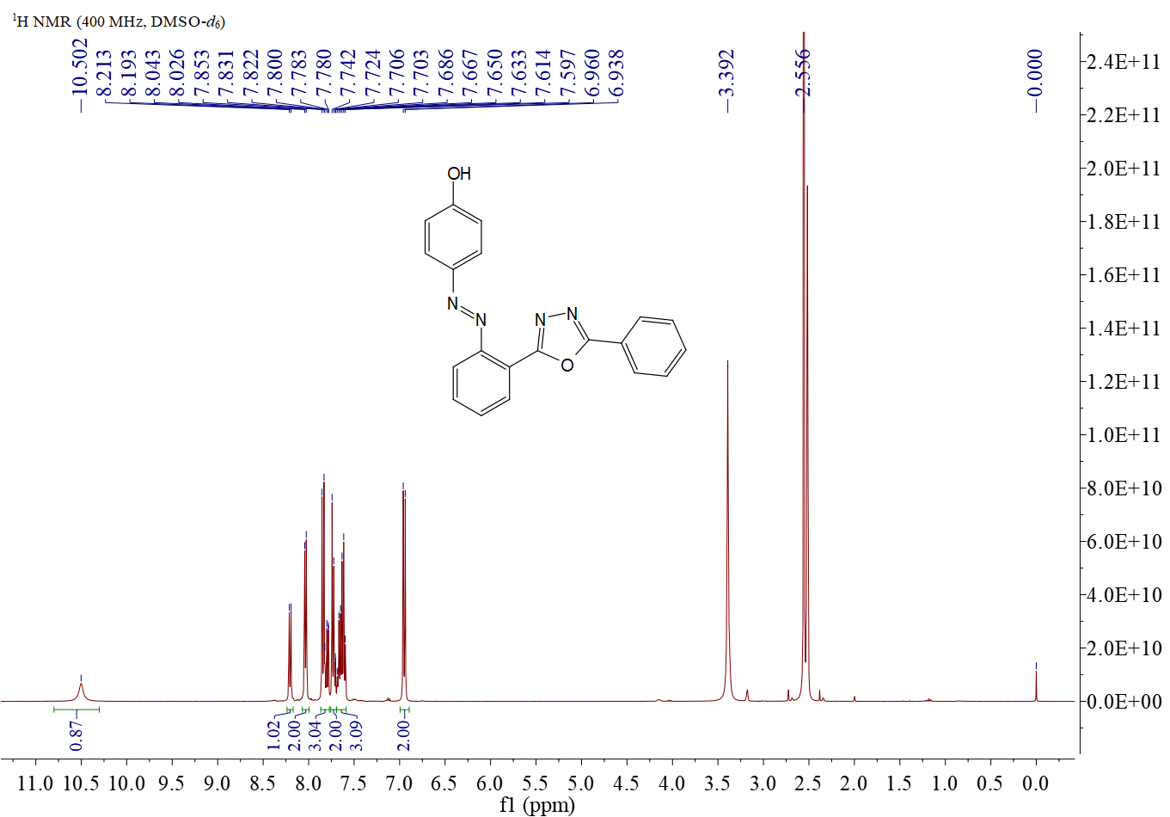
Figure S1. ¹H NMR spectrum of compound 5aa
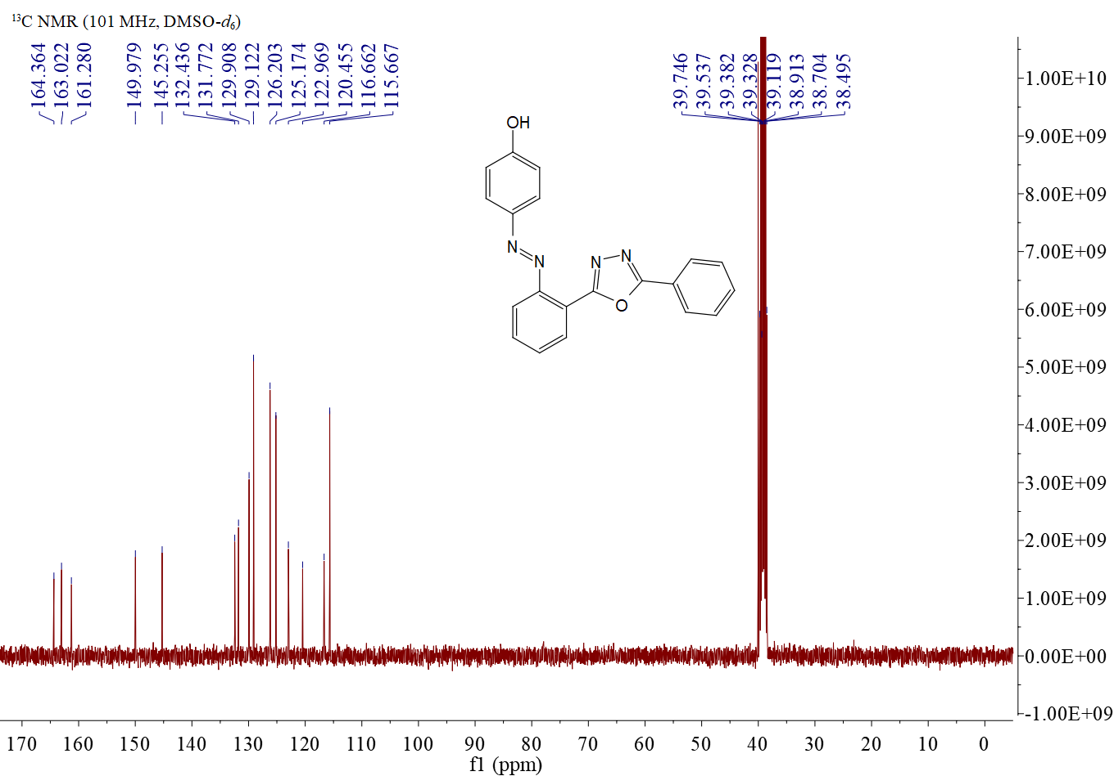
Figure S2. ¹³C NMR spectrum of compound 5aa

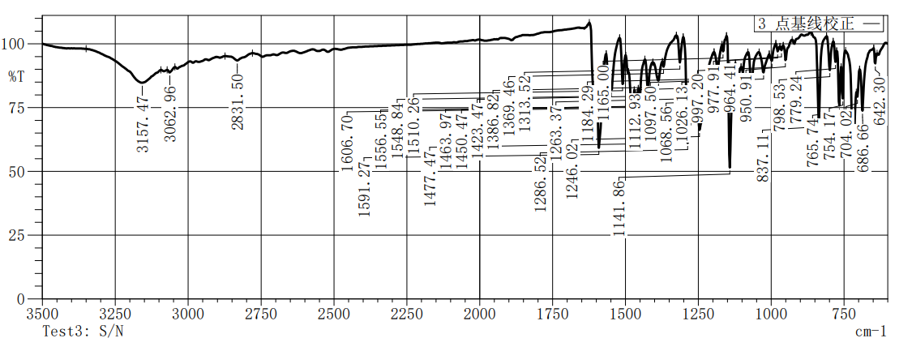
Figure S3.IR spectrum of compound 5aa

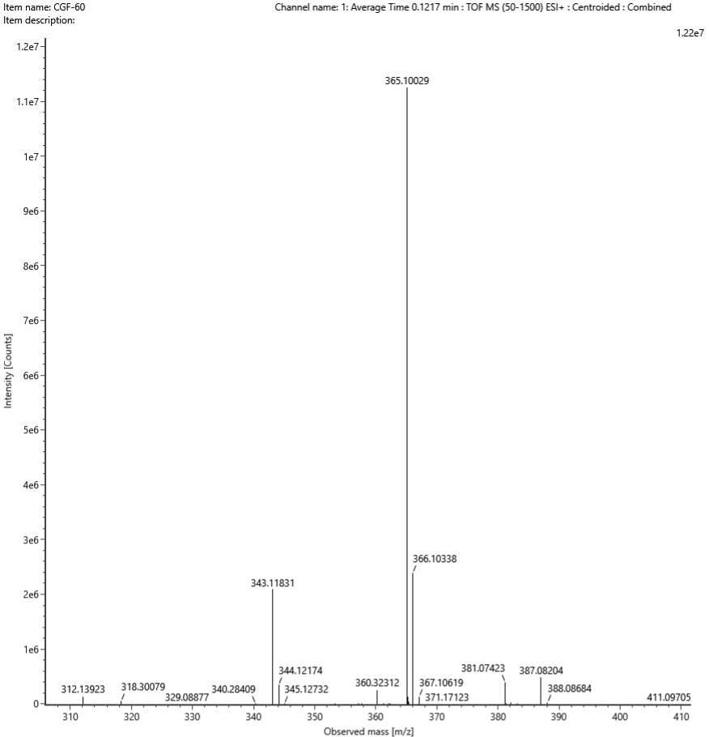
Figure S4. HRMS spectrum of compound 5aa
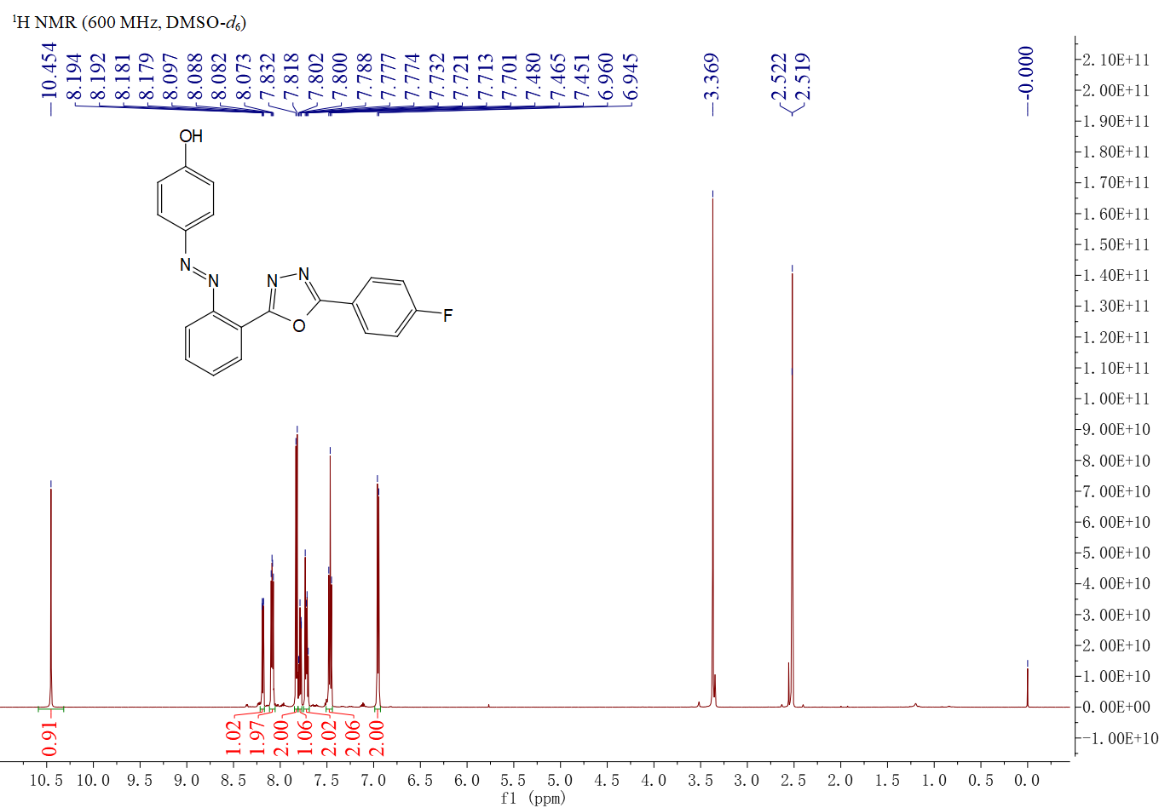
Figure S5. ¹H NMR spectrum of compound 5ab

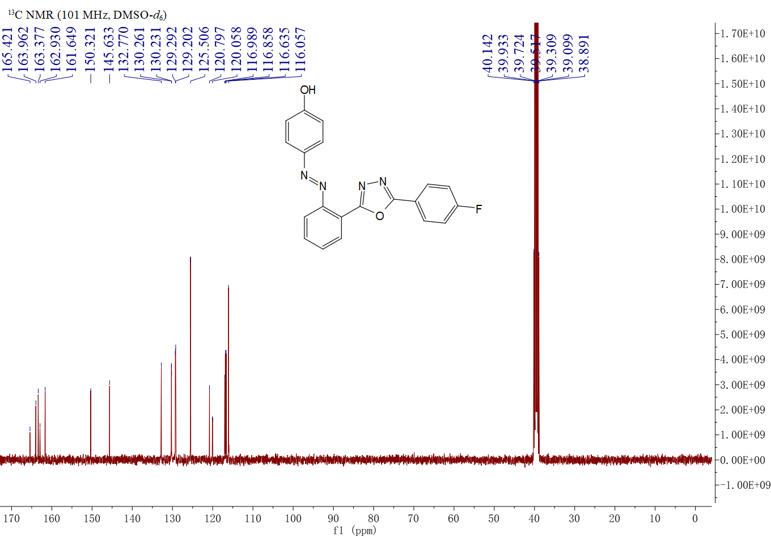
Figure S6. ¹³C NMR spectrum of compound 5ab

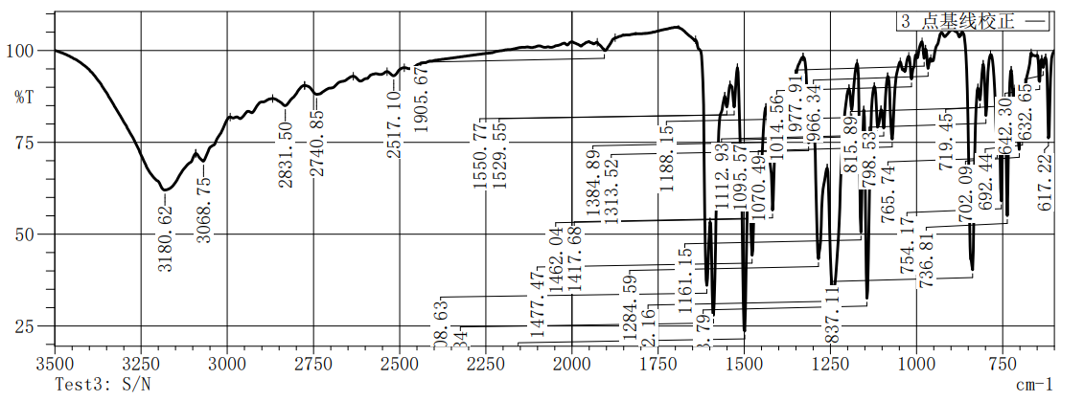
Figure S7.IR spectrum of compound 5ab

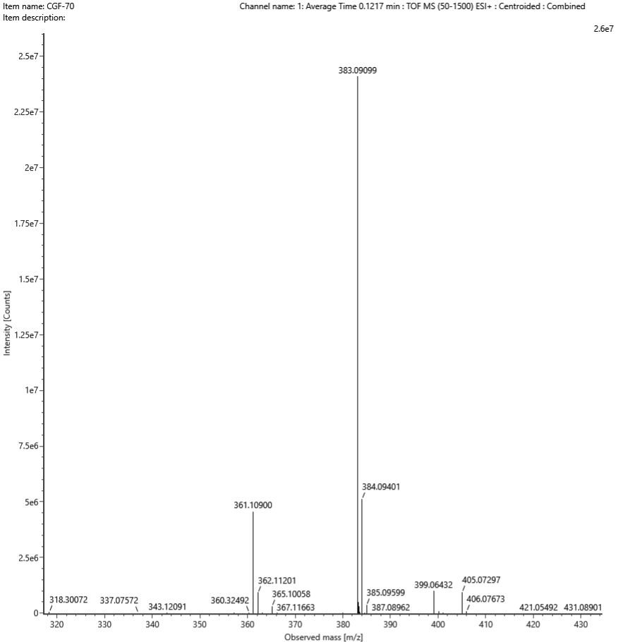
Figure S8. HRMS spectrum of compound 5ab

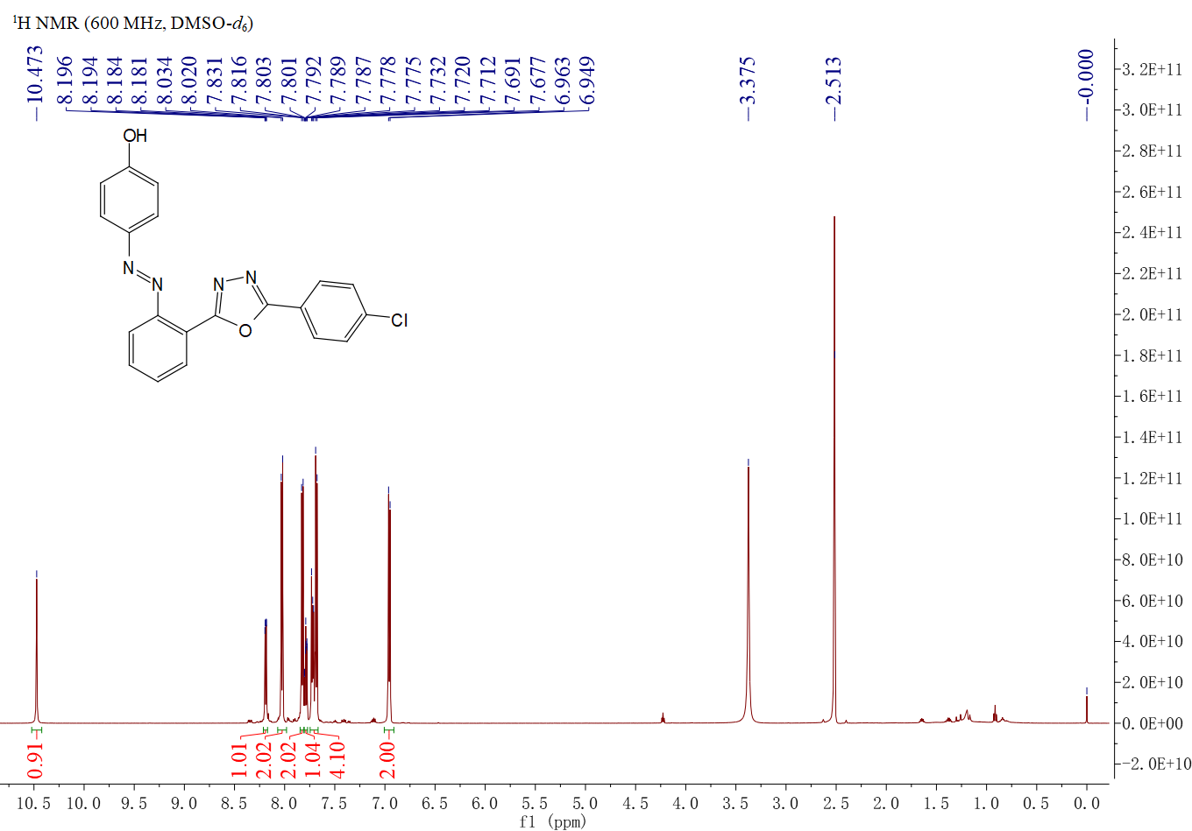
Figure S9. ¹H NMR spectrum of compound 5ac
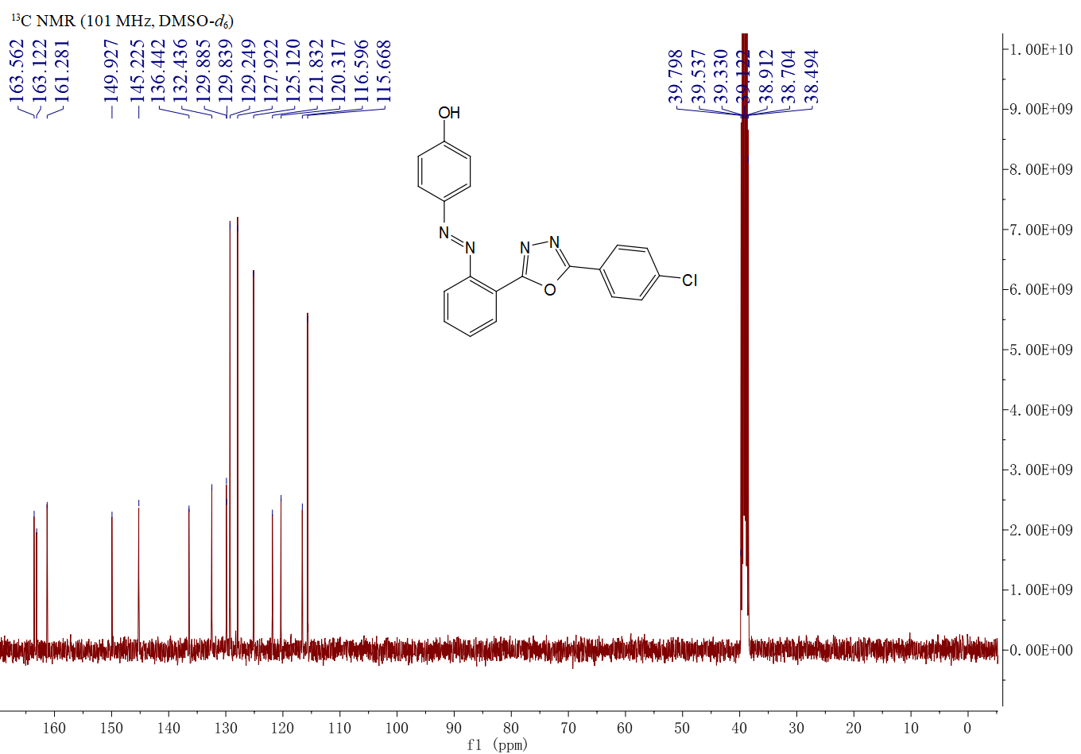
Figure S10. ¹³C NMR spectrum of compound 5ac

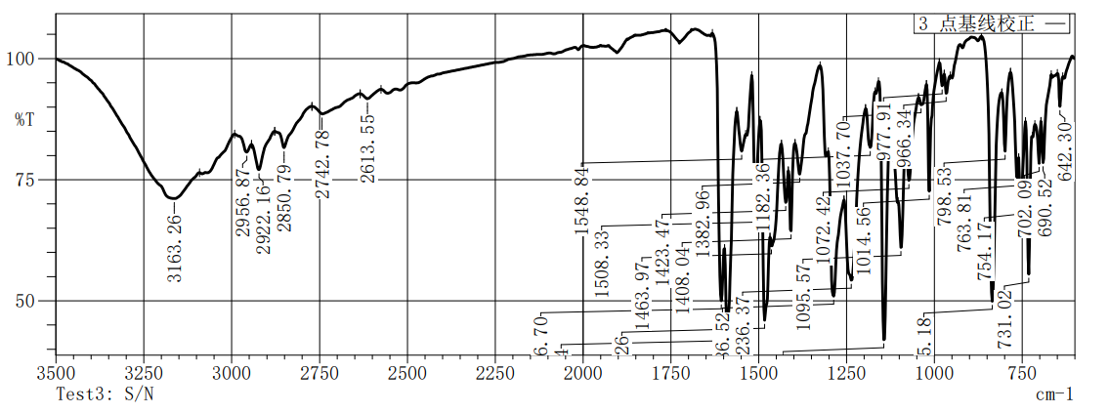
Figure S11.IR spectrum of compound 5ac

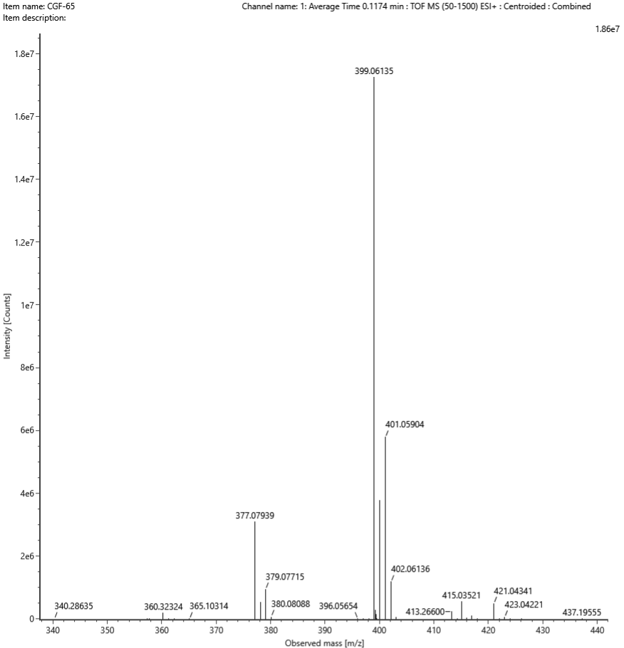
Figure S12. HRMS spectrum of compound 5ac
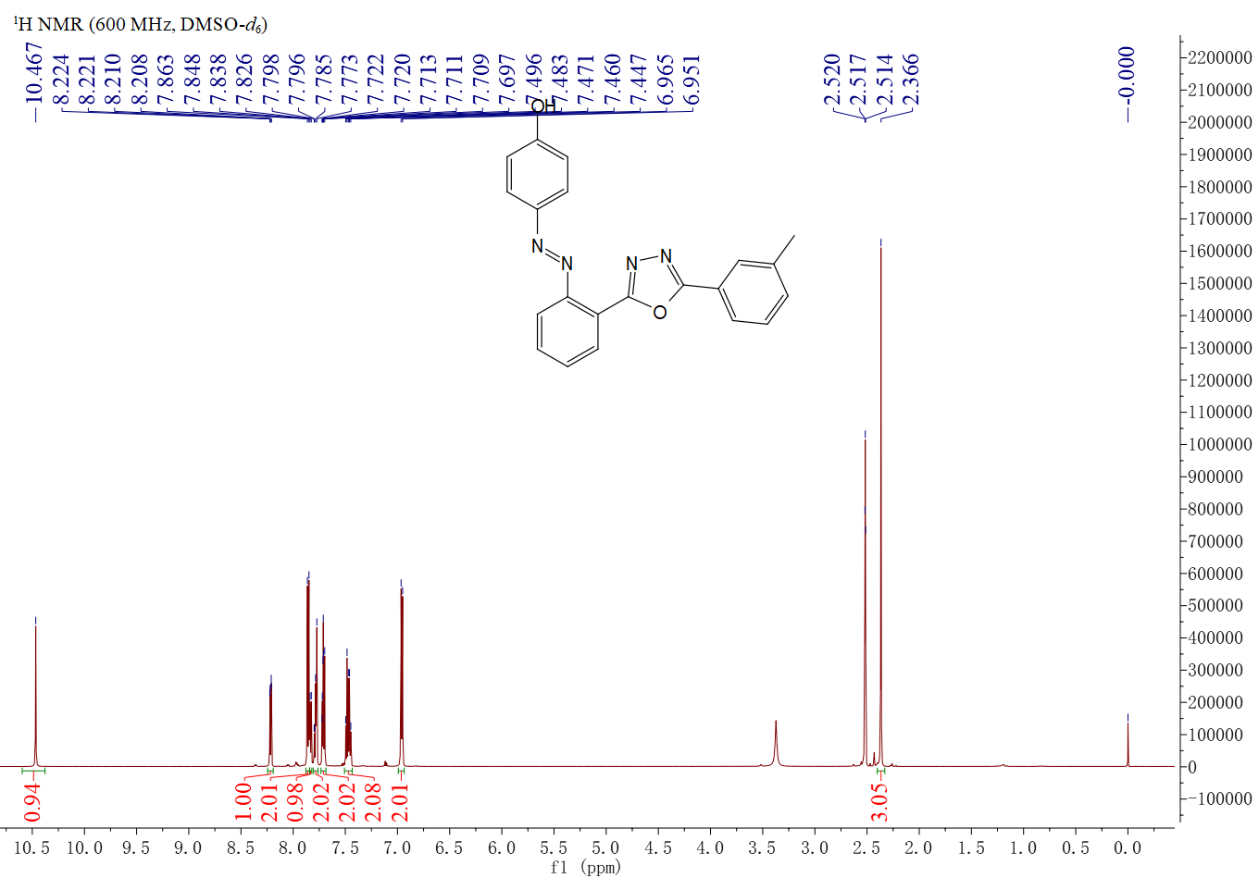
Figure S13. ¹H NMR spectrum of compound 5ad

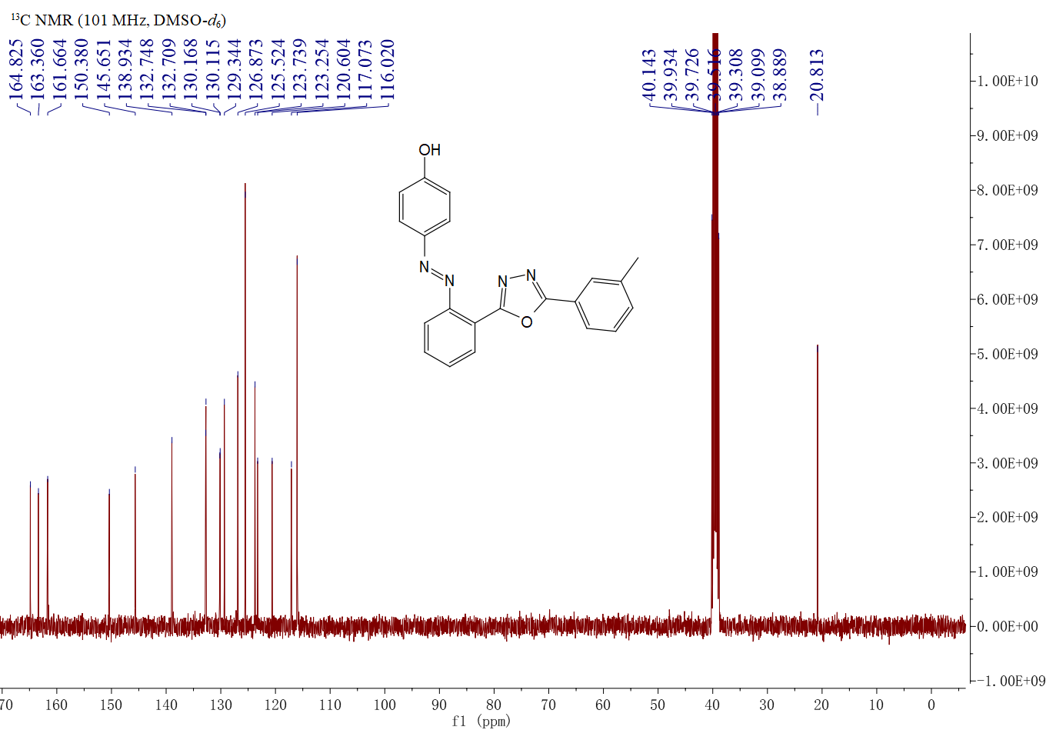
Figure S14. ¹³C NMR spectrum of compound 5ad

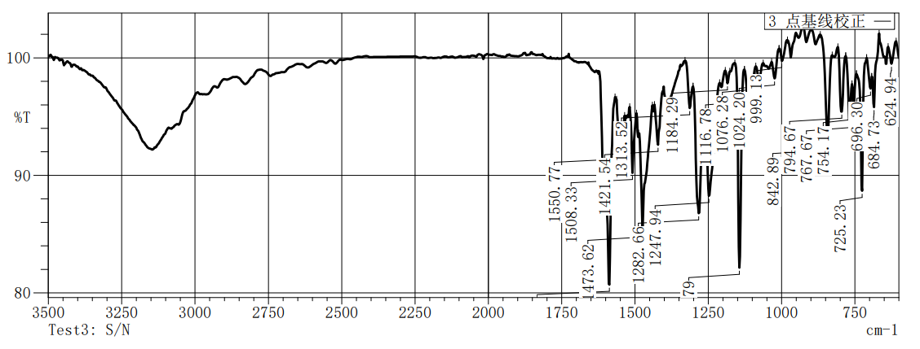
Figure S15.IR spectrum of compound 5ad

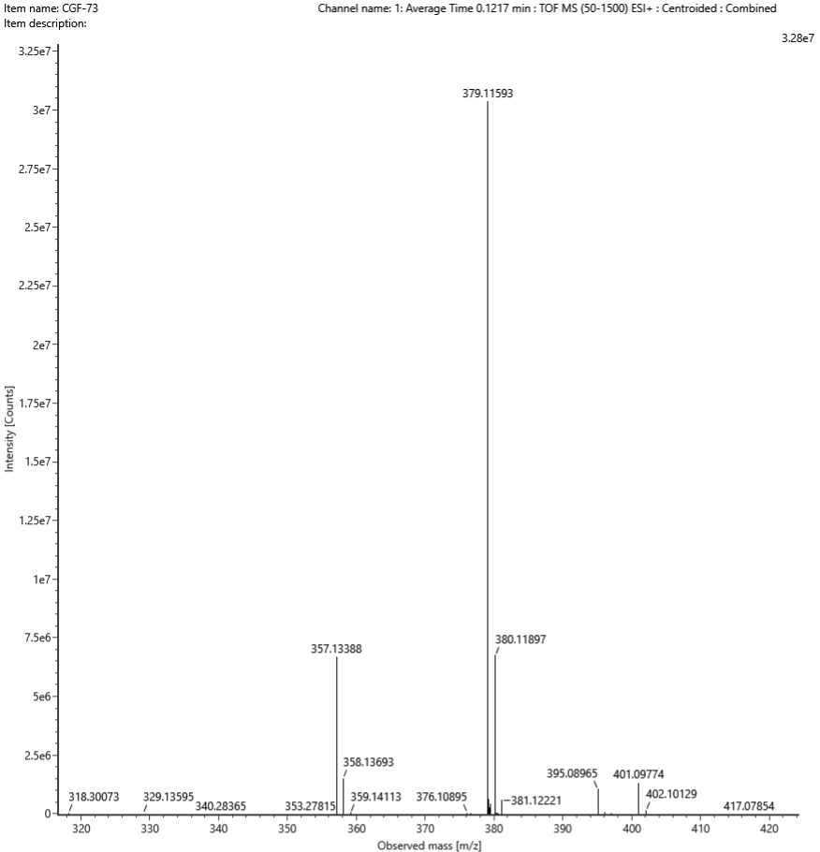
Figure S16. HRMS spectrum of compound 5ad

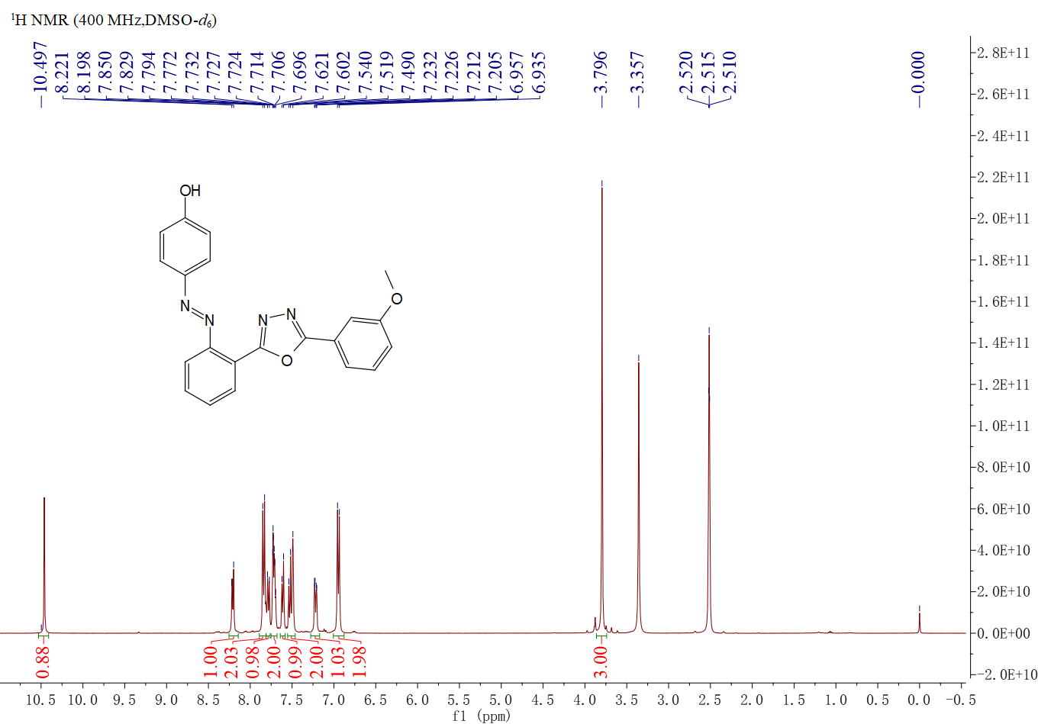
Figure S17. ¹H NMR spectrum of compound 5ae
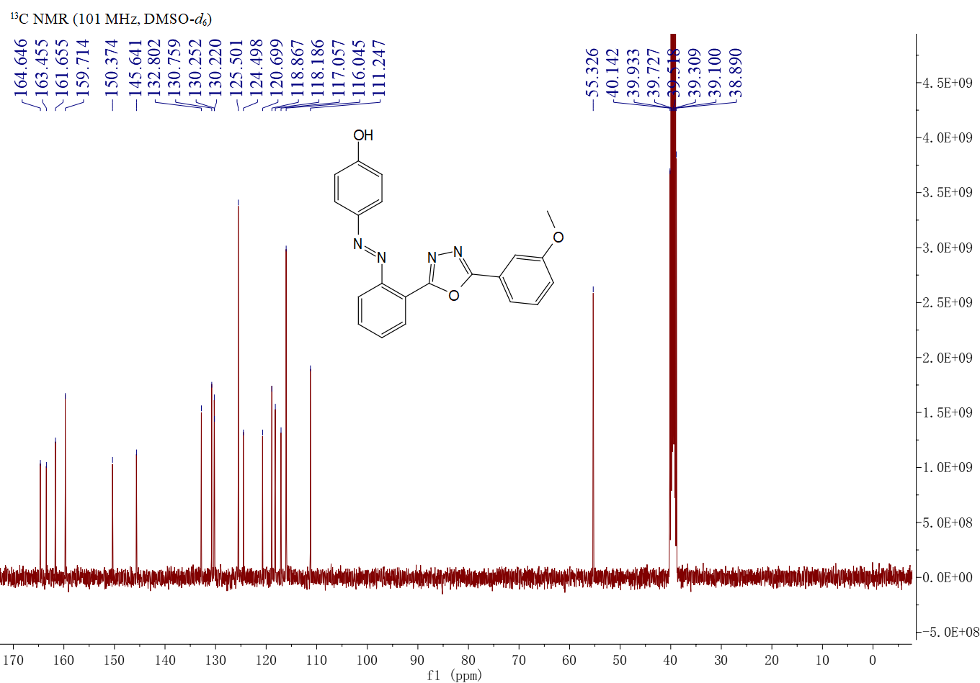
Figure S18. ¹³C NMR spectrum of compound 5ae

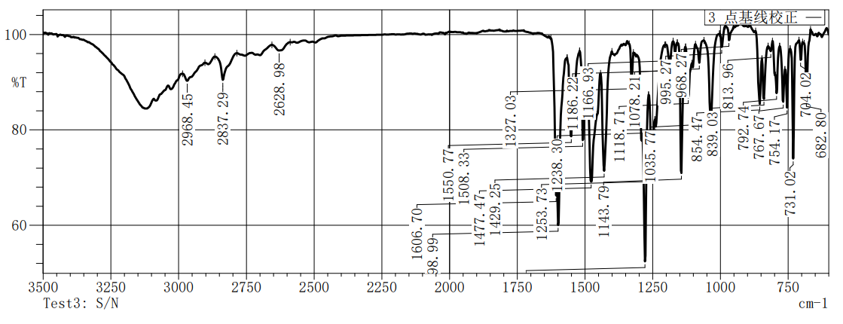Figure S19.IR spectrum of compound 5ae

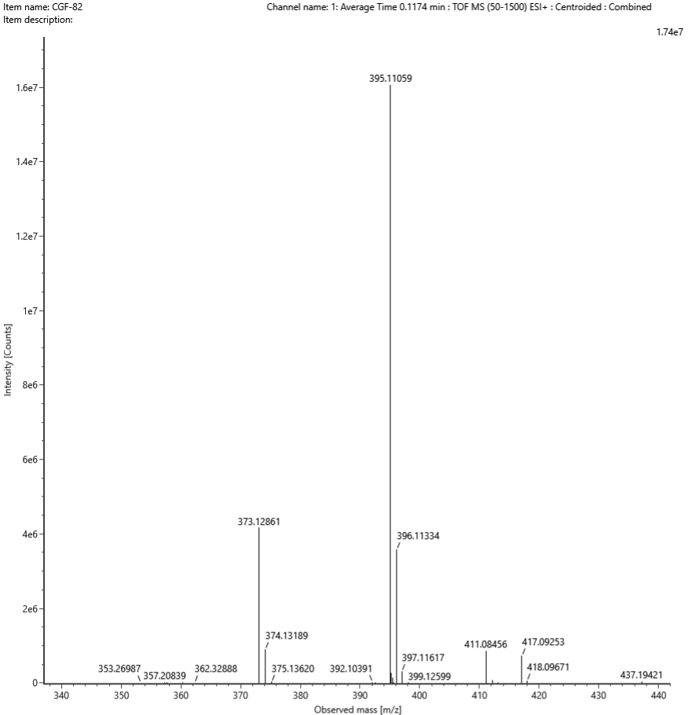
Figure S20. HRMS spectrum of compound 5ae
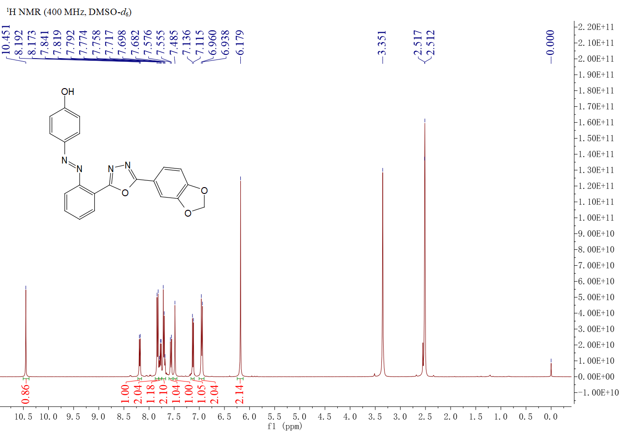
Figure S21. ¹H NMR spectrum of compound 5af

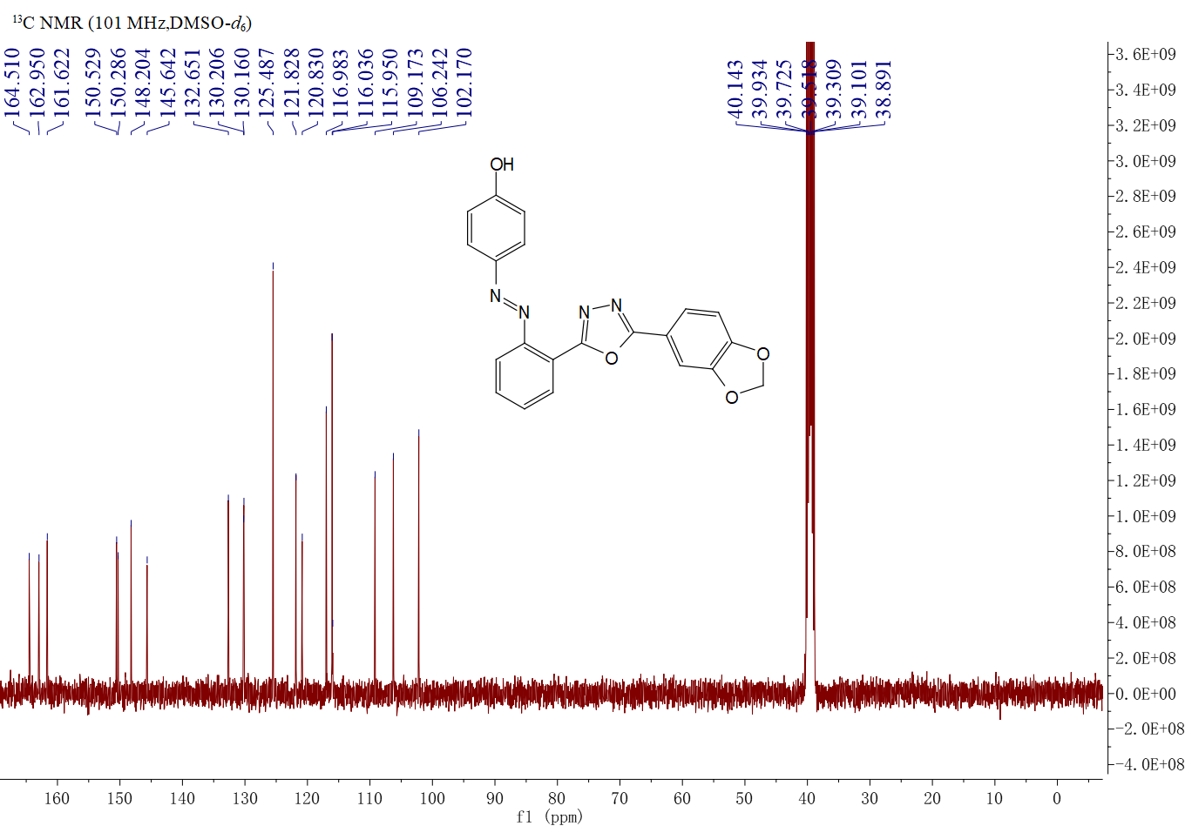
Figure S22. ¹³C NMR spectrum of compound 5af

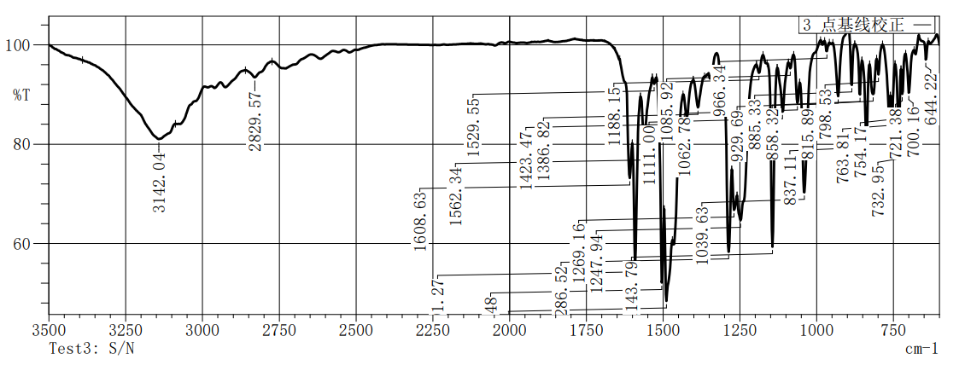
Figure S23.IR spectrum of compound 5af
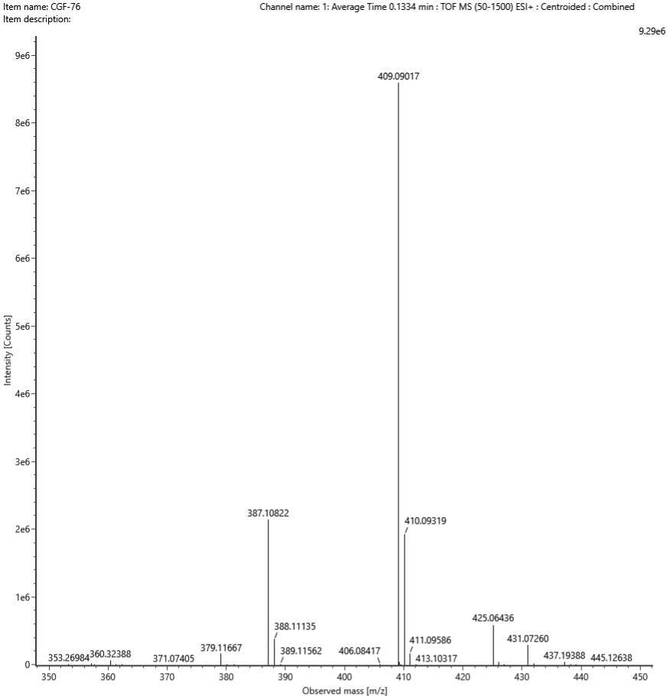
Figure S24. HRMS spectrum of compound 5af
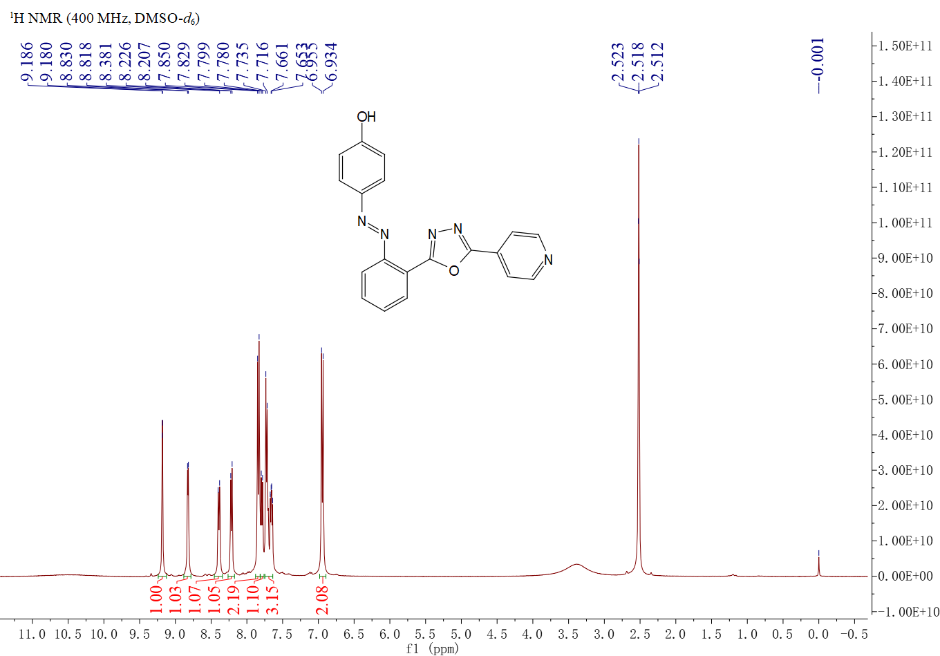
Figure S25. ¹H NMR spectrum of compound 5ag
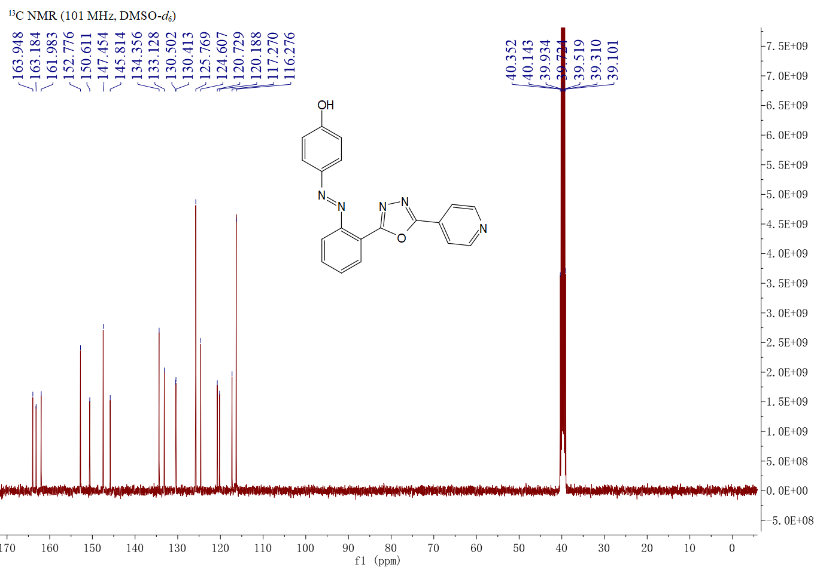
Figure S26. ¹³C NMR spectrum of compound 5ag

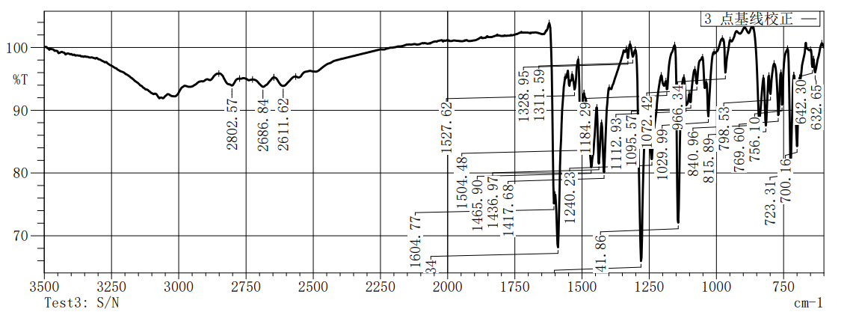
Figure S27.IR spectrum of compound 5ag

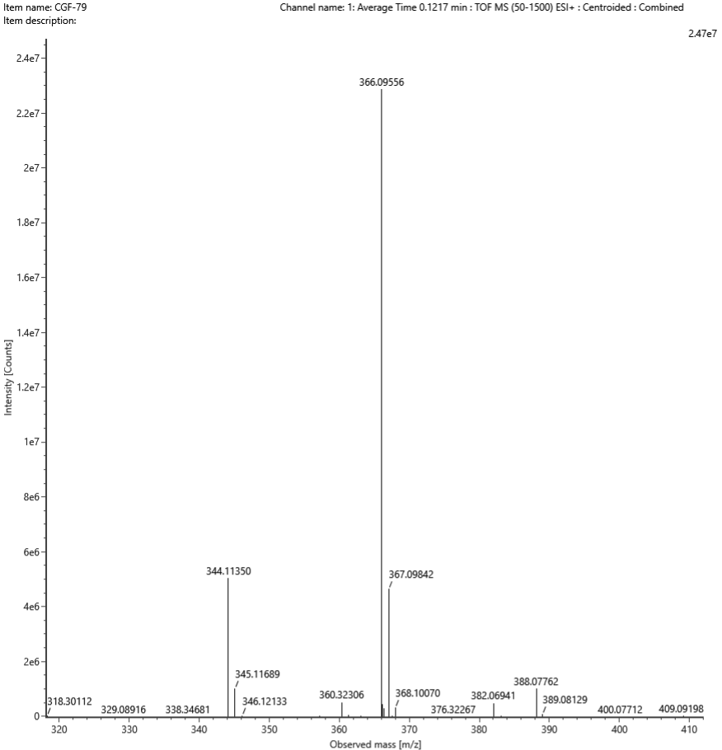
Figure S28. HRMS spectrum of compound 5ag
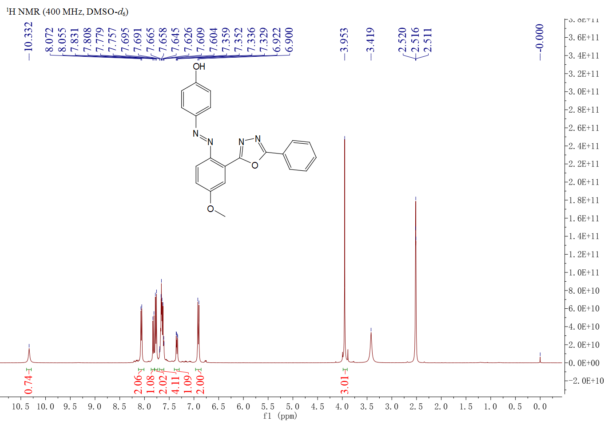
Figure S29. ¹H NMR spectrum of compound 5ba

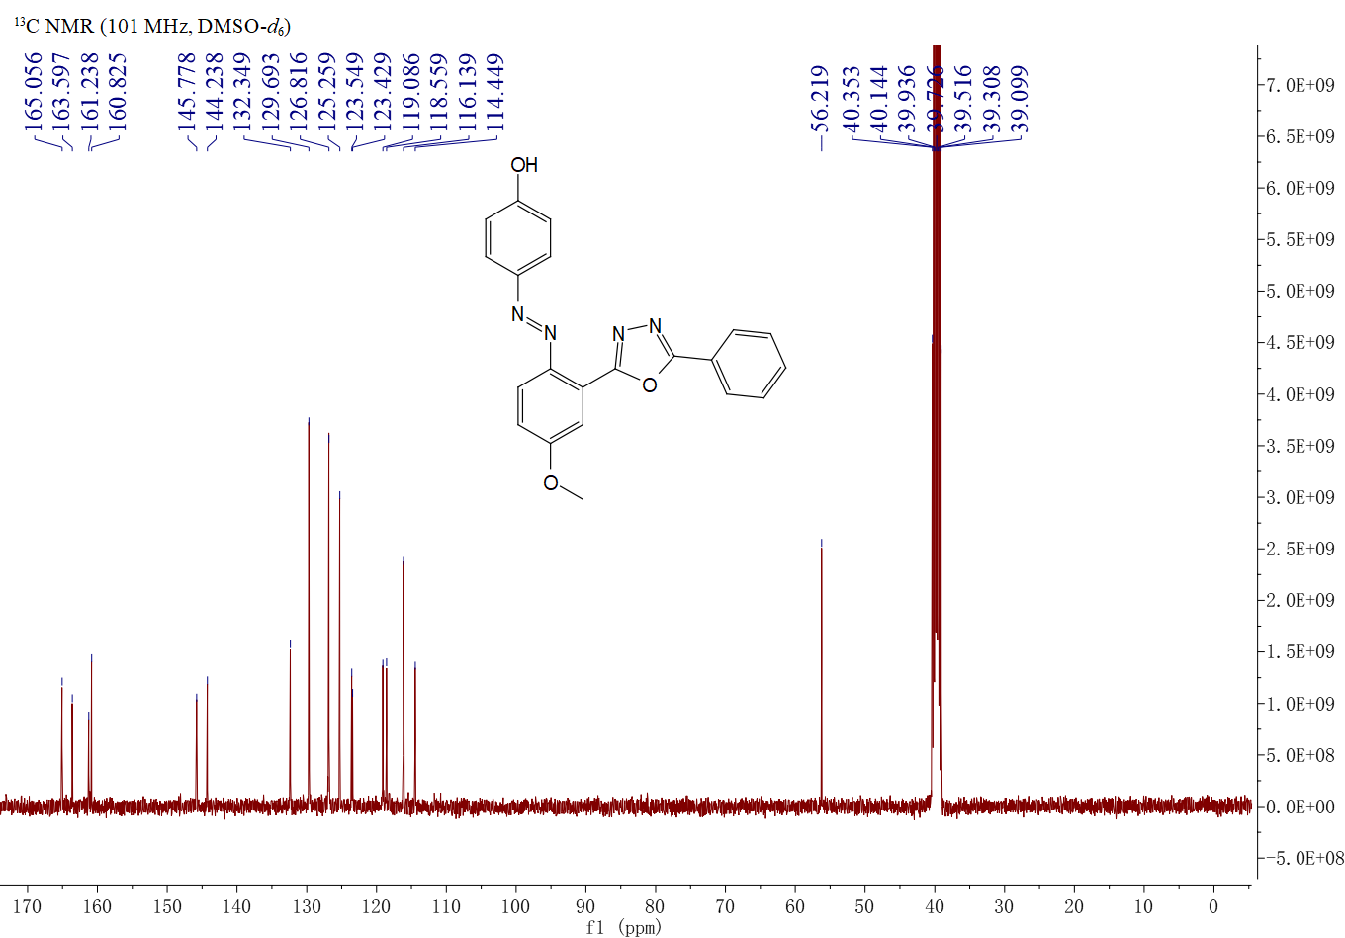
Figure S30. ¹³C NMR spectrum of compound 5ba

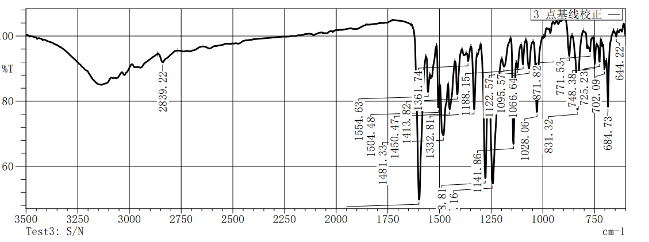
Figure S31.IR spectrum of compound 5ba
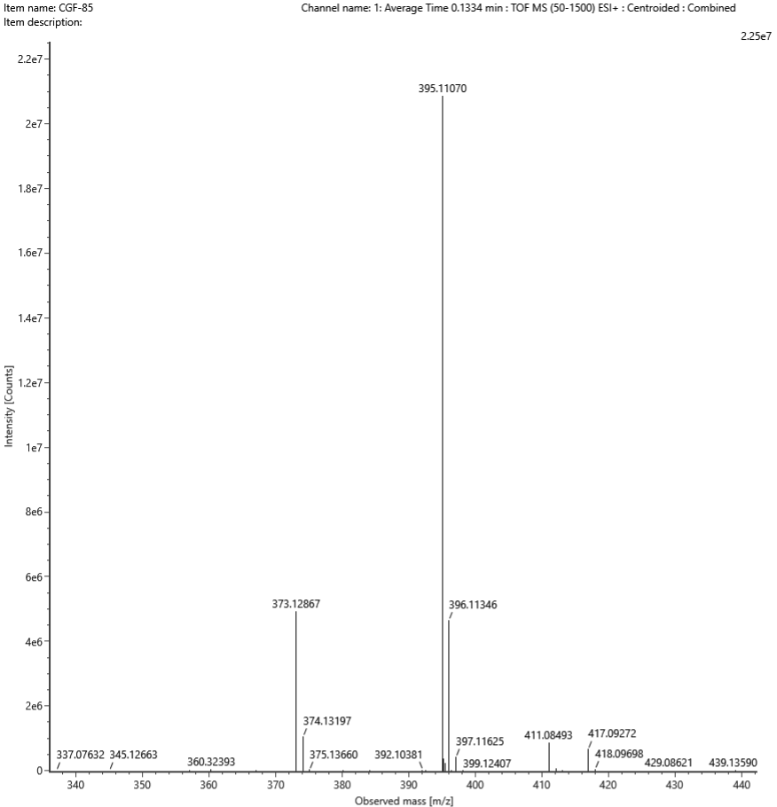
Figure S32.HRMS spectrum of compound 5ba

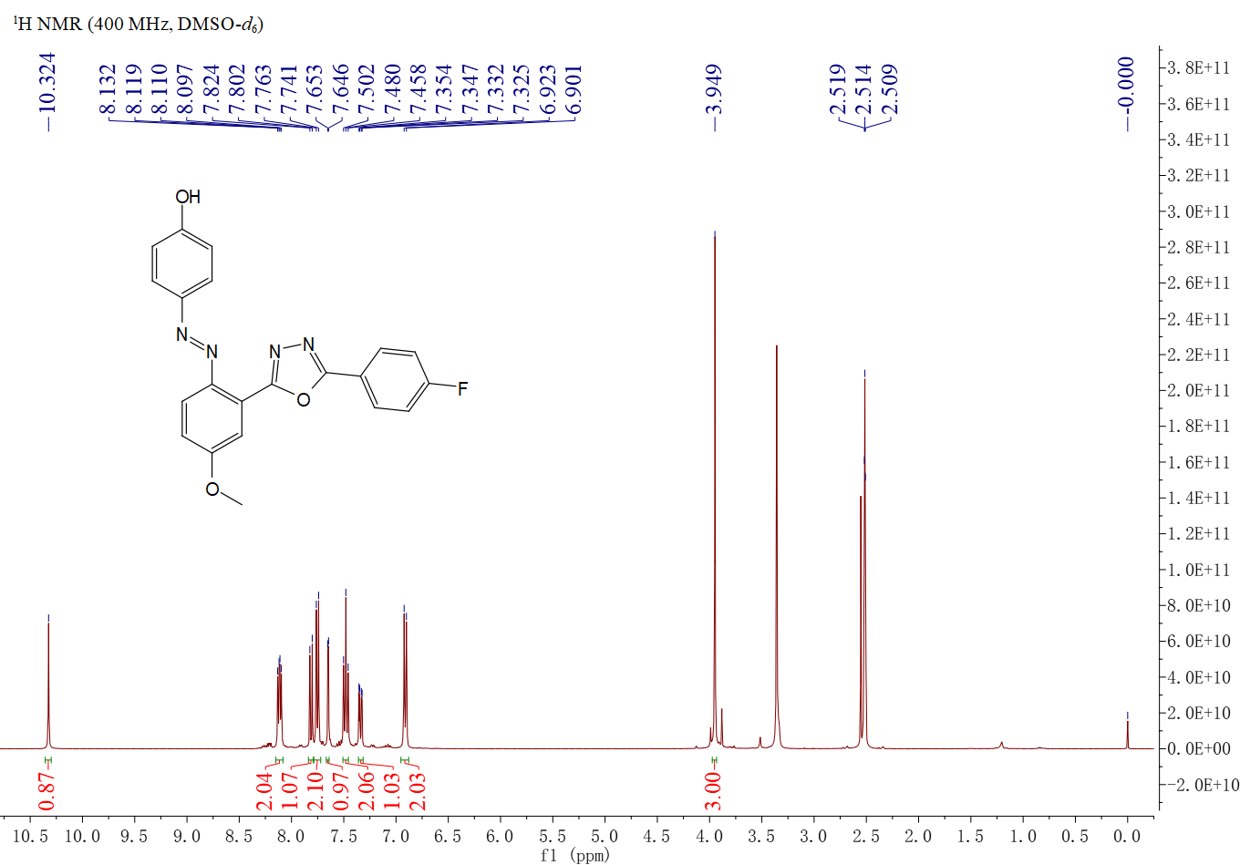
Figure S33. ¹H NMR spectrum of compound 5bb
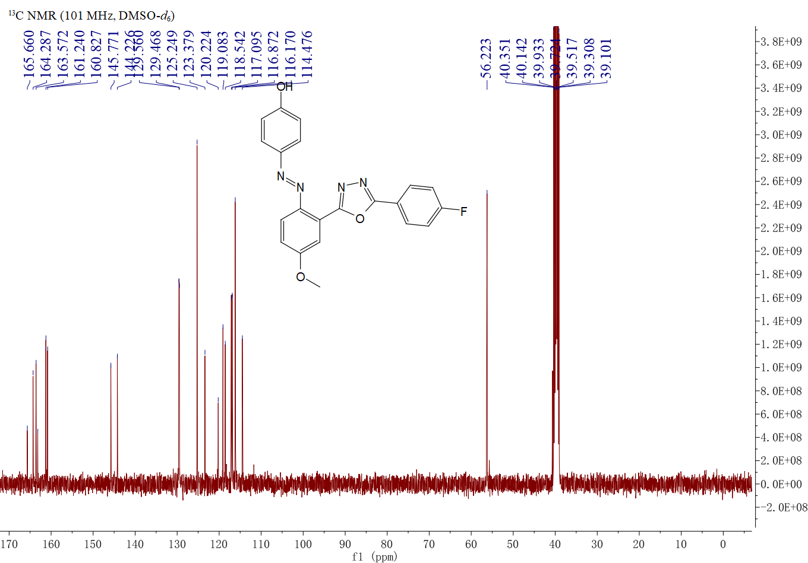
Figure S34. ¹³C NMR spectrum of compound 5bb

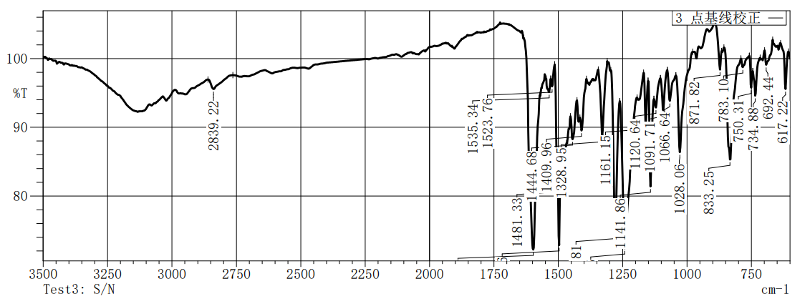
Figure S35.IR spectrum of compound 5bb

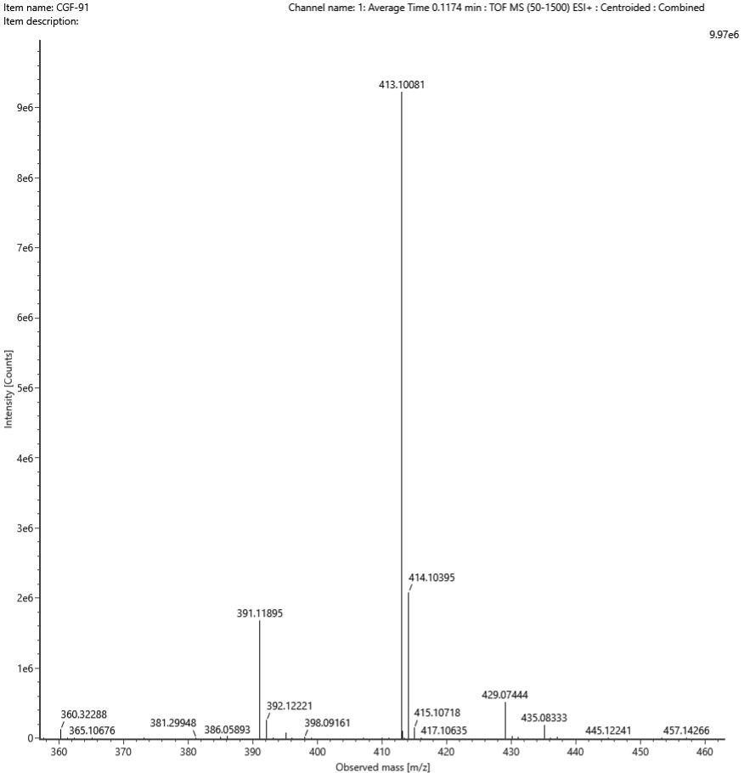
Figure S36. HRMS spectrum of compound 5bb
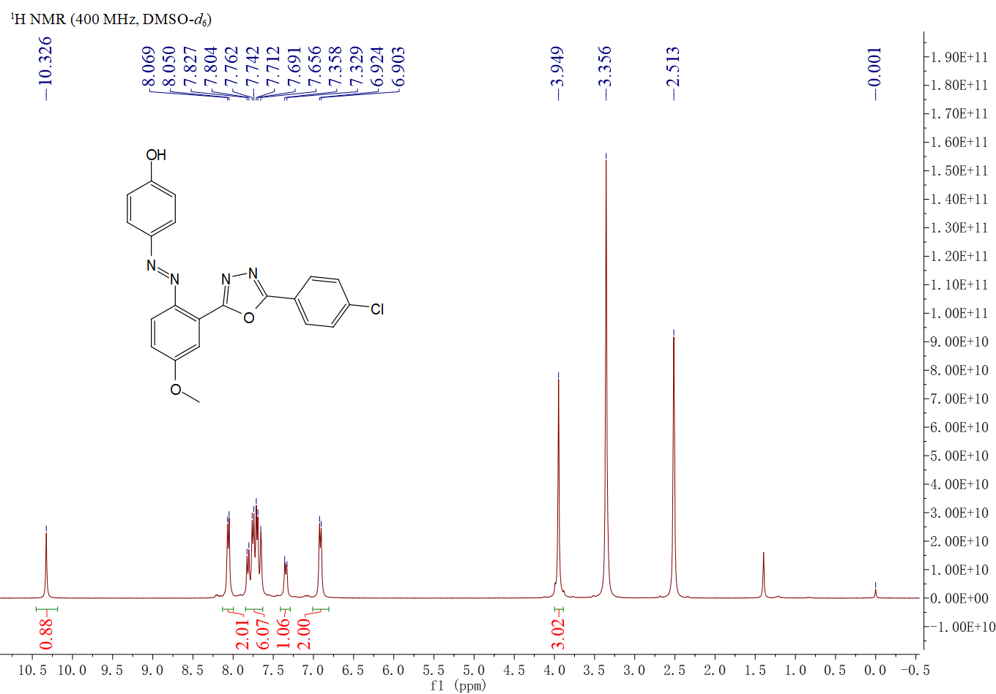
Figure S37. ¹H NMR spectrum of compound 5bc

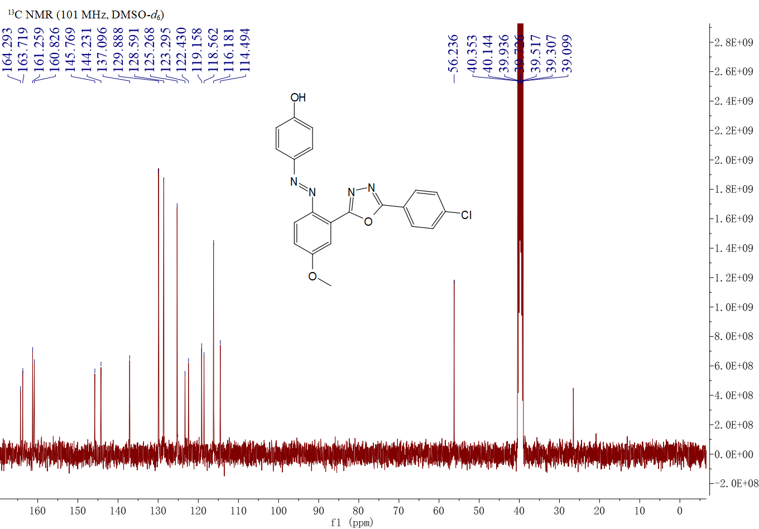
Figure S38. ¹³C NMR spectrum of compound 5bc

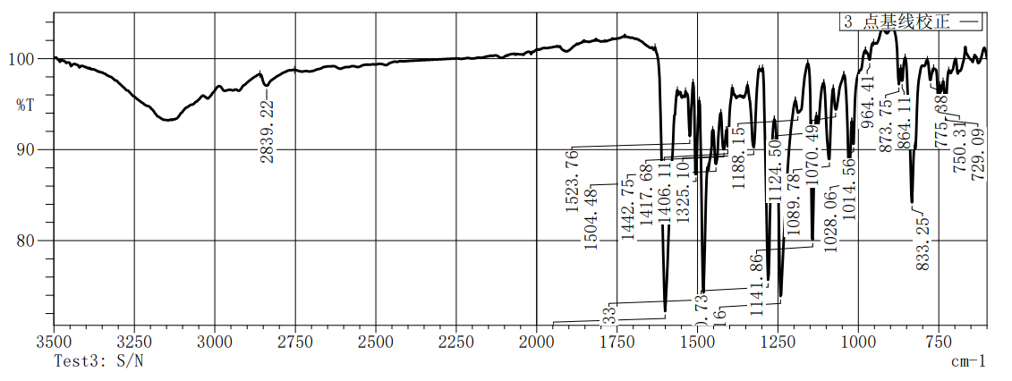
Figure S39.IR spectrum of compound 5bc

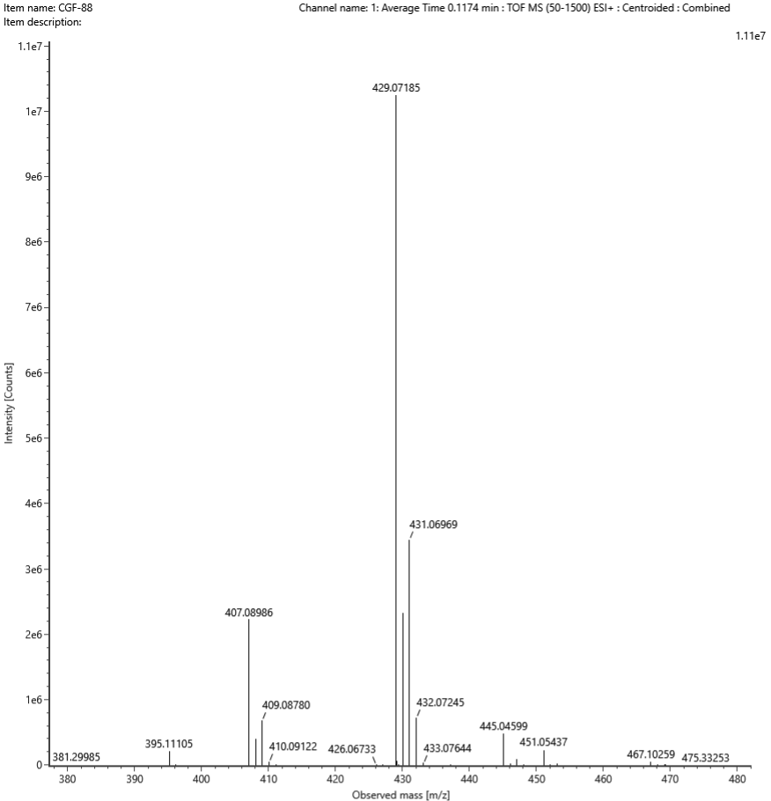
Figure S40. HRMS spectrum of compound 5bc

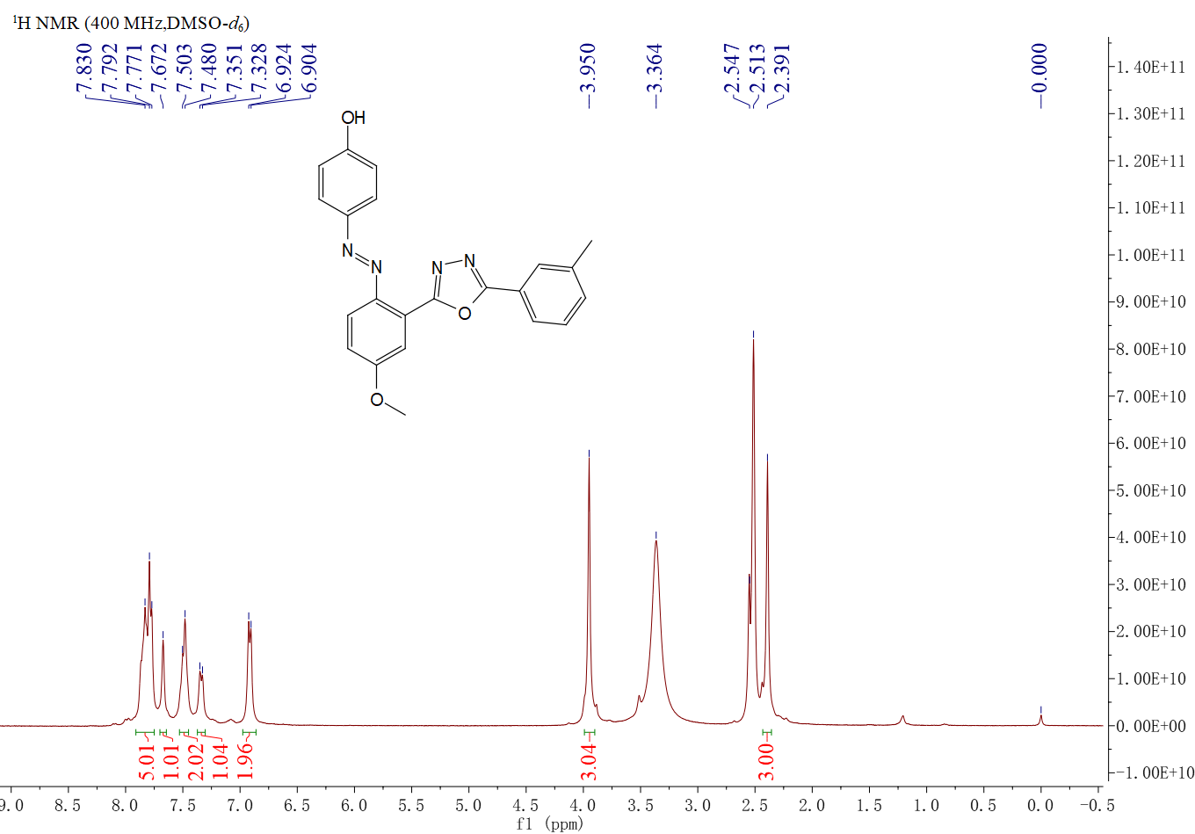
Figure S41. ¹H NMR spectrum of compound 5bd
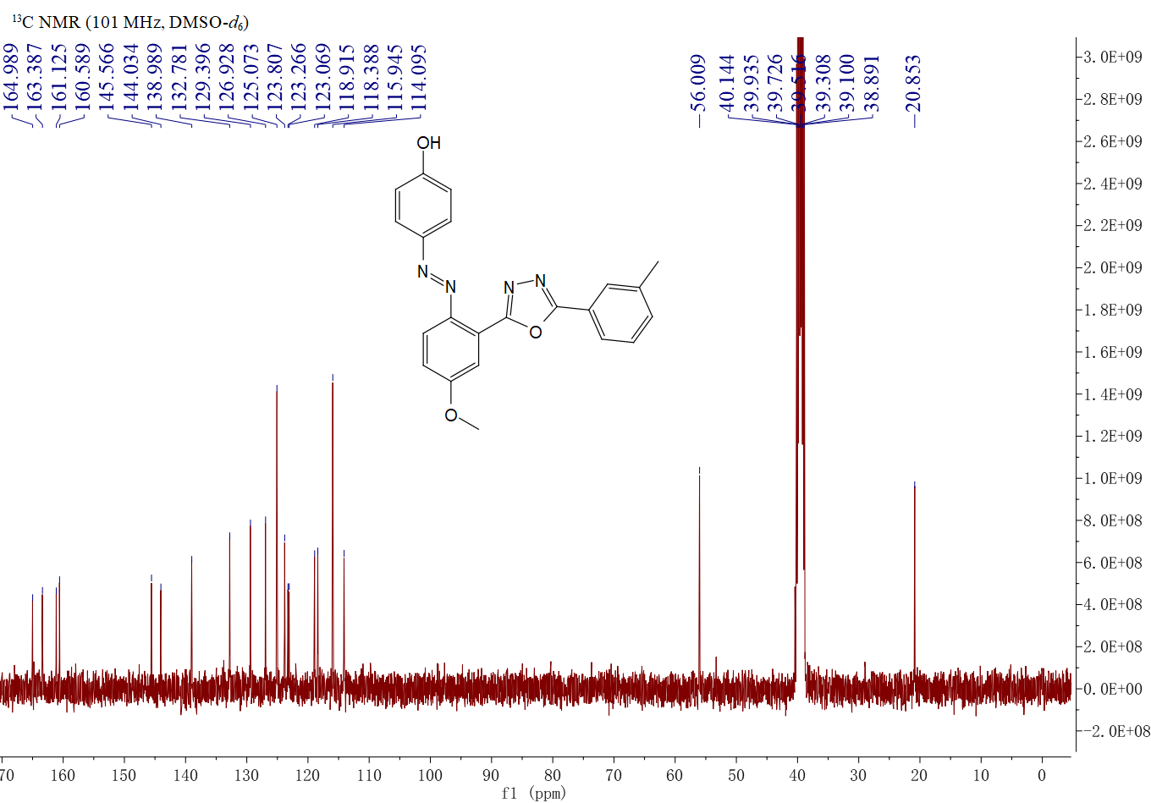
Figure S42. ¹³C NMR spectrum of compound 5bd

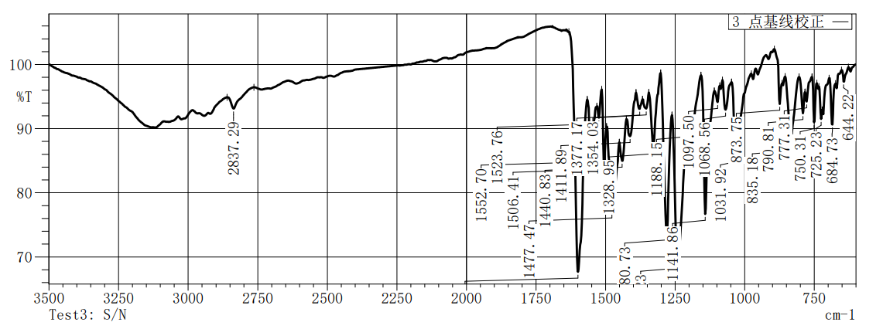
Figure S43.IR spectrum of compound 5bd

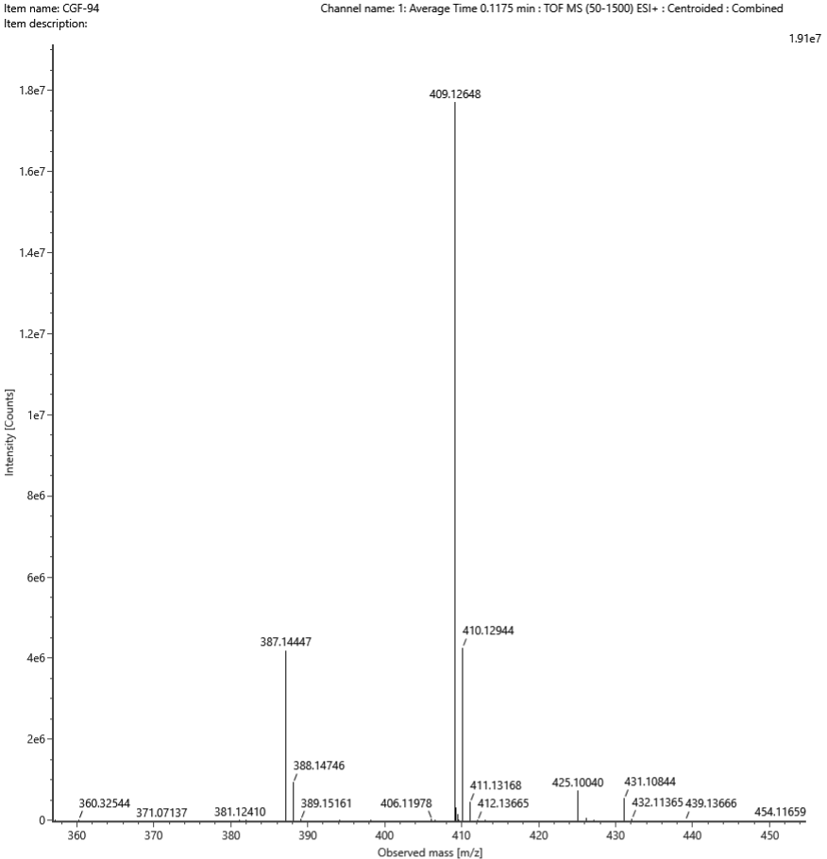
Figure S44. HRMS spectrum of compound 5bd
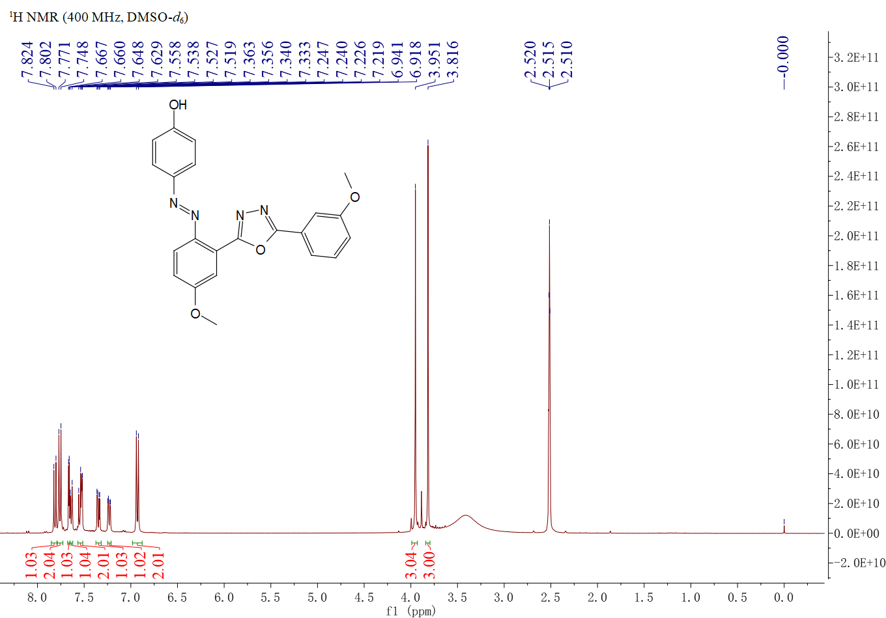
Figure S45. ¹H NMR spectrum of compound 5be

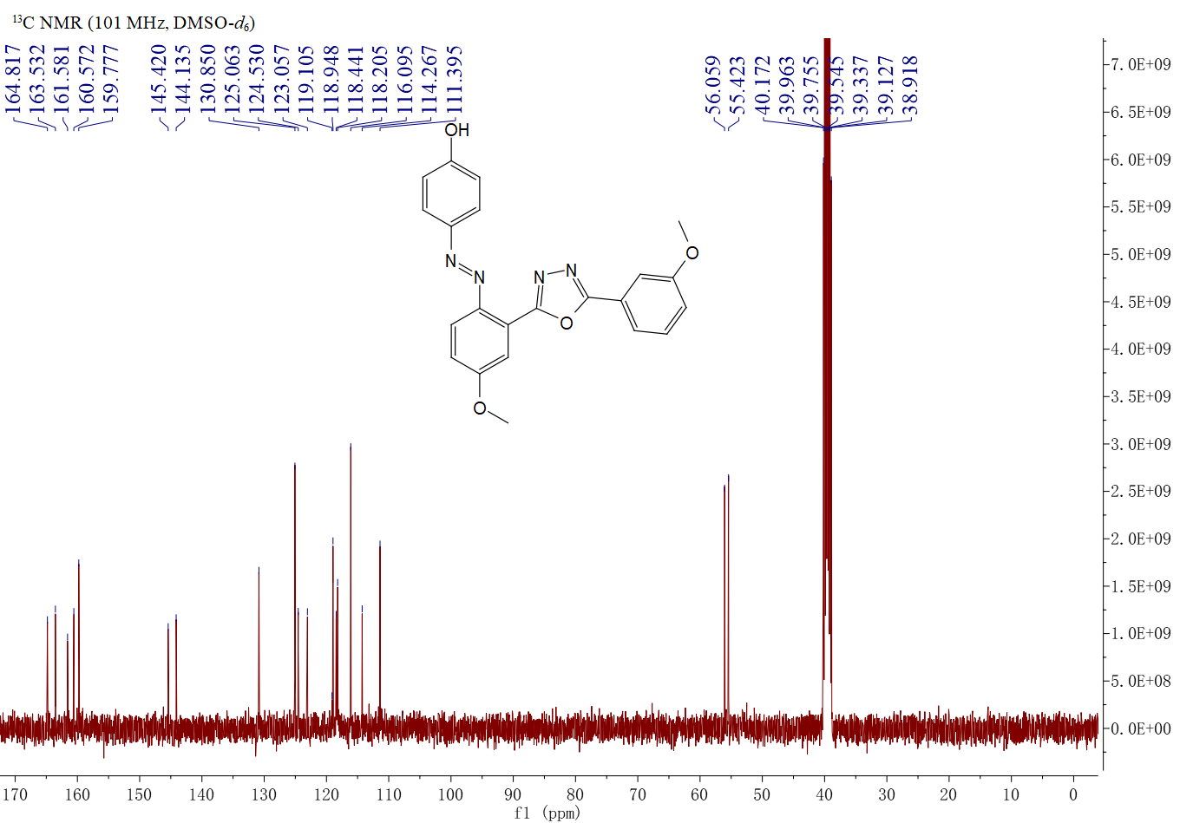
Figure S46. ¹³C NMR spectrum of compound 5be

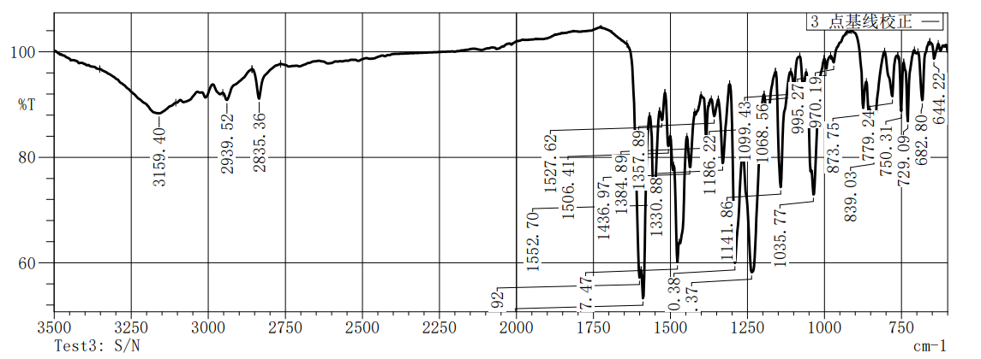
Figure S47.IR spectrum of compound 5be

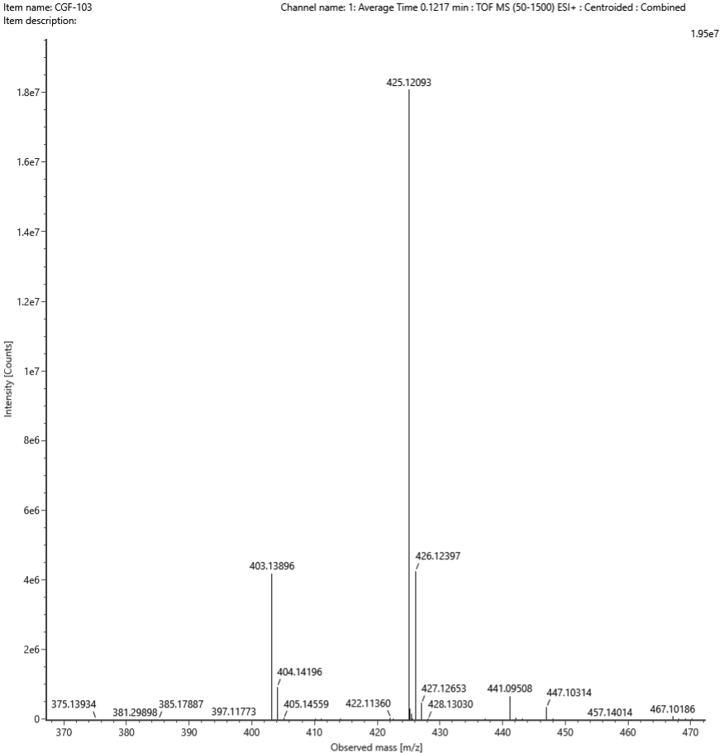
Figure S48. HRMS spectrum of compound 5be

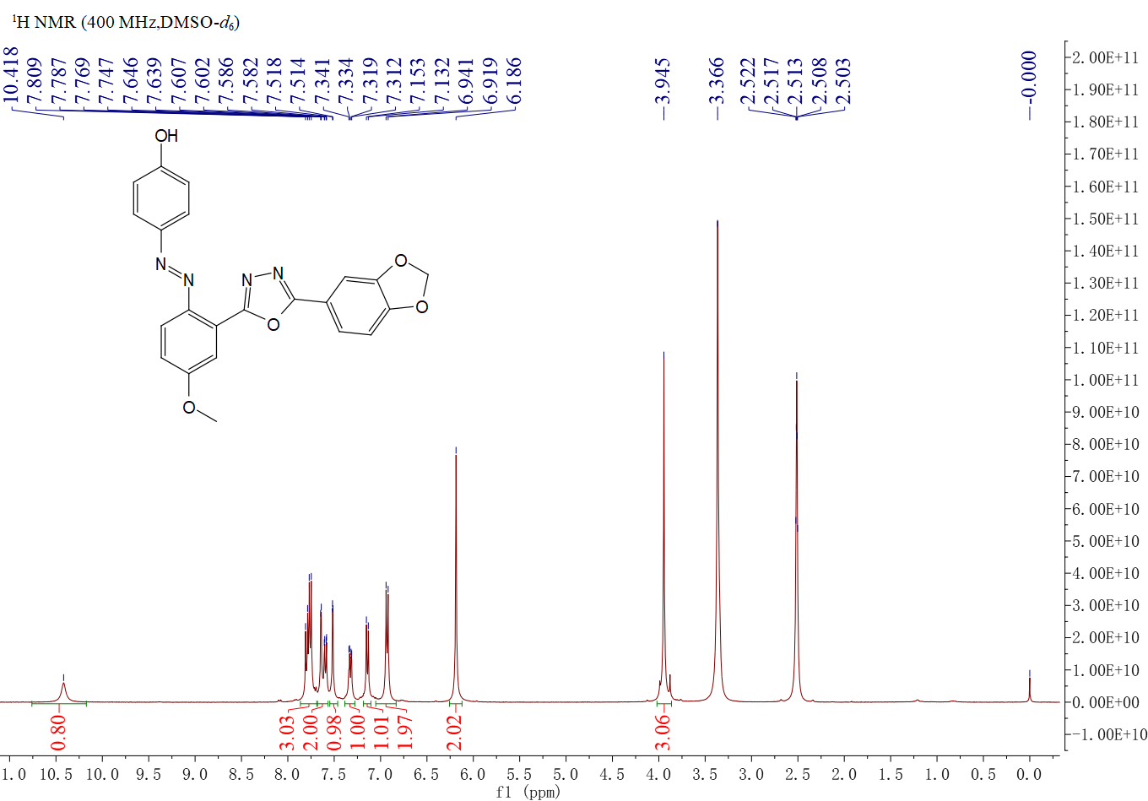
Figure S49. ¹H NMR spectrum of compound 5bf
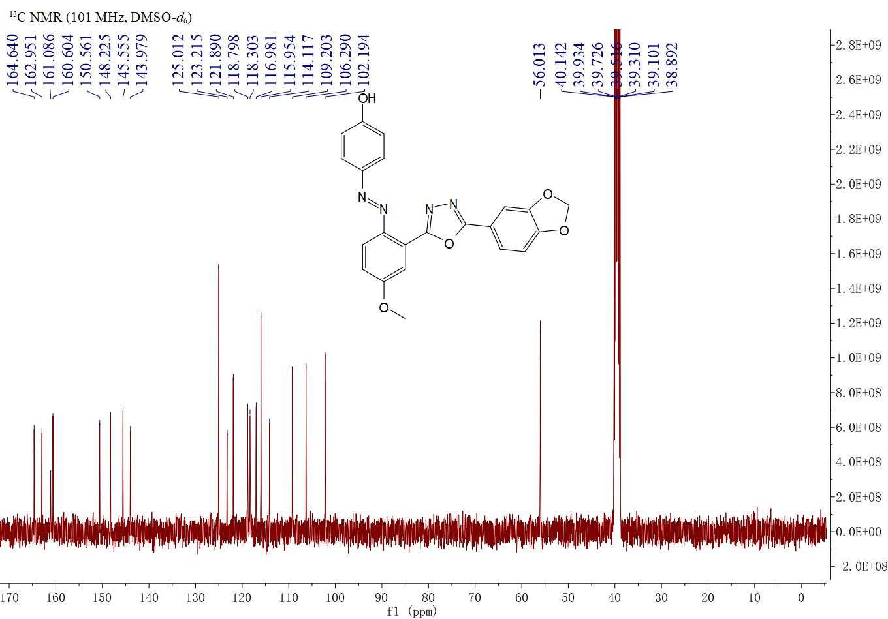
Figure S50. ¹³C NMR spectrum of compound 5bf

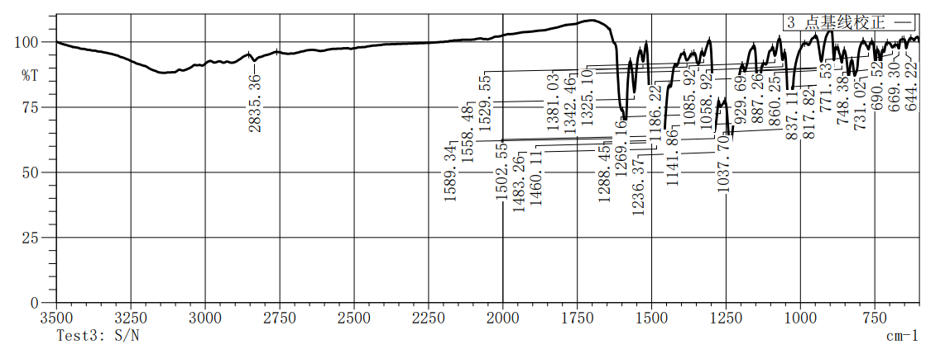
Figure S51.IR spectrum of compound 5bf

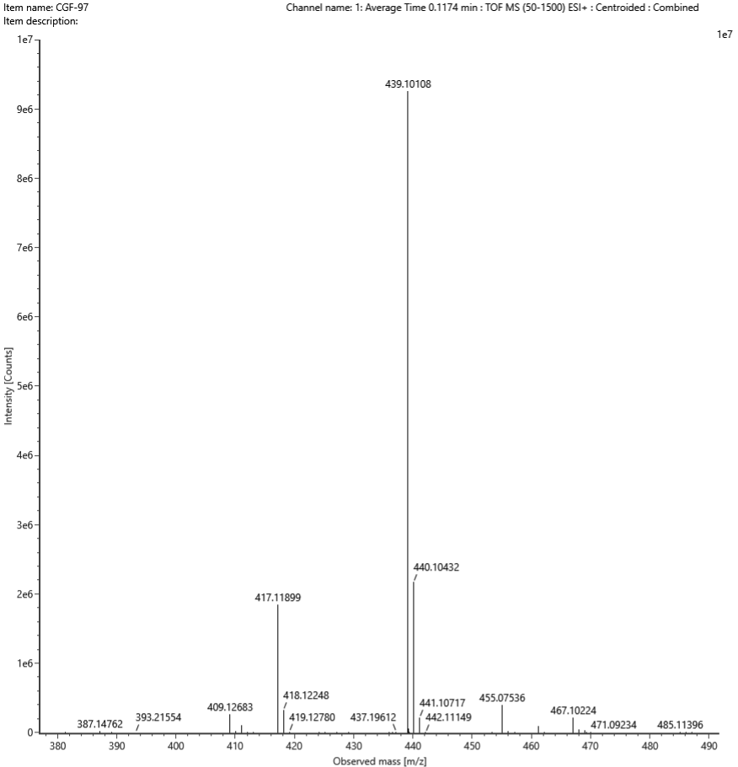
Figure S52. HRMS spectrum of compound 5bf
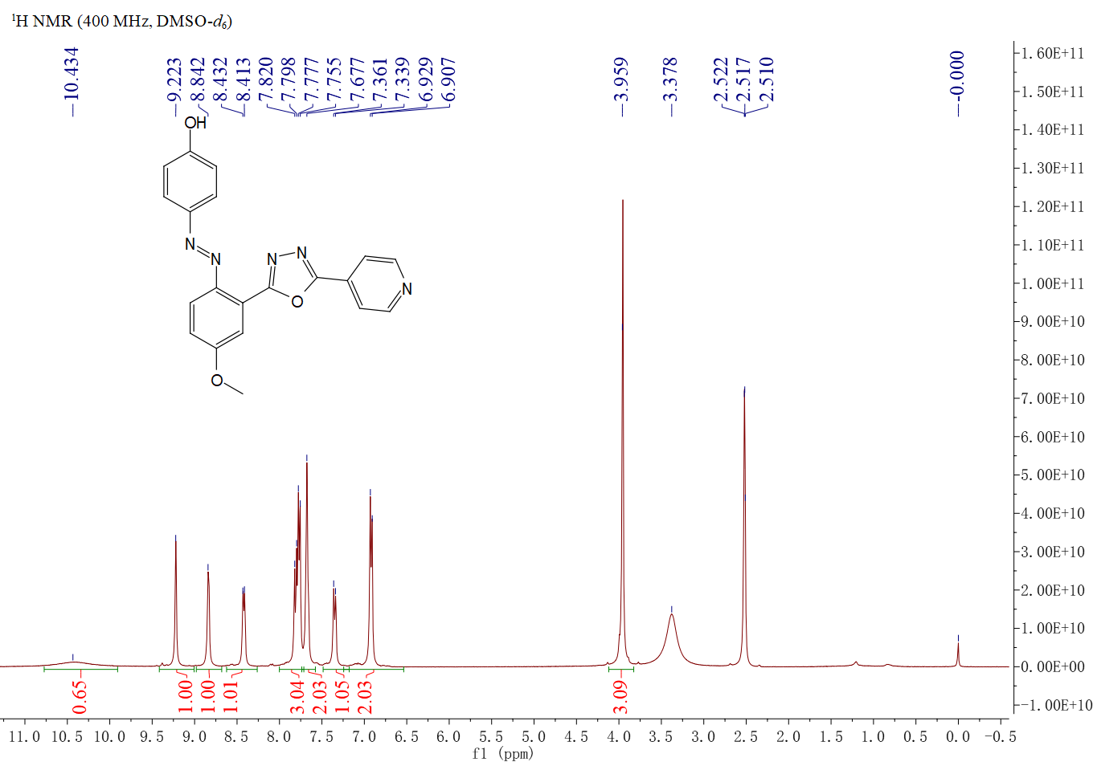
Figure S53. ¹H NMR spectrum of compound 5bg

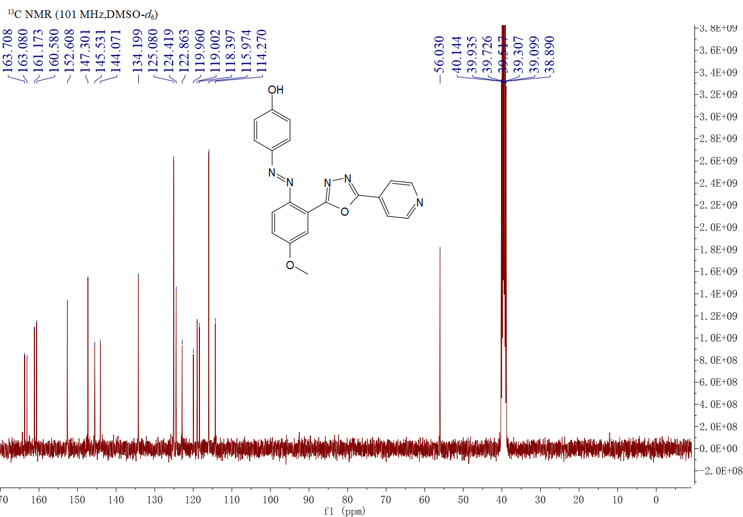
Figure S54. ¹³C NMR spectrum of compound 5bg

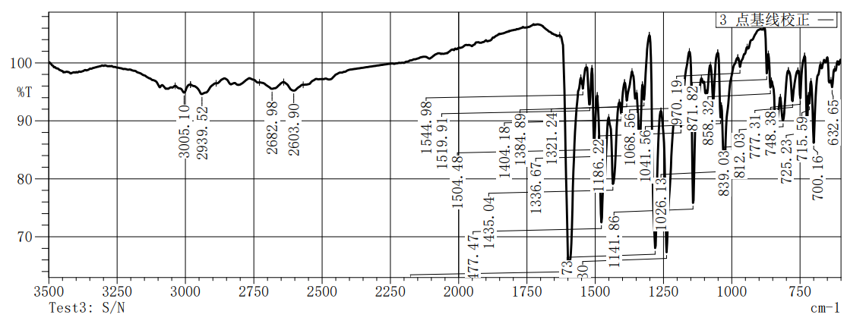
Figure S55.IR spectrum of compound 5bg

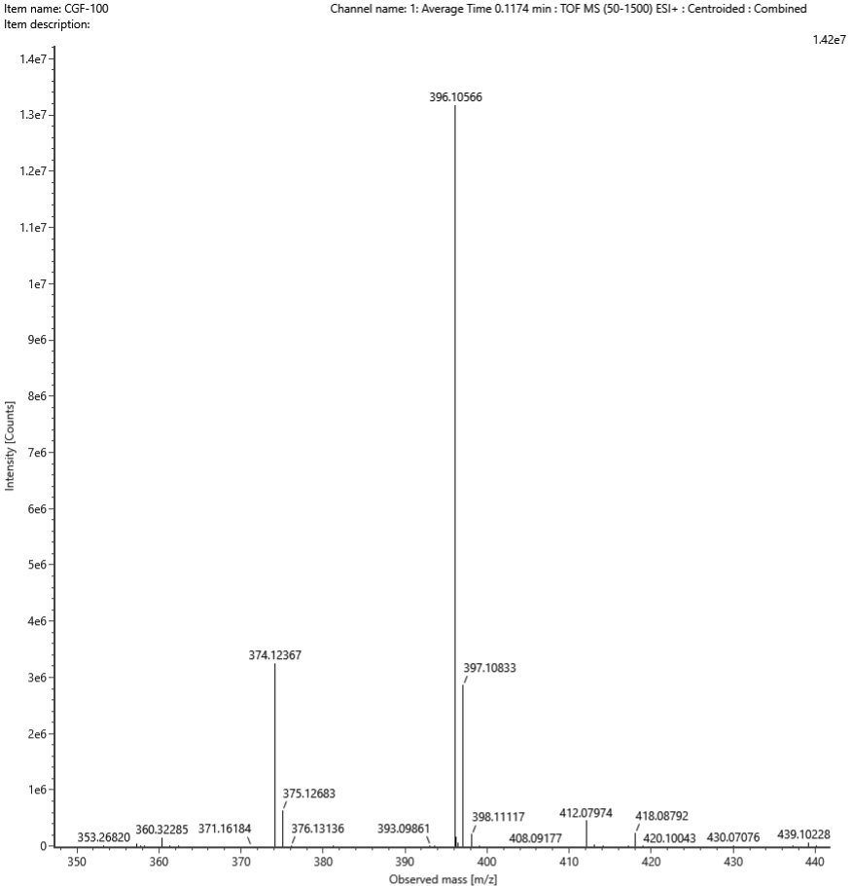
Figure S56. HRMS spectrum of compound 5bg

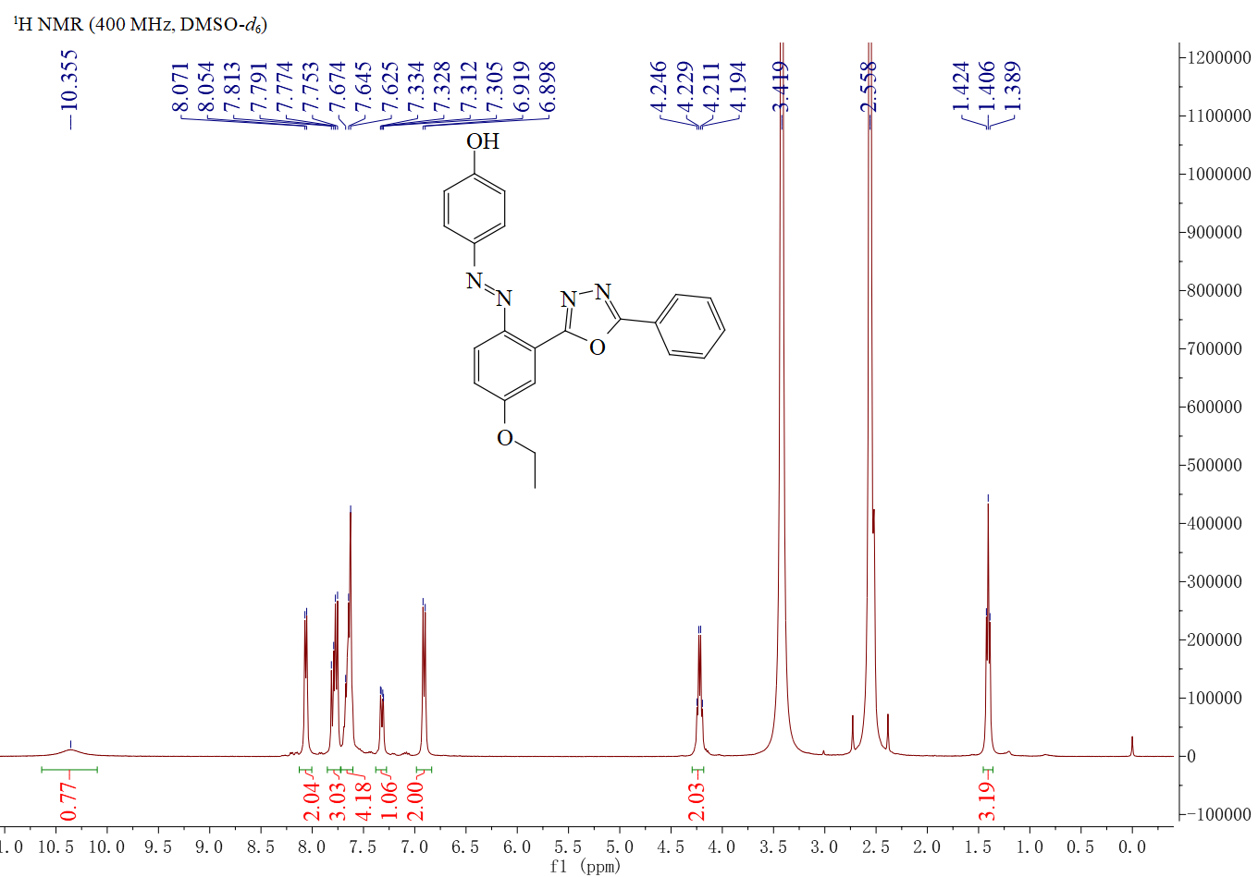
Figure S57 ¹H NMR spectrum of compound 5ca
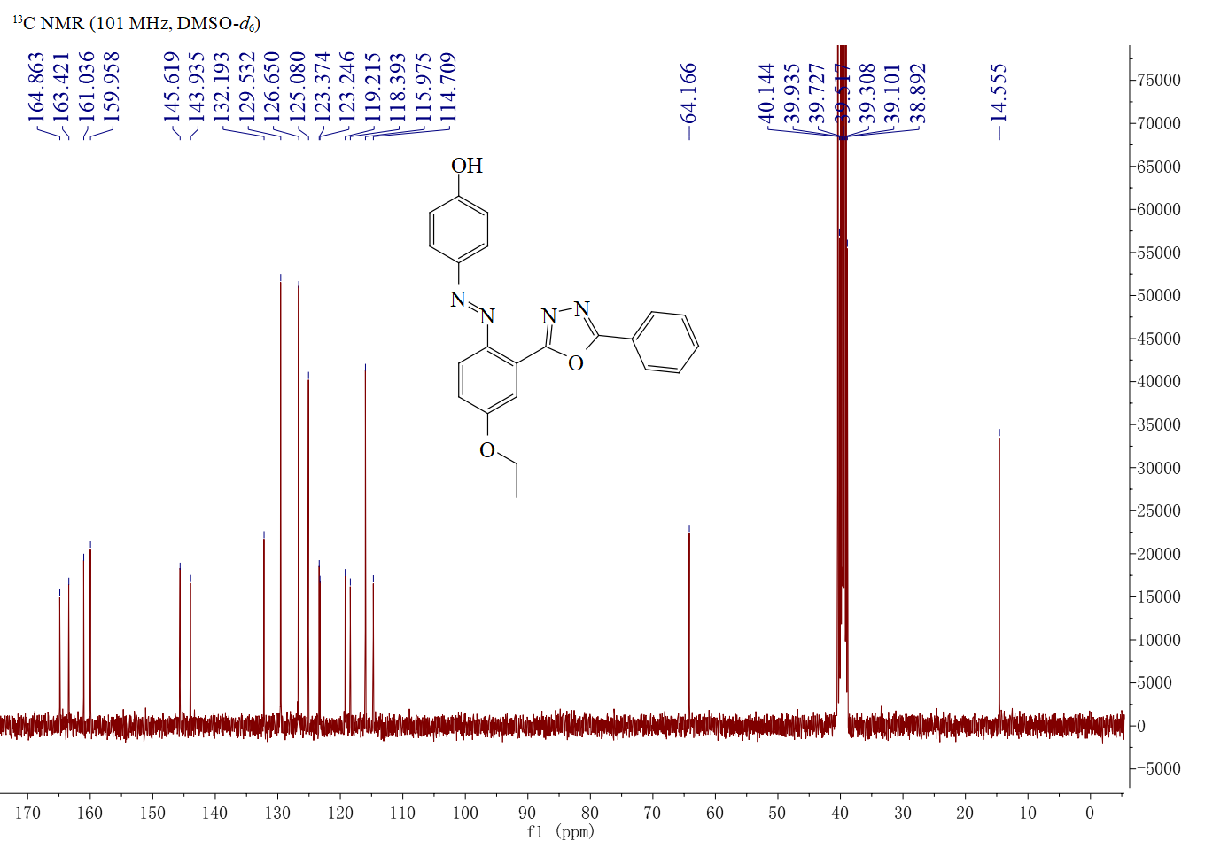
Figure S58. ¹³C NMR spectrum of compound 5ca

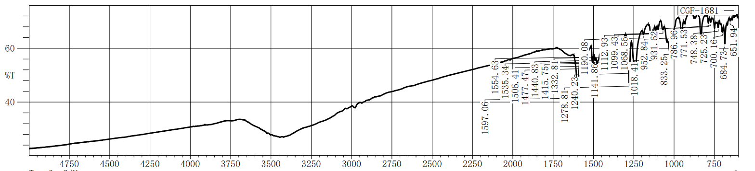
Figure S59.IR spectrum of compound 5ca

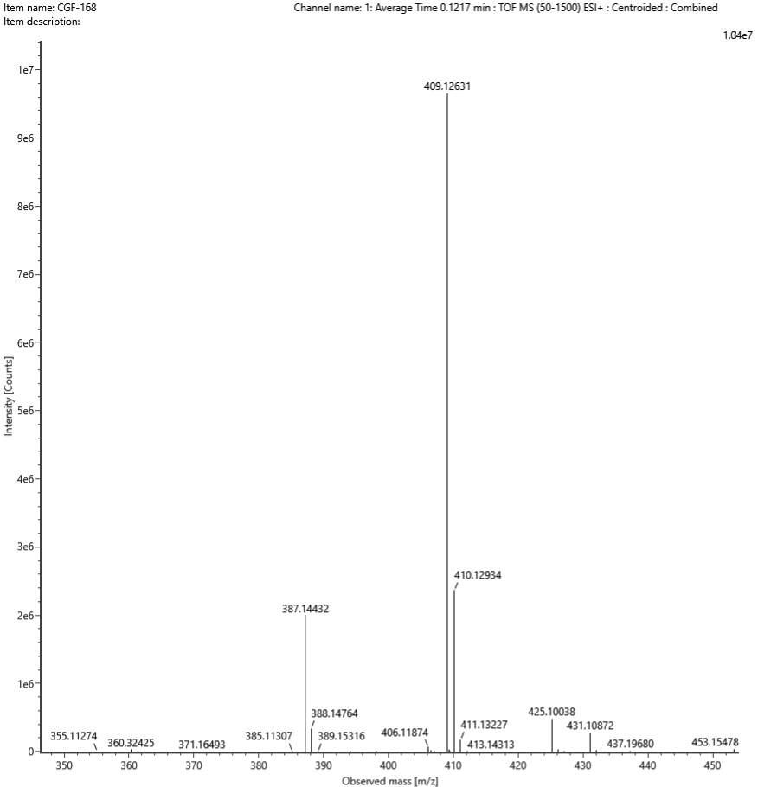
Figure S60. HRMS spectrum of compound 5ca
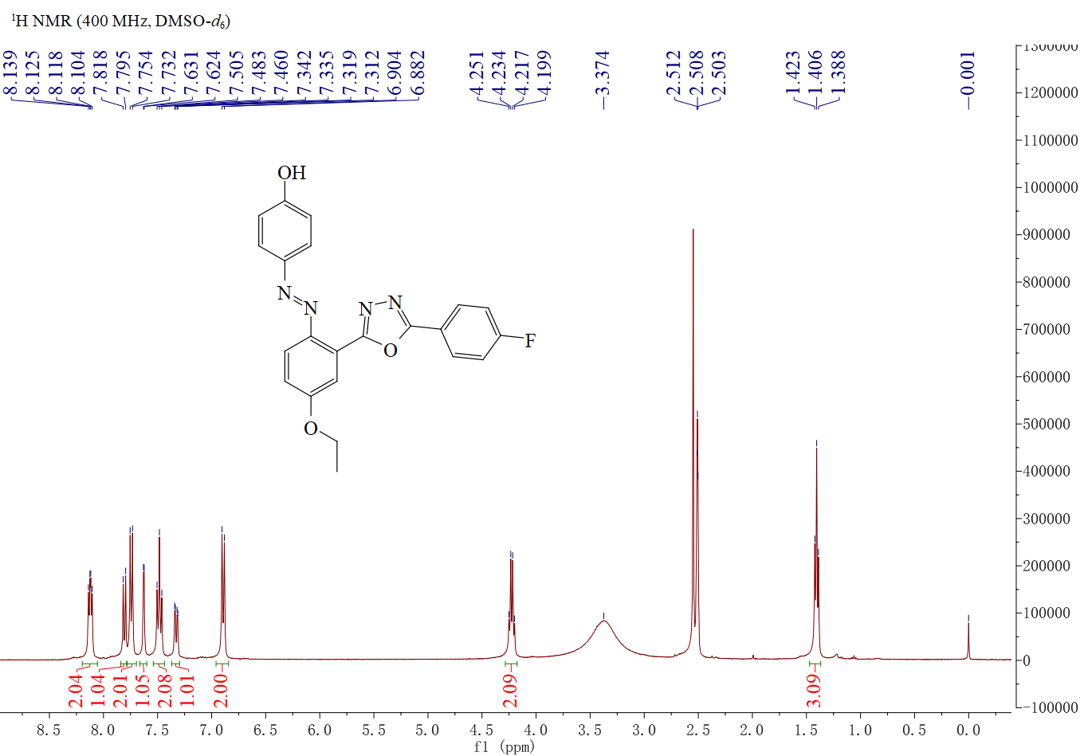
Figure S61. ¹H NMR spectrum of compound 5cb

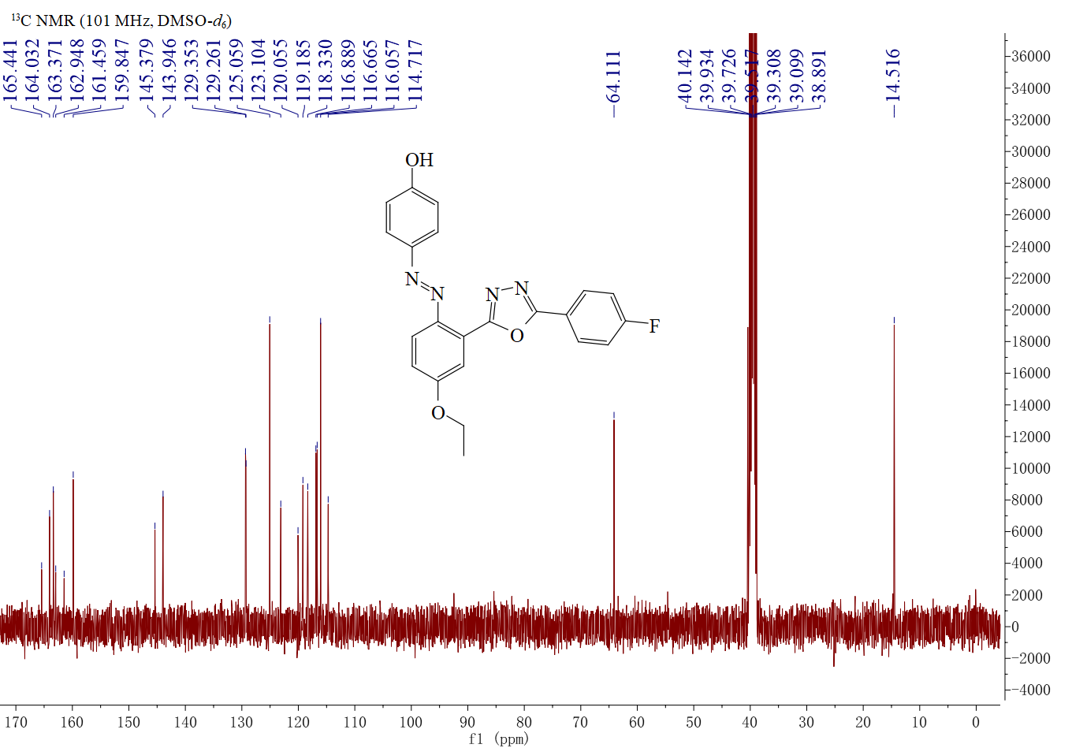
Figure S62 ¹³C NMR spectrum of compound 5cb

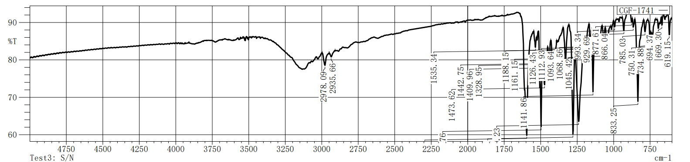
Figure S63.IR spectrum of compound 5cb

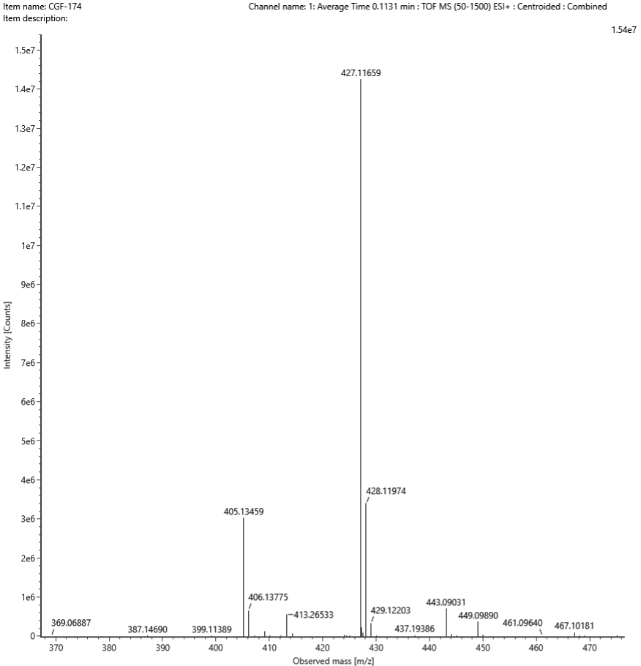
Figure S64. HRMS spectrum of compound 5cb

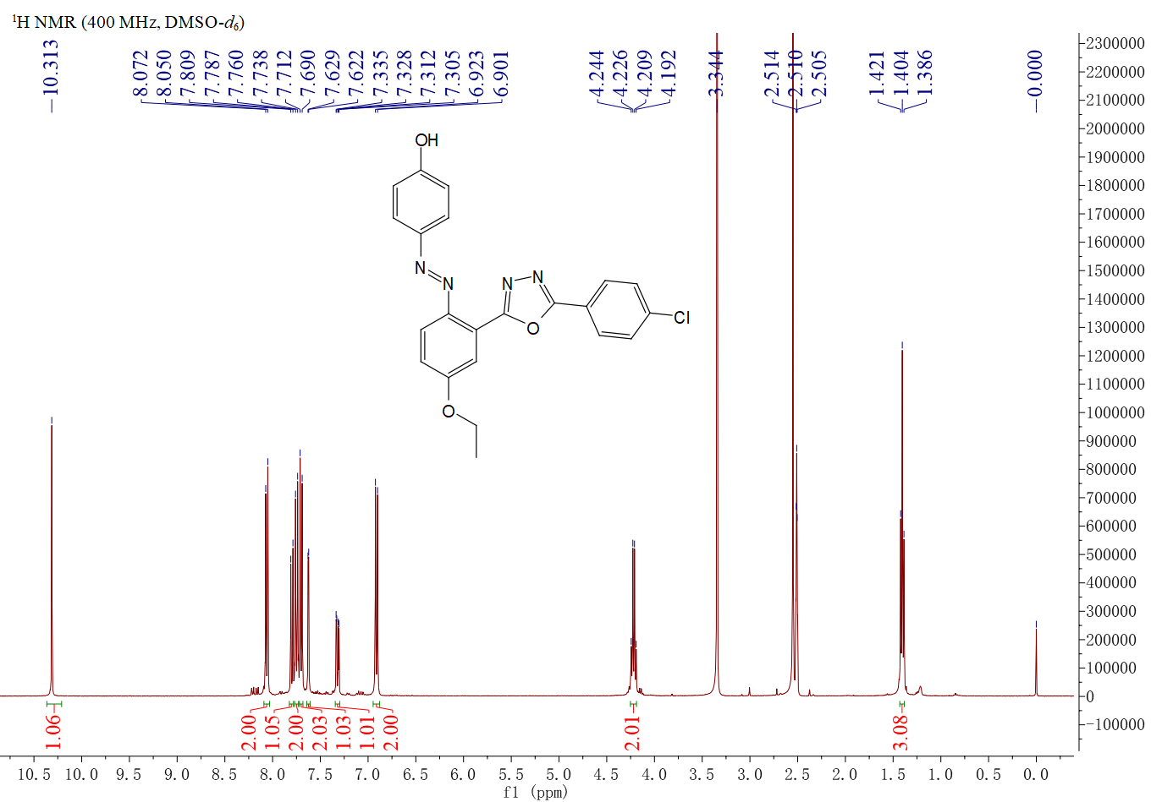
Figure S65. ¹H NMR spectrum of compound 5cc
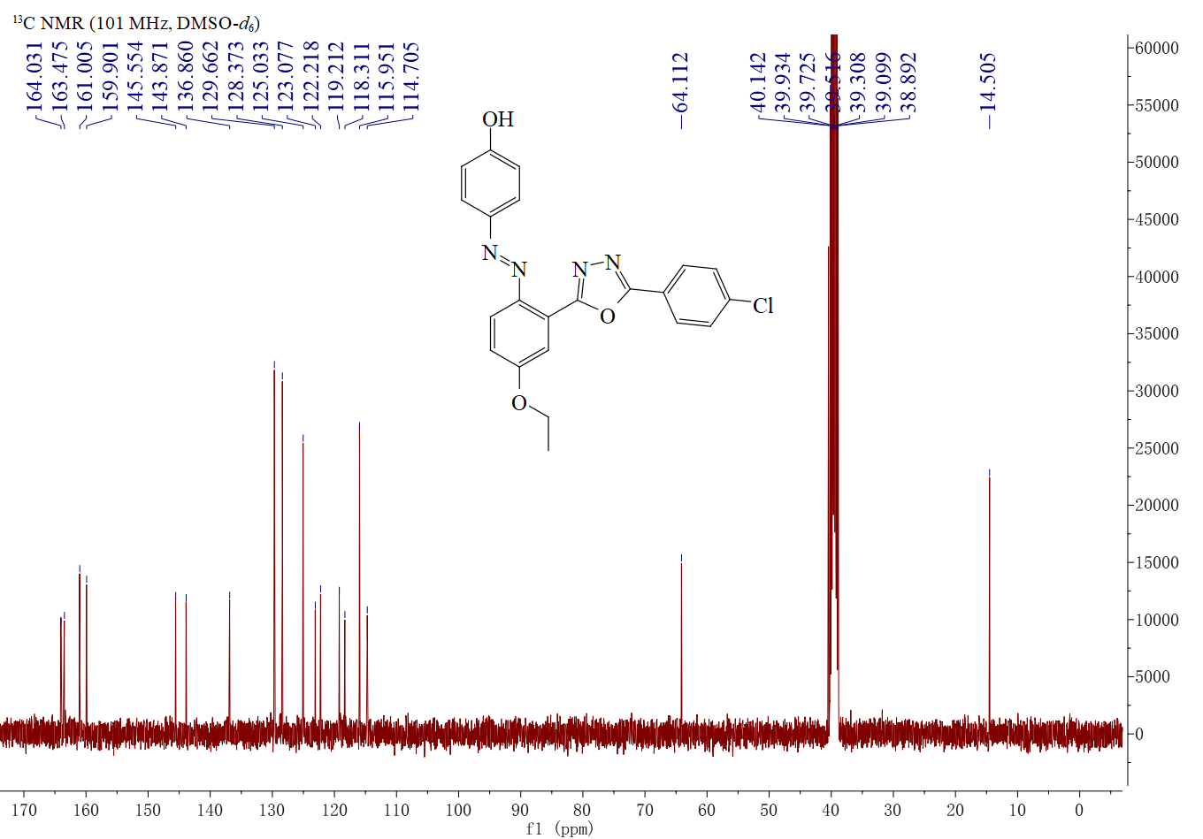
Figure S66. ¹³C NMR spectrum of compound 5cc

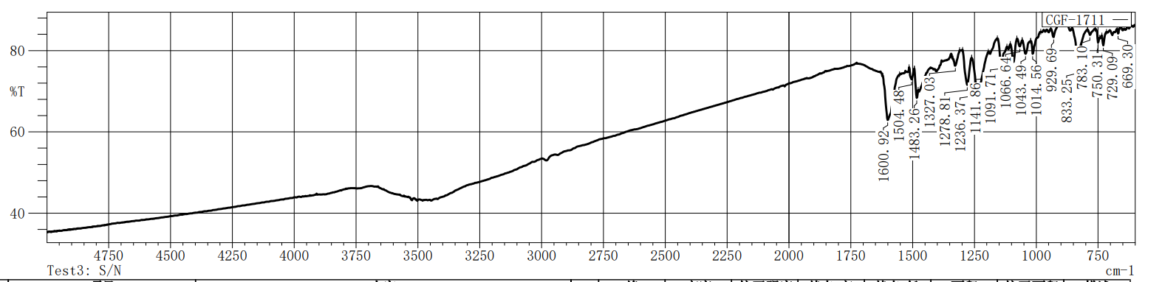
Figure S67.IR spectrum of compound 5cc

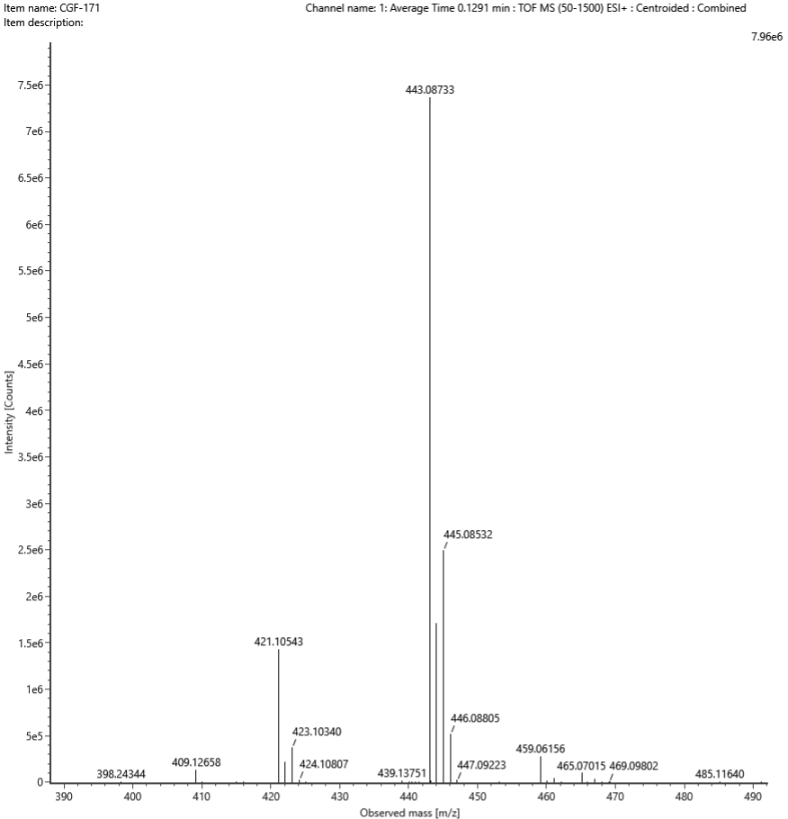
Figure S68. HRMS spectrum of compound 5cc
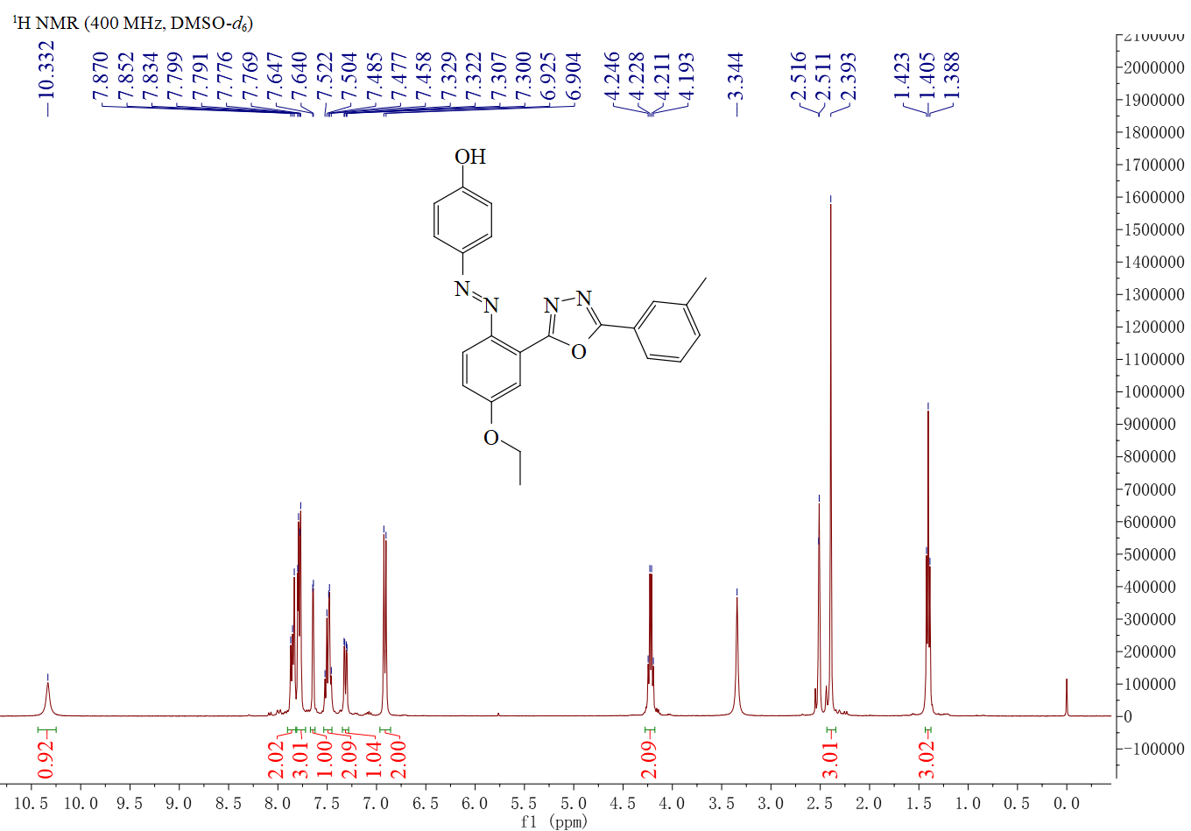
Figure 69. ¹H NMR spectrum of compound 5cd

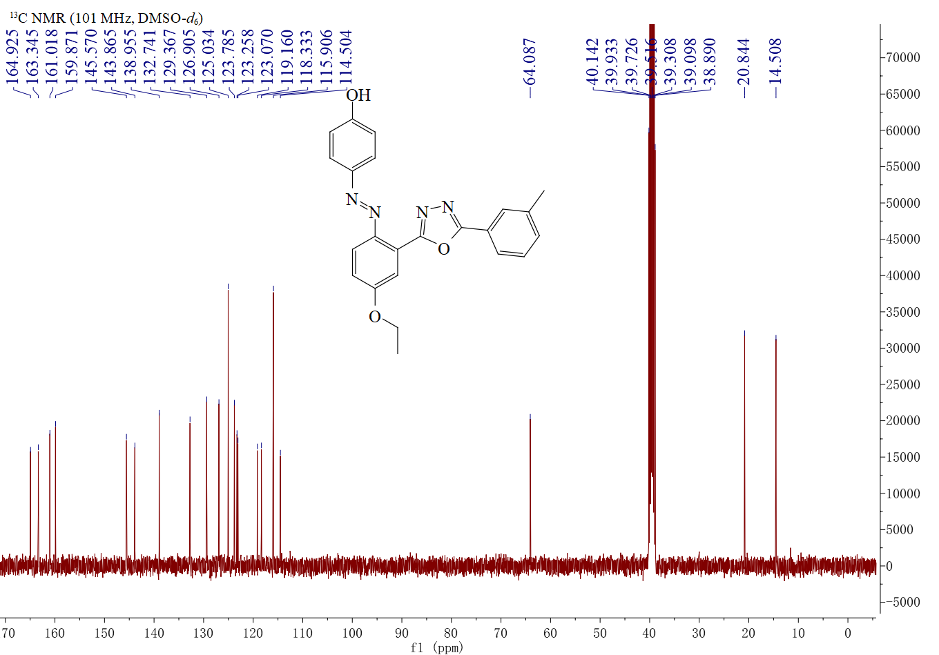Figure S70 ¹³C NMR spectrum of compound 5cd

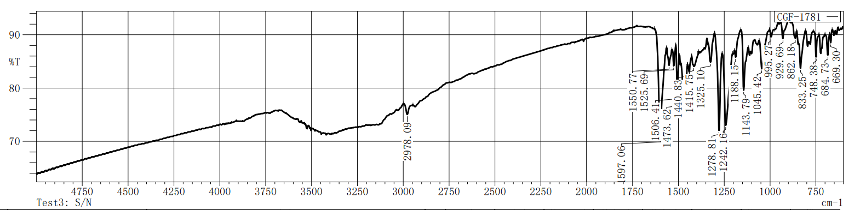
Figure S71.IR spectrum of compound 5cd

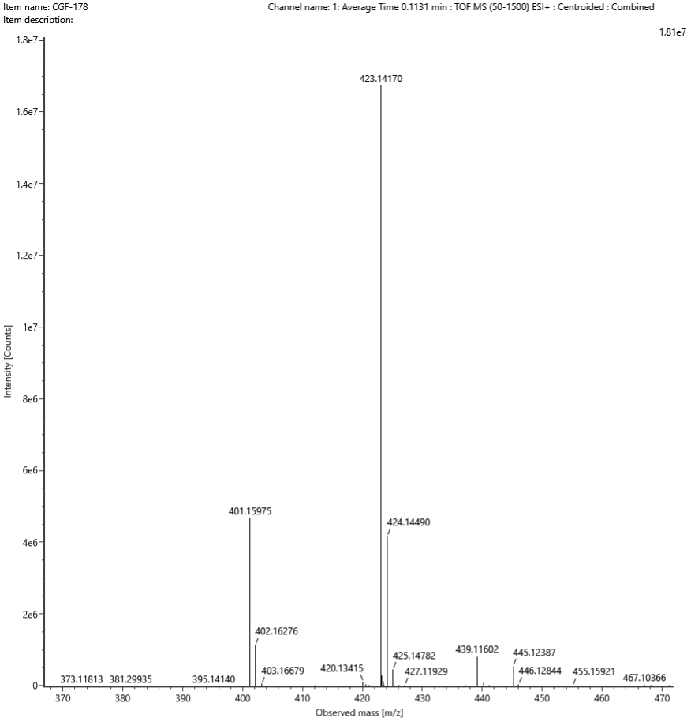
Figure S72. HRMS spectrum of compound 5cd

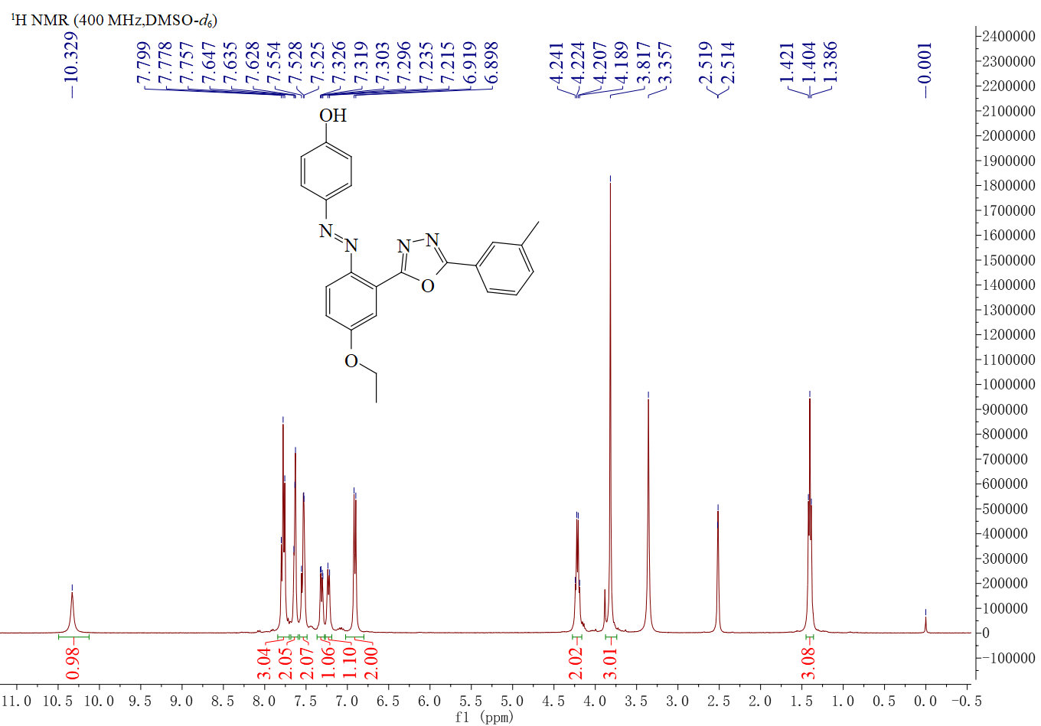
Figure 73. ¹H NMR spectrum of compound 5ce
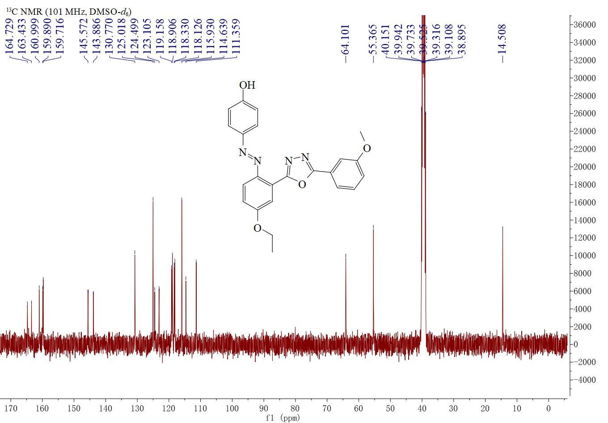
Figure S74. ¹³C NMR spectrum of compound 5ce

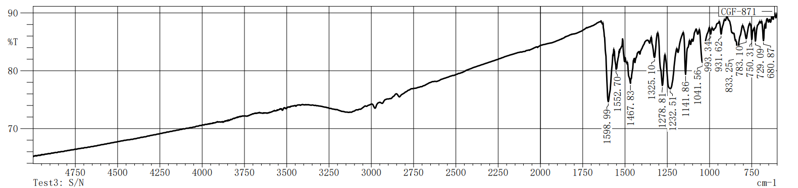
Figure S75.IR spectrum of compound 5ce

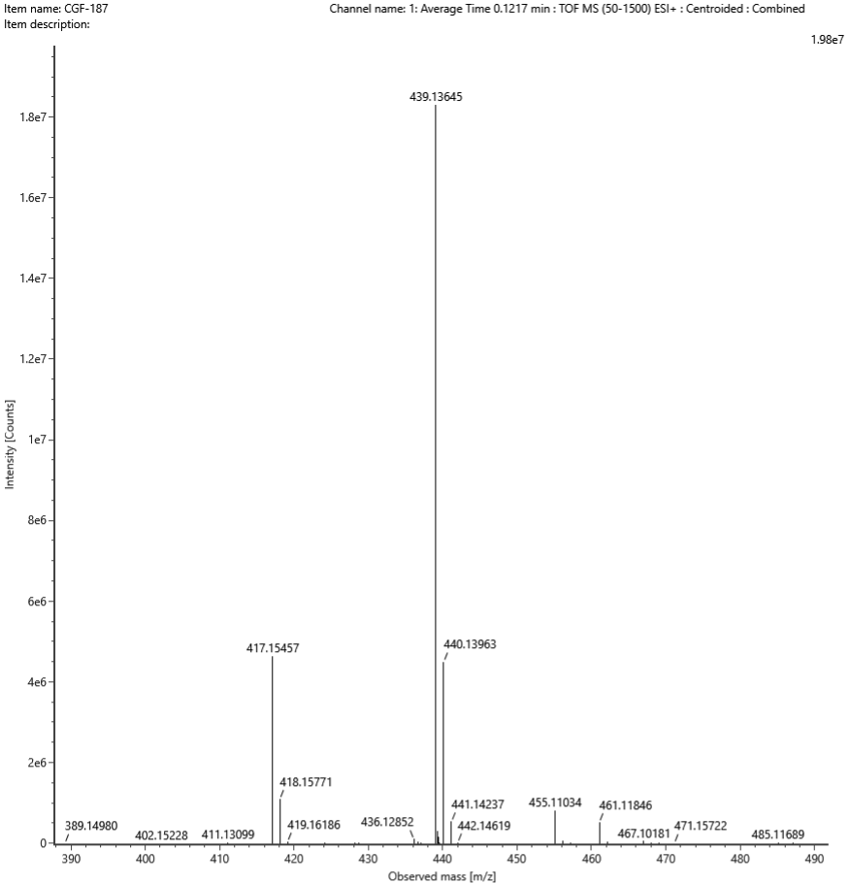
Figure S76. HRMS spectrum of compound 5ce
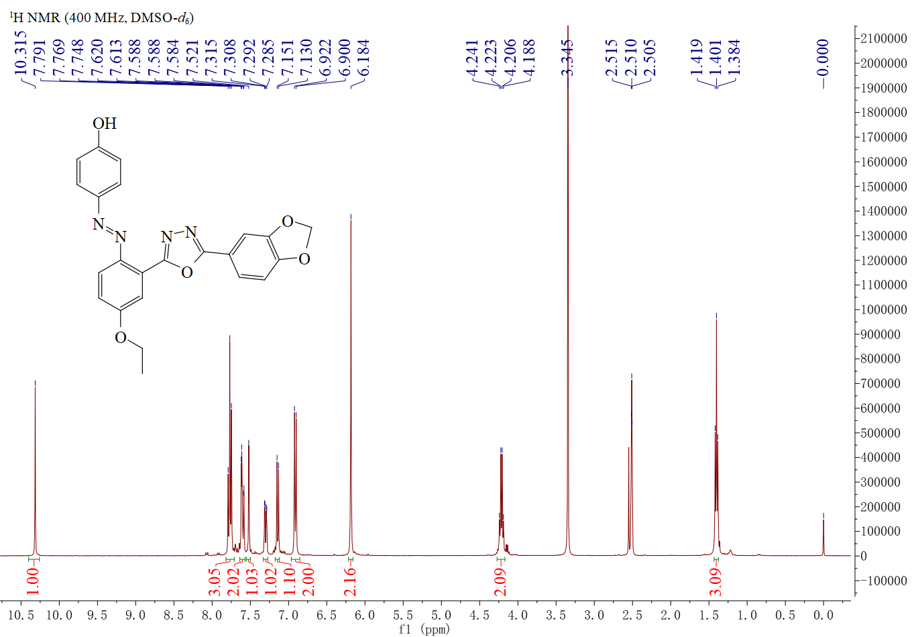
Figure S77. ¹H NMR spectrum of compound 5cf

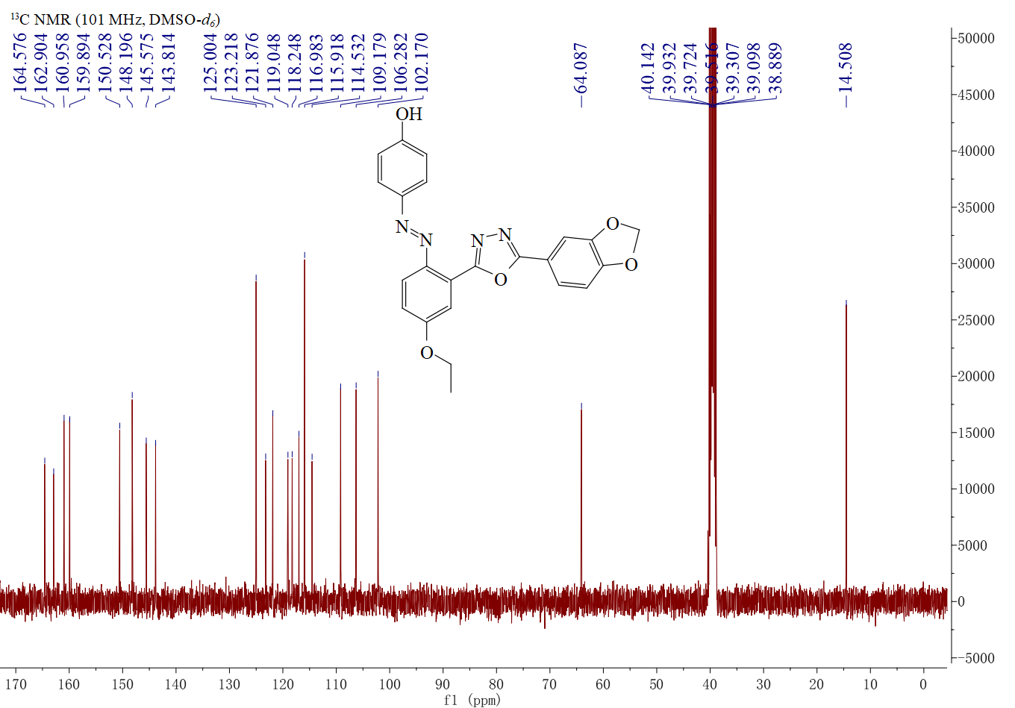Figure S78. ¹³C NMR spectrum of compound 5cf

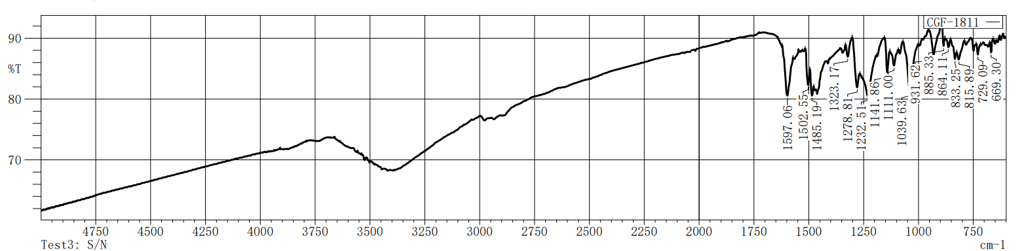
Figure S79.IR spectrum of compound 5cf

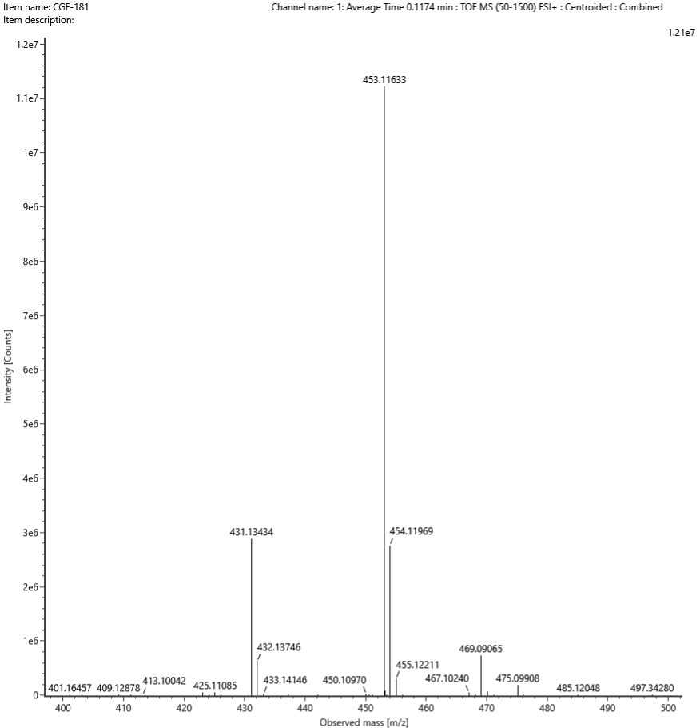
Figure S80. HRMS spectrum of compound 5cf

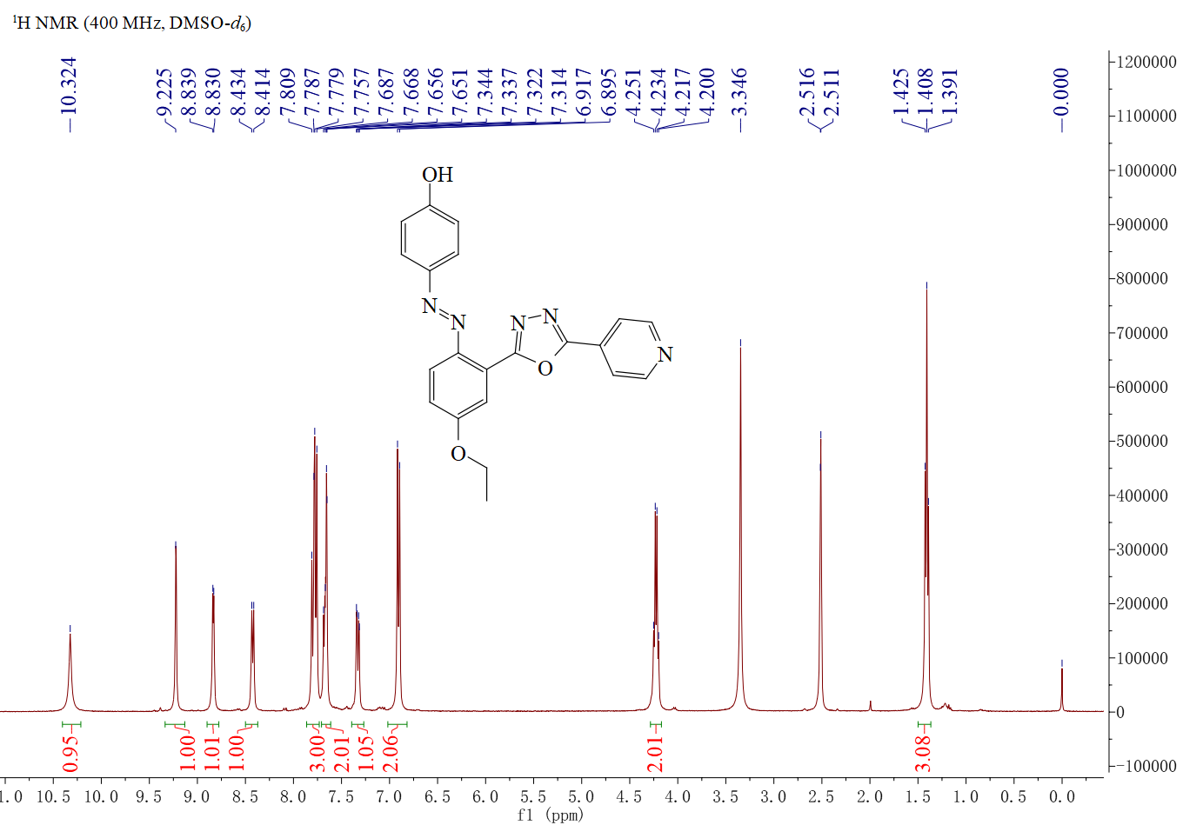
Figure 81. ¹H NMR spectrum of compound 5cg
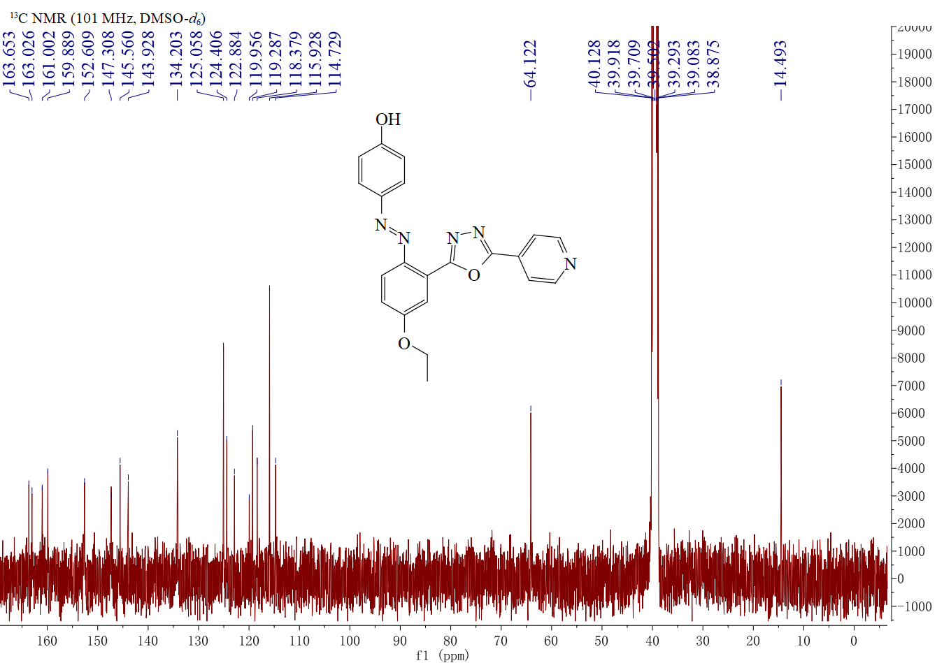
Figure S82. ¹³C NMR spectrum of compound 5cg

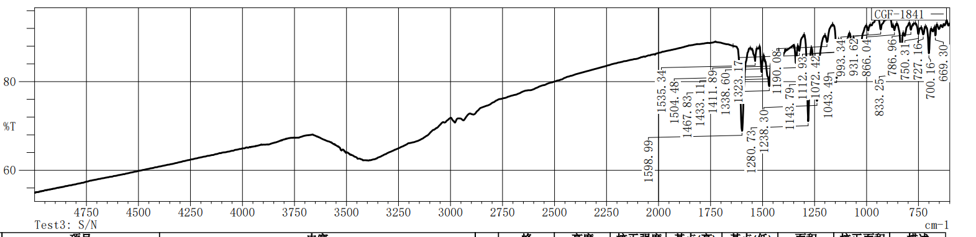
Figure S83.IR spectrum of compound 5cg

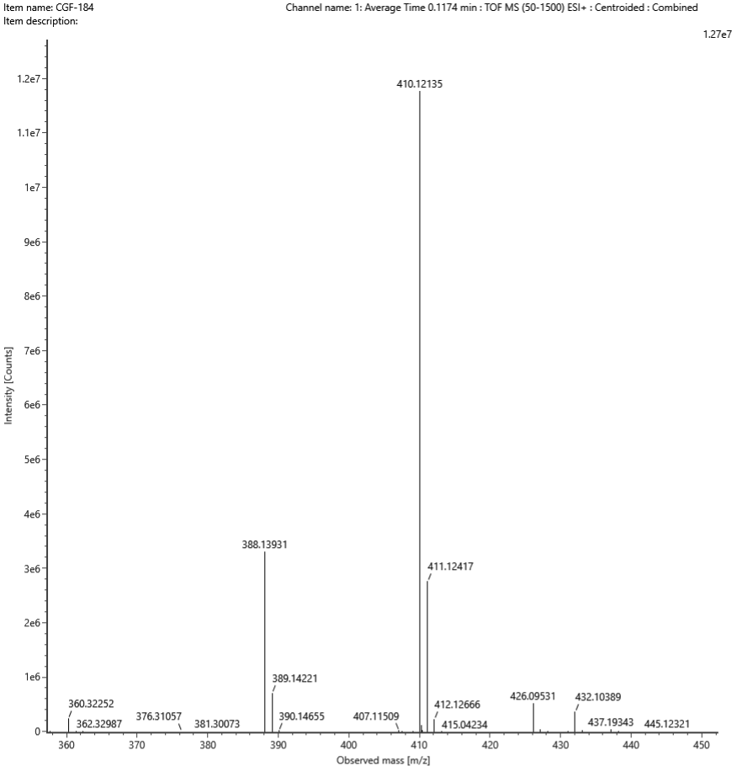
Figure S84. HRMS spectrum of compound 5cg
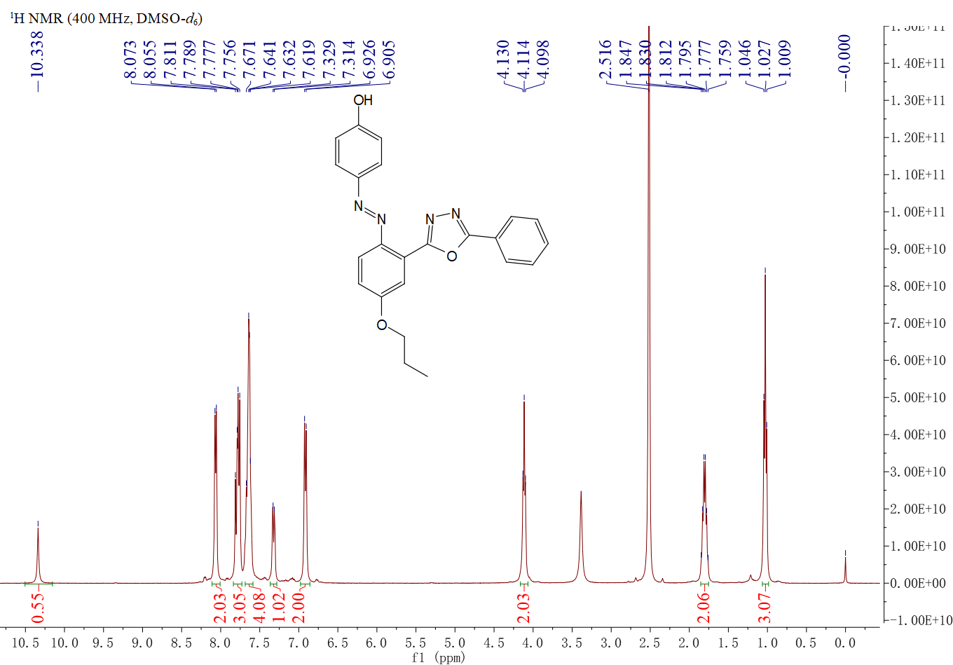
Figure 85. ¹H NMR spectrum of compound 5da

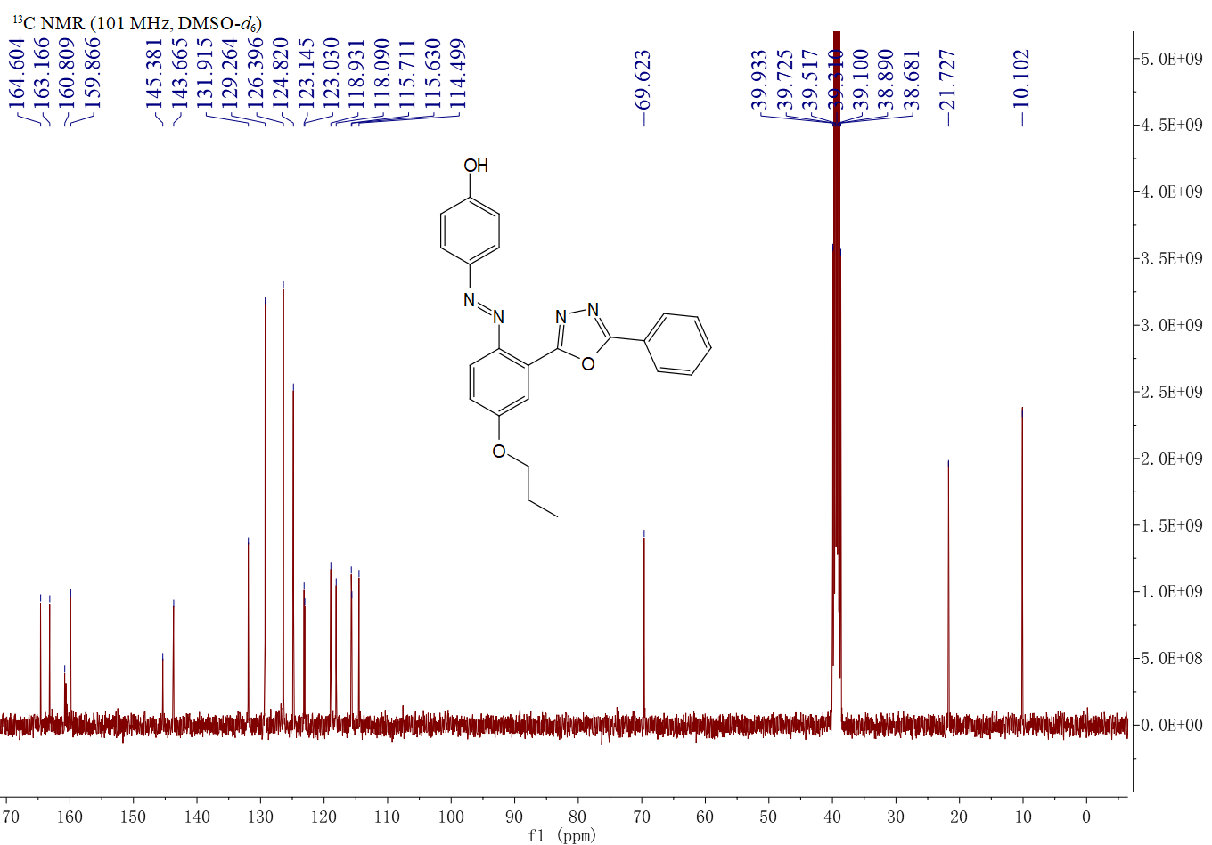
Figure S86. ¹³C NMR spectrum of compound 5da

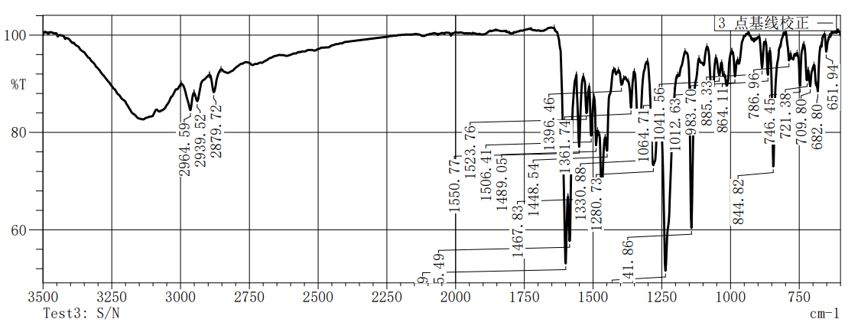
Figure S87.IR spectrum of compound 5da

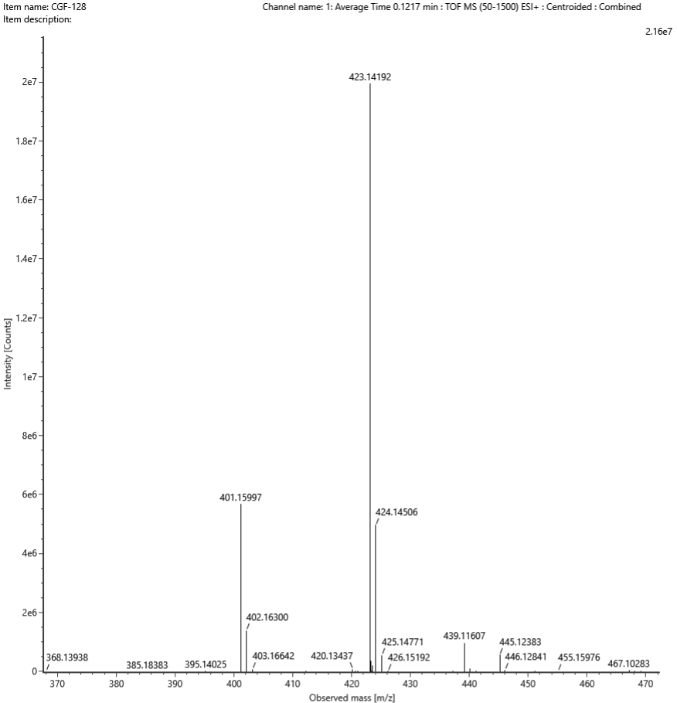
Figure S88. HRMS spectrum of compound 5da

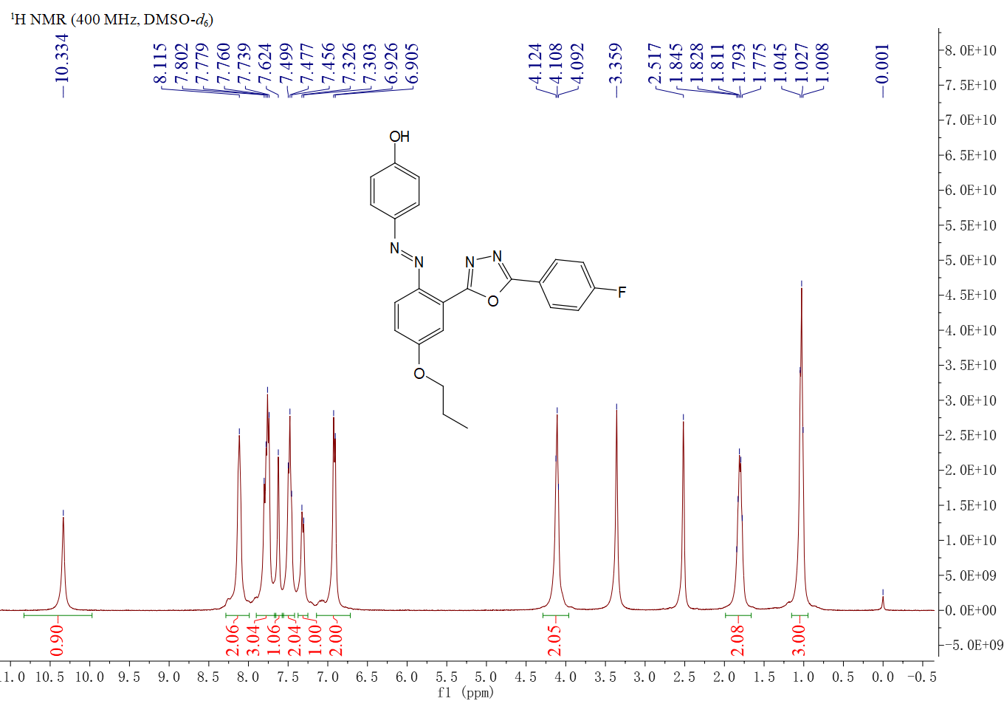
Figure 89. ¹H NMR spectrum of compound 5db
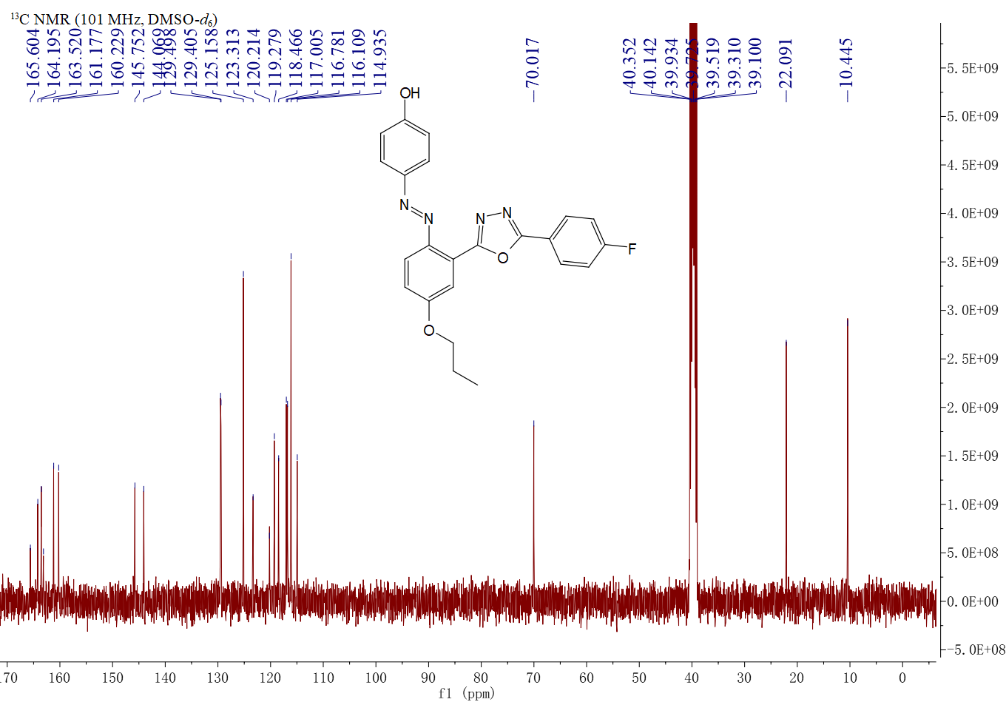
Figure S90. ¹³C NMR spectrum of compound 5db

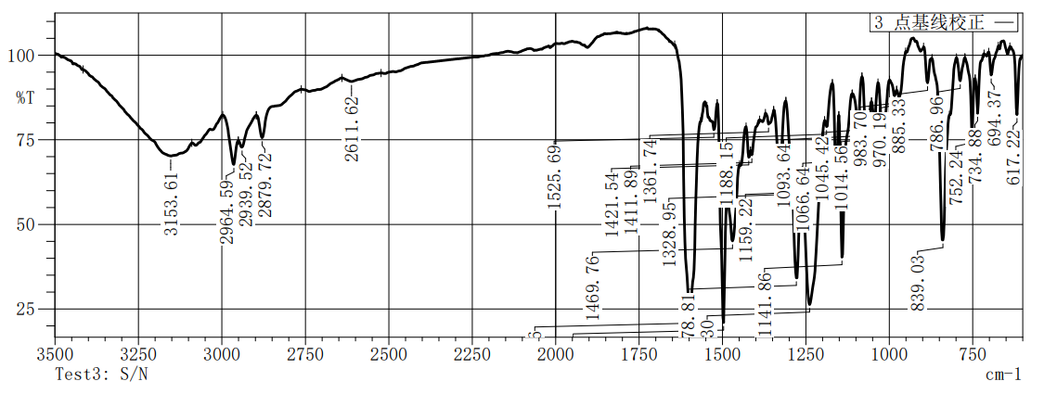
Figure S91.IR spectrum of compound 5db

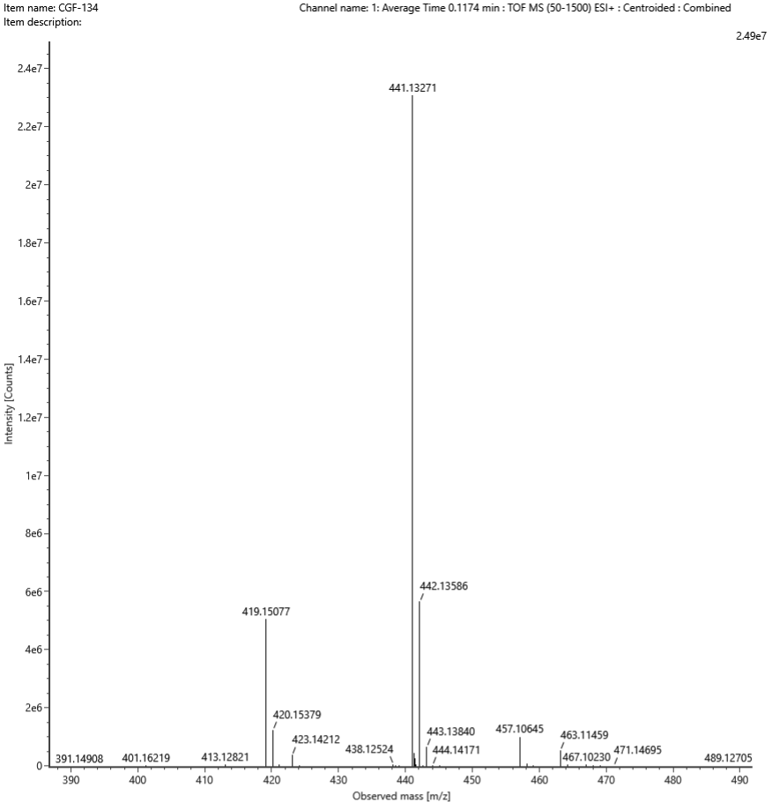
Figure S92. HRMS spectrum of compound 5db
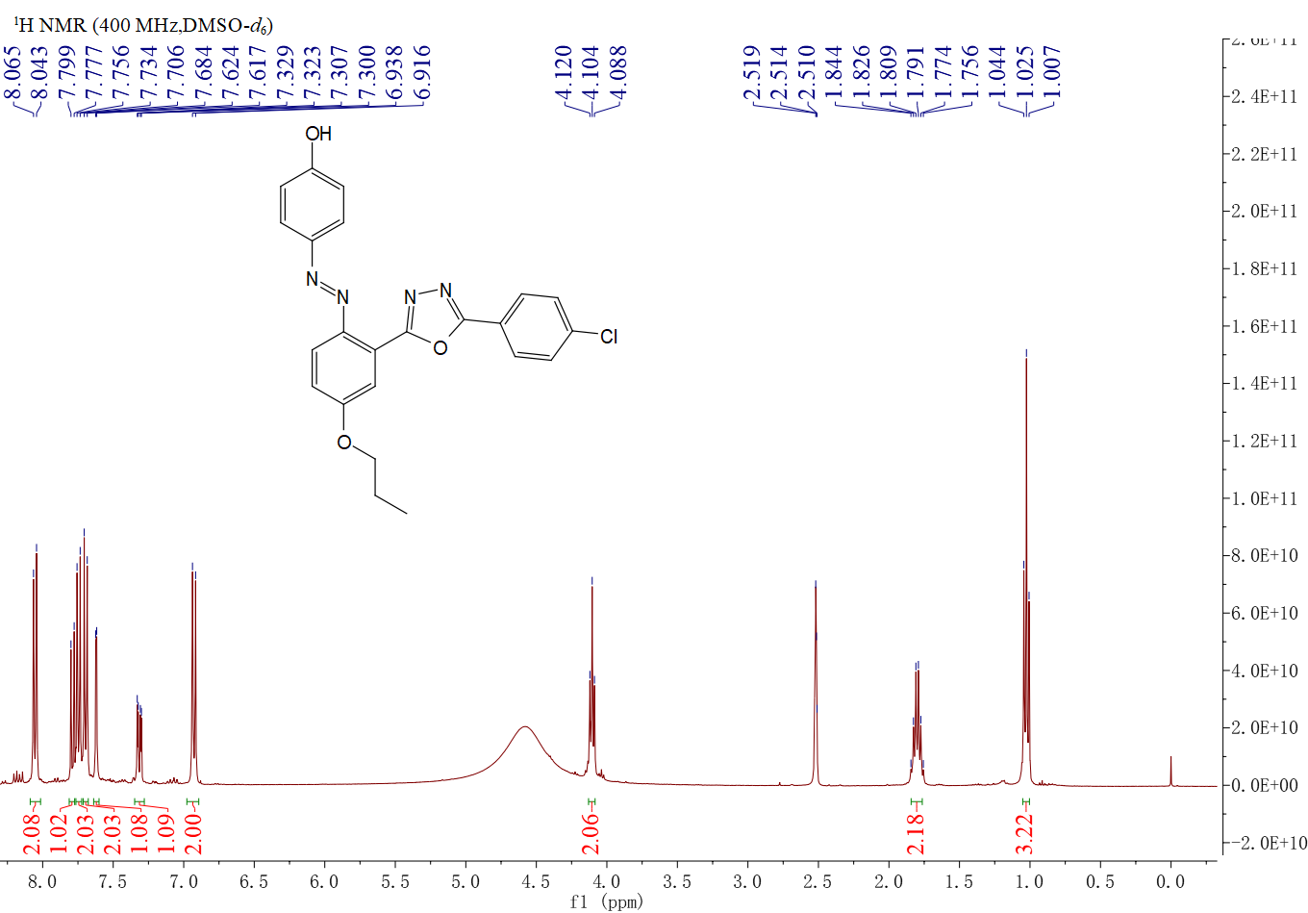
Figure 93. ¹H NMR spectrum of compound 5dc

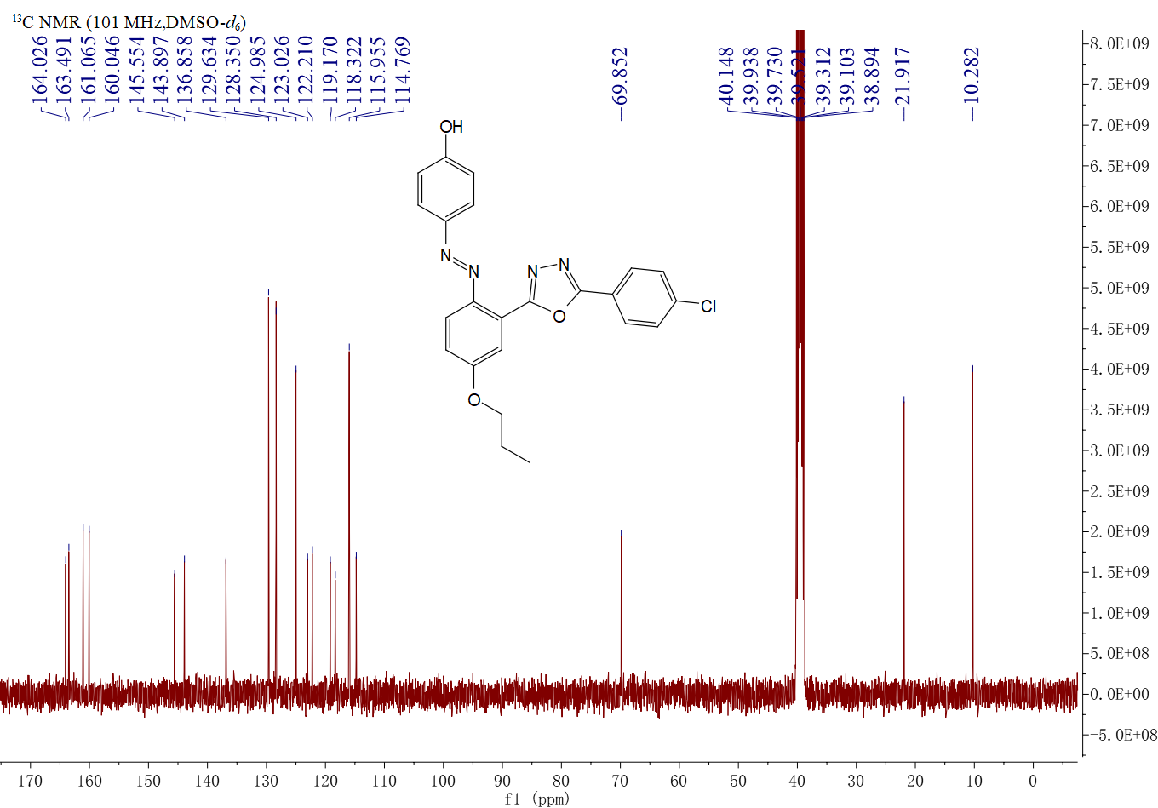
Figure S94. ¹³C NMR spectrum of compound 5dc

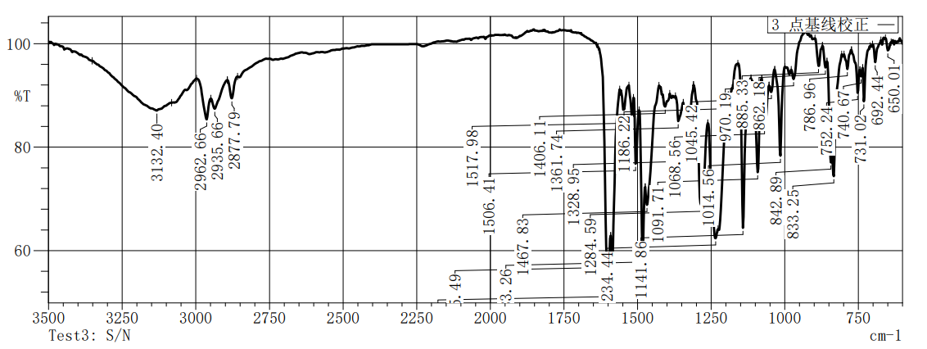
Figure S95.IR spectrum of compound 5dc

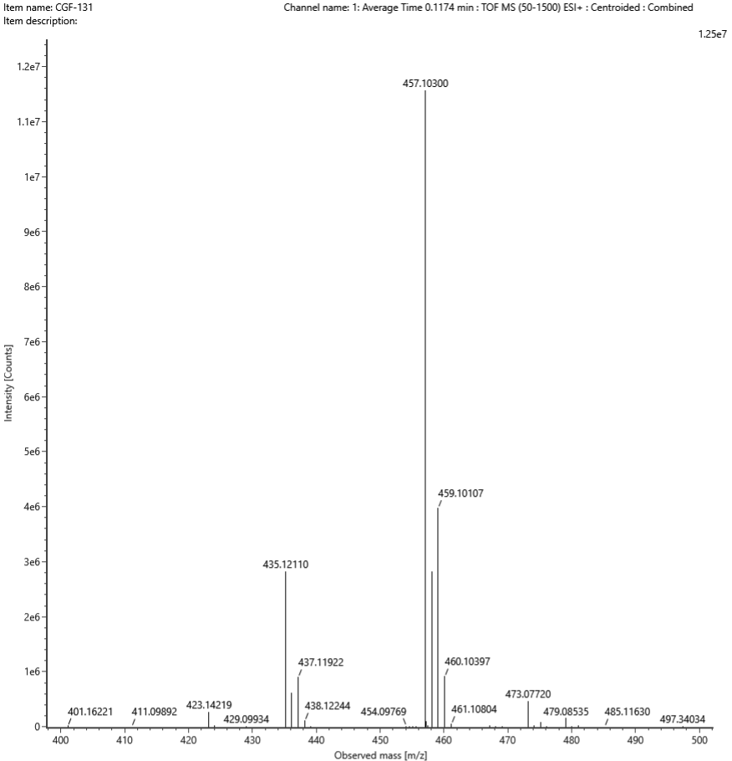
Figure S96. HRMS spectrum of compound 5dc

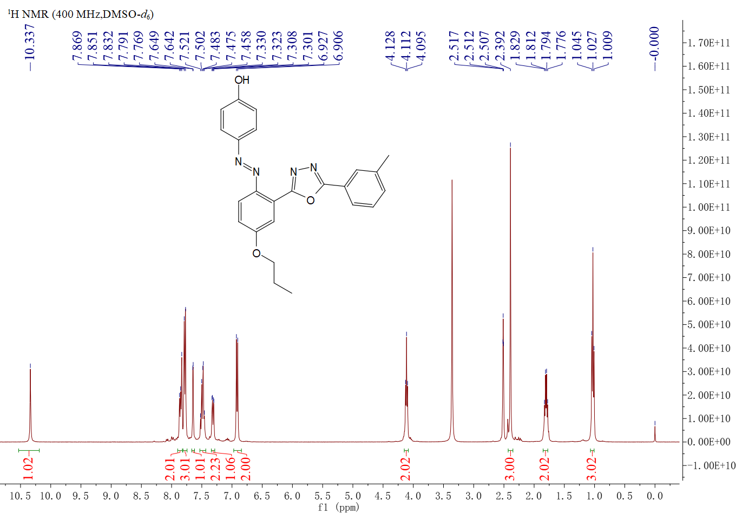
Figure97. ¹H NMR spectrum of compound 5dd
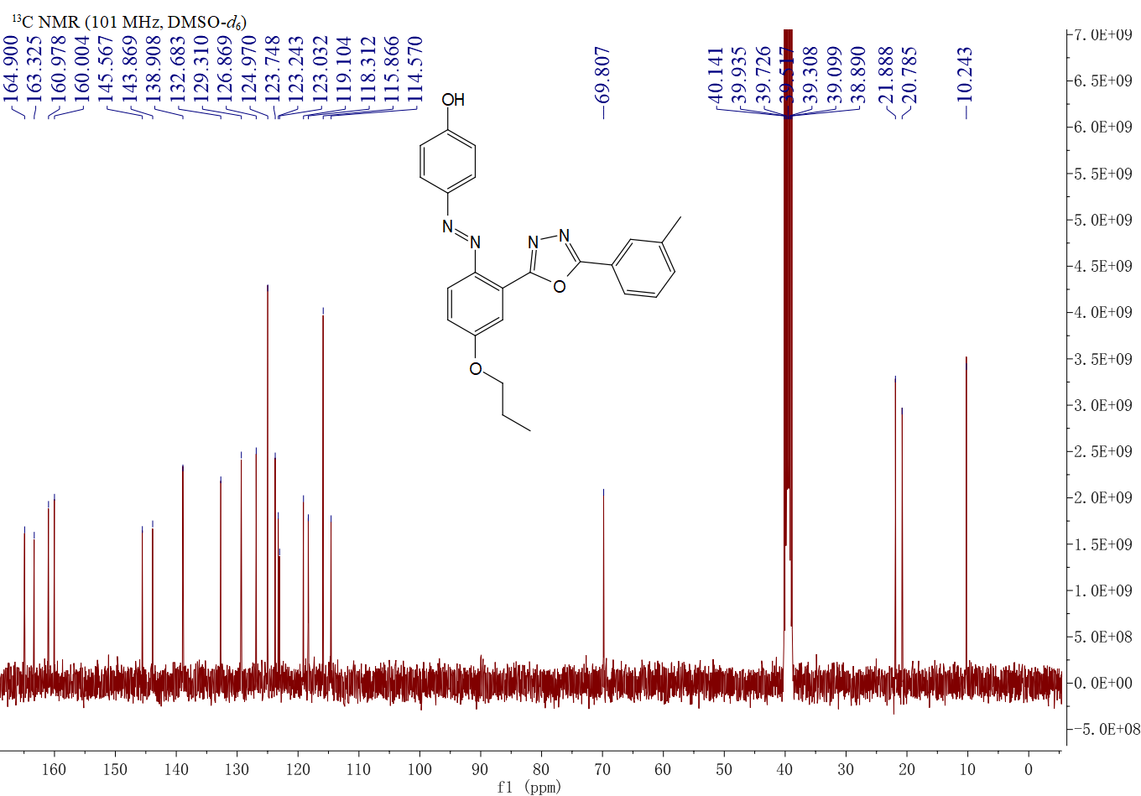
Figure S98. ¹³C NMR spectrum of compound 5dd

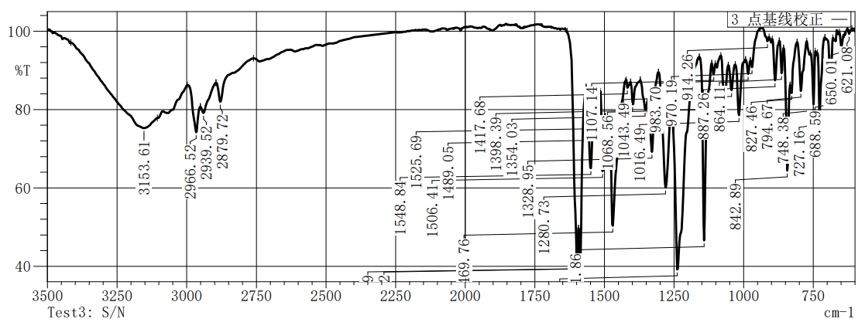
Figure S99.IR spectrum of compound 5dd

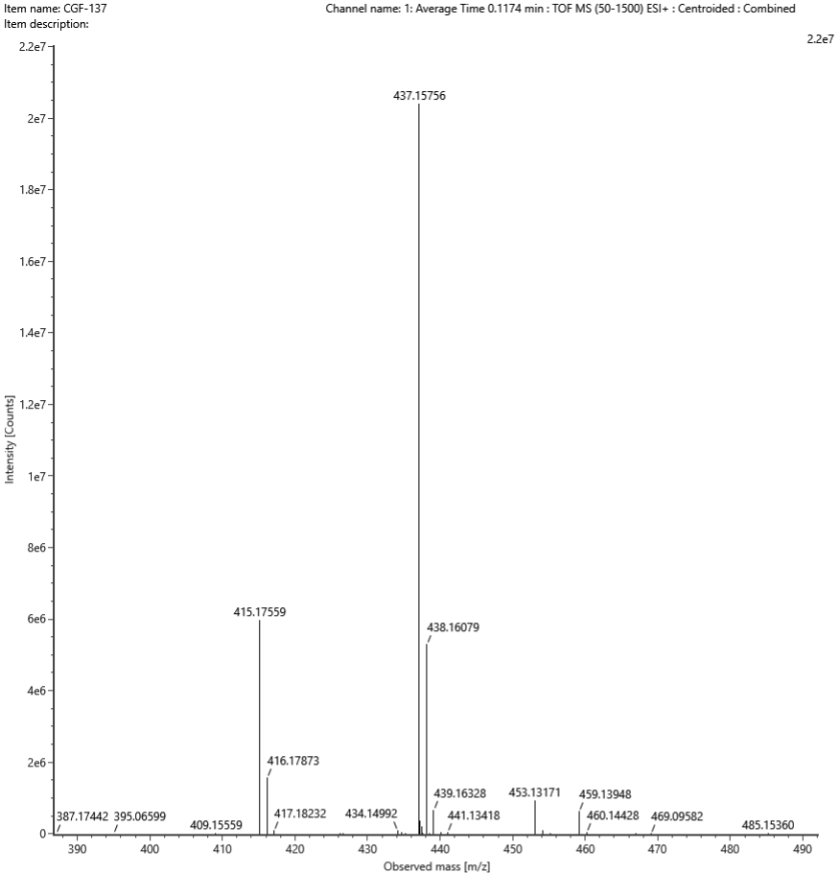
Figure S100. HRMS spectrum of compound 5dd
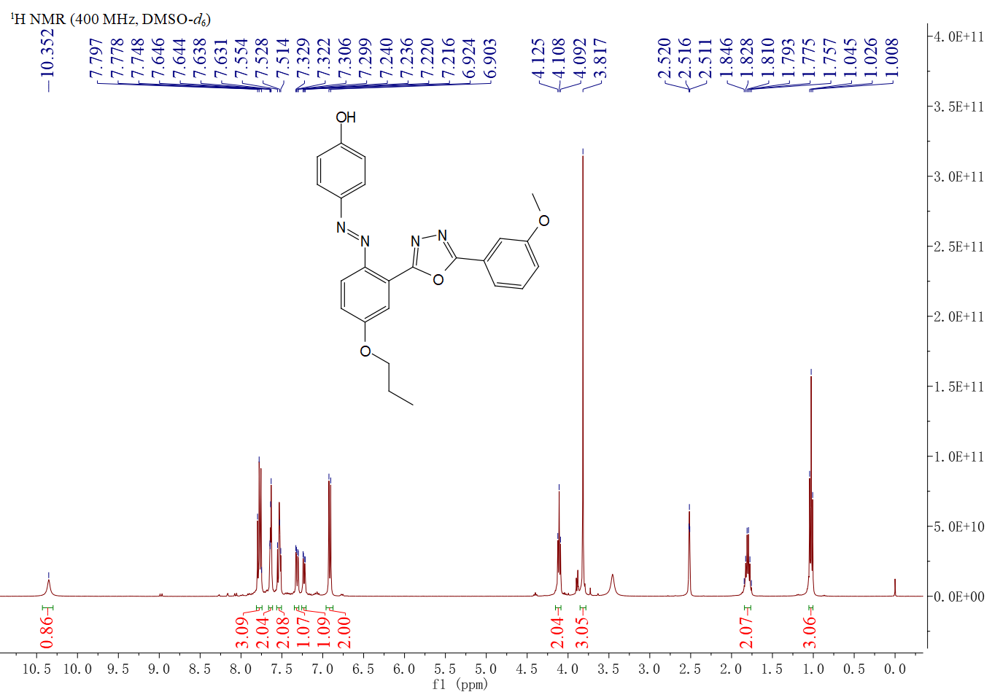
Figure 101. ¹H NMR spectrum of compound 5de

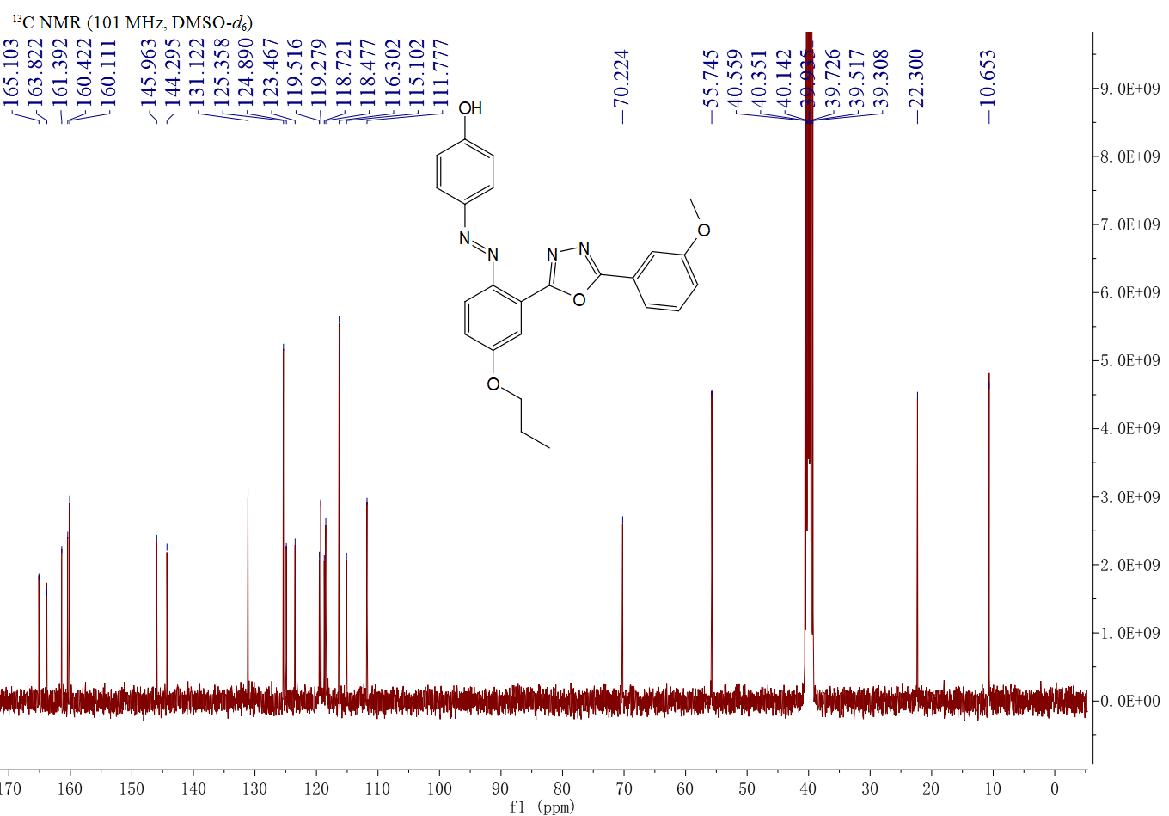
Figure S102. ¹³C NMR spectrum of compound 5de

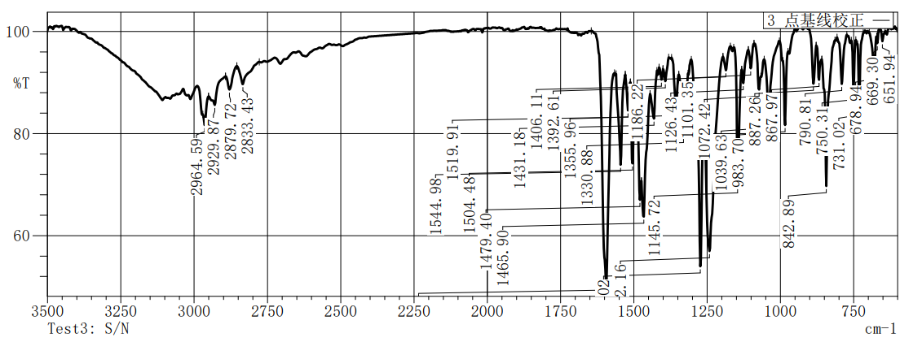
Figure S103.IR spectrum of compound 5de

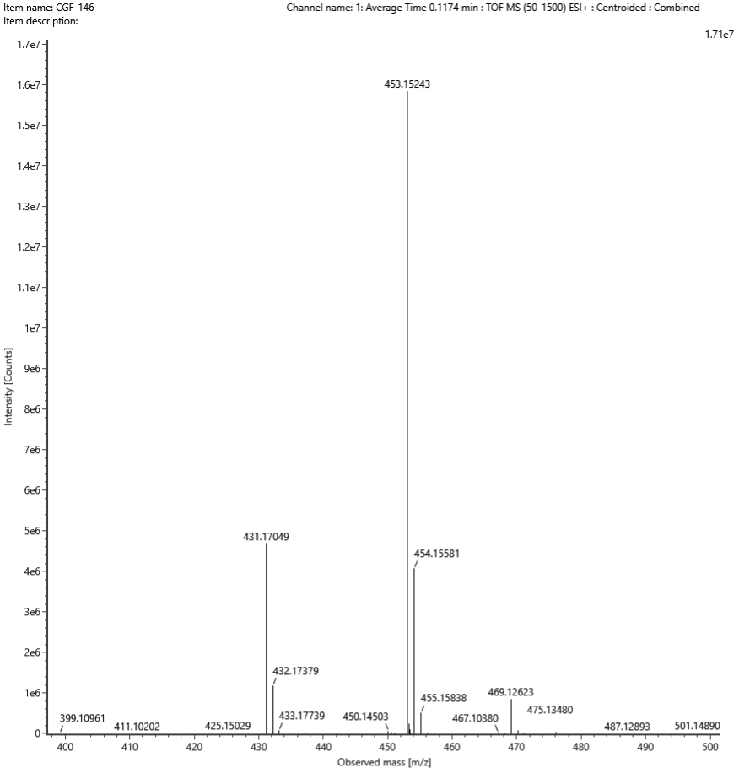
Figure S104. HRMS spectrum of compound 5de

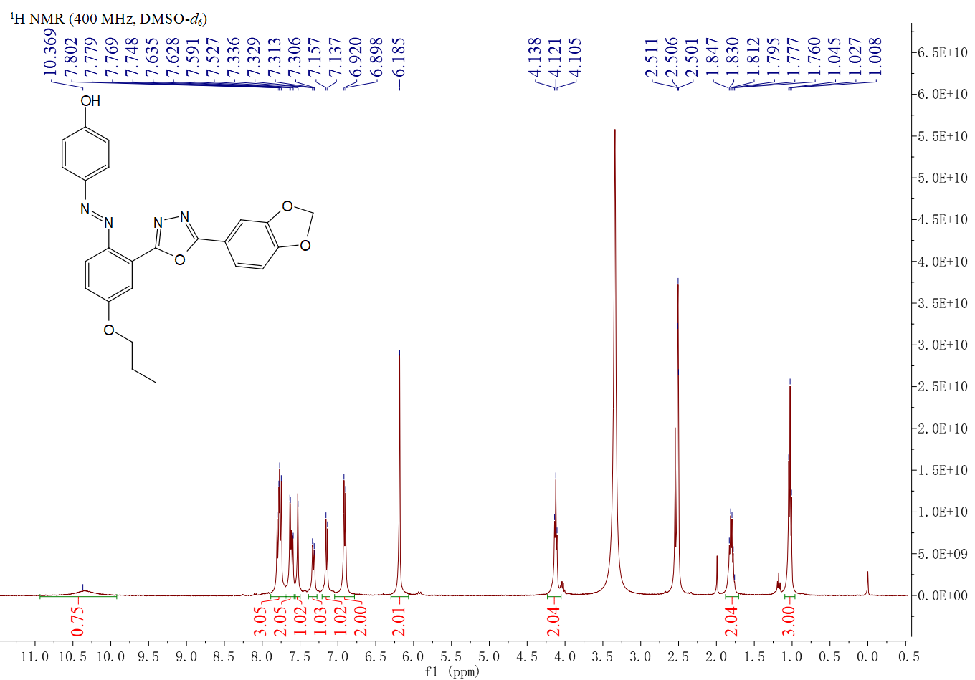
Figure 105. ¹H NMR spectrum of compound 5df
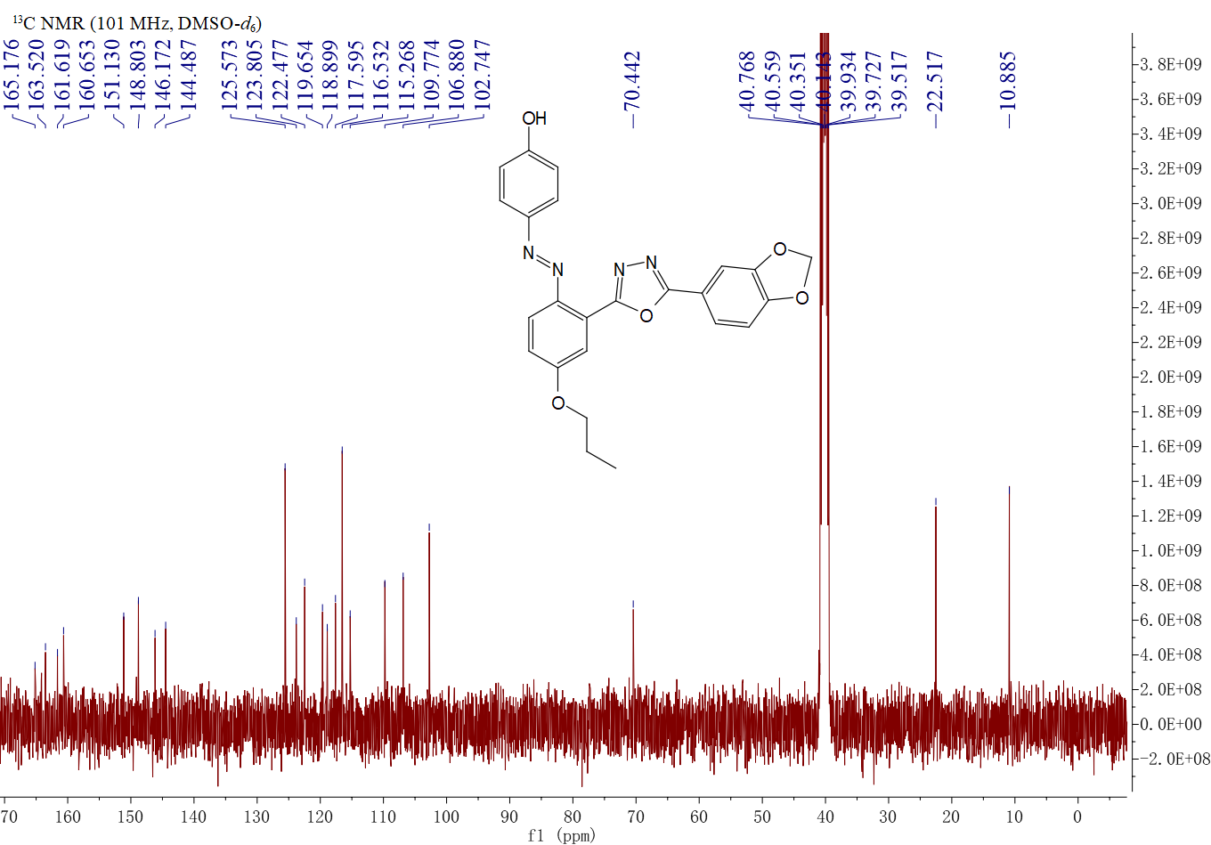
Figure S106. ¹³C NMR spectrum of compound 5df

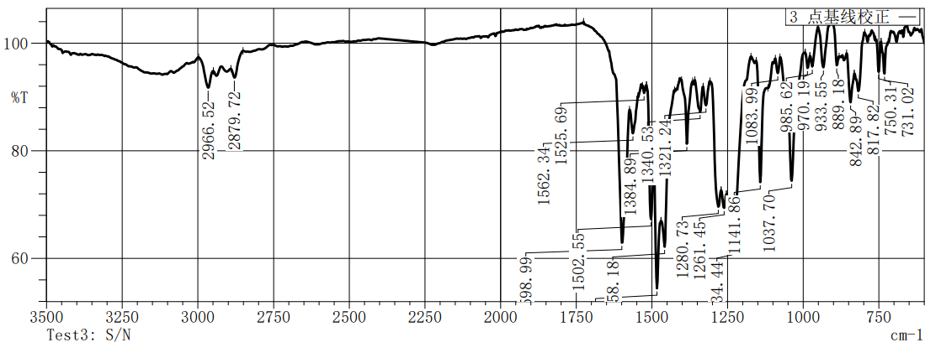
Figure S107.IR spectrum of compound 5df

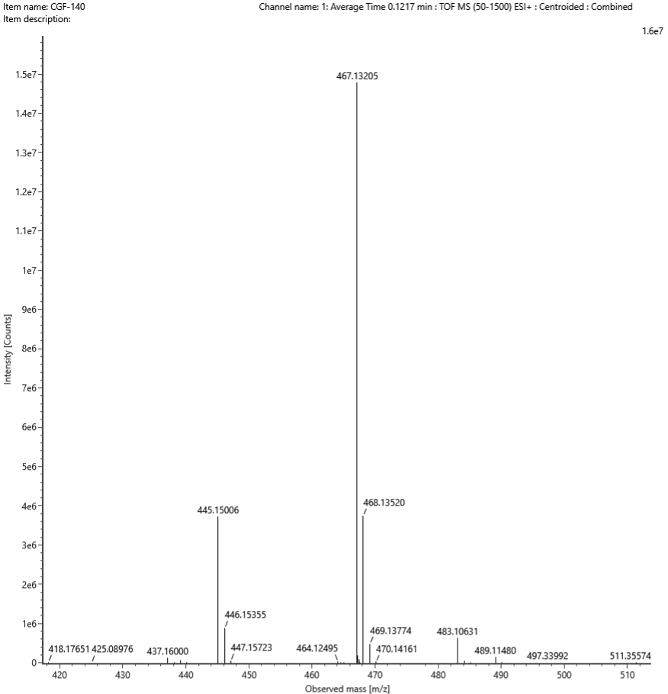
Figure S108. HRMS spectrum of compound 5df
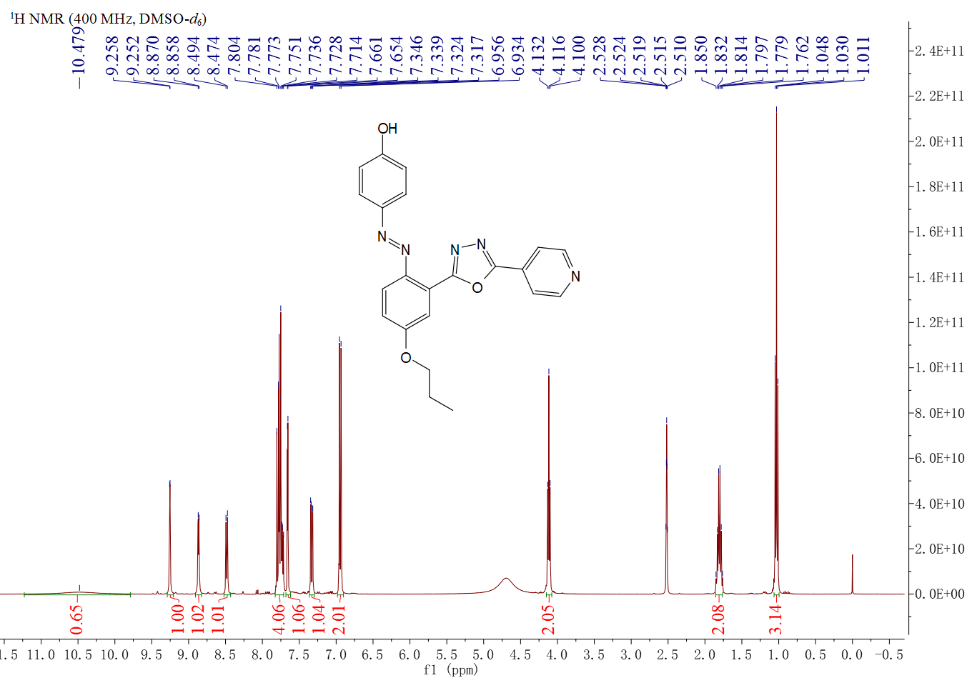
Figure 109. ¹H NMR spectrum of compound 5dg

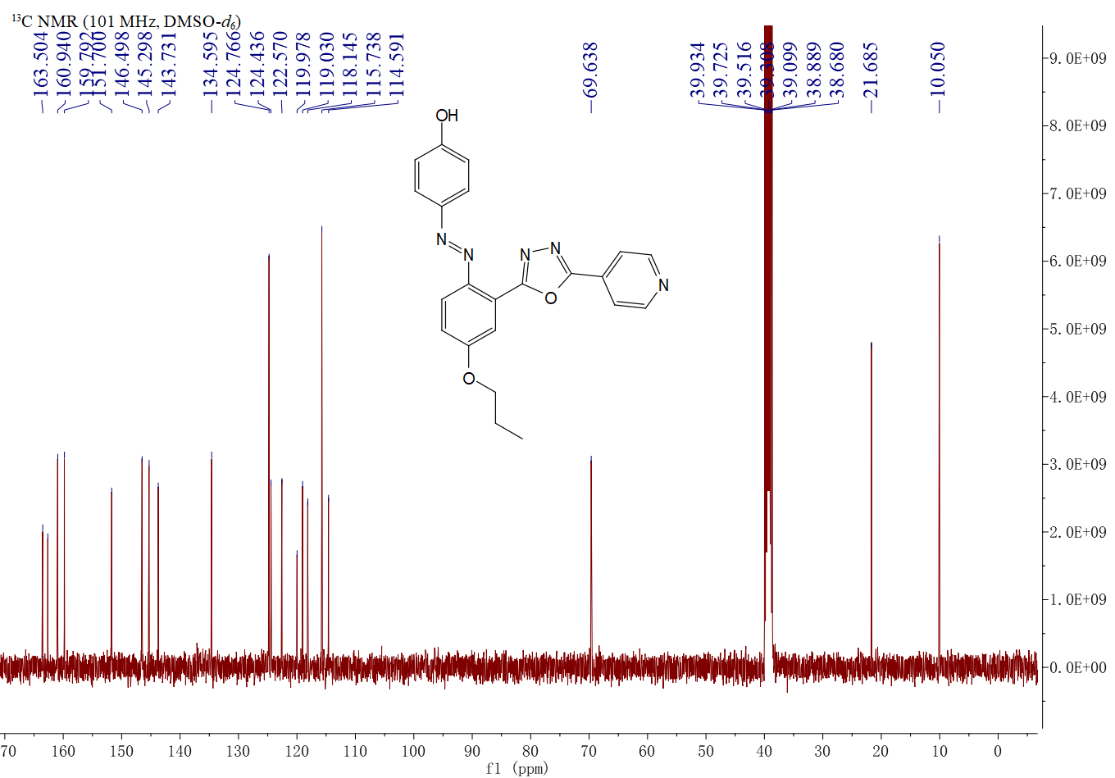
Figure S110. ¹³C NMR spectrum of compound 5dg

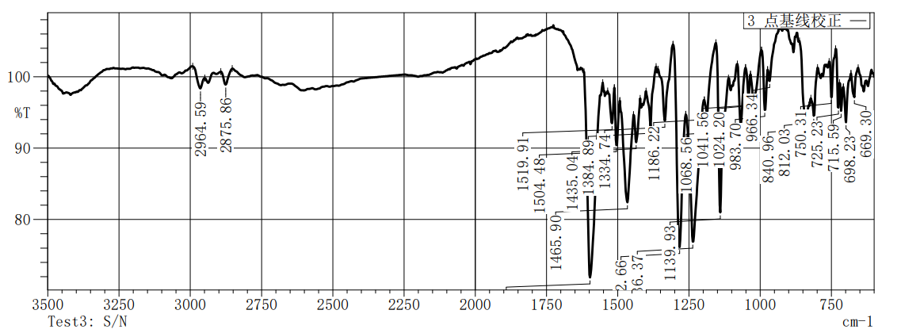
Figure S111.IR spectrum of compound 5dg

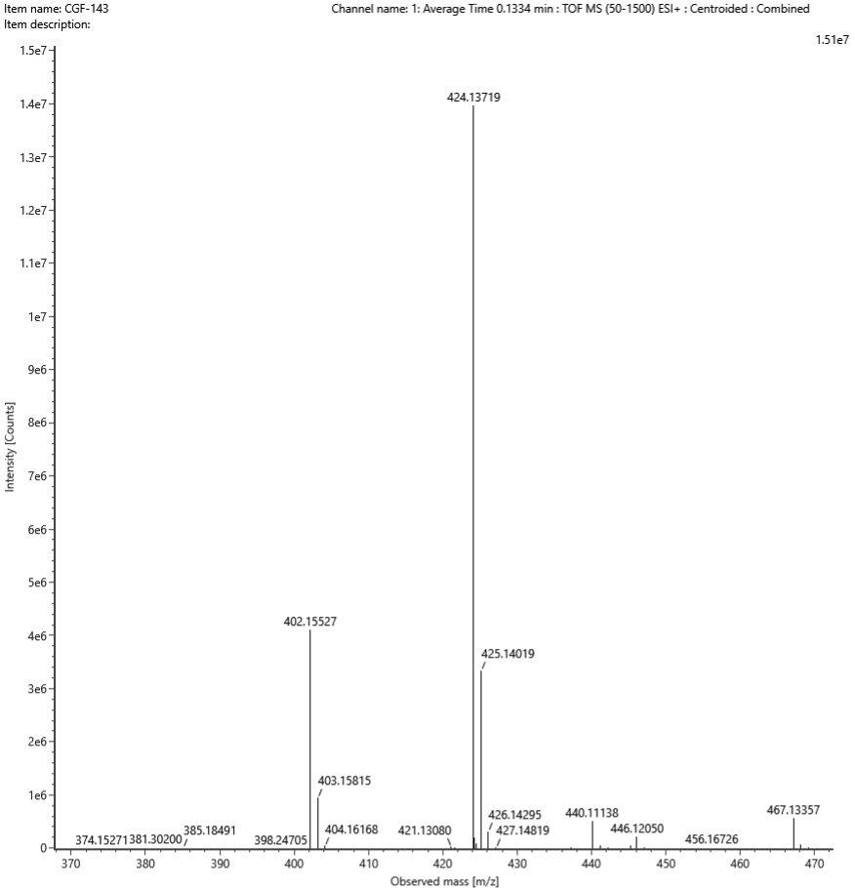
Figure S112. HRMS spectrum of compound 5dg

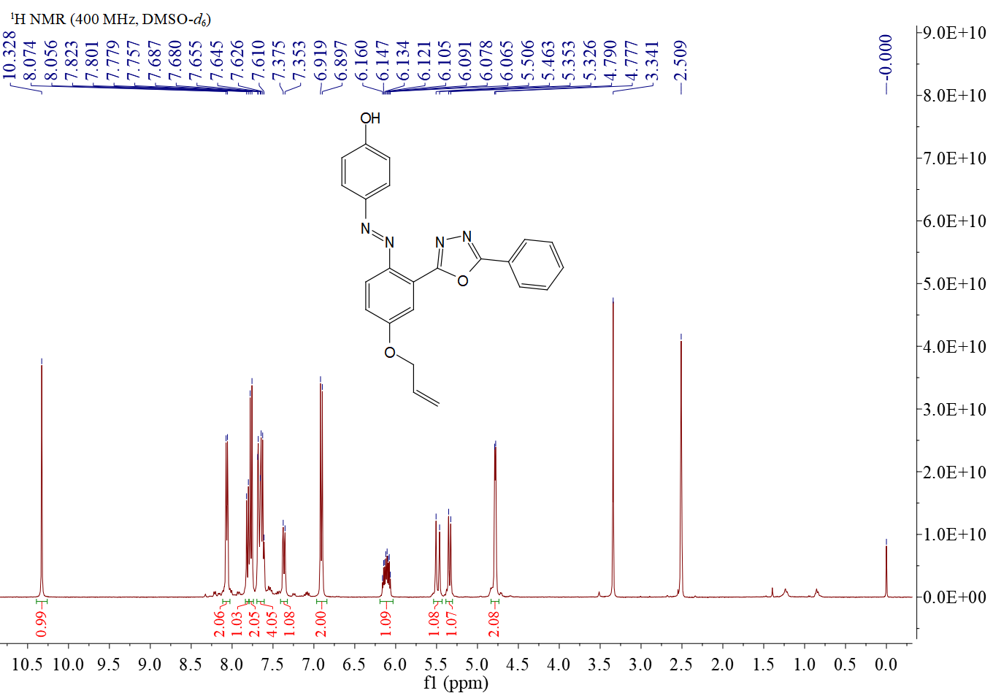
Figure 113. ¹H NMR spectrum of compound 5ea
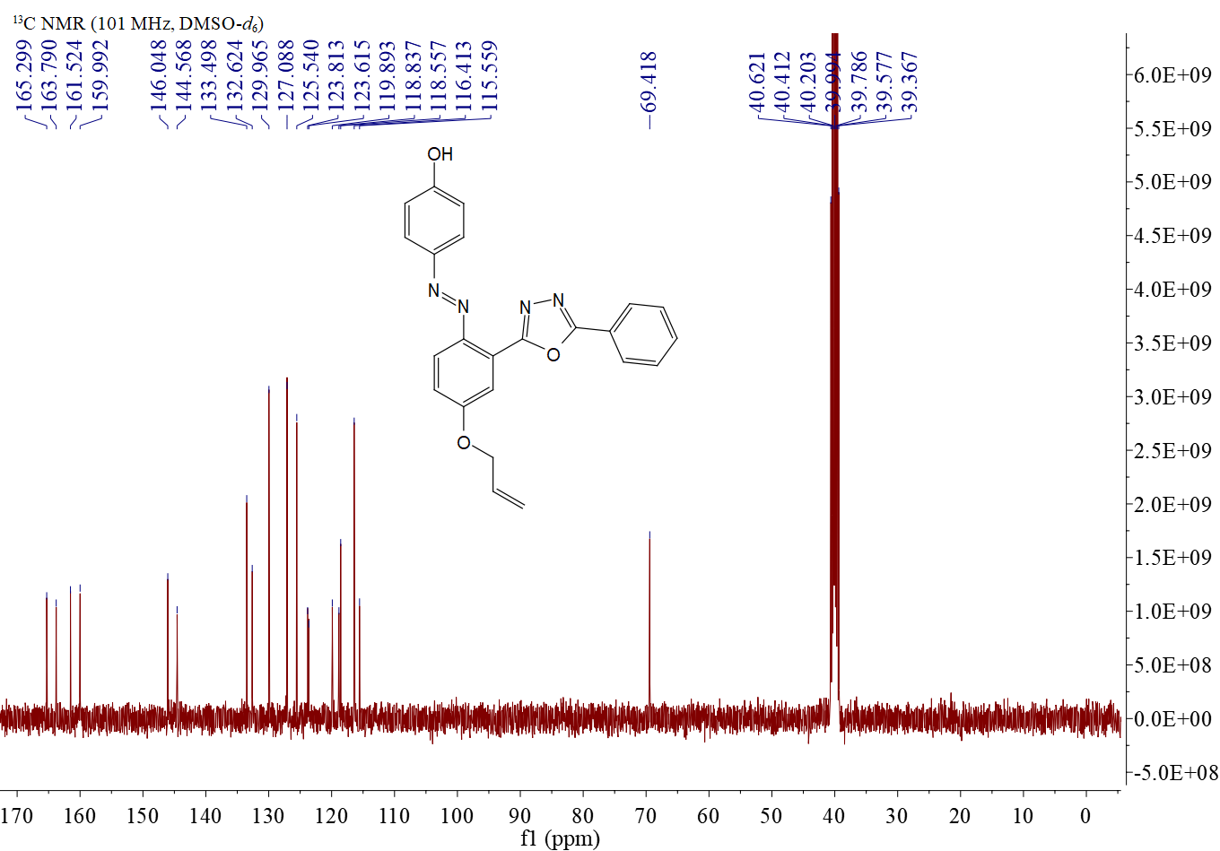
Figure S114. ¹³C NMR spectrum of compound 5ea

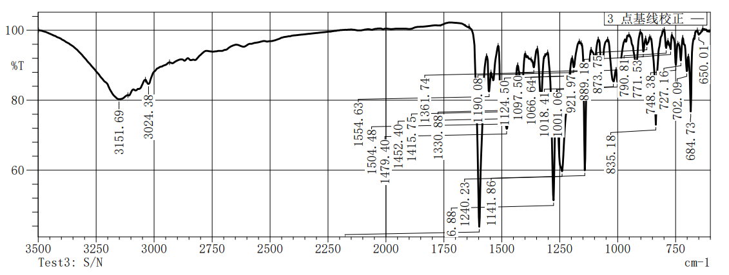
Figure S115.IR spectrum of compound 5ea

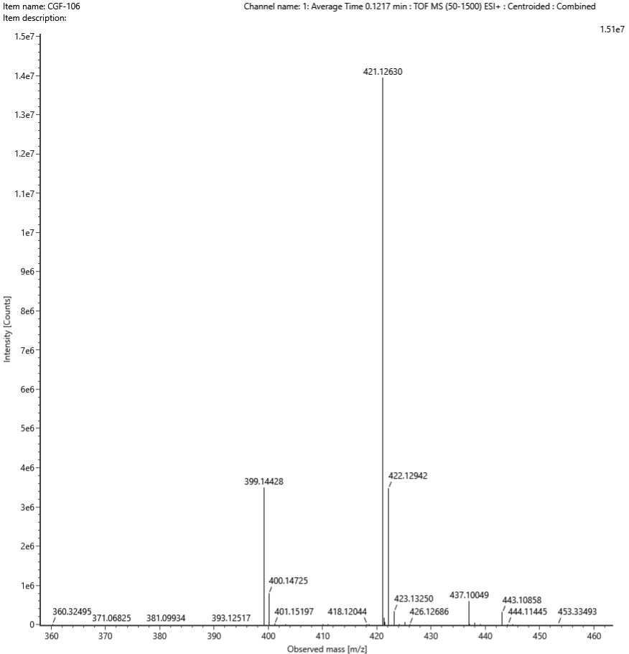
Figure S116. HRMS spectrum of compound 5ea
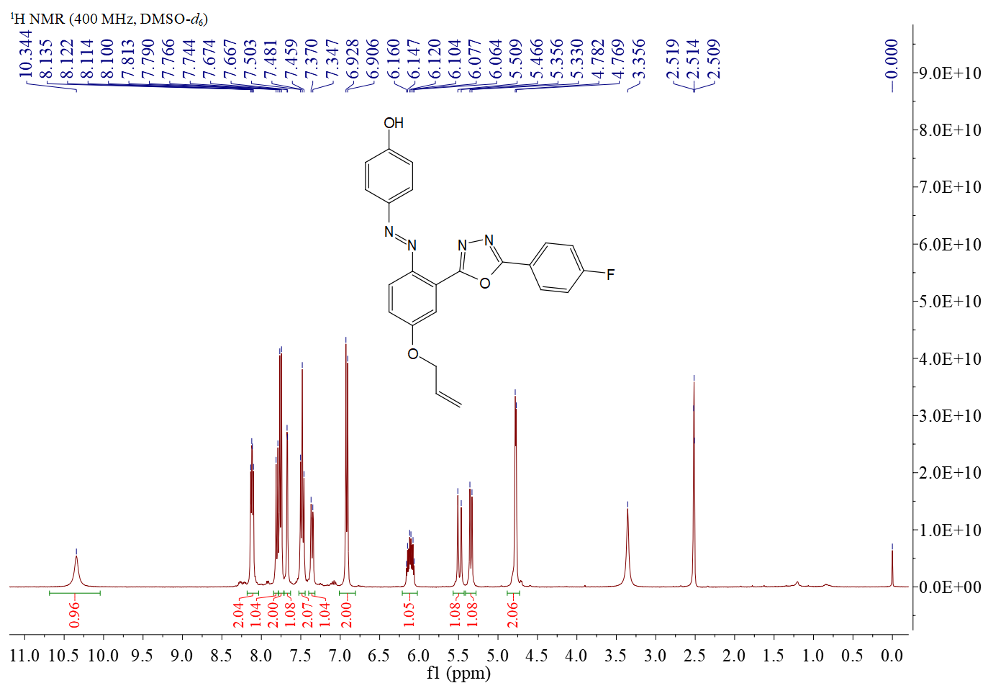
Figure 117. ¹H NMR spectrum of compound 5eb

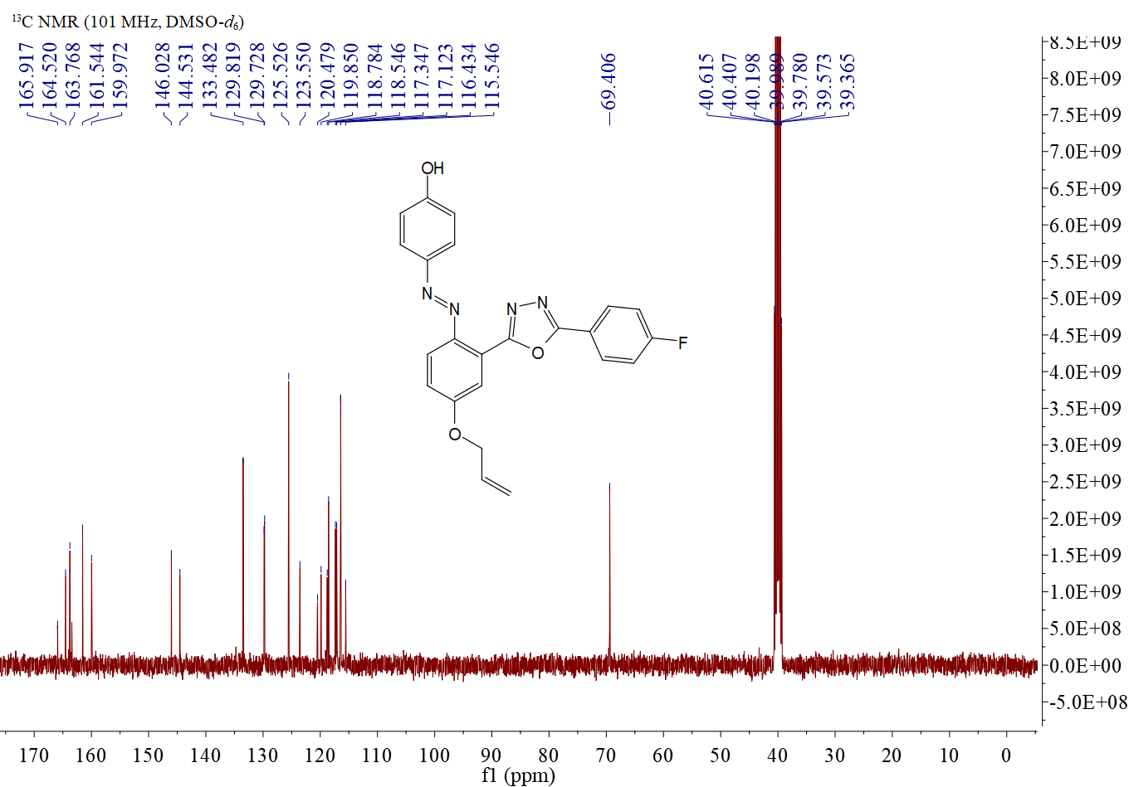
Figure S118. ¹³C NMR spectrum of compound 5eb

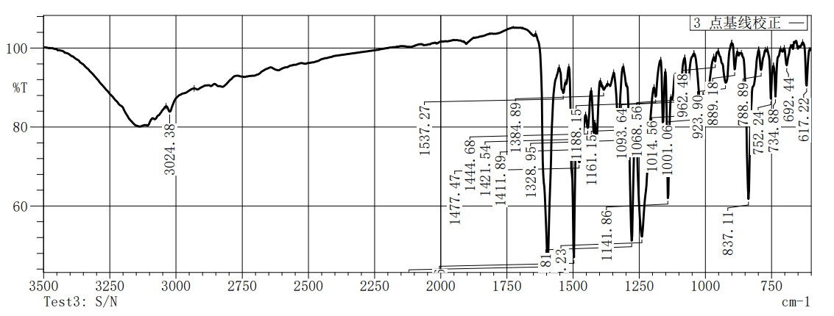
Figure S119.IR spectrum of compound 5eb

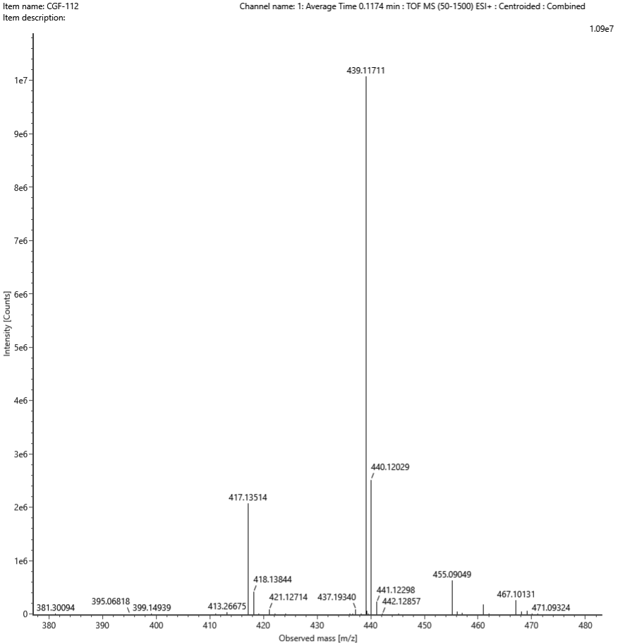
Figure S120. HRMS spectrum of compound 5eb

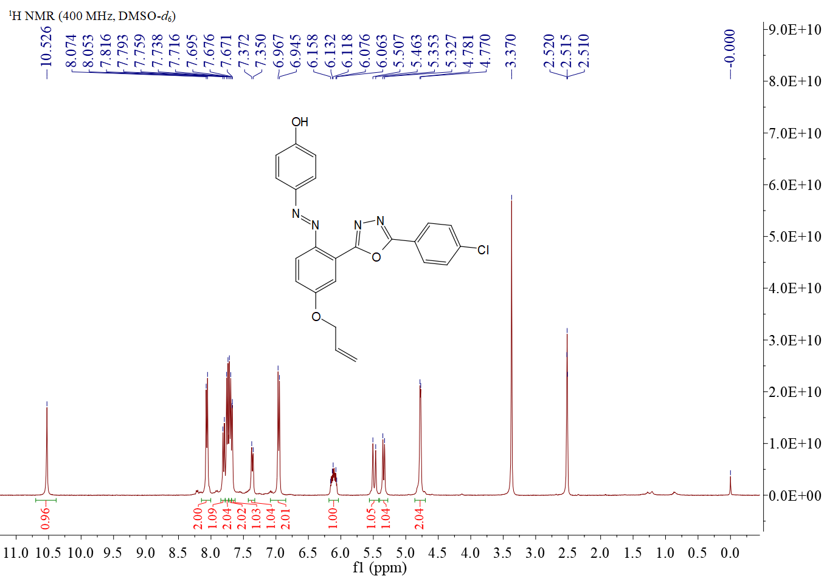
Figure 121. ¹H NMR spectrum of compound 5ec
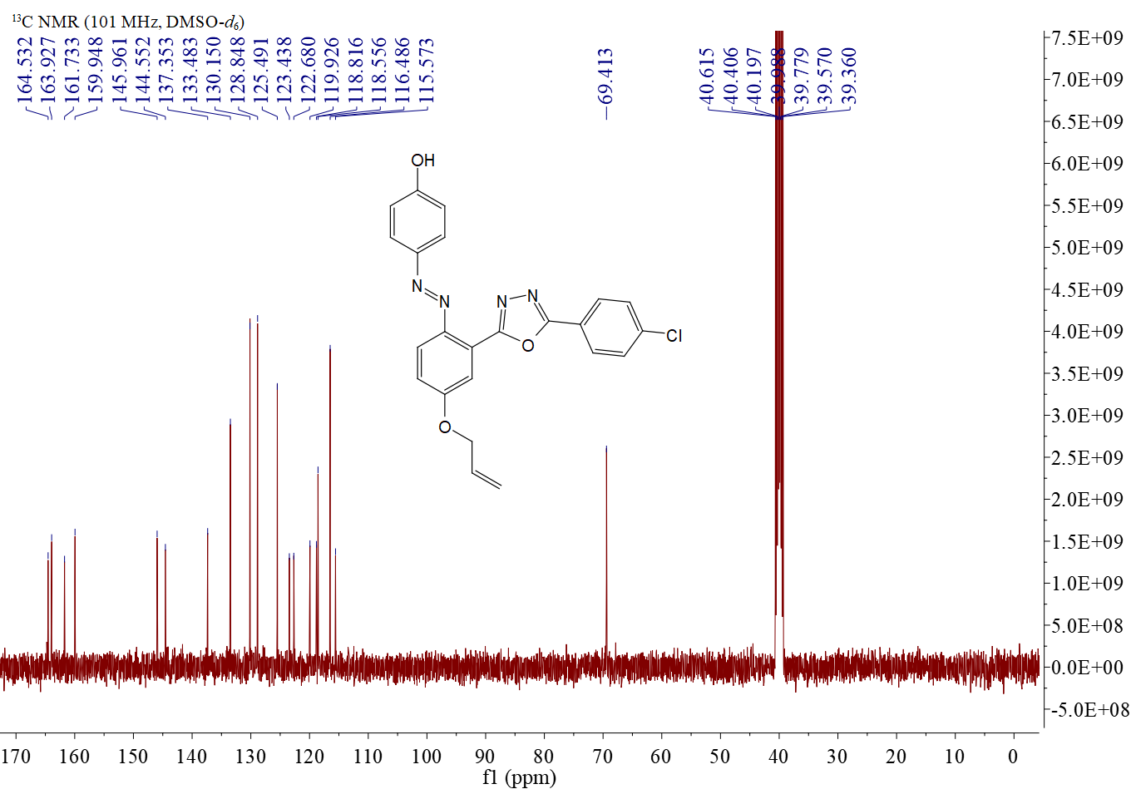
Figure S122. ¹³C NMR spectrum of compound 5ec

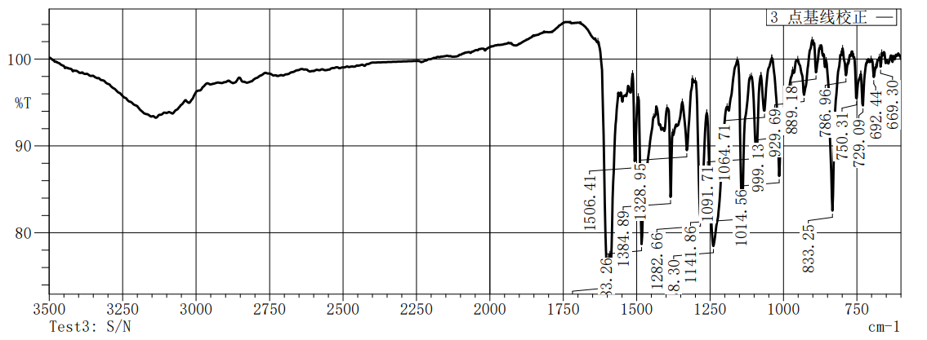
Figure S123.IR spectrum of compound 5ec

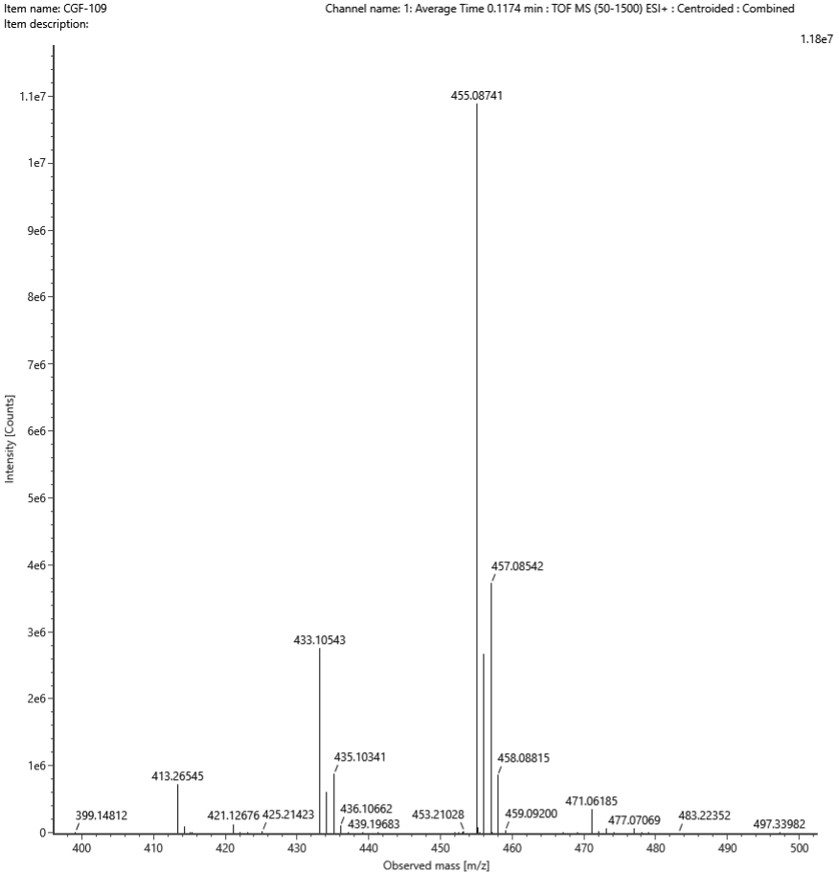
Figure S124. HRMS spectrum of compound 5ec
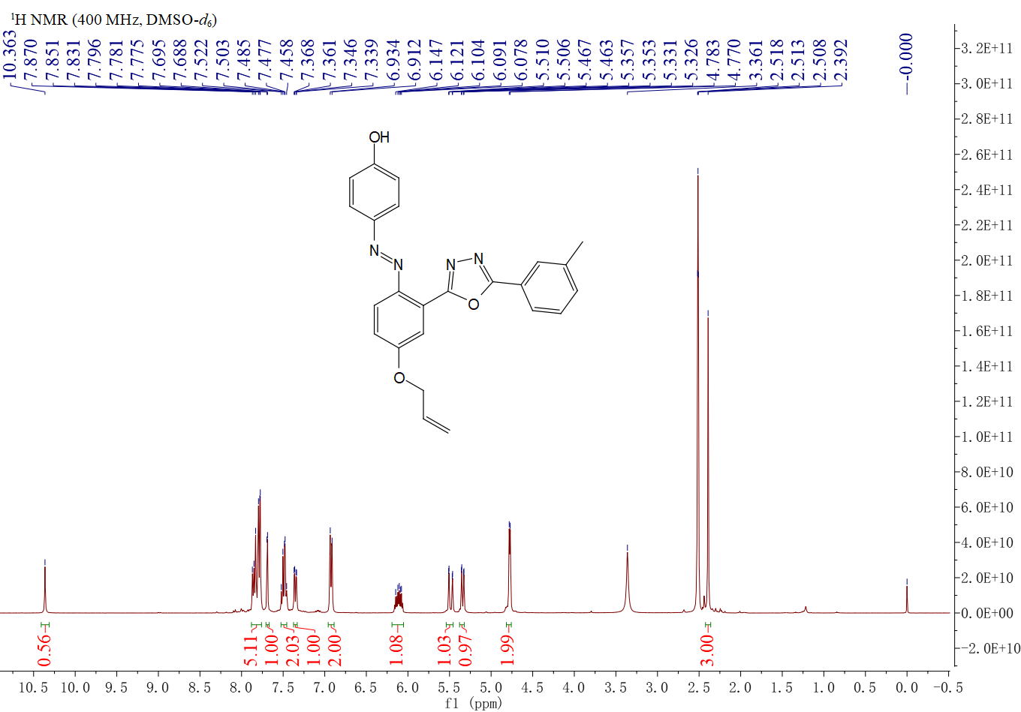
Figure 125. ¹H NMR spectrum of compound 5ed

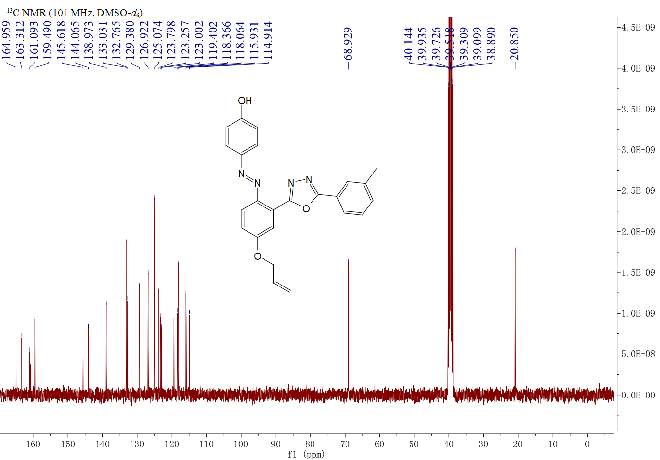
Figure S126. ¹³C NMR spectrum of compound 5ed

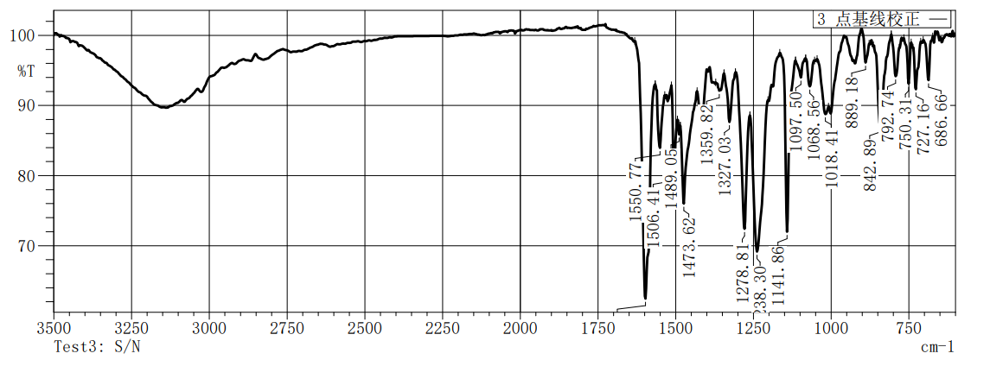
Figure S127.IR spectrum of compound 5ed

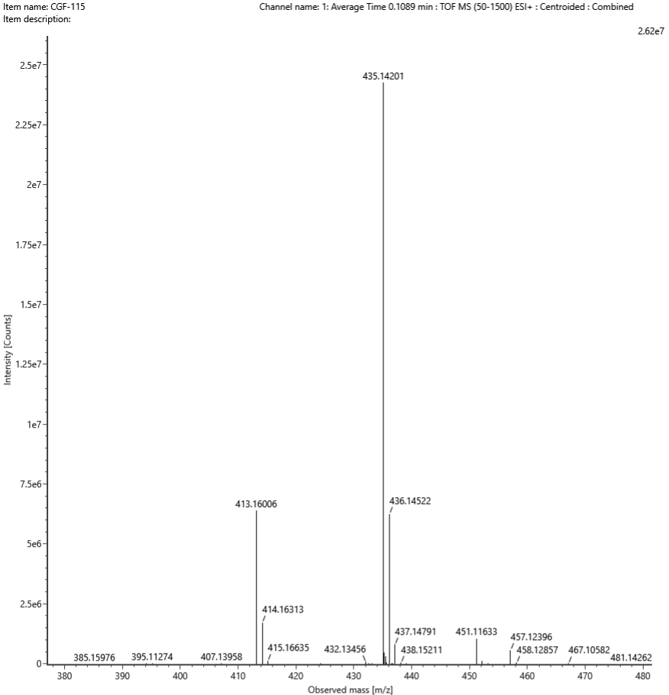
Figure S128. HRMS spectrum of compound 5ed

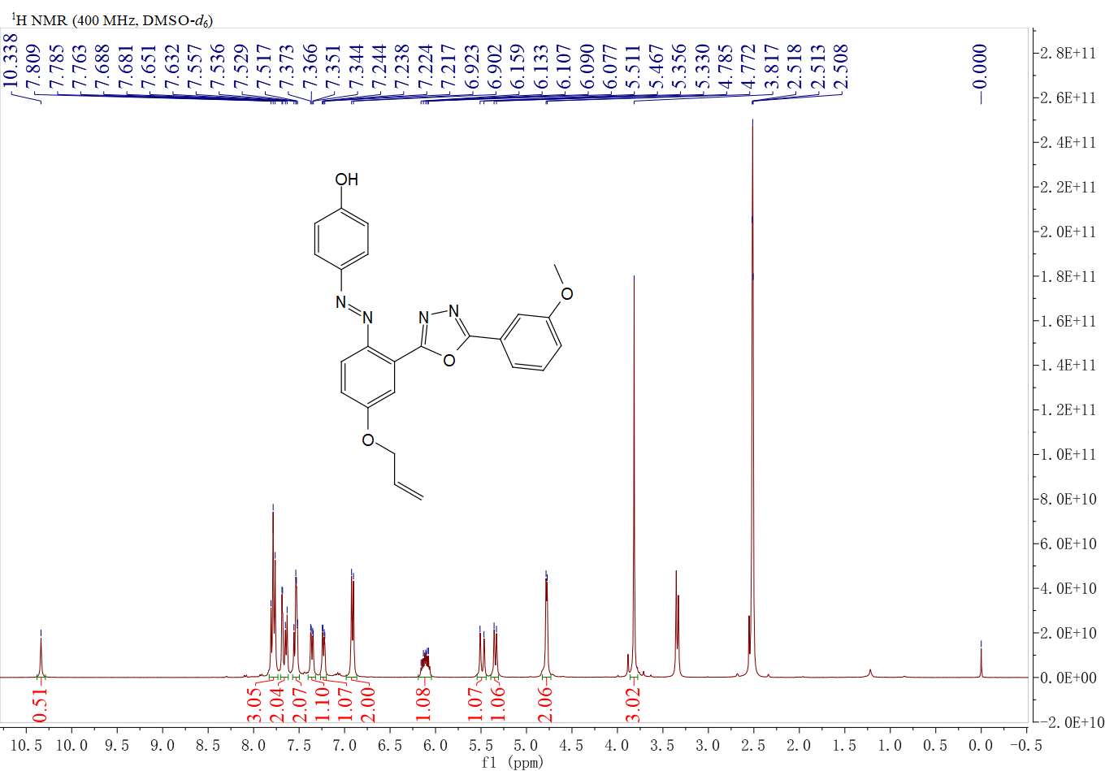
Figure 129. ¹H NMR spectrum of compound 5ee
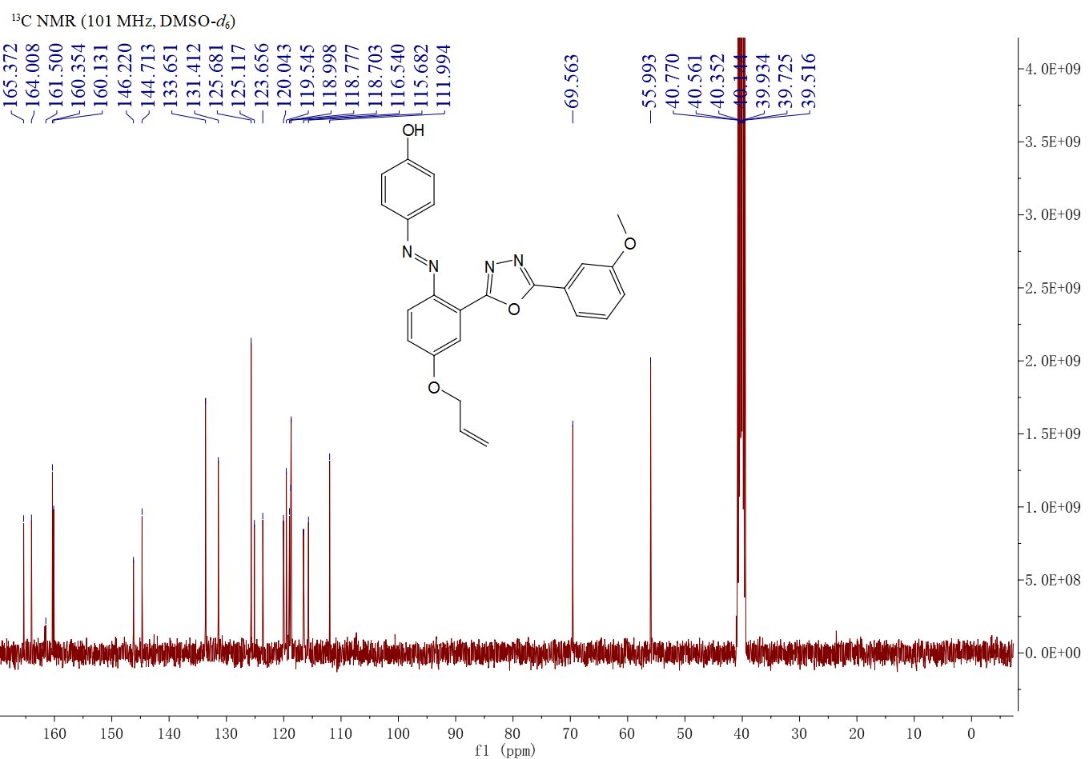
Figure S130. ¹³C NMR spectrum of compound 5ee

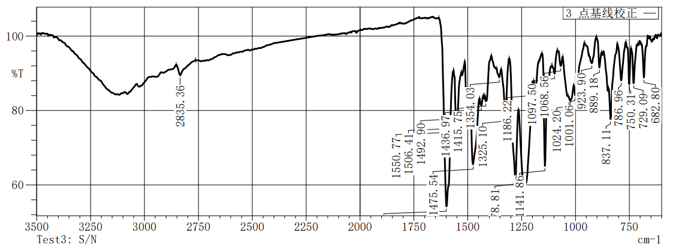
Figure S131.IR spectrum of compound 5ee

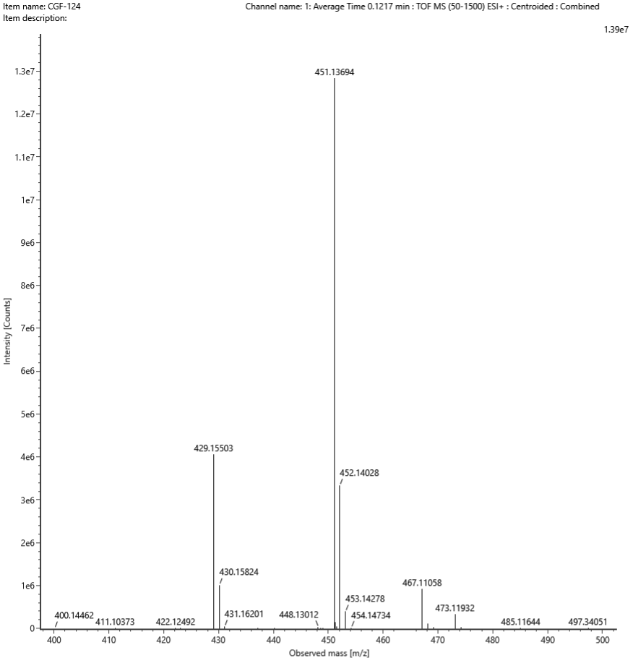
Figure S132. HRMS spectrum of compound 5ee
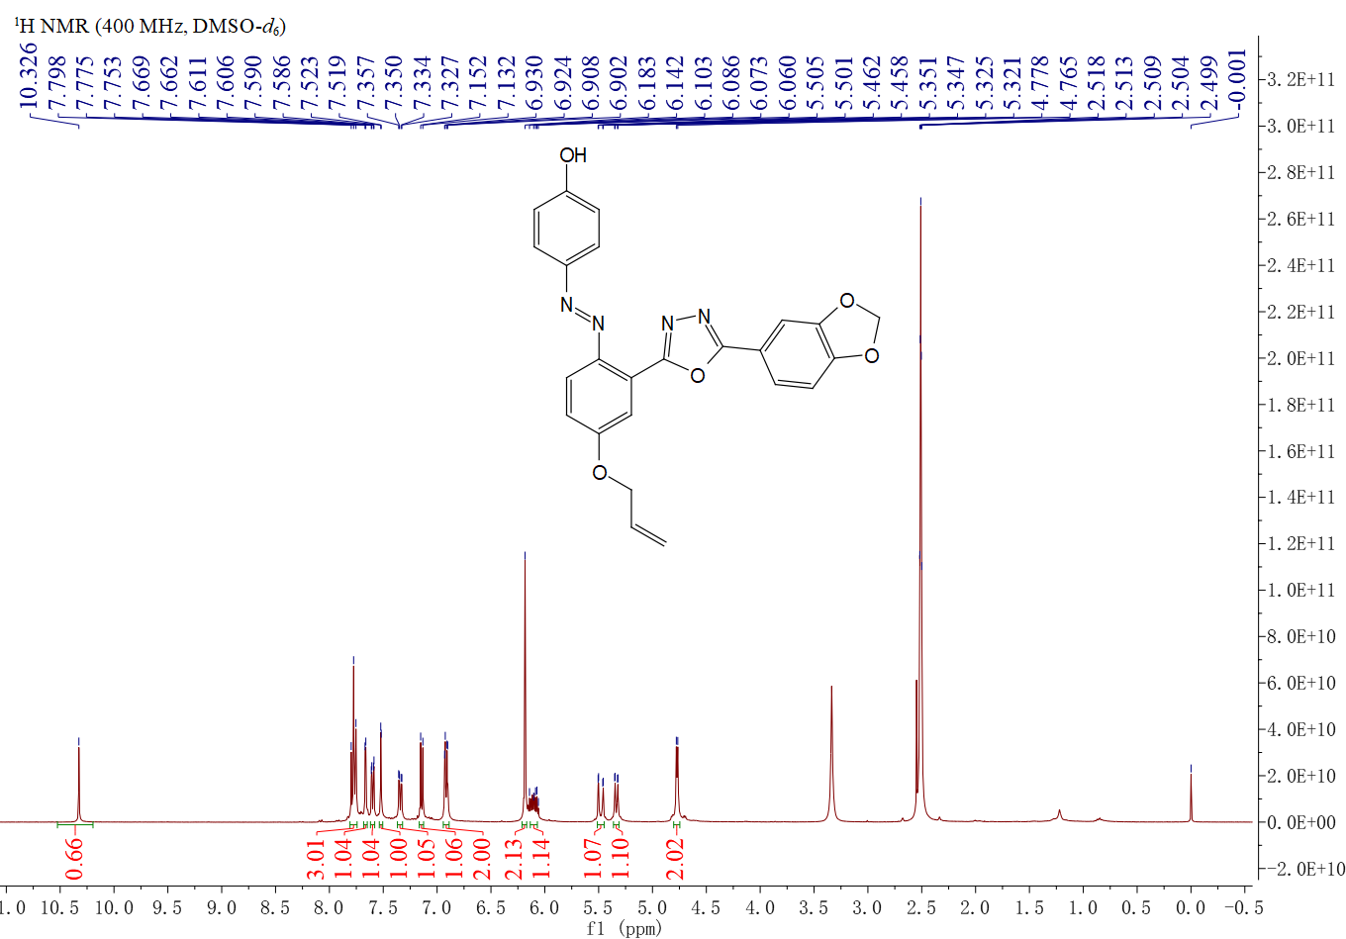
Figure 133. ¹H NMR spectrum of compound 5ef

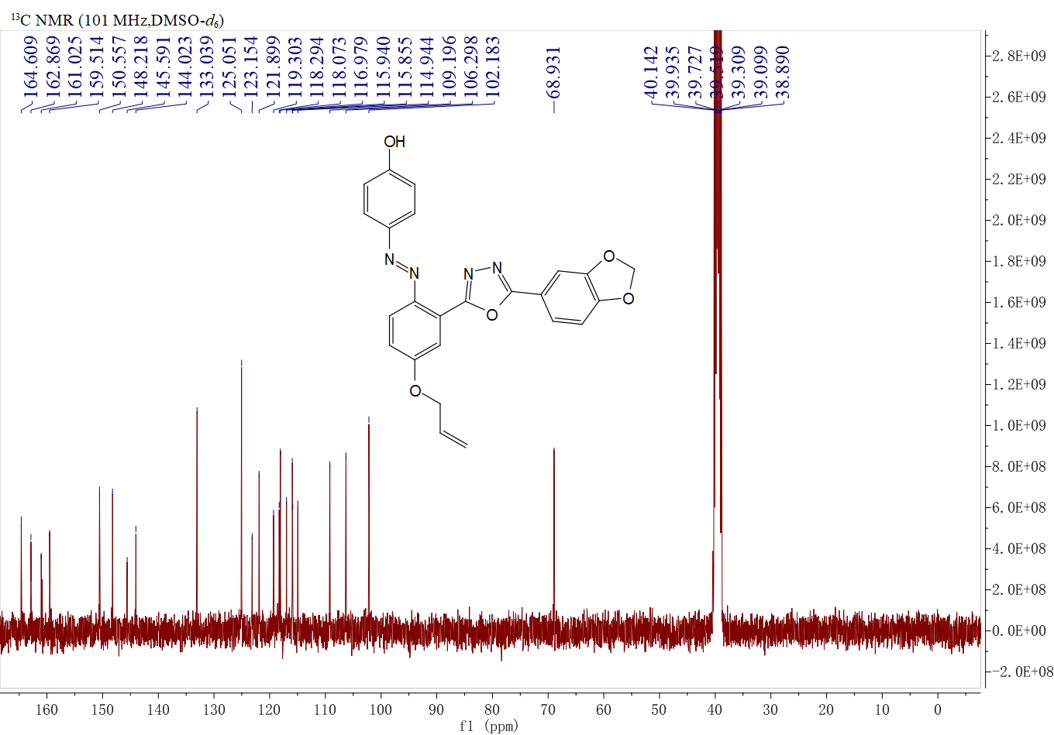
Figure S134. ¹³C NMR spectrum of compound 5ef

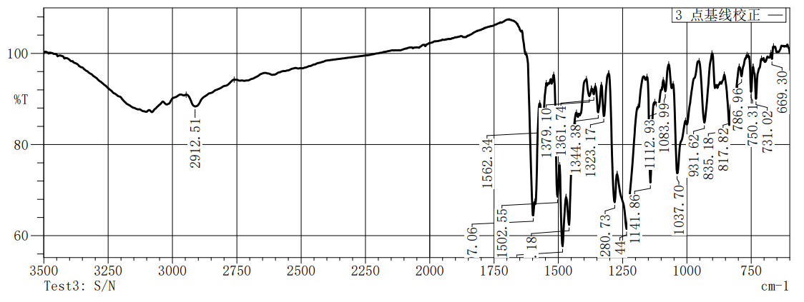
Figure S135.IR spectrum of compound 5ef

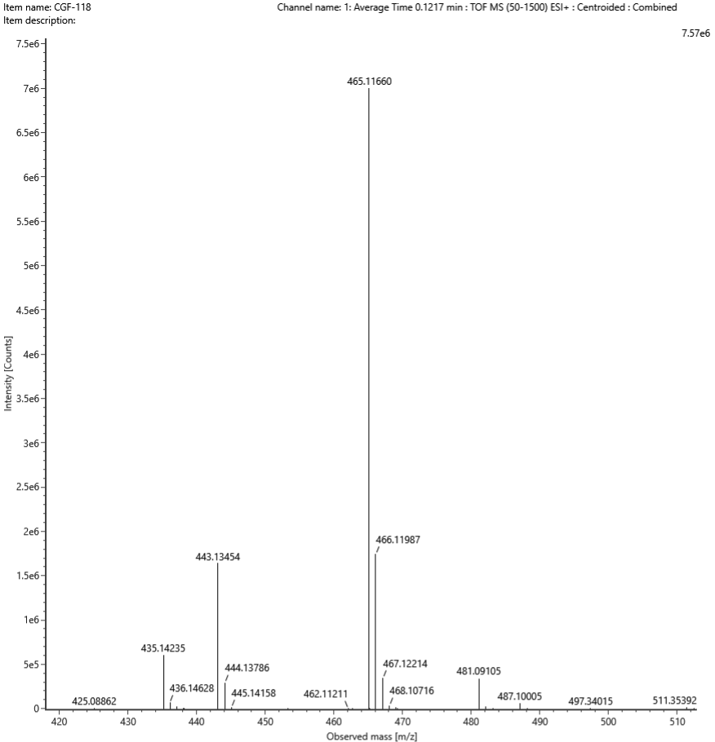
Figure S136. HRMS spectrum of compound 5ef

Figure 137. ¹H NMR spectrum of compound 5eg
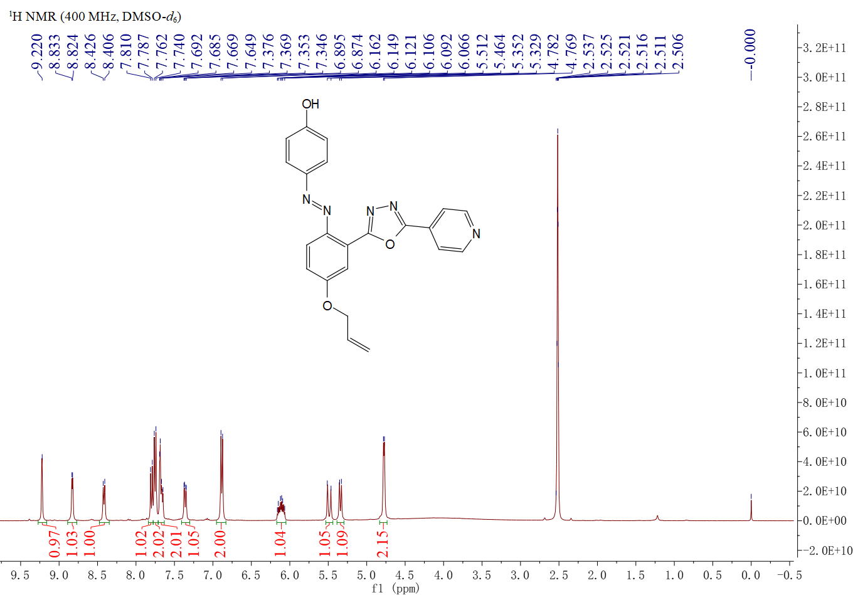
Figure S138. ¹³C NMR spectrum of compound 5eg

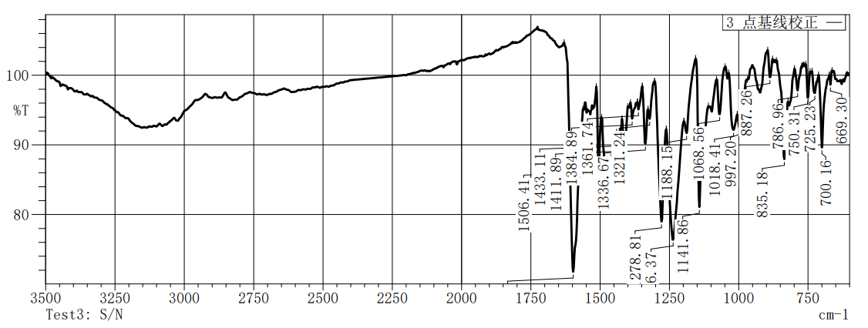
Figure S139.IR spectrum of compound 5eg

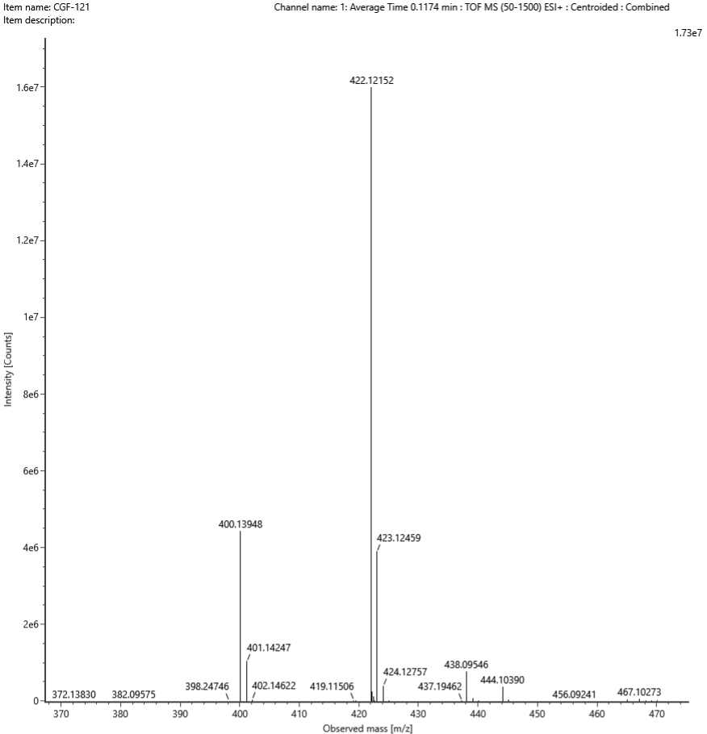
Figure S140. HRMS spectrum of compound 5eg
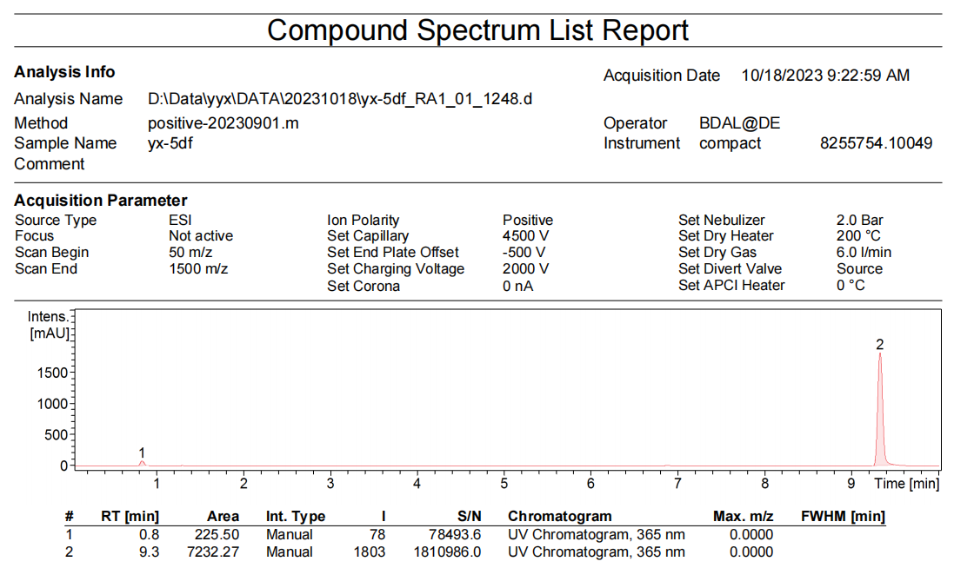
Figure S141. LC spectrum of compound 5df

