Experimental and theoretical evaluation of the anticorrosive proprieties of new 1,2,3-triazolyl-acridine derivatives

Caio Machado Fernandesª, Renato C. S. Lessa^{b}, Dora C. S. Costa^{c}, Lucas Guedesª, Vinicius Martinsª, Awad A. Al-Rashdi^{d}, Vitor Francisco Ferreira da Silva^{c}, Fernando de C. da Silva^{c}, Júlio César M. Silvaª, Marcela C. de Moraes^{b}, Hassane Lgaz^{e*}, Eduardo A. Ponzio^{a*}

ªLaboratório de Materiais da UFF, Instituto de Química, Universidade Federal Fluminense, Niterói, 24020-141, Rio de Janeiro, Brasil.
^{b}BioCrom, Laboratório de Cromatografia de Bioafinidade e Química Ambiental, Instituto de Química, Universidade Federal Fluminense, Niterói, 24020-141, Rio de Janeiro, Brasil.
^{c}LabSOA, Laboratório de Síntese Orgânica Aplicada, Instituto de Química, Universidade Federal Fluminense, Niterói, 24020-141, Rio de Janeiro, Brasil.
^{d}Chemistry Department, Umm Al-Qura University, Al-Qunfudah University College, Saudi Arabia.
^{e}Innovative Durable Building and Infrastructure Research Center, Center for Creative Convergence Education, Hanyang University ERICA, 55 Hanyangdaehak-ro, Sangrok-gu, Ansan-si, Gyeonggi-do, 15588, Republic of Korea

*Corresponding author: eduardoariel@id.uff.br (E.A.P.)
*Co-corresponding author: hlgaz@hanyang.ac.kr (H.L.)

Espectral Data
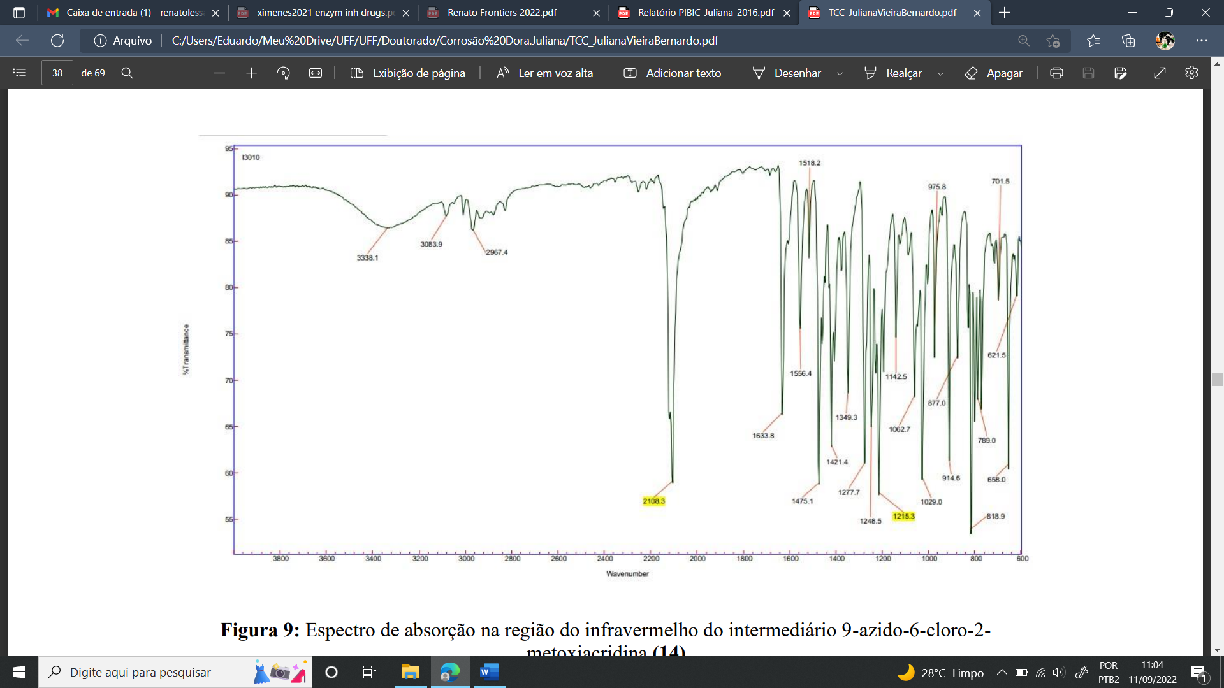
Figure S1. IR Spectrum (in KBr pellet) of 9-azido-6-chloro-2-methoxyacridine.
Figure S2. ¹H NMR Spectrum (DMSO-d₆, 300.00 MHz) of TTA.
Figure S3. ¹³C NMR Spectrum (APT, DMSO-d₆, 75.0 MHz) of compound TTA.

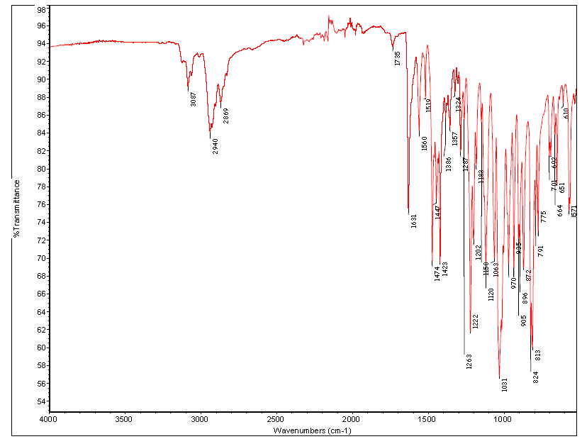
Figure S4. IR Spectrum of compound TTA.

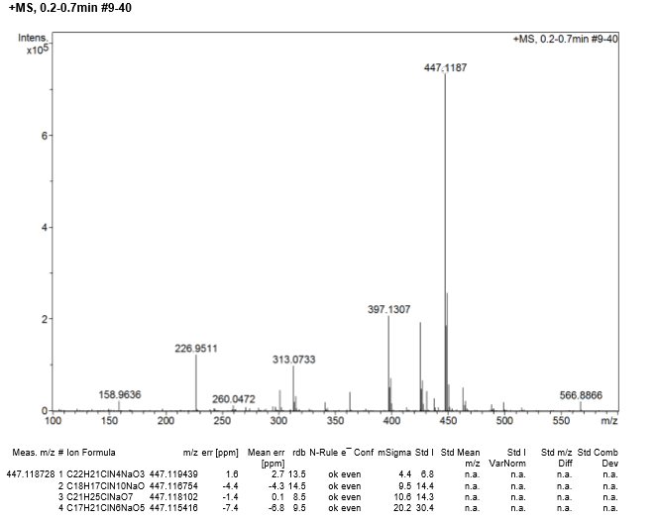
Figure S5. HRMS Spectrum (ESI) of compound TTA.

Figure S6. ¹H NMR Spectrum (DMSO-d₆, 500.00 MHz) of compound ATM.

Figure S7. ¹³C NMR Spectrum (APT, DMSO-d₆, 126.00 MHz) of compound ATM.

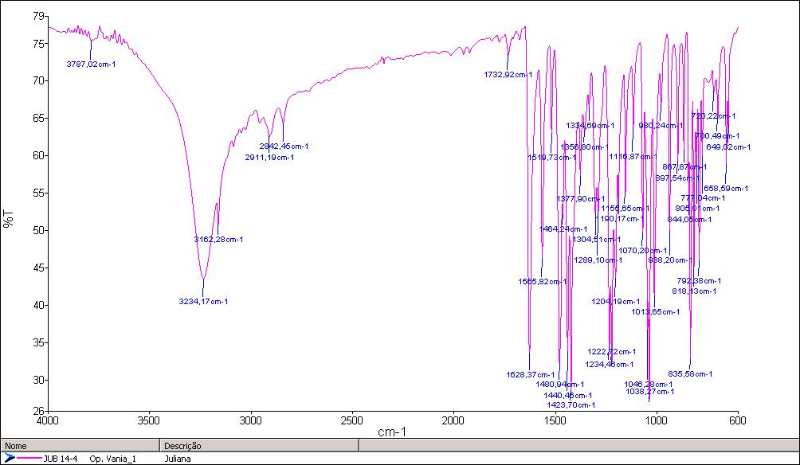
Figure S8. IR Spectrum (in KBr pellet) of compound ATM.

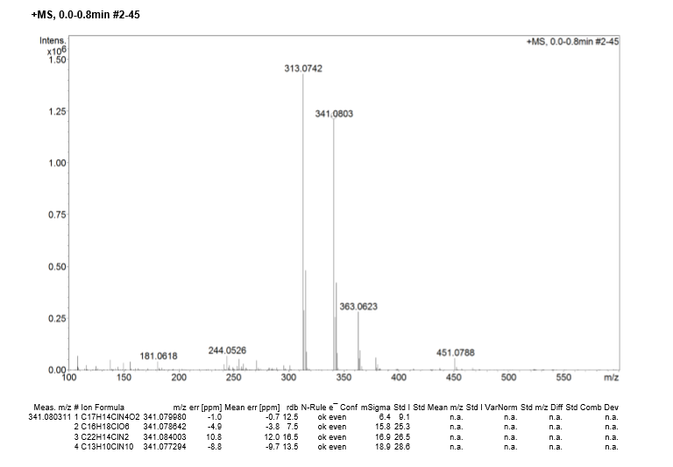
Figure S9. HRMS Spectrum (ESI) of compound ATM.
Figure S10. ¹H NMR Spectrum (DMSO-d₆, 500.00 MHz) of compound ATA.
Figure S11. ¹³C NMR Spectrum (APT, DMSO-d₆, 126.00 MHz) of compound ATA.

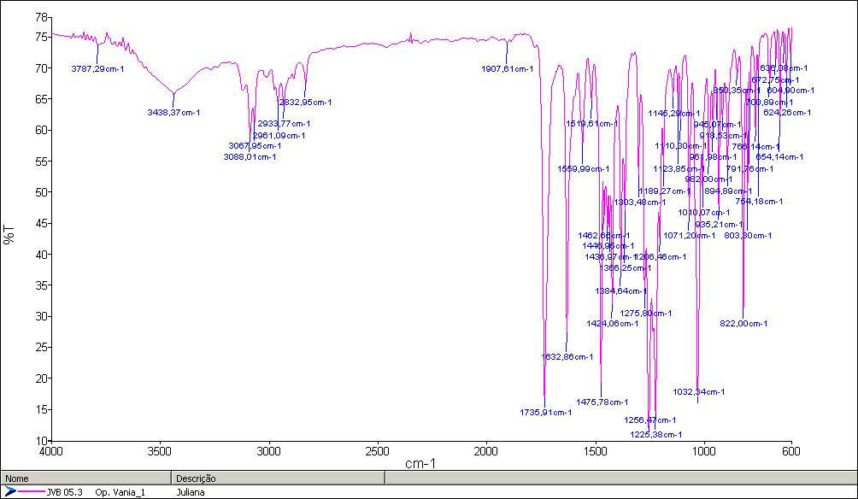
Figure S12. IR Spectrum (in KBr pellet) of compound ATA.
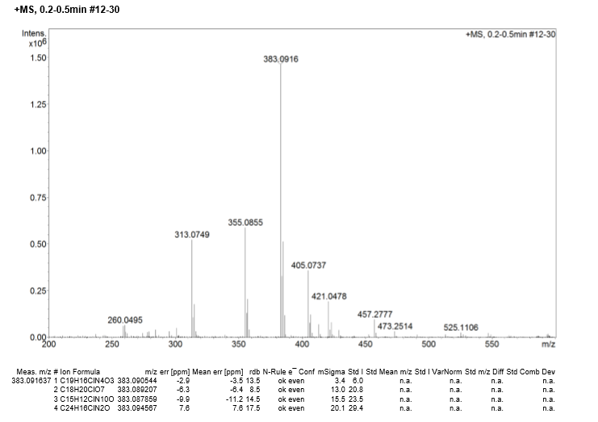Figure S13. HRMS Spectrum (ESI) of compound ATA.
Figure S14. Langmuir isotherms for TTA, ATM, and ATA at 298, 313, and 333 K.

Figure S15. Intermodulation spectra for TTA in HCl 1 mol L⁻¹ at 298 K.

Figure S16. Intermodulation spectra for ATM in HCl 1 mol L⁻¹ at 298 K.

Figure S17. Intermodulation spectra for ATA in HCl 1 mol L⁻¹ at 298 K.

Table S1. Apparent activation energy (E_{a}) for mild steel in the absence and presence of different concentrations of TTA, ATM, and ATA in 1 mol L⁻¹ HCl at 298, 318 and 338 K.
Compound | Conc.  (mmol L⁻¹) | E_{a} (kJ mol⁻¹)
Blank | - | 70.2
TTA | 0.0625 | 63.7
 | 0.125 | 62.8
 | 0.25 | 62.5
 | 0.50 | 64.7
 | 1.00 | 61.2
ATM | 0.0625 | 62.2
 | 0.125 | 60.0
 | 0.25 | 60.2
 | 0.50 | 57.2
 | 1.00 | 61.7
ATA | 0.0625 | 61.2
 | 0.125 | 63.7
 | 0.25 | 63.3
 | 0.50 | 62.0
 | 1.00 | 60.5

