**SUPPORTING INFORMATION**

**Development and evaluation of rosmarinic acid loaded novel fluorescent porous organosilica nanoparticles as potential drug delivery system for cancer treatment**

Uyen-Chi Nguyen Le1, Ngoc Xuan Dat Mai2,3, Kieu-Minh Le4, Hoang Anh Vu4, Huynh-Nhu Thi Tran3,5, Tan Le Hoang Doan2,3,*

1 Faculty of Basic Science, University of Medicine and Pharmacy at Ho Chi Minh City, Ho Chi Minh City, Vietnam.

2 Center for Innovative Materials and Architectures, Vietnam National University, Ho Chi Minh City, Vietnam.

3 Vietnam National University, Ho Chi Minh City, Vietnam

4 Center for Molecular Biomedicine, University of Medicine and Pharmacy at Ho Chi Minh City, Ho Chi Minh City, Vietnam

5 Faculty of Biotechnology, University of Science, Vietnam National University, Ho Chi Minh City, Vietnam

Address correspondence to e-mail: [dlhtan@inomar.edu.vn](mailto:dlhtan@inomar.edu.vn)

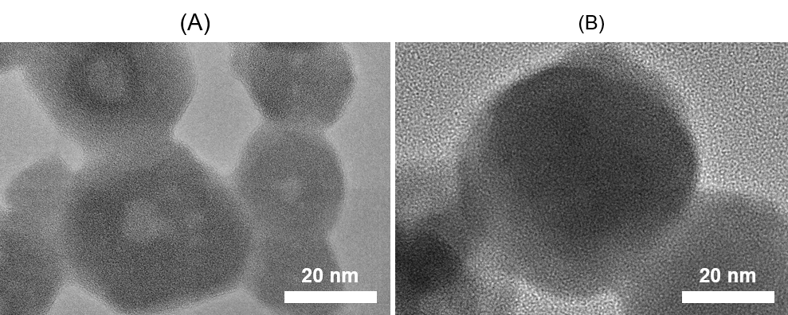

**Figure S1**. TEM images of (A) nanoparticles, and (B) rosmarinic acid-loaded nanoparticles. Scale bar: 20 nm.

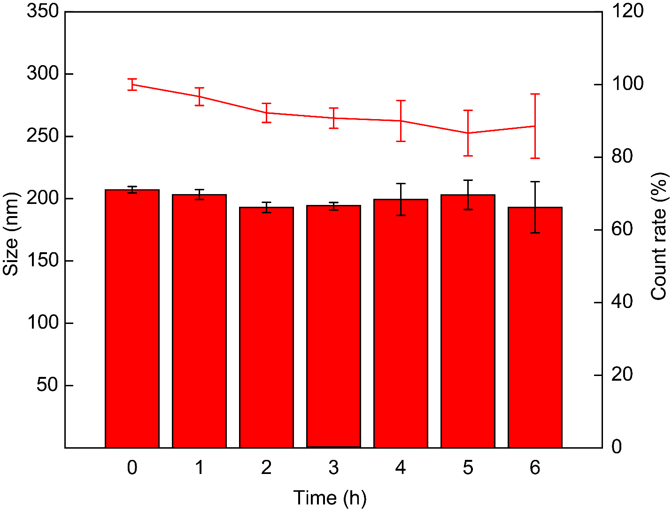

**Figure S2**. Size and count rate of NPs at various times