**Supporting Information**

**Biomass-derived carbon/iron composite (FexOy-BC (RM)) with excellent Cd(II) adsorption from wastewater**

**- Red mud resource utilization**

*Jiamin Qia, †,Hengxi Zhua, †, Tianyu Yanga, Xingyuan Wang a, Zixuan Wang a, Xiaoli Leia, Bin Lia,b,*, Wenmin Qianc,\**

1. *Faculty of Environmental Science and Engineering, Kunming University of Science and Technology, Kunming 650500, Yunnan, China*
2. *National-Regional Engineering Center for Recovery of Waste Gases from Metallurgical and Chemical Industries, Kunming, 650500, Yunnan, China*
3. *Yunnan Academy of Eco-Environmental Sciences, Kunming, 650500, Yunnan, China*

*\*Corresponding author:*

*Tel: +86 13529198525, E-mail:libin@kust.edu.cn (B. Li),*

*Tel:+86 17606909110, E-mail:qwm_noon@yahoo.com.cn(W. Qian).*

*† These authors contributed equally to this work.*

**1.1 Adsorption and regeneration experiment**

A specific amount of FexOy-BC (RM) was weighed and placed into a 60 mL brown bottle. Then, 25 mL of Cd(II) solution with a specific concentration was added. The pH value was adjusted with 1 M NaOH or HCl. For eight hours, the mixture was shaken with a water bath constant temperature oscillator (WE-1, Tianjin Ounuo Instrument Co., Ltd.). Using a 0.45-um water system filter, the sample solution was filtered. The Cd(II) concentration was determined by flame atomic absorption spectrometry (FAAS , Hitachi, Japan). A study was conducted on the effects of Cd(II) concentration, adsorbent dosage, pH, and adsorption time on adsorption efficiency. The adsorbent dosage was increased from 0.5 - 6 g/L to investigate the effect of different conditions on Cd(II) adsorption efficiency, From 2 - 20 mg/L of Cd(II), and from 2 - 7 mg/L of pH, the C0 was increased. At specific time intervals (5, 10, 20, 40, 60, 90, 120, 180, 240, 300, 360, 400 min) the concentration of Cd(II) in the sample solution was determined using flame absorption spectrometry (FAas, Hitachi, Japan). At each point, two parallel samples were taken , and the results were averaged. A regeneration experiment was conducted on the material to evaluate its performance. The adsorbed material was separated using a magnet and recovered for later use. The adsorbed material was placed into 50 mL of 2 M NaOH solution for ultrasonic soaking for 5 h. It was then centrifugally washed with deionized water until it became neutral. The adsorbent was placed into a vacuum drying oven and dried to constant weight at 65 ℃ for later use. The adsorbent was then reapplied to the Cd(II) adsorption-desorption cycle test.

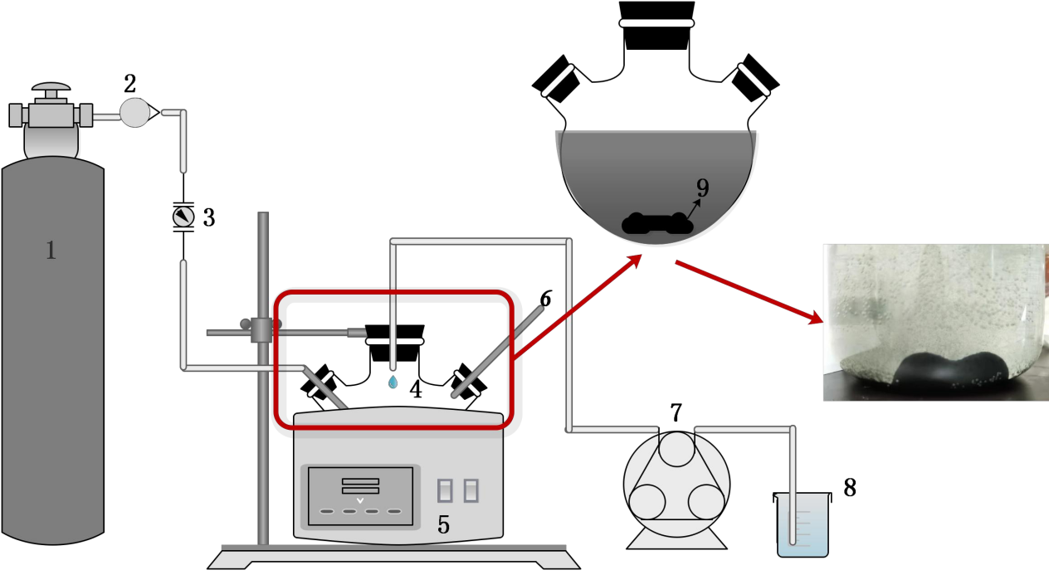

**Fig.S1 Flow chart of adsorption material synthesis (1 nitrogen cylinder, 2 pressure reducing valve, 3 flow meter, 4 reaction flask, 5 water bath, 6 N2 and H2 vent, 7 peristaltic pump, 8 NaBH4 solution, 9 rotor, 10 iron-carbon composite)**

**Table S1 Wenshan red mud in-situ XRF**

|  |  |  |  |  |  |  |  |  |  |  |  |
| --- | --- | --- | --- | --- | --- | --- | --- | --- | --- | --- | --- |
| **Element** | **O** | **Na** | **Mg** | **Al** | **Si** | **Cl** | **Ca** | **Ti** | **Fe** | **K** | **S** |
| **（wt%）** | **36.54** | **5.56** | **0.19** | **9.55** | **6.06** | **0.07** | **11.97** | **4.10** | **24.11** | **0.19** | **0.46** |

|  |  |  |  |  |  |  |  |  |  |  |  |  |  |  |
| --- | --- | --- | --- | --- | --- | --- | --- | --- | --- | --- | --- | --- | --- | --- |
| **Element** | **O** | **Na** | **Mg** | **Al** | **Si** | **Cl** | **Ca** | **Ti** | **Fe** | **K** | **S** | **P** | **Cu** | **Sr** |
| **（wt%）** | **11.75** | **0.03** | **0.08** | **0.07** | **0.20** | **0.12** | **1.19** | **0.01** | **0.14** | **0.62** | **0.04** | **0.04** | **0.01** | **0.01** |

**Table S2 Walnut shell in-situ XRF**

**Table S3 Walnut shell original sample organic element content test**

|  |  |  |
| --- | --- | --- |
| **Element** | **O** | **C** |
| **（wt%）** | **11.75** | **85.74** |

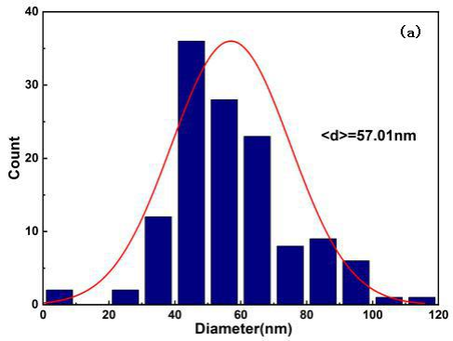

**Fig.S2 Particle size distribution of FexOy-BC(RM)**

**Table S4 Comparison of specific surface area, pore volume and average pore size of red mud measured by BJH method and FexOy-BC(RM)**

|  |  |  |  |
| --- | --- | --- | --- |
| **Materials** | **Specific surface area**  **m2/g** | **Confusion**  **cm3/g** | **Average pore size**  **nm** |
| **RM** | **10.3315** | **0.02518** | **11.0134** |
| **FexOy-BC(RM)** | **18.0285** | **0.043768** | **23.6490** |

|  |  |
| --- | --- |
|  |  |

**Fig.S3 FexOy-BC(RM) TEM**

|  |  |  |
| --- | --- | --- |
|  |  |  |
|  | | |

**Fig.S4 XPS spectra of FexOy-BC (RM) before and after adsorption**

|  |  |
| --- | --- |
|  |  |

**Fig. S5 The adsorption kinetics of Cd(II) onto FexOy-BC (RM) fitted by**

**pseudo-first-order model (a) and pseudo-second-order model (b) (pH = 6, C0 =**

**10 mg/L, t = 25 ℃, M=0.5～5 g/L)**

**Table S5 Fitting parameters of Cd(II) adsorption kinetic model for iron carbon composite material FexOy-BC (RM)**

|  |  |  |  |  |  |  |  |  |
| --- | --- | --- | --- | --- | --- | --- | --- | --- |
| **FexOy- BC(RM)** | **M(g.L-1)** | **qe(mg.g -1)** | **Pseudo-first-order model** | | | **Pseudo-first-order model** | | |
| **K1(h-1)** | **qe(mg.g -1)** | ***R1* 2** | **K2(h-1)** | **qe(mg.g -1)** | ***R2* 2** |
| **0.5** | **11.0430** | **28.6338** | **10.9578** | **0.9997** | **41.0452** | **10.9719** | **0.9998** |
| **1** | **5.8779** | **22.2747** | **5.7622** | **0.9981** | **26.1861** | **5.7848** | **0.9988** |
| **2** | **2.0611** | **3.2855** | **2.1271** | **0.9948** | **1.6366** | **2.1271** | **0.9948** |
| **4** | **2.2241** | **7.0987** | **2.2178** | **0.9812** | **5.8045** | **2.2178** | **0.9812** |
| **5** | **1.5391** | **15.2119** | **1.4824** | **0.9883** | **31.6031** | **1.4998** | **0.9942** |

|  |  |
| --- | --- |
|  |  |
|  |  |

**Fig.S6 SEM pattern of FexOy-BC (RM) (a b c d) and FexOy-BC (e f g h) before (a b**

**e f) and after (c d g h) adsorption**

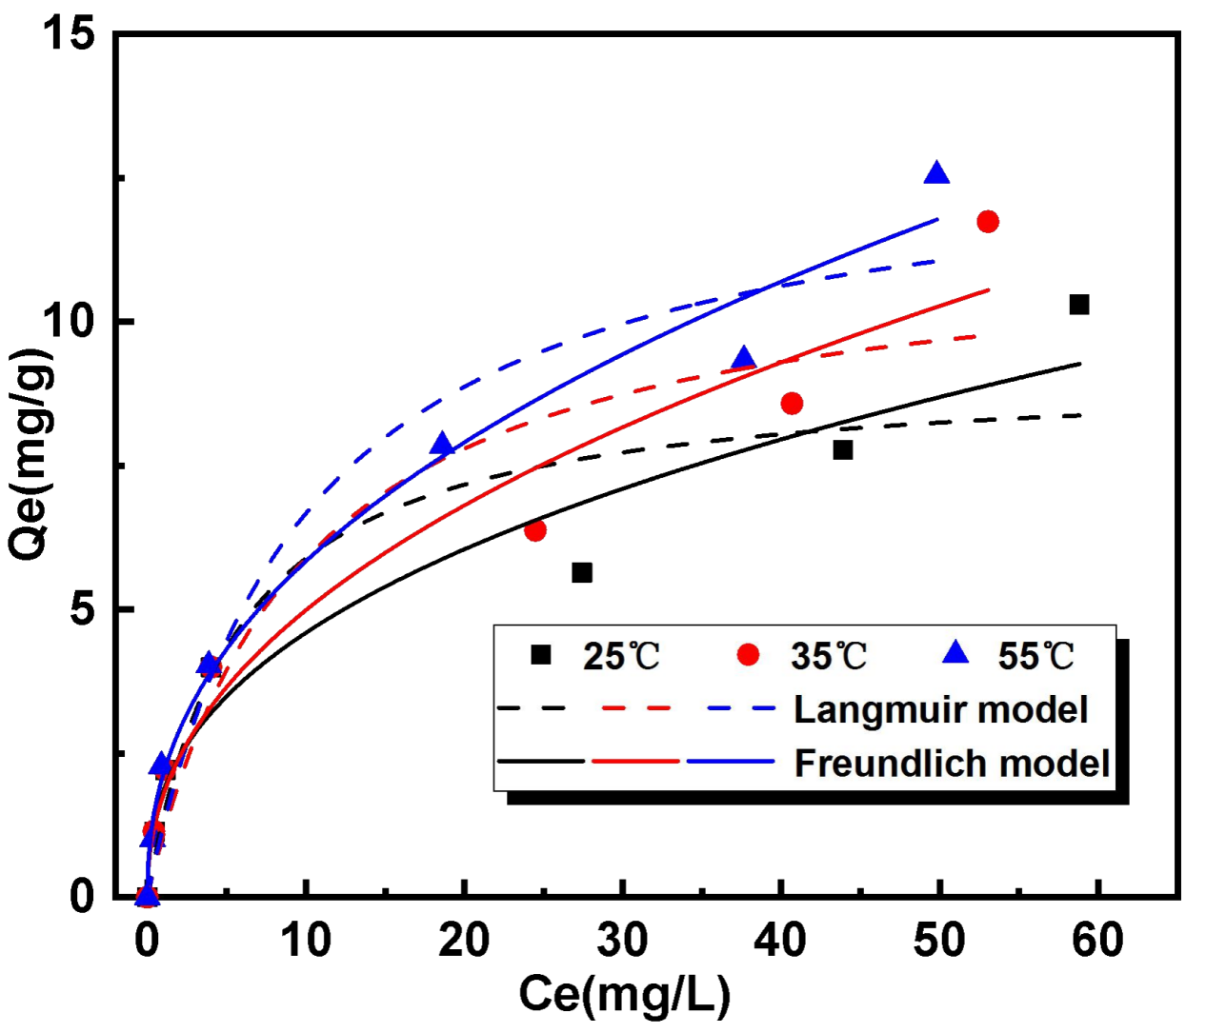

**Fig. S7 FexOy-BC (RM) adsorption isotherms for Cd(II) fitted to Langmuir**

**and Freundlich models (M = 4 g/L, pH = 6, C0 = 5～100 mg/L, T = 25, 35, 55 ℃)**

**Table S6 Parameters of Freundlich and Langmuir adsorption** **isotherm model**

|  |  |  |  |  |  |  |  |
| --- | --- | --- | --- | --- | --- | --- | --- |
| **FexOy- BC(RM)** | **T(℃)** | **Langmuir model** | | | **Freundlich model** | | |
| **K1(h-1)** | **qe(mg.g -1)** | ***R1* 2** | **K2(h-1)** | **qe(mg.g -1)** | ***R2* 2** |
| **25** | **9.1658** | **0.1797** | **0.8783** | **1.8470** | **2.5258** | **0.9492** |
| **35** | **11.5310** | **0.1043** | **0.8901** | **1.7746** | **2.2276** | **0.9581** |
| **55** | **13.2383** | **0.1015** | **0.9451** | **2.1358** | **2.2893** | **0.9820** |

|  |  |  |  |
| --- | --- | --- | --- |
|  |  |  | **C:/Users/QJM/Desktop/文章/1.png1** |
| **(a)** |  |  | **(b)** |

**Fig. S8 Analysis of adsorbent characterization: (a) N2 adsorption/desorption isotherms of** **FexOy-BC(RM)**

**Table S7 Mechanism of Cd(II) removal from aqueous solution by diferent adsorbent**

|  |  |  |  |
| --- | --- | --- | --- |
| **Adsorbent** | **Adsorbent feedstock** | **Main adsorption mechanism** | **Refs.** |
| LDH | Mg-Al-CO3–+Magnetic  Fe3O4/Mg-Al-CO3– | CdCO3 precipitation, surface adsorption, surface complexation | (Zhao et al. 2023) |
| FMBC | Biochar+KMnO4+Fe(NO3)3 | Complex, cation-π bonding | (Zhao et al. 2023) |
| MBC800-0.6300 | Corn straw+ferric nitrate | Chemisorption, electrostatic interac  tion, monolayer adsorption | (Khan et al. 2020) |
| RM | Bauxite residue | Alkaline precipitation | This work |
| FexOy-BC | FeSO4·7H2O+WS | Adsorption, complexation | This work |
| FexOy-BC(RM) | Bauxite residue(Fe)+WS | Adsorption, complexation, reduction | This work |

**Table S8 Performance comparison**

|  |  |  |  |  |
| --- | --- | --- | --- | --- |
| **Materials** | **Adsorption capacity**  **(mg/g)** | **Solution pH** | **Temperature (K)** | **Ref.** |
| Iron oxide activated red | 0.12 | 6 | 200 | (Khan et al. 2020) |
| Origin red mud | 1.35 | 6 | 298 | (SANTONA et al. 2006) |
| Acidified red mud | 0.95 | 6 | 298 | (SANTONA et al. 2006) |
| FexOy-BC(RM) | 2.2893 | 6 | 318 | This work |

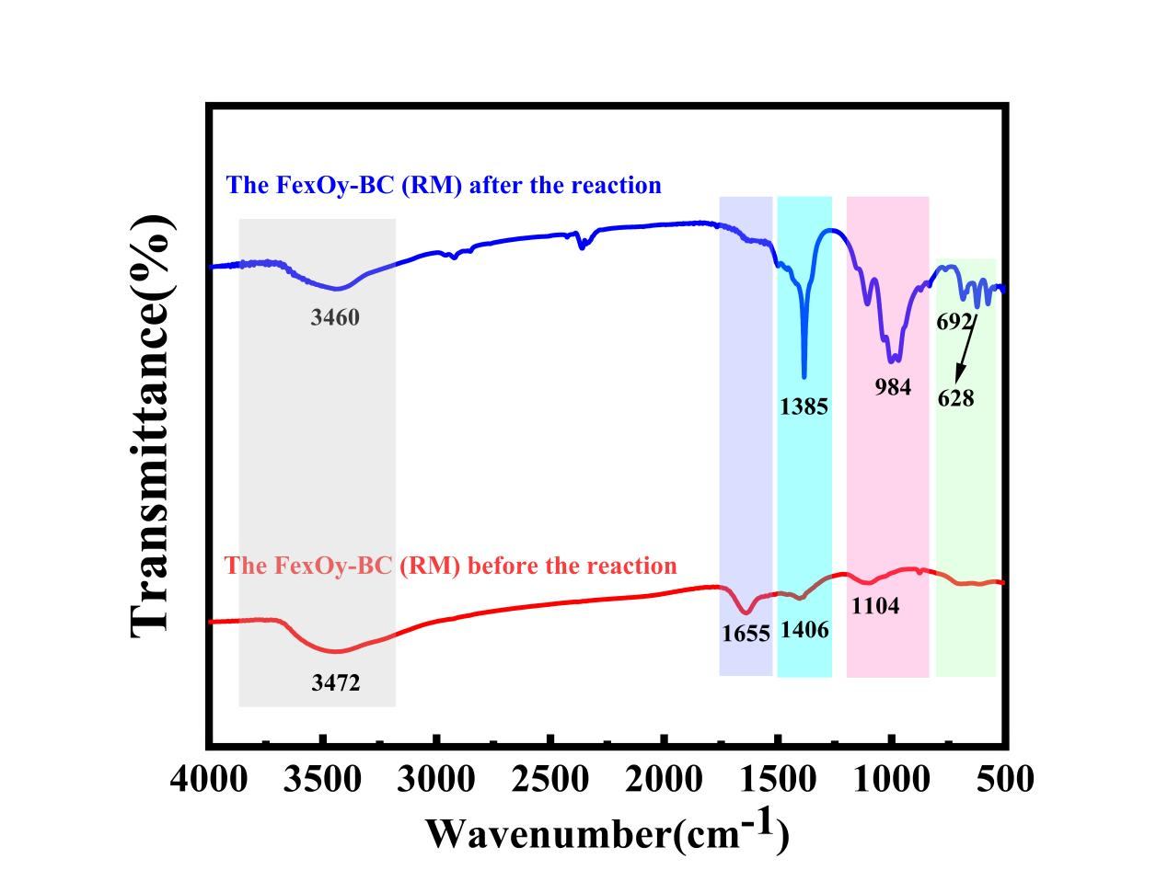

**Fig. S9 FTIR comparison before and after adsorption**

**References:**

Khan ZH, Gao M, Qiu W, Islam MS, Song Z (2020) Mechanisms for cadmium adsorption by magnetic biochar composites in an aqueous solution. Chemosphere 246:125701

SANTONA L, CASTALDI P, MELIS P (2006) Evaluation of the interaction mechanisms between red muds and heavy metals. Journal of Hazardous Materials 136:324-329

Zhao Z, Li Y, Zhou Y, Hou Y, Sun Z, Wang W, Gou J, Cheng X (2023) Activation of sulfite by micron-scale iron-carbon composite for metronidazole degradation: Theoretical and experimental studies. Journal of Hazardous Materials 448:130873