Supplementary Data
Structure-based design, synthesis and biological evaluation of N-substituted 6H-thiochromeno[2,3-c]quinolin-12(12H)-ones as potential breast cancer drugs
Maryam Rachmawati Sumitra^{a,b}, Lung-Ching Chen^{c,d}, Wei-Chen Tsai^{e}, Muhamad Ansar^{f}, Bashir Lawal^{a,b}, Ntlotlang Mokgautsi^{a,b}, Jih-Hwa Guh ^{j}, Alexander T.H Wu^{g,h,i}*, Hsu-Shan Huang^{a,b,e,i,k}*
ª PhD Program for Cancer Molecular Biology and Drug Discovery, College of Medical Science and Technology, Taipei Medical University, Taipei 11031, Taiwan
^{b} Graduate Institute of Cancer Biology and Drug Discovery, College of Medical Science and Technology, Taipei Medical University, Taipei 11031, Taiwan
^{c} Division of Cardiology, Department of Internal Medicine, Shin Kong Wu Ho-Su Memorial Hospital, Taipei 11101, Taiwan (marcus1831@gmail.com)
^{d} School of Medicine, Fu Jen Catholic University, New Taipei 24205, Taiwan
^{e} School of Pharmacy, National Defense Medical Center, Taipei 11490, Taiwan
^{f} Ph.D. Program in the Clinical Drug Development of Herbal Medicine, Taipei Medical University, Taipei 11031, Taiwan
^{g} The PhD Program of Translational Medicine, College of Science and Technology, Taipei Medical University, Taipei 11031, Taiwan
^{h} Clinical Research Center, Taipei Medical University Hospital, Taipei Medical University, Taipei 11031, Taiwan
^{i} Graduate Institute of Medical Sciences, National Defense Medical Center, Taipei 11490, Taiwan
^{j} School of Pharmacy, National Taiwan University, No. 33, Linsen S. Rd., Zhongzheng Dist., Taipei 10025, Taiwan
^{k} Ph.D. Program in Biotechnology Research and Development, College of Pharmacy, Taipei Medical University, Taipei 11031, Taiwan.
* Correspondence: huanghs99@tmu.edu.tw (H.-S.H.), chaw1211@tmu.edu.tw (ATH Wu)
Contents of figures Page no.
Fig. S1. ¹H NMR of compound 3 06
Fig. S2. ¹³C NMR of compound 3 06
Fig. S3. ¹H NMR of compound TC-S-1 (4) 07
Fig. S4. ¹³C NMR of compound TC-S-1 (4) 07
Fig. S5. ¹H NMR of compound 5 08
Fig. S6. ¹³C NMR of compound 5 08
Fig. S7. HRMS of compound 5 09
Fig. S8. ¹H NMR of compound 6 09
Fig. S9. ¹³C NMR of compound 6 10
Fig. S10. HRMS of compound 6 10
Fig. S11. ¹H NMR of compound 7 11
Fig. S12. ¹³C NMR of compound 7 11
Fig. S13. HRMS of compound 7 12
Fig. S14. ¹H NMR of compound 8 12
Fig. S15. ¹³C NMR of compound 8 13
Fig. S16. HRMS of compound 8 13
Fig. S17. ¹H NMR of compound 9 14
Fig. S18. ¹³C NMR of compound 9 14
Fig. S19. HRMS of compound 9 15
Fig. S20. ¹H NMR of compound 10 15
Fig. S21. ¹³C NMR of compound 10 16
Fig. S22. HRMS of compound 10 16
Fig. S23. ¹H NMR of compound 11 17
Fig. S24. ¹³C NMR of compound 11 17
Fig. S25. HRMS of compound 11 18
Fig. S26. ¹H NMR of compound 12 18
Fig. S27. ¹³C NMR of compound 12 19
Fig. S28. HRMS of compound 12 19
Fig. S29. ¹H NMR of compound 13 20
Fig. S30. ¹³C NMR of compound 13 20
Fig. S31. HRMS of compound 13 21
Fig. S32. ¹H NMR of compound 14 21
Fig. S33. ¹³C NMR of compound 14 22
Fig. S34. HRMS of compound 14 22
Fig. S35. ¹H NMR of compound 15 23
Fig. S36. ¹³C NMR of compound 15 23
Fig. S37. HRMS of compound 15 24
Fig. S38. ¹H NMR of compound 16 24
Fig. S39. ¹³C NMR of compound 16 25
Fig. S40. HRMS of compound 16 25
Fig. S41. ¹H NMR of compound 17 26
Fig. S42. ¹³C NMR of compound 17 26
Fig. S43. HRMS of compound 17 27
Fig. S44. ¹H NMR of compound 18 27
Fig. S45. ¹³C NMR of compound 18 28
Fig. S46. HRMS of compound 18 28
Fig. S47. ¹H NMR of compound 19 29
Fig. S48. ¹³C NMR of compound 19 29
Fig. S49. HRMS of compound 19 30
Fig. S50. ¹H NMR of compound 20 30
Fig. S51. ¹³C NMR of compound 20 31
Fig. S52. HRMS of compound 20 31
Fig. S53. ¹H NMR of compound 21 32
Fig. S54. ¹³C NMR of compound 21 32
Fig. S55. HRMS of compound 21 33
Fig. S56. ¹H NMR of compound 22 33
Fig. S57. ¹³C NMR of compound 22 34
Fig. S58. HRMS of compound 22 34
Fig. S59. ¹H NMR of compound 23 35
Fig. S60. ¹³C NMR of compound 23 35
Fig. S61. HRMS of compound 23 36
Fig. S62. ¹H NMR of compound 24 36
Fig. S63. ¹³C NMR of compound 24 37
Fig. S64. HRMS of compound 24 37
Fig. S65. ¹H NMR of compound 25 38
Fig. S66. ¹³C NMR of compound 25 38
Fig. S67. HRMS of compound 25 39
Fig. S68. ¹H NMR of compound 26 39
Fig. S69. ¹³C NMR of compound 26 40
Fig. S70. HRMS of compound 26 40
Fig. S71. ¹H NMR of compound 27 41
Fig. S72. ¹³C NMR of compound 27 41
Fig. S73. HRMS of compound 27 42
Fig. S74. ¹H NMR of compound 28 42
Fig. S75. ¹³C NMR of compound 28 43
Fig. S76. HRMS of compound 28 43
Fig. S77. ¹H NMR of compound 29 44
Fig. S78. ¹³C NMR of compound 29 44
Fig. S79. HRMS of compound 29 45
Fig. S80. ¹H NMR of compound 30 45
Fig. S81. ¹³C NMR of compound 30 46
Fig. S82. HRMS of compound 30 46
Fig. S83. Binding interactions of compounds 18 and several receptor active sites 47
Fig. S84. Binding interactions of compounds 20 and several receptor active sites 48

Contents of Tables Page no.
Table S1. Comparison of ¹H NMR and ¹³C NMR of compound 3, 4, 5 and 25 50
Table S2. SC-XRD analysis details of compound 25 50
Table S3. ADME and Toxicity prediction of compound 5, 17, 18, 19, 51
20, 21, 24, doxorubicin and camptothecin
Table S4. Synthesis of 6H-thiochromeno [2,3-c] quinoline-12(12H)-one 52
(TC-S-1) derivatives

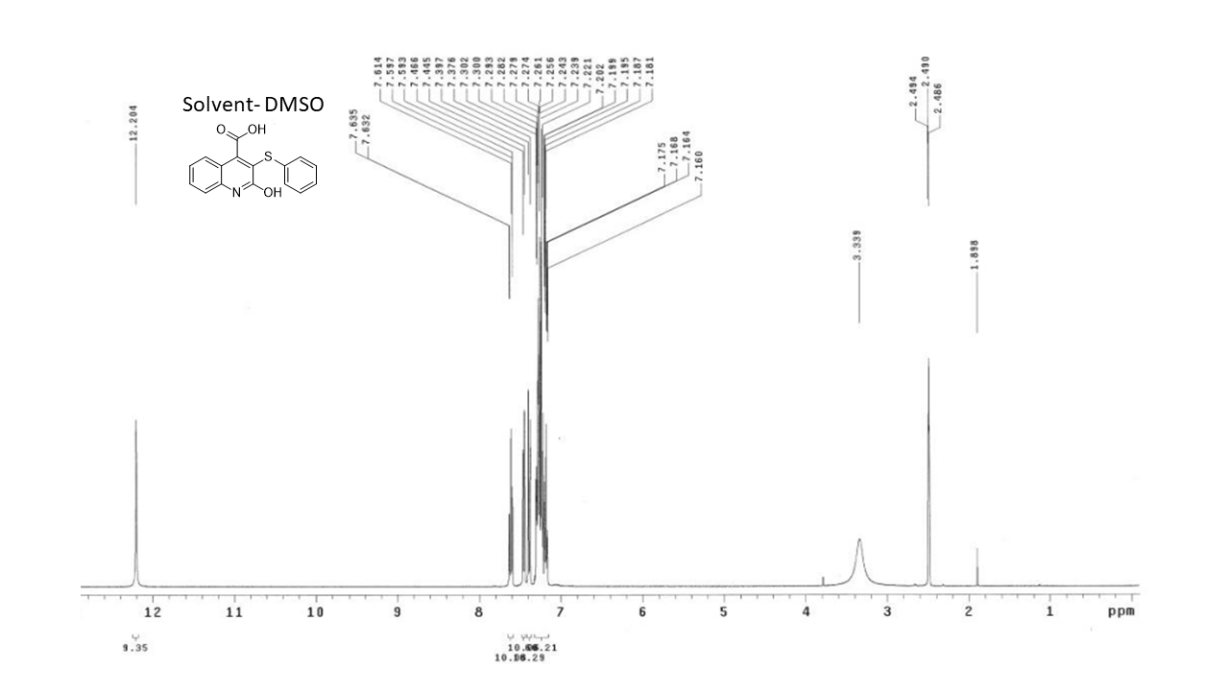
Fig. S1. ¹H NMR of compound 3
Fig. S2. ¹³C NMR of compound 3

Fig. S3. ¹H NMR of compound TC-S-1 (4)

Fig. S4. ¹³C NMR of compound TC-S-1 (4)

Fig. S5. ¹H NMR of compound 5
Fig. S6. ¹³C NMR of compound 5

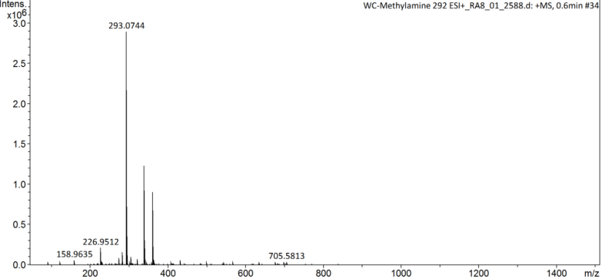
Fig. S7. HRMS of compound 5

Fig. S8. ¹H NMR of compound 6

Fig. S9. ¹³C NMR of compound 6

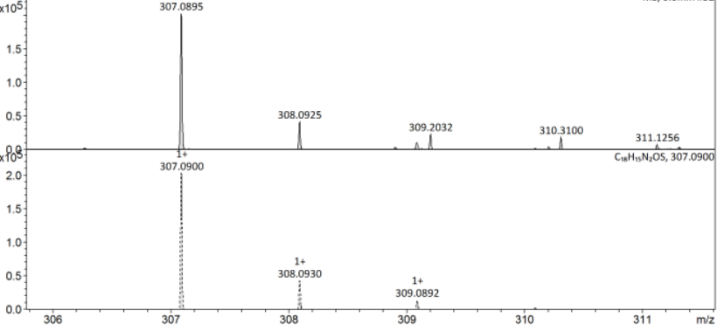
Fig. S10. HRMS of compound 6

Fig. S11. ¹H NMR of compound 7
Fig. S12. ¹³C NMR of compound 7
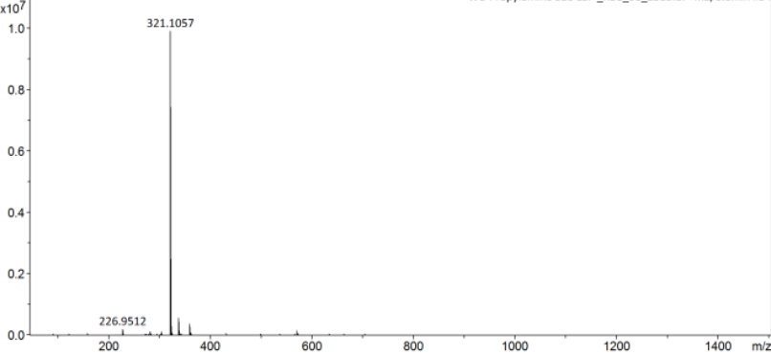
Fig. S13. HRMS of compound 7

Fig. S14. ¹H NMR of compound 8

Fig. S15. ¹³C NMR of compound 8

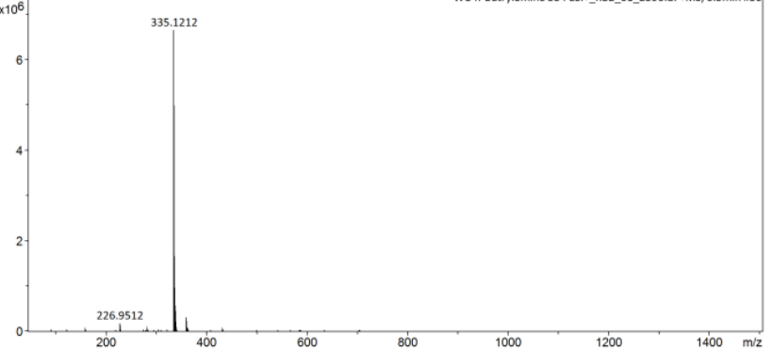

Fig. S16. HRMS of compound 8

Fig. S17. ¹H NMR of compound 9
Fig. S18. ¹³C NMR of compound 9
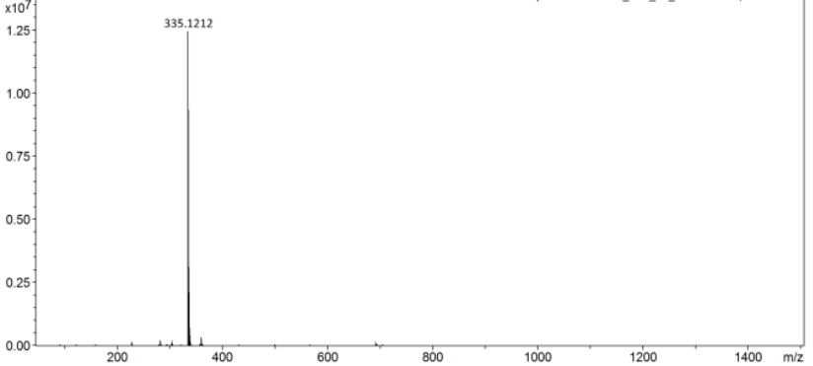
Fig. S19. HRMS of compound 9

Fig. S20. ¹H NMR of compound 10

Fig. S21. ¹³C NMR of compound 10

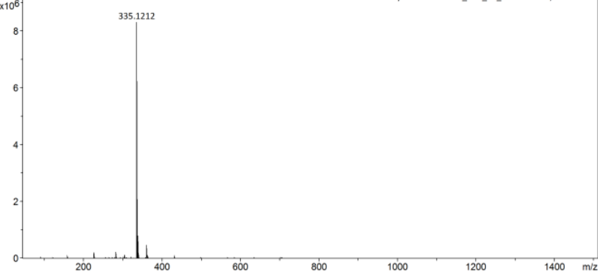
Fig. S22. HRMS of compound 10

Fig. S23. ¹H NMR of compound 11
Fig. S24. ¹³C NMR of compound 11

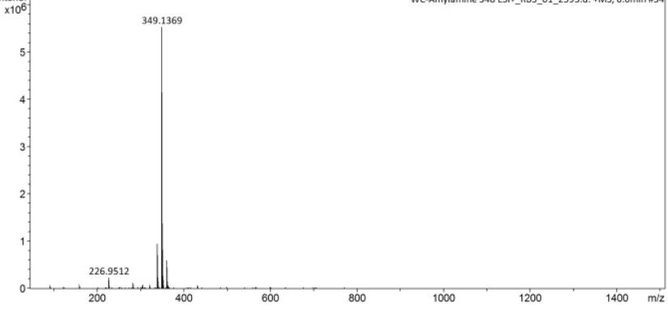
Fig. S25. HRMS of compound 11

Fig. S26. ¹H NMR of compound 12

Fig. S27. ¹³C NMR of compound 12

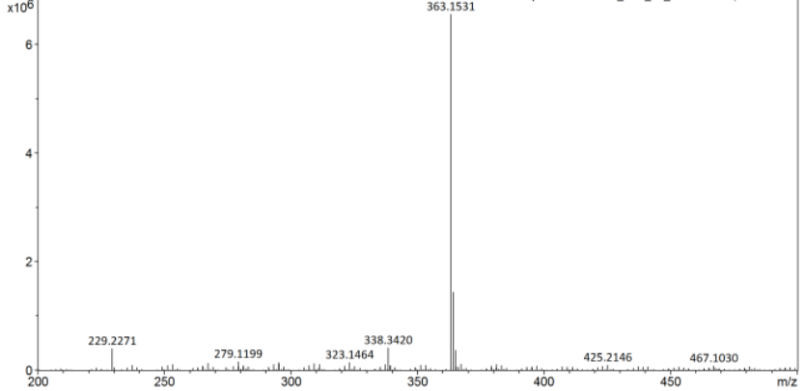
Fig. S28. HRMS of compound 12

Fig. S29. ¹H NMR of compound 13
Fig. S30. ¹³C NMR of compound 13
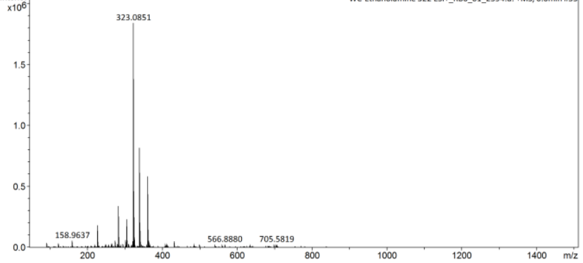
Fig. S31. HRMS of compound 13

Fig. S32. ¹H NMR of compound 14

Fig. S33. ¹³C NMR of compound 14

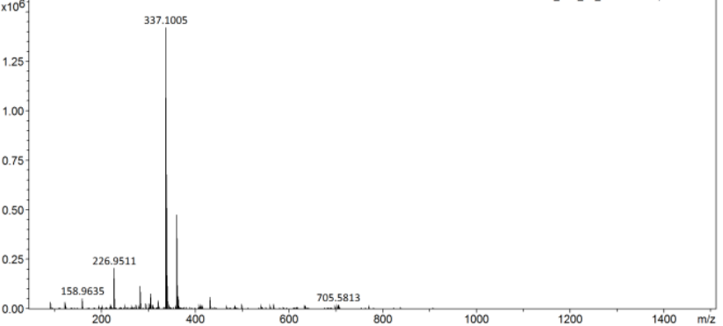
Fig. S34. HRMS of compound 14

Fig. S35. ¹H NMR of compound 15
Fig. S36. ¹³C NMR of compound 15
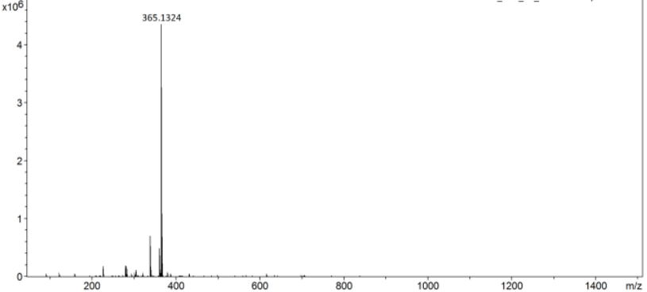
Fig. S37. HRMS of compound 15

Fig. S38. ¹H NMR of compound 16

Fig. S39. ¹³C NMR of compound 16

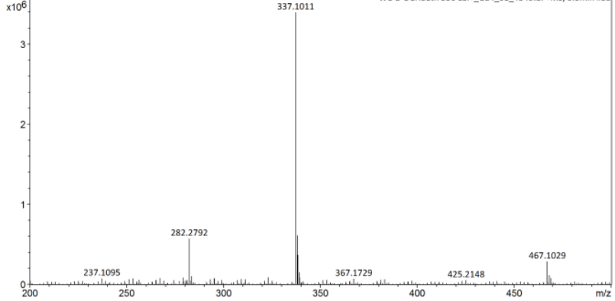
Fig. S40. HRMS of compound 16

Fig. S41. ¹H NMR of compound 17

Fig. S42. ¹³C NMR of compound 17
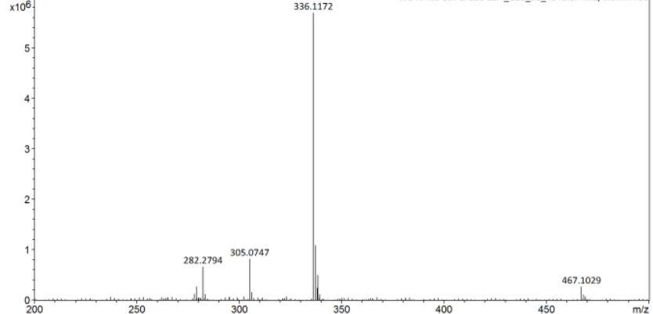
Fig. S43. HRMS of compound 17

Fig. S44. ¹H NMR of compound 18

Fig. S45. ¹³C NMR of compound 18

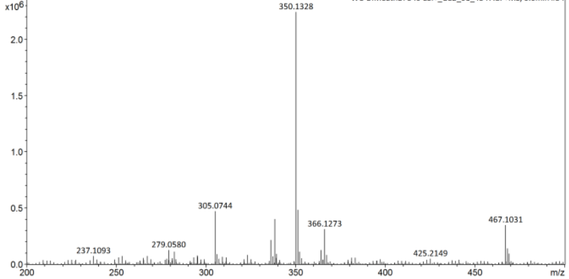
Fig. S46. HRMS of compound 18

Fig. S47. ¹H NMR of compound 19
Fig. S48. ¹³C NMR of compound 19
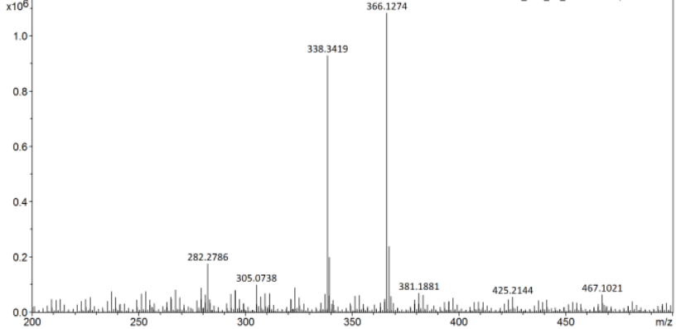
Fig. S49. HRMS of compound 19

Fig. S50. ¹H NMR of compound 20

Fig. S51. ¹³C NMR of compound 20

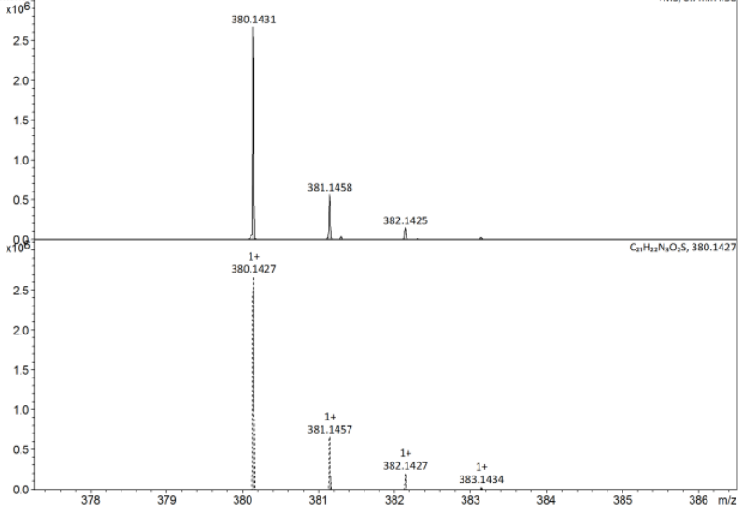
Fig. S52. HRMS of compound 20
Fig. S53. ¹H NMR of compound 21

Fig. S54. ¹³C NMR of compound 21
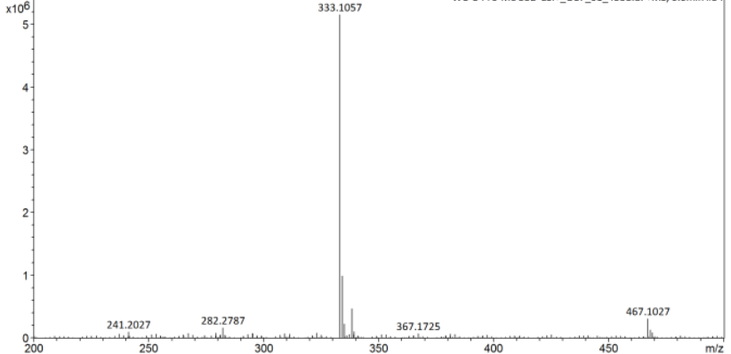
Fig. S55. HRMS of compound 21

Fig. S56. ¹H NMR of compound 22

Fig. S57. ¹³C NMR of compound 22

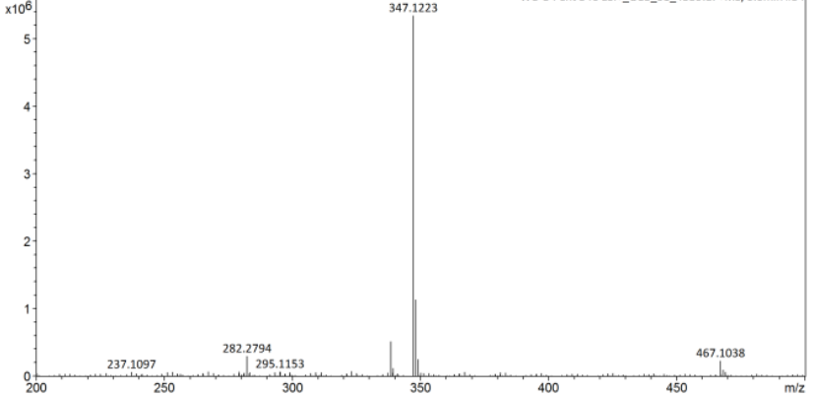
Fig. S58. HRMS of compound 22

Fig. S59. ¹H NMR of compound 23
Fig. S60. ¹³C NMR of compound 23
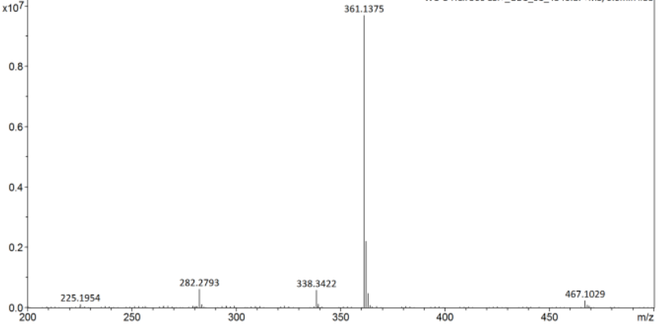Fig. S61. HRMS of compound 23

Fig. S62. ¹H NMR of compound 24
Fig. S63. ¹³C NMR of compound 24

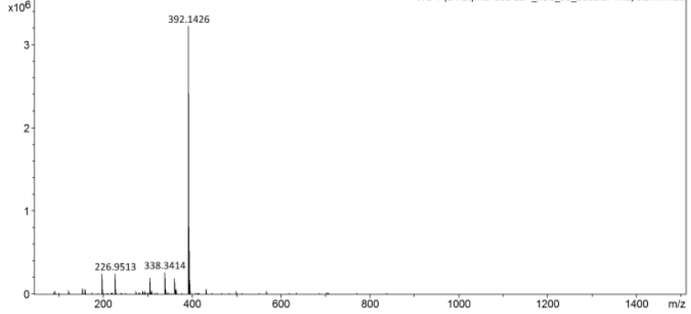
Fig. S64. HRMS of compound 24

Fig. S65. ¹H NMR of compound 25
Fig. S66. ¹³C NMR of compound 25

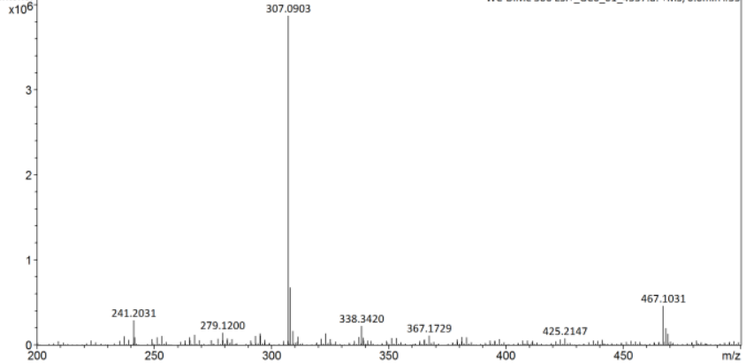
Fig. S67. HRMS of compound 25

Fig. S68. ¹H NMR of compound 26

Fig. S69. ¹³C NMR of compound 26

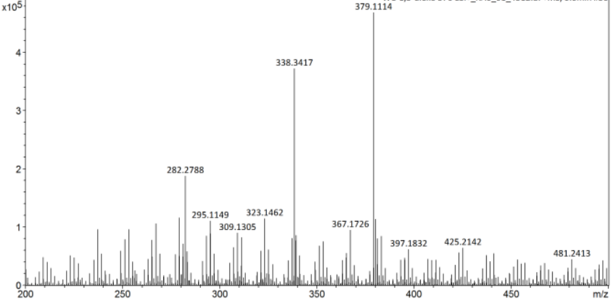
Fig. S70. HRMS of compound 26

Fig. S71. ¹H NMR of compound 27
Fig. S72. ¹³C NMR of compound 27

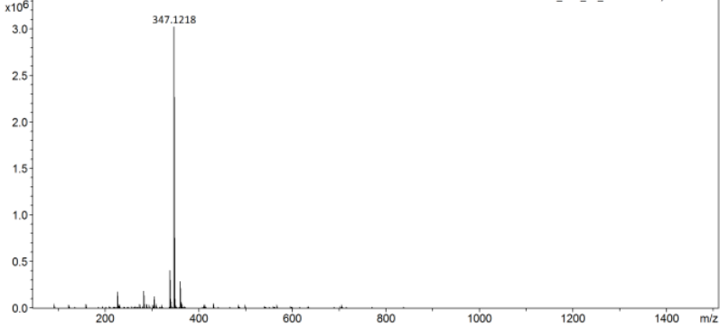
Fig. S73. HRMS of compound 27

Fig. S74. ¹H NMR of compound 28

Fig. S75. ¹³C NMR of compound 28

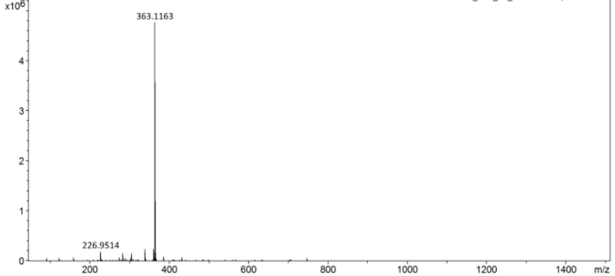
Fig. S76. HRMS of compound 28

Fig. S77. ¹H NMR of compound 29
Fig. S78. ¹³C NMR of compound 29
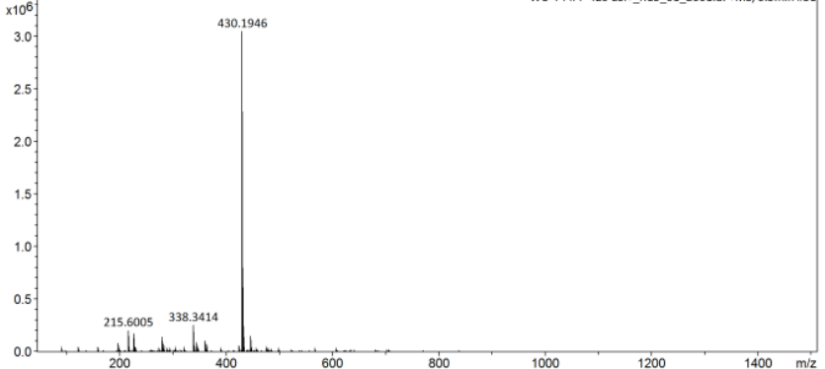
Fig. S79. HRMS of compound 29

Fig. S80. ¹H NMR of compound 30

Fig. S81. ¹³C NMR of compound 30

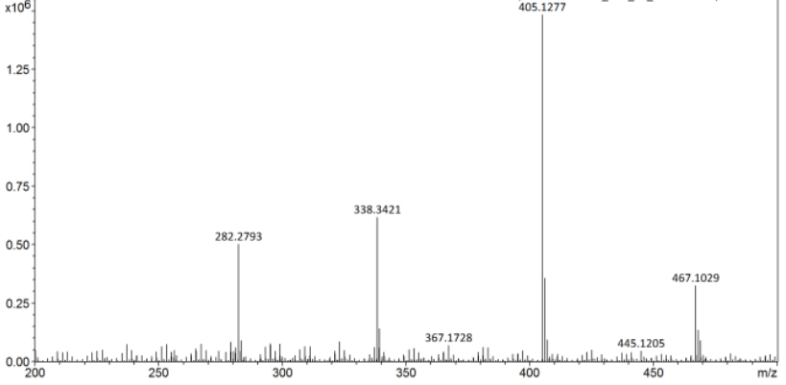

Fig. S79. HRMS of compound 30
A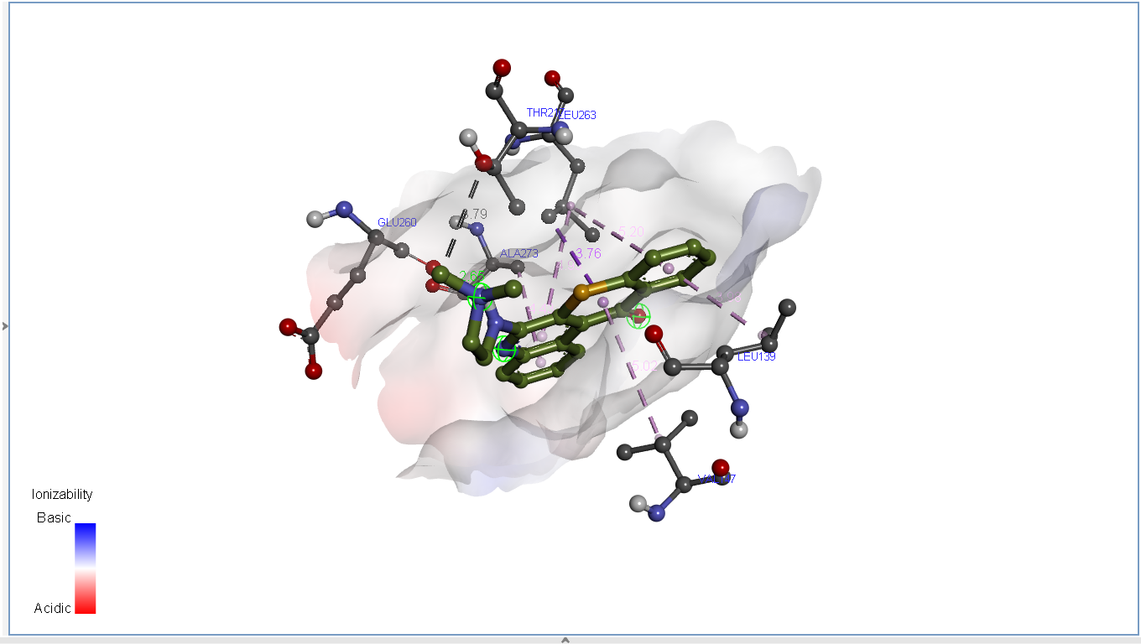 | B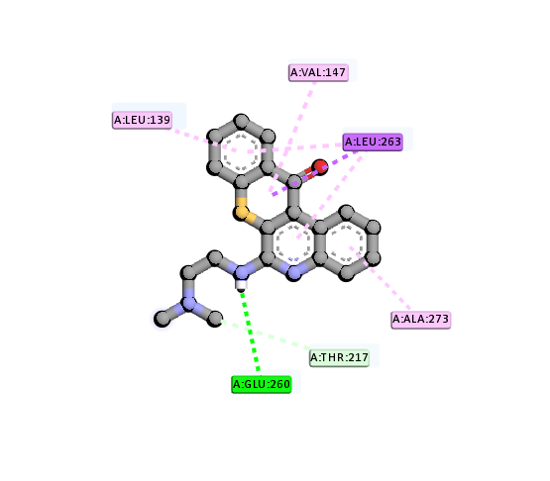
C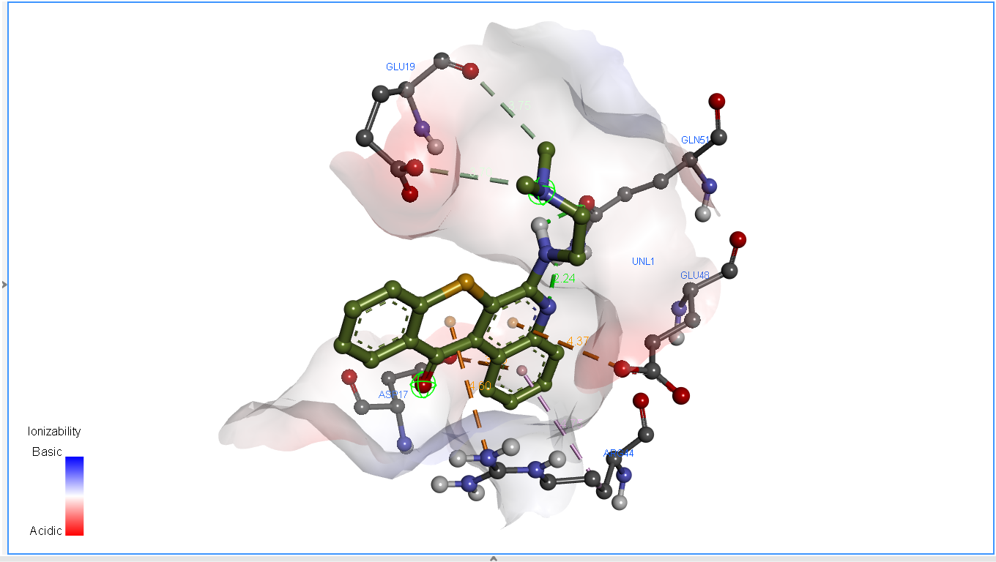 | D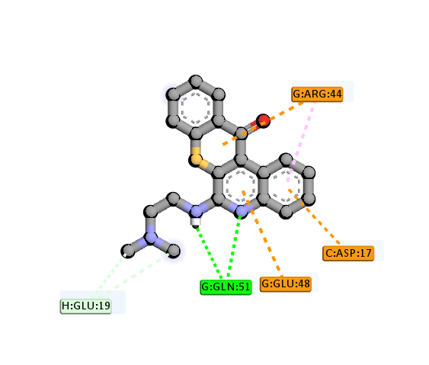
E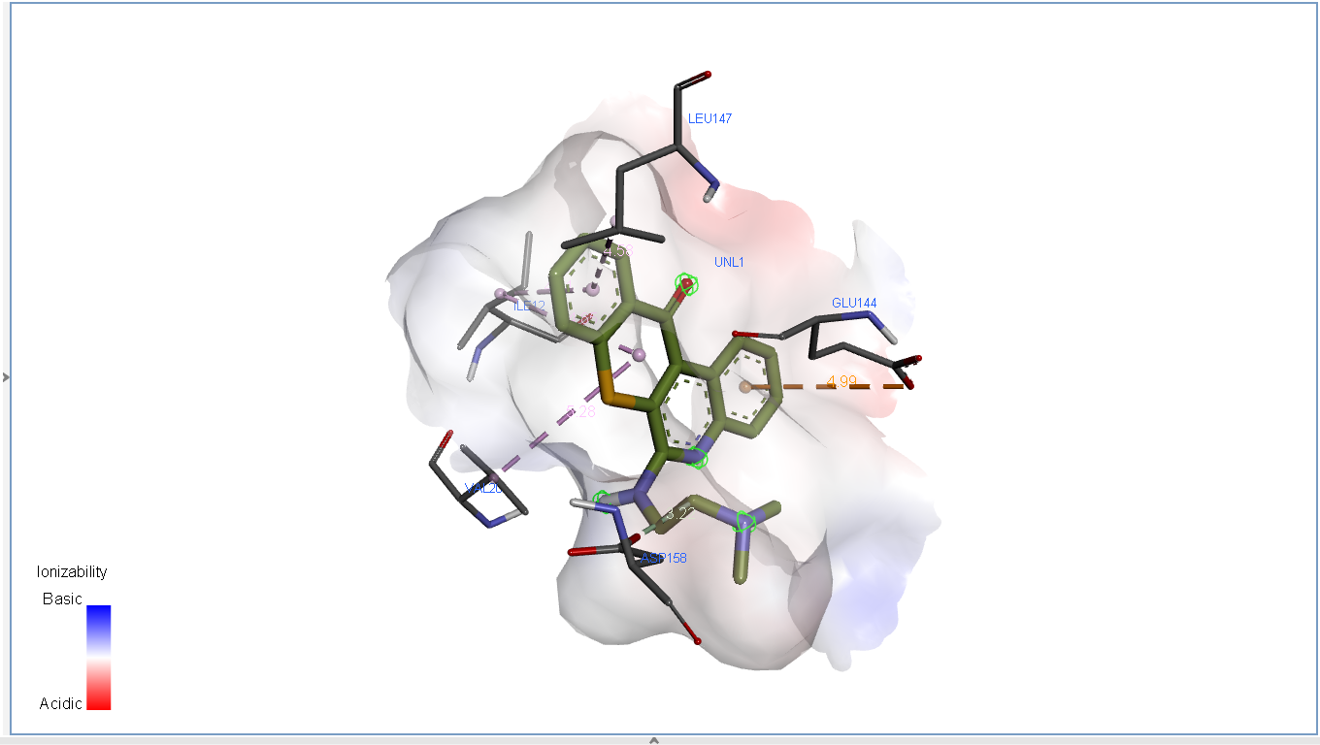 | F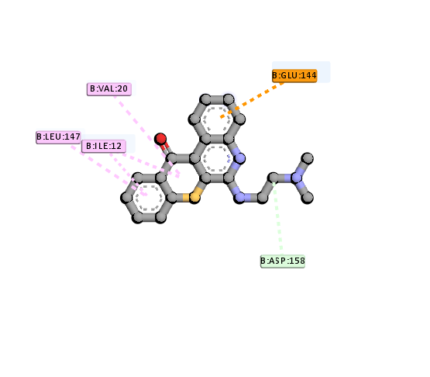
G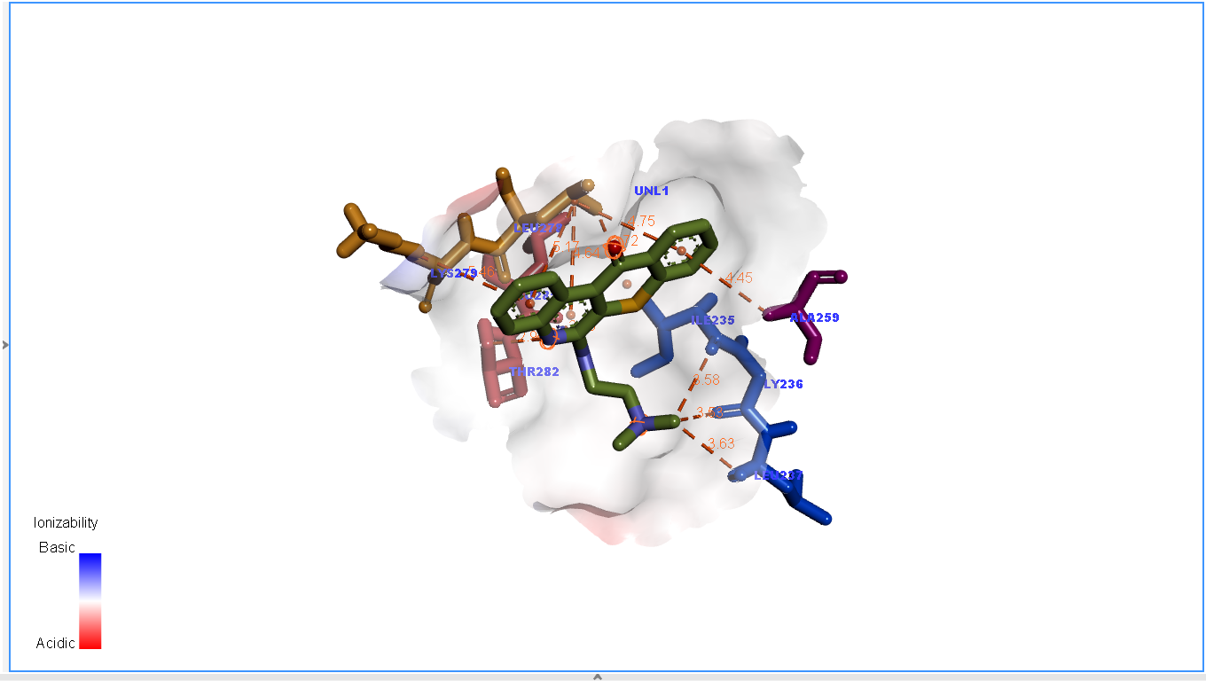 | H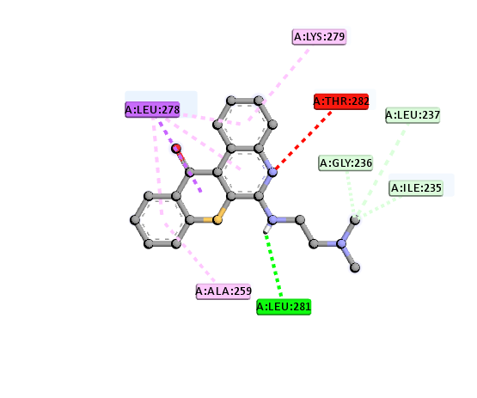
Figure S83. Binding interactions of compounds 18 and several receptor active sites. (A) 3D structures of 18 and AURKA (PDB ID: 5ORY) receptor and distances (left). (B) 2D analysis of the amino acids and bonding interactions within the complex formed by 18 and AURKA using Discovery Studio software. (C) 3D structures of 18 and the Bcr-Abl (PDB ID: 1K1F) receptor and distances (left). (D) 2D analysis of the amino acids and bonding interactions within the complex formed by 18 and Bcr-Abl using Discovery Studio software. (E) 3D structures of 18 and the CDK4 (PDB ID: 2W9Z) receptor and distances (left). (F) 2D analysis of the amino acids and bonding interactions within the complex formed by 18 and CDK4 using Discovery Studio software. (G) 3D structures of 18 and the CDK6 (PDB ID: 3NUP) receptor and distances (left). (H) 2D analysis of the amino acids and bonding interactions within the complex formed by 18 and CDK6 using Discovery Studio software

A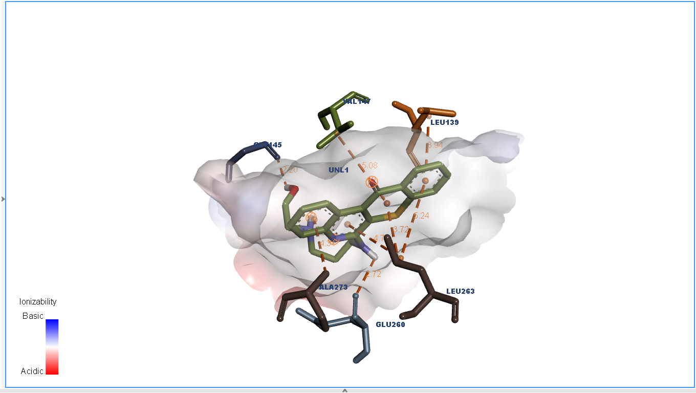 | B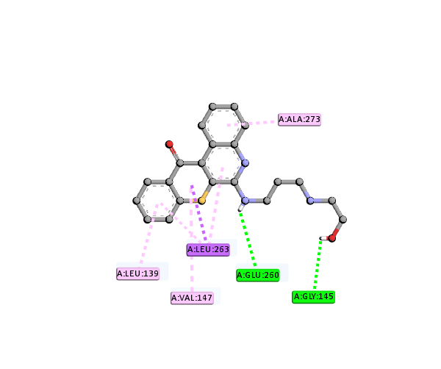
C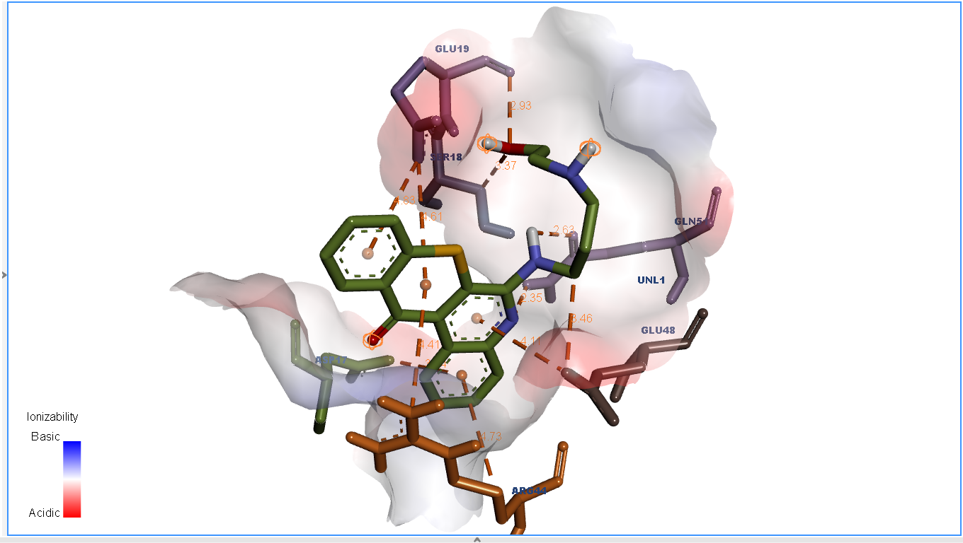 | D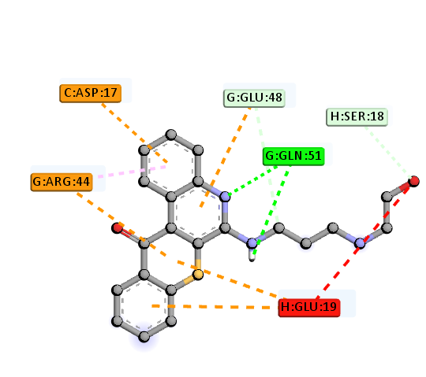
E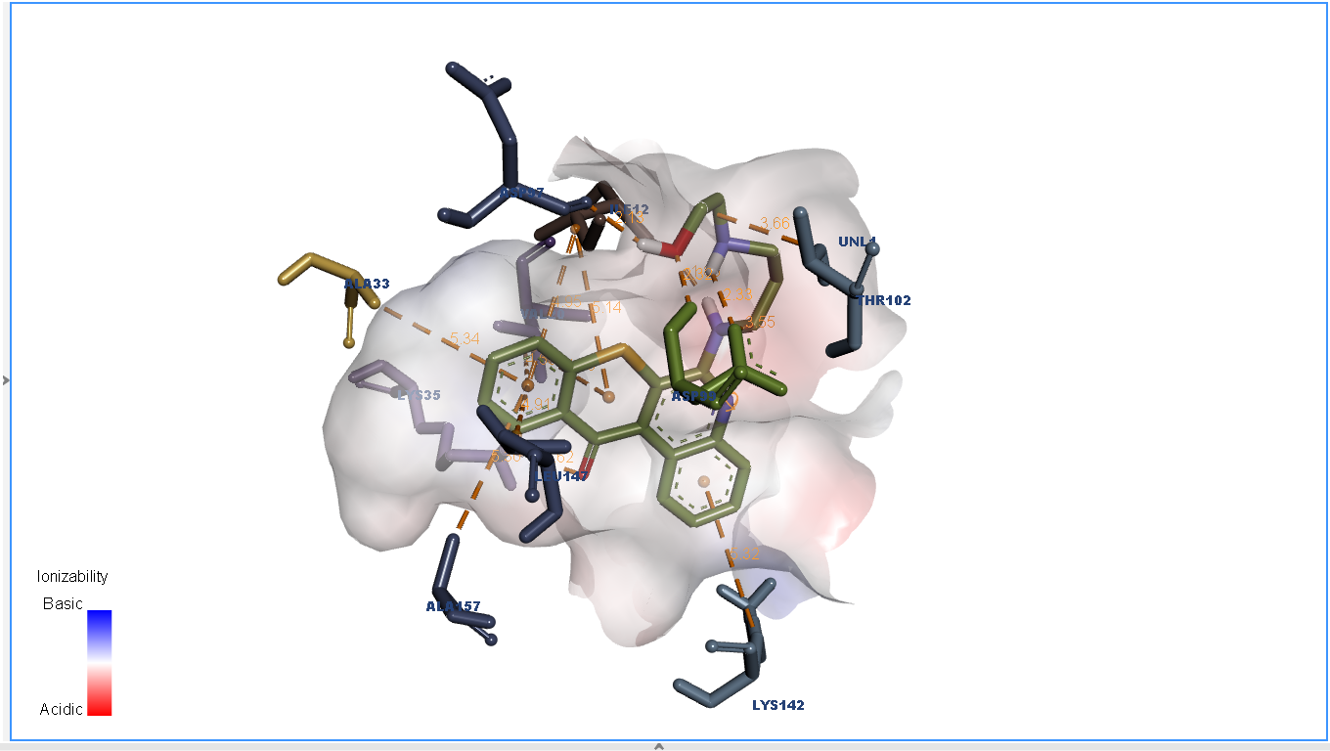 | F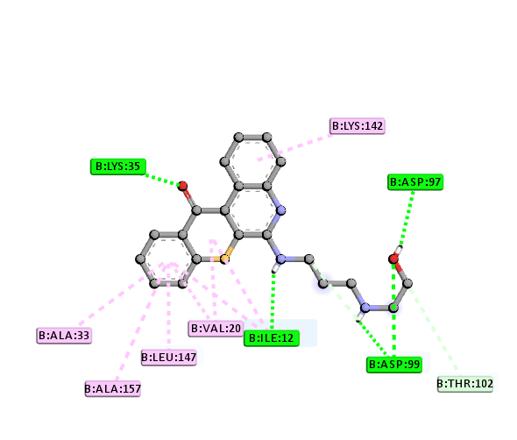
G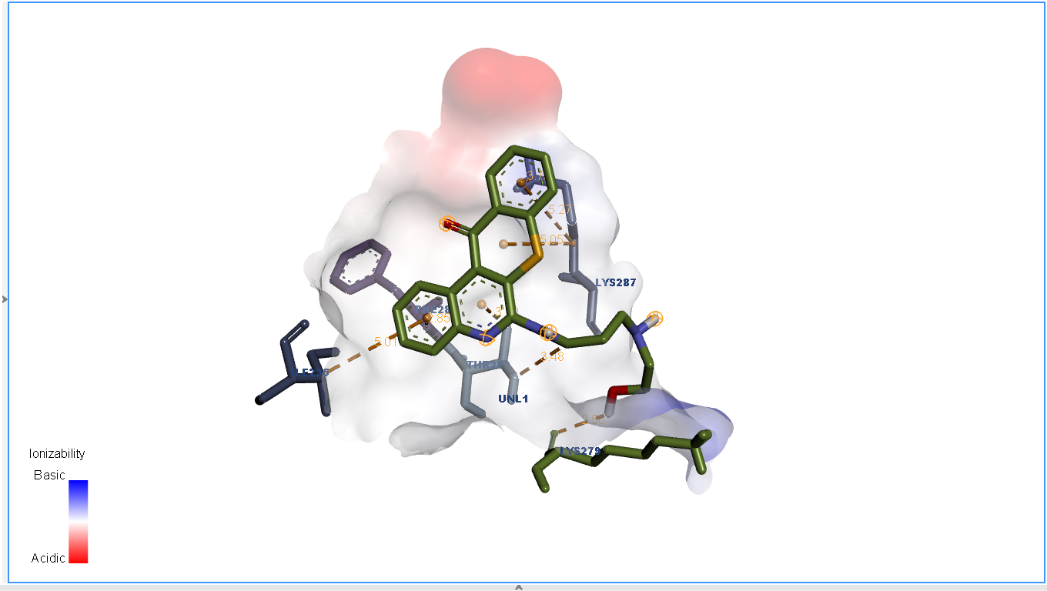 | H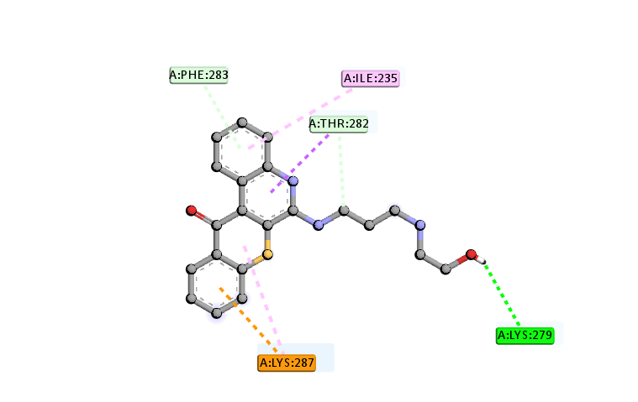

Figure S84. Binding interactions of compounds 20 and several receptor active sites. (A) 3D structures of 20 and AURKA (PDB ID: 5ORY) receptor and distances (left). (B) 2D analysis of the amino acids and bonding interactions within the complex formed by 20 and AURKA using Discovery Studio software. (C) 3D structures of 20 and the Bcr-Abl (PDB ID: 1K1F) receptor and distances (left). (D) 2D analysis of the amino acids and bonding interactions within the complex formed by 20 and Bcr-Abl using Discovery Studio software. (E) 3D structures of 20 and the CDK4 (PDB ID: 2W9Z) receptor and distances (left). (F) 2D analysis of the amino acids and bonding interactions within the complex formed by 20 and CDK4 using Discovery Studio software. (G) 3D structures of 20 and the CDK6 (PDB ID: 3NUP) receptor and distances (left). (H) 2D analysis of the amino acids and bonding interactions within the complex formed by 20 and CDK6 using Discovery Studio software

Table S1. Comparison of ¹H NMR and ¹³C NMR of compound 3, 4, 5 and 25
Compound Structures | ¹H NMR δ (ppm) | ¹³C NMR δ (ppm)
3 | 400 MHz, DMSO-d6 7.16-7.32 (6H, m, Ar-H), 7.38 (1H, d, J = 8.4 Hz, Ar-H), 7.45 (1H, d, J = 8.4 Hz, Ar-H), 7.61 (1H, t, J = 8.4 Hz, Ar-H), 12.20 (1H, s,-COOH) | 100 MHz, DMSO-d6 115.17, 115.78, 120.26, 122.73, 125.74, 126.28, 128.05, 128.97, 132.00, 134.84, 139.64, 151.18, 159.07, 166.44 (C=O)
TC-S-1 (4) | 400 MHz, DMSO-d6 7.74 (1H, t, J = 8 Hz, Ar-H2), 7.85-7.92 (3H, m, Ar-H3, 9, 10), 8.08-8.11 (2H, m, Ar-H1, 8), 8.49 (1H, dd, J = 8, 0.8 Hz, Ar-H11), 9.62 (1H, dd, J = 8.4, 1.6 Hz, Ar-H4) | 100 MHz, DMSO-d6 124.92, 126.39, 127.43, 128.81, 129.25, 129.57, 130.34, 130.63, 130.84, 131.49, 133.76, 134.44, 144.94, 146.79, 181.52 (C=O)
5 | 400 MHz, CDCl3 3.24 (3H, d, J = 4.4 Hz, -CH3), 4.94 (1H, s, -NH- ), 7.43 (1H, t, J = 7.2 Hz, Ar-H2), 7.54-7.66 (4H, m, Ar-H3,8,9,10 ), 7.84 (1H, d, J = 8.4 Hz, Ar-H1), 8.56 (1H, d, J = 8 Hz, Ar-H11), 9.46 (1H, d, J = 8.8 Hz, Ar-H4) | 100 MHz, CDCl3 29.35, 120.89, 123.88, 124.45, 125.95, 126.01, 127.09, 127.62, 129.29, 129.76, 129.98, 131.65, 132.10, 132.84, 145.60, 151.38, 182.18 (C=O)
25 | 400 MHz, CDCl3 3.07 (6H, s, -CH3), 7.54-7.70 (5H, m, Ar-H2,3,8,9,10), 7.98 (1H, dd, J = 8.4, 1.2 Hz, Ar-H1), 8.59 (1H, dt, J = 8.4, 0.8 Hz, Ar-H11), 9.61 (1H, dd, J = 8.4, 1.2 Hz, Ar-H4) | 100 MHz, CDCl3 42.96, 123.52, 125.74, 126.18, 126.96, 127.13, 128.37, 129.13, 129.44, 130.56, 130.96, 131.25, 132.03, 136.02, 144.75, 158.34, 182.68 (C=O)

Table S2. SC-XRD analysis details of compound 25
Empirical formula | C18 H14 N2 O S
Formula weight | 306.37
Temperature | 200(2) K
Wavelength | 0.71073 A
Crystal system | monoclinic
Space group | P 21/c
Unit cell dimensions | a = 4.6270(2) Å α = 90.00º  b = 16.8654(8) Å β = 91.784(2)º  c = 18.7303(9) Å γ = 90.00º
Volume | 1460.93(12)
Z | 4
Density (calculated) | 1.393 Mg / m3
Absorption coefficient | 0.224 mm-1
F (000) | 640
Crystal size | 0.08 (0.03-0.79)
Theta range for data collection | 0
Index ranges | -5<h<4, -18<k<20, -21<l<22
Theta range for reflection | 1.63-25.00
Reflection average R equivalents | 0.0582
Reflection average sigmaI/netI | 0.0597
Completeness to theta = 25.00 o | 99.7
Absorption correction | multi-scan
Max. and min. Absorption | 0.9933 and 0.8427
Goodness-of-fit on F2 | 1.013
R indices (all data) | 0.0744

Table S3. ADME and Toxicity prediction of compound 5, 17, 18, 19, 20, 21, 24, doxorubicin and camptothecin
ADMET Evaluation | Compound
 | 5 | 17 | 18 | 19 | 20 | 21 | 24 | Doxorubicin | Camptothecin
Absorption
Caco-2 Permeability | -5.08 | -5.27 | -4.89 | -5.43 | -5.45 | -5.18 | -5.13 | -6.16 | -4.93
HIA | High | High | High | High | High | High | High | - | High
Pgp-substrate | No | Yes | No | Yes | Yes | Yes | Yes | - | Yes
Distribution
PPB (%) | 95.59 | 80.95 | 88.59 | 62.76 | 68.60 | 97.97 | 92.36 | 90.86 | 90.80
BBB | Yes | No | Yes | No | No | Yes | No | - | No
Metabolism
CYP1A2 inhibitor | +++ | +++ | +++ | +++ | +++ | +++ | +++ | -- | +++
CYP1A2 substrate | + | ++ | +++ | - | + | -- | ++ | - | ++
CYP2C19 inhibitor | ++ | - | -- | - | - | ++ | ++ | --- | +
CYP2C19 inhibitor | -- | - | ++ | -- | --- | --- | -- | --- | -
Excretion
CL | 2.76 | 5.43 | 4.62 | 5.12 | 5.05 | 2.55 | 3.99 | 13.02 | 6.86
T_{1/2} | 0.09 | 0.07 | 0.04 | 0.01 | 0.09 | 0.05 | 0.03 | 0.73 | 0.33
Toxicity
hERG Blockers | --- | ++ | +++ | ++ | ++ | -- | ++ | --- | --
AMES Toxicity | ++ | ++ | ++ | - | - | ++ | + | ++ | ++
Carcinogencity | ++ | --- | -- | --- | --- | ++ | -- | + | +
Acute Toxicity Rule | 0 alert | 0 alert | 0 alert | 0 alert | 0 alert | 0 alert | 0 alert | 0 alert | 0 alert
LC₅₀FM | 5.31 | 5.12 | 5.19 | 4.77 | 4.84 | 5.64 | 4.92 | 3.65 | 6.07
*The prediction probability values are transformed into six symbols: 0-0.1(---), 0.1-0.3(--), 0.3-0.5(-), 0.5-0.7(+), 0.7-0.9(++), and 0.9-1.0(+++).

Table S5. Synthesis of 6H-thiochromeno [2,3-c] quinoline-12(12H)-one (TC-S-1) derivatives.
No. | Compound | R | Yield (%) | No. | Compound | R | Yield (%)
1 | 3 | - | 86 | 15 | 17 |  | 47
2 | 4 | -Cl | 74 | 16 | 18 |  | 52
3 | 5 |  | 71 | 17 | 19 |  | 49
4 | 6 |  | 83 | 18 | 20 |  | 84
5 | 7 |  | 69 | 19 | 21 |  | 56
6 | 8 |  | 69 | 20 | 22 |  | 50
7 | 9 |  | 35 | 21 | 23 |  | 57
8 | 10 |  | 67 | 22 | 24 |  | 49
9 | 11 |  | 69 | 23 | 25 |  | 96
10 | 12 |  | 96 | 24 | 26 |  | 51
11 | 13 |  | 45 | 25 | 27 |  | 69
12 | 14 |  | 91 | 26 | 28 |  | 29
13 | 15 |  | 71 | 27 | 29 |  | 38
14 | 16 |  | 69 | 28 | 30 |  | 40

