**Supporting information**

**Identification of anti-tumor constituents from toad skin and toad venom by** **UPLC-QTOF/MS in-depth chemical profiling combined with bioactivity-based molecular networking**

Ruxia Liu1#, Yuhao Zhang2#, Ruijing Zhang4#, Huawu Zeng3, Yunheng Shen3, Xu Li3, Chi Ma4, Fan Huang4, Lulu Wang3, Renwen Zhu4, Xike Xu3, Weidong Zhang 1,2,3,4*, Ji Ye3*

1. School of Pharmacy, Fujian University of Traditional Chinese Medicine, Fuzhou, 350122, China.

2. School of Traditional Chinese Pharmacy, China Pharmaceutical University, Nanjing, Jiangsu 211198, P.R. China.

3. School of Pharmacy, Naval Medical University, Shanghai 200433, China.

4. Institute of Interdisciplinary Integrative Medicine Research, Shanghai University of Traditional Chinese Medicine, Shanghai 201203, PR China.

*Corresponding authors at: Institute of Interdisciplinary Integrative Medicine Research, Shanghai University of Traditional Chinese Medicine, Shanghai, 201203, China (W.D. Zhang).

E-mail addresses: [wdzhangy@hotmail.com(W.D. Zhang)](mailto:wdzhangy@hotmail.com(W.D.%20Zhang))

[catheline620@163.com](mailto:catheline620@163.com) (J. Ye)

**Content**

**Figure S1**. Setting of collision energy parameters·······················································S3

**Table S1.** The optimized MRM parameters of the nine target analytes·······························S3

**Figure S2**. Chemical structures of 18 reference substances·············································S4

**Table S2.** Characterization of 162 constituents from toad skin and toad venom by UPLC-QTOF/MS······································································································S5

**Figure S3.** Molecular networking, secondary mass spectrometry and the prediction of fragmentation pathway of bufotoxins. (A) Molecular network of bufotoxins (yellow means TV, brown means TS, the size of node is directly related to parent mass, the thickness of the connections between nodes is directly related to the structural similarity). (B) Secondary mass spectrometry and prediction of fragmentation behavior of arenobufotoxins and suberoyl argenins (brown means fragment ions of suberoyl argenins, yellow means fragment ions of arenobufotoxins). ·······························S21

**Figure S4**. MS2 spectra of gamabufotalintoxin, arenobufotoxin, and bufotoxin····················S21

**Figure S5.** Molecular networking, the prediction of fragmentation route and discovery of new compounds of IAAs. (A) Molecular networking of IAAs (yellow means TV, brown means TS, the size of node is directly related to parent mass, the thickness of the connections between nodes is directly related to the structural similarity). (B) Secondary mass spectrometry and fragmentation behavior of dehydrobufotenine. (C) Secondary mass spectrometry and prediction of fragmentation behavior of bufotenidine, bufoserotonin C and unknown compound of m/z 575.312. ·······································································································S22

**Figure S6.** Molecular network, the prediction of cracking law and secondary mass spectrometry of small cyclic peptides·························································································S22

**Figure S7**. Venn diagram of compounds in TS and TV···················································S23

**Figure S8.** Base peak chromatograms of each fraction obtained by UPLC-QTOF/MS··············S23

**Table S3.** Characterization of 44 detected components in plasma originated from toad skin by LC-QTOF/MS·····································································································S24

**Table S4.** The regression equation, linear range and contents of nine main bufagenins in toad skin with UPLC-QTOF-MS/MS method·······································································S26

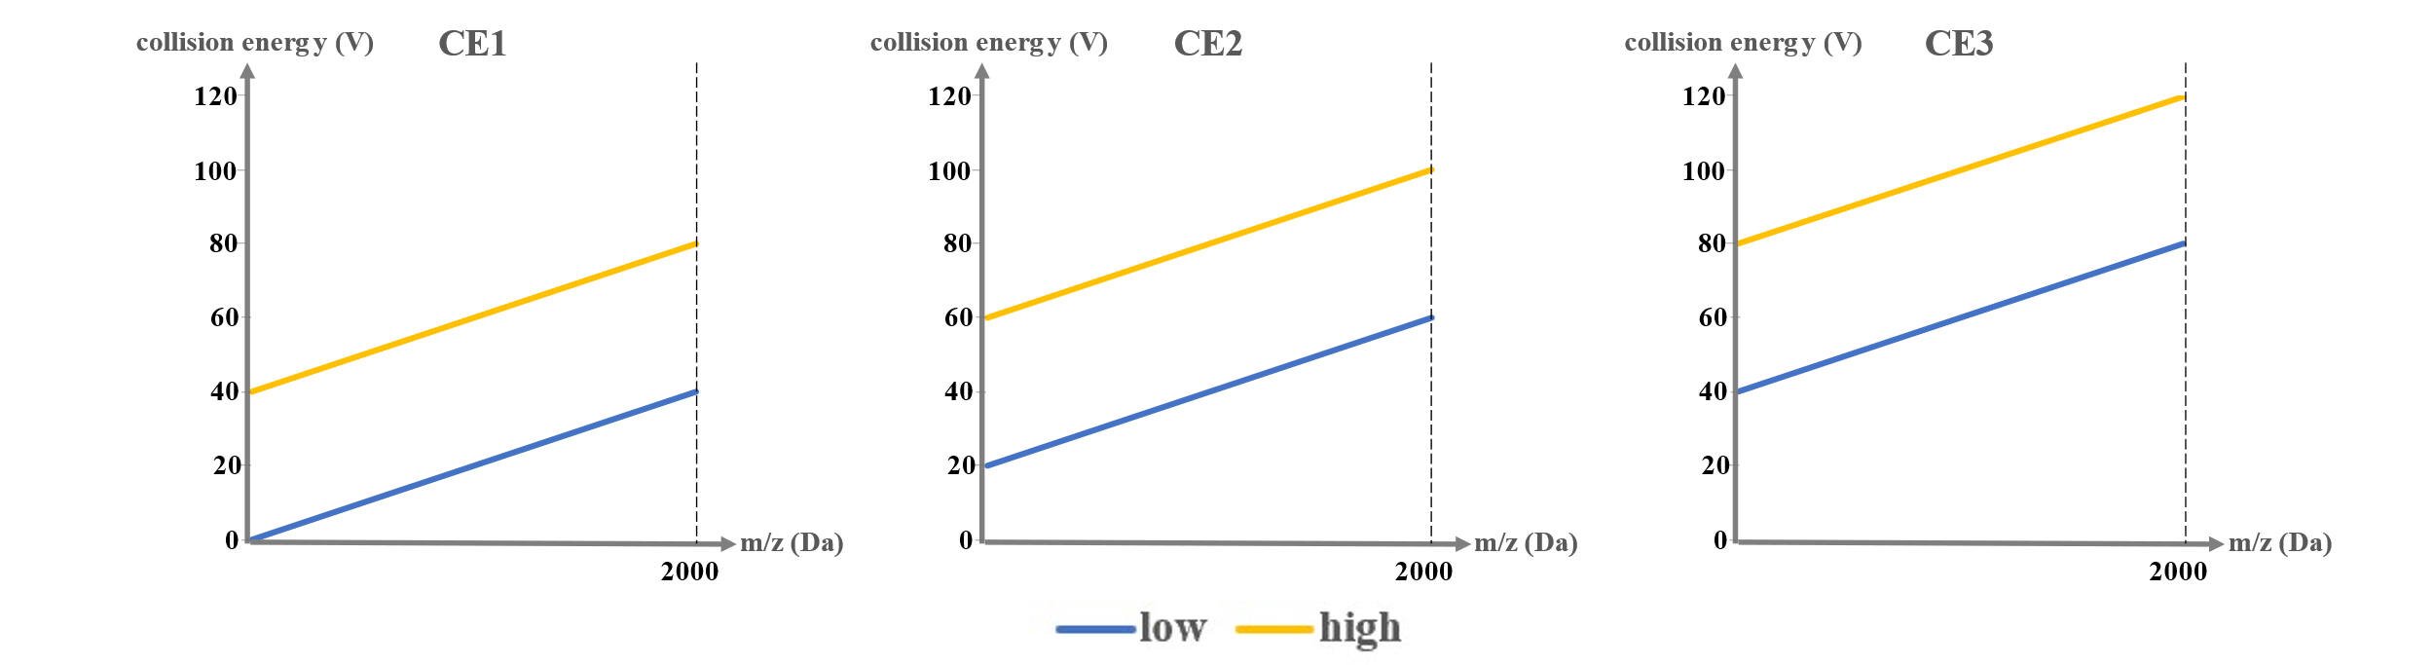

**Figure S1.** Setting of collision energy parameters

**Table** **S1.** The optimized MRM parameters of the nine target analytes

|  |  |  |  |  |  |  |
| --- | --- | --- | --- | --- | --- | --- |
| Bufogenins | Retation time (min) | Precursor ion (m/z) | Main product ions (m/z) | Cone Voltage (V) | Collision energy (V) | |
| CE1 | CE2 |
| Bufoarenogin | 5.57 | 417.2281 | 399.2175 | 20 | 43 | 45 |
| Gamabufotalin | 5.95 | 403.2478 | 385.2372 | 20 | 32 | 34 |
| Arenobufagin | 7.63 | 417.2288 | 399.2202 | 20 | 38 | 40 |
| Hellebrigenin | 7.95 | 417.2275 | 335.1994, 363.1933 | 20 | 33 | 35 |
| Desacetylcinobufotalin | 8.18 | 417.2277 | 335.1925 | 20 | 24 | 26 |
| Telocinobufagin | 11.51 | 403.2485 | 349.2143 | 18 | 30 | 32 |
| Bufotalin | 12.34 | 445.2588 | 349.2127, 367.2294 | 20 | 22 | 24 |
| Cinobufotalin | 13.63 | 459.2383 | 363.1973, 381.2082 | 20 | 27 | 29 |
| Cinobufagin | 18.72 | 443.2429 | 365.2089 | 20 | 27 | 29 |



**Figure S2.** Chemical structures of 18 reference substances

**Table S2.** Characterization of 162 constituents from toad skin and toad venom by UPLC-QTOF/MS

| Peak | tR  (min) | Full Scan Mass | | Mass Error  (ppm) | Formula | Selective Ion | Fragment Ion | Identification | Source |
| --- | --- | --- | --- | --- | --- | --- | --- | --- | --- |
| Molecular | Theoretical |
| 1 | 0.99 | 175.1187 | 175.1195 | -4.57 | C6H14N4O2 | [M+H]+ | 158.0930, 130.0985, 116.0808, 112.0867 | L-arginine | TV |
| 2 | 1.10 | 118.0866 | 118.0862 | 3.39 | C5H11NO2 | [M+H]+ | 59.0742, 56.0495 | Glycine betaine | TS |
| 3 | 1.12 | 143.0819 | 143.0815 | 2.80 | C6H10N2O2 | [M+H]+ | 125.0709, 97.0769 | Cyclo(ala-ala) | TS |
| 4 | 1.15 | 176.1042 | 176.1035 | 3.97 | C6H13N3O3 | [M+H]+ | 134.0808, 130.0975, 117.0543, 116.0715 | Argininic acid | TS |
| 5 | 1.17 | 123.0558 | 123.0553 | 4.06 | C6H6N2O | [M+H]+ | 95.0613, 80.0461 | Nicotinamide | TS |
| 6 | 1.19 | 136.0622 | 136.0617 | 3.67 | C5H5N5 | [M+H]+ | 119.0341, 94.0399 | Adenine | TS/TV |
| 7 | 1.20 | 303.1658 | 303.1663 | -1.65 | C12H22N4O5 | [M+H]+ | 286.1407, 285.1572, 268.1289, 250.1184, 175.1194, 158.0927, 130.0982, 112.0873 | Adipyl arginine isomer | TS/TV |
| 8 | 1.21 | 275.1354 | 275.1350 | 1.45 | C10H18N4O5 | [M+H]+ | 258.1094, 257.1256, 240.0977, 175.1193, 158.0925 | Succinyl arginine | TS/TV |
| 9 | 1.25 | 347.1942 | 347.1935 | 2.02 | C14H26N4O6 | [M+H]+ | 329.1832, 312.1558, 276.1345, 175.1202, 158.0932, 130.0978, 112.0901 | 7-Hydroxyl-suberyl arginine isomer | TS |
| 10 | 1.29 | 178.0862 | 178.0863 | -0.56 | C10H11NO2 | [M+H]+ | 160.0750, 150.0901, 132.0437 | 5-Hydroxy tryptophol | TS/TV |
| 11 | 1.54 | 275.1342 | 275.1350 | -2.91 | C10H18N4O5 | [M+H]+ | 258.1090, 257.1252, 240.0963, 175.1188, 158.0926 | Succinyl arginine isomer | TS/TV |
| 12 | 1.57 | 152.0569 | 152.0567 | 1.32 | C5H5N5O | [M+H]+ | 135.0309, 110.0359 | Guanine | TS |
| 13 | 1.57 | 113.0348 | 113.0346 | 1.77 | C4H4N2O2 | [M+H]+ |  | Uracil | TS |
| 14 | 1.57 | 137.0466 | 137.0458 | 5.84 | C5H4N4O | [M+H]+ | 119.0356 | Hypoxanthine | TS |
| 15 | 1.57 | 153.0412 | 153.0407 | 3.27 | C5H4N4O2 | [M+H]+ | 136.0145, 110.0353 | Xanthine | TS |
| 16 | 1.72 | 185.0920 | 185.0921 | -0.54 | C8H12N2O3 | [M+H]+ | 168.0664, 157.0978, 139.0862 | Bufogargarizanine-D | TS |
| 17 | 2.04 | 152.0569 | 152.0567 | 1.32 | C5H5N5O | [M+H]+ | 135.0305, 110.0331 | Isoguanine | TS/TV |
| 18 | 2.16 | 127.0498 | 127.0502 | -3.15 | C5H6N2O2 | [M+H]+ | 110.0232, 109.0403 | Thymine | TS |
| 19 | 2.25 | 152.0570 | 152.0567 | 1.97 | C5H5N5O | [M+H]+ | 135.0301, 110.0341 | Guanine isomer | TS |
| 20 | 2.25 | 155.0821 | 155.0815 | 3.87 | C7H10N2O2 | [M+H]+ | 127.0872, 82.0654 | Cyclo(pro-gly) | TS |
| 21 | 2.46 | 303.1666 | 303.1663 | 0.99 | C12H22N4O5 | [M+H]+ | 286.1402, 285.1557, 268.1290, 250.1192, 175.1205, 158.0934, 130.0978, 112.0877 | Adipyl arginine | TS/TV |
| 22 | 2.77 | 219.1492 | 219.1492 | 0.00 | C13H18N2O | [M+H]+ | 160.0762, 132.0813, 115.0542 | Bufotenidine isomer | TS/TV |
| 23 | 2.98 | 219.1135 | 219.1128 | 3.19 | C12H14N2O2 | [M+H]+ | 204.0902, 160.0765, 145.0529, 132.0812 | N-Acetyl-5-hydroxytryptamine | TS |
| 24 | 3.31 | 347.1941 | 347.1935 | 1.73 | C14H26N4O6 | [M+H]+ | 330.1719, 312.1574, 297.1849, 279.1696, 175.1204, 155.0666, 146.0982, 130.0983, 113.0457 | 7-Hydroxyl-suberyl arginine | TS/TV |
| 25 | 3.62 | 219.1497 | 219.1492 | 2.28 | C13H18N2O | [M+H]+ | 160.0761, 132.0818, 115.0548 | Bufotenidine | TS/TV |
| 26 | 3.69 | 205.1340 | 205.1341 | -0.49 | C12H16N2O | [M+H]+ | 160.0757, 132.0815, 115.0547 | Bufotenin | TS/TV |
| 27 | 3.75 | 203.1178 | 203.1179 | -0.49 | C12H14N2O | [M+H]+ | 188.0956, 160.0760, 132.0815 | Shepherdine | TS |
| 28 | 4.19 | 220.1188 | 220.1185 | 1.36 | C9H17NO5 | [M+H]+ | 202.1070, 184.0966, 116.0329 | D-pantothenic acid | TS |
| 29 | 4.36 | 317.1833 | 317.1819 | 4.41 | C13H24N4O5 | [M+H]+ | 300.1556, 282.1448, 264.1341, 236.1402, 175.1199, 158.0925, 130.0976, 112.0894 | Pimeoyl arginine | TS/TV |
| 30 | 4.62 | 203.1184 | 203.1179 | 2.46 | C12H14N2O | [M+H]+ | 188.0914, 173.0715, 155.0604 | Dehydrobufotenine | TS/TV |
| 31 | 4.95 | 283.0742 | 283.0747 | -1.77 | C12H14N2O4S | [M+H]+ | 203.1188, 188.0945, 173.0715 | Bufothionine | TS/TV |
| 32 | 5.19 | 326.1713 | 326.1716 | -0.92 | C15H23N3O5 | [M+H]+ | 308.1618, 280.1666, 262.1555, 244.1451, 170.0941, 153.0678, 152.0846, 124.0883, 109.0774 | Unknow | TS/TV |
| 33 | 5.31 | 329.1824 | 329.1825 | -0.30 | C14H24N4O5 | [M+H]+ | 312.1562, 294.1454, 276.1352, 175.1190, 158.0926 | Suberoyl argenine-2H | TV |
| 34 | 5.32 | 211.1451 | 211.1447 | 1.89 | C11H18N2O2 | [M+H]+ | 193.1353, 165.1383, 151.1243, 136.1001, 121.0776 | Cyclo(Leu-Pro) isomer | TS |
| 35 | 5.47 | 331.1979 | 331.1981 | -0.60 | C14H26N4O5 | [M+H]+ | 278.1506, 272.1492, 250.1555, 175.1191, 158.0924, 112.0881 | Suberoyl arginine | TS/TV |
| 36 | 5.75 | 345.2140 | 345.2132 | 2.32 | C15H28N4O5 | [M+H]+ | 328.1871, 327.2028, 310.1771, 292.1664, 264.1714 | Azelayl arginine isomer | TS/TV |
| 37 | 6.00 | 359.2292 | 359.2289 | 0.84 | C16H30N4O5 | [M+H]+ | 342.2028, 272.1494, 203.1511, 158.0970, 116.0717 | Sebacylargenin isomer | TV |
| 38 | 6.05 | 343.1980 | 343.1981 | -0.29 | C15H26N4O5 | [M+H]+ | 326.1663, 325.1862, 308.1499, 280.1749, 175.1193, 158.0930, 130.0984, 112.0880 | Azelayl argenine-2H | TS/TV |
| 39 | 6.13 | 359.2302 | 359.2289 | 3.62 | C16H30N4O5 | [M+H]+ | 342.2030, 272.1496, 253.1557, 172.1073, 115.0870 | Sebacyl arginine | TS/TV |
| 40 | 6.18 | 227.1387 | 227.1390 | -1.32 | C11H18N2O3 | [M+H]+ | 209.1291, 199.1445, 170.0692, 153.1368, 136.1145, 114.0553 | Cyclo(Hpro-Leu) isomer | TS |
| 41 | 6.24 | 345.2142 | 345.2132 | 2.90 | C15H28N4O5 | [M+H]+ | 328.1871, 327.2036, 310.1765, 292.1662, 264.1708, 175.1187, 158.0929, 116.0701, 112.0874 | Azelayl arginine isomer | TS/TV |
| 42 | 6.44 | 227.1395 | 227.1390 | 2.20 | C11H18N2O3 | [M+H]+ | 210.1128, 199.1446, 182.1180, 170.0691, 153.1374, 136.1145, 114.0560, 86.0608 | Cyclo(Hpro-Leu) | TS |
| 43 | 6.53 | 487.3167 | 487.3172 | -1.03 | C28H42N2O5 | [M+H]+ | 469.3066, 451.2987, 416.2413, 381.2066, 363.1962, 353.2115, 345.1887, 335.2007, 286.1402, 260.1967, 189.1252, 171.1148, 161.1317, 116.0708 | 3-O-(2-hydroxyputrescine)- resibufagin (notsure) | TS/TV |
| 44 | 6.68 | 326.1509 | 326.1505 | 1.22 | C18H20N3O3 | [M+H]+ | 167.0820, 160.0767, 132.0815, 115.0544 | Bufoserotonin C | TV |
| 45 | 6.73 | 345.2135 | 345.2132 | 0.87 | C15H28N4O5 | [M+H]+ | 328.1897, 327.2002, 310.1764, 292.1634, 264.1708, 175.1195, 158.0949, 116.0706, 112.0871 | Azelaylargenin | TS/TV |
| 46 | 6.74 | 416.2434 | 416.2437 | -0.72 | C24H33NO5 | [M+H]+ | 398.2334, 380.2226, 370.2381, 363.1958, 345.1853 | 3-Amino-resibufagin isomer | TS/TV |
| 47 | 7.10 | 377.1458 | 377.1456 | 0.53 | C17H20N4O6 | [M+H]+ | 359.1326, 323.1108, 243.0862, 198.0652, 172.0267 | Riboflavin | TS |
| 48 | 7.22 | 261.1241 | 261.1234 | 2.68 | C14H16N2O3 | [M+H]+ | 243.1126, 233.1281, 215.1212, 170.0691, 141.0560, 131.0510, 120.0824, 114.0557, 103.0547, 86.0610, 68.0501 | Cyclo(Phe-Hpro) | TS |
| 49 | 7.65 | 357.2130 | 357.2138 | -2.24 | C16H28N4O5 | [M+H]+ | 340.1941, 298.1737, 158.0891 | Sebacylargenin-2H | TV |
| 50 | 7.70 | 359.2298 | 359.2289 | 2.51 | C16H30N4O5 | [M+H]+ | 342.2029, 300.1812, 186.1183, 158.0931 | Sebacylargenin isomer | TV |
| 51 | 7.90 | 211.1441 | 211.1447 | -2.84 | C11H18N2O2 | [M+H]+ | 183.1498, 155.1548, 138.1281, 86.0960, 70.0632, 55.1526 | Cyclo(Leu-Pro) | TS |
| 52 | 7.95 | 416.2427 | 416.2437 | -2.40 | C24H33NO5 | [M+H]+ | 398.2332, 381.2069, 363.1960, 345.1856, 335.2008, 317.1907 | 3-Amino-resibufagin | TS |
| 53 | 8.45 | 359.2289 | 359.2289 | 0.00 | C16H30N4O5 | [M+H]+ | 342.2028, 306.1758, 278.1852, 202.1277, 175.1195, 158.0933, 112.0872 | Sebacyl arginine isomer | TV |
| 54 | 8.57 | 211.1444 | 211.1447 | -1.42 | C11H18N2O2 | [M+H]+ | 183.1503 | Cyclo(Leu-Pro) isomer | TS |
| 55 | 8.58 | 195.1124 | 195.1128 | -2.05 | C10H14N2O2 | [M+H]+ | 177.1029, 149.1078 | Cyclo(Pro-Pro) | TS |
| 56 | 9.17 | 359.2296 | 359.2289 | 1.95 | C16H30N4O5 | [M+H]+ | 342.2028, 300.1822 | Sebacyl arginine isomer | TS/TV |
| 57 | 9.64 | 419.2440 | 419.2434 | 1.43 | C24H34O6 | [M+H]+ | 401.2323, 383.2221, 365.2113, 347.2014, 337.2170, 335.2011, 319.2060 | Hellebrigenol isomer | TS/TV |
| 58 | 9.86 | 433.2220 | 433.2221 | -0.23 | C24H32O7 | [M+H]+ | 415.2115, 397.2011, 387.2171, 363.1961, 351.1957 | 3β,4β,11α,14α-Tetrahydroxy-12-oxo-20,21,22,23-tetradehydro-5α-bufanolide | TS |
| 59 | 10.02 | 419.2435 | 419.2434 | 0.24 | C24H34O6 | [M+H]+ | 401.2330, 383.2226, 365.2117, 347.2005, 337.2162, 335.2008, 319.2065 | Hellebrigenol | TS/TV |
| 60 | 10.28 | 417.2258 | 417.2272 | -3.36 | C24H32O6 | [M+H]+ | 399.2166, 381.2067, 363.1963, 345.1859, 335.2005, 317.1906, 249.1647 | Hellebrigenol-9,11-ene | TS/TV |
| 61 | 10.32 | 416.2436 | 416.2437 | -0.24 | C24H33NO5 | [M+H]+ | 398.2328, 383.2225, 345.1854, 317.1898 | 3-Amino-resibufagin isomer | TS |
| 62 | 10.45 | 433.2222 | 433.2221 | 0.23 | C24H32O7 | [M+H]+ | 415.2122, 397.2014, 363.1954 | 5,11-Dihydroxy-19-oxo-bufalin | TV |
| 63 | 10.61 | 575.3125 | 575.3121 | 0.70 | C34H42N2O6 | [M+H]+ | 557.3017, 557.2960, 539.2899, 521.2772, 363.1960, 345.1876, 160.0766, 132.0813, 115.0546 | 3-(5-Hydroxy tryptophol)- Desacetylcinobufotalin | TS/TV |
| 64 | 10.85 | 419.2432 | 419.2434 | -0.48 | C24H34O6 | [M+H]+ | 401.2325, 383.2220, 365.2119, 355.22  74, 347.2013 | 7β-12α-Dihydroxybufalin/5β-7β-Dihydroxybufalin/11α-Hydroxyltelocinobufagin | TS/TV |
| 65 | 11.07 | 475.2325 | 475.2326 | -0.21 | C26H34O8 | [M+H]+ | 457.2226, 415.2122, 397.2012, 355.2274 | 5,12β-Dihydroxycinobufagin isomer | TV |
| 66 | 11.19 | 401.2332 | 401.2323 | 2.24 | C24H32O5 | [M+H]+ | 383.2219, 365.2121, 355.2279, 347.2015, 337.2170 | 12β-Hydroxylresibufogenin isomer | TS |
| 67 | 11.60 | 417.2258 | 417.2272 | -3.36 | C24H32O6 | [M+H]+ | 399.2175, 381.2060, 371.2229, 363.1957, 353.2118, 345.1852, 335.2009, 307.2057, 131.0858 | Psi-Bufarenogin | TS |
| 68 | 11.71 | 417.2281 | 417.2272 | 2.16 | C24H32O6 | [M+H]+ | 399.2171, 381.2066, 371.2213, 363.1968, 353.2111, 345.1853, 335.2009, 317.1904, 307.2057, 289.1964, 173.0970, 159.1157, 131.0853, 119.0857, 105.0698 | Bufarenogin | TS/TV |
| 69 | 11.86 | 431.2069 | 431.2064 | 1.16 | C24H30O7 | [M+H]+ | 413.1962, 395.1855, 377.1753, 367.1907, 359.1675, 349.1801, 331.1693, 313.1590, 303.1751 | 16-Desacetyl-19-oxocinobufotalin | TS/TV |
| 70 | 12.03 | 415.2117 | 415.2115 | 0.48 | C24H30O6 | [M+H]+ | 397.2010, 369.2067, 351.1961, 333.1851  305.1900 | 19-Oxo-desacetylcinobufagin | TS/TV |
| 71 | 12.25 | 403.2478 | 403.2479 | -0.25 | C24H34O5 | [M+H]+ | 385.2482, 367.2276, 349.2173, 339.2329, 331.2069, 321.2219, 303.2127, 253.1951 | Gamabufotalin | TS/TV |
| 72 | 12.43 | 419.2422 | 419.2434 | -2.86 | C24H34O6 | [M+H]+ | 401.2326, 383.2222, 373.2379, 365.2121, 355.2269, 347.2007 | Hellebrigenol isomer | TS/TV |
| 73 | 12.57 | 417.2287 | 417.2272 | 3.60 | C24H32O6 | [M+H]+ | 401.2326, 399.2172, 383.2221, 365.2114, 355.2272, 337.2167, 319.2061 | 12β-Hydroxylresibufaginol | TS/TV |
| 74 | 12.68 | 673.3437 | 673.3449 | -1.78 | C34H48N4O10 | [M+H]+ | 275.1342, 175.1221, 158.1001, 130.0979, 112.0834 | Hellebrigenol-3-O-succinate-arginine/Arenobufagin-3-O-succinate-arginine | TS/TV |
| 75 | 12.79 | 475.2324 | 475.2326 | -0.42 | C26H34O8 | [M+H]+ | 457.2234, 439.2123, 437.1959, 415.2118, 397.2009, 379.1814, 361.1799, 351.1965, 333.1852 | 5,12β-Dihydroxycinobufagin | TS/TV |
| 76 | 12.85 | 475.2327 | 475.2326 | -0.21 | C26H34O8 | [M+H]+ | 457.2230, 437.1967, 397.2012, 379.1908, 333.1852 | 5,12β-Dihydroxycinobufagin isomer | TS/TV |
| 77 | 13.04 | 417.2262 | 417.2272 | -2.40 | C24H32O6 | [M+H]+ | 399.2161, 381.2059, 363.1964, 335.2015, 155.0853, 145.1007, 119.0840 | 12β-Hydroxylresibufaginol isomer | TS/TV |
| 78 | 13.05 | 415.2110 | 415.2115 | -1.20 | C24H30O6 | [M+H]+ | 397.2018, 379.1914, 369.2068, 351.1955, 333.1857, 323.2013, 305.1901 | 3-Keto-arenobufagin | TS |
| 79 | 13.20 | 401.2338 | 401.2323 | 3.74 | C24H32O5 | [M+H]+ | 383.2219, 365.2117, 355.2271, 347.2017, 337.2167, 329.1906 | 12β-Hydroxylresibufogenin isomer | TS |
| 80 | 13.4 | 417.2259 | 417.2272 | -3.12 | C24H32O6 | [M+H]+ | 381.2068, 363.1954, 353.2117, 335.2009, 317.1901, 289.1963, 169.1032, 155.0856, 119.0857 | 11β-Hydroxylresibufaginol | TS |
| 81 | 13.56 | 403.2483 | 403.2479 | 0.99 | C24H34O5 | [M+H]+ | 385.2384, 367.2272, 349.2167, 321.2220, 303.2114, 253.1954 | Bufogenin B | TS |
| 82 | 13.67 | 701.3745 | 701.3762 | -2.42 | C36H52N4O10 | [M+H]+ | 683.3574, 303.1667, 250.1185, 175.1197, 158.0928 | Arenobufagin-3-O-adipoyl argininy | TS/TV |
| 83 | 13.81 | 731.4232 | 731.4231 | 0.14 | C38H58N4O10 | [M+H]+ | 713.3923, 331.1976, 278.1504, 250.1558, 175.1187, 158.0931 | Hellebrigenol-3-O-suberoyl argininyl | TS/TV |
| 84 | 13.94 | 371.2219 | 371.2217 | 0.54 | C23H30O4 | [M+H]+ | 353.2113, 335.2012, 325.2014, 317.1898, 307.2067, 299.1804, 289.1953, 275.1813, 257.1902, 239.1779 | Resibufagenin | TS/TV |
| 85 | 14.04 | 419.2428 | 419.2434 | -1.43 | C24H34O6 | [M+H]+ | 401.2330, 383.2219, 365.2112, 347.2004, 337.2169, 319.2057, 301.1952 | 7β-12α-Dihydroxybufalin/5β-7β-Dihydroxybufalin/11α-Hydroxyltelocinobufagin | TS/TV |
| 86 | 14.07 | 401.2321 | 401.2323 | -0.50 | C24H32O5 | [M+H]+ | 383.2218, 365.2120, 347.2007, 337.2163 | 12β-Hydroxylresibufogenin isomer | TS/TV |
| 87 | 14.16 | 687.3951 | 687.3969 | -2.62 | C36H54N4O9 | [M+H]+ | 669.3864, 303.1668, 250.1189, 175.1184, 158.0936 | Gamabufotalin-3-O-adipoyl argininyl/Telocinobufagin-3-O-adipoyl argininyl | TS/TV |
| 88 | 14.27 | 403.2481 | 403.2479 | 0.50 | C24H34O5 | [M+H]+ | 385.2383, 367.2273, 349.2170, 339.2328, 331.2063, 321.2215, 303.2108, 289.2093, 253.1953 | 19-Hydroxylbufalin | TS/TV |
| 89 | 14.49 | 417.2278 | 417.2272 | 1.44 | C24H32O6 | [M+H]+ | 399.2173, 381.2072, 371.2223, 363.1960, 353.2112, 335.2013, 307.2052, 289.1956 | Arenobufagin | TS/TV |
| 90 | 14.58 | 401.2328 | 401.2323 | 1.25 | C24H32O6 | [M+H]+ | 383.2227, 365.2122, 347.2017, 337.2161, 319.2035 | 12β-Hydroxylresibufogenin isomer | TS/TV |
| 91 | 14.67 | 701.3782 | 701.3762 | 2.85 | C36H52N4O10 | [M+H]+ | 399.2166, 303.1654, 285.1573, 175.1189, 158.0934 | Hellebrigenin-3-O-adipoyl-argininyl | TS/TV |
| 92 | 14.78 | 401.2336 | 401.2323 | 3.24 | C24H32O6 | [M+H]+ | 383.2215, 365.2113, 347.2016, 337.2172, 329.1902 | 12β-Hydroxylresibufogenin isomer | TS |
| 93 | 14.87 | 459.2367 | 459.2377 | -2.18 | C26H34O7 | [M+H]+ | 417.2272, 399.2181, 381.2057, 363.1957, 335.2008 | Cinobufaginol isomer | TV |
| 94 | 14.93 | 415.2101 | 415.2115 | -3.37 | C24H30O6 | [M+H]+ | 397.2016, 381.2060, 379.1906, 363.1968, 353.2107, 351.1958, 345.1849, 335.2012 | Bufotalinin isomer | TS/TV |
| 95 | 15.00 | 417.2275 | 417.2272 | 0.72 | C24H32O6 | [M+H]+ | 399.2171, 381.2059, 363.1953, 353.2108 345.1853, 335.2004, 299.1788, 289.1957, 275.1797 | Hellebrigenin | TS/TV |
| 96 | 15.18 | 475.2316 | 475.2326 | -2.10 | C26H34O8 | [M+H]+ | 457.2229, 439.2118, 437.1964, 427.2119, 409.2001, 399.2162, 397.2006 | 16-O-Acetoxybufarenogin | TS/TV |
| 97 | 15.16 | 729.4074 | 729.4075 | -0.14 | C38H56N4O10 | [M+H]+ | 711.3971, 399.2171, 381.2070, 331.1976, 278.1503, 250.1550, 175.1192, 158.0927 | Arenobufotoxin | TS/TV |
| 98 | 15.31 | 417.2282 | 417.2272 | 2.40 | C24H32O6 | [M+H]+ | 399.2173, 381.2065, 363.1951, 353.2107, 345.1855, 335.2009, 327.1753, 317.1899, 299.1796, 213.1645, 183.1183, 157.1029, 131.0874, 105.0713 | Desacetylcinobufotalin | TS/TV |
| 99 | 15.48 | 403.2496 | 403.2479 | 4.22 | C24H34O5 | [M+H]+ | 385.2379, 367.2278, 349.2172, 331.2063, 321.2219, 303.2111, 253.1956 | 12β-Hydroxybufalin | TS/TV |
| 100 | 15.60 | 729.4077 | 729.4075 | 0.27 | C38H56N4O10 | [M+H]+ | 711.3967, 683.4009, 399.2163, 381.2064, 363.1957, 331.1958, 278.1502, 250.1553, 175.1191, 158.0933 | Hellebritoxin | TS/TV |
| 101 | 15.82 | 715.4254 | 715.4282 | -3.91 | C38H58N4O9 | [M+H]+ | 697.4181, 385.2374, 331.1978, 278.1503, 250.1565, 175.1197, 158.0931, 112.0871 | Gamabufotalitoxin | TS/TV |
| 102 | 15.89 | 459.2380 | 459.2377 | 0.65 | C26H34O7 | [M+H]+ | 417.2288, 381.2083, 363.1968, 351.1935, 333.1893, 305.1920 | Cinobufaginol | TS/TV |
| 103 | 15.94 | 401.2326 | 401.2323 | 0.75 | C24H32O5 | [M+H]+ | 383.2219, 365.2118, 347.2007, 337.2172, 319.2062, 257.1098, 239.1083, 229.1183 | 12β-Hydroxylresibufogenin | TS/TV |
| 104 | 16.00 | 401.2329 | 401.2323 | 1.50 | C24H32O5 | [M+H]+ | 383,2216, 365.2123, 347.2015, 337.2169 | 12β-Hydroxylresibufogenin isomer | TS |
| 105 | 16.17 | 715.4306 | 715.4282 | 3.35 | C38H58N4O9 | [M+H]+ | 697.4172, 331.1979, 278.1498, 250.1557, 175.1195, 158.0933, 112.0874 | Gamabufotalitoxin isomer | TS/TV |
| 106 | 16.17 | 701.4136 | 701.4126 | 1.43 | C37H56N4O9 | [M+H]+ | 683.4018, 317.1825, 264.1351, 236.1397, 175.1194 | Gamabufotalin-3-O-pimelate-arginine/ Telocinobufagin-3-O-pimelate-arginine | TS/TV |
| 107 | 16.30 | 643.3705 | 643.3707 | -0.31 | C34H50N4O8 | [M+H]+ | 275.1348, 175.1194, 158.0929 | Bufalin-3-O-succinate-arginine | TS/TV |
| 108 | 16.32 | 401.2329 | 401.2323 | 1.50 | C24H32O5 | [M+H]+ | 383.2231, 365.2117, 353.2124, 347.1981, 337.2161, 287.2008, 269.1911, 251.1797 | Resibufaginol isomer | TS/TV |
| 109 | 16.34 | 415.2118 | 415.2115 | 0.72 | C24H30O6 | [M+H]+ | 397.2009, 379.1906, 369.2072, 361.1804, 351.1953, 343.1697, 333.0849, 315.1755 | Bufotalinin | TS/TV |
| 110 | 16.38 | 403.2484 | 403.2479 | 1.24 | C24H34O5 | [M+H]+ | 385.2376, 367.2264, 349.2165, 339.2319, 331.2054, 303.2113, 253.1952 | Desacetylbufagin | TS/TV |
| 111 | 16.43 | 401.2327 | 401.2323 | 1.00 | C24H32O5 | [M+H]+ | 383.2216, 365.2114, 347.2009, 337.2172, 215.1802 | Resibufaginol | TS/TV |
| 112 | 16.47 | 403.2464 | 403.2479 | -3.72 | C24H34O5 | [M+H]+ | 385.2388, 367.2264, 349.2157, 339.2303, 331.2062, 321.2217, 313.1960 | 1β-Hydroxylbufalin | TS/TV |
| 113 | 16.51 | 715.4263 | 715.4282 | -2.66 | C38H58N4O9 | [M+H]+ | 697.4179, 331.1976, 278.1505, 250.1556, 175.1200, 158.0927, 112.0867 | Telocinobufatoxin isomer | TS/TV |
| 114 | 16.54 | 729.4089 | 729.4075 | 1.92 | C38H56N4O10 | [M+H]+ | 711.3964, 683.4019, 399.2169, 381.2084, 363.1953, 331.1978, 278.1498, 250.1555, 175.1192, 158.0931 | Desacetylcinobufotoxin | TS/TV |
| 115 | 16.59 | 473.2166 | 473.217 | -0.85 | C26H32O8 | [M+H]+ | 455.2102, 413.1966, 395.1858, 377.1760, 367.1906, 359.1677, 349.1803, 331.1697, 303.1751 | 19-Oxocinobufotalin | TS/TV |
| 116 | 16.64 | 401.2327 | 401.2323 | 1.00 | C24H32O5 | [M+H]+ | 383.2219, 365.2117, 347.2008, 337.2166,  319.2062 | 11β-Hydroxylresibufogenin | TS |
| 117 | 16.71 | 415.2119 | 415.2115 | 0.96 | C24H30O6 | [M+H]+ | 397.2017, 379.1904, 369.2071, 361.1802, 351.1904, 343.1695, 333.1853, 315.1749, 305.1900 | 3-Keto-arenobufagin | TS/TV |
| 118 | 16.81 | 715.4282 | 715.4282 | 0.00 | C38H58N4O9 | [M+H]+ | 697.4179, 679.4070, 331.1981, 278.1505, 250.1551, 175.1190, 158.0929, 112.0880 | Telocinobufatoxin | TS/TV |
| 119 | 16.81 | 401.2330 | 401.2323 | 1.74 | C24H32O5 | [M+H]+ | 383.2219, 365.2118, 355.2275, 347.2011, 337.2167, 269.1804 | 19-Oxobufalin | TS/TV |
| 120 | 16.96 | 641.3535 | 641.355 | -2.34 | C34H48N4O8 | [M+H]+ | 275.1351, 175.1201, 158.0932 | Resibufogenin-3-O-succinate-arginine/  -3-O-succinate-  arginine | TS/TV |
| 121 | 17.04 | 713.411 | 713.4126 | -2.24 | C38H56N4O9 | [M+H]+ | 695.4015, 331.1976, 278.1502, 250.1564, 175.1198, 158.0931, 112.0871 | Marinobufagin-3-O-suberoyl argininyl | TS/TV |
| 122 | 17.14 | 771.4168 | 771.4180 | -1.56 | C40H58N4O11 | [M+H]+ | 753.4138, 381.2066, 363.1960, 345.1850, 331.1970, 278.1511, 250.1543, 175.1192, 158.0930, 112.0878 | Cinobufotalitoxin | TS/TV |
| 123 | 17.15 | 671.4014 | 671.4020 | -0.89 | C36H54N4O8 | [M+H]+ | 653.3914, 303.1665, 286.1406, 268.1293, 175.1167, 158.0927 | Bufalin-3-O-adipate-arginine | TS/TV |
| 124 | 17.19 | 699.3588 | 699.3605 | -2.43 | C36H50N4O10 | [M+H]+ | 383.2226, 275.1342, 257.1250, 240.0974, 175.1192, 158.0930 | Cinobufagin-3-O-succinate-arginine | TS/TV |
| 125 | 17.20 | 727.3904 | 727.3918 | -1.92 | C38H54N4O10 | [M+H]+ | 331.1982, 278.1505, 250.1551, 175.1197, 158.0924 | Bufotalinin-3-O-suberoyl argininyl | TV |
| 126 | 17.32 | 403.2485 | 403.2479 | 1.49 | C24H34O5 | [M+H]+ | 385.2375, 367.2276, 349.2163, 339.2326, 321.2214 | Telocinobufagin | TS/TV |
| 127 | 17.39 | 459.2386 | 459.2377 | 1.96 | C26H34O7 | [M+H]+ | 441.2280, 423.2173, 405.2070, 399.2169, 381.2056, 363.1953, 345.1848, 335.2014 | 12β-Hydroxylcinobufagin | TV |
| 128 | 17.44 | 473.2177 | 473.217 | 1.48 | C26H32O8 | [M+H]+ | 431.2075, 413.1966, 395.1864, 367.1900 | 19-Oxocinobufotalin isomer | TS/TV |
| 129 | 17.59 | 711.395 | 711.3969 | -2.67 | C38H54N4O9 | [M+H]+ | 693.3859, 331.1977, 278.1504, 250.1551, 175.1191, 158.0932 | Resibufagin-3-O-suberoyl argininyl | TV |
| 130 | 17.60 | 757.4391 | 757.4388 | 0.40 | C40H60N4O10 | [M+H]+ | 739.4280, 679.4065, 331.1978, 278.1508,  250.1555, 175.1196, 158.0932 | Bufotoxin | TV |
| 131 | 17.63 | 401.2328 | 401.2323 | 1.25 | C24H32O5 | [M+H]+ | 383.2224, 365.2117, 347.2013, 337.2171 319.2063, 305.1838, 253.1953 | Desacetylcinobufagin | TS/TV |
| 132 | 17.68 | 403.2486 | 403.2479 | 1.74 | C24H34O5 | [M+H]+ | 385.2375, 367.2274, 349.2167, 339.2326, 331.2054, 321.2210, 313.1962, 303.2112 | Telocinobufagin isomer | TS |
| 133 | 17.69 | 685.4159 | 685.4176 | -2.48 | C37H56N4O8 | [M+H]+ | 667.4083, 317.1814, 300.1560, 282.1448, 264.1339, 236.1399, 175.1194, 158.0934 | Bufalin-3-O-pimeloyl argininyl | TV |
| 134 | 17.71 | 445.2588 | 445.2590 | 0.67 | C26H36O6 | [M+H]+ | 403.2489, 385.2379, 367.2272, 349.2172, 331.2064, 321.2220, 303.2117, 253.1950, 159.1170, 145.1009, 131.0857, 119.0857, 105.0704, 91.0548 | Bufotalin | TS/TV |
| 135 | 17.74 | 401.2328 | 401.2323 | 1.25 | C24H32O5 | [M+H]+ | 383.2226, 365.2115, 355.2274 | 20,21-Epoxyresibufogenin | TS |
| 136 | 17.97 | 399.2175 | 399.2166 | 2.25 | C24H30O5 | [M+H]+ | 381.2067, 363.1958, 353.2119, 345.1856,  335.2011, 319.2017, 257.1904 | Resibufagin | TS/TV |
| 137 | 17.97 | 457.2232 | 457.2221 | 2.41 | C26H32O7 | [M+H]+ | 439.2038, 415.2083, 397.2076, 379.1935, 361.1855 | 19-Oxocinobufagin | TS/TV |
| 138 | 18.07 | 699.4319 | 699.4333 | -2.00 | C38H58N4O8 | [M+H]+ | 681.4189, 331.1976, 278.1506, 250.1557, 175.1193, 158.0926, 112.0871 | Bufalin-3-O-suberoyl argininyl | TV |
| 139 | 18.15 | 459.2383 | 459.2377 | 1.31 | C26H34O7 | [M+H]+ | 441.2277, 417.2274, 399.2173, 381.2075, 363.1963, 353.2119, 345.1859, 335.2010, 317.1914 | Cinobufotalin | TS/TV |
| 140 | 18.22 | 401.2326 | 401.2323 | 0.75 | C24H32O5 | [M+H]+ | 383.2219, 365.2101, 355.2355, 347.1990, 337.2171, 319.2059, 299.1997, 281.1714, 269.1867, 251.1795 | 19-Oxobufalin isomer | TS/TV |
| 141 | 18.23 | 441.2256 | 441.2272 | -3.63 | C26H32O6 | [M+H]+ | 399.2170, 381.2066, 363.1951, 345.1857, 335.2014, 213.1632 | 3-Keto-cinobufagin | TS/TV |
| 142 | 18.25 | 385.2371 | 385.2373 | -0.52 | C24H32O4 | [M+H]+ | 367.2209, 349.2161, 339.2328, 321.2222 | Artebufogenin A | TV |
| 143 | 18.50 | 445.2588 | 445.2585 | 0.67 | C26H36O6 | [M+H]+ | 385.2377, 367.2269, 349.2178, 339.2315, 321.2215 | Bufotalin isomer | TS |
| 144 | 18.56 | 697.4169 | 697.4176 | -1.00 | C38H56N4O8 | [M+H]+ | 679.4067, 331.1978, 278.1508, 250.1554, 175.1198, 158.0930 | Resibufotoxin | TV |
| 145 | 18.65 | 755.4222 | 755.4231 | -1.19 | C40H58N4O10 | [M+H]+ | 383.2220, 331.1966, 278.1546, 250.1545, 175.1221, 158.0946 | Cinobufotoxin | TV |
| 146 | 18.67 | 383.2209 | 383.2217 | -2.09 | C24H30O4 | [M+H]+ | 365.2115, 347.2010, 337.2168 | 3-Dehydrobufagin | TS/TV |
| 147 | 18.86 | 443.2433 | 443.2428 | 1.13 | C26H34O6 | [M+H]+ | 425.2325, 401.2323, 383.2222, 365.2108,  347.2001, 329.1952, 319.2062 | 3-Keto-bufotalin | TS |
| 148 | 18.91 | 401.2332 | 401.2323 | 2.24 | C24H32O5 | [M+H]+ | 383.2216, 365.2121, 347.2018, 337.2170 | 22,23-Epoxyresibufogenin | TS |
| 149 | 18.94 | 387.2539 | 387.2535 | 1.03 | C24H34O4 | [M+H]+ | 369.2431, 351.2320, 341.2481, 333.2221, 323.2372, 315.2111, 305.2264 | Bufalin | TS/TV |
| 150 | 18.97 | 399.2172 | 399.2166 | 1.50 | C24H30O5 | [M+H]+ | 381.2059, 363.1950, 353.2119, 345.1849,  335.2014 | Resibufagin isomer | TS/TV |
| 151 | 19.09 | 473.2529 | 473.2539 | -2.11 | C27H37O7 | [M+H]+ | 417.2277, 399.2176, 381.2075, 363.1957, 345.1851, 335.2008, 317.1920, 307.2071 | Methylatedhydroxylcinobufagin | TV |
| 152 | 19.10 | 573.3046 | 573.3064 | -3.14 | C32H44O9 | [M+H]+ | 555.2957, 399.2170, 381.2058, 363.1954, 335.2006, 175.0933, 157.0918 | Desacetylcinobufolin-3-O-suberic acid | TV |
| 153 | 19.12 | 373.2381 | 373.2373 | 2.14 | C23H32O4 | [M+H]+ | 355.2278, 337.2163, 327.2330, 319.2061, 309.2219 | Xysmalogenin | TS |
| 154 | 19.28 | 385.2370 | 385.2373 | -0.78 | C24H32O4 | [M+H]+ | 367.2272, 349.2165, 353.2119, 337.2133, 175.0984, 157.0857 | Bufalone | TV |
| 155 | 19.37 | 573.3043 | 573.3064 | -3.66 | C32H44O9 | [M+H]+ | 555.2924, 399.2180, 381.2065, 363.1957 | Desacetylcinobufolin-3-O-suberic acid isomer | TV |
| 156 | 19.53 | 443.2429 | 443.2428 | 0.23 | C26H34O6 | [M+H]+ | 401.2326, 383.2128, 365.2118, 347.2010, 337.2170, 319.2058, 301.1958 | Cinobufagin | TS/TV |
| 157 | 19.80 | 401.2321 | 401.2323 | -0.50 | C24H32O5 | [M+H]+ | 383.2221, 365.2118, 347.2001, 337.2161, 319.2057, 301.1954, 215.1796 | Marinobufagin isomer | TV |
| 158 | 19.85 | 385.2381 | 385.2373 | 2.08 | C24H32O4 | [M+H]+ | 367.2283, 349.2175, 339.2327, 331.2065, 321.2209, 303.2113 | Resibufogenin | TS/TV |
| 159 | 19.87 | 399.2167 | 399.2166 | 0.25 | C24H30O5 | [M+H]+ | 381.2062, 363.1953, 353.2123, 345.1863, 335.2008, 307.2063 | Resibufagin isomer | TV |
| 160 | 20.05 | 437.1922 | 437.1933 | 2.51 | C24H30O6 | [M+H]+ | 397.1987, 119.0857 | Argentinogen | TS/TV |
| 161 | 20.64 | 425.2321 | 425.2323 | -0.47 | C26H32O5 | [M+H]+ | 383.2221, 365.2109, 347.2007, 319.2065, 159.1169, 105.0703 | Dehydrocedrelone (notsure) | TV |
| 162 | 22.31 | 367.227 | 367.2273 | -0.82 | C24H30O3 | [M+H]+ | 349.2173, 313.1956, 259.1336 | Scillaridin A | TV |

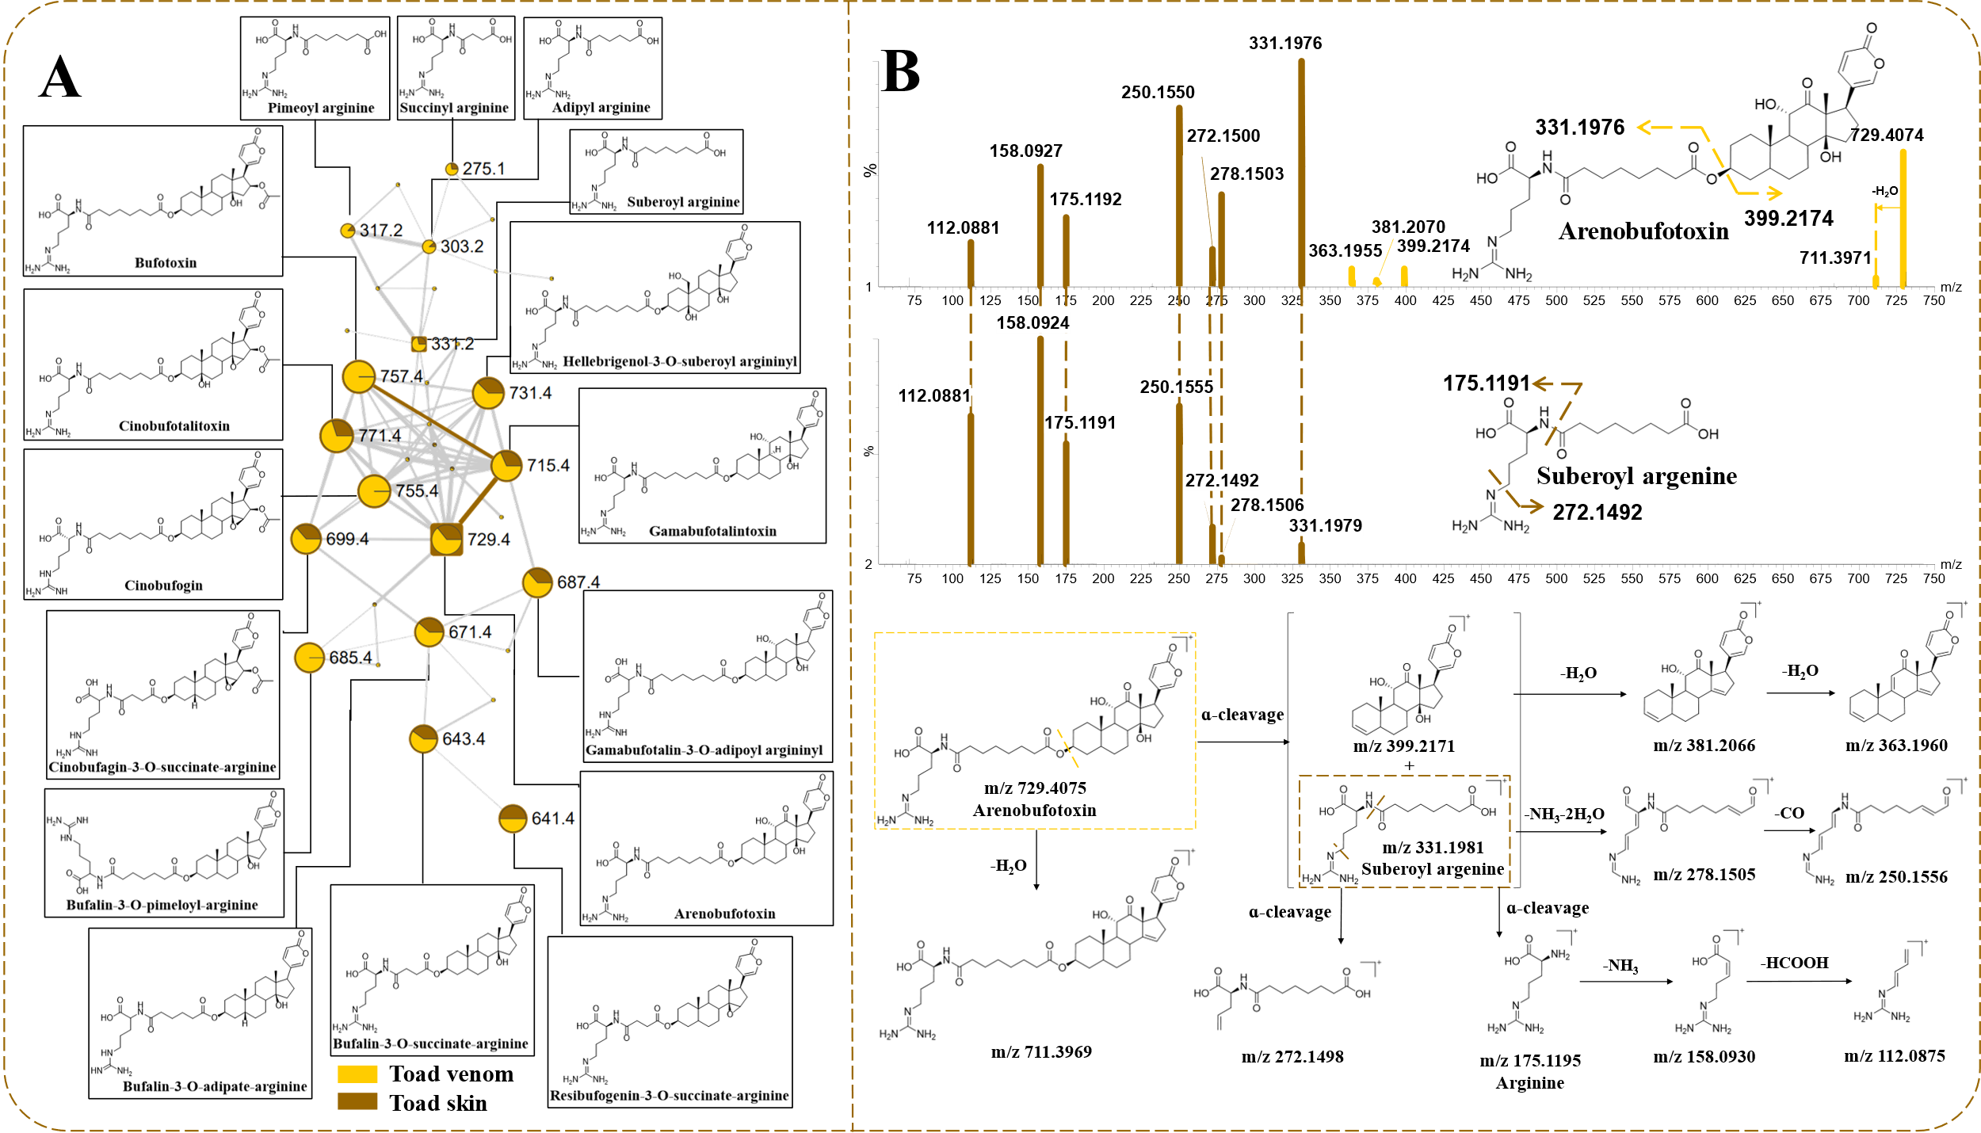

**Figure S3**. Molecular networking, secondary mass spectrometry and the prediction of fragmentation pathway of bufotoxins. (A) Molecular networking of bufotoxins (yellow means TV, brown means TS, the size of node is directly related to parent mass, the thickness of the connections between nodes is directly related to the structural similarity). (B) Secondary mass spectrometry and prediction of fragmentation behavior of arenobufotoxins and suberoyl argenins (brown means fragment ions of suberoyl argenins, yellow means fragment ions of arenobufotoxins).

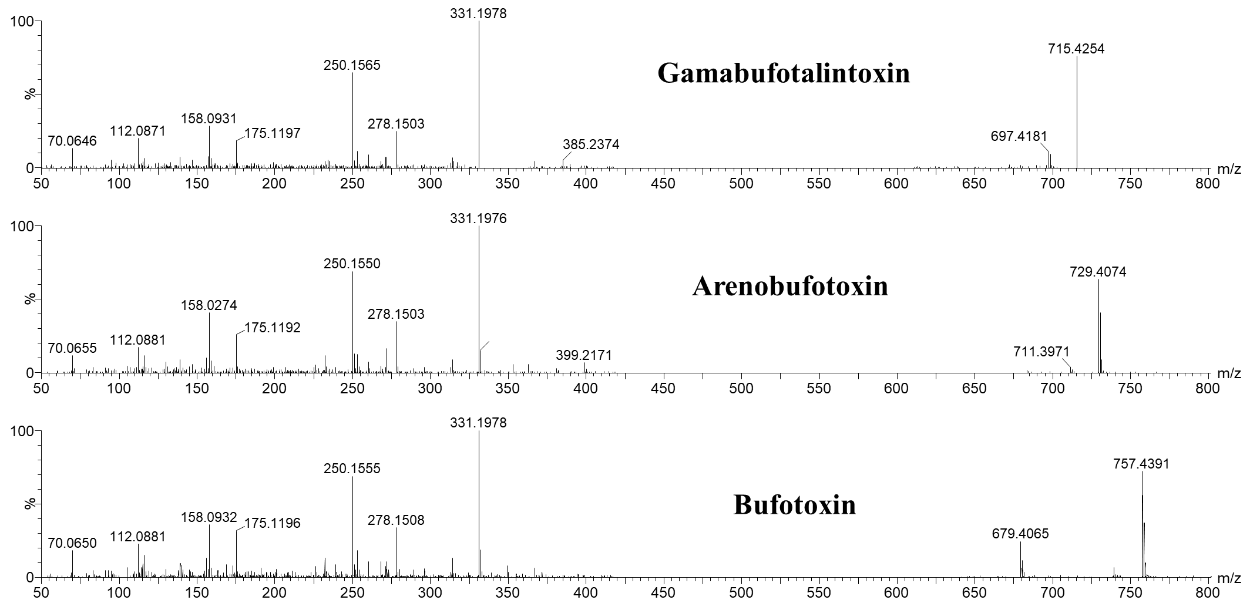

**Figure S4**. MS2 spectra of gamabufotalintoxin, arenobufotoxin, and bufotoxin

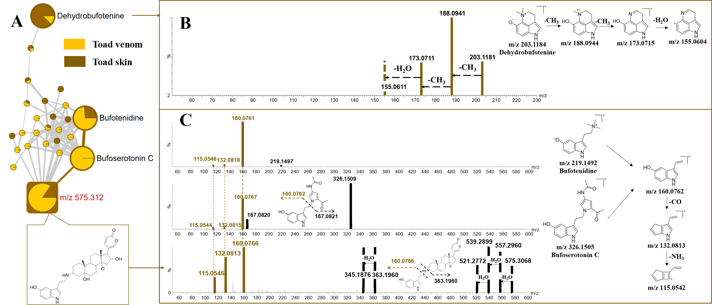 **Figure S5**. Molecular networking, the prediction of fragmentation route and discovery of new compounds of IAAS. (A) Molecular networking of IAAS (yellow means TV, brown means TS, the size of node is directly related to parent mass, the thickness of the connections between nodes is directly related to the structural similarity). (B) Secondary mass spectrometry and fragmentation behavior of dehydrobufotenine. (C) Secondary mass spectrometry and prediction of fragmentation behavior of bufotenidine, bufoserotonin C and unknown compound of *m/z* 575.312.

**Figure S6.** Molecular network, the prediction of cracking law and secondary mass spectrometry of small cyclic peptides. (a) Molecular network and the prediction of cracking law of three cyclic peptides. (b) The secondary mass spectrometry of three cyclic peptides on the GNPS platform. Black means original spectrogram information, green means spectral information of compounds matched by GNPS platform

TV

TS

27

93

42

**Figure S7.** Venn diagram of compounds in TS and TV.

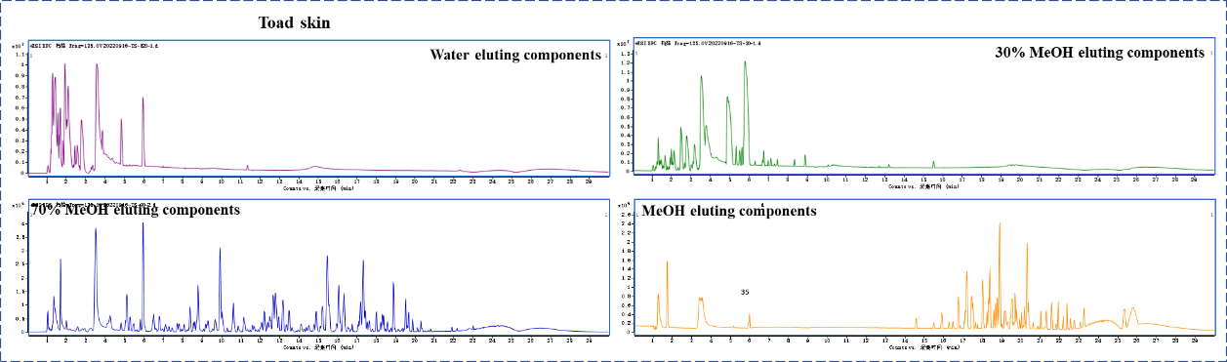

**Figure S8.** Base peak chromatograms of each fraction obtained by UPLC-QTOF/MS

|  |  |  |  |  |  |  |
| --- | --- | --- | --- | --- | --- | --- |
| **Table S3.** Characterization of 44 detected components in plasma originated from toad skin by LC-QTOF/MS | | | | | | |
| No. | tR(min) | Formula | Molecular ion(m/z) | Error(ppm) | Fragment ions | Identification |
| P1 | 1.109 | C5H11NO2 | 118.0867 | 4.23 |  | Glycinebetaine |
| P2 | 1.29 | C10H11NO2 | 178.0869 | 3.37 | 160.0755 | 5-Hydroxy tryptophol |
| P3 | 2.184 | C5H6N2O2 | 127.0508 | 4.72 |  | Thymine |
| P4 | 2.288 | C7H10N2O2 | 155.0813 | -1.29 | 127.0872 | Cyclo(pro-gly) |
| P5 | 2.387 | C12H22N4O5 | 303.1668 | 1.65 | 286.1408, 250.1186, 175.1194 | Adipylarginine |
| P6 | 2.898 | C12H14N2O2 | 219.1127 | -0.46 | 160.0763, 145.0531 | N-acetyl-5-Hydroxytryptamine |
| P7 | 3.535 | C13H18N2O | 219.1497 | 2.28 | 160.0760, 132.0790 | Bufotenidine |
| P8 | 4.178 | C9H17NO5 | 220.1184 | -0.45 | 202.1070, 184.0963 | D-pantothenic acid |
| P9 | 4.299 | C13H24N4O5 | 317.1816 | -0.95 | 236.1397, 158.0930 | Suberoylarginine |
| P10 | 4.54 | C12H14N2O | 203.1178 | -0.49 | 188.0939, 173.0712 | Dehydrobufotenine |
| P11 | 4.901 | C12H14N2O4S | 283.0746 | -0.35 | 203.1179, 188.0947, 173.0714 | Bufothionine |
| P12 | 5.452 | C14H26N4O5 | 331.1976 | 0.60 | 272.1493, 175.1198, 158.0929 | Sebacylargenin |
| P13 | 6.24 | C11H18N2O3 | 227.1390 | 1.76 | 199.1447, 170.0690 | Cyclo(Hpro-Leu) isomer |
| P14 | 6.569 | C11H18N2O3 | 227.1395 | 2.20 | 199.1442, 170.0685 | cyclo(Hpro-Leu) |
| P15 | 7.201 | C17H20N4O6 | 377.1464 | 2.12 | 243.0861 | Riboflavin |
| P16 | 7.721 | C14H16N2O3 | 261.1227 | -2.68 | 233.1281, 120.0823, 114.0561 | Cyclo(Phe-HPro) |
| P17 | 10.899 | C24H34O6 | 419.2449, | 1.59 | 401.2327, 365.2121 | Hellebrigenol |
| P18 | 11.862 | C24H32O6 | 417.2260 | -2.88 | 399.2159 | Bufarenogin |
| P19 | 12.546 | C24H34O5 | 403.2493 | 3.47 | 385.2382, 367.2279, 349.2165 | Gamabufotalin |
| P20 | 12.641 | C24H34O6 | 419.2448 | 3.34 | 383.2209, 251.1791 | Hellebrigenol isomer |
| P21 | 12.808 | C24H32O6 | 417.2269 | -0.72 | 399.2170, 363.1965, 335.2025 | 12β-hydroxylresibufaginol |
| P22 | 13.629 | C24H32O6 | 417.2269 | -0.72 | 399.2150, 335.2021 | 11β-hydroxylresibufaginol |
| P23 | 13.819 | C24H34O5 | 403.2476 | -0.74 | 385.2367, 367.2275, 349.2169 | Bufogenin B |
| P24 | 14.16 | C24H34O6 | 441.2234 | -3.17 | 383.2193, 365.2093, 347.1986 | Hellebrigenol isomer |
| P25 | 14.612 | C24H34O5 | 403.2477 | -1.74 | 367.2271, 349.2181, 331.2066 | 19-Hydroxylbufalin |
| P26 | 14.714 | C24H32O6 | 417.2263 | -2.16 | 399.2167, 381.2064, 363.1952, 353.2112 | Arenobufagin |
| P27 | 15.291 | C24H32O6 | 417.2283 | 2.64 | 399.2174, 381.2056, 371.2218, 363.1957, 353.2110, 345.1850, 335.2008 | Hellebrigenin |
| P28 | 15.544 | C24H32O6 | 417.2258 | -3.36 | 399.2169, 381.2059, 363.1955, 353.2115, 345.1845, 335.2061 | Desacetylcinobufotalin |
| P29 | 15.668 | C24H34O5 | 403.2481 | 0.50 | 385.2367, 367.2289, 349.2196 | 12β-Hydroxybufalin |
| P30 | 16.145 | C24H32O6 | 461.2547 | 1.73 | 425.2345, 419.2247, 383.2222 | 12β-Hydroxylresibufogenin |
| P31 | 16.486 | C24H30O6 | 417.2259 | -3.12 | 399.2170, 381.2064, 363.1967, 335.2012 | Bufotalinin |
| P32 | 16.54 | C24H34O5 | 415.2107 | -1.93 | 397.2019, 379.1912 | 1β-Hydroxylbufalin |
| P33 | 16.871 | C24H30O6 | 403.2484 | 1.24 | 385.2375, 367.2274, 349.2162 | 3-Keto-arenobufagin |
| P34 | 17.422 | C24H34O5 | 415.2108 | -1.69 | 397.2012 | Telocinobufagin |
| P35 | 17.707 | C24H32O5 | 403.2469 | -2.48 | 349.2176, 339.2237 | Desacetylcinobufagin |
| P36 | 17.753 | C24H34O5 | 401.2338 | 3.74 | 423.2142 | Telocinobufagin isomer |
| P37 | 17.811 | C26H36O6 | 403.2471 | -1.98 | 367.2278, 349.2165 | Bufotalin |
| P38 | 18.316 | C26H34O7 | 445.2578 | -1.57 | 403.2489, 367.2266, 346.2162, 321.2210 | Cinobufotalin |
| P39 | 18.631 | C26H36O6 | 459.2365 | -2.61 | 441.2283, 417.2271, 399.2168, 381.2065, 363.1954 | Bufotalin isomer |
| P40 | 18.995 | C24H32O5 | 445.2569 | -3.59 | 385.2377, 367.2269, 349.2165 | 22,23-Epoxyresibufogenin |
| P41 | 19.042 | C24H34O4 | 401.2332 | 2.24 | 383.2214, 365.2219 | Bufalin |
| P42 | 19.82 | C26H34O6 | 387.2527 | -0.77 | 369.2429, 351.2324 | Cinobufagin |
| P43 | 19.868 | C24H32O4 | 443.2434 | 1.35 | 425.2324, 401.2313, 383.2224, 365.2106 | Resibufogenin |
| P44 | 20.185 | C24H30O6 | 385.2379 | 1.56 | 367.2277, 349.2168, 339.2325 | Argentinogen |

**Table S4.** The regression equation, linear range and contents of nine main bufagenins in toad skin with UPLC-QTOF-MS/MS method

|  |  |  |  |  |
| --- | --- | --- | --- | --- |
| Bufagenins | Regression | Linear range (μg/mL) | R2 | Contents of TS (μg/mg) |
| Bufarenogin | Y = 273.13 X + 0.2267 | 0.625-20.0 | 0.9937 | 1.82 |
| Gamabufotalin | Y = 32.876 X + 0.0723 | 0.625-20.0 | 0.9958 | 2.09 |
| Arenobufagin | Y = 24.596 X + 0.0161 | 0.625-40.0 | 0.9981 | 6.44 |
| Hellebrigenin | Y = 60.453 X - 0.0179 | 0.625-20.0 | 0.9998 | 3.74 |
| Desacetylcinobufotalin | Y = 177.98 X + 0.2398 | 0.625-40.0 | 0.9948 | 0.948 |
| Telocinobufagin | Y = 48.461 X + 0.045 | 0.625-40.0 | 0.9958 | 1.03 |
| Bufotalin | Y = 787.97 X + 0.8246 | 0.156-20.0 | 0.9979 | 0.12 |
| Cinobufotalin | Y = 403.73 X - 0.0031 | 0.313-20.0 | 0.9987 | 0.83 |
| Cinobufagin | Y = 6.106 X + 0.0184 | 0.313-40.0 | 0.9962 | 0.48 |