**Electronic Supplementary Information (ESI) for**

**Efficient lead removal from aqueous solutions using a new sulfonated covalent organic framework: synthesis, characterization, and adsorption performance**

Mohammad Khosravania, Mohsen Dehghani Ghanatghestania*, Farid Moeinpourb*, Hossein Parvaresha

*a Department of Environment, Faculty of Natural Resources, Bandar Abbas Branch, Islamic Azad University, Bandar Abbas, Iran*

*b Department of Chemistry, Bandar Abbas Branch, Islamic Azad University, Bandar Abbas 7915893144, Iran*

*Corresponding authors.

*Mohsen Dehghani Ghanatghestani; E-mail: dehghani9332@gmail.com*

*Farid Moeinpour; Email: Fa.Moeinpour@iau.ac.ir*

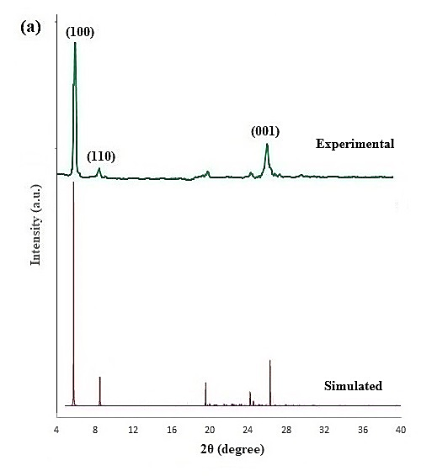

**Fig. S1.** (a) PXRD pattern of TFPOTDB-SO3H, (b) FT-IR spectra of TFPOT, DB-SO3H and TFPOTDB-SO3H, (c) N2 sorption isotherm and pore-size distribution of TFPOTDB-SO3H and (d) TGA plot of TFPOTDB-SO3H

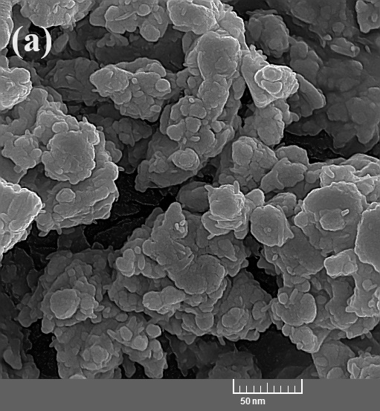 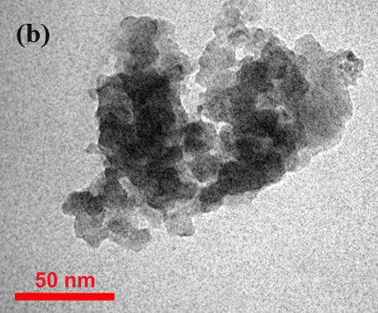

**Fig. S2.** SEM (a) and TEM (b) images of TFPOTDB-SO3H, along with EDS analysis of TFPOTDB-SO3H (c)

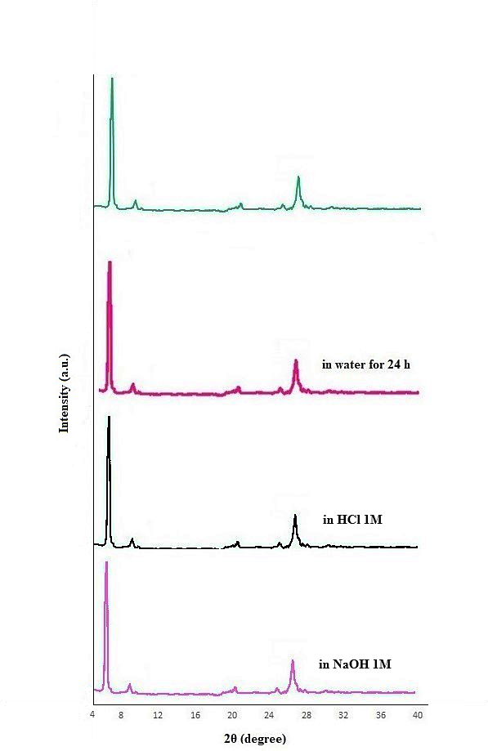

**Fig. S3.** The PXRD patterns of TFPOTDB-SO3H synthesized samples following immersion in water, HCl (1M) and NaOH (1M) solutions

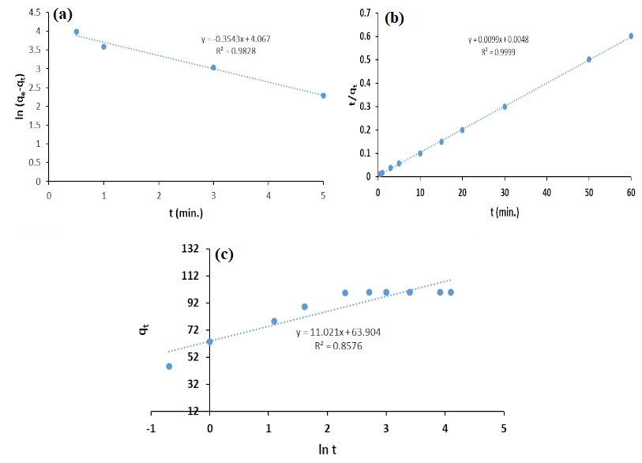

**Fig. S4.** Linearized plots of pseudo first order model (a), pseudo second order model (b) and Elovich model (c) for Pb(II) adsorption on TFPOTDB-SO3H

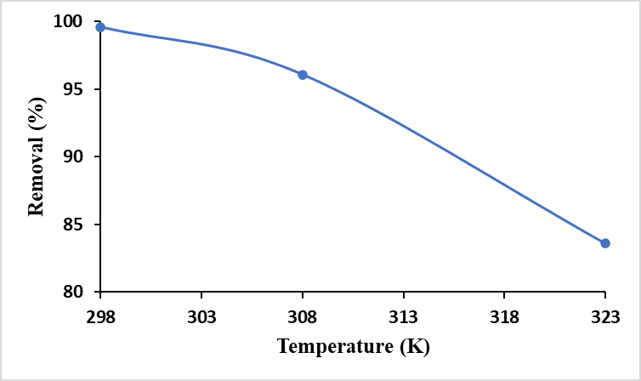

**Fig. S5.** Temperature effect on Pb(II) removal by TFPOTDB-SO3H

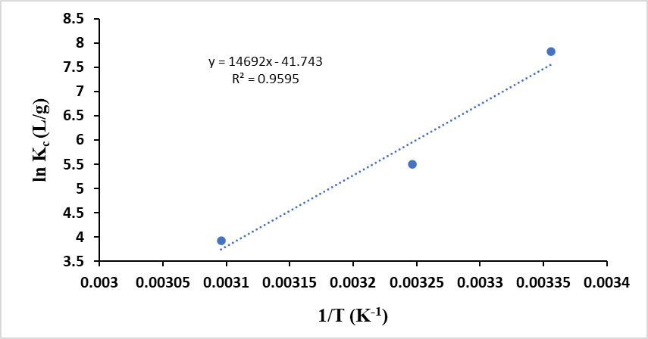

**Fig. S6.** Plot of ln *K*c vs. 1/*T* for the Pb(II) adsorption on TFPOTDB-SO3H

**Fig. S7.** The effects of coexisting ions on the removal of Pb(II) byTFPOTDB-SO3H at pH = 6 after 10 min. For anions, removal efficiencies refer to Pb(II) removal.

**Table S1.** Kinetic models variables for Pb(II) ions adsorption on TFPOTDB-SO3H

|  |  |  |  |
| --- | --- | --- | --- |
| Kinetic model | Parameters | | |
| Pseudo-first order | qe,cal a(mg/g) | k1 | R2 |
|  | 58.3816 | 0.3543 | 0.9828 |
|  |  |  |  |
| Pseudo-second order | qe,cal (mg/g) | k2 | R2 |
|  | 101.0101 | 1.4361 | 0.9999 |
|  |  |  |  |
| Elovich | α | β | R2 |
|  | 3375.5691 | 0.09074 | 0.8576 |

a The experimental adsorption capacity at equilibrium (qe) is equal to 99.4000 mg/g.

**Table S2.** Thermodynamic parameters for the adsorption of Pb(II) on TFPOTDB-SO3H

|  |  |  |  |
| --- | --- | --- | --- |
| *T* (K) | Δ*G* (kJ/mol) | Δ*H* (kJ/mol) | Δ*S* (kJ /mol K) |
| 298 | -19.375 | -122.149 | -0.347 |
| 308 | -14.095 |
| 323 | -10.557 |  |

**Table S3.** Kd values for water contaminated with multiple metals

|  |  |  |  |  |  |  |  |
| --- | --- | --- | --- | --- | --- | --- | --- |
| Metal ions | Ag+ | Fe3+ | Cd2+ | **Pb2+** | Zn2+ | Mn2+ | Ni2+ |
| *K*d | 2.08E+03 | 1.14E+03 | 1.71E+03 | **3.99E+06** | 4.82E+02 | 7.18E+02 | 6.16E+02 |