**Supplementary Materials**

Theoretical study of new 3-(methylthio)-8-phenyl-8H-thieno[2,3-b]indole derivatives for application in DSSC: solvent effect, adsorption process on the surface of TiO2

Mohammed Elkabous *a*,Yasser Karzazi *a,\**

*a Laboratory of Applied Chemistry and Environment (URAC 18), Faculty of Sciences, University Mohammed I, B.P. 4808, 60046 Oujda, Morocco.*

## **Section 1: The Theoretical Background**

## 

To evaluate the efficiency and photovoltaic performance of DSSCs, using parameters such as open circuit photoelectric voltage ($V_{oc}$), fill factor *(FF)*, short circuit current density ($J_{sc}$) and incident solar power ($P_{IN}$). The efficiency ($η$) of a DSSC can be formulated using the following equation(sang-aroon et al., 2013):

|  |  |
| --- | --- |
| $$η=\frac{J_{sc}FFV_{OC}}{P_{IN}}$$ | ***Eq.(S1)*** |

Where $V_{OC}$ is the open circuit photoelectric voltage, which is the potential difference between the Fermi level occupied by electrons in the dye and the conduction band of Titanium oxide(Menzel et al., 2012). Its formula is given by:

|  |  |
| --- | --- |
| $$eV_{oc}=E_{LUMO}-E_{CB}$$ | ***Eq.(S2)*** |

According to equation (1), in order to obtain more efficient DSSCs, *JSC* should be as high as possible and is defined by the following equation :

|  |  |
| --- | --- |
| $$J_{SC}=\int{‍}λLHE(λ)Φ_{inject}η_{collect}dλ$$ | ***Eq.(S3)*** |

LHE ($λ$) represents the light-harvesting efficiency, $Φ_{inject}$ is the electron injection efficiency and $η_{collect}$ is the charge collection efficiency which is considered a constant.

The LHE is described as follows (Deng, 2013):

|  |  |
| --- | --- |
| $$LHE=1-10^{-A}=1-10^{-f}$$ | ***Eq.(S4)*** |

Where A(*f*) is the absorption (oscillating strength) of the dyes associated with the absorption energy ($E_{00}$).

To analyze the relationship between $Φ_{inject}$ and injection driving force $ΔG_{inject}$ of the dyes based on electron injection from the photoinduced excited state of the dye into the TiO2 surface, the energy relationship can be expressed (Katoh et al., 2004):

|  |  |
| --- | --- |
| $$Φ_{inject}∞f\left(-ΔG_{inject}\right)$$ | ***Eq.(S5)*** |
| $$ΔG_{inject}=E_{ox}^{dye*}+E_{CB}^{TiO_{2}}=E_{ox}^{dye}-E_{00}+E_{CB}^{TiO_{2}}$$ | ***Eq.(S6)*** |

Where $E_{ox}^{dye*}$ is the oxidation potential energy of the dyes in the excited state, $E_{ox}^{dye}$ is the ground state oxidation potential energy of the dye. $E_{CB}^{TiO_{2}}$ is the reduction potential of the TiO2 conduction band. Herein we use, –4.0 eV for $E_{CB}^{TiO_{2}}$ (Ning et al., 2010), $E_{00}$ represents the vertical excitation energy.

The regeneration of the dye is a very important step in the process of conversion of light into an electric current (Boschloo and Hagfeldt, 2009), The thermodynamic energy $ΔG_{dye}^{regent}$ that allows us to know the efficiency of this regeneration is given by the following formula:

|  |  |
| --- | --- |
| $$ΔG_{dye}^{regent}=E_{redox}^{electrolyte}+E_{ox}^{dye}$$ | ***Eq.(S7)*** |

$E_{redox}^{electrolyte}$ is the redox potential of the electrolyte (tri iodide-iodide) which is given as (4.85 eV)(Yang et al., 2016).

As per the formula below, we were able to determine the dye adsorption energy on the titanium oxide (110) surface :

|  |  |
| --- | --- |
| $$E_{ads}=E_{TiO_{2}+Dye+toluene}-(E_{TiO_{2}}+E_{Toluene}+ E_{Dye})$$ | ***Eq.(S8)*** |

$E_{TiO_{2}+Dye+toluene}$ is the total energy of the complex, $E_{TiO_{2}}$ is the energy for the anatase surface model and $E_{Dye}$ is the energy of the dye (Srinivas et al., 2011). According to the above expression, a negative value of $E_{ads}$ means that the adsorption is favourable.

## **Section 2: Opto-electronic characteristics**

**Table S1** : Comparative analysis of maximum absorption $λ_{Max}^{ }$ simulated with different functionals and a consistent basis set 6-31G(d,p) in Toluene.

|  |  |  |  |  |  |  |  |
| --- | --- | --- | --- | --- | --- | --- | --- |
| Functional | M062X | PBE1PBE | B3YLP | MPW1  MPW91 | CAM-B3YLP | WB97XD | Experimental |
|  | 496.49 | 494.39 | 588.08 | 564.69 | 497.16 | 484.38 | 502 |

**Table S2** : Basis set effect on $λ_{Max}^{ }$ with CAM-3BLYP functional in Toluene.

|  |  |  |  |  |  |
| --- | --- | --- | --- | --- | --- |
| Basis set | 6-31G | 6-31G(d,p) | 6-31G(d,p)+ | 6-31G(d,p)++ | Experimental |
|  | 487.04 | 497.16 | 510.19 | 510.22 | 502 |

**Table S3**: Values of the HOMO and LUMO energies, and the energy gap for the studied dyes, as calculated at the B3LYP/6-31G(d,p) level

|  |  |  |  |  |  |  |  |  |
| --- | --- | --- | --- | --- | --- | --- | --- | --- |
| **Dye** | **Gas** | | | |  | **Toluene** | | |
| *EHOMO*(eV) | | *ELUMO* (eV) | *Egap* (eV) | *EHOMO*(eV) | *ELUMO* (eV) | *Egap* (eV) |
| D1 | | -5.36 | -2.63 | 2.73 |  | -5.39 | -2.71 | 2.68 |
| D2 | | -5.19 | -2.71 | 2.48 |  | -5.23 | -2.73 | 2.43 |
| D3 | | -5.12 | -2.69 | 2.43 |  | -5.10 | -2.73 | 2.37 |
| D4 | | -5.21 | -2.89 | 2.32 |  | -5.19 | -2.90 | 2.29 |
| D5 | | -5.32 | -3.33 | 1.99 |  | -5.27 | -3.34 | 1.93 |
| MKZ-39 | | -5.18 | -2.75 | 2.43 |  | -5.18 | -2.80 | 2.37 |

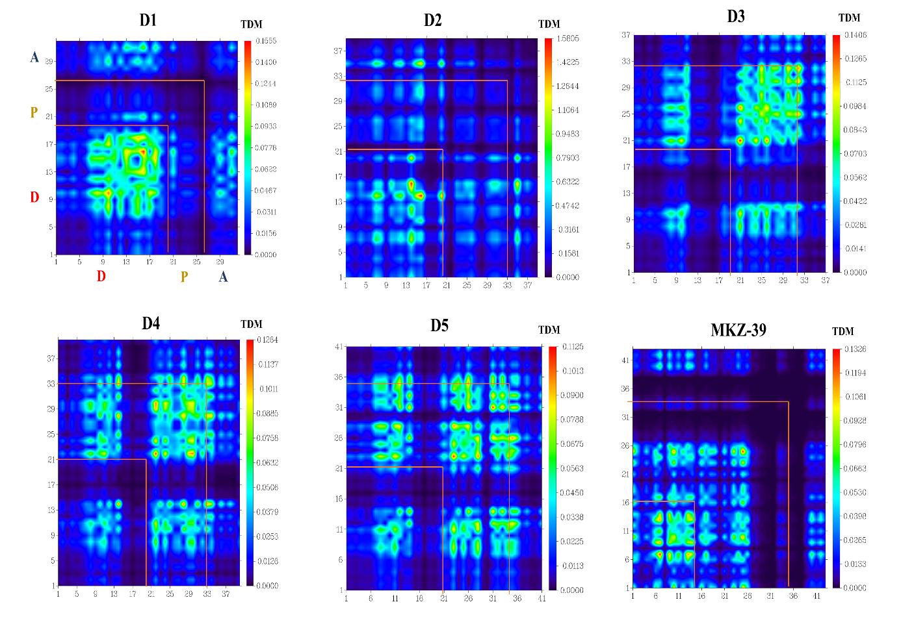

**Figure S1:** Simulated TDM and EDD for the investigated dyes **Di (i = 1, 5)** and the reference molecule MKZ-39 in gas phase at S1 Donor (D), Bridge (P) and Acceptor (A).

**References**

Babu, D.D., Gachumale, S.R., Anandan, S., Adhikari, A.V., 2015. New D-π-A type indole based chromogens for DSSC: Design, synthesis and performance studies. Dyes and Pigments 112, 183–191. <https://doi.org/10.1016/j.dyepig.2014.07.006>

Boschloo, G., Hagfeldt, A., 2009. Characteristics of the Iodide/Triiodide Redox Mediator in Dye-Sensitized Solar Cells. Acc Chem Res 42, 1819–1826. <https://doi.org/10.1021/ar900138m>

Deng, W.F. and W., 2013. Incorporation of Thiadiazole Derivatives as π-Spacer to Construct Efficient Metal-free Organic Dye Sensitizers for Dye-sensitized Solar Cells: A Theoretical Study. Communications in Computational Chemistry 1, 152–170. <https://doi.org/10.4208/CICC.2013.V1.N2.6>

Katoh, R., Furube, A., Yoshihara, T., Hara, K., Fujihashi, G., Takano, S., Murata, S., Arakawa, H., Tachiya, M., 2004. Efficiencies of Electron Injection from Excited N3 Dye into Nanocrystalline Semiconductor (ZrO2, TiO2, ZnO, Nb2O5, SnO2, In2O3) Films. J Phys Chem B 108, 4818–4822. <https://doi.org/10.1021/jp031260g>

Menzel, R., Ogermann, D., Kupfer, S., Weiß, D., Görls, H., Kleinermanns, K., González, L., Beckert, R., 2012. 4-Methoxy-1,3-thiazole based donor-acceptor dyes: Characterization, X-ray structure, DFT calculations and test as sensitizers for DSSC. Dyes and Pigments 94, 512–524. <https://doi.org/10.1016/j.dyepig.2012.02.014>

Ning, Z., Fu, Y., Tian, H., 2010. Improvement of dye-sensitized solar cells: what we know and what we need to know. Energy Environ. Sci. 3, 1170–1181. <https://doi.org/10.1039/C003841E>

sang-aroon, W., Saekow, S., Amornkitbamrung, V., 2013. Density functional theory study on the electronic structure of Monascus dyes as photosensitizer for dye-sensitized solar cells. J Photochem Photobiol A Chem 236, 35–40. <https://doi.org/10.1016/j.jphotochem.2012.03.014>

Srinivas, K., Kumar, C.R., Reddy, M.A., Bhanuprakash, K., Rao, V.J., Giribabu, L., 2011. D-Ï€-A organic dyes with carbazole as donor for dye-sensitized solar cells. Synth Met 161, 96–105. <https://doi.org/10.1016/j.synthmet.2010.11.004>

Yang, Z., Liu, Y., Liu, C., Lin, C., Shao, C., 2016. TDDFT screening auxiliary withdrawing group and design the novel D-A-Ï€-A organic dyes based on indoline dye for highly efficient dye-sensitized solar cells. Spectrochim Acta A Mol Biomol Spectrosc 167, 127–133. <https://doi.org/10.1016/j.saa.2016.05.041>