**Supplementary Material:**

**Nattokinase Enhances the Sensitivity of Cancer Cells to Oxaliplatin through Mitochondrial Pathway and Induction of Apoptosis**

Yong-Po Zhang a, Yue-Wei Tian a, Jiang Geng b, Xin-Hui Zhou a, Meng-Ze Li a, Guang-Huan Liu a, Chun-Yan Gao a*\**, Ai-Qin Yue c, Jin-Zhong Zhao a*\** and Wei-Jun Du c*\**

[[1]a] *Department of Basic Sciences, Shanxi Agricultural University, Taigu Shanxi 030801, P. R. China*

[b] *Shanxi Provincial Cancer Hospital, Taiyuan Shanxi 030012, P. R. China*

[c] *College of Agronomy, Shanxi Agricultural University, Taigu Shanxi 030801, P. R. China*

C:\Users\Administrator\Desktop\图片\洗脱曲线.tif

**Figure S1**. Elution curve for gel filtration chromatography

**Table S1. Fribin plate area corresponding to urokinase of different concentrations**

|  |  |
| --- | --- |
| Urokinase activity (U/mL) | Dissolution circle area (mm2) |
| 50 | 346.36 |
| 100 | 363.05 |
| 200 | 380.13 |
| 400 | 415.48 |
| 600 | 452.39 |
| 800 | 490.87 |
| 1000 | 530.93 |

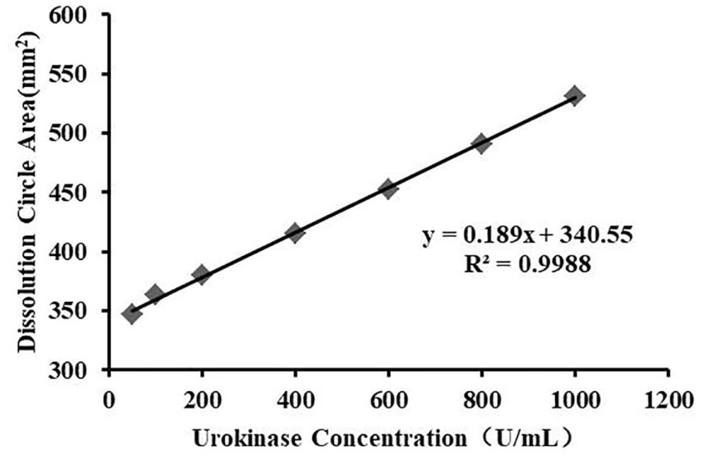

**Figure S2**. Standard curve of urokinase activity

**Table S2. Pt content of oxaliplatin alone and in combination with NK to cells.**

|  |  |  |  |  |
| --- | --- | --- | --- | --- |
| Drug | ng Pt/million cells | | | |
| BGC-823 | HeLa | HepG-2 | NCI-H460 |
| Control | 73.33±35.12 | 360.00±34.64 | 33.33±5.77 | 453.33±23.09 |
| NK | 96.67±35.12 | 423.33±64.29 | 63.33±37.86 | 333.33±49.33 |
| OXA | 2866.67±268.58## | 3233.33±1088.36## | 526.67±122.20## | 4480.00±255.34## |
| OXA+NK | 3106.67±80.83## | 5893.33±122.20##* | 906.67±241.11##* | 4553.33±122.20## |

(##: P＜0.01 vs Control or NK; *: P＜0.05 vs Oxaliplatin)

1. * Corresponding authors. E-mail address: gaocy@sxau.edu.cn, zhaojz@sxau.edu.cn, duweijun@sxau.edu.cn