**Extraction process optimization of alisol B 23-acetate from Alismatis Rhizoma and its protection against carbon tetrachloride-induced acute liver injury**

Peng Leia, Zhirong Zhoua, Jierong Peia, Li Jiaa, Lifeng Hana, b, Miaomiao Jianga, b, *

a Tianjin Key Laboratory of Therapeutic Substance of Traditional Chinese Medicine, Tianjin, China.

b Haihe Laboratory of Modern Chinese Medicine, Tianjin, China.

* Corresponding authors at: Tianjin University of Traditional Chinese Medicine, 10 Poyanghu Road, West Area, Tuanbo New Town, Jinghai District, Tianjin, P. R. China, 301617. E-mail address: miaomiaojiang@tjutcm.edu.cn (M. JIANG).

*1. Extraction,* *separation, and purification of alisol B 23-acetate (AB23A)*

4 kg of Alismatis Rhizoma was pulverized, and a 70% ethanol reflux extraction was conducted three times at a solid-liquid ratio of 1:13, each time for 2 hours. The extracts were concentrated, and ethanol was recovered. The obtained material was suspended in water and sequentially extracted with petroleum ether, ethyl acetate, and n-butanol at a volume ratio of 1:1. After concentrating and recovering the solvents, the petroleum ether extract (AR-PE) was obtained at 62.7 g, the ethyl acetate extract (AR-EA) at 31.9 g, and the n-butanol extract at 55.0 g.

AB23A in the petroleum ether and ethyl acetate extracts was further separated, purified, and enriched using silica gel column chromatography (Qingdao Haiyang Chemical Co., Ltd., China), octadecylsilane-bonded silica gel chromatography (YMC CO., LTD., Japan), gel column chromatography (GE HealthCare, USA), and preparative liquid chromatography (Shimadzu Corporation., Japan) to obtain the monomeric AB23A (Fig. S1).

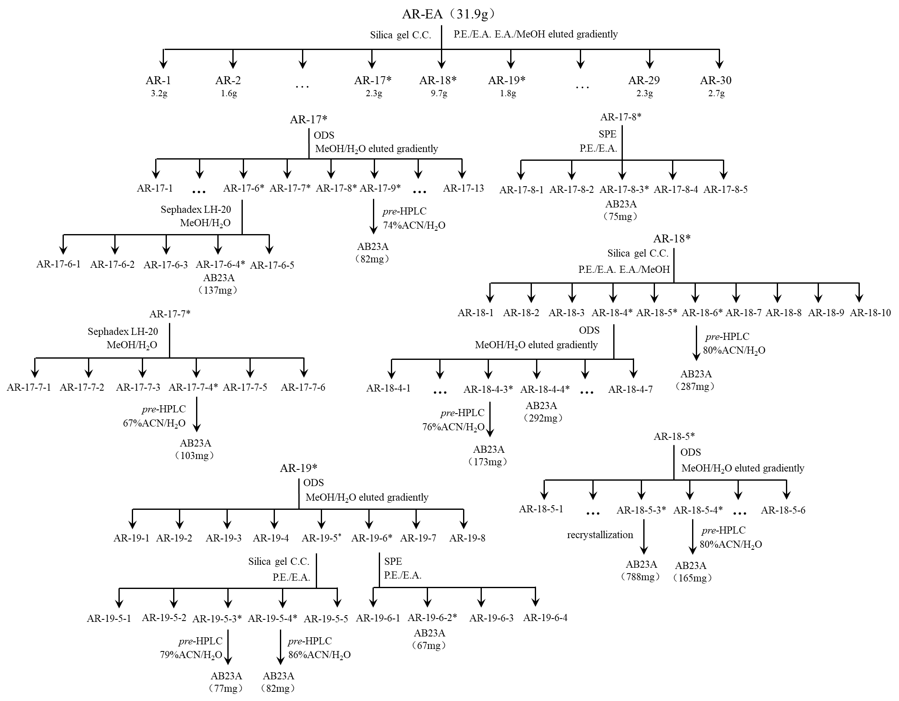

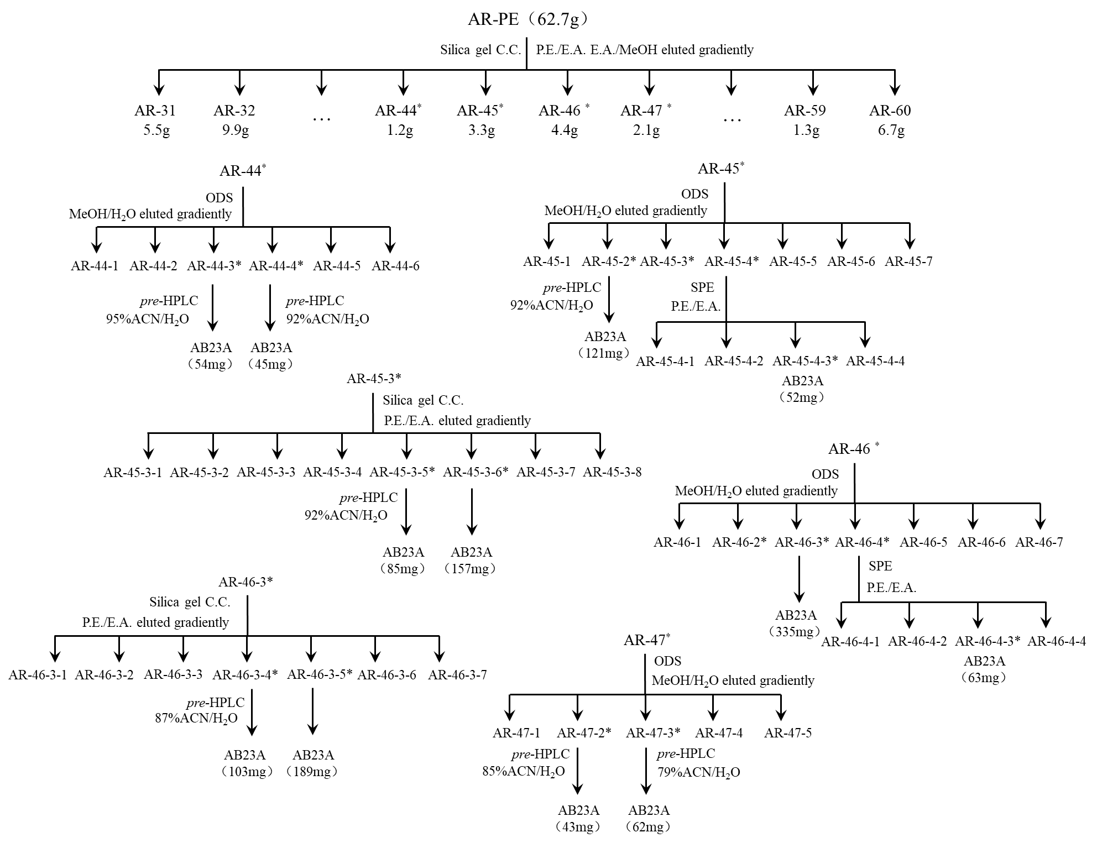

Fig. S1 Separation and purification process of AB23A.

*2. Confirmation and purity of AB23A*

The AB23A sample was weighed and dissolved in 600 μL of deuterated methanol containing 0.1% TSP. Structural confirmation was performed using an AVANCE ΙΙΙ 500 MHz nuclear magnetic resonance spectrometer (Bruker, Germany), and purity was calculated according to the internal standard quantification formula.

$$\begin{aligned}m_{s}=\frac{A_{s}}{A_{i}}×\frac{E_{s}}{E_{i}}×m_{i}\#\left(\text{1}\right)\end{aligned}$$

where *ms* represents the mass of the measured sample, and *mi* is the mass of the internal standard. *As* and *Ai* represent the average values of the selected signal integrals of the sample and internal standard, respectively. *Es* and *Ei* represent the proton equivalents of the sample and internal standard, respectively, given by $$\begin{aligned}E=\frac{M}{n}\#\left(\text{2}\right)\end{aligned}$$

where *M* is the molecular weight of the calculated substance, and *n* is the number of protons in the integrated signal.

$$\begin{aligned}S\left(\%\right)=\frac{m_{s}}{m}×100\%\#\left(\text{3}\right)\end{aligned}$$

where *S* is the percentage content of the measured sample, *ms* is the weight of the measured sample, and *m* is the real weight of the sample.

The proton nuclear magnetic resonance (NMR) spectrum of the sample was shown in Fig. S2. The integral result of the internal standard peak area was set to "1.00" for normalization of the hydrogen signal peak area in the sample. The quantification peak for the sample was chosen at *δ*H 1.17 (3H, s), and its normalized result was 1.23. By substituting the values into the formula, the percentage content of AB23A in the purified sample was calculated to be 95.48%.

Fig. S2 The 1H-NMR spectrum of AB23A.

Table S1 BBD experimental design and results (*n* = 3).

|  |  |  |  |  |  |
| --- | --- | --- | --- | --- | --- |
| NO. | A | B | C | D | Extraction rate (μg/g) |
| 1 | 60 | 2 | 2 | 10 | 2184.91 |
| 2 | 70 | 2 | 2 | 12.5 | 2819.01 |
| 3 | 70 | 2 | 2 | 12.5 | 2819.01 |
| 4 | 70 | 2 | 3 | 10 | 2767.30 |
| 5 | 70 | 1.5 | 2 | 10 | 2585.92 |
| 6 | 70 | 2 | 2 | 12.5 | 2819.01 |
| 7 | 80 | 2 | 3 | 12.5 | 2448.17 |
| 8 | 60 | 2 | 2 | 15 | 2588.71 |
| 9 | 70 | 2 | 1 | 15 | 2228.39 |
| 10 | 70 | 2 | 3 | 15 | 2856.46 |
| 11 | 60 | 2.5 | 2 | 12.5 | 2538.57 |
| 12 | 80 | 2 | 2 | 15 | 2042.25 |
| 13 | 70 | 2 | 2 | 12.5 | 2819.01 |
| 14 | 70 | 2.5 | 2 | 15 | 2692.60 |
| 15 | 60 | 2 | 3 | 12.5 | 2597.37 |
| 16 | 80 | 2 | 1 | 12.5 | 1569.24 |
| 17 | 80 | 2.5 | 2 | 12.5 | 1860.63 |
| 18 | 80 | 2 | 2 | 10 | 2099.49 |
| 19 | 60 | 2 | 1 | 12.5 | 2051.92 |
| 20 | 70 | 1.5 | 1 | 12.5 | 2235.55 |
| 21 | 70 | 1.5 | 2 | 15 | 2524.7 |
| 22 | 70 | 2.5 | 2 | 10 | 2284.82 |
| 23 | 80 | 1.5 | 2 | 12.5 | 2289.23 |
| 24 | 70 | 2.5 | 1 | 12.5 | 1971.95 |
| 25 | 60 | 1.5 | 2 | 12.5 | 2243.17 |
| 26 | 70 | 2.5 | 3 | 12.5 | 2881.14 |
| 27 | 70 | 2 | 1 | 10 | 1970.99 |
| 28 | 70 | 1.5 | 3 | 12.5 | 2750.74 |
| 29 | 70 | 2 | 2 | 12.5 | 2819.01 |

Table S2 Analysis of variance (ANOVA) results for quadratic model.

|  |  |  |  |  |  |  |
| --- | --- | --- | --- | --- | --- | --- |
| Source | Sums of squares | Degree of freedom | Mean squares | | F-value | P-value |
| Model | 3.628E+06 | 14 | | 2.592E+05 | 13.14 | < 0.0001 |
| A | 2.995E+05 | 1 | | 2.995E+05 | 15.19 | 0.0016 |
| B | 13306.90 | 1 | | 13306.90 | 0.6749 | 0.4251 |
| C | 1.522E+06 | 1 | | 1.522E+06 | 77.17 | < 0.0001 |
| D | 90075.33 | 1 | | 90075.33 | 4.57 | 0.0507 |
| AB | 1.310E+05 | 1 | | 1.310E+05 | 6.65 | 0.0219 |
| AC | 27801.85 | 1 | | 27801.85 | 1.41 | 0.2548 |
| AD | 53135.94 | 1 | | 53135.94 | 2.69 | 0.1229 |
| BC | 38809.87 | 1 | | 38809.87 | 1.97 | 0.1824 |
| BD | 54989.18 | 1 | | 54989.18 | 2.79 | 0.1171 |
| CD | 7075.42 | 1 | | 7075.42 | 0.3588 | 0.5587 |
| A² | 1.254E+06 | 1 | | 1.254E+06 | 63.59 | < 0.0001 |
| B² | 1.392E+05 | 1 | | 1.392E+05 | 7.06 | 0.0188 |
| C² | 2.934E+05 | 1 | | 2.934E+05 | 14.88 | 0.0017 |
| D² | 1.470E+05 | 1 | | 1.470E+05 | 7.45 | 0.0163 |
| Residual | 2.760E+05 | 14 | | 19717.19 |  |  |
| Lack of Fit | 2.401E+05 | 10 | | 24011.83 | 2.67 | 0.1779 |
| Pure Error | 35922.38 | 4 | | 8980.60 |  |  |
| Cor Total | 3.904E+06 | 28 | |  |  |  |

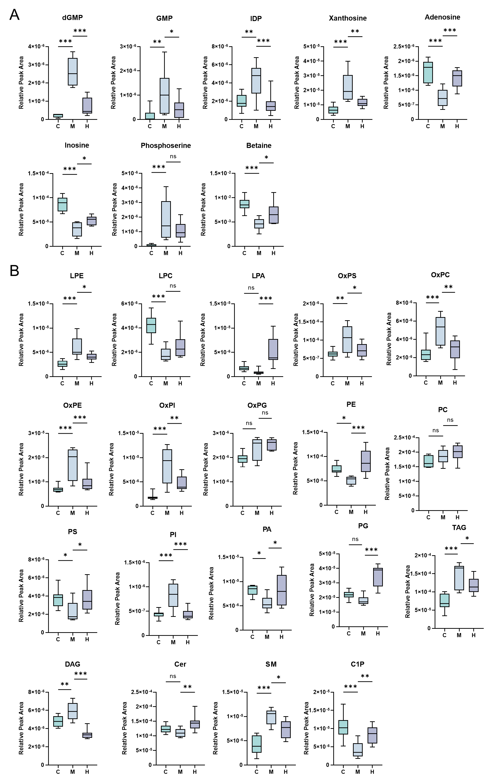

**Fig. S3** Box plots of relative content of metabolites regulated by alisol B 23-acetate (AB23A). **(A)** Relative content changes of eight key metabolites. **(B)** Relative content changes of nineteen key lipids.