Preparation and performance of FeCo bimetallic organic frameworks with super adsorption and excellent peroxymonosulfate activation for tetracycline removal

Shuangfei Zhang, Ziru Shao, Deyong Wu[1]*

School of Chemical and Environmental Engineering, Hubei Minzu University, Enshi, Hubei Province 445000, China

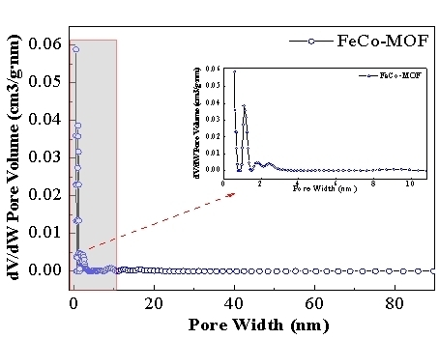

Fig.S1 The pore-size distribution plot of FeCo-MOF.

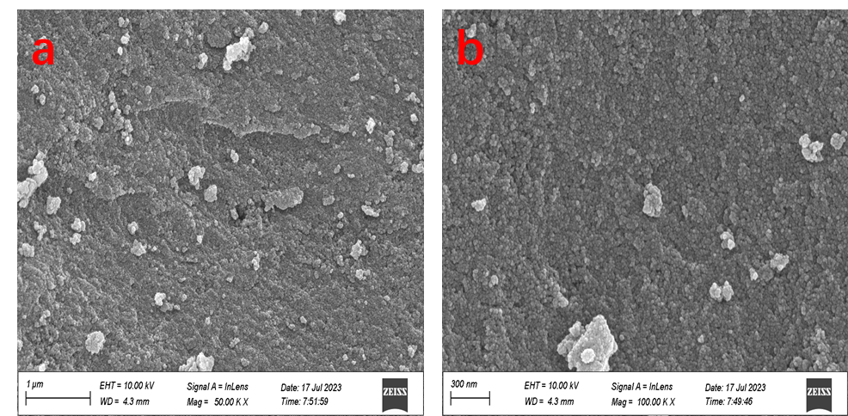

Fig. S2 SEM images of Fe-MOF

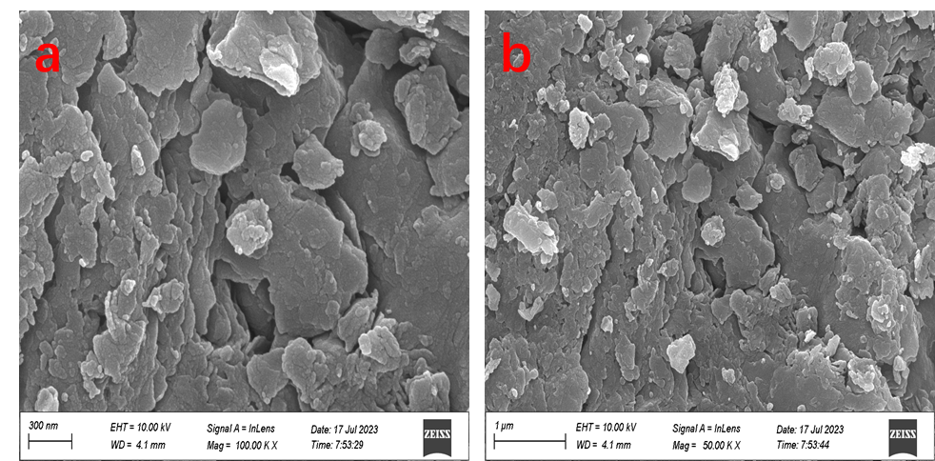

Fig. S3 SEM images of Co-MOF

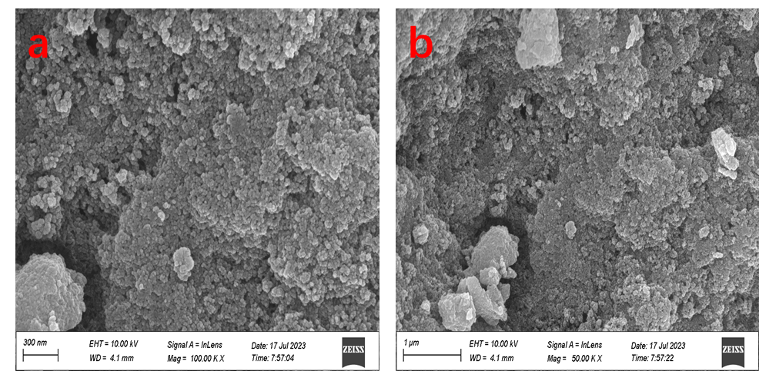

Fig. S4 SEM images of FeCo-MOF

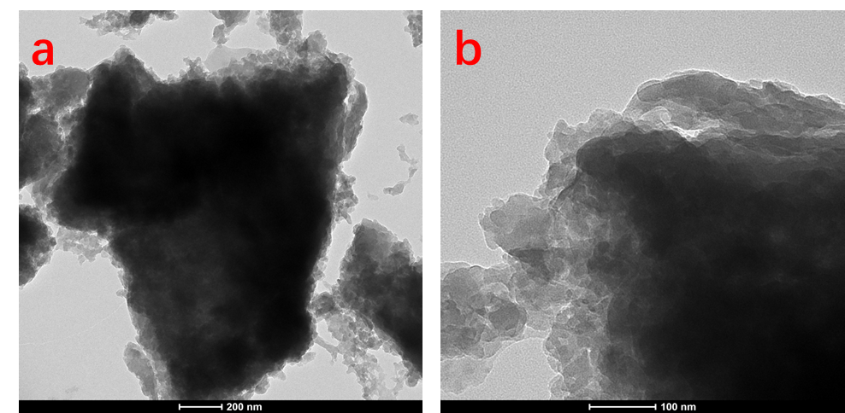

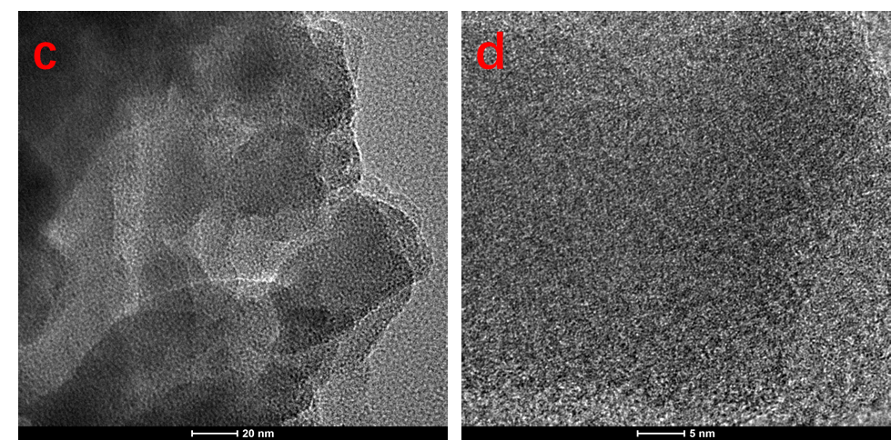

**Fig.S5** TEM images of FeCo-MOF

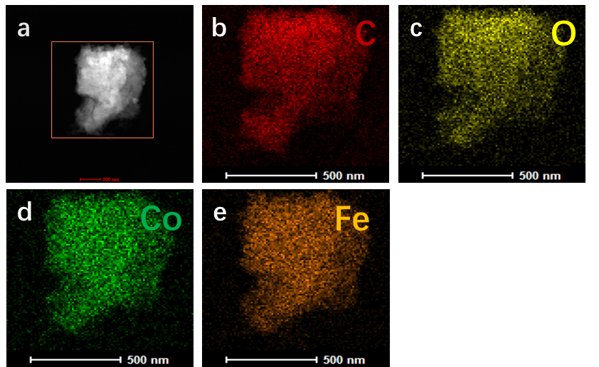

Fig.S6 TEM-mapping of C, O, Co, Fe in FeCo-MOF catalyst

Fig.S7. The standard curve between concentration and absorbancy of TC



Fig.S8 The degradation rate of the TC in the different systems, .



Fig.S9 The K values of FeCo-MOF/PMS/TC at different inorganic anions with different concentrations.

1. * Corresponding author.

   E-mail address: wdy001815@126.com (D. Wu).