Cd-CeO₂@C: synthesis via consumption of Cd²⁺ and organic pollutants and removal of organic pollutants
Heyun Tan^{a☆}, yuantao Cai^{a☆}, Gangfeng Liangª, Paolo Aprea^{b}, Shiyou Haoª
ªXingzhi College, College of Chemistry and Life Sciences, Zhejiang Normal University, 321004 Jinhua，P. R. of China
^{b}Department of Chemical, Materials and Production Engineering, University Federico II, P.le V. Tecchio 80, 80125, Naples, Italy

Heyun Tan and yuantao Cai, equally contributed to this paper, are the co-first authors.
*Corresponding author:
E-mail: sky54@zjnu.cn (Shiyou Hao)

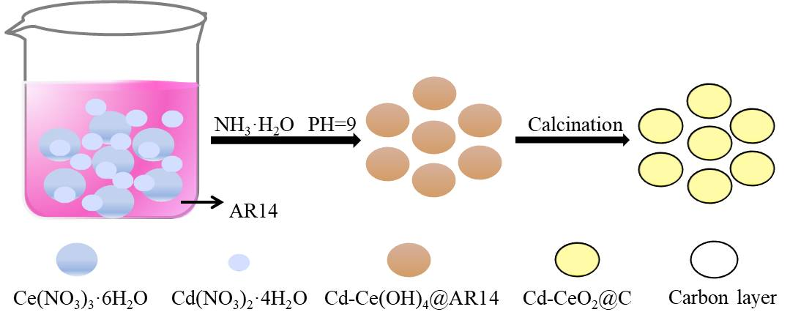
Fig. S1 Synthesis sequence diagram of Cd-CeO₂@C.
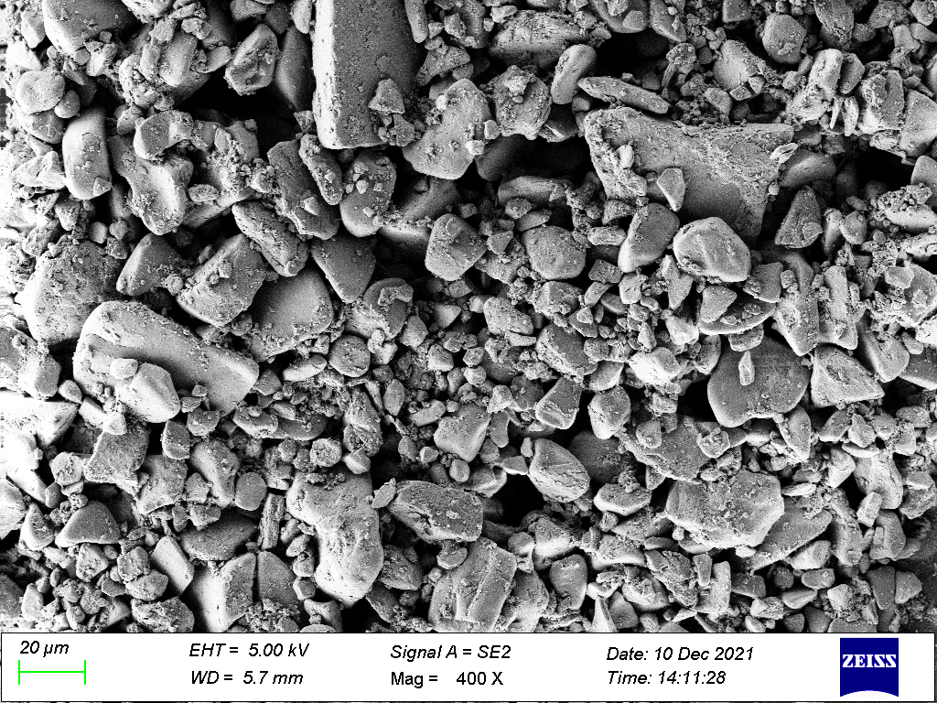
Fig. S2 SEM of 0.5%Cd-CeO₂-0.02C.
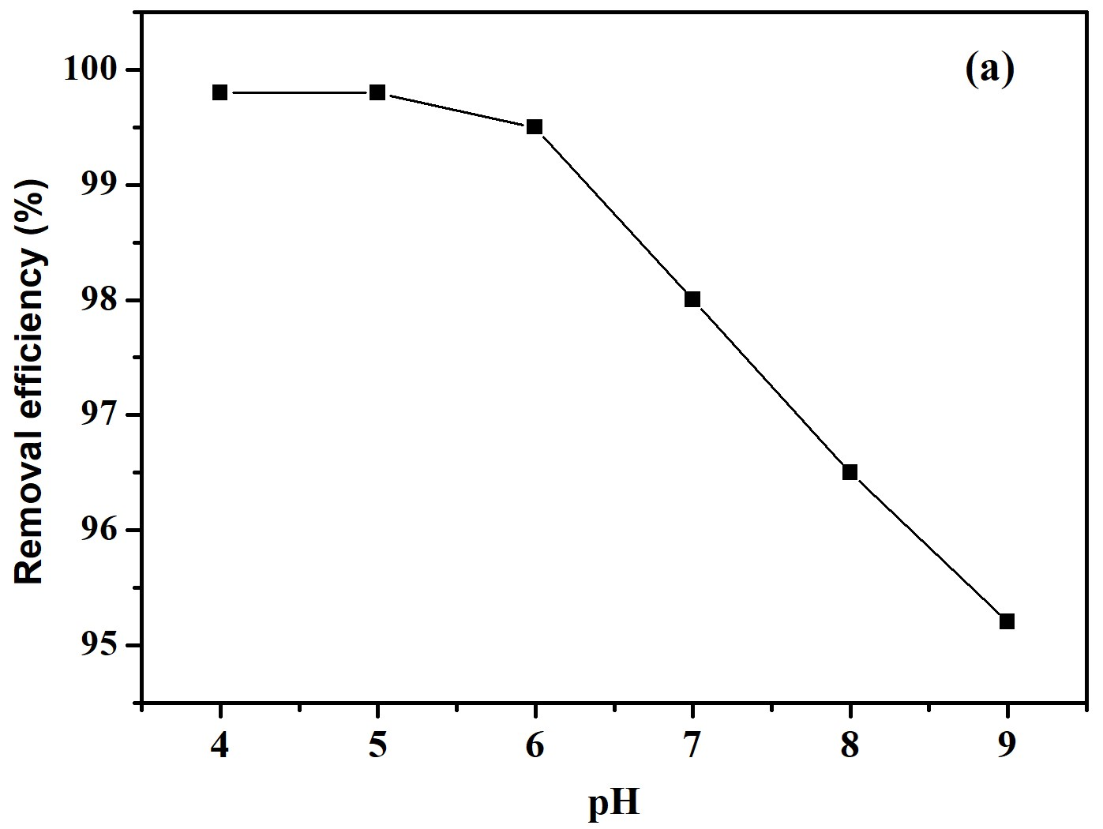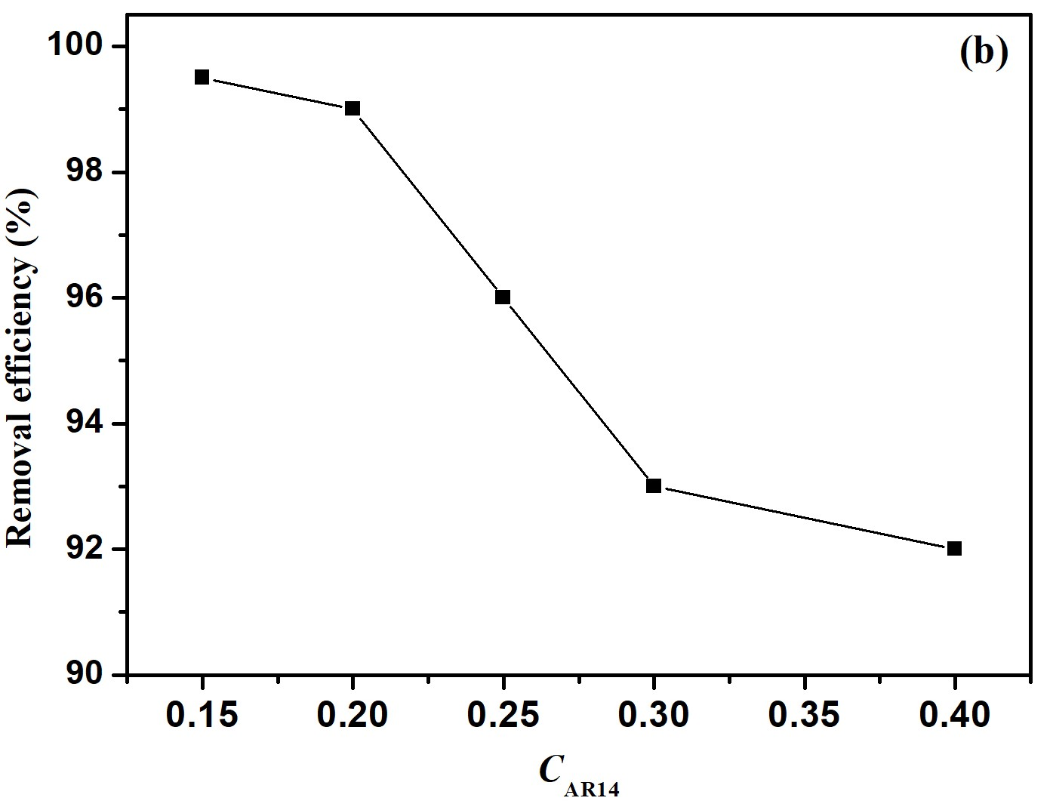
Fig. S3 Effect of pH (a) and concentration of AR14 (b) on the removal efficiency of AR14 over 0.5%Cd-CeO₂-0.02C.

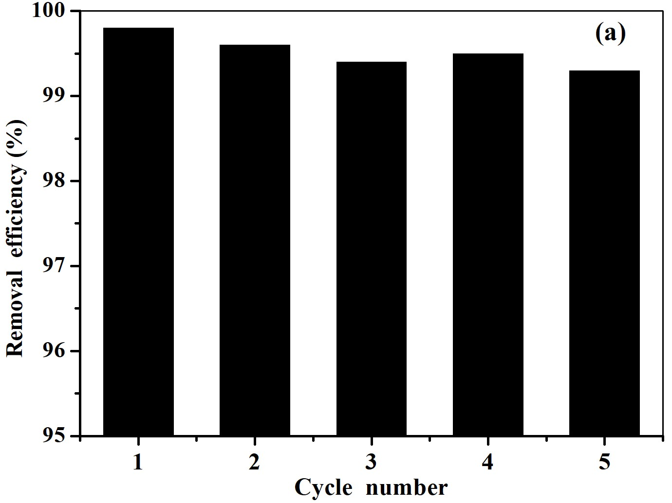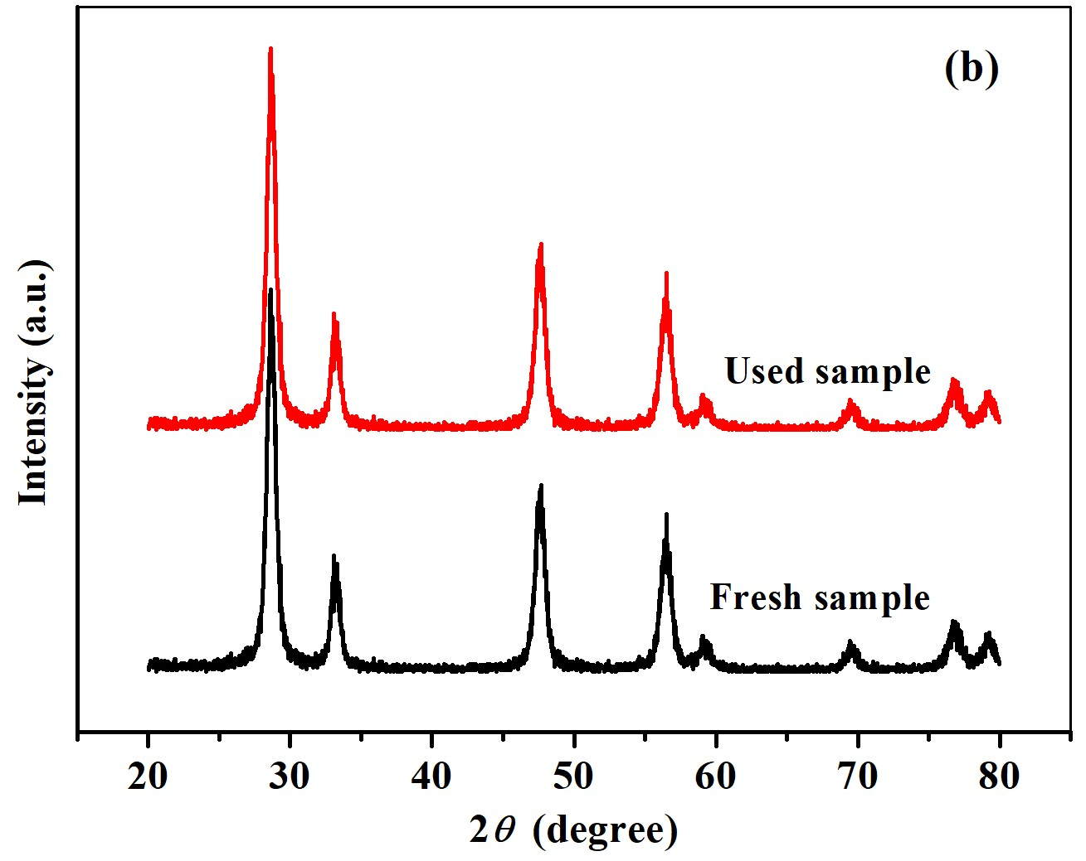
Fig. S4 Reuse performance (a) and XRD patterns before and after photocatalysis (b) of 0.5%Cd-CeO₂-0.02C.
Fig. S5 Effect of different scavengers on the degradation efficiency of AR14.
During the photocatalysis, hydroxyl radicals (•OH), superoxide radicals (•), and holes (h⁺) play an important role in the catalytic efficiency (He et al., 2019, Jiang et al., 2018). To determine the main active species, 0.5%Cd-CeO₂-0.02C was chosen as the representative for active species capturing tests, and terephthalic acid (PTA), benzoquinone (BQ), and potassium iodide (KI) were added to capture the hydroxyl radicals (•OH), superoxide radical anions (•), and holes (h⁺), respectively. Fig.S5 shows the effect of the different scavengers on the degradation efficiency of AR14. As shown in Fig. S5, the photocatalytic efficiency of AR14 was hardly changed after addition of benzoquinone and potassium iodide, while the degradation rate significantly decreased when terephthalic acid was added, indicating that hydroxyl radical is mainly responsible for the degradation of AR14. From the results of Fig. S6, it can be seen that signals of •OH are actually detected during the photocatalysis.
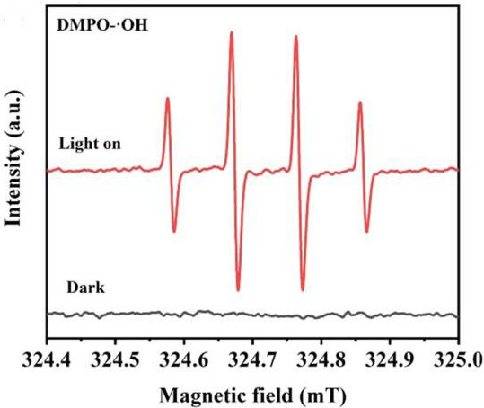
Fig. S6 ESR spectra of DMPO-⋅OH over 0.5%Cd-CeO₂-0.02C.
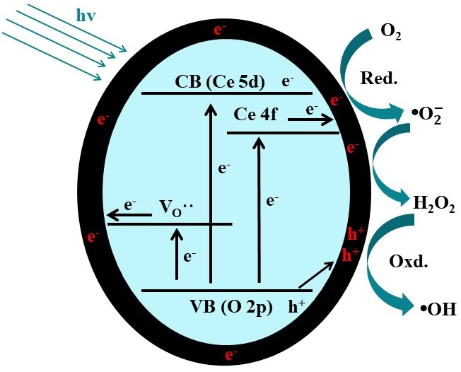
Fig. S7 Mechanism diagram of AR14 degradation by Cd-CeO₂@C. VB: valence band. CB: conduction band.
Based on the corresponding experimental results and analysis, the photocatalytic degradation mechanism of AR14 over Cd-CeO₂@C is presented in Fig. S7. After the replacement of Ce⁴⁺ or Ce³⁺ by Cd²⁺, oxygen vacancies easily form, resulting in the intermediate valence band (oxygen vacancy level). Under solar radiation, photogenerated electrons easily move from valence band to the intermediate valence band. Due to the formation of a large number of carbon bonds in the catalyst, the electrons transferred to the catalyst surface can be accelerated to interact with the adsorbed O₂ and form •. • can in turn reduce Ce⁴⁺ to Ce³⁺ (promoting the formation of oxygen defects), and it can also be converted into H₂O₂ and •OH (Xiao et al., 2020). The holes in the valence band migrate to the CeO₂ surface to oxidize the adsorbed water and OH⁻, generating hydroxyl radicals (•OH) to oxidize AR14 into smaller molecules.
References

Jiang Z.F., Wan W.M., Li H.M., Zhao H.J., Wong P.K., 2018. A Hierarchical Z-scheme α-Fe₂O₃/g-C₃N₄ hybrid for enhanced photocatalytic CO₂ reduction. Adv. Mater. 30, 1706108-1706117.
Xiao Y.H., Carena L., Näsi M.T., Vähätalo A.V., 2020. Superoxide-driven autocatalytic dark production of hydroxyl radicals in the presence of complexes of natural dissolved organic matter and iron. Water. Res. 177, 115782.
Ye K.H., Yang H., Li M.Y., Huang Y.C., Zhang S.Q., Ji H.B., 2019. An ultrathin carbon layer activated CeO₂ heterojunction nanorods for photocatalytic degradation of organic pollutants. Appl. Catal. B-Environ. 259, 118085.

