**Supporting information**

**An** **ecofriendly bleaching method for cashmere fiber with** **hydrogen peroxide and laccase in SCF-CO2 by avoiding heavy effluent discharge**

*Fan Wang1, 2, 3, Yuan-Bin Zheng1, 2, 3, Xin-Xin Cao1, 2, 3, Zi-Qing Du1, 2, 3, Jia-Jie Long*1,2,3*

*1 College of Textile and Clothing Engineering,* *Soochow University, Suzhou 215123, China.*

*2 National scientific research base for waterless coloration and finishing with supercritical fluid (China Textile Engineering Society), Soochow University, Suzhou 215123, China.*

*3Jiangsu Engineering Research Center of Textile Dyeing and Printing for Energy Conservation, Discharge Reduction and Cleaner Production（ERC）, Soochow University, Suzhou 215123, China.*

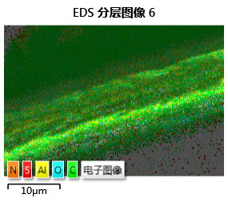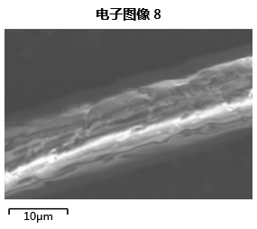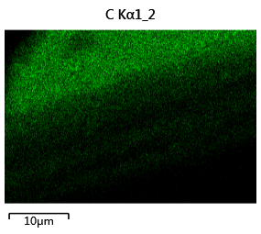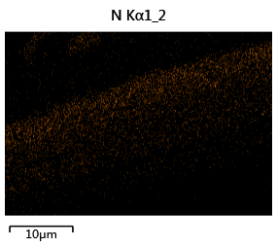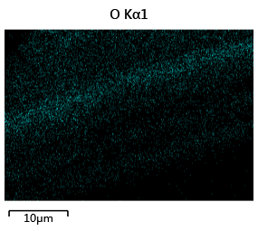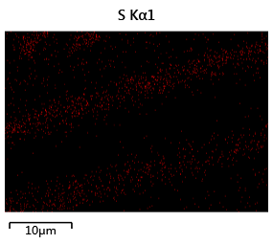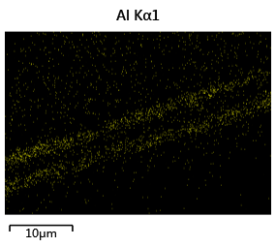

**(c) C Kα1_2**

**(a)**

**(b)**

**(d) N Kα1_2**

**(f) S Kα1**

**(e) O Kα1**

**(g) Al Kα1**

**(A)**

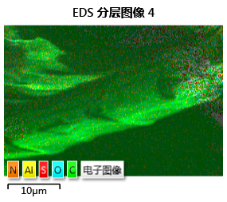

**(a)**

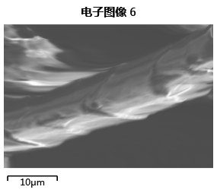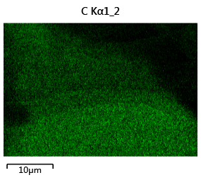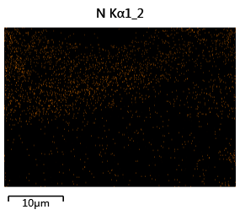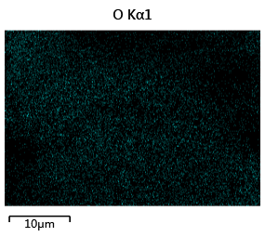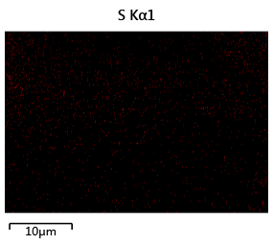

**(b)**

**(c) C Kα1_2**

**(d) N Kα1_2**

**(e) O Kα1_2**

**(f) S Kα1_2**

**(B)**

**Fig. S1** EDS images and surface compositions, element distributions of the control cashmere fiber (A) (a-g) and the bleached cashmere fiber (B) (a-f) by the developed method under a condition of a temperature at 55 ℃ and a pressure at 18.0 MPa for 90 min with the optimized working solution in SCF-CO2.



**Fig S2** Stress-strain curves of the control cashmere fiber (1) and the bleached one (2) by the developed method under a condition of a temperature at 55 ℃ and a pressure at 18.0 MPa for 90 min with the optimized working solution in SCF-CO2.



**Fig S3** TG (a)-DTG (b) curves of the control cashmere fiber (1) and the bleached one (2) by the developed method under a condition of a temperature at 55 ℃ and a pressure at 18.0 MPa for 90 min with the optimized working solution in SCF-CO2.