**Support Information**

**Preparation of S-doped biochar with sodium thiosulfate as activator and sulfur source and its highly efficient adsorption for Hg2+**

*Zengrun Xiea, Yuanyuan Zhangb, Shengxiao Zhang*, a,* *Hou Chena, Chenyu Dua, and* *Caijuan Zhonga*

*aSchool of Chemistry and Materials Science, Institute of Environmental Science, Ludong University, Yantai 264025, Shandong province, China*

*bEnvironmental Monitor Station of Yantai, Shandong Province, China, No. 118, Qingnian South Road, Yantai 264000, Shandong province, China*

\***Corresponding author: Shengxiao Zhang**

**Ludong University**

**School of Chemistry and Materials Science**

**Yantai 264025, China**

**E-mail Address:** [**beijingzsx@163.com**](mailto:beijingzsx@163.com) **(Shengxiao Zhang)**

**Tel: (086) 0535-6672176; Fax: (086) 0535-6695905**

**Text S1** **Raman spectra of BC and S4BC**

The Raman spectra of BC and S4BC are shown in Figure S4. It can be clearly seen that all samples exhibit obvious D and G peaks at 1340 cm-1 and 1580 cm-1. D-band reflects the defects on the graphite layer, which are caused by functional groups, heteroatom doping, serrated/armchair edges and holes (Cai et al., 2021). The E2g vibration mode of the honeycomb sp2 hybrid carbon produces a G band around 1580 cm-1 (Zhang et al., 2016). The relative strength (ID/IG) of D-band and G-band reflects the defect degree of carbon materials. As shown in the figure, the ID/IG value of S4BC is higher than that of BC. This shows that activation and sulfur doping by Na2S2O3 will deform the carbon skeleton and produce more defects than the original carbon materials, which can be used as mercury adsorption sites.

**Text S2** **Effects of interfering ions on Hg2+ adsorption**

Many metal ions including K+, Na+ and Ca2+ often coexist in different kinds of water body. Therefore, it is very important to study the adsorption performance of S4BC-800 in the presence of co-existing cations. Before adding the adsorbent, chloride salts of these three ions were added to the solution to study the influence on adsorption of Hg2+ by S4BC-800. It can be seen from Figure S5 that the existence of K+, Na+ and Ca2+ results in a little decrease of Hg2+ adsorption. During metal ion adsorption the functions including ion exchange, metal-ligand complexation, cation-π bond and surface precipitation cannot be ignored. With the addition of coexisting ions, some of the interaction between adsorbent and Hg2+ may be destroyed, which will reduce the adsorption capacity. However, the decrease of the Hg2+ adsorption is almost negligible in the presence of coexisting ions, and even when the concentrations of coexisting ions attain 1000 mg/L, the adsorption capacity still remains at a high level. In soft and hard acid-base theory, K+, Na+ and Ca2+, belonging to hard acid, do not affect the specific “soft-soft” interaction between Hg2+ and functional groups containing S, so the adsorption capacity will not decrease significantly with the increase of coexisting ion content. The results show that S4BC-800 material can effectively adsorb Hg2+ from complex matrix.

**Text S3 Adsorption kinetics**

In order to investigate the adsorption rate of Hg2+ on S4BC-800, the adsorption kinetics experiment was carried out. The pH value was set at 6.5, and the initial concentration of Hg2+ was 100, 180 and 300 mg/L. The result is shown in Figure S6 (a). It can be observed that the intake of Hg2+ gradually increases with the extension of adsorption time, and finally attains a platform. In the initial stage, the rapid adsorption of Hg2+ by S4BC-800 is attributed to the existence of rich Hg2+ and plenty of available adsorption sites, which is helpful for the adsorbent to quickly combine with metal ions(Das et al., 2021). In order to study the adsorption behavior of Hg2+ on the adsorbent, the pseudo first-order kinetic model and pseudo second-order kinetic model are used to fit the adsorption data. These models can provide important information about the distribution of adsorbate molecules on the solid/liquid interface(Yang et al., 2021) .Figure S6 (b, c) shows pseudo first-order and second-order kinetic fitting line, and Table S2 lists the parameters related to the kinetic process. Compared with the pseudo first-order dynamic model, the pseudo second-order dynamic model can better fit the dynamic data, and the correlation coefficient (R2) is closer to 1, indicating the adsorption is a chemisorption process.(dos Reis et al., 2022; dos Reis et al., 2023)

**Table S1** The dosage of raw materials and different activation temperatures for synthesizing SXBC-Y.

|  |  |  |  |
| --- | --- | --- | --- |
| Composites name | Weight of BC (g) | Weight of Na2S2O3·5H2O (g) | Pyrolysis temperature (℃) |
| S0.5BC-800 | 1.0 | 0.5 | 800 |
| S1BC-800 | 1.0 | 1.0 | 800 |
| S2BC-800 | 1.0 | 2.0 | 800 |
| S4BC-800 | 1.0 | 4.0 | 800 |
| S5BC-800 | 1.0 | 5.0 | 800 |
| S4BC-500 | 1.0 | 4.0 | 500 |
| S4BC-600 | 1.0 | 4.0 | 600 |
| S4BC-700 | 1.0 | 4.0 | 700 |
| S4BC-900 | 1.0 | 4.0 | 900 |

**Table S2** Kinetic model parameters for the uptake of Hg2+ onto S4BC-800

|  |  |  |  |  |  |  |
| --- | --- | --- | --- | --- | --- | --- |
| Hg2+ (mg/L) | Pseudo-first-order mode | | | Pseudo-second-order model | | |
| qe (mg/L) | k1 (g/mg min) | R2 | qe (mg/L) | k2 (g/mg min) | R2 |
| 100 | 243.30 | 0.94×10-2 | 0.9072 | 349.65 | 2.04×10-4 | 0.9998 |
| 180 | 299.40 | 0.76×10-2 | 0.5317 | 462.96 | 1.16×10-4 | 0.9996 |
| 300 | 345.71 | 0.93×10-2 | 0.9661 | 653.59 | 4.48×10-4 | 0.9996 |

**Table S3** Comparison of the adsorption capacity with other adsorbents

|  |  |  |  |
| --- | --- | --- | --- |
| Adsorbents | Solution pH | qmax (mg/g) | Reference |
| Sulfur-mesoporous Carbon | 5.0 | 70.8 | (Saha et al., 2016) |
| MSCs | 7.0 | 187 | (Zhang et al., 2021) |
| SWCNT-SH | 5.0 | 131 | (Bandaru et al., 2013) |
| MNPC-T700-M3 | 6.0 | 476 | (Huang et al., 2017) |
| M-DAPS50-COF-SH | 5.0 | 383 | (Afshari et al., 2020) |
| RHAC | 5.0 | 55 | (Liu et al., 2020) |
| N, S-MoSe2 | 6.0 | 208 | (Long et al., 2021) |
| S-MAOP | 7.0 | 512 | (Huang and Shuai, 2019) |
| Fe3O4@SiO2-SH | 7.0 | 148.8 | (Zhang et al., 2013) |
| Magnetic Go Composites | 6.0 | 71.3 | (Guo et al., 2016) |
| S4BC-800 | 6.5 | 724 | This work |

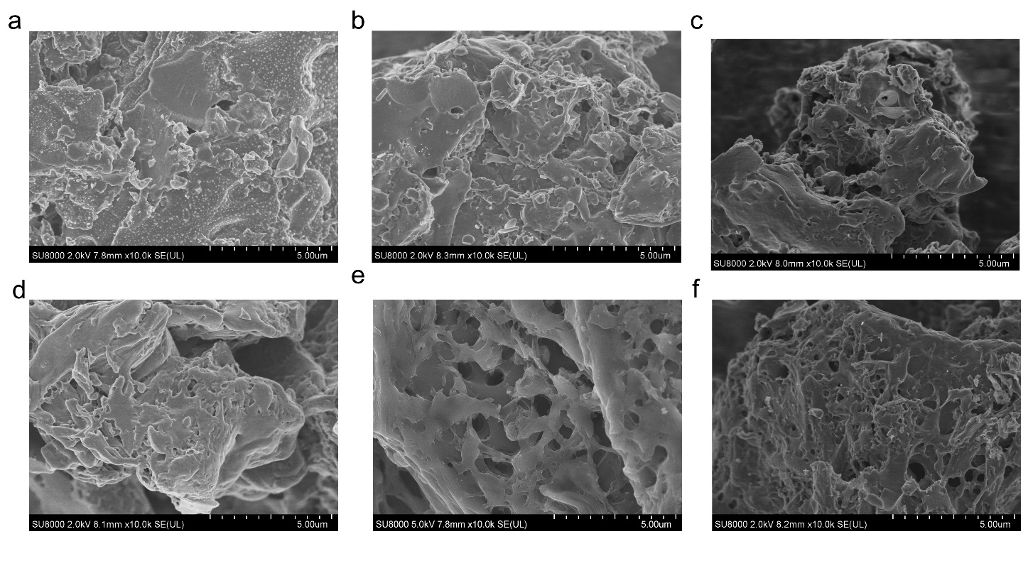

**Figure S1** SEM images of (a) BC, (b) S0.5BC-800, (c) S1BC-800, (d) S2BC-800, (e) S4BC-800 and (f) S5BC-800

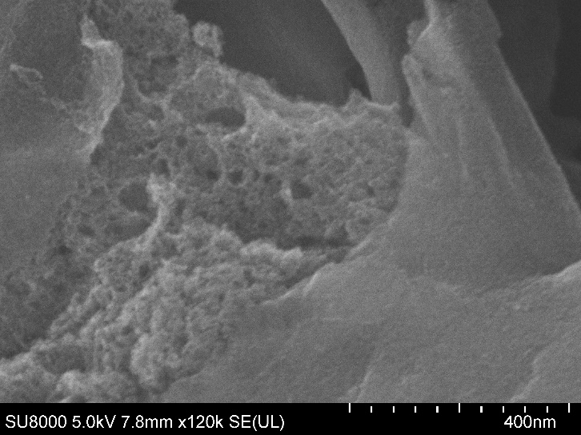

**Figure S2** SEM images of S4BC-800

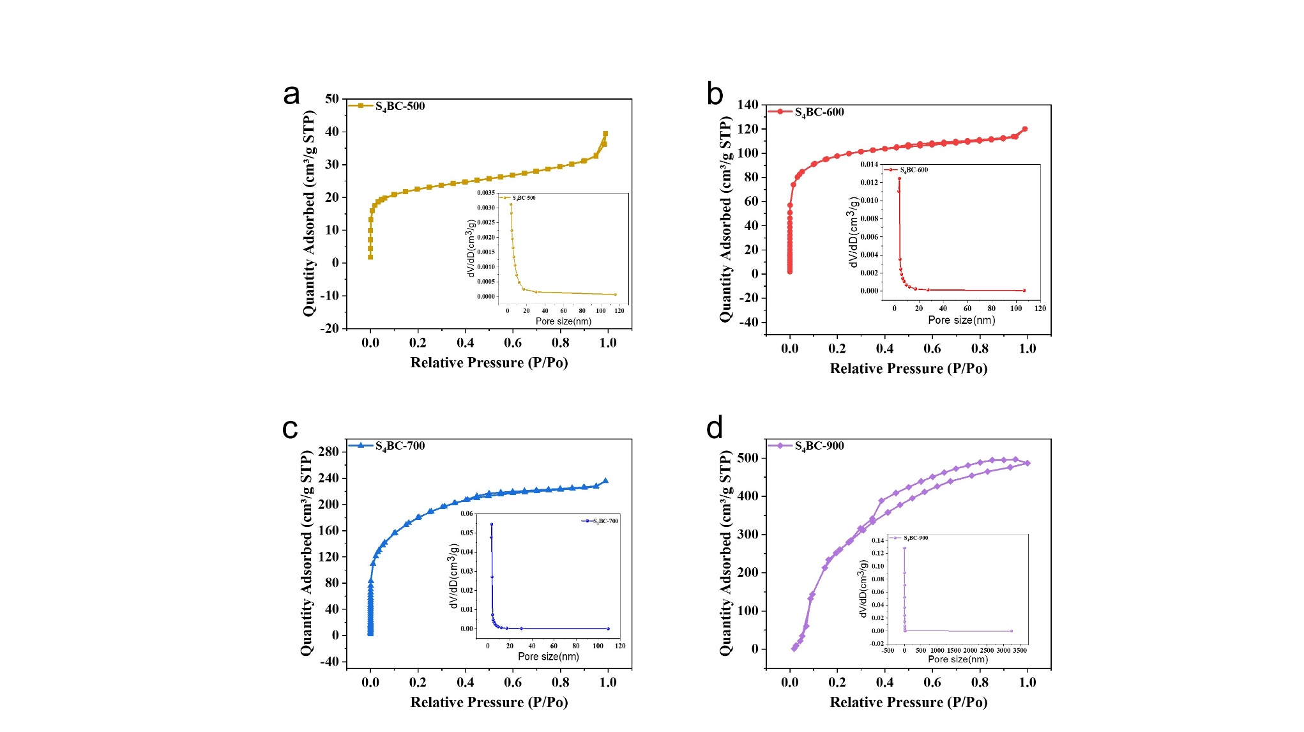

**Figure S3** N2 adsorption-desorption isotherms and pore size distributions of (a) S4BC-500, (b) S4BC-600, (c) S4BC-700, (d) S4BC-900,.

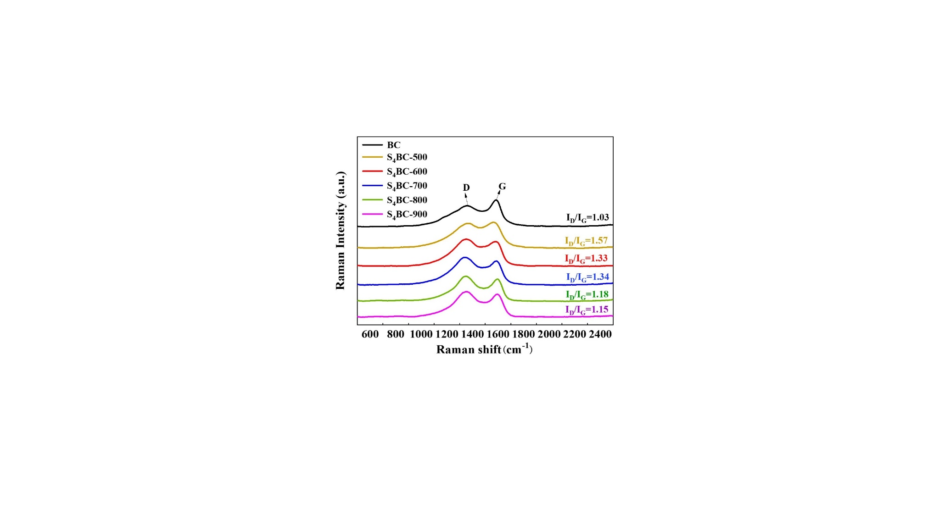

**Figure S4** Raman spectra of BC and S4BC

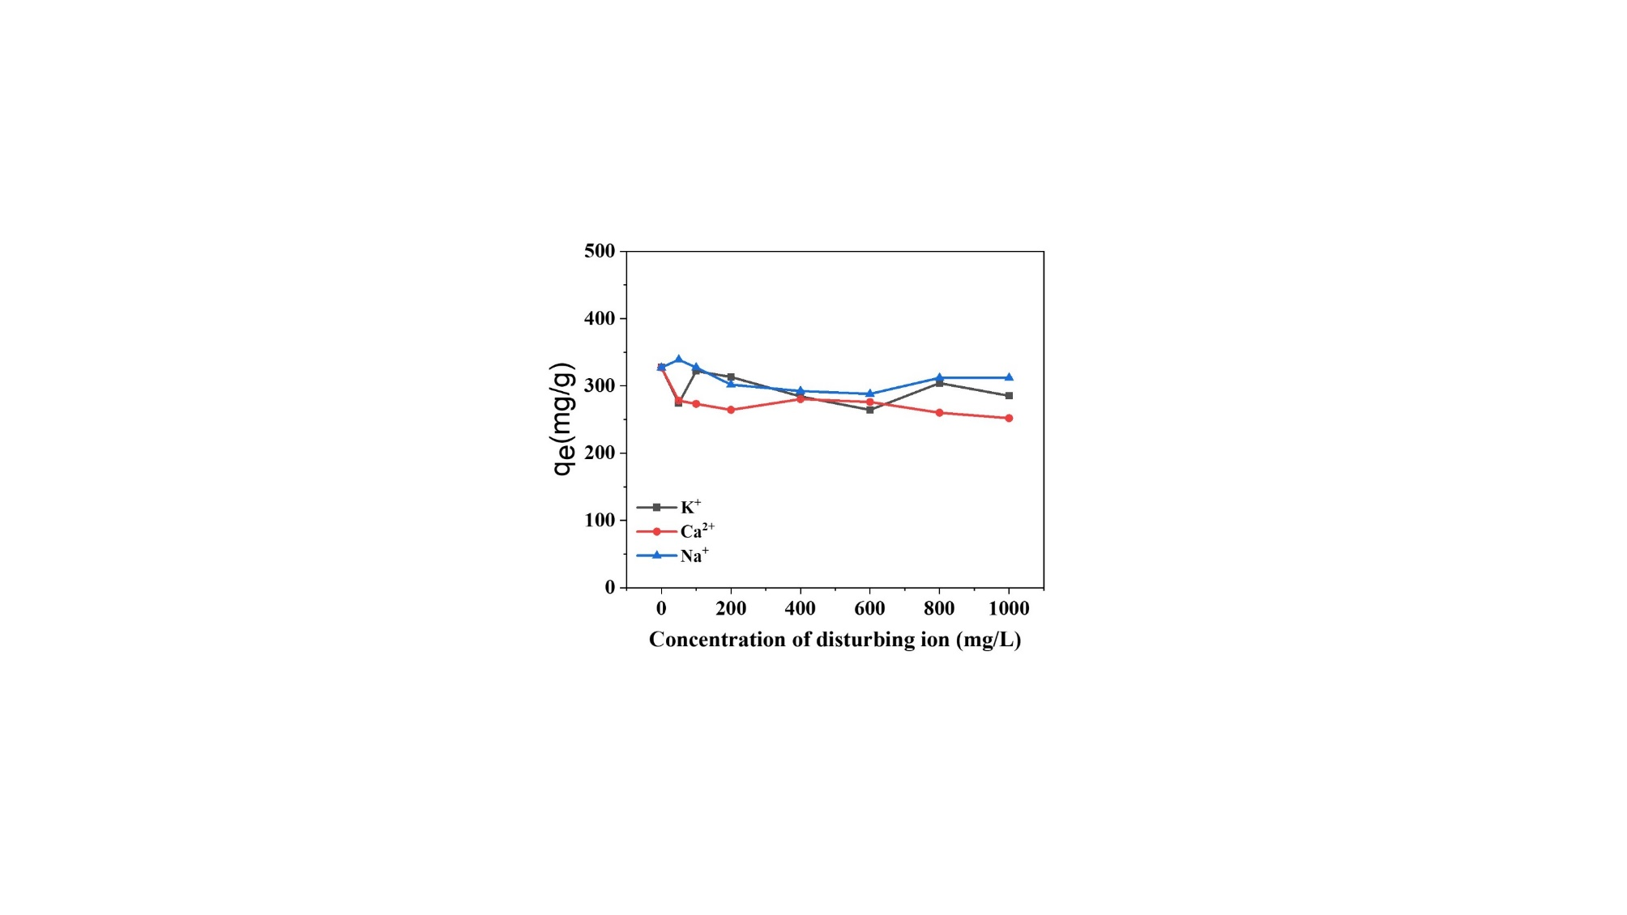

**Figure S5** Effect of coexisting ions on mercury adsorption by S4BC-800

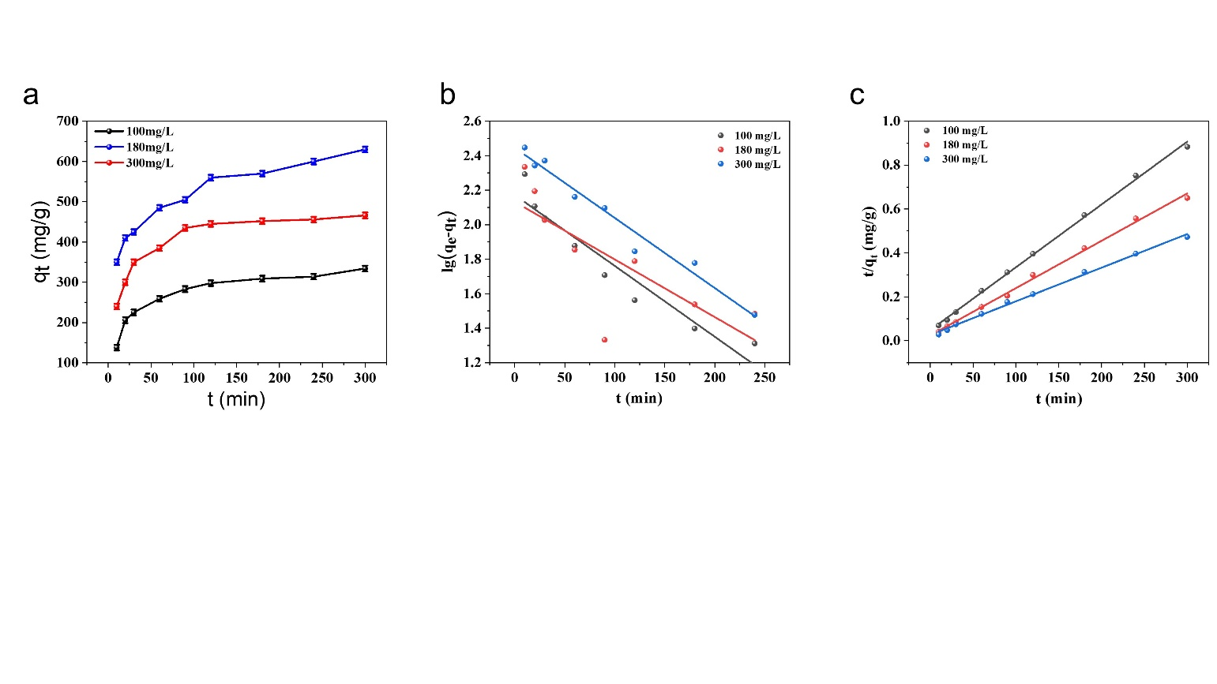





**Figure S6** (a)Kinetic diagram of adsorption of pollutants by S4BC-800, (b) Pseudo-first-order kinetic fitting diagram of pollutants by S4BC-800, (c) Pseudo-second-order kinetic fitting diagram of pollutants by S4BC-800.

**References**

Afshari, M., Dinari, M., Zargoosh, K., Moradi, H., 2020. Novel Triazine-Based Covalent Organic Framework as a Superadsorbent for the Removal of Mercury(II) from Aqueous Solutions. Ind. Eng. Chem. Res. 59, 9116-9126.

Bandaru, N.M., Reta, N., Dalal, H., Ellis, A.V., Shapter, J., Voelcker, N.H., 2013. Enhanced adsorption of mercury ions on thiol derivatized single wall carbon nanotubes. J. Hazard. Mater. 261, 534-541.

Cai, A., He, H., Zhang, Q., Xu, Y., Li, X., Zhang, F., Fan, X., Peng, W., Li, Y., 2021. Synergistic Effect of N-Doped sp2 Carbon and Porous Structure in Graphene Gels toward Selective Oxidation of C-H Bond. ACS Appl. Mater. Interfaces 13, 13087-13096.

Das, S., Chatterjee, S., Mondal, S., Modak, A., Chandra, B.K., Das, S., Nessim, G.D., Majee, A., Bhaumik, A., 2021. Thiadiazole containing N- and S-rich highly ordered periodic mesoporous organosilica for efficient removal of Hg(II) from polluted water. Chem. Commun. 56, 3963-3966.

dos Reis, G.S., Pinto, D., Lima, É.C., Knani, S., Grimm, A., Silva, L.F.O., Cadaval, T.R.S., Dotto, G.L., 2022. Lanthanum uptake from water using chitosan with different configurations. Reactive and Functional Polymers 180.

dos Reis, G.S., Thivet, J., Laisné, E., Srivastava, V., Grimm, A., Lima, E.C., Bergna, D., Hu, T., Naushad, M., Lassi, U., 2023. Synthesis of novel mesoporous selenium-doped biochar with high-performance sodium diclofenac and reactive orange 16 dye removals. Chem. Eng. Sci. 281.

Guo, Y.F., Deng, J., Zhu, J.Y., Zhou, X.J., Bai, R.B., 2016. Removal of mercury(II) and methylene blue from a wastewater environment with magnetic graphene oxide: adsorption kinetics, isotherms and mechanism. RSC Adv. 6, 82523-82536.

Huang, L.J., He, M., Chen, B.B., Cheng, Q., Hu, B., 2017. Highly Efficient Magnetic Nitrogen-Doped Porous Carbon Prepared by One-Step Carbonization Strategy for Hg2+ Removal from Water. ACS Appl. Mater. Interfaces 9, 2550-2559.

Huang, L.J., Shuai, Q., 2019. Facile Approach To Prepare Sulfur-Functionalized Magnetic Amide-Linked Organic Polymers for Enhanced Hg(II) Removal from Water. ACS Sustainable Chem. Eng. 7, 9957-9965.

Liu, Z.Y., Sun, Y., Xu, X.R., Qu, J.B., Qu, B., 2020. Adsorption of Hg(II) in an Aqueous Solution by Activated Carbon Prepared from Rice Husk Using KOH Activation. Acs Omega 5, 29231-29242.

Long, C.C., Li, X., Jiang, Z.X., Zhang, P., Qing, Z.H., Qing, T.P., Feng, B., 2021. Adsorption-improved MoSe2 nanosheet by heteroatom doping and its application for simultaneous detection and removal of mercury (II). J. Hazard. Mater. 413, 125470.

Saha, D., Barakat, S., Van Bramer, S.E., Nelson, K.A., Hensley, D.K., Chen, J.H., 2016. Noncompetitive and Competitive Adsorption of Heavy Metals in Sulfur-Functionalized Ordered Mesoporous Carbon. ACS Appl. Mater. Interfaces 8, 34132-34142.

Yang, Z.L., Gu, Y.Y., Yuan, B.L., Tian, Y.M., Shang, J., Tsang, D.C.W., Liu, M.X., Gan, L.H., Mao, S., Li, L.C., 2021. Thio-groups decorated covalent triazine frameworks for selective mercury removal. J. Hazard. Mater. 403, 123702.

Zhang, B., Petcher, S., Gao, H., Yan, P., Cai, D., Fleming, G., Parker, D.J., Chong, S.Y., Hasell, T., 2021. Magnetic sulfur-doped carbons for mercury adsorption. J. Colloid Interface Sci. 603, 728-737.

Zhang, H., Noonan, O., Huang, X., Yang, Y., Xu, C., Zhou, L., Yu, C., 2016. Surfactant-Free Assembly of Mesoporous Carbon Hollow Spheres with Large Tunable Pore Sizes. ACS Nano 10, 4579-4586.

Zhang, S.X., Zhang, Y.Y., Liu, J.S., Xu, Q., Xiao, H.Q., Wang, X.Y., Xu, H., Zhou, J., 2013. Thiol modified Fe3O4@SiO2 as a robust, high effective, and recycling magnetic sorbent for mercury removal. Chem. Eng. J. 226, 30-38.