Supplementary material



**Fig.S1** The zeta potential value of the N/Fe-CNTs.

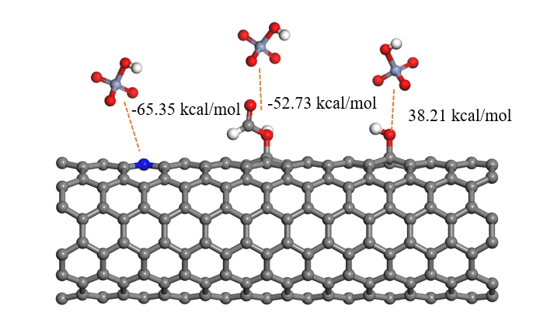

**Fig.S2** The calculated result of -COOH, -OH, and graphitic N interactions with Cr(VI).

**Table S1 Adsorption kinetic models and main parameters.**

|  |  |  |
| --- | --- | --- |
| **Kinetic models** | **Equation** | **Main parameters** |
| Pseudo-first order |  | K1 means adsorption rate constant (1/min). |
| Pseudo-second order |  | K2 is adsorption rate constant (1/min). |
| Intraparticle diffusion |  | K3 means rate constant (mg/g min1/2). C is a constant. |

**Table S2 Adsorption isotherm models and main parameters**

|  |  |  |
| --- | --- | --- |
| Isotherms | Equations | Parameters |
| Langmuir | $$q_{e}=\frac{k_{L}q_{m}C_{e}}{1+k_{L}C_{e}}$$ | qm means the adsorption amount (mg/g).  kL (L/mg) is coefficient. |
| Freundlich | $$q_{e}=k_{F}C_{e}^{1/n}$$ | kF is adsorption constant (mg/g). (L/mg)1/n, 1/n is adsorption intensity |
| Hill | $$qe=\frac{Qm{Ce}^{n}}{{C^{n}+Ce}^{n}}$$ | Qm is the maximum  adsorption capacity (mg/g) , n and C are the number of ions per site  and semi saturated concentration, respectively. |
| Temkin | $$q_{e}=B_{T}lnK_{T}+B_{T}lnC_{e}$$ | $B_{T}$ is adsorption heat, J/mol $K_{T}$ is binding equilibrium, L/g |

**Table S3 The Cr(Ⅵ) adsorption capacity of various adsorbents.**

|  |  |  |  |
| --- | --- | --- | --- |
| Adsorbents | qm (mg g-1) | BET surface (m2 g−1) | References |
| N/Fe-CNTs | 27.47 | 158.71 | This study |
| MAG | 14.7 | 311 | [1] |
| Corncob activated carbon | 9.98 | 826.6 | [2] |
| Bamboo bark-based AC | 19.53 | 1068 | [3] |
| BCS, BCW | 24.6, 23.6 | 26.3, 11.4 | [4] |
| BC-Fe, BC-Fe-U | 16.3, 14.7 | 163, 117 | [5] |
| Coconut shell based AC | 54 | 1022.4 | [6] |

**Reference**

[1] N.V. Pechishcheva, S.K. Estemirova, А.V. Kim, P.V. Zaitceva, E.V. Sterkhov, Y.V. Shchapova, I.S. Zhidkov, M.Y. Skrylnik, Adsorption of heхavalent chromium on mechanically activated graphite, Diamond and Related Materials, 127 (2022) 109152.

[2] H. Li, P. Gao, J. Cui, F. Zhang, F. Wang, J. Cheng, Preparation and Cr(VI) removal performance of corncob activated carbon, Environmental Science and Pollution Research, 25 (2018) 20743-20755.

[3] Y.-J. Zhang, J.-L. Ou, Z.-K. Duan, Z.-J. Xing, Y. Wang, Adsorption of Cr(VI) on bamboo bark-based activated carbon in the absence and presence of humic acid, Colloids and Surfaces A: Physicochemical and Engineering Aspects, 481 (2015) 108-116.

[4] A. Tytłak, P. Oleszczuk, R. Dobrowolski, Sorption and desorption of Cr(VI) ions from water by biochars in different environmental conditions, Environmental Science and Pollution Research, 22 (2015) 5985-5994.

[5] J. Dobrzyńska, A. Wysokińska, R. Olchowski, Raspberry stalks-derived biochar, magnetic biochar and urea modified magnetic biochar - Synthesis, characterization and application for As(V) and Cr(VI) removal from river water, Journal of Environmental Management, 316 (2022).

[6] Y. Wang, C. Peng, E. Padilla-Ortega, A. Robledo-Cabrera, A. López-Valdivieso, Cr(VI) adsorption on activated carbon: Mechanisms, modeling and limitations in water treatment, Journal of Environmental Chemical Engineering, 8 (2020) 104031.