Table S1a. Sc-At In Vitro Screening Compound Information

|  |  |  |  |  |
| --- | --- | --- | --- | --- |
| Compound | Formula | OB (%) | DL | Compound Source |
| Longikaurin A | C20H28O5 | 47.72 | 0.53 | Sc |
| Deoxyharringtonine | C28H37NO8 | 39.27 | 0.81 | Sc |
| Deoxyshikonin | C21H22O6 | 73.85 | 0.18 | Sc |
| Angeloylgomisin O | C28H34O8 | 31.97 | 0.85 | Sc |
| Schizandrer B | C28H34O9 | 30.71 | 0.83 | Sc |
| Gomisin-A | C23H28O7 | 30.69 | 0.78 | Sc |
| Gomisin G | C30H32O9 | 32.68 | 0.83 | Sc |
| Gomisin R | C22H24O7 | 34.84 | 0.86 | Sc |
| Wuweizisu C | C22H24O6 | 46.27 | 0.84 | Sc |
| Marmesin | C14H14O4 | 50.28 | 0.18 | At |
| 8-Isopentenyl-kaempferol | C20H18O6 | 38.04 | 0.39 | At |
| Eduesmin | C22H26O6 | 52.35 | 0.62 | At |
| Cycloartenol | C30H50O | 38.69 | 0.78 | At |
| kaempferol | C15H10O6 | 41.88 | 0.24 | At |

Table S1b. Number of marker compounds detected under each condition

|  |  |  |  |
| --- | --- | --- | --- |
| Sc:At(w:w) | 75% ethanol | 90% ethanol | 95% ethanol |
| 1∶1 | 10 | 14 | 14 |
| 1∶2 | 7 | 11 | 11 |
| 2∶1 | 10 | 12 | 13 |

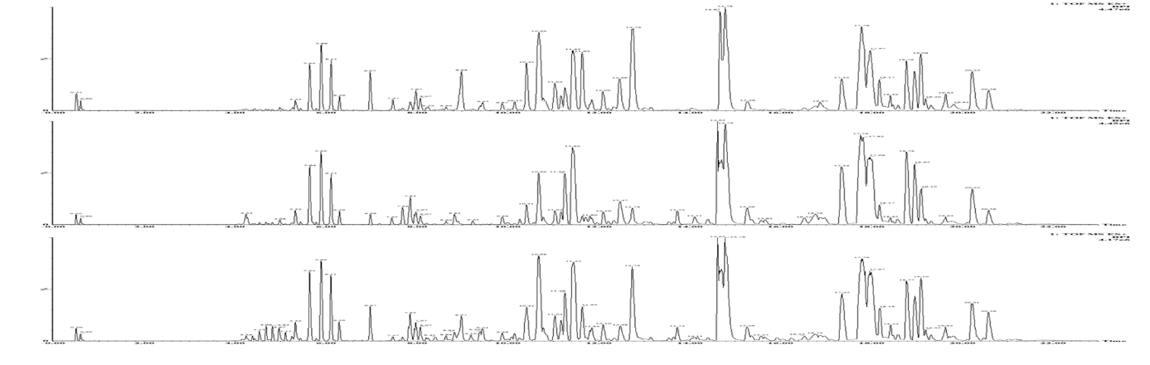

**A**

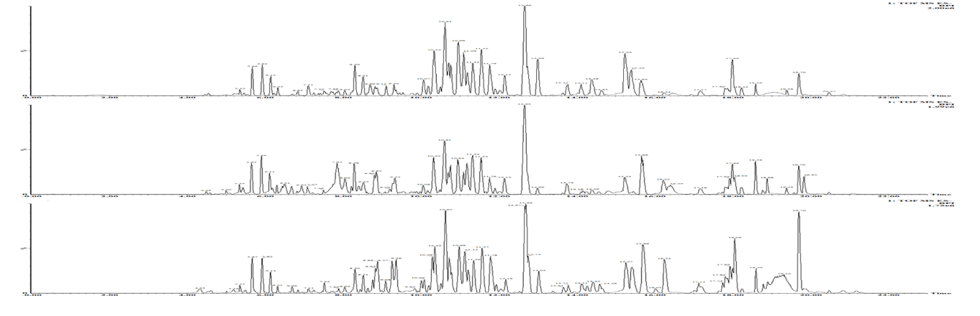

**B**

Fig.S1 A, BPI plot of fecal sample in positive ion mode; B, BPI graph of fecal samples in negative ion mode