**Supporting Information**

**Experimental Details**

**Materials and reagents**

ZrCl4 (98%, Energy Chemical), C8H7NO4 (99%, Energy Chemical), N, N-dimethylformamide (99.9%, Energy Chemical), CH3COOH (99.5%, Energy Chemical), Thioacetamide (99%, Energy Chemical), ZnCl2 (AR, Aladdin), InCl3 (99.9%, Energy Chemical), glycerol (98%, Energy Chemical), H2O (laboratory preparation). All of the reagents and solvents were commercially available and used without further purification.

**Synthesis method**

Synthesis of UiO-66-NH2: ZrCl4 (1mmol), 2-aminoterephthalic acid (1mmol), were added to a breaker containing 50 mL of DMF. Ultrasonication for 3 min. HAc was added to this solution and then sonicated for 3 min, and the above mixture was transferred to a PTFE-lined autoclave with a volume of 100 mL. Keep at 120°C for 24 h. After cooling to room temperature, it was washed several times with DMF and ethanol by centrifugation and dried at 80 °C.

Synthesis of ZIS:In a flask, 8 mL of water, 2mL of glycerol were added to the flask and stirred for 30 min, then InCl3 4H2O (117.2mg), ZnCl2 (27.2mg) and TAA (60.1mg) were added. Subsequently, after stirring for 10 minutes, the resulting mixture was placed in an 80 ℃ oil bath for 2 hours. The obtained samples were then collected, washed with ethanol and deionized water, and then dried at 60 °C for 24h.

Synthesis of UiO-66-NH2/ZIS-y (y=1, 2, 3, 4) : UiO-66-NH2 (5/10/30/50mg) was dissolved in 8mL of water, 2mL of glycerol and stirred for 30 min. Then InCl3 4H2O (117.2mg), ZnCl2 (27.2mg) and TAA (60.1mg) were added. Subsequently, after stirring for 10 minutes, the resulting mixture was placed in an 80 ℃ oil bath for 2 hours. The obtained samples were then collected, washed with ethanol and deionized water, and then dried at 60 °C for 24h.

**Characterization and photoelectrochemical testing of materials**

Powder X-ray diffraction patterns were tested using a D8 Advance X-ray powder diffractometer from Bruker, Germany, as a means of obtaining the structure and crystalline phase of the samples. Transmission electron microscopy (Tecnai G2 20) from FEI, USA, was used to test the morphology of the catalysts, qualitative and quantitative elemental analysis (EDX), and electron diffraction analysis of the internal microstructure (SAED), with an accelerating voltage of 200KV, a point resolution of 0.24nm, and an X-ray spectrometer with a resolution of 130 eV, which was performed by placing the catalysts on a copper mesh. The specific surface area and pore size of the catalysts were tested by a specific surface area and void analyzer (ASAP2020) from Kantar-Autosorb-IQ, USA. The specific surface area and pore size of the samples were calculated by using the BET and BJH models, respectively. The catalysts were tested by using the BET and BJH models. Thermo Fisher Scientific's X-ray spectrometer (Thermo ESCALAB 250 XI) measures the chemical composition and chemical state of catalyst surfaces and qualitatively detects the binding energies of almost all elements (except H and He). The UV-visible diffuse reflectance spectrometer (UV-3600 Plus) of Shimadzu, Japan, was used to determine the absorption properties of the catalysts by utilizing the properties of selective absorption, transmission or reflection of light by substances. The fluorescence spectrometer (FLS980) from Edinburgh, UK, was used to determine the photoluminescence of the catalyst, the light source irradiated the catalyst, the catalyst emitted fluorescence, the detector accepted the signal, and the photoelectric flow was processed to obtain the response value. The light source was a xenon lamp with λex = 370 nm, and this experiment mainly tested the compounding efficiency of photogenerated electrons and holes.

The electrochemical performance of the samples was tested using an electrochemical workstation (CHI760E, Shanghai Zhenhua, China) in a three-electrode system with 0.5 mol L-1NaSO4 electrolyte (pH=7.0) and 0 V bias voltage, with a Pt electrode as the counter electrode, a saturated Ag/AgCl electrode as the reference electrode, and ITO dripped with catalyst slurry as the working electrode for the photocurrent response performance Tests. The test methods used for M-S are the same as those described above.

**Experimental method for CO2 photocatalysis**

Photocatalytic performance test: 1 mg of catalyst, 5 mg of photosensitizer, 5 mL of triethanolamine and 1 mL of acetonitrile were added as solvents to a homemade 50 mL sealed photocatalytic tube, and the reaction of photocatalytic CO2 reduction was carried out under the simulated sunlight irradiation. Prior to the reaction, high purity CO2 (99.99%) gas was bubbled in a sealed tube for about 20 min until the CO2 concentration was saturated and the dissolved oxygen in the system was completely removed. A 300 W xenon lamp with an AM 1.5 filter was used as the light source. The light intensity was 200 Mw/cm2.All experiments were carried out at ambient pressure and the reaction system was kept at 20°C under circulating condensate. At the end of 1 h of illumination, the gaseous products produced during the photocatalytic reduction of CO2 were collected with a 1 mL syringe and then immediately analyzed by a GC-7920 equipped with a flame ionization detector (FID) and a thermal conductivity detector (TCD).

Control experiment: A homemade 50mL sealed photocatalytic tube was filled with 1mg of catalyst and the reaction was carried out without the addition of photosensitizer, triethanolamine other conditions were the same. The reaction of photocatalytic CO2 reduction was carried out under simulated sunlight irradiation by adding 1 mg of catalyst, 5 mg of photosensitizer, 5 mL of triethanolamine and 1 mL of acetonitrile as solvent in a homemade 50 mL sealed photocatalytic tube. Before the reaction, Ar gas was introduced to bubble in the sealed tube for about 20 min until complete removal of dissolved oxygen from the system was achieved. Other conditions were consistent.

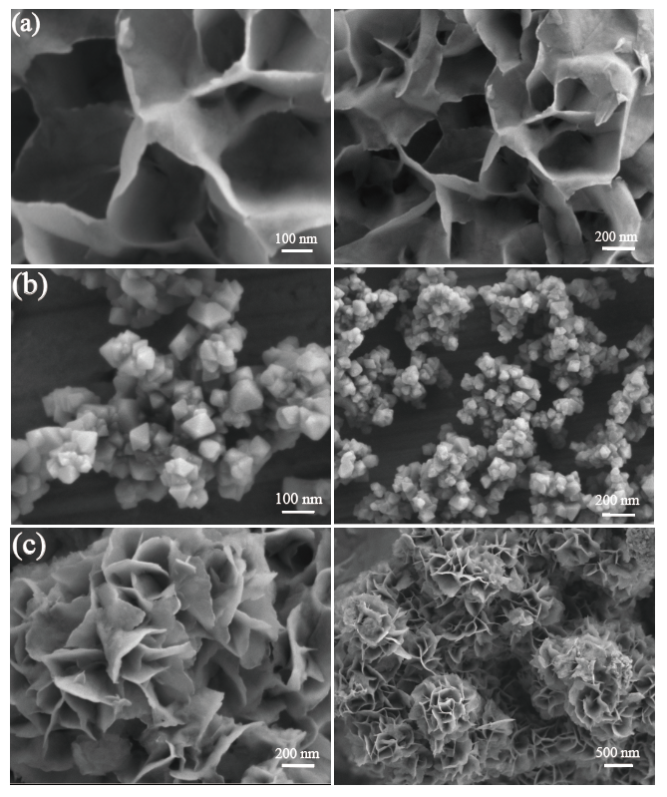

Fig S1. SEM results of ZIS (a), UiO-66-NH2 (b), UiO-66-NH2/ZIS-2 (c).

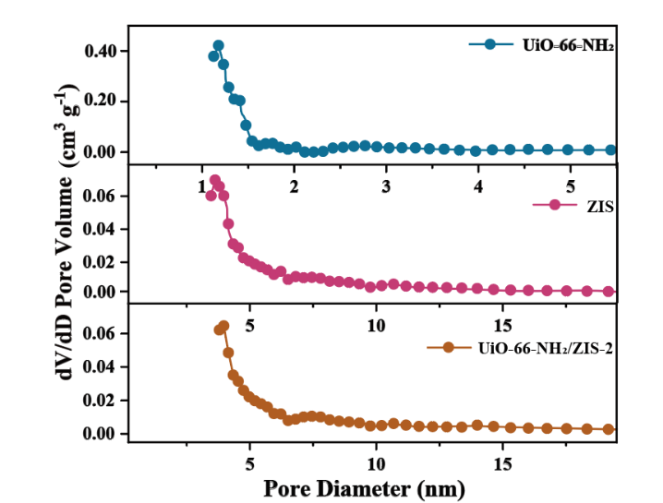

Fig S2. BJH pore size distributions of UiO-66-NH2, ZIS, and UiO-66- NH2/ZIS-2.

|  |  |  |
| --- | --- | --- |
| **Samples** | **SBET(m2/g)** | **Pore size(nm)** |
| UiO-66-NH2 | 739.439 | 0.573 |
| ZIS | 63.034 | 3.969 |
| UiO-66-NH2/ZIS-2 | 144.804 | 3.627 |

Table S1. BET specific surface area for different samples.

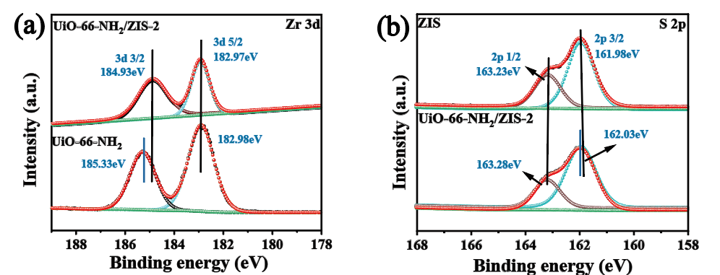

Fig S3. (a) High-resolution X-ray photoelectron spectroscopy (XPS) spectra of pure UiO-66-NH2, pure ZIS, and UiO-66-NH2/ZIS-2. (a) Zr 3d ; (b) S 2p ;

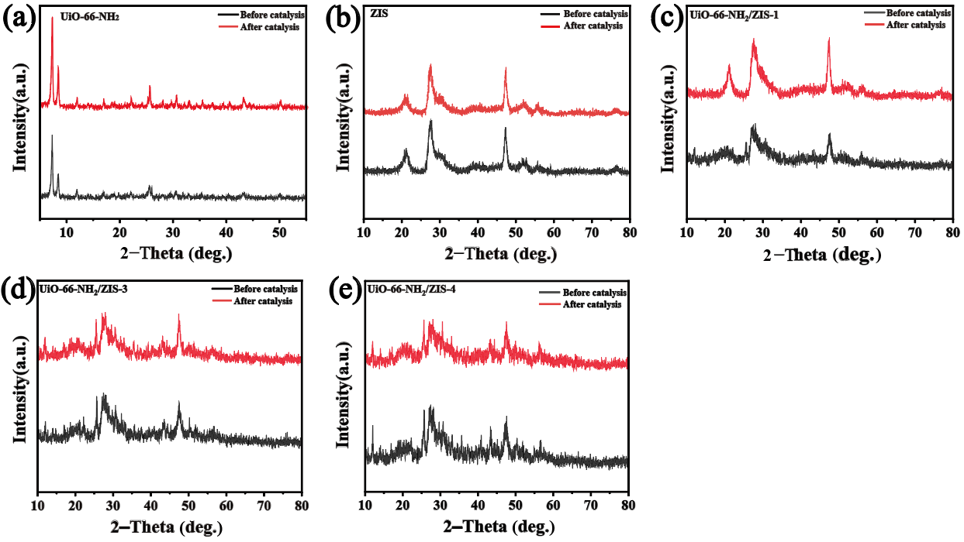Fig. S4. X-ray powder diffraction (XRD) patterns before and after the stability tests of of the prepared samples.

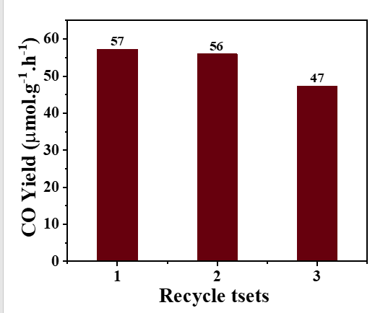

Fig. S5. The curves of recycling tests.

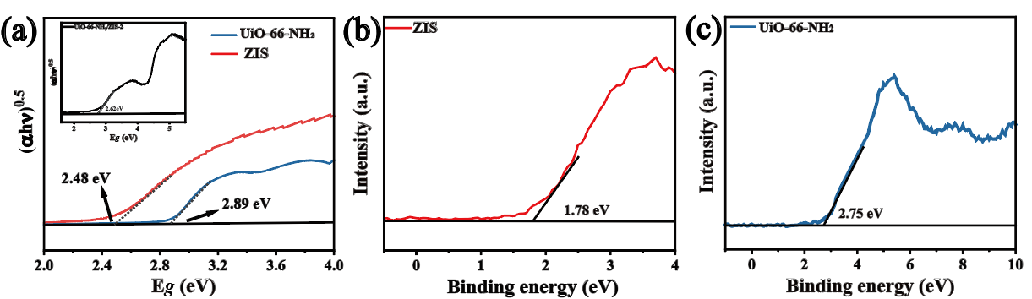

Fig. S6 (a) the corresponding Tauc plots of all the as-prepared samples. (b) VB-XPS spectra of pure UiO-66-NH2 andpure ZIS(c).

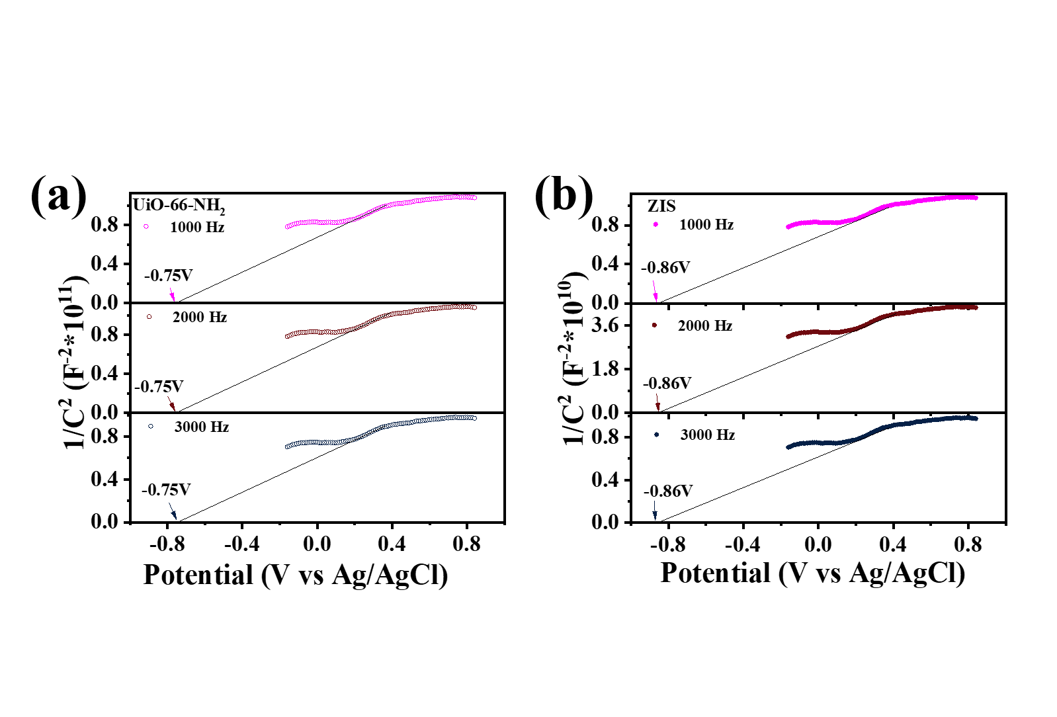

Fig. S7 Mott–Schottky plots of (a) UiO-66-NH2 and (b) ZIS.

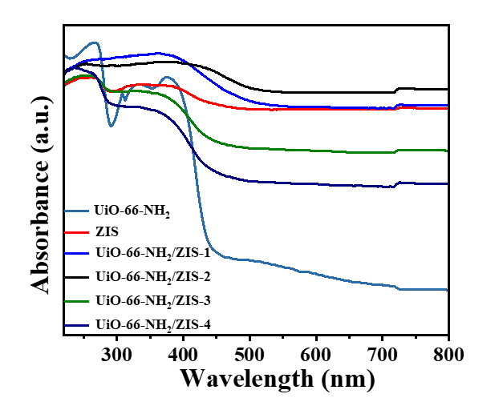

Fig. S8 The UV diagrams of the prepared catalysts.

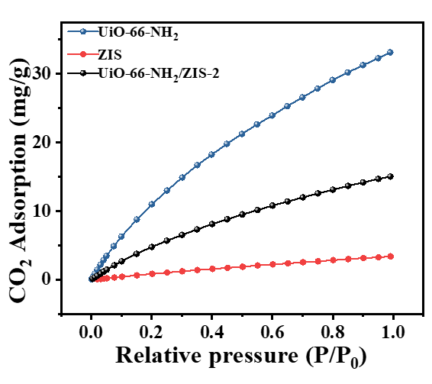

Fig S9. CO2 adsorption curves of UiO-66-NH2, ZIS and UiO-66-NH2/ZIS-2.

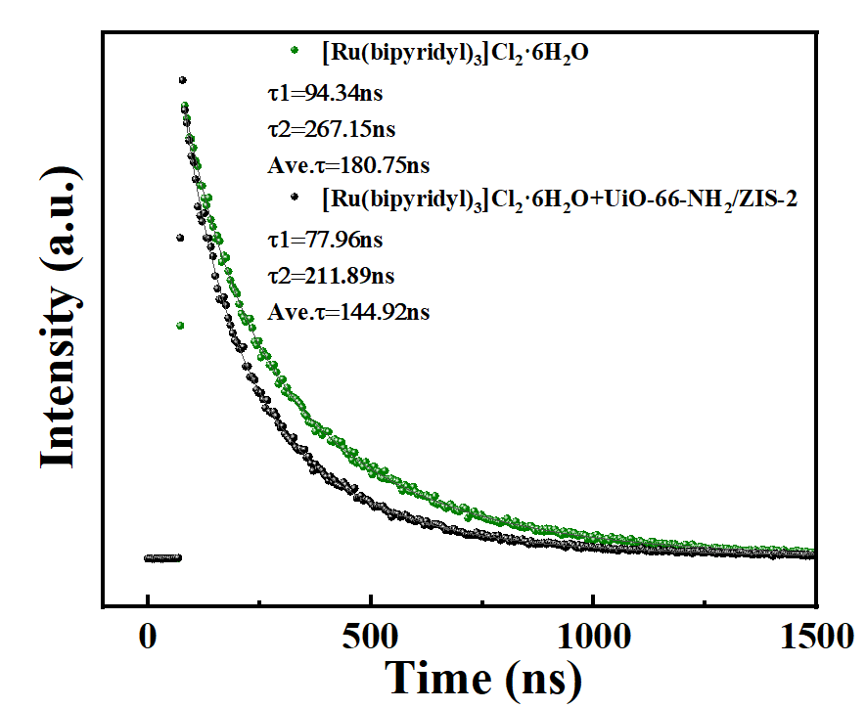

Fig S10. Time-resolved transient PL decay of [Ru(bipyridyl)3]Cl2·6H2O and UiO-66-NH2/ZIS-2.

Table S2. Comparison of the photocatalytic activity of as-obtained UiO-66-NH2/ZnIn2S4 in reduction of CO2 to CO with those of previously reported photocatalysts.

|  |  |  |  |  |  |  |
| --- | --- | --- | --- | --- | --- | --- |
| **Catalyst** | **Reaction conditions** | | | **Product** | **Yield**  **μmol h-1 g-1** | **Ref.** |
| ZnIn2S4/MOF‐808 | | water vapor | | CO | 8.21 | [1] |
| g‑C3N4/UiO-66(Zr/Ce) | | pure acetonitrile | | CH3OH  C2H5OH | 54.71  38.10 | [2] |
| Ni2P/ZnIn2S4 | | DI H2O | | CH4 | 68.31 | [3] |
| NH2-UiO-66/CuZnS | | H2O NaHCO3 H2SO4 | | CO | 22.85 | [4] |
| ZnIn2S4-In2O3 | | DI H2O Co(bpy)32+ TEOA Acetonitrile | | CO | 3075 | [5] |
| C/CdS@ZnIn2S4 | | DI H2O | | CO | 115.4 | [6] |
| Bi2MoO6@ZnIn2S4 | | water vapor | | CO | 23.11 | [7] |
| ZnIn2S4/BiVO4 | | DI H2O | | CO | 4.75 | [8] |
| ZnS/ZnIn2S4 | | DI H2O | | CO | 87.43 | [9] |
| ZnIn2S4/TiO2 | | DI H2O | | CO  CH4 | 1754  481 | [10] |
| UiO-66-NH2/ZnIn2S4 | | | TEOA Acetonitrile | CO | 39 | This work |

**References**

[1] M. Song, X. Song, X. Liu, W. Zhou, P. Huo, Enhancing photocatalytic CO2 reduction activity of ZnIn2S4/MOF-808 microsphere with S-scheme heterojunction by in situ synthesis method, Chinese Journal of Catalysis 51 (2023) 180-192.

[2] W. Wang, S. Song, P. Wang, M. He, Z. Fang, X. Yuan, H. Li, C. Li, X. Wang, Y. Wei, W. Song, H. Xu, Z. Li, Chemical Bonding of g-C3N4/UiO-66(Zr/Ce) from Zr and Ce Single Atoms for Efficient Photocatalytic Reduction of CO2 under Visible Light, ACS Catalysis 13 (2023) 4597-4610.

[3] Y. Song, Y. Wang, C. Hu, C. Ye, Z. Qian, Y. Zhao, W. Cai, Facet Engineering-Induced Construction of Ni2P/ZnIn2S4 Heterostructures for Boosted Photocatalytic CO2 Reduction, ACS Applied Materials & Interfaces 15 (2023) 30199-30211.

[4] J. Sun, Y. Guan, G. Yang, S. Qiu, H. Shao, Y. Wang, G. Li, S. Xiao, S-Scheme Photocatalyst NH2–UiO-66/CuZnS with Enhanced Photothermal-Assisted CO2 Reduction Performances, ACS Sustainable Chemistry & Engineering 11 (2023) 14827-14840.

[5] S. Wang, B.Y. Guan, X.W.D. Lou, Construction of ZnIn2S4–In2O3 Hierarchical Tubular Heterostructures for Efficient CO2 Photoreduction, Journal of the American Chemical Society 140 (2018) 5037-5040.

[6] X. Zhang, P. Wang, X. Lv, X. Niu, X. Lin, S. Zhong, D. Wang, H. Lin, J. Chen, S. Bai, Stacking Engineering of Semiconductor Heterojunctions on Hollow Carbon Spheres for Boosting Photocatalytic CO2 Reduction, ACS Catalysis 12 (2022) 2569-2580.

[7] J. He, J. Lin, Y. Zhang, Y. Hu, Q. Huang, G. Zhou, W. Li, J. Hu, N. Hu, Z. Yang, Interfacial Mo-S bond-reinforced hierarchical S-scheme heterostructure of Bi2MoO6@ZnIn2S4 for highly-selective and efficient CO2 photoreduction into CO, Chemical Engineering Journal 480 (2024) 148036.

[8] Q. Han, L. Li, W. Gao, Y. Shen, L. Wang, Y. Zhang, X. Wang, Q. Shen, Y. Xiong, Y. Zhou, Z. Zou, Elegant Construction of ZnIn2S4/BiVO4 Hierarchical Heterostructures as Direct Z-Scheme Photocatalysts for Efficient CO2 Photoreduction, ACS Applied Materials & Interfaces 13 (2021) 15092-15100.

[9] Y. Zhao, Y. Chen, L. Du, Q. Wang, X. Liu, L. Li, G. Tian, Fabrication of size-controlled hierarchical ZnS@ZnIn2S4 heterostructured cages for enhanced gas-phase CO2 photoreduction, Journal of Colloid and Interface Science 605 (2022) 253-262.

[10] Y. Ge, C. Zhang, Z. Yu, D. Wang, ZnIn2S4/TiO2 photocatalyst for CO2 photoreduction: Advancing sustainable energy conversion to renewable solar fuels, Journal of Industrial and Engineering Chemistry (2023) 335-345.