**Synthesis of Lignin-based covalent organic frameworks bio-composites: Quantitative evaluation of adsorption-photoreduction of hexavalent chromium**

Huiying Hu1, Kaijian Bi1, Haizhong Yu1, Pengjiao Tian1*, Xiqing Wang1*

1 College of food technology and chemical engineering, Hubei University of Arts and Science, Xiangyang, Hubei Province, China

Corresponding author: [13120018505@163.com (P.J](mailto:13120018505@163.com%20(P.J). Tian), [Xiqingwang91@163.com](mailto:Xiqingwang91@163.com) (X.Q. Wang)

This file including 2 Page, including 2 figures.

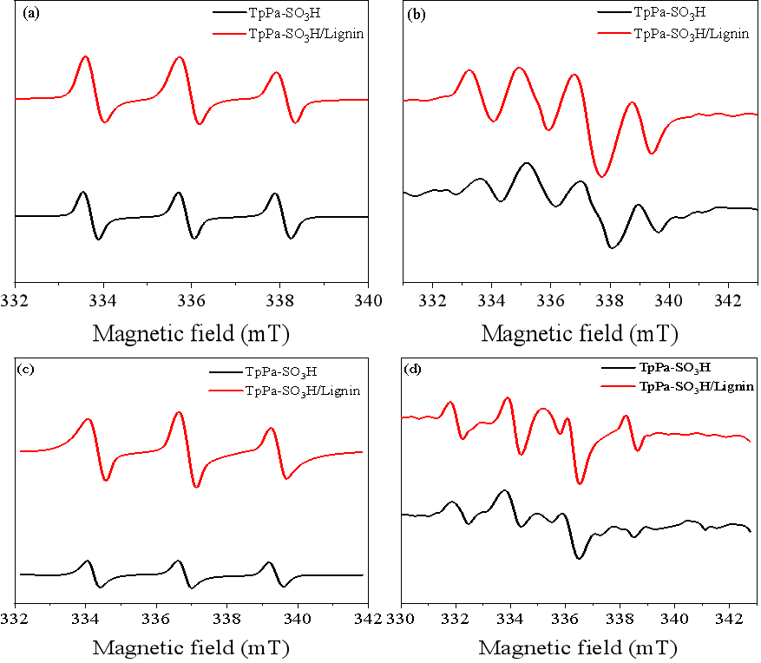

Fig. S1 DMPO-e- (a), DMPO-▪OH (b), TEMP-1O2 (c), and DMPO-▪O2- (d) spectra of TpPa-SO3H and TpPa-SO3H/Lignin under illumination for 10 min.



Fig. S2 High resolution XPS spectra of O1s peak of TpPa-SO3H (a) and TpPa-SO3H/lignin (b) and high resolution XPS spectra of N1s peak of TpPa-SO3H (c) and TpPa-SO3H/lignin (d).