***Supporting information***

**Copolymerization of Ethylene and Isoprene Initiated by Metallocene Catalyst** Amjad Ali1,2,3, Muhammad Nadeem4, Ahmad Naveed1**,** Jamile Mohammadi Moradian1*, Syed Najeeb Uz-Zaman Haider1**,** Shahid Khan1, Adnan Murad Bhayo5,Jianwei Lu1, Rai Nauman Ali1**,** Naushad Ahmad6, Fan Zhiqiang3, Li Guo1*

1School of Materials Science & Engineering, Jiangsu University, Zhenjiang 212013, P.R. China

2Institute of Chemistry, University of Silesia, Szkolna 9, Katowice 40-600, Poland

3MOE Key Laboratory of Macromolecular Synthesis and Functionalization, Department of Polymer Science and Engineering, Zhejiang University, Hangzhou 310027, P.R. China.

4School of Life Sciences, Wuchang University of Technology, Wuhan, 430223, PR China.

5Department of Chemistry and Chemical Biology, McMaster University, Hamilton, Ontario L8S 2C8, Canada

6Department of Chemistry, College of Science, King Saud University, Riyadh 11451, Kingdom of Saudi Arabia

**\*Corresponding author:** *Corresponding author,E-mail: [jamie@ujs.edu.cn](mailto:jamie@ujs.edu.cn) (Jamile Mohammadi Moradian); liguo@ujs.edu.cn (Prof. Li Guo)

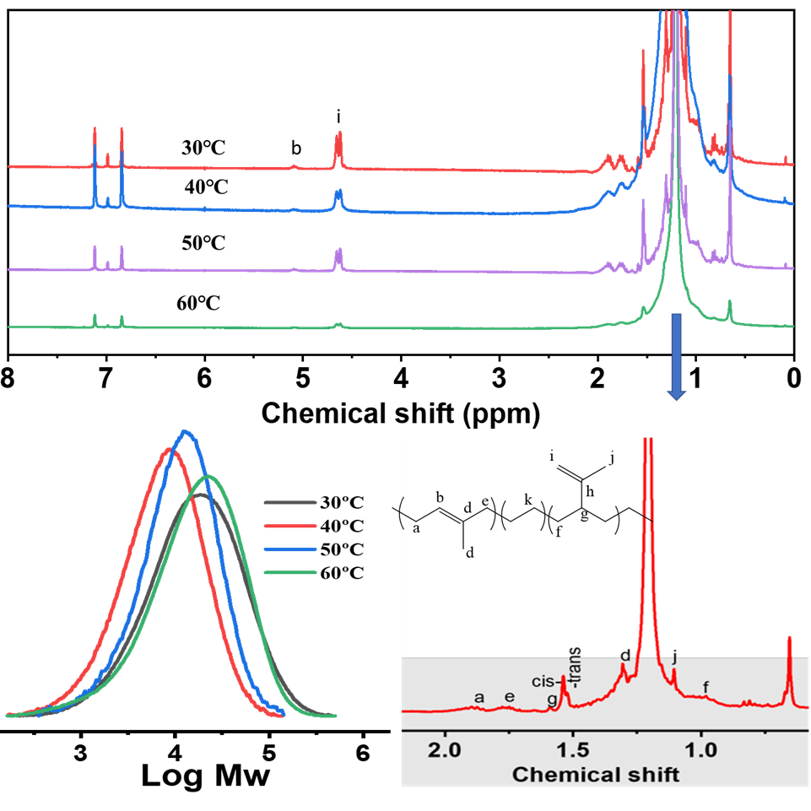

**Figure S1.**

**Figure S1.** 1HNMR and GPC of PE and E/Ip copolymers under different reaction temperatures.

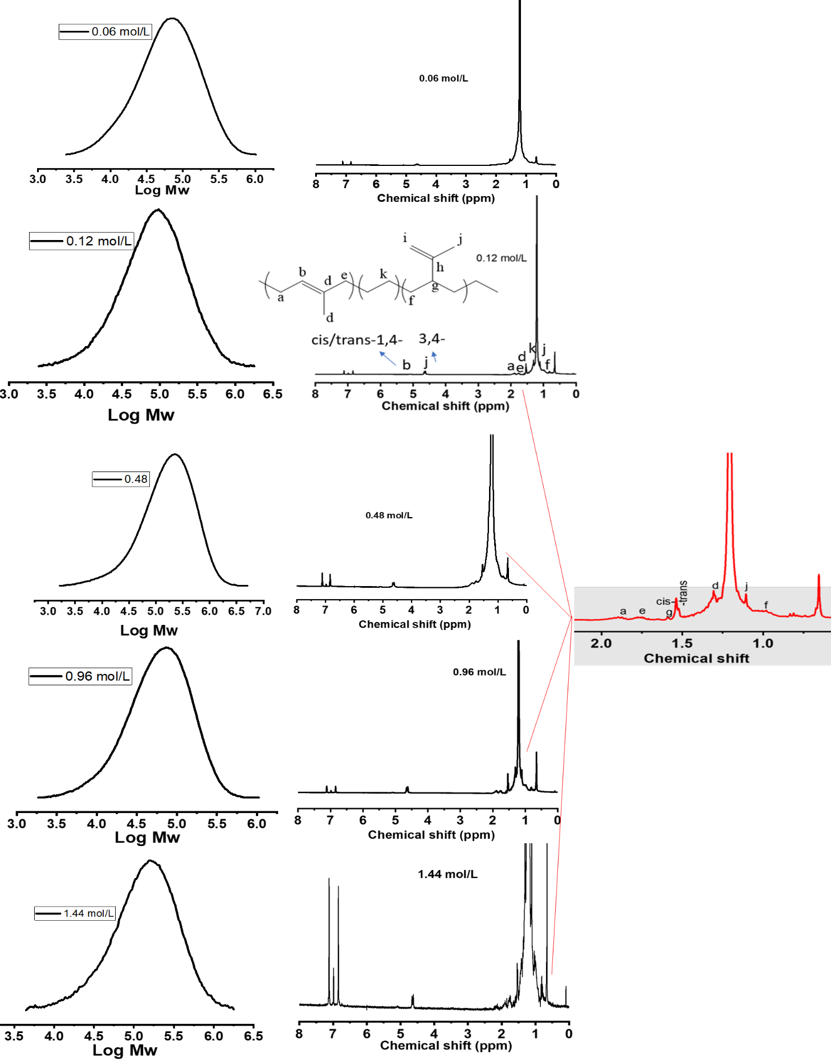

**Figure S2.** 1HNMR and GPC of PE and E/Ip copolymers under different isoprene concentrations.

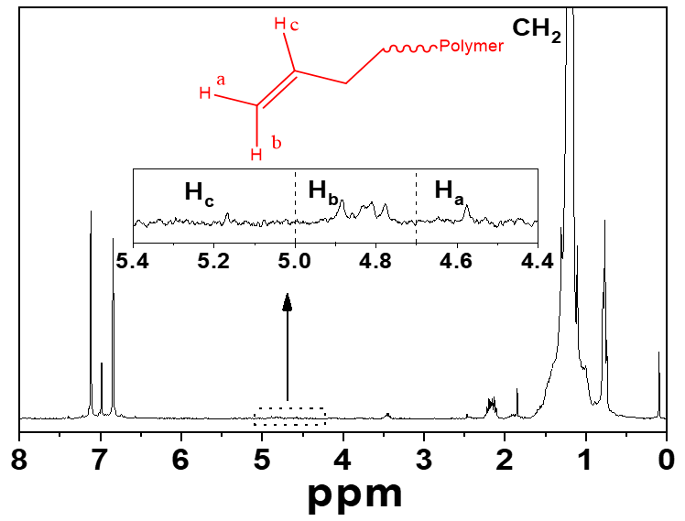

**Figure S3.** The number of PE chains formed via chain transfer reactions and reactivation by isoprene is mentioned in Scheme 2.