**Fabrication of BN/CuO@MWCNTs composites for enhancing heat transfer and photothermal conversion of phase change materials**

*Weifang Han a,*, Deyi Liu a, Guoliang Wang a, Suliang Li b, En You b, Zhengfeng Jia a, Yuchao Li a\**

*a School of Materials Science and Engineering, Liaocheng University, Liaocheng, 252059, China*

*b Zhejiang Construction Engineering Co., Ltd. of China Construction Eighth Engineering Division, Zhejiang, 311215, China*

E-mail: hanweifang@lcu.edu.cn (W. Han); liyuchao@lcu.edu.cn (Y. Li)

**Table S1.** The amount of raw material used for the preparation of BN@CuO hybrids.

|  |  |  |  |  |
| --- | --- | --- | --- | --- |
| **Material Type** | **Boric acid**  **(H3BO3)** | **Melamine**  **(C3N6H6)** | **CuSO4** | **aRB/Cu** |
| BN/CuO | 0.1 mol  (6.1830 g) | 0.05 mol  (6.3060 g) | 0.010 mol  (1.60g) | 10.0 |
| 0.1 mol  (6.1830 g) | 0.05 mol  (6.3060 g) | 0.015 mol  (2.40 g) | 6.7 |
| 0.1 mol  (6.1830 g) | 0.05 mol  (6.3060 g) | 0.020 mol  (3.20 g) | 5.0 |
| 0.1 mol  (6.1830 g) | 0.05 mol  (6.3060 g) | 0.025mol  (4.00 g) | 4.0 |
| 0.1 mol  (6.1830 g) | 0.05 mol  (6.3060 g) | 0.030 mol  (4.80g) | 3.3 |

aRB/Cu: Molar ratio of H3BO3 to CuSO4.

**Table S2.** The amount of raw material used for the preparation of BN/CuO*@*MWCNTs composite.

|  |  |  |  |  |  |  |
| --- | --- | --- | --- | --- | --- | --- |
| **Material Type** | **Boric acid**  **(H3BO3)** | **Melamine**  **(C3N6H6)** | **CuSO4** | **MWCNTs** | **PVP** |  |
| BN/CuO*@*MWCNTs | 0.1 mol  (6.1830 g) | 0.05 mol  (6.3060 g) | 0.005 mol  (0.80g) | 0.01mol  (0.12 g) | 1 g |  |
| 0.1 mol  (6.1830 g) | 0.05 mol  (6.3060 g) | 0.01 mol  (1.60 g) | 0.05 mol  (0.6 g) | 1 g |  |
| 0.1 mol  (6.1830 g) | 0.05 mol  (6.3060 g) | 0.02 mol  (3.20 g) | 0.1 mol  (1.2 g) | 1 g |  |
| 0.1 mol  (6.1830 g) | 0.05 mol  (6.3060 g) | 0.03 mol  (4.79 g) | 0.15 mol  (1.8 g) | 1 g |  |

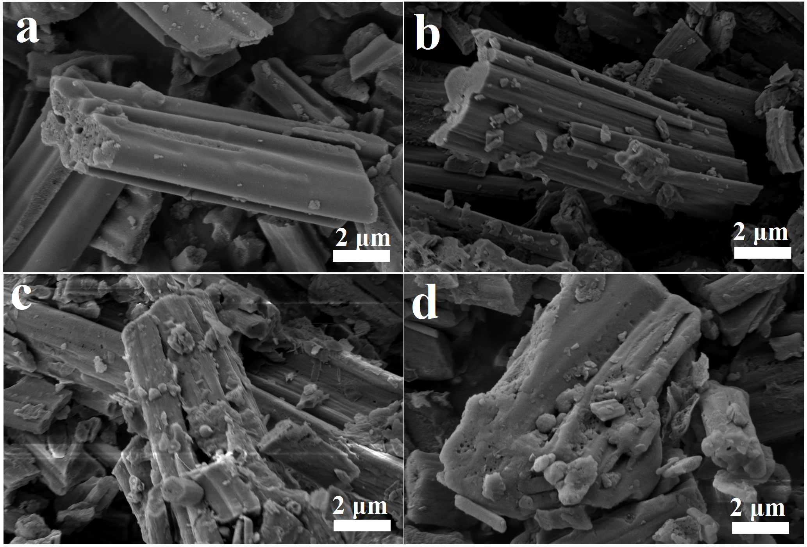

**Fig. S1.** SEM images of the BN/CuO hybrids prepared at different RB/Cu: (a) 10.0, (b) 6.7, (c) 4.0, (d) 3.3.

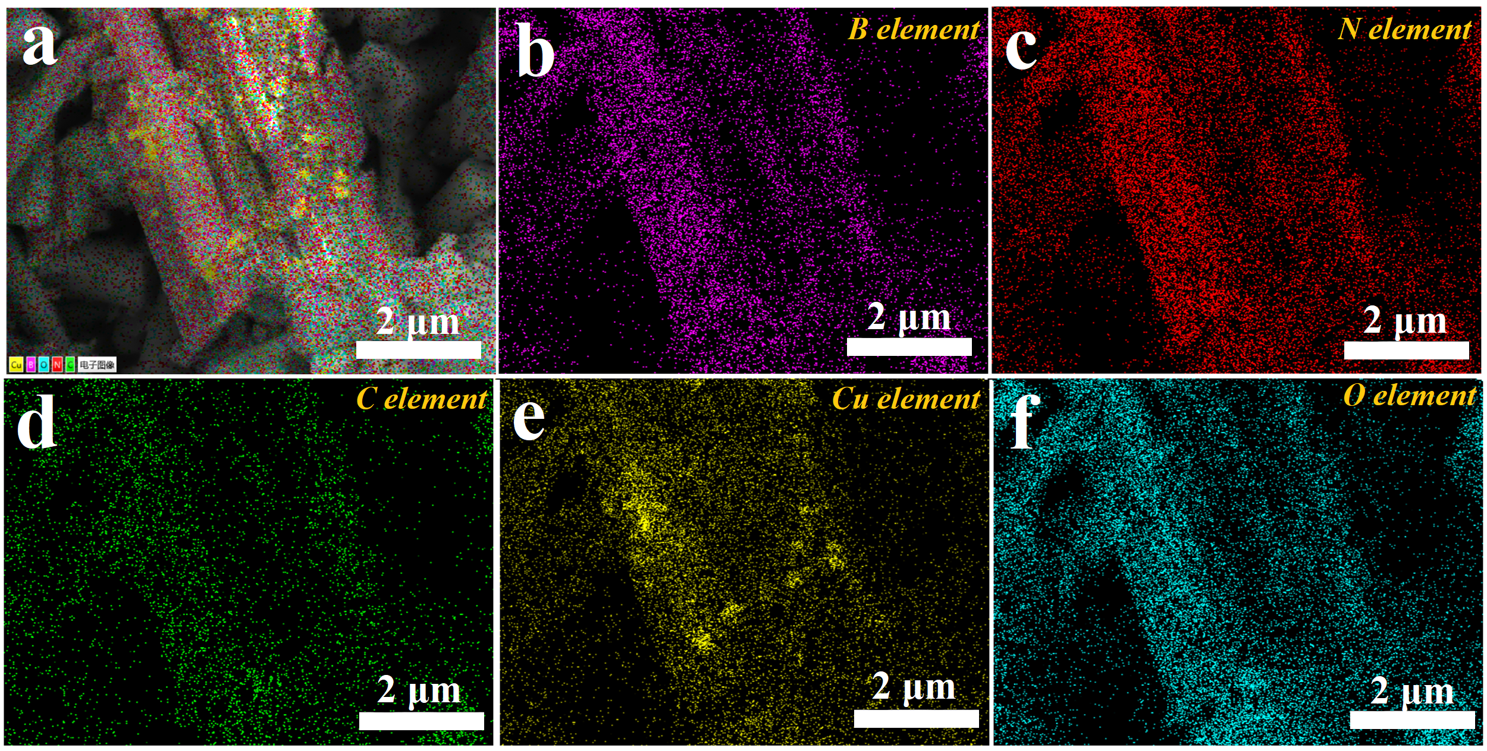

**Fig. S2.** Elemental mapping images of BN/CuO hybrid: (b) B, (c) N, (d) C, (e) Cu and (f) O elements.

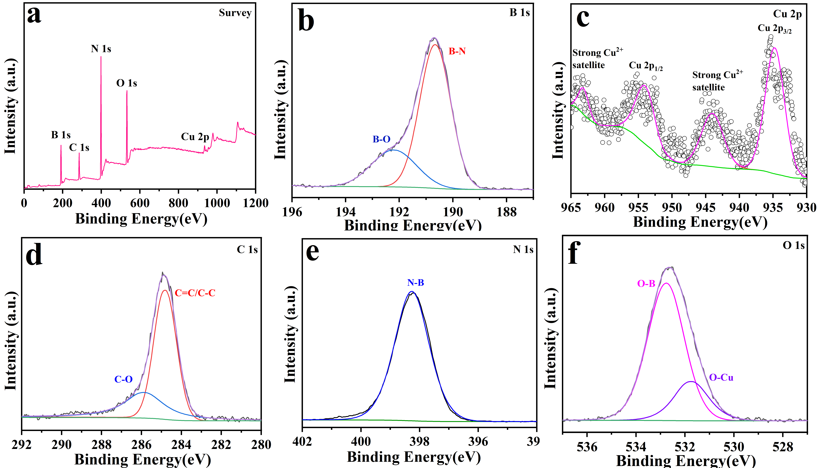

**Fig. S3.** XPS analysis of hybrid. (a) Survey spectrum, (B) high-resolution spectrum of (b) B 1s, (c) Cu 2p and (d) C 1s (e) N 1s (f) O 1s.



**Fig. S4.** XRD pattern of CuO

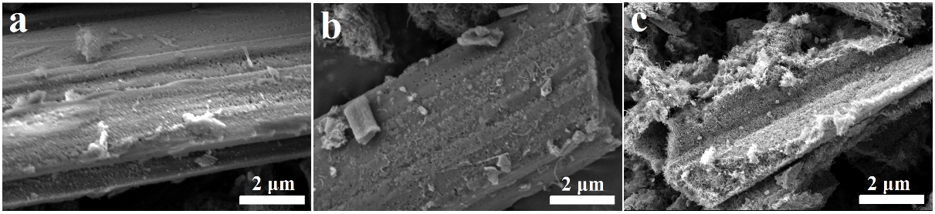

**Fig. S4.** SEM images of the BN/CuO/MWCNTs composites prepared at RB/Cu=3.6 and different amount of MWCNTs: (a) 0.01mol, (b) 0.50 mol and (c) 0.15 mol.



**Fig. S5.** XRD pattern of CuO

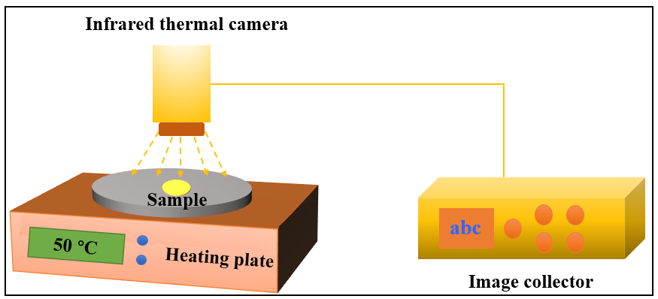

**Fig. S6.** Devices for testing the heat transfer performance



**Fig. S7.** Nitrogen adsorption/desorption isotherms of BN, BN/CuO hybrid and BN/CuO@MWCNTs composite



**Fig. S8.** UV–vis–NIR spectra absorption spectra

**Table S3.** Thermophysical properties of PEG and PEG-based composite PCMs.

|  |  |  |  |  |
| --- | --- | --- | --- | --- |
| Sample | *ΔΗm* (J/g) | *Tm* (°C) | *ΔΗc* (J/g) | *Tc* (°C) |
| PEG | 172.3 | 58.6 | 169.4 | 38.4 |
| PEG/BN | 153.1 | 58.1 | 151.8 | 40.0 |
| PEG/BN/CuO | 153.4 | 57.5 | 152.3 | 41.7 |
| PEG/BN/CuO@MWCNTs | 154.5 | 56.4 | 153.2 | 43.8 |

**Table S4.** Solar-thermal conversion efficiencies data of the PEG/BN/CuO and PEG/BN/CuO@MWCNTs composites.

|  |  |  |
| --- | --- | --- |
|  | PEG/BN/CuO | PEG/BN/CuO@MWCNTs |
| m (g) | 0.10 | 0.10 |
| *P* (mW/cm2) | 100 | 100 |
| *s* (cm2) | 1.16 | 1.16 |
| *Δt* (s) | 174.54 | 144.40 |
| Input energy a (J) | 20.25 | 16.75 |
| Thermal energy storage b (J) | 15.34 | 15.45 |
| $η$ (%) | 75.8 | 92.2 |

a Input energy= *P*×*s*×*Δt*

b Thermal energy storage = *m*×*ΔHm*

**Table S5.** The comparison of heat transfer and photothermal conversion between this work and some previously reported PEG-based PCMs.

|  |  |  |  |  |
| --- | --- | --- | --- | --- |
| Composite PCMs | Filler | TC (W/m·K) | η (%) | Ref. |
| PEG/GNPs | 4 | 3.11 | 86 | 2018[1] |
| PEG/Ti3C2Tx | 20 w% | 0.293 | 94.5% | 2019[2] |
| RHTC/PEG | 7 | 0.51 | 90.1 | 2021[3] |
| Ti3C2Tx@PVA/PEG | 7.68 | 0.428 | 96.5 | 2021[4] |
| B-GAPCM | --- | 1.07 | 89.3 | 2021[5] |
| CF/(HO-BNNS@CuO)/PEG | 10 wt% | 1.12 | 91.8 | 2022[6] |
| PAAAM/RHTC/PEG |  | 0.76 | 93.3 | 2022[7] |
| PI/PR Aerogel/PEG | 16 | 0.3469 | 82.5 | 2022[8] |
| FCPCMs | 40 | 1.733 | 95 | 2022[9] |
| PU/GO/PEG | 11 | 0.972 | 95.3 | 2022[10] |
| MXene@PVP/PEG | 10 | 0.533 | 96.2 | 2023[11] |
| PVDF/RB/PEG | 9.1 | 1.01 | 92.1 | 2024[12] |
| PEG@PFCC | --- | 1.61 | 91.5 | 2024[13] |
| BCNSs/PEG | 14.3 | 0.635 | 80.2 | 2024[14] |
| PEG/CPAC | 3.9 | 0.61 | 94.6 | 2024[15] |
| CuO@PEG | 20 | 0.52 | 91.6 | 2024[16] |
| MPC@PEG |  | 0.96 | 90.8 | 2024[17] |
| PEG/BN/CuO@MWCNTs | 10 | 2.35 | 92.2 | This work |

**Reference**

[1] T. Qian, S. Zhu, H. Wang, A. Li, B. Fan, Comparative study of single-walled carbon nanotubes and graphene nanoplatelets for improving the thermal conductivity and solar-to-light conversion of PEG-infiltrated phase-change material composites, ACS Sustainable Chem. Eng., 7 (2019) 2446-2458.

[2] X. Fan, L. Liu, X. Jin, W. Wang, S. Zhang, B. Tang, MXene Ti3C2Tx for phase change composite with superior photothermal storage capability, J. Mater. Chem. A, 7 (2019) 14319-14327.

[3] H. Yang, Y. Bai, C. Ge, S. Li, X. Zhang, High Thermal Conductivity of Carboxyl-rich Carbon/Polyethylene Glycol Composites for Enhanced Photothermal Conversion and Latent Heat Storage, Chin. J. Chem., 39 (2021) 3245-3254.

[4] Z. Mo, P. Mo, M. Yi, Z. Hu, G. Tan, M.S. Selim, Y. Chen, X. Chen, Z. Hao, X. Wei, Ti3C2Tx@Polyvinyl alcohol foam-Supported Phase Change Materials with Simultaneous Enhanced Thermal Conductivity and Solar-Thermal Conversion Performance, Sol. Energy Mater. Sol. Cells, 219 (2021) 110813.

[5] Z. Bao, N. Bing, H. Yao, Y. Zhang, H. Xie, W. Yu, Three-dimensional interpenetrating network phase-change composites with high photothermal conversion and rapid heat storage and release, ACS Appl. Energy Mater., 4 (2021) 7710-7720.

[6] H. Yang, L. He, R. Liu, C. Ge, C. Ma, X. Zhang, Ultralight and flexible carbon-based phase change composites with high porosity for enhanced shape memory and photothermal conversion performance, Sol. Energy Mater. Sol. Cells, 244 (2022) 111816.

[7] H. Yang, Y. Bai, C. Ge, L. He, W. Liang, X. Zhang, Polyethylene glycol-based phase change materials with high photothermal conversion efficiency and shape stability in an aqueous environment for solar water heater, Compos. Part A, 154 (2022) 106778.

[8] Z. Zheng, T. Shi, H. Liu, D. Wu, X. Wang, Polyimide/phosphorene hybrid aerogel-based composite phase change materials for high-efficient solar energy capture and photothermal conversion, Appl. Therm. Eng., 207 (2022) 118173.

[9] J. Chen, Z. Mo, Y. Chen, P. Mo, Z. Hu, X. Chen, J. Yu, Z. Hao, X. Zeng, R. Sun, J. Xu, Highly Stable MXene-Based Phase Change Composites with Enhanced Thermal Conductivity and Photothermal Storage Capability, ACS Appl. Energy Mater., 5 (2022) 11669-11683.

[10] J. Wang, Z. Wu, H. Xie, T. Wang, Y. Wang, Y. Huang, L. Dong, Graphene oxide/polyurethane-based composite solid–solid phase change materials with enhanced energy storage capacity and photothermal performance, Int. J. Energy Res., 46 (2022) 22744-22756.

[11] Y. Chen, J. Chen, Z. Hao, M.S. Selim, J. Yu, X. Chen, Polyvinylpyrrolidone-bridged MXene skeleton constructed by photothermal assisted sacrificial template method for phase change materials with form stability and photothermal conversion, Chem. Eng. J., 463 (2023) 142375.

[12] H. Yang, M. Si, Y. guo, C. Ge, L. He, X. Zhang, RHTC/HO-BNNS structure collaboratively improves thermal conductivity and photothermal conversion properties of phase change materials, Sol. Energy Mater. Sol. Cells, 268 (2024) 112746.

[13] L. Wang, M. Zhou, H. Fu, An in-situ growth Fe3O4 and polyaniline on carbon cloth encapsulated composite phase change materials with high thermal conductivity and photothermal energy conversion and storage, J. Energy Storage, 78 (2024) 110090.

[14] J. Zhang, Z. Zheng, L. Xu, H. Xie, Z. Fei, P.J. Dyson, N. Yan, Light- and electro-driven phase change materials derived from activated porous biochar nanosheets and encapsulated polyethylene glycol, Colloids Surf., A, 690 (2024) 133783.

[15] Y. Liu, Y. Liu, W. Chen, X. Hu, Y. He, Y. Ma, Y. Xie, W. Luo, L. Luo, L. Jiang, X. Jiang, Q. Li, Polyethylene glycol/melamine foam composite phase change materials modified by CdS/Ag exhibits high photothermal conversion performance, Desalination, 585 (2024) 117783.

[16] H. Pang, G. Li, L. Cheng, C. He, X. Wang, X. Zhang, 3D flower-like CuO@PEG composite phase change materials with photo response for applications in energy conversion and storage, J. Energy Storage, 82 (2024) 110537.

[17] S. Wang, Q. Huang, Z. Sun, Y. Wang, T. Liang, B. Wang, C. Fan, C. Liu, Porous carbon network-based composite phase change materials with heat storage capacity and thermal management functions, Carbon, 226 (2024) 119174.